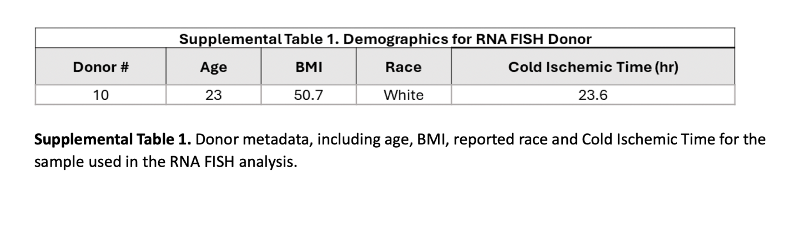

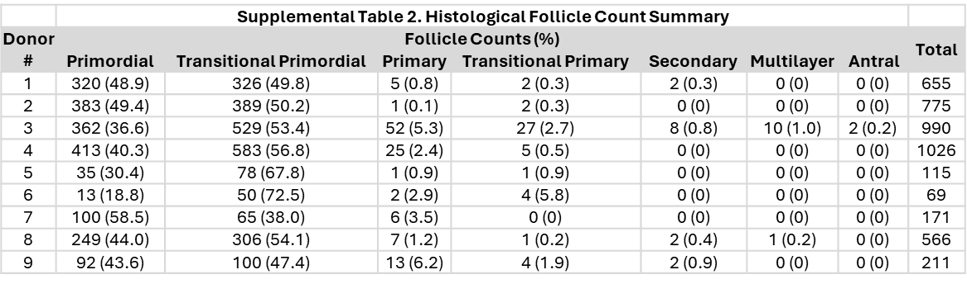
Supplemental Table 2. Histological follicle count summary. The number of follicles counted for the 9 donors sequenced at each follicle stage, along with the percent distribution across stages, shown in the parentheses.

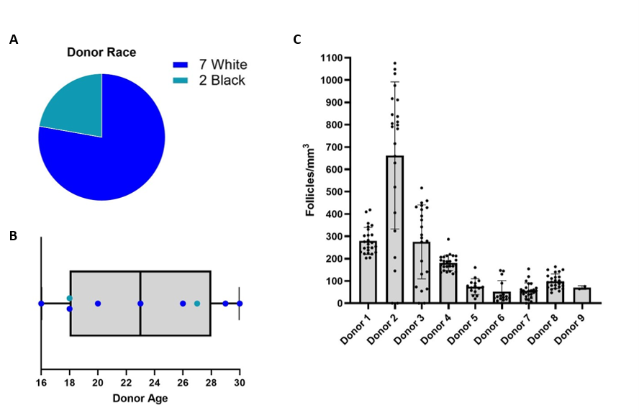
Supplemental Figure 1. Donor demographics and histological analysis. A. Breakdown of reported race for 9 donors used for sequencing. B. Spread of donor ages with reported race indicated by teal or dark blue colors. C. Follicle densities, as counts per mm³, compared across the 9 donors.

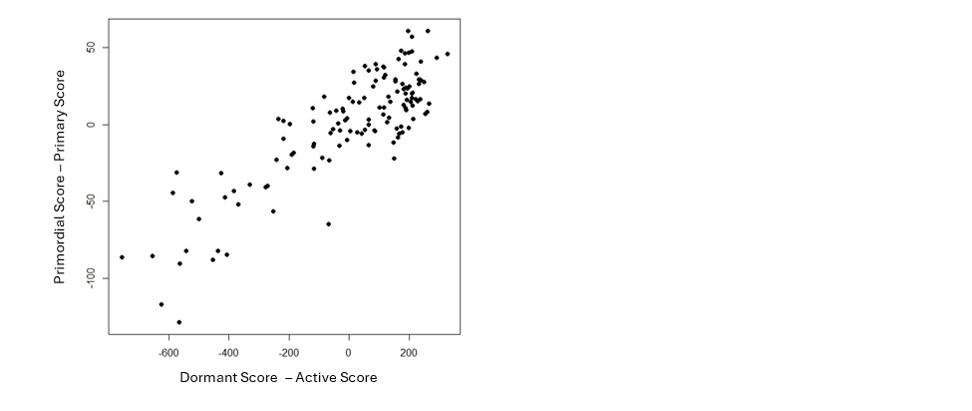
Supplemental Figure 2. Concordance between the primordial-primary scores (y axis) and dormant-active scores (x axis) over the 133 oocytes.

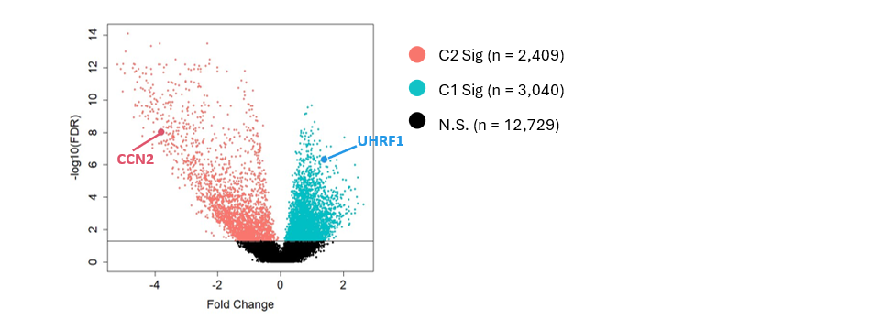
Supplemental Figure 3. Selection of UHRF1 and CCN2 as markers for Cluster 1 and 2, respectively, based on DE analysis results.

