Supplementary data
Supplementary Table 1: Composition of Culture Minimal Media used in the isolation of epiphytic and endophytic bacteria. The media were supplemented with different pigments and nitrogen sources. Each medium treatment was applied at high and low concentrations. Cycloheximide (100 ppm) was added into media to inhibit fungi growth and pH was adjusted to 7.0.
Culture Medium: Minimal Medium + Nitrogen/Pigment Source
 | Epiphytic Bacteria |  | Endophytic Bacteria
 | High | Low | High | Low
LB | 35 g/L |  | 35 g/L
Chlorophyll | 0.2 g/L | 0.02 g/L | 0.2 g/L | 0.02 g/L | + Cycloheximide (100 ppm), pH 7.0
β-carotene | 0.2 g/L | 0.02 g/L | 0.2 g/L | 0.02 g/L | + Cycloheximide (100 ppm), pH 7.0
Quercitin | 0.2 g/L | 0.02 g/L | 0.2 g/L | 0.02 g/L | + Cycloheximide (100 ppm), pH 7.0
Glycine | 2 g/L | 0.2 g/L | 2 g/L | 0.2 g/L
Alanine | 2 g/L | 0.2 g/L | 2 g/L | 0.2 g/L
Aspartic acid | 2 g/L | 0.2 g/L | 2 g/L | 0.2 g/L

Supplementary Table 2: PERMANOVA results illustrating the effect of orchards, apple cultivars and microbe lifestyles on the antibiotic resistance profiles. Significant effects (p < 0.05) are indicated with an asterisk (*).
Factor | Df | Sum Sq | R² | F | Pr(>F)
Orchard | 3 | 564.5 | 0.21138 | 1.0646 | 0.92
Apple cultivar | 1 | 270.7 | 0.05173 | 0.6160 | 0.455
Microbe lifestyle | 1 | 2899.1 | 0.55411 | 6.5980 | 0.028 *
Apple cultivar*microbe lifestyle | 1 | 304.6 | 0.05823 | 0.6933 | 0.467

Supplementary Table 3: Contamination checks and completeness metrics of the metagenome-assembled genomes (MAGs). The table includes Bin ID, Marker lineage, genomes, markers, marker sets detected per MAG with the varying levels of redundancy (0–5+), completeness percentage, estimated contamination, and strain heterogeneity.
Bin Id | Marker lineage | Genomes | Markers | Marker sets | 0 | 1 | 2 | 3 | 4 | 5+ | Completeness | Contamination | Strain heterogeneity
B7_contig | o__Actinomycetales (UID1572) | 580 | 288 | 173 | 0 | 286 | 2 | 0 | 0 | 0 | 100 | 0,77 | 50 | d__Bacteria;p__Actinobacteriota;c__Actinomycetia;o__Actinomycetales;f__Cellulomonadaceae;g__Cellulosimicrobium;s__ | Genome not assigned to closest species as it falls outside its pre-defined ANI radius
B298_contig | f__Enterobacteriaceae (UID5054) | 223 | 876 | 305 | 0 | 871 | 5 | 0 | 0 | 0 | 100 | 0,6 | 0 | d__Bacteria;p__Proteobacteria;c__Gammaproteobacteria;o__Enterobacterales;f__Enterobacteriaceae;g__Pantoea;s__Pantoea agglomerans | N/A
B78_contig | o__Actinomycetales (UID1815) | 120 | 574 | 266 | 1 | 535 | 34 | 4 | 0 | 0 | 99,94 | 6,37 | 0 | d__Bacteria;p__Actinobacteriota;c__Actinomycetia;o__Mycobacteriales;f__Mycobacteriaceae;g__Rhodococcus;s__Rhodococcus erythropolis_D | N/A
B483_contig | g__Streptomyces (UID2052) | 52 | 563 | 281 | 2 | 535 | 25 | 1 | 0 | 0 | 99,73 | 4,48 | 0 | d__Bacteria;p__Actinobacteriota;c__Actinomycetia;o__Streptomycetales;f__Streptomycetaceae;g__Streptomyces;s__ | Genome not assigned to closest species as it falls outside its pre-defined ANI radius
B465_contig | g__Streptomyces (UID2052) | 52 | 563 | 281 | 2 | 554 | 7 | 0 | 0 | 0 | 99,73 | 1,24 | 0 | d__Bacteria;p__Actinobacteriota;c__Actinomycetia;o__Streptomycetales;f__Streptomycetaceae;g__Streptomyces;s__ | Genome not assigned to closest species as it falls outside its pre-defined ANI radius
B472_contig | f__Rhizobiaceae (UID3564) | 78 | 840 | 354 | 1 | 819 | 19 | 1 | 0 | 0 | 99,72 | 2,97 | 0 | d__Bacteria;p__Proteobacteria;c__Alphaproteobacteria;o__Rhizobiales;f__Rhizobiaceae;g__Agrobacterium;s__Agrobacterium pusense | N/A
B142_contig | f__Rhizobiaceae (UID3564) | 78 | 840 | 354 | 1 | 828 | 10 | 1 | 0 | 0 | 99,72 | 1,97 | 7,69 | d__Bacteria;p__Proteobacteria;c__Alphaproteobacteria;o__Rhizobiales;f__Rhizobiaceae;g__Agrobacterium;s__Agrobacterium pusense | N/A
B69_contig | c__Bacilli (UID285) | 586 | 325 | 181 | 1 | 323 | 1 | 0 | 0 | 0 | 99,45 | 0,55 | 0 | d__Bacteria;p__Firmicutes;c__Bacilli;o__Staphylococcales;f__Staphylococcaceae;g__Staphylococcus;s__Staphylococcus arlettae | N/A
B386_contig | o__Actinomycetales (UID1572) | 580 | 286 | 171 | 1 | 280 | 5 | 0 | 0 | 0 | 99,42 | 2,14 | 0 | d__Bacteria;p__Actinobacteriota;c__Actinomycetia;o__Actinomycetales;f__Dermabacteraceae;g__Brachybacterium;s__Brachybacterium paraconglomeratum | N/A
B135_contig | o__Actinomycetales (UID1593) | 69 | 400 | 198 | 3 | 391 | 6 | 0 | 0 | 0 | 98,93 | 2,31 | 0 | d__Bacteria;p__Actinobacteriota;c__Actinomycetia;o__Actinomycetales;f__Microbacteriaceae;g__Curtobacterium;s__Curtobacterium flaccumfaciens_B | N/A

Supplementary Figure 1: Antibiotic resistance network of the bacterial isolates against antibiotics. The bacterial nodes were color-coded according to the bacterial genus level while the antibiotic nodes (Emipenem, tetracycline, penicillin, ceftriaxone, ciprofloxacin, erythromycin and vancomycin) were depicted based on the resistance proportions of epiphytes (purple) and endophytes (green). The size of the nodes is proportional to the number of connections (degree). The edges connecting bacterial nodes to antibiotics represent significant positive interaction (resistance).
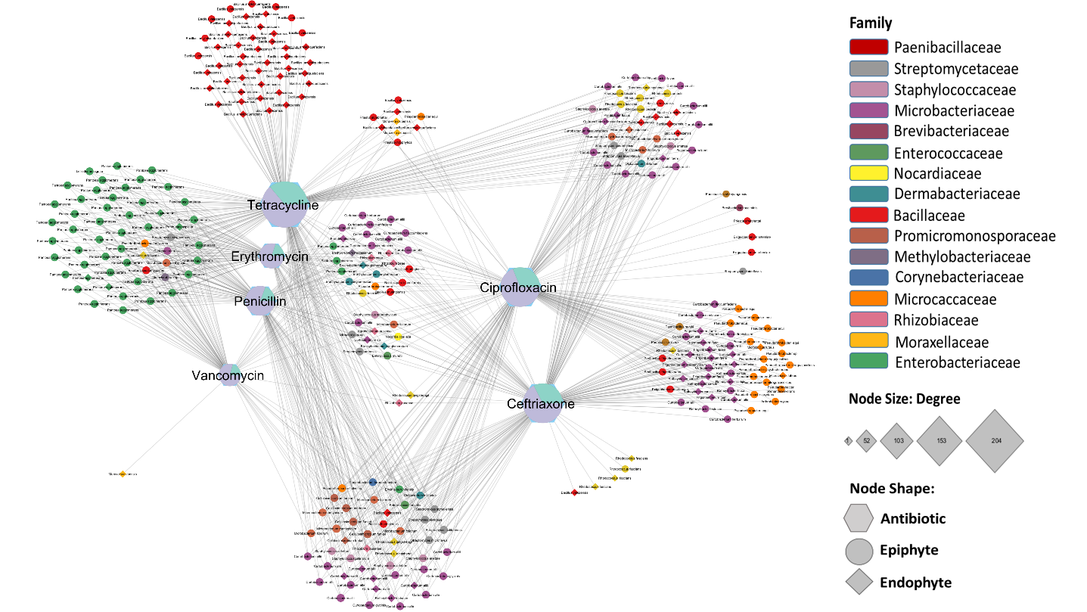

Supplementary Figure 2: Predominant taxa associated with resistant isolates. The y-axis represents the number of the resistant isolates, while x-axis microbial lifestyle (endophyte and epiphyte) of golden reinders and Mandy apples. Resistance were determined based on the phenotypic resistance profiles.
