An atlas of cell type specific regulatory effects in cattle

The supplementary information contains:
Supplementary Figures
Supplementary Tables (in a separate Excel file)

Supplementary Fig. 1. Data summary of the CattleCell-GTEx project.
- Sample size and cell type count of 22 bovine tissues. The bar plot represents sorted sample sizes of bulk tissues from the CattleGTEx project (v1), while the red line represents the cell-type counts of respective tissues obtained from the Cattle Cell Atlas project.
- Clustering of 8,866 bulk RNA-seq samples based on 2,923 differentially expressed genes (adjust.p < 0.05 and log₂FC > 1) across 22 bovine tissues.
- Clustering of 999,192 single cells based on expression of 2,000 highly variable genes across 81 cell-types. Cells are colored by seven major cell lineages.
- Same as (c), but cells are colored by tissue types, consistent with (b).
- Clustering of 4,505 CD8+ T cells across three tissues, namely heart, lung and uterus.

Supplementary Fig. 2. Distribution models used for benchmarking cell-type deconvolution methods. To benchmark seven different cell deconvolution methods, we simulated distributions for cell composition, namely uniform, normal, and bimodal, with varying combinations of standard deviations (sd).
Supplementary Fig. 3. Performance evaluation of seven cell-type deconvolution methods across different simulation scenarios.
- Performance of seven deconvolution methods (i.e., xxx, xxx, xxx, xxx and xxx) across three cell component distribution models in three tissues, including CNS, hear, and ileum. Dot colors represent 1/ Root Mean Square Error (RMSE) value, and dot sizes show average Pearson’s correlation (p) between estimated cell-type fraction and true cell-type fraction. xxx
- Pearson’s correlation (r) between estimated cell-type fraction and true cell-type fraction under seven deconvolution methods in common and rare cell types from Central Nervous System (CNS).xxx

Supplementary Fig. 4. Estimated cell-type compositions across 10 tissues in digestive and nerve systems. Bar plots represent estimated cell-type components of 3,862 bulk samples from 10 tissues in digestive (i.e., colon, duodenum, ileum, jejunum, large intestine, liver, and rumen) and nerve (i.e., central nervous system- CNS, hypothalamus, and pituitary gland) system, including 46 cell types.
Supplementary Fig. 5. Estimated cell-type compositions across 12 tissues in immune, reproductive, integumentary, Cardiovascular and Respiratory systems. Bar plots represent estimated cell-type components of 5,004 bulk RNA-seq amples from 12 tissues in immune (i.e., blood, lymph node, and spleen), reproductive (i.e., mammary gland, oviduct, testis, placenta, epididymis, and uterus), integumentary (skin), cardiovascular (heart), and respiratory (lung) system, including 53 cell types.

Supplementary Fig. 6. Overview of cell-type deconvolution results of xxx RNA-seq samples in 22 bovine tissues.
- Tissue-sharing patterns of 81 deconvoluted cell types across 22 tissues.
- Coefficient variations (CV) of estimated cell-type fractions across respective samples in 297 tissue-cell pairs.
Supplementary Fig. 7. Estimated cell-state compositions across 10 tissue-cell pairs in digestive systems. Bar plots represent estimated cell-state components of 1,497 bulk samples from 10 tissue-cell pairs in the digestive system, representing four tissues.

Supplementary Fig. 8. Estimated cell-state compositions across 12 tissue-cell pairs in immune and reproductive systems. Bar plots represent estimated cell-state components of 3,065 bulk samples across 12 tissue-cell pairs from immune (blood and lymph node) and reproductive (testis, uterus and placenta) system.
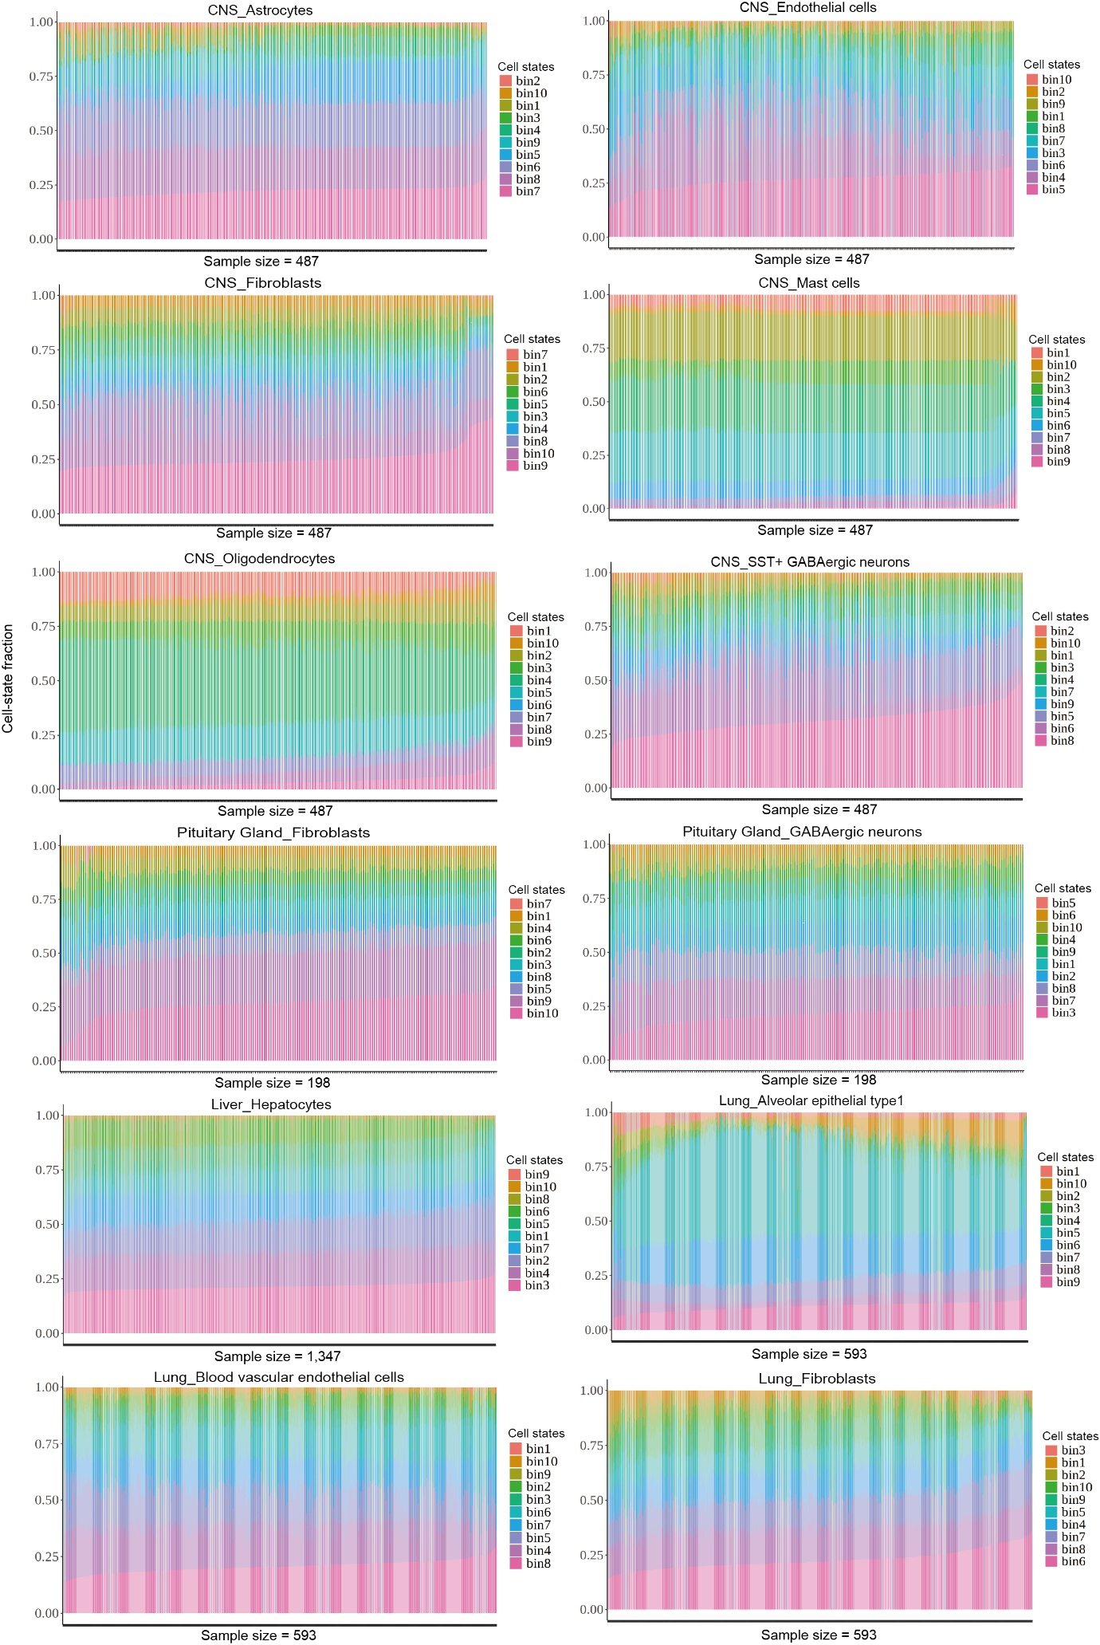
Supplementary Fig. 9. Estimated cell-state compositions across 12 tissue-cell pairs in nerve, digestive and respiratory organ systems. Bar plots represent estimated cell-state components of 2,625 bulk samples across 12 tissue-cell pairs from nerve (CNS and pituitary gland), respiratory (lung) and digestive (liver) system.
Supplementary Fig. 10. Estimated cell-state compositions across 10 tissue-cell pairs in reproductive and integumentary organ systems. Bar plots represent estimated cell state components of 1,011 bulk samples across 10 tissue-cell pairs in reproductive (mammary gland and epididymis) and integumentary (skin) organ systems.

Supplementary Fig.11. Summary of cell-state deconvolution results of xxx
- Estimated cell-state fraction across samples across 44 tissue-cell pairs.
- Coefficient variations (CV) in estimated cell-state fraction across the respective samples.

Supplementary Fig. 12. Summary of bulk eQTL (beQTL) mapping.
- Pearson’s correlation (r) between the proportion of detectable beGenes and sample size across 22 tissues.
- The overall tissue-sharing pattern of beQTL at Local False Sign Rate (LFSR) < 5% across 22 tissues.
- Heatmap of tissues depicting the corresponding pairwise Spearman’s correlation (ρ) of beQTL effect sizes across 22 tissues. Tissues are grouped by hierarchical clustering.
- Effect sizes distribution of lead SNPs in 18,391 beGene and 2,994 non-beGenes.
- Correlation between credible set counts by fine-mapping analysis in SuSiE (v.1.0) and independent beQTL counts by conditional analysis in Omiga (v.1.0.3) across 22 tissues.
- Distribution and the average number of independent beQTL per beGene detected by conditional analysis across 22 tissues. Tissues (x axis) are ordered from left to right by decreasing counts of independent beQTL per beGene.
- Distribution and the average number of credible sets per beGene detected by fine mapping analysis across 22 tissues. Tissues (x axis) are ordered from left to right by decreasing counts of credible sets per beGene.
Supplementary Fig. 13. Predicting cell-type gene expression across 100 common tissue-cell pairs.
- Benchmarking of gene expression prediction in three tissues. The color represents Pearson’s correlation (p) between estimated gene expression and true gene expression.
- The t-distributed Stochastic Neighbor Embedding (tSNE) plot for visualizing samples based on 898 cell-type differential expressed genes (adjust.p < 0.05 and log₂FC > 0.5) across 100 common tissue-cell pairs. Cells are colored by seven cell lineages.
- Same with (b), but cells are colored by tissue types.
- Distribution of estimated cis-heritability (cis-h²) of gene expression across 100 common tissue-cell pairs in 22 bulk tissues. The diamond represents the median of cis-h² of all tested genes.

Supplementary Fig. 14. Cell-type stratified eQTL (cseQTL) mapping.
- The number of cseGenes across 53 tissue-cell pairs. Tissues are ordered by increasing sample size.
- Counts of tissue/cell-type shared and specific cseGenes across 16 tissues.
- Comparison of lead eQTL among beQTL-specific, cseQTL-specific and shared eGenes.
- The overall cell type-sharing pattern of cseQTL at Local False Sign Rate (LFSR) < 5% across 53 tissue-cell pairs.
- Correlation between credible set counts by fine-mapping analysis in SuSiE (v.1.0) and independent eQTL counts by conditional analysis in Omiga (v.1.0.3) across 53 tissue-cell pairs.
- Distribution and the average number of credible set counts per cseGene detected by fine-mapping analysis across 53 tissue-cell pairs.
- Distribution and the average number of independent cseQTL per cseGene detected by conditional analysis across 53 tissue-cell pairs.

Supplementary Fig. 15. Functional enrichment of cseQTL.
- Distribution of annotated genome-wide SNPs across 12 sequence ontologies.
- Enrichment levels of lead cseQTL under four enhancer-like elements and four promoter-like elements.
- Distribution of cseQTL around gene body of cseGenes, denoted by the horizontal red bar. TSS: Transcription Start Site, and TES: Transcription End Site.
- Numbers of differential single-cell ATAC (sc-ATAC) active region (p-val < 0.05 and log2FC > 1) across five cell types.
- Enrichment of lead cseQTL with cell-type differential ATAC active regions between five cell-types in sc-ATAC data and the respective cell-types in cseQTL.

Supplementary Fig. 16. Number of cell-type interaction eGenes detected across 44 tissue-cell pairs in 12 tissues.

Supplementary Fig. 17. Colocalization between cseQTL and cell-type ieQTL.
- Pairwise Spearman’s correlation (xxx) of effect sizes across 10 tissues under beQTL and fibroblasts ieQTL.
- Pairwise Spearman’s correlation (xxx) of effect sizes between cseQTLs and cell-type-specific ieQTLs across 29 tissue–cell pairs, each with more than 20 cseGenes and cell-type ieGenes.
- PP4 distribution of colocalization analysis between cseGenes and cell-type ieGenes across 53 matching tissue-cell pairs.
Supplementary Fig. 18. Cell-state interaction eQTL (ieQTL) mapping results.
- Proportion of cell-state ieGenes in all 21,385 PCGs tested across 21 tissue-cell pairs.
- Spearman’s correlation (xxx) between the proportion of detectable cell-state ieGenes and sample size * cell-type fraction across 21 tissue-cell pairs.
- Cell-state sharing patterns of cell-state ieQTL in three cell types of blood.

Supplementary Fig. 19. Distribution of 2,070 independent quantitative trait loci (P < xxx) across 44 cattle complex traits.
Supplementary Fig. 20. Colocalization results of 44 complex traits with beQTL, cseQTL, cell-type ieQTL and cell-state ieQTL.
- Proportion of GWAS loci with colocalization signal using beQTL only and using both beQTL and cell-type eQTL across 44 complex traits.
- Numbers of GWAS loci that are colocalized with different types of eQTL across 44 complex traits. The line color represents different combinations of eQTL.
- Corrected numbers of cseGene with colocalization signal between 53 cell-types and 44 complex traits. The dot shows corrected colocalized eGene counts between each tissue-cell pair with each trait. The dot color represents different cell lineages.
Supplementary Fig. 21. Transcriptome-wide association studies (TWAS) of 44 complex traits in cattle.
- Distribution of 48,190 gene models with average rho > 0.05 across 53 tissue-cell pairs.
- TWAS results of 44 complex traits across 53 tissue-cell pairs. The dot color represents the significant level of TWAS results between 53 tissue-cell pairs and 44 traits. The dot size represents the significant (FDR < 0.05) eGene counts in each tissue-cell-trait trio.
Supplementary Fig.22 GWAS enrichment results between 250 tissue-cell pairs and 44 complex traits in cattle.
- Distribution of 2,586 significant tissue-cell-trait trios across 44 complex traits.
- Significant level of enrichment in each colocalized tissue-cell-trait trio. The dot size represents the colocalized eGene counts in each combination, and the dot color represents the average PP4 value in colocalization analysis. The asterisk represents significant enrichment (FDR < 0.05).
Supplementary Fig. 23. Annotation of spatial transcriptome data in cattle brain.
- Uniform Manifold Approximation and Projection (UMAP) plot for 10 cell clusters identified in spatial transcriptome data.
- Seven annotated cell-types (Ast3: Astrocyte subtype 3; End1: Endothelial cell subtype 1; End2: Endothelial cell subtype 2; Ex7: Excitatory neuron subtype 7; Ex8: Excitatory neuron subtype 8; Oli3: Oligodendrocyte subtype 3; Opc0: Oligodendrocyte precursor cell 0) in cattle brain and cell distribution in each of them.
- Three annotated brain regions (neocortex, pallidum and white matter) and cell distribution in each of them.
Supplementary Fig. 24. Enrichment between bulk eQTL and selection signatures of dairy cattle vs. beef cattle.
- The box plot represents the Fst distribution of 248,690 genomic regions across 10 Fst groups from no-selection (Fst1) to strongest selection (Fst10).
- Enrichment results (odd ratio) of 10 Fst groups with all beQTL in 18,391 beGenes.
- Effect size distribution of lead beQTL of beGenes overlapped with genomic regions located in Fst1-9 groups and Fst10 group respectively.
- Enrichment results (odd ratio) between genomic regions in Fst10 group (strongest selection) and tissue-specific beQTL across 17 tissues.
- 21 KEGG pathways enriched by tissue-specific beGenes under strong selection pressure (top 10% Fst).
Supplementary Fig. 25. Enrichment between cell-type seQTL and selection signatures.
- 97 KEGG pathways enriched in cell-type-specific cseGenes that are under strong selection between diary and beef cattle (top 10% Fst).
- The Manhattan plot represents an example of colocalized cell-type-specific cseGene under strong selection pressure. The cseQTL, rs210230814, of USP3 in luminal cells of mammary gland is also an independent QTL in milk fat percent trait. This cesQTL is also under strong selection pressure (Fst = 0.25).
- The box plot represents gene expression (TMM) under three genotypes (left) in rs210230814, and the bar plot represents the frequency of allele G in this SNP under five cattle breeds (right).

