Additional File 1

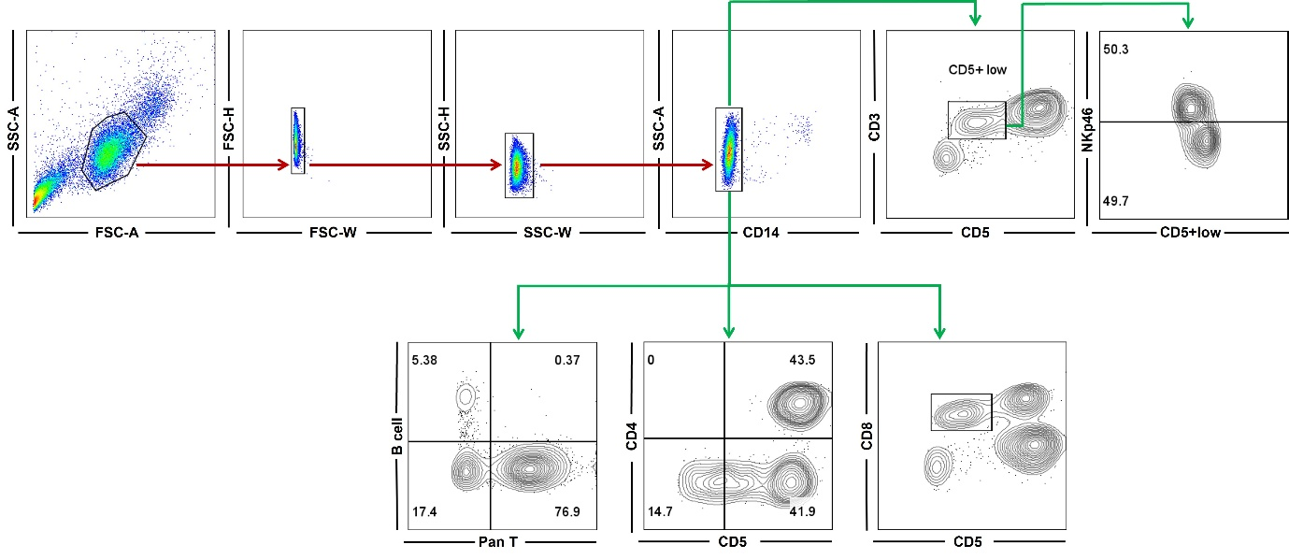
Figure S1. Gating strategy for flow cytometric analysis of canine peripheral blood mononuclear cells (PBMCs). A representative gating workflow is shown to identify viable CD14⁻ lymphocytes (highlighted by red arrows), which were used for downstream immunophenotyping. This gating strategy was consistently applied across all flow cytometry datasets to identify CD3⁺CD5^{+low}, NKp46⁺CD5⁺^{low}, Non-B Non-T, CD4⁺CD5⁺, and CD8⁺CD5⁺^{low} lymphocyte subsets. Plots marked with green arrows represent sample data from each respective analysis, demonstrating consistent application of the gating procedure.

