Supplemental Information

Cysteamine-functionalized reduced graphene oxide aerogel with anchored silver nanoparticles for enhanced electrochemical carbon dioxide reduction in aqueous solutions

Hamed Negahbanfardª, Hamid R. Zare^{a,*}, Nasim Hassani^{b}, Hossein Khoshroª, Ali Benvidiª

ªDepartment of Chemistry, Yazd University, Yazd 89195-741, Iran
^{b}Department of Physical Chemistry, Faculty of Chemistry, Razi University, 67144-14971, Taq-e Bostan, Kermanshah, Iran
*Corresponding author: Fax number: +98 35 38210991, Telephone number: +98 35 31232669, E-mail address: hrzare@yazd.ac.ir (Hamid R. Zare)

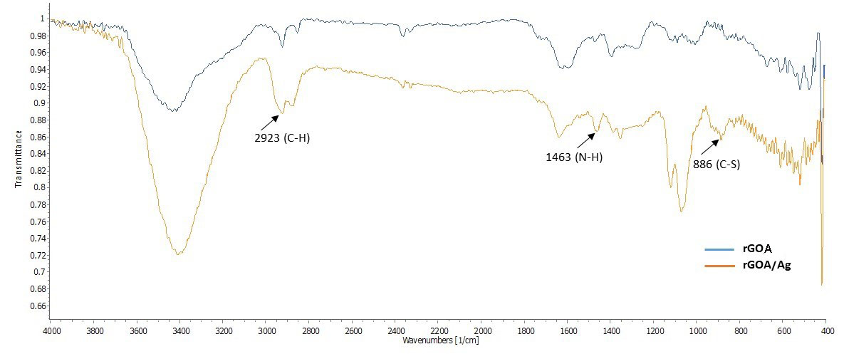
Fig S1. FT-IR spectrum of rGOA species and the rGOA/AgNPs nanocomposite.

Calculation of the effective surface area of GCE, rGO/AgNPs/GCE, and rGOA/AgNPs/GCE
To determine the effective surface area of GCE, rGO/AgNPs, and rGOA/AgNPs, cyclic voltammograms were recorded for these electrodes in a 0.5 mM solution of K₃[Fe(CN)₆]·3H₂O at various scan rates (Figs. S2A to S2C). The variation of cathodic current in the voltammograms as a function of the square root of the scan rate for the different electrodes is plotted in Figs. S2D to S2F. Based on the slope of these graphs and considering the number of electrons (n) equal 1, with a diffusion coefficient (D) of 7.60 × 10⁻⁶ cm² s⁻¹ for [Fe(CN)₆]³⁻ [1], the effective surface area (A) of the GCE, rGO/AgNPs, and rGOA/AgNPs electrodes was calculated using the Randles-Sevcik equation. The calculated surfaces area are 0.0275±0.01 cm², 0.03615±0.01 cm², and 0.05417±0.01 cm² respectively. The results show that the effective surface area of rGO/AgNPs/GCE is greater than that of GCE, and that the effective surface area of rGOA/AgNPs/GCE is larger than that of rGO/AgNPs/GCE.

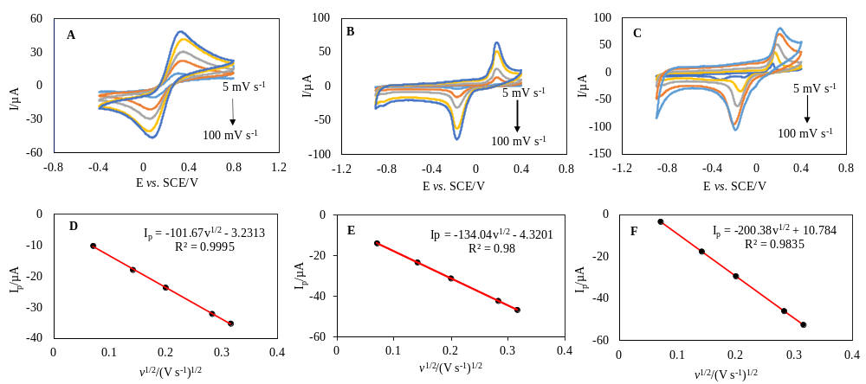
Fig. S2. Cyclic voltammograms for (A) GCE, (B) rGO/AgNPs, and (C) rGOA/AgNPs in a 5.0 mM K₃[Fe(CN)₆] solution at scan rates of 5, 20, 40, 80, and 100 mV s⁻¹. Panels (D), (E), and (F) displays plots of the variation in cathodic peak current from the recorded voltammograms as a function of the square root of the scan rate for GCE, rGO/AgNPs, and rGOA/AgNPs, respectively.

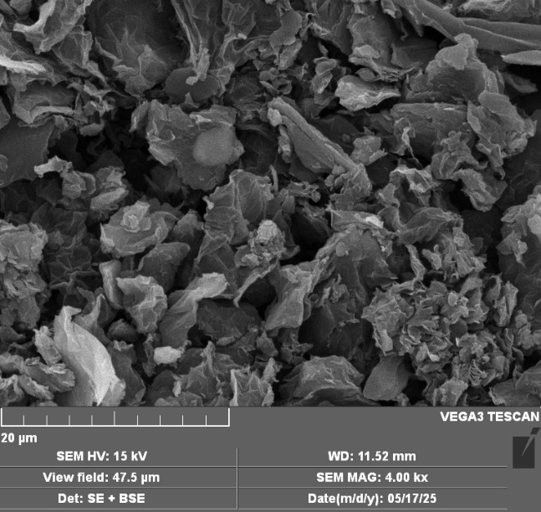
Fig. S3. Scanning electron microscope (SEM) image of rGOA
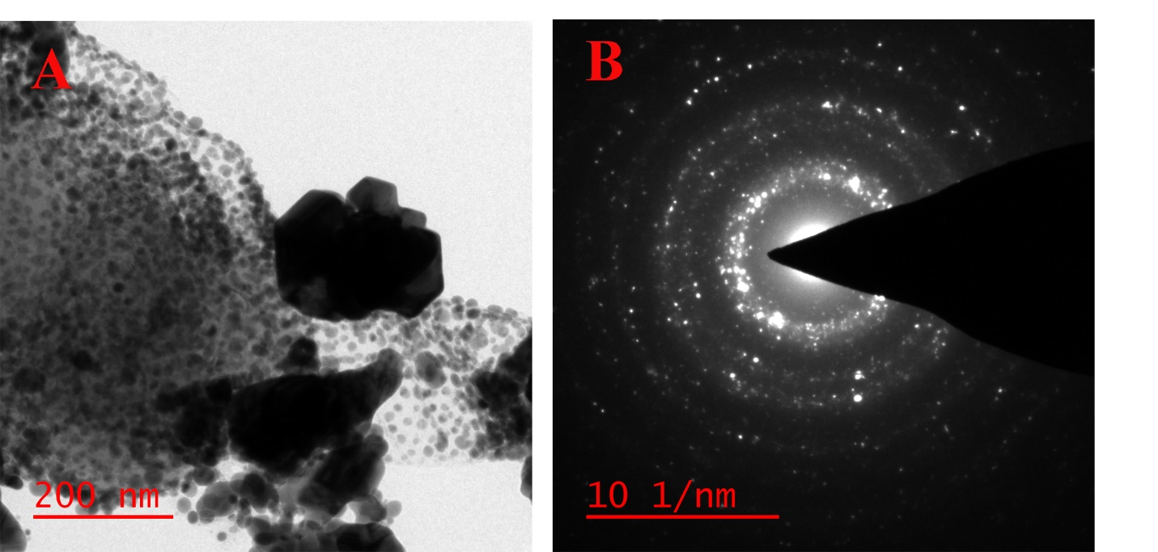
Fig. S4. (A) HR-TEM image of the rGOA/AgNPs nanocomposite (B) Selected Area Electron Diffraction (SAED) pattern of the rGOA/AgNPs nanocomposite.

Calculation of the diffusion coefficient (D) of CO₂ in aqueous solution
Chronoamperometry was employed to determine the diffusion coefficient of CO₂ in an aqueous solution at the surface of the rGOA/AgNPs/GCE electrode. The chronoamperograms for a 0.5 M NaHCO₃ solution at pH 7 and an aqueous solution containing 0.1 M K₂SO₄ and 0.1 M H₂SO₄ at pH 3, both saturated with CO₂, are presented in Figs. S5A and S5B. For the electroactive species CO₂, the limiting diffusion current of the electrochemical reaction can be described by the Cottrell equation (Eq. 1) [1]. Using this equation, the diffusion coefficients (D) of CO₂ at pH 7 and pH 3 were obtained from the slopes of the i vs. t^{-1/2} plots (insets of Figs. S5A and S5B), yielding values of 1.93 × 10⁻⁵ cm² s⁻¹ and 1.48 × 10⁻⁵ cm² s⁻¹, respectively, which are consistent with previously reported values [2].
I = nFAD^{1/2}C_{s}π^{-1/2}t^{-1/2} (1)
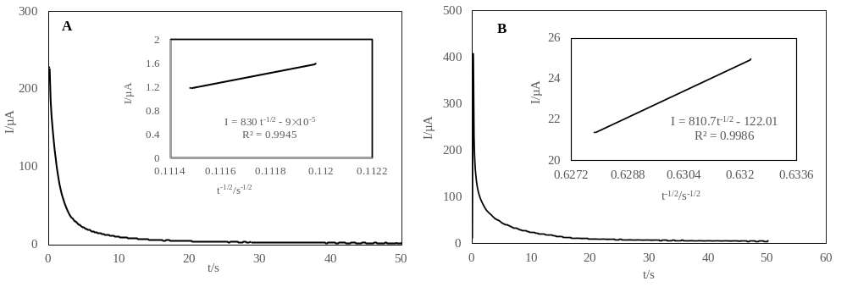
Fig. S5. (A) Chronoamperogram of rGOA/AgNPs/GCE in a 0.5 M NaHCO₃ solution saturated with CO₂, recorded at a potential step of -500 mV. (B) Chronoamperogram of rGOA/AgNPs/GCE in a 0.1 M K₂SO₄ and 0.1 M H₂SO₄ solution saturated with CO₂, recorded at a potential step of -1400 mV. The insets in both Figs present the i vs. t^{-1/2} plots derived from the chronoamperograms.

Calculation of electron transfer coefficient (α) for CO₂ in aqueous solution
To determine the electron transfer coefficient values for the CO₂ reduction process, cyclic voltammograms of the rGOA/AgNPs/GCE electrode were recorded in two solutions: 0.5 M NaHCO₃ saturated with CO₂ at pH 7, and 0.1 M K₂SO₄ combined with 0.1 M H₂SO₄ saturated with CO₂ at pH 3, using a scan rate of 20 mV s⁻¹ (Figs. S6A and S6C). Based on the data related to the electron transfer kinetics, Tafel plots (Figs. S6B and S6D) were drawn. The slopes of these Tafel plots allowed us to determine the values of α at pH 7 and pH 3 to be 0.3 and 0.33, respectively [1].
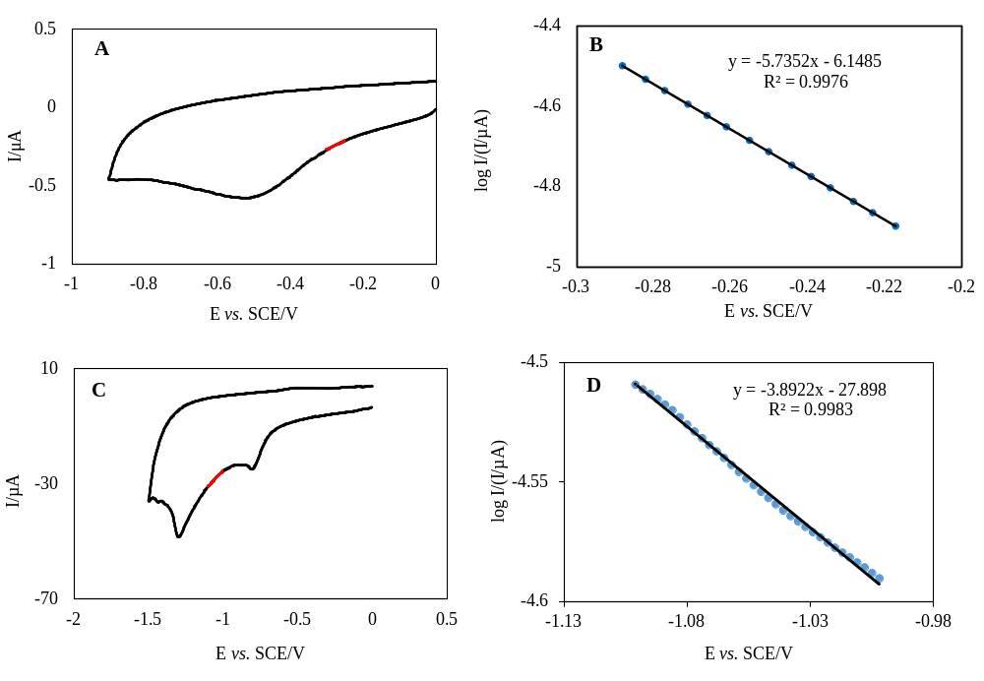
Fig. S6. (A) Cyclic voltammogram of the rGOA/AgNPs/GCE electrode in a 0.5 M NaHCO₃ solution at pH 7.0. (B) Tafel plot derived from the data in (A). (C) Cyclic voltammograms of the rGOA/AgNPs/GCE electrode in 0.1 M K₂SO₄ and 0.1 M H₂SO₄ solution at pH 3.0. (D) Tafel plot derived from the data in (C). The cyclic voltammograms in (A) and (C) were recorded in CO₂-saturated solutions at a scan rate of 20 mV s⁻¹. The red-highlighted area indicated the Tafel region.

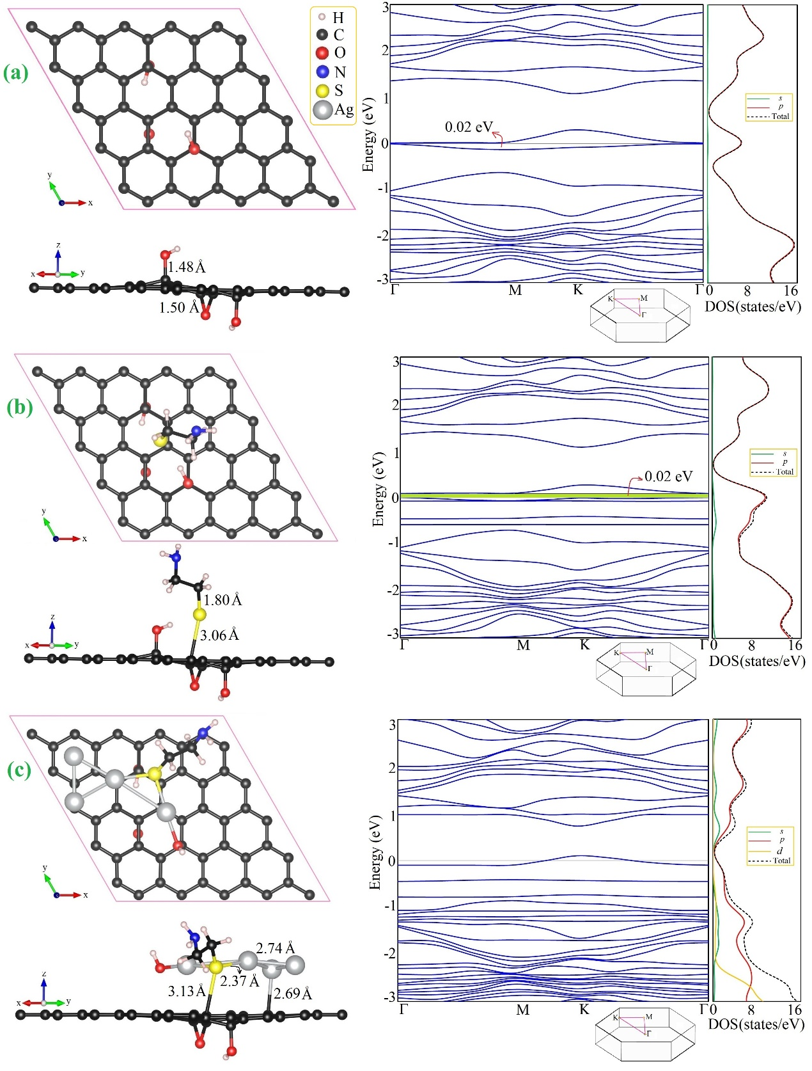

Fig. S7. The optimized structures (left side) and the corresponding electronic band structures and density of states (DOS) for (a) rGO, (b) the cysteamine-functionalized rGO surface (cysteamine/rGO), and (c) the Ag₄-cysteamine/rGO complex. The inset shows the path in the first Brillouin zone.

References
[1] Allen J. Bard, Larry R. Faulkner, Henry S. White, Electrochemical Methods: Fundamentals and Applications, Third Edition, 2022, John Wiley & Sons, Ltd
[2] Zhu X, Huang J, Eikerling M, (2021) Electrochemical CO₂ reduction at silver from a local perspective. ACS Catal 11:14521-14532

