Supporting Information

Antibacterial Silver Modified Gallium Metal-Organic Frameworks for Odontogenic Infections

Fellype Diorgennes Cordeiro Gomes, Diptomit Biswas, Mary Cristina Ferreira Alves, Severino Alves Júnior, Scott H. Medina

Content Page Number

Supplementary Fig. S1. Optical density growth curves for S. mitis and S. pneumoniae S3

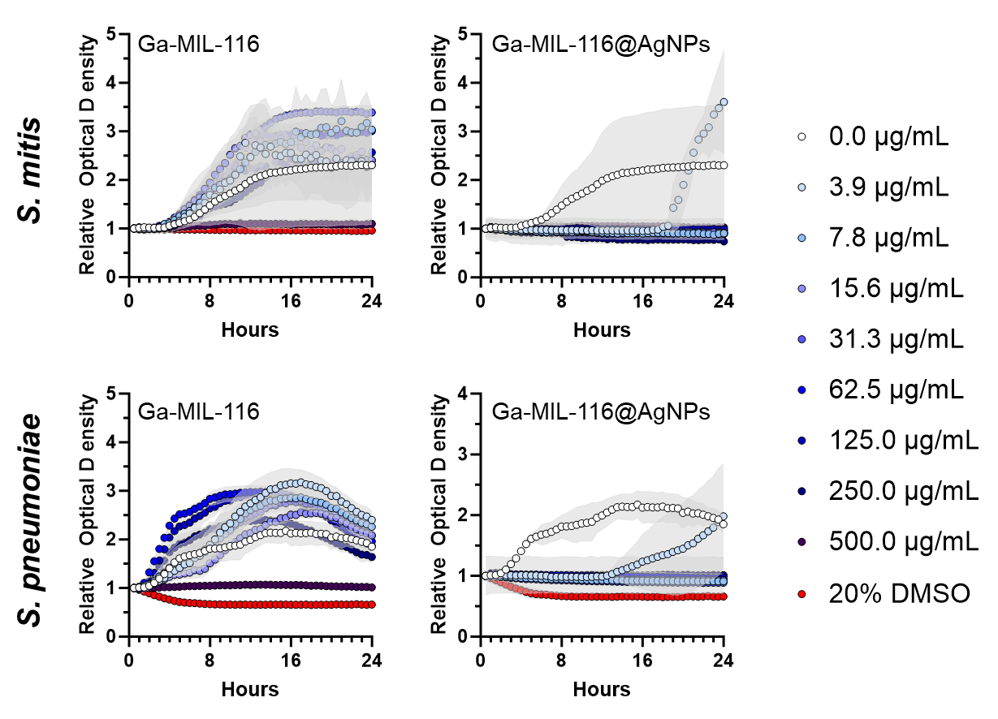

Figure S1: Time-dependent relative optical density of S. mitis (top) and S. pneumoniae (bottom) microbes grown in the presence of Ga-MIL-116 (left) or Ga-MIL-116@AgNPs (right). Untreated (0.0 μg/mL) and 20% DMSO treated samples included as negative and positive controls, respectively. Standard deviations of the curves are shown by the respective light gray colored overlay.

