Supplementary Figures
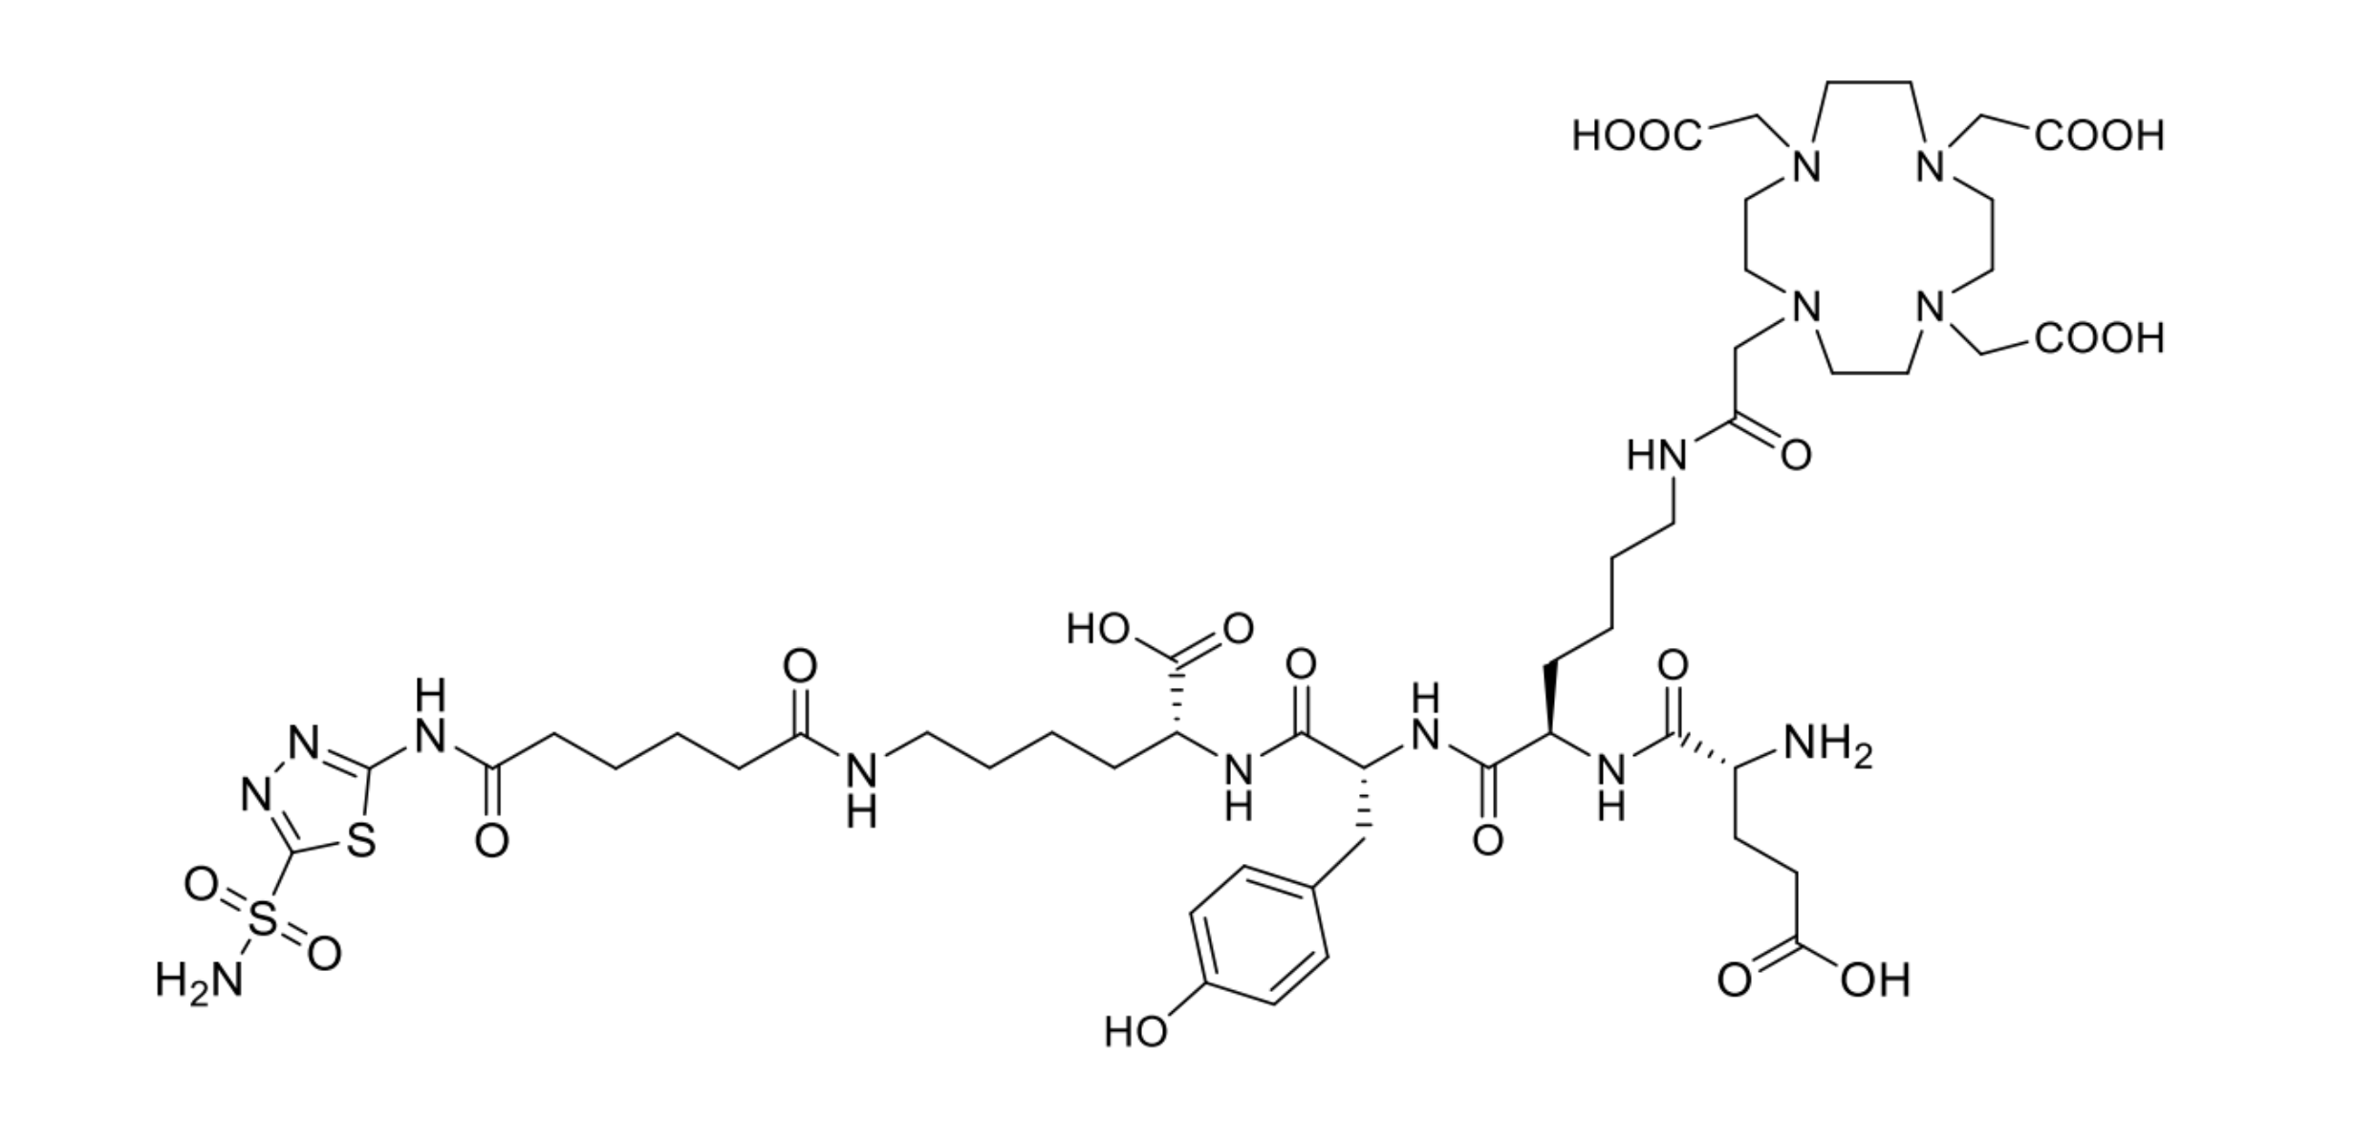
Supplementary Figure S1. Structure of NYM080.
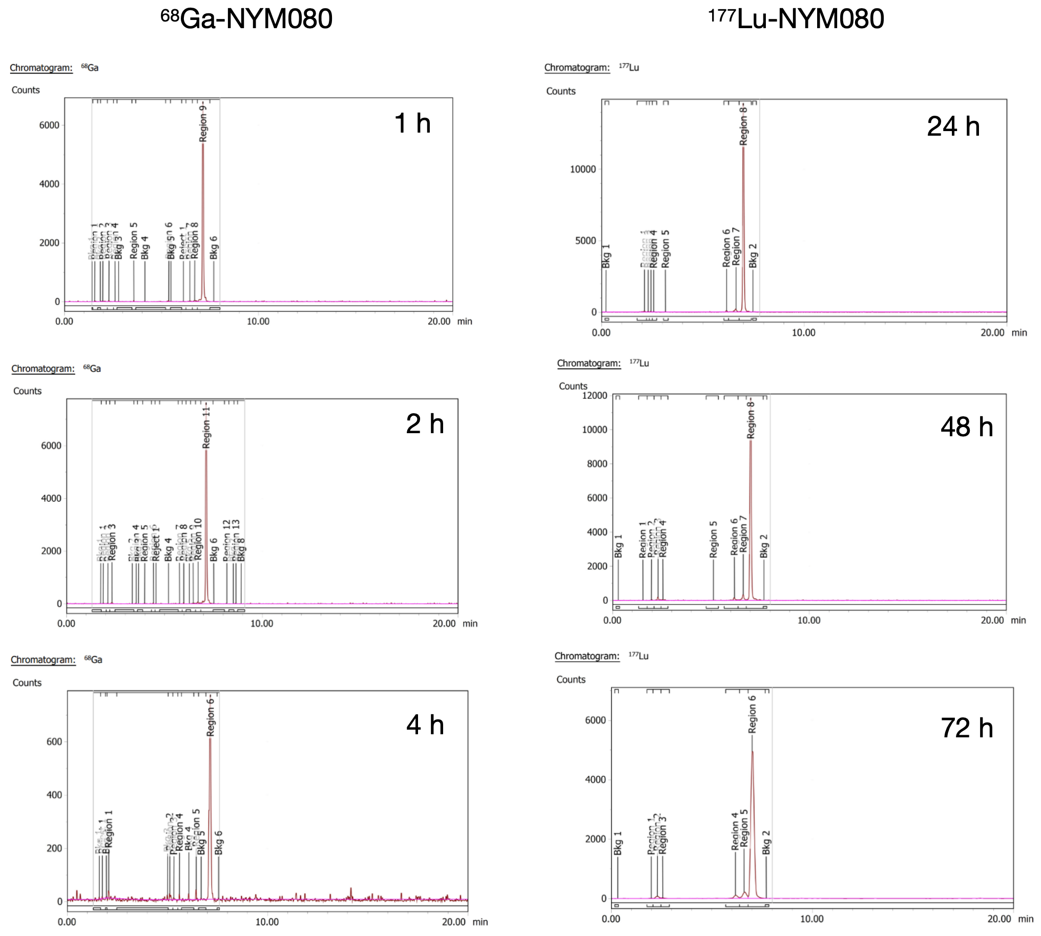
Supplementary Figure S2. Stability of ⁶⁸Ga-NYM080 and ¹⁷⁷Lu-NYM080 in human serum.
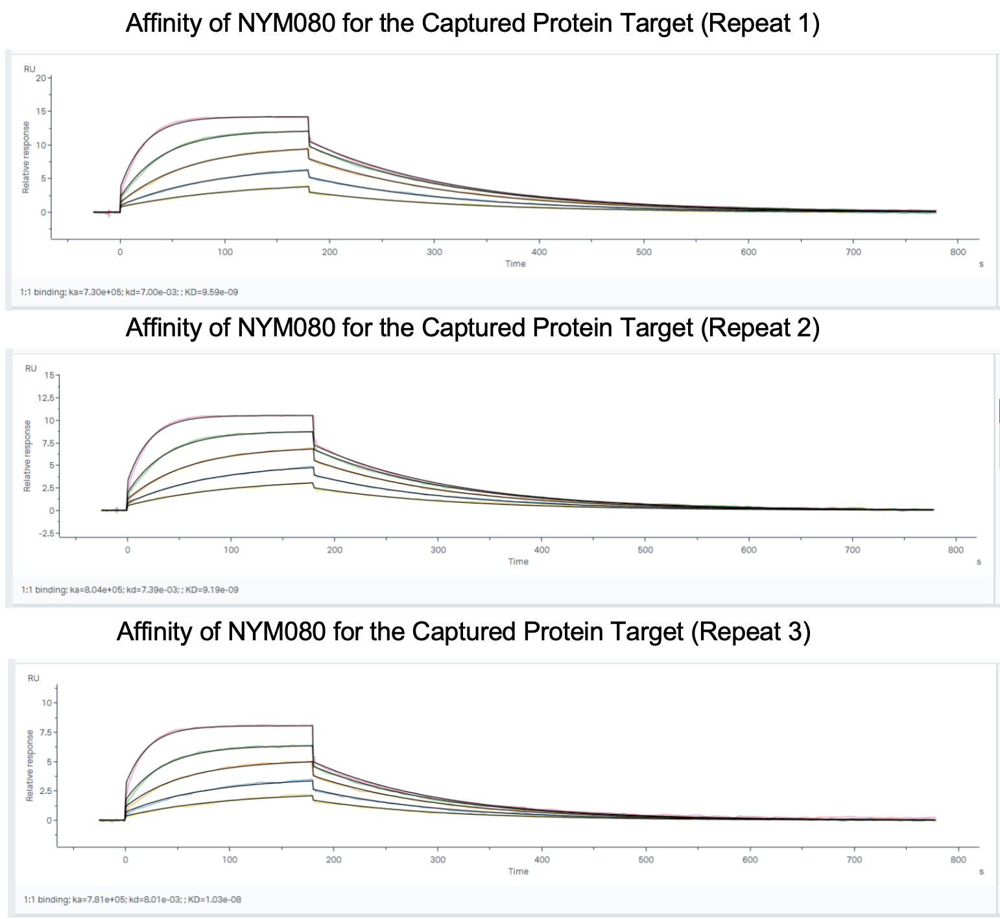
Supplementary Figure S3. Affinity of NYM080 for the Captured CAIX pProtein target

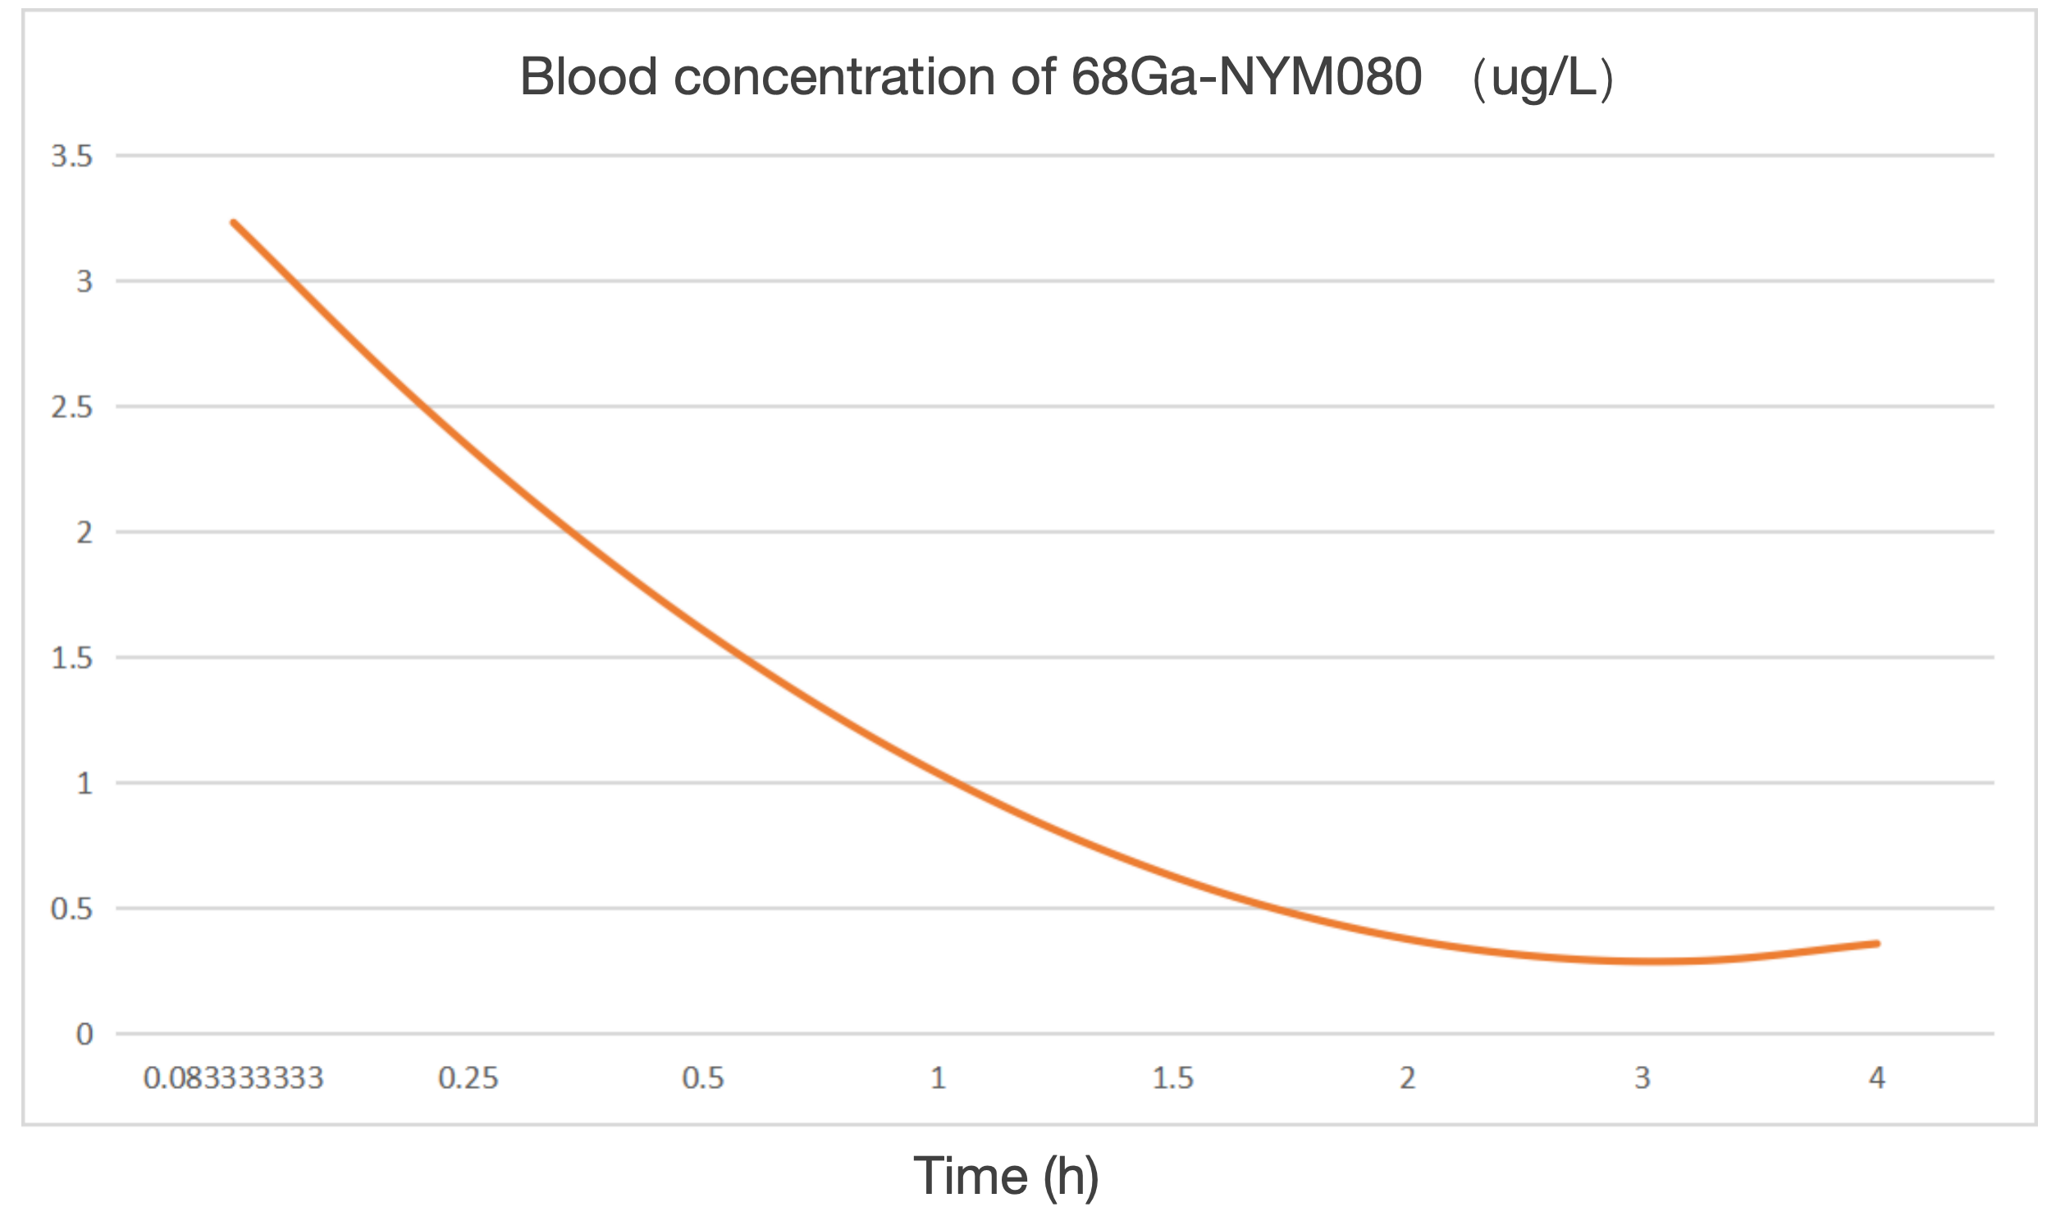
Supplementary Figure S4. Blood pharmacokinetics of 68Ga-NYM080 in ICR mice. n=6.

