Supporting Information for
Recent Sea Surface Temperature Trends Hinder Antarctic Stratospheric Ozone Recovery
Yihang Hu¹, Wenshou Tian*¹, Jiankai Zhang¹, Zhe Wang¹, Douwang Li¹, Qinghua Yang²
¹School of Atmospheric Sciences, Lanzhou University, Lanzhou, China
²School of Atmospheric Sciences, Sun Yat-sen University, and Southern Marine Science and Engineering Guangdong Laboratory (Zhuhai), Zhuhai, China
Corresponding author: Wenshou Tian, wstian@lzu.edu.cn
Contents of this file:
Tables S1-S3
Figures S1-S7

Table S1. The longitudes and latitudes of Antarctic stations in the SBUV v8.7 datasets.
Station | Longitude | Latitude
Antarctic-1 | 69.90°W | 62.58°S
Antarctic-2 | 61.22°W | 62.68°S
Arrival Heights | 166.67°E | 77.83°S
Belgrano | 34.63°W | 68.58°S
Casey | 110.54°E | 66.28°S
Davis | 77.97°E | 68.58°S
Dumount D’urville | 140.02°E | 66.67°S
Halley Bay | 26.67°W | 73.55°S
King George Island | 58.90°W | 62.18°S
Maitri | 11.45°E | 70.46°S
Marambio | 56.62°W | 64.23°S
Mario Zucchelli | 164.12°E | 74.69°S
Mawson | 62.87°E | 67.60°S
Mcmurdo | 166.65°E | 77.85°S
Mendel | 57.88°W | 63.80°S
Mirny | 93.00°E | 66.55°S
Molodeznaya | 45.90°E | 67.68°S
Neumayer | 8.25°W | 70.65°S
Novolazarevskaya | 11.87°E | 70.77°S
Palmer | 64.05°W | 64.75°S
Rothera | 68.12°W | 67.57°S
San Martin | 67.10°W | 68.13°S
Sanae | 2.50°W | 70.33°S
Scott Base | 165.60°E | 77.80°S
Syowa | 39.58°E | 69.00°S
Terra Nova Bay | 164.05°E | 74.42°S
Troll | 2.53°E | 72.02°S
Vernadsky Faraday | 64.17°W | 65.15°S

Table S2. The relative differences of ODS emissions between LowODS scenario and High ODS scenario.
ODSs | Relative difference
CCl₄ | -23.5%
CF₂ClBr | -26.7%
CF₃Br | 18.7%
CFC-11 | -15.5%
CFC-113 | -17.2%
CFC-12 | -9.4%
CH₃Br | -24.0%
CH₃CCl₃ | -98.0%
CH₃Cl | -1.6%
HCFC-22 | 78.3%

Table S3. The experimental configurations
Experiments | Descriptions
E0 | The control experiment. The monthly SST forcing data are taken from the climatology of ERSST v5 dataset during 1980-2000. The monthly ODS emission data are taken from the averages over 1998-2002 in WMO (2018) A1 scenario.
E1 | The SST forcing data applied in model are the same as the E0. The monthly ODS emission data are taken from the averages over 2019-2023 in WMO (2018) A1 scenario.
E2 | The monthly linear increments of SST during 2000-2021 are added on the SST forcing data used in E0. The monthly ODS emission data are taken from the averages over 2019-2023 in WMO (2018) A1 scenario.
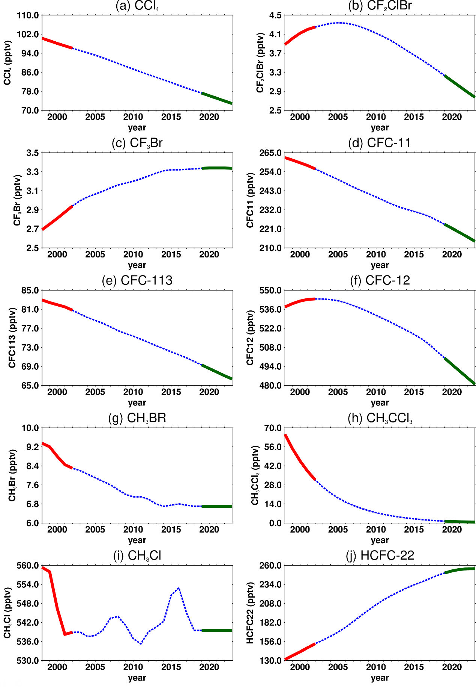
Fig. S1 The time series (blue dashed lines) of anthropogenic ODS emissions derived from the WMO (2018) A1 scenario. The periods of 1998-2002 and 2019-2023 are highlighted by red and green solid lines, respectively.
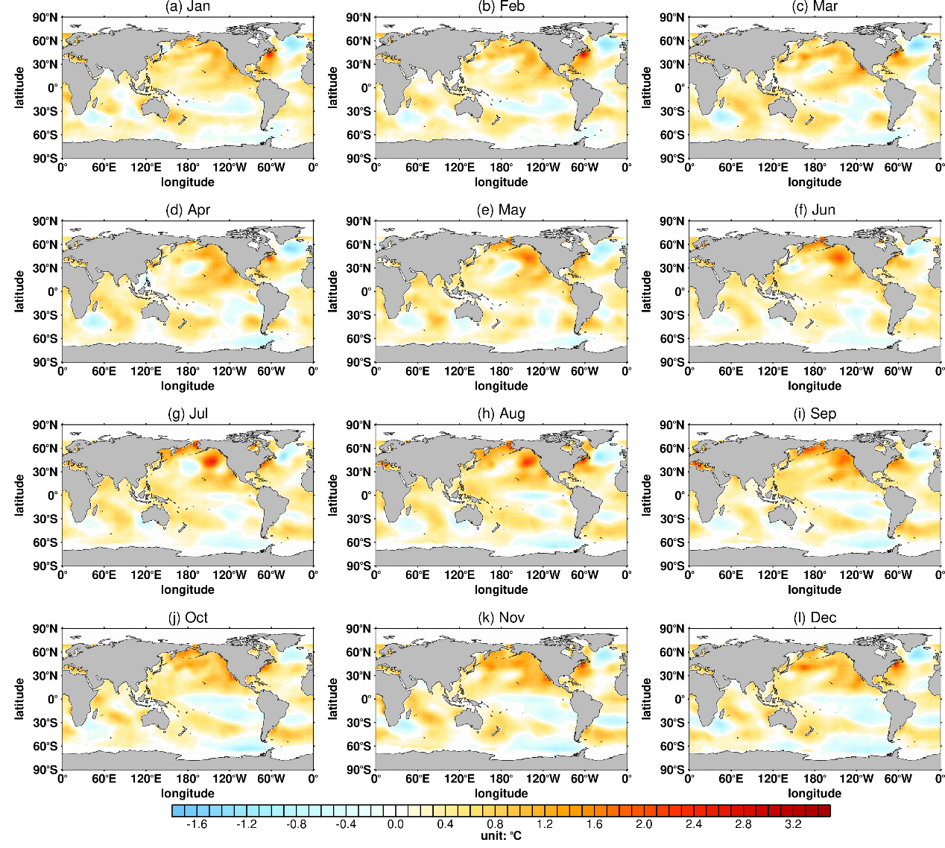
Fig. S2 Differences in SST forcing data from January to December between E2 and E1 (E0).

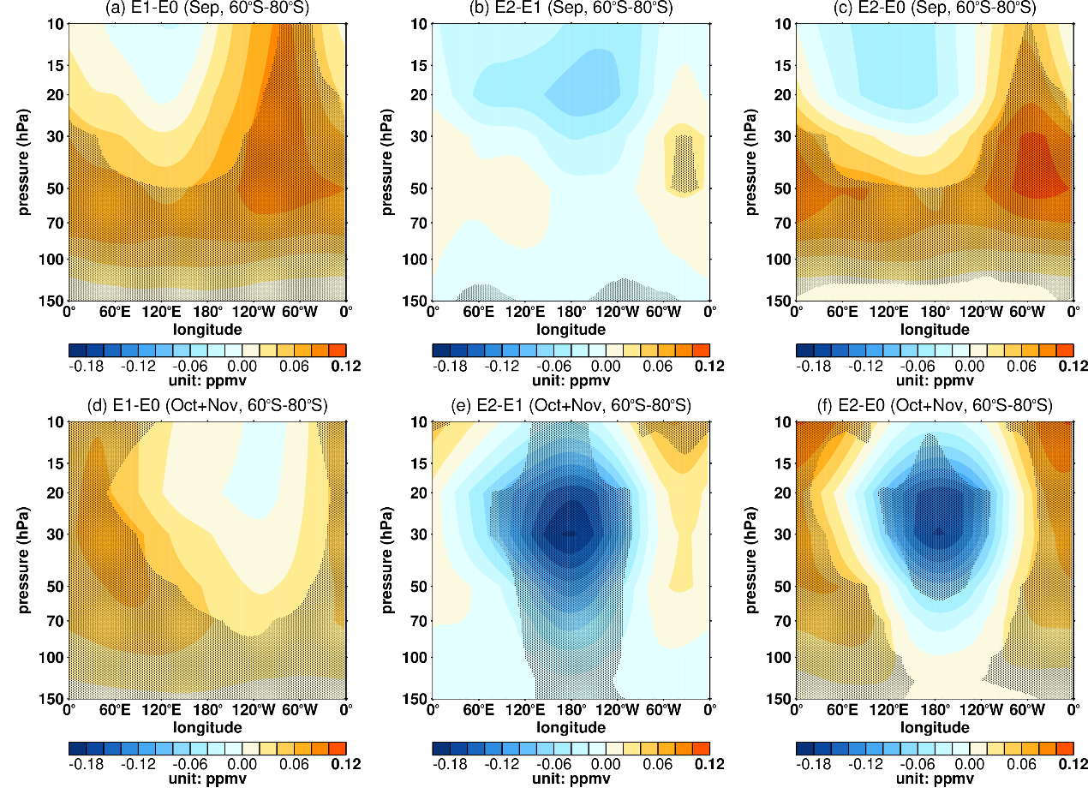
Fig. S3 Antarctic ozone concentrations responses induced by reductions in ODS emissions and SST trends. (a-c) Antarctic ozone concentration anomalies on longitude-pressure profiles during September in response to (a) ODS reductions (E1 minus E0), (b) SST trends (E2 minus E1), and (c) both ODS reductions and SST trends (E2 minus E0). Panels (d-f) are similar to panels (a-c), but during October-November. The dotted regions represent the differences that are significant at/above the 90% confidence level.

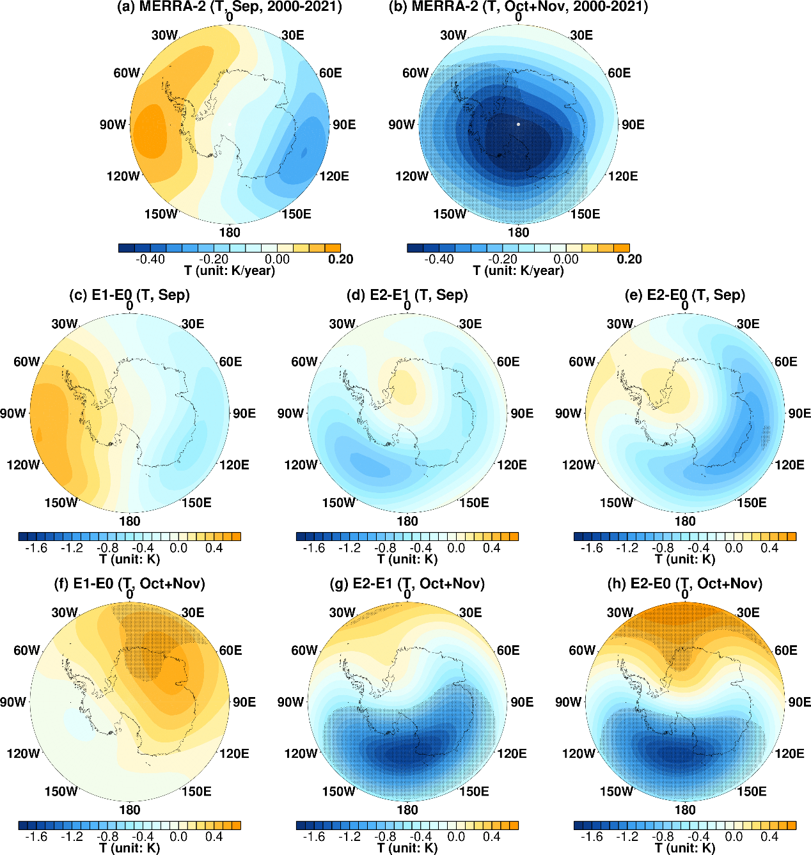
Fig. S4 The temperature trends derived from the MERRA-2 reanalysis data, and the temperature responses induced by reductions in ODS emissions and SST trends derived from the simulations. (a) Trends in September temperature during 2000-2021 derived from the MERRA-2 dataset. (b) is similar to (a), but in October-November. (c-e) Anomalies of temperature during September in response to (c) ODS reductions (E1 minus E0), (d) SST trends (E2 minus E1), and (e) both ODS reductions and SST trends (E2 minus E0). Panels (f-h) are similar to panels (c-e), but during October-November. The dotted regions represent the trends or differences that are significant at/above the 90% confidence level. All results presented in this figure are averaged over 100-10 hPa.
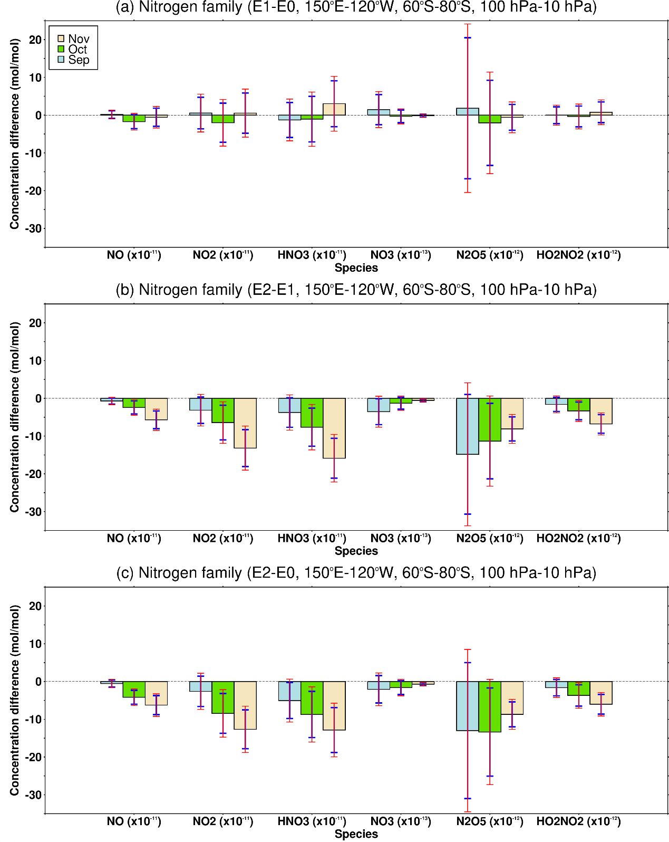
Fig. S5 Differences of the regional (150°E-120°W, 60°S-80°S, 100-10 hPa) averaged nitrogen family species in September (blue pillars), October (green pillars) and November (yellow pillars) derived from (a) E1 minus E0, (b) E2 minus E1 and (c) E2 minus E0. The units of NO, NO₂ and HNO₃ in this figure are 10⁻¹¹ mol/mol. The unit of NO₃ is 10⁻¹³ mol/mol. The units of N₂O₅ and HO₂NO₂ are 10⁻¹² mol/mol. The confidence intervals of the differences at the 95% and the 90% significance levels are shown by the red and the blue error bars, respectively.
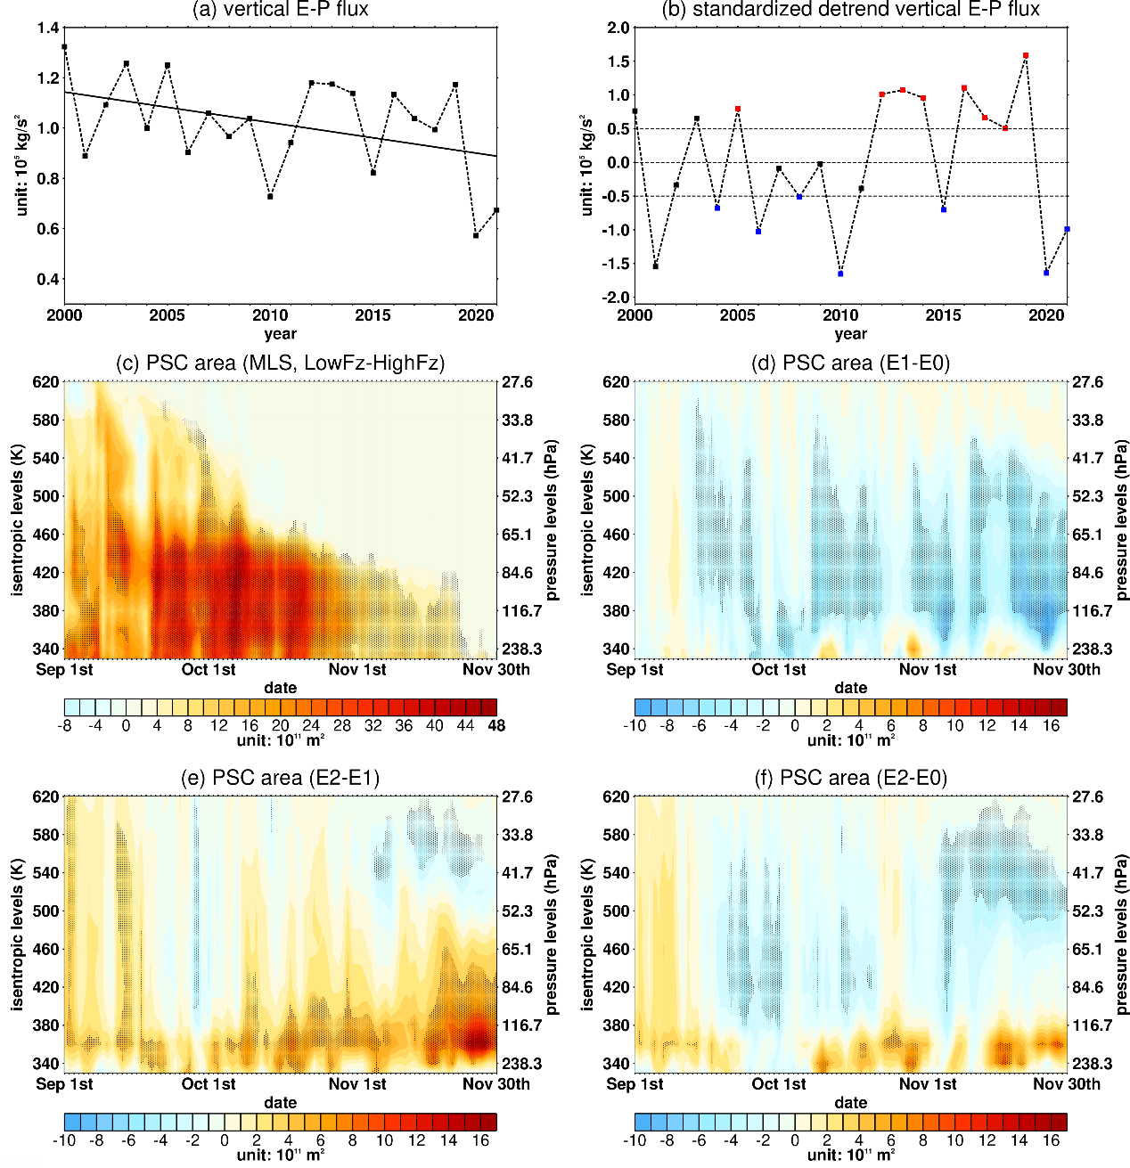
Fig. S6 The time series of vertical E-P flux and the daily evolutions of Antarctic polar stratospheric clouds (PSC) area anomalies on isentropic levels. (a) Time series (dashed lines) of regional (50°S-70°S, 100-30 hPa) mean vertical E-P flux averaged over September-November during 2000-2021, and the linear regression (solid line). (b) The standardized detrend vertical E-P flux based on the time series in panel (a). The years with standardized vertical E-P flux greater than 0.5 (strong planetary wave activity years) and less than -0.5 (weak planetary wave activity years) over the period of the MLS satellite observations (2004-2021) are marked by red dots and blue dots, respectively. (c) Daily differences in PSC areas between the weak planetary wave years and the strong planetary wave years from 1st September to 30th November. (d-f) Anomalies of PSC areas from 1st September to 30th November in response to (c) ODS reductions (E1 minus E0), (d) SST trends (E2 minus E1) and (f) both ODS reductions and SST trends (E2 minus E0).

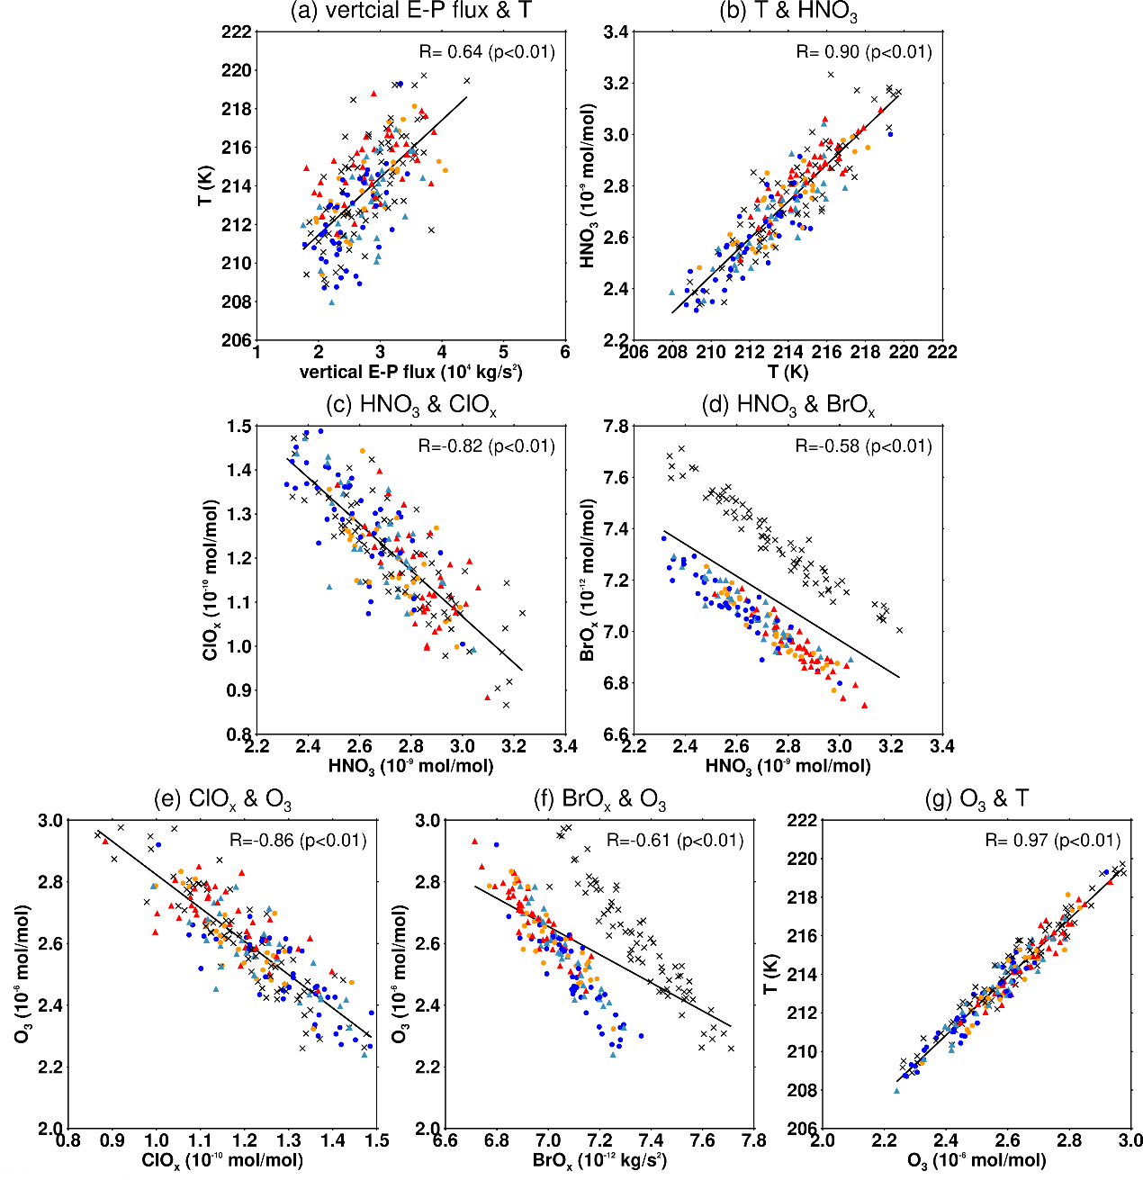
Fig. S7 Scatter plots derived from the simulations. (a) Vertical components of E-P flux and temperature. (b) Temperature and HNO₃. (c) HNO₃ and ClO_{x}. (d) HNO₃ and BrO_{x}. (e) ClO_{x} and O₃. (f) BrO_{x} and O₃. (g) O₃ and temperature. All dots presented here averaged during October-November. The vertical components of E-P flux are averaged over 50°S-70°S, 100-10 hPa, and other variables are all averaged over stratospheric South Pacific region (150°E-120°W, 60°S-80°S, 100-10 hPa). The cross dot (“×”), triangle dot (“▲”) and circle dot (“”) are represent the ensemble members of the E0, E1 and E2, respectively. The red and yellow dots mark the ozone recovery ensemble members in E1 and E2, respectively, compared to the control experiment E0. The light blue and blue dots mark the ozone loss ensemble members in E1 and E2, respectively, compared to E0. The straight lines are the regressions of scatters. The correlation coefficients between the two variables, and the corresponding significant levels are labelled on the right-upper corner of each panel.

