Design and Prototype Development Of A Harvesting Machine Mower For Poppy (Papaver Somniferum L.) Plant

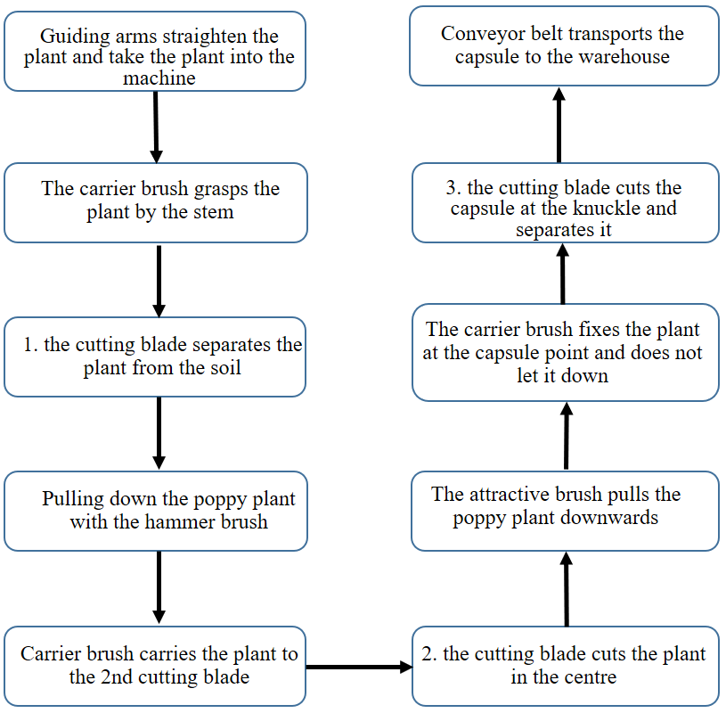
Figure 2.1. Work flow chart of the prototype machine
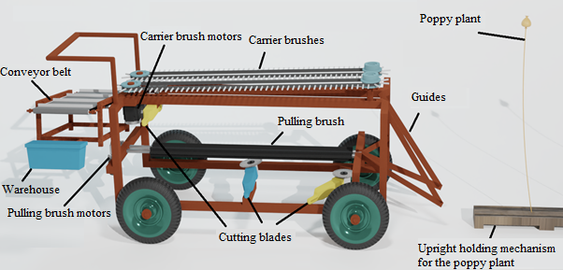
Figure 2.9. Prototype machine solid model side view

