The benefits of combining an immunomodulator with a chemotherapy agent in chondrosarcoma : a proof of concept with mifamurtide

Rohan Quoniou*^{,1,£}, Elisa Bortoli**^{,1,£}, Emmanuel Moreau^{1,}, Florent Cachin^{1,2}, Emmanuel Chautard^{1,3,£}, Caroline Peyrode***^{,1, £}
¹Imagerie Moléculaire et Stratégies Théranostiques, UMR1240, Université Clermont Auvergne, INSERM, 63000 Clermont-Ferrand, France
²Service de Médecine Nucléaire, Centre Jean PERRIN, 63000 Clermont-Ferrand, France
³Service de Pathologie, Centre Jean PERRIN, 63000 Clermont-Ferrand, France

£: the authors have contributed equally
*1st autor: rohanquoniou@yahoo.fr
** 1st co-autor: elisa.bortoli@doctorant.uca.fr
***: caroline.peyrode@uca.fr

A)
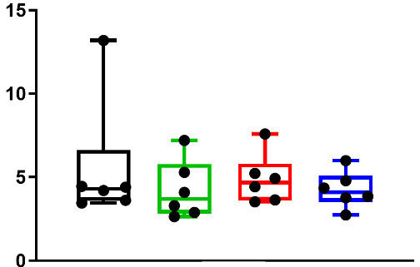
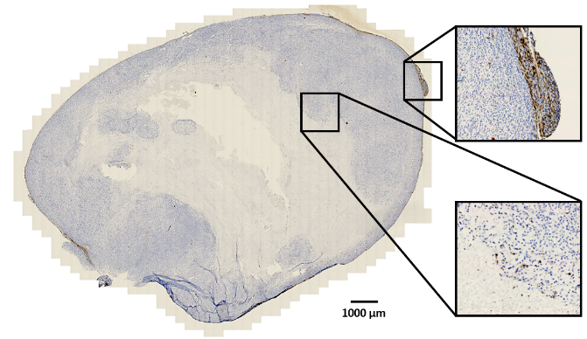
Ctrl
Mifa
Doxo
Mifa + Doxo
Percentage of CD68+ cells
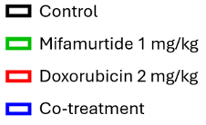
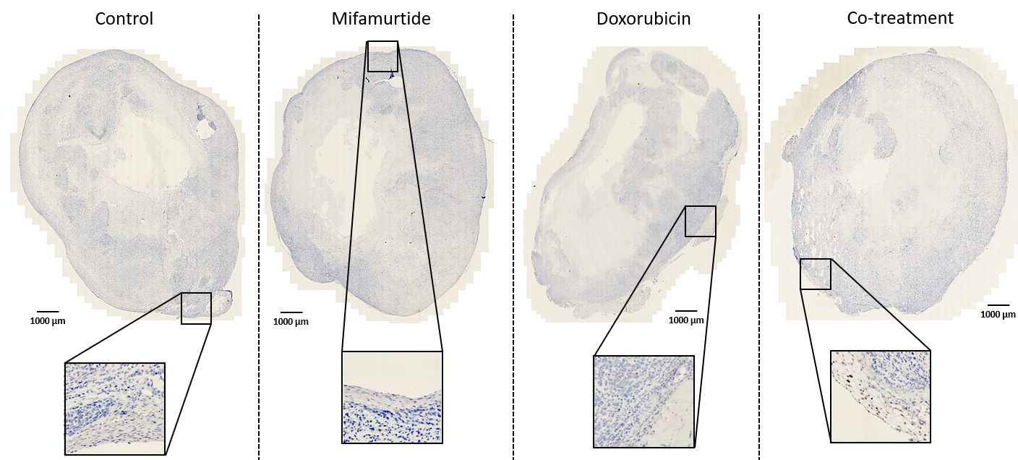

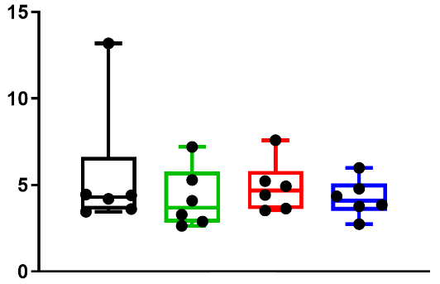
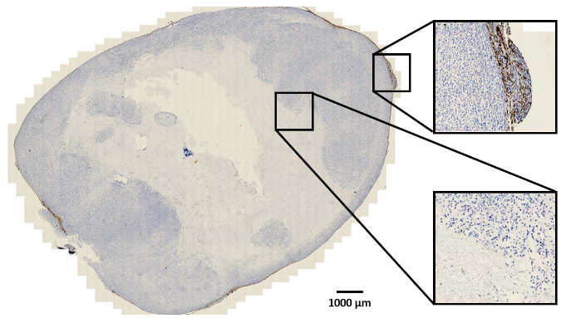
Ctrl
Mifa
Doxo
Mifa + Doxo
Percentage of CD206+ cells
B)

C)

Figure S.1: Impact of treatments on the macrophages phenotype (late stage)
A. and B. Left: Representative images of control tumour sections after IHC with A. CD68 (M0) or B. CD206 (M2). Right: Rate of positive labelled cells in % for each condition. C. Representative images of a tumour section for each condition after IHC with the CD86 marker (M1). Scales represent 1000µm. All data are expressed as mean values +/- standard deviation from the measurement of 6 mice per group. Statistical tests performed are two-factor ANOVA with no significant difference compared to control.

