Appendix
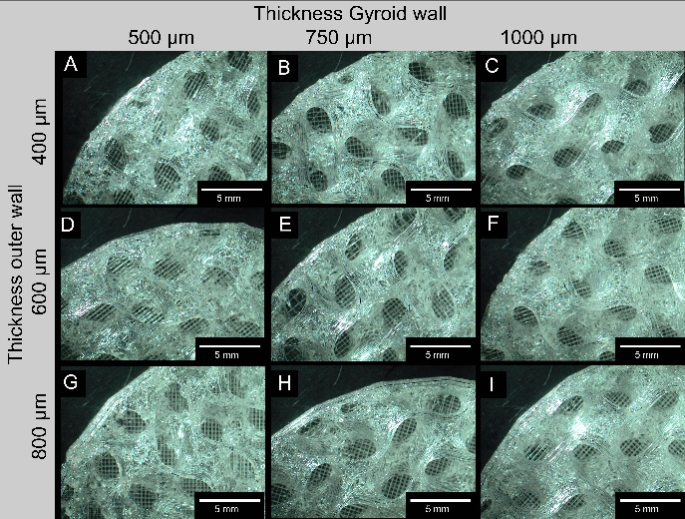
Figure A 1: Representative comparison of the varying wall thicknesses of the inner and outer regions of the Gyroid structure made of SemiSoft. To facilitate accurate wall thickness measurements, 3D printing was paused at 30% to avoid potential measurement errors due to surface curvature (example shown for a 8 mm³ Gyroid volume).

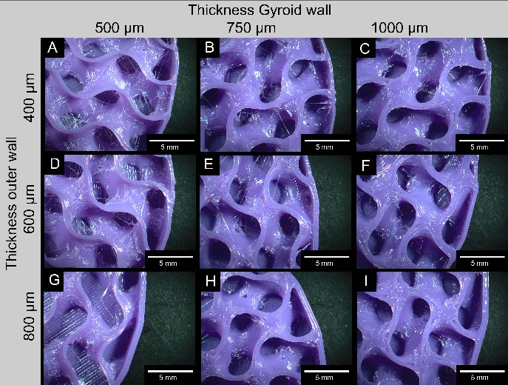
Figure A 2: Representative comparison of the varying wall thicknesses of the inner and outer regions of the Gyroid structure made of OVERTURE TPU. To facilitate accurate wall thickness measurements, 3D printing was paused at 30% to avoid potential measurement errors due to surface curvature (example shown for a 8 mm³ Gyroid volume).

Table A 1: Gyroid Dimensions for additive manufacturing
Sample | Gyroid Dimensions
Sample | Volume  [mm³] | Wall thickness  Gyroid [mm] | Wall thickness  outer wall [mm]
#01 | 10 | 0.5 | 0.4
#02 | 10 | 0.75 | 0.4
#03 | 10 | 1.0 | 0.4
#04 | 8 | 0.5 | 0.4
#05 | 8 | 0.75 | 0.4
#06 | 8 | 1.0 | 0.4
#07 | 6 | 0.5 | 0.4
#08 | 6 | 0.75 | 0.4
#09 | 6 | 1.0 | 0.4
#10 | 4 | 0.5 | 0.4
#11 | 4 | 0.75 | 0.4
#12 | 4 | 1.0 | 0.4
#13 | 10 | 0.5 | 0.6
#14 | 10 | 0.75 | 0.6
#15 | 10 | 1.0 | 0.6
#16 | 8 | 0.5 | 0.6
#17 | 8 | 0.75 | 0.6
#18 | 8 | 1.0 | 0.6
#19 | 6 | 0.5 | 0.6
#20 | 6 | 0.75 | 0.6
#21 | 6 | 1.0 | 0.6
#22 | 4 | 0.5 | 0.6
#23 | 4 | 0.75 | 0.6
#24 | 4 | 1.0 | 0.6
#25 | 10 | 0.5 | 0.8
#26 | 10 | 0.75 | 0.8
#27 | 10 | 1.0 | 0.8
#28 | 8 | 0.5 | 0.8
#29 | 8 | 0.75 | 0.8
#30 | 8 | 1.0 | 0.8
#31 | 6 | 0.5 | 0.8
#32 | 6 | 0.75 | 0.8
#33 | 6 | 1.0 | 0.8
#34 | 4 | 0.5 | 0.8
#35 | 4 | 0.75 | 0.8
#36 | 4 | 1.0 | 0.8

