Clinical Potential of Antibody–Drug Conjugates in Early-Phase Clinical Trials for Late-Line Treatment of Advanced Solid Tumors

Ippei Miyamotoª, Takahiro Kogawaª, Kana Kurokawaª, Eriko Miyawakiª, Yohei Ariharaª, Shota Fukuoka^{a,b}, Yukinori Ozaki^{a,c}, Makiko Ono^{a,d}, Mayu Yunokawa^{a,d,e}, Masumi Yamazaki^{a,g}, Naomi Hayashi^{g}, Ippei Fukada^{c,g}, Takayuki Ueno^{a,f}, Shunji Takahashi^{a,d}, Shigehisa Kitanoª

ªDepartment of Advanced Medical Development, Cancer Institute Hospital of Japanese Foundation for Cancer Research, Tokyo, Japan
^{b}Department of Gastroenterological Chemotherapy, Cancer Institute Hospital of JFCR, Tokyo, Japan
^{c}Department of Breast Medical Oncology, Cancer Institute Hospital of JFCR, Tokyo, Japan
^{d}Department of Medical Oncology, The Cancer Institute Hospital of JFCR, Tokyo, Japan
^{e}Department of Gynecology, The Cancer Institute Hospital of JFCR, Tokyo, Japan
^{f}Department of Breast Surgical Oncology, The Cancer Institute Hospital of JFCR, Tokyo, Japan
^{g}Department of Genomic Medicine, Cancer Institute Hospital of JFCR, Tokyo, Japan

Corresponding Author: Shigehisa Kitano, M.D., Ph.D.
Department of Advanced Medical Development, The Cancer Institute Hospital of JFCR, 3-8-31, Ariake, Koto-ku, Tokyo 135-8550, Japan
E-mail address: shigehisa.kitano@jfcr.or.jp
Target journal: Investigational New Drugs

Supplementary Material
Supplementary Table 1 The criteria for the late-line setting in this study

Cancer type | Unresponsive treatment | Cases
Metastatic castration-resistant prostate cancer | ARAT, docetaxel | 2
Neuroendocrine carcinoma | Platinum | 3
Colorectal cancer | After 2 lines of chemotherapy including irinotecan, oxaliplatin. | 2
HER2-negative gastric cancer | Platinum, taxane, ICI | 2
Pancreatic cancer | After 2 lines of chemotherapy including GnP, mFFX or nal-IRI + 5FU or S1, etc. | 1
Hepatocellular carcinoma | Atezolizumab/bevacizumab | 1
Hormone-positive breast cancer | Hormonal therapy, CDK4/6 inhibitors + after 2 lines of chemotherapy | 2
Ovarian cancer | Platinum | 3
Cervical cancer | Platinum | 4
Urothelial cancer | Gemcitabine/ Cisplatin, ICI | 1
Triple-negative breast cancer | After 3 lines of chemotherapy including taxane | 3
Non-small cell lung cancer | Platinum, ICI + after 1 line of chemotherapy | 2
Small cell lung cancer | Platinum | 1
Anaplastic thyroid cancer | Lenvatinib | 1
ARAT, androgen receptor-axis-targeted; ICI, immune checkpoint inhibitor.

Supplementary Table 2 Characteristics of investigational drugs in the others group (clinical trials excluding ADCs and CGP-matched trials)
Characteristics | No. (%)
Immunotherapy | 70 (68.0)
Monotherapy | 44 (42.7)
Combination | 26 (25.2)
Molecular targeted | 32 (31.1)
Monotherapy | 30 (29.1)
Combination | 2 (1.9)
Virus therapy | 1 (1.0)

Supplementary Fig. 1 Flow diagram of the patient exclusion procedure in this study

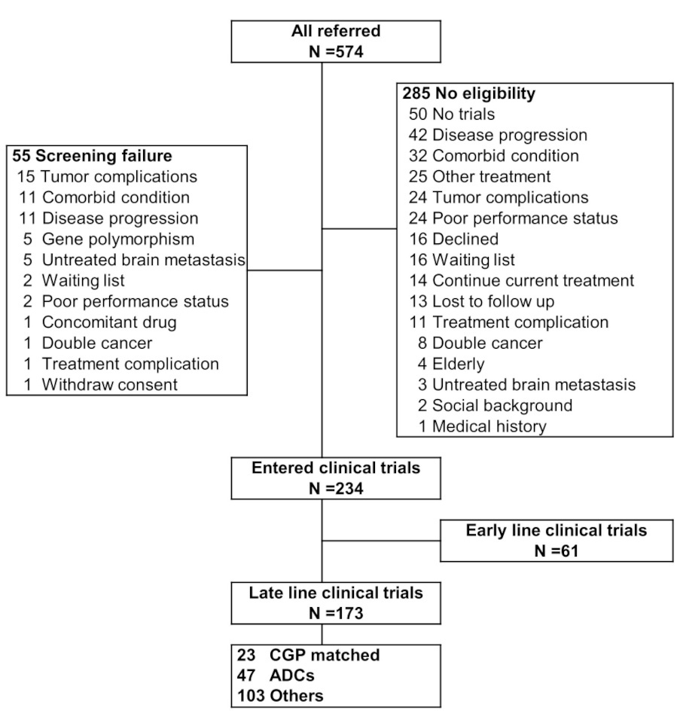
ADCs, antibody-drug conjugates; CGP, comprehensive genomic profiling.

Supplementary Fig. 2 Overall survival according to prognostic scores. a Overall survival according to RMH score. b Overall survival according to GRIm-Score
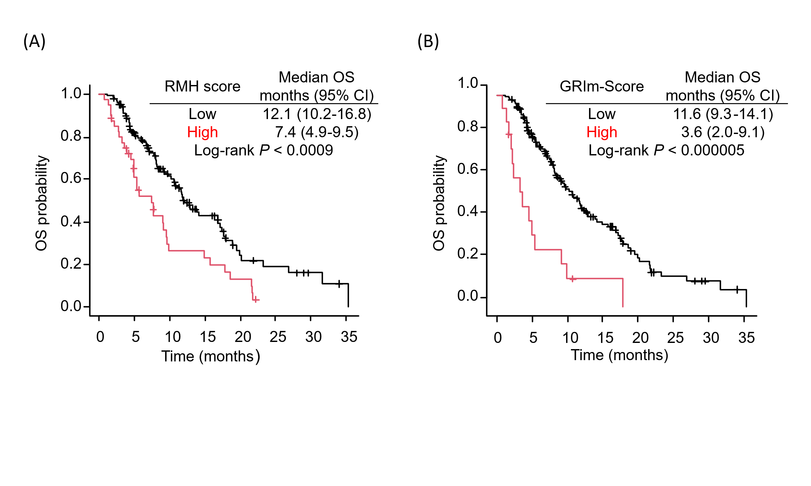
OS, overall survival; CI, confidence intervals; RMH score, The Royal Marsden Hospital prognostic score; GRIm-Score, Gustave Roussy Immune score.

Supplementary Fig. 3 Comparison of overall survival between patients in the ADCs group with low prognostic scores and no pleural effusions and/or ascites, and those in the non-ADCs group (CGP-matched trials and others)
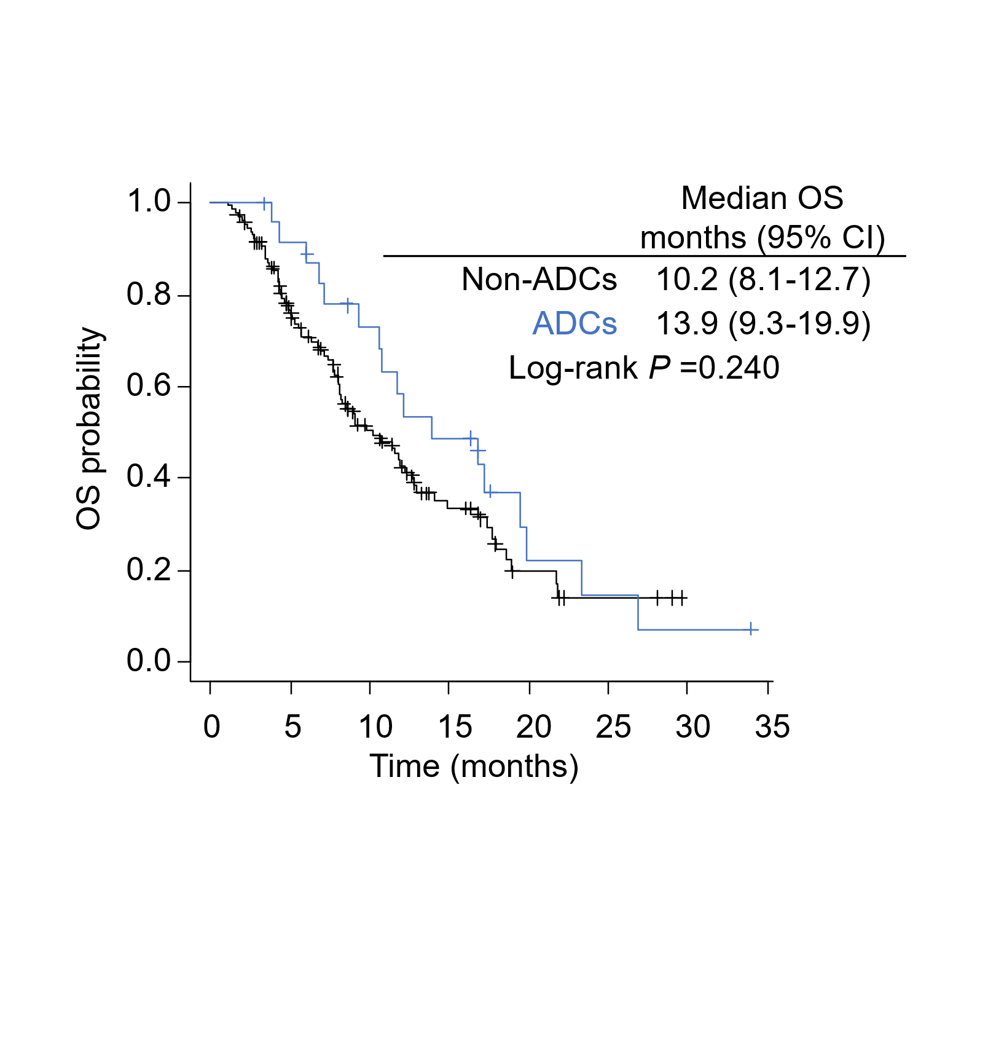
OS, overall survival; CI, confidence intervals; ADCs, antibody-drug conjugates.

