Supplementary Material 1

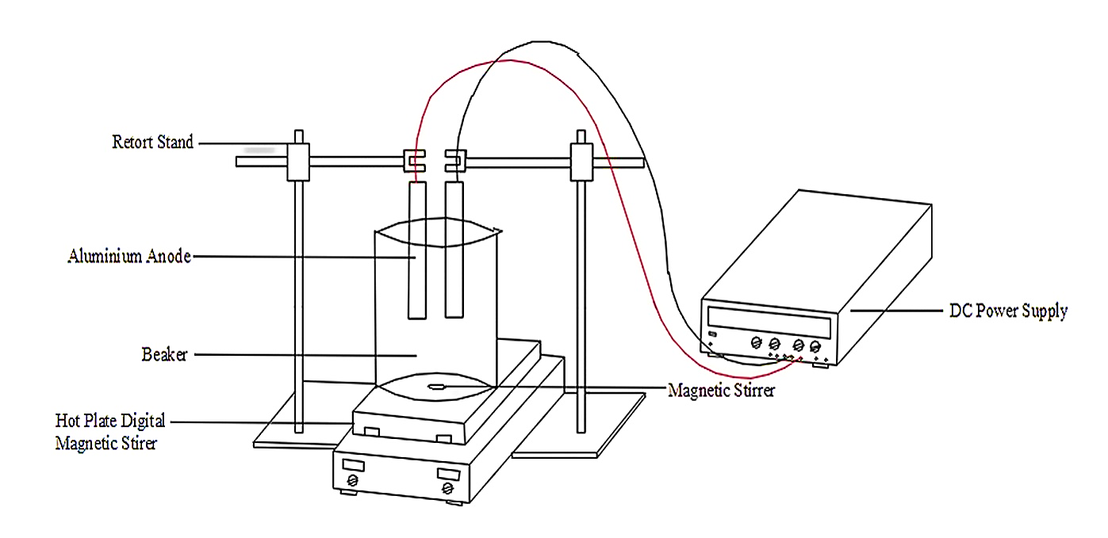
Fig. S1. Experimental Setup

Table S1. Range of Operational Parameters.
Operational Parameters | Range | References
pH | 3 - 6 | Bashir et al., 2019
Reaction Time | 10 - 60 minutes | Bashir et al., 2019
Current Density | 4 – 15 mA/cm² | Preliminary experiment
H₂O₂ Dosage | 0 – 1 g/L | Barrera-Diaz et al., 2014

Table S2. Initial Characteristics of Biologically Treated Poultry SWW.
Parameters | Unit | Range | Average
COD | mg/L | 2350-2900 | 2625
BOD₅ | mg/L | 131.5-150 | 140.75
pH | - | 6.55-6.92 | 6.735
Colour | PtCo | 2333-2467 | 2400
Turbidity | NTU | 229.67-311.5 | 270.56
Temperature | ºC | 24.2-25 | 24.6
Total Suspended Solids, TSS | mg/L | 317-400 | 358.5
Ammoniacal Nitrogen, NH₃-N | mg/L | 36-37 | 36.5
Oxidation Reduction Potential, ORP | mV | 59.2-60.1 | 59.65
Electrical Conductivity | mS | 333.4-334.1 | 333.75
Total Dissolved Solids, TDS | ppm | 329-332 | 330.5
Salinity | ppm | 194.5-196.2 | 195.35
Resistivity | kΩ | 1.516-1.523 | 1.52
Measuring DO | mg/L | 0.56-0.62 | 0.59
Aluminium ion (Al³⁺) | mg/L | 1.52-1.64 | 1.58

Table S3. ANOVA for COD, TSS, Colour and pH..

 | Source | Sum of Square | df | Mean Square | F value | p-value | Remark
COD | Model | 211.45 | 4 | 29.59 | 15.35 | <0.0001 | Significant
TSS | Model | 101.04 | 14 | 7.22 | 8.96 | <0.0001 | Significant
Colour | Model | 156.32 | 14 | 11.17 | 6.80 | 0.0003 | Significant
pH | Model | 28.89 | 10 | 2.89 | 23.11 | <0.0001 | Significant

Table S4. RSM Model Fit Summary.

Statistical Figure | COD | TSS | Colour | Treated pH
Standard Deviation | 1.39 | 0.90 | 1.28 | 0.35
Mean | 95.01 | 97.48 | 96.49 | 5.93
Coefficient of Variance (C.V.%) | 1.46 | 0.92 | 1.33 | 5.97
Predicted Residual Error Sum of Square (PRESS) | 16.97 | 73.35 | 15.77 | 14.30
R² | 0.8797 | 0.8932 | 0.8639 | 0.9240
Adequate Precision (AP) | 9.726 | 13.864 | 11.721 | 19.495

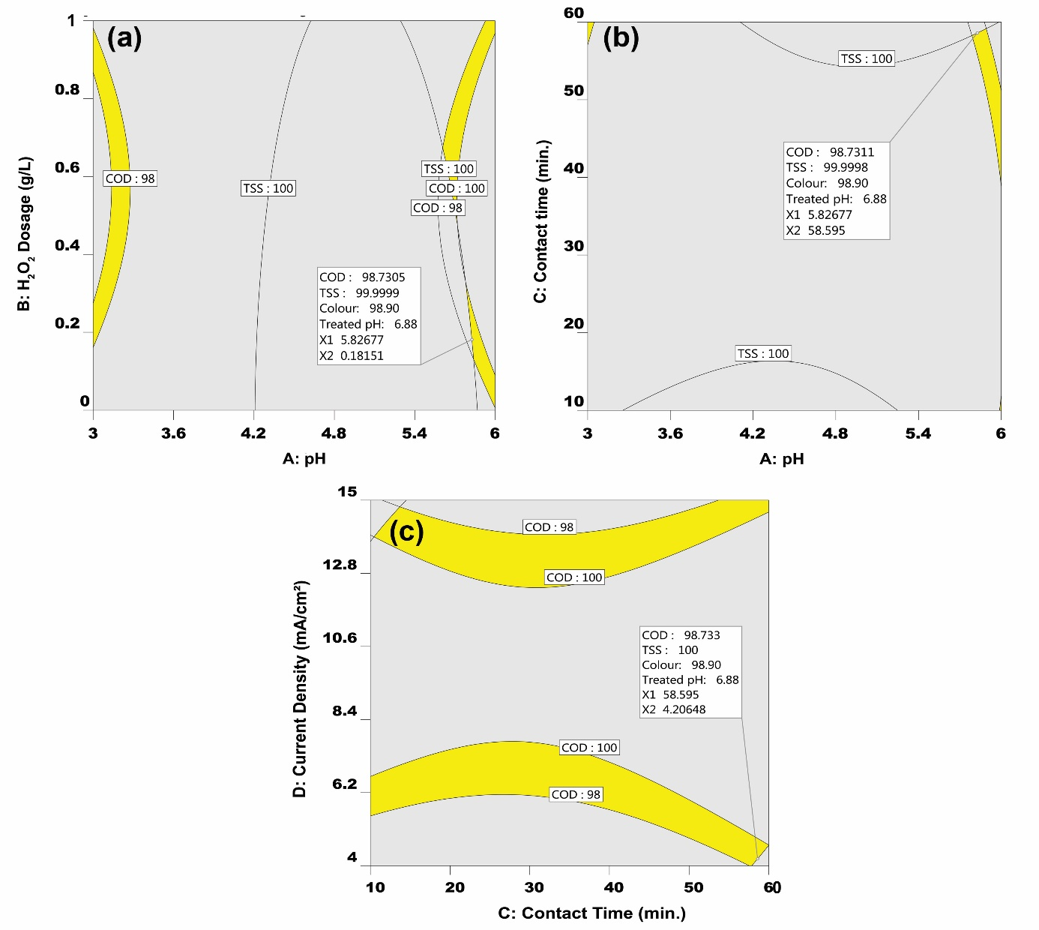
Fig. S2. Graphical optimization of independent parameters with overlay plots

