Table S1. Selected genes were tested by two-way ANOVA (*p < 0.05; **p < 0.01; ***p < 0.001). Enzymes having significant interaction are shaded.
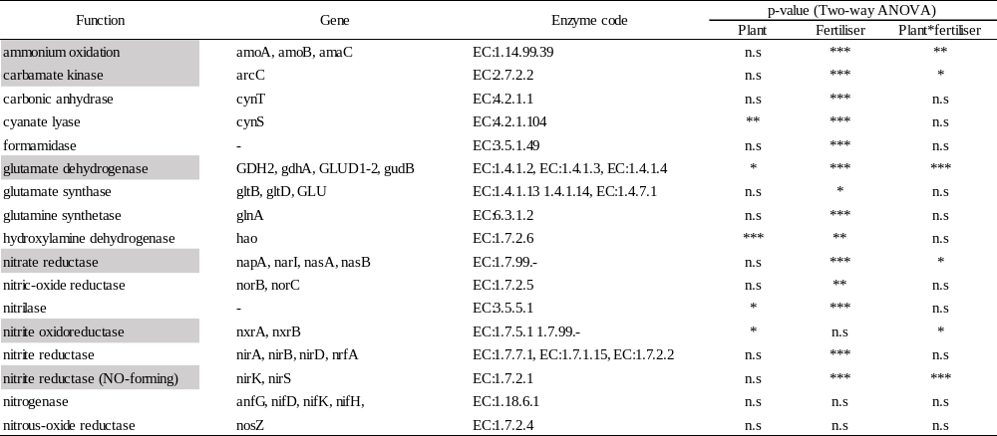

Table S2. 16S rRNA gene abundance. The number of replications was 3 for each treatment. Two-way ANOVA was performed to examine the interaction effects between plant species and fertiliser treatments. The results for multiple pairwise comparisons are shown with different letters.
Treatment | Log (copy number) g soil⁻¹
SM
Ctr | 12.2 ± 0.0
CF | 12.2 ± 0.1 |  |  | b
CM | 12.2 ± 0.1
MM
Ctr | 11.8 ± 0.0
CF | 12.2 ± 0.1 |  |  | ab
CM | 11.9 ± 0.2
PM
Ctr | 12.2 ± 0.2
CF | 12.1 ± 0.1 |  |  | ab
CM | 12.0 ± 0.1
VM
Ctr | 11.7 ± 0.1
CF | 12.0 ± 0.2 |  |  | a
CM | 12.1 ± 0.1
Two-way ANOVA | p
Plant | <0.01
Fertiliser | 0.045
Plant × fertiliser | 0.069

Table S3. Dry matter (DM) of plant shoots and roots. Legume DM shows legume shoot DM, and maize DM shows maize shoot DM. Root DM in mixed treatment contains both legume and maize below-ground DM. Total DM includes shoot and root DM in each treatment. Values with different letters within a row show means with significant differences (honestly significant difference, Tukey-Kramer, p < 0.05). The average numbers of nodulation in legume roots are shown.
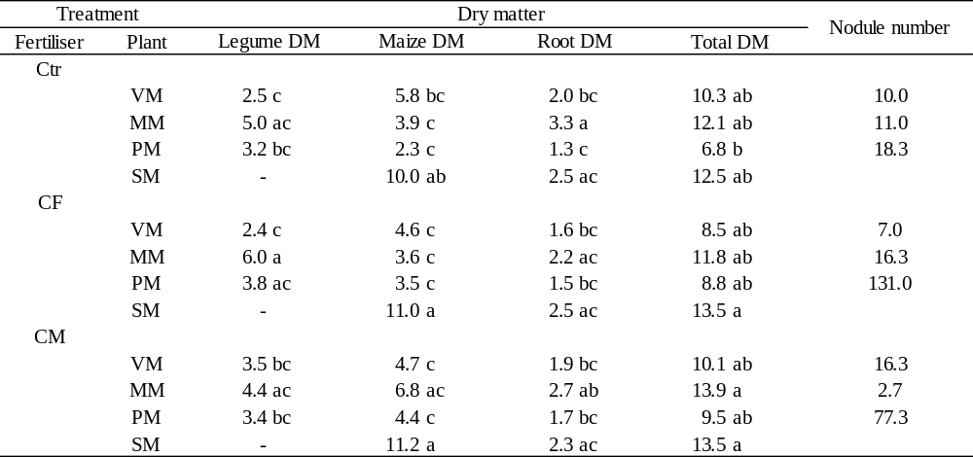

Table S1. Selected genes were tested by two-way ANOVA (*p < 0.05; **p < 0.01; ***p < 0.001). Enzymes having significant interaction are shaded.
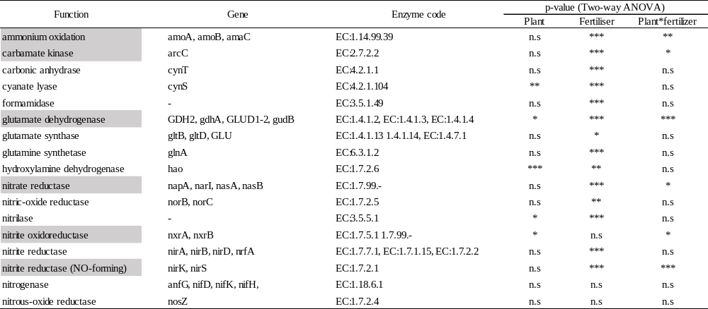

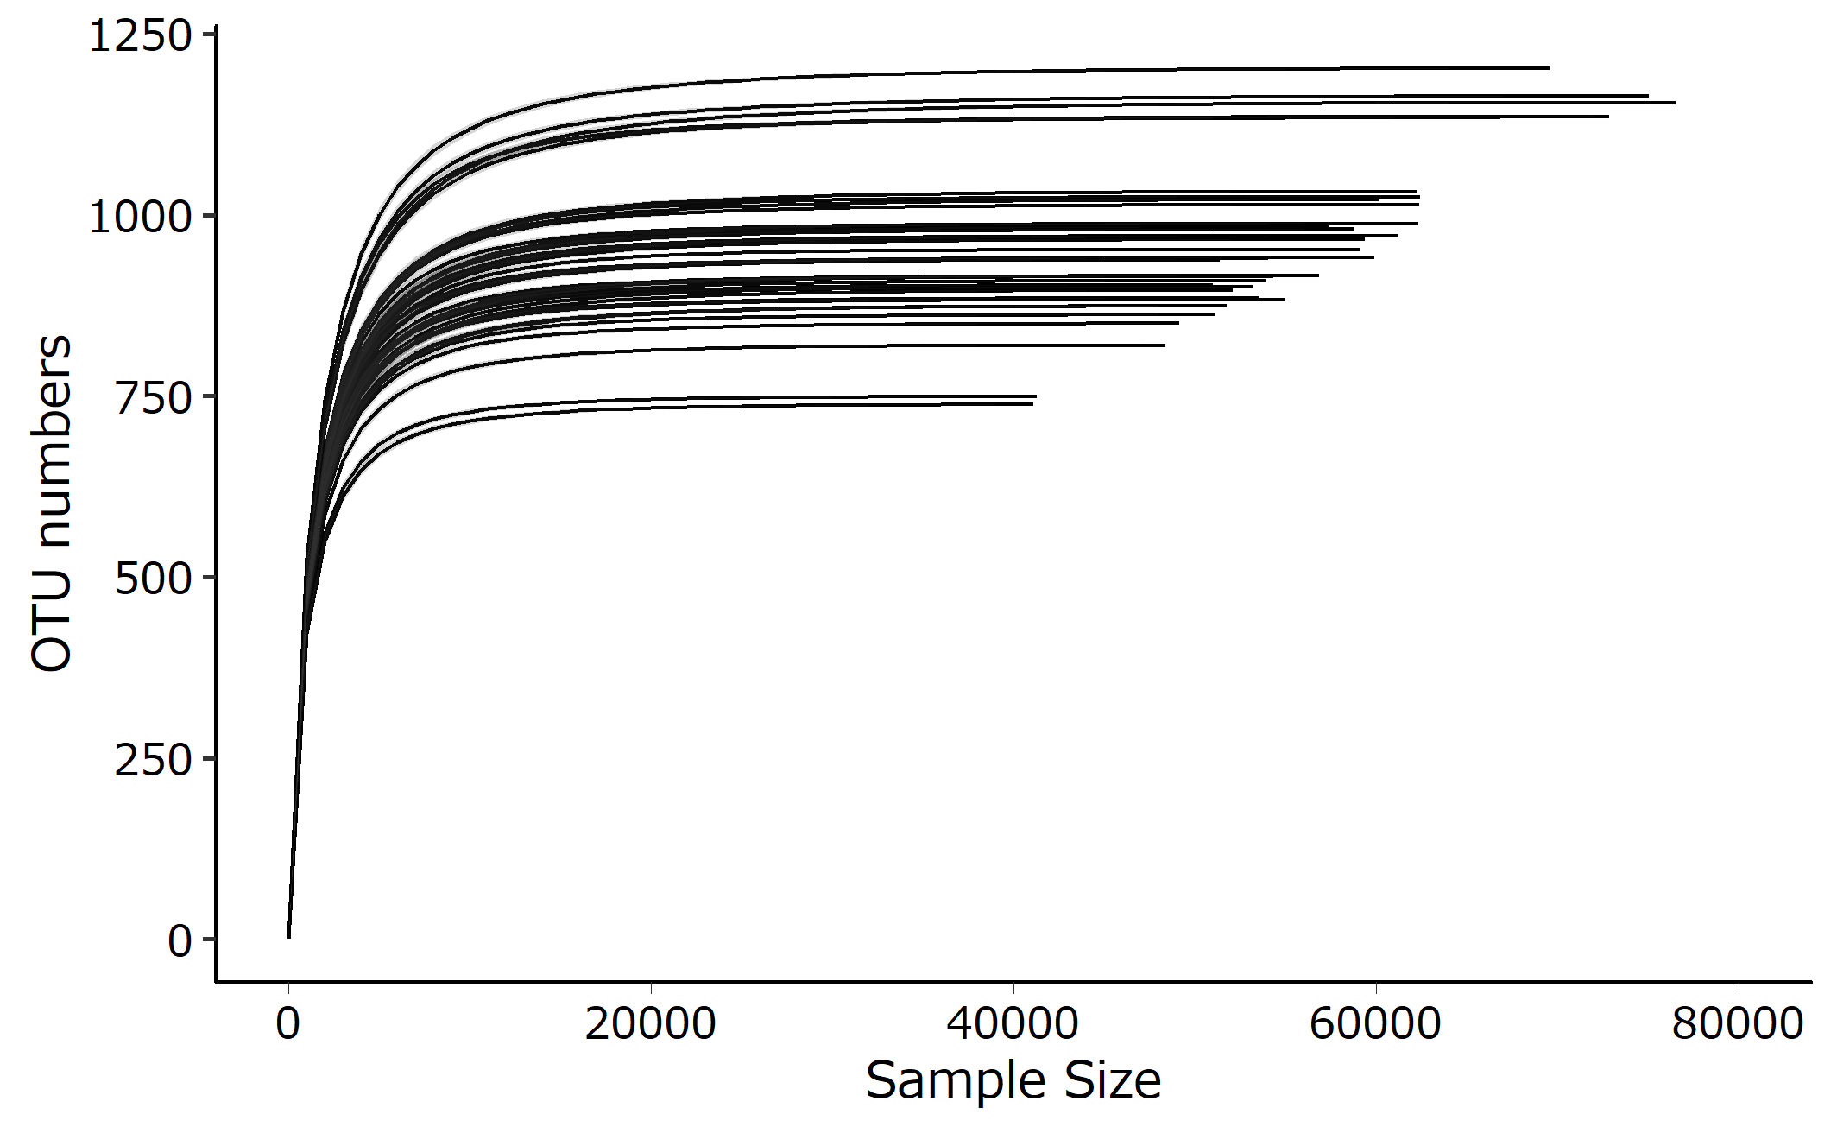
Figure S1. α-Rarefaction curve of all samples. The curves were evaluated using the interval of step sample size of 1000.

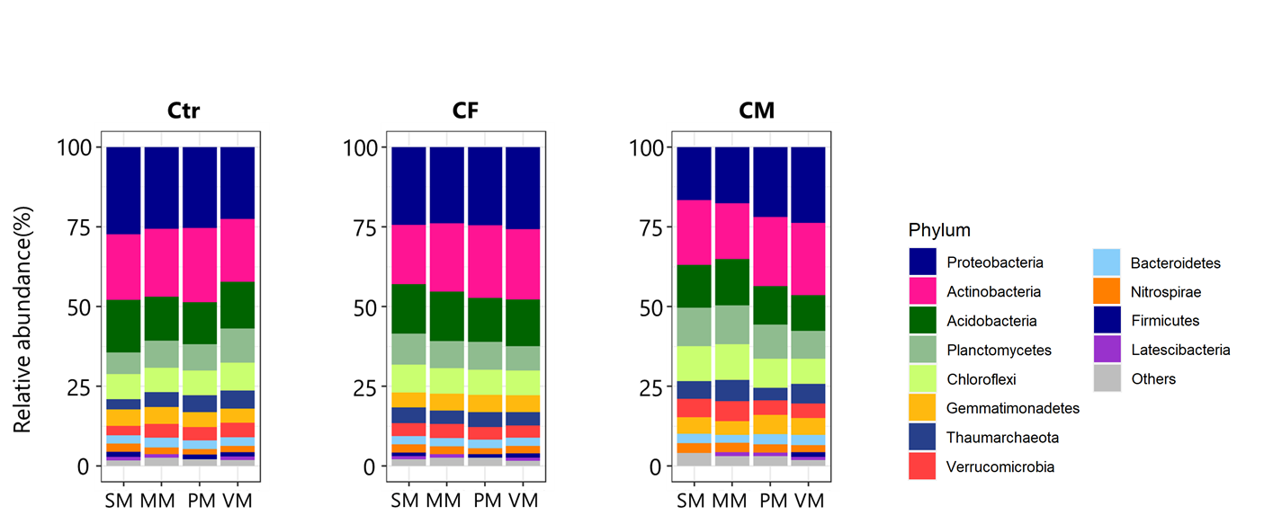
Figure S2. Relative abundance of the total community based on phylum-level classification. Only phyla with a relative abundance of >0.1% in the averaged value were represented. Plant species: SM, MM, PM, and VM; fertiliser treatments: Ctr, CF, and CM.

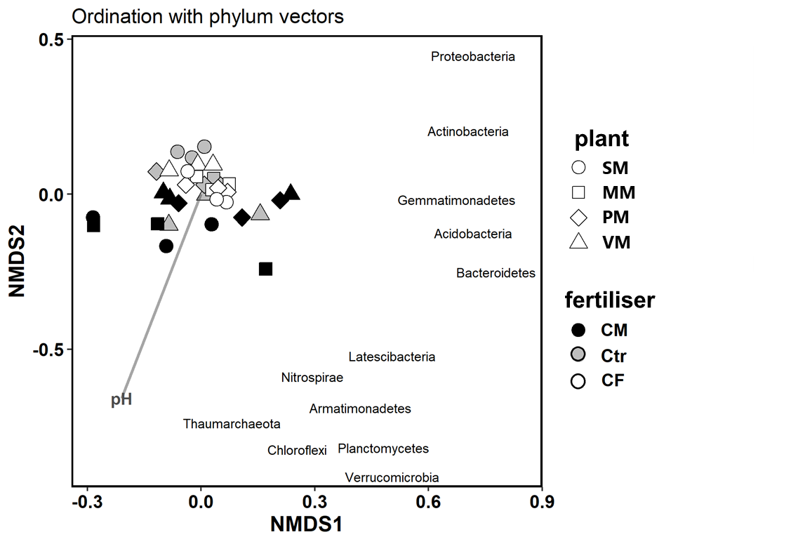
Figure S3. Nonmetric multidimension scaling plot based on Bray-Curtis dissimilarity with significant bacterial phyla (p < 0.001) and environmental factors (stress = 0.131). The bacterial community was significantly influenced by fertiliser treatment (p < 0.05) and pH (p < 0.001).

