Extended Figures and Legends
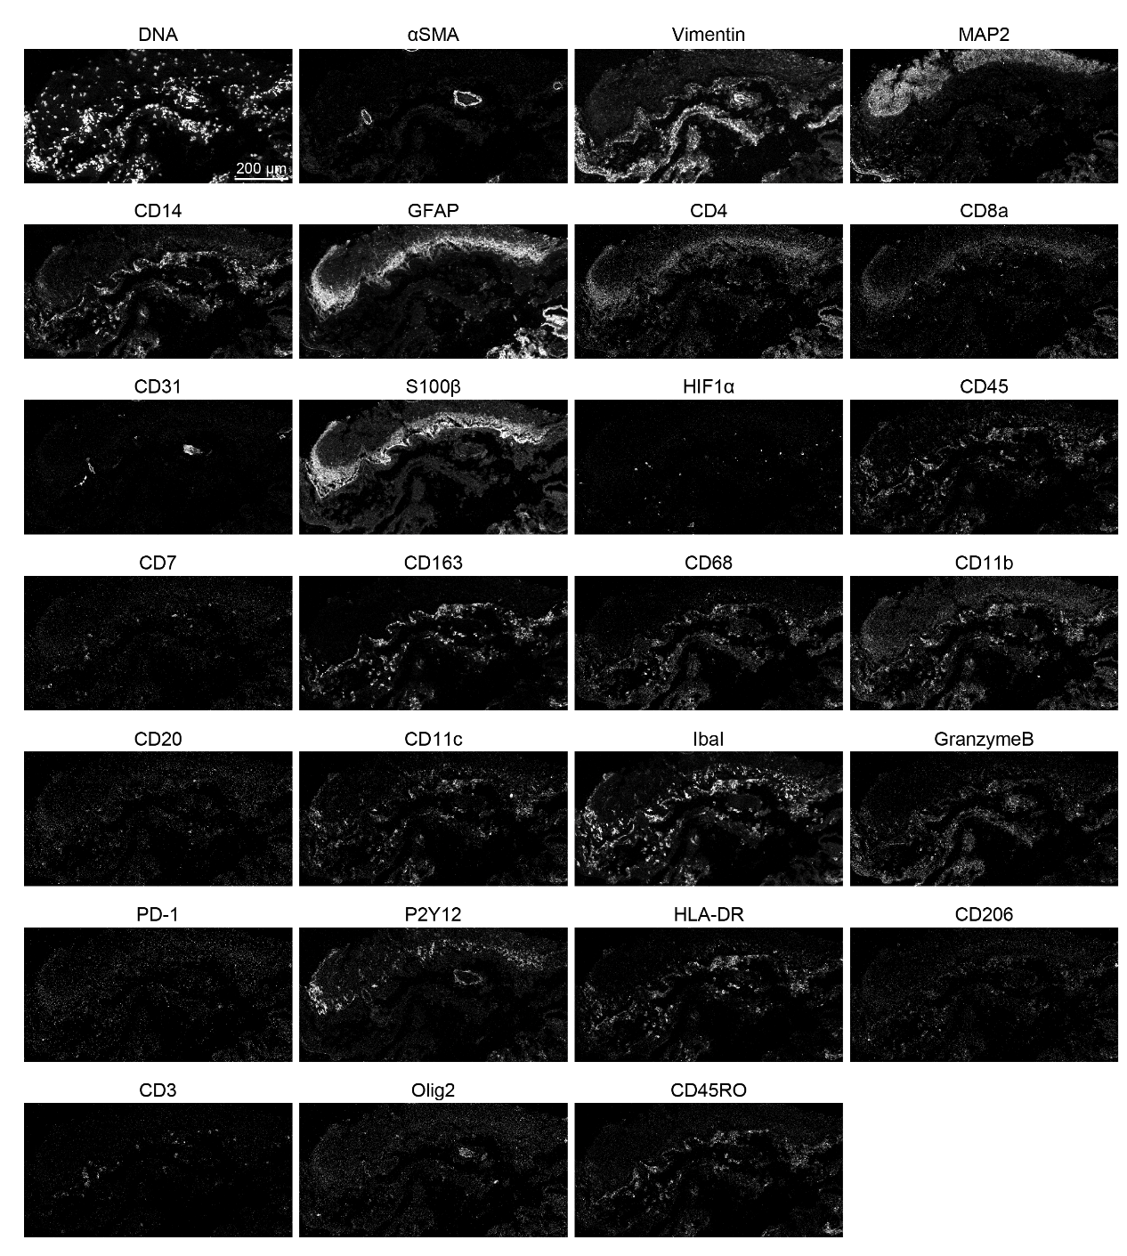
Extended Data Fig. 1 | Representation of a single marker in the context of a 27-marker IMC panel.

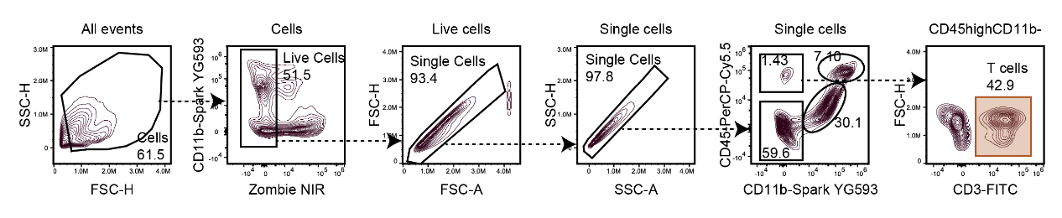
Extended Data Fig. 2 | Gating strategy for identifying T cells in mouse brain.

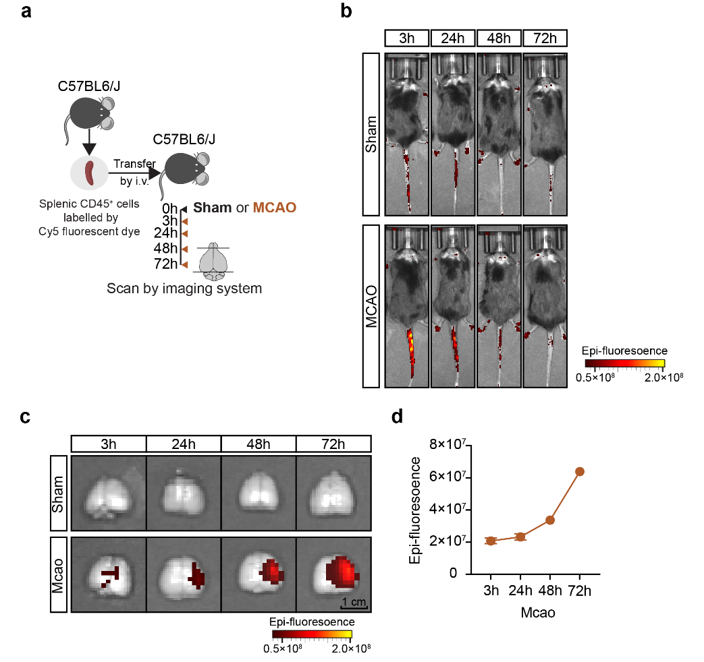
Extended Data Fig. 3 | Time-dependent accumulation of transferred splenic CD45⁺ cells in the brain following MCAO.
a, Schematic representation of experimental design. Splenic CD45⁺ cells isolated from donor mice were labeled with Cy5 fluorescent dye and intravenously transferred into recipient mice. Recipients were subjected to either Sham or MCAO surgery. At indicated time points (0h, 3h, 24h, 48h, 72h), mice were scanned using an in vivo imaging system to track the distribution of labeled cells in mice brain. b, Representative whole-body in vivo epi-fluorescence images illustrating the distribution of transferred Cy5-labeled splenic CD45⁺ cells in Sham and MCAO-operated mice at 3-, 24-, 48-, and 72-hours post-surgery. Color represents epi-fluorescence intensity. c, Ex vivo fluorescent imaging of brains from sham and MCAO mice at the indicated time points, showing signal accumulation specifically in the brains of MCAO mice over time. d, Quantification of epi-fluorescence signal in the brains of MCAO mice at the indicated time points. Color represents epi-fluorescence intensity.
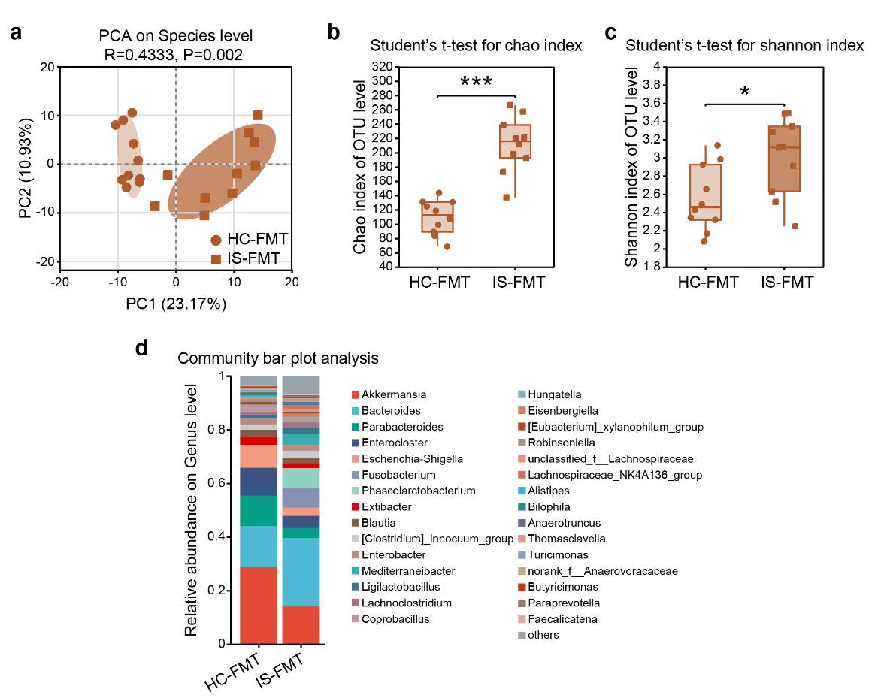
Extended Data Fig. 4 | Changes in gut microbiota diversity and composition induced by IS-FMT compared to HC-FMT.
a, Principal coordinate analysis (PCA) at the species level of gut microbiota (R = 0.4333, P = 0.002). b, Chao index of OTU level in HC-FMT and IS-FMT groups (Student’s t-test). c, Shannon index of OTU level in HC-FMT and IS-FMT groups (Student’s t-test). d, Relative abundance of gut microbiota at the genus level in HC-FMT and IS-FMT groups (community bar plot).

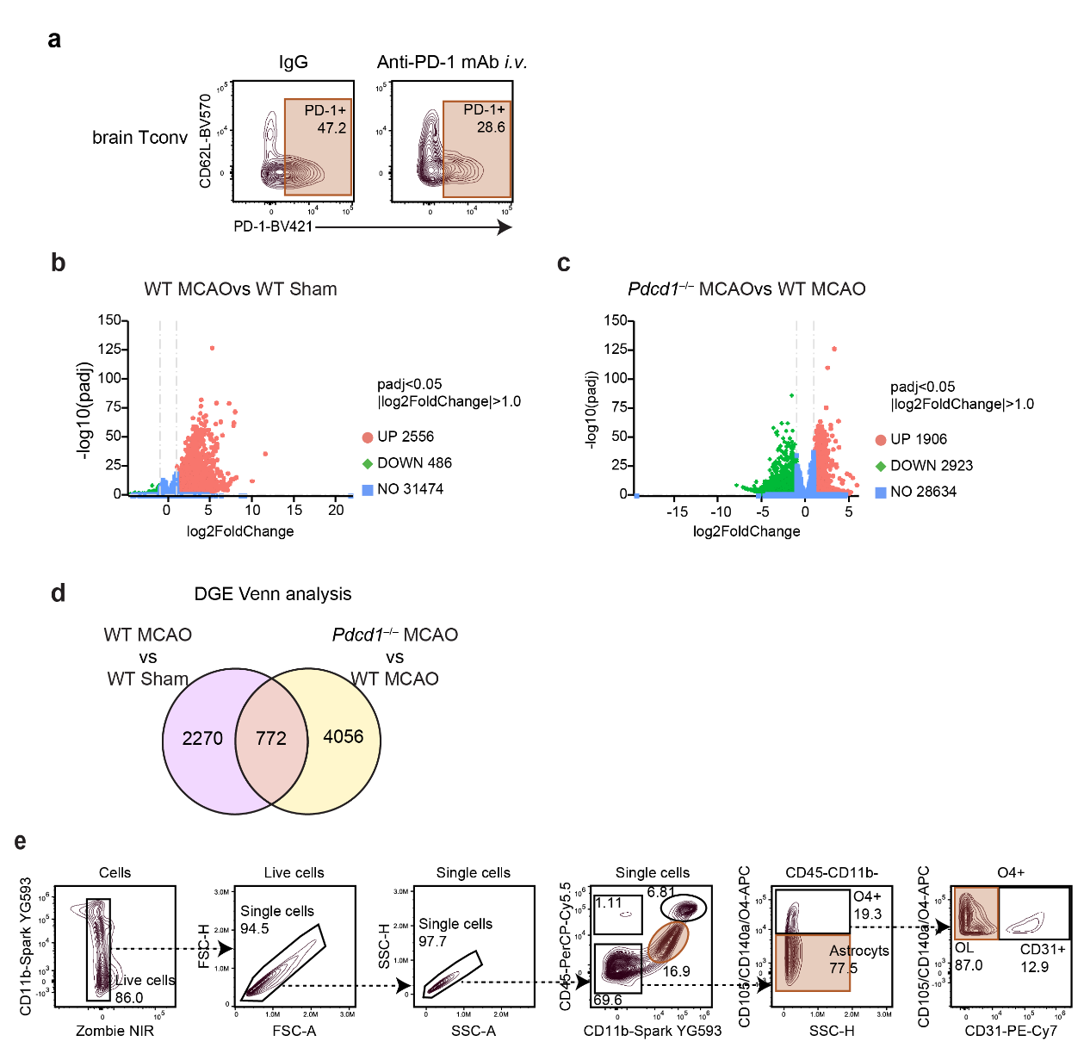
Extended Data Fig. 5 | PD-1 blockade promotes neurological recovery following stroke.
a, The representative biaxial plots show PD-1 expression on brain conventional T cells of MCAO mice in IgG or anti–PD-1 mAb groups. b, Volcano plot of differentially expressed genes (DEGs) in brain from WT mice: MCAO versus Sham. Upregulated (red), downregulated (green), and non-significant genes (blue) are shown. c, Volcano plot of DEGs in brains: Pdcd1–/– MCAO versus WT MCAO. Upregulated (red), downregulated (green), and non-significant genes (blue) are shown. d, Venn diagram depicting the overlap and distribution of DEGs between WT MCAO vs WT Sham and Pdcd1–/– MCAO vs WT MCAO comparisons. e, Flow cytometry gating strategy for microglia, astrocytes, and oligodendrocytes in the brains of MCAO mice.
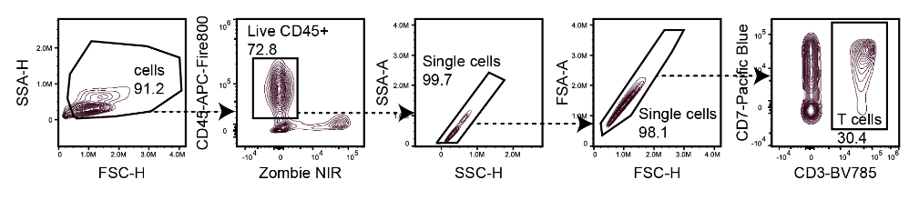
Extended Data Fig. 6 | Gating strategy for identification of T cells in whole blood from IS patients.

