Supplementary Material

Summary
Supplementary Table S1 – Search Strategy 2
Supplementary Table S2 – Risk of Bias Assessment (RoB 2 Tool) 3
Supplementary Table S3 – Summary of Included Studies 4
Supplementary Table S4 – GRADE Assessment of Certainty of Evidence 5
Supplementary Figure S1. Funnel plot assessing publication bias for the outcome of adequate antimicrobial therapy. 6
Supplementary Figure S2. Funnel plot for the outcome of time to targeted therapy. 8
Supplementary Figure S3. Sensitivity Analysis for antibiotic adequacy without inhale WP3. 9
Supplementary Figure S4. Sensitivity analysis for antibiotic adequacy without the FLAGSHIP II trial. 10
Supplementary Figure S5. Sensitivity analysis for antibiotic adequacy without the Poole study 11
Supplementary Figure S6. Sensitivity analysis for time to effective therapy without the INHALE WP3 study. 12
Supplementary Figure S7. Sensitivity analysis for time to effective therapy without the Virk et al trial. 13

Pubmed | ("Pneumonia"[Mesh] OR pneumonia[tiab] OR "ventilator-associated pneumonia"[tiab] OR VAP[tiab] OR "hospital-acquired pneumonia"[tiab] OR "nosocomial pneumonia"[tiab])  AND  ("Intensive Care Units"[Mesh] OR "Critical Care"[Mesh] OR ICU[tiab] OR "intensive care"[tiab] OR "critical care"[tiab])  AND  ("Polymerase Chain Reaction"[Mesh] OR PCR[tiab] OR "multiplex PCR"[tiab] OR "syndromic PCR"[tiab] OR "rapid molecular diagnostics"[tiab] OR "molecular testing"[tiab] OR "nucleic acid amplification"[tiab] OR "panel testing"[tiab])  AND  (randomized[tiab] OR randomised[tiab] OR RCT[tiab] OR "randomized trial"[tiab] OR "randomised trial"[tiab] OR "clinical trial"[tiab] OR multicenter[tiab])
EMBASE | ('pneumonia'/exp OR 'pneumonia':ti,ab,kw OR 'ventilator-associated pneumonia':ti,ab,kw OR 'vap':ti,ab,kw OR 'hospital-acquired pneumonia':ti,ab,kw OR 'nosocomial pneumonia':ti,ab,kw) AND ('intensive care unit'/exp OR 'intensive care'/exp OR 'icu':ti,ab,kw OR 'intensive care':ti,ab,kw OR 'critical care':ti,ab,kw) AND ('polymerase chain reaction'/exp OR 'pcr':ti,ab,kw OR 'multiplex pcr':ti,ab,kw OR 'syndromic pcr':ti,ab,kw OR 'rapid molecular diagnostics':ti,ab,kw OR 'molecular testing':ti,ab,kw OR 'nucleic acid amplification':ti,ab,kw OR 'panel testing':ti,ab,kw) AND ('randomized':ti,ab,kw OR 'randomised':ti,ab,kw OR 'rct':ti,ab,kw OR 'randomized trial':ti,ab,kw OR 'randomised trial':ti,ab,kw OR 'clinical trial':ti,ab,kw OR 'multicenter':ti,ab,kw)
Cochrane Library | (pneumonia:ti,ab,kw OR "ventilator-associated pneumonia":ti,ab,kw OR vap:ti,ab,kw OR "hospital-acquired pneumonia":ti,ab,kw OR "nosocomial pneumonia":ti,ab,kw)  AND  ("intensive care":ti,ab,kw OR "critical care":ti,ab,kw OR icu:ti,ab,kw)  AND  ("polymerase chain reaction":ti,ab,kw OR pcr:ti,ab,kw OR "multiplex pcr":ti,ab,kw OR "syndromic pcr":ti,ab,kw OR "rapid molecular diagnostics":ti,ab,kw OR "molecular testing":ti,ab,kw OR "nucleic acid amplification":ti,ab,kw OR "panel testing":ti,ab,kw)  AND  (randomized:ti,ab,kw OR randomised:ti,ab,kw OR rct:ti,ab,kw OR "randomized trial":ti,ab,kw OR "randomised trial":ti,ab,kw OR "clinical trial":ti,ab,kw OR multicenter:ti,ab,kw)

Supplementary Table S1 – Search Strategy

Supplementary Table S2 – Risk of Bias Assessment (RoB 2 Tool)

Study | Randomization Process | Deviations from Intended Interventions | Missing Outcome Data | Measurement of the Outcome | Selection of the Reported Result | Overall Risk of Bias
INHALE WP3 (2025) | Low | Low | Low | Low | Low | Low
FLAGSHIP II (2022) | Low | Some concerns | Low | Low | Some concerns | Some concerns
Virk et al. (2024) | Low | Low | Low | Low | Low | Low
Poole et al. (2022) | Low | Low | Low | Low | Low | Low

Supplementary Table S3 – Summary of Included Studies

Study | Country | Sample Size (PCR/Control) | PCR Platform | Pneumonia Type | Follow-up Duration | Main Outcomes Assessed
INHALE WP3 (2025) | UK | 223 / 219 | FilmArray | HAP, VAP | 28 days | Antibiotic adequacy, mortality
FLAGSHIP II (2022) | Switzerland | 71 / 59 | Seegene, RespiFinder | CAP, HAP | 30 days | Time to therapy, de-escalation
Virk et al. (2024) | USA | 563 / 589 | FilmArray | HAP, VAP | 30 days | Antibiotic changes, mortality
Poole et al. (2022) | UK | 100 / 100 | FilmArray | Mixed | 60 days | Antibiotic de-escalation

Supplementary Table S4 – GRADE Assessment of Certainty of Evidence

Outcome | Risk of Bias | Inconsistency | Indirectness | Imprecision | Publication Bias | Overall Certainty
Adequacy of initial antimicrobial therapy | Low to moderate | High (I² = 83%) | None | Moderate (wide CI) | Possible (n=4) | Moderate
Time to effective antibiotic therapy | Low to moderate | Very high (I² = 100%) | None | High (wide CI) | Possible (n=4) | Low
In-hospital mortality | Low | None (I² = 0%) | None | Moderate | Unlikely | Moderate

Supplementary Figure S1. Funnel plot assessing publication bias for the outcome of adequate antimicrobial therapy.
The x-axis represents the odds ratio (log-transformed), and the y-axis displays the standard error of the effect size. Each point represents a study, labeled with its study name. Visual inspection suggests possible asymmetry, potentially indicative of publication bias or small-study effects. However, given the small number of included studies (n = 4), this observation should be interpreted with caution.
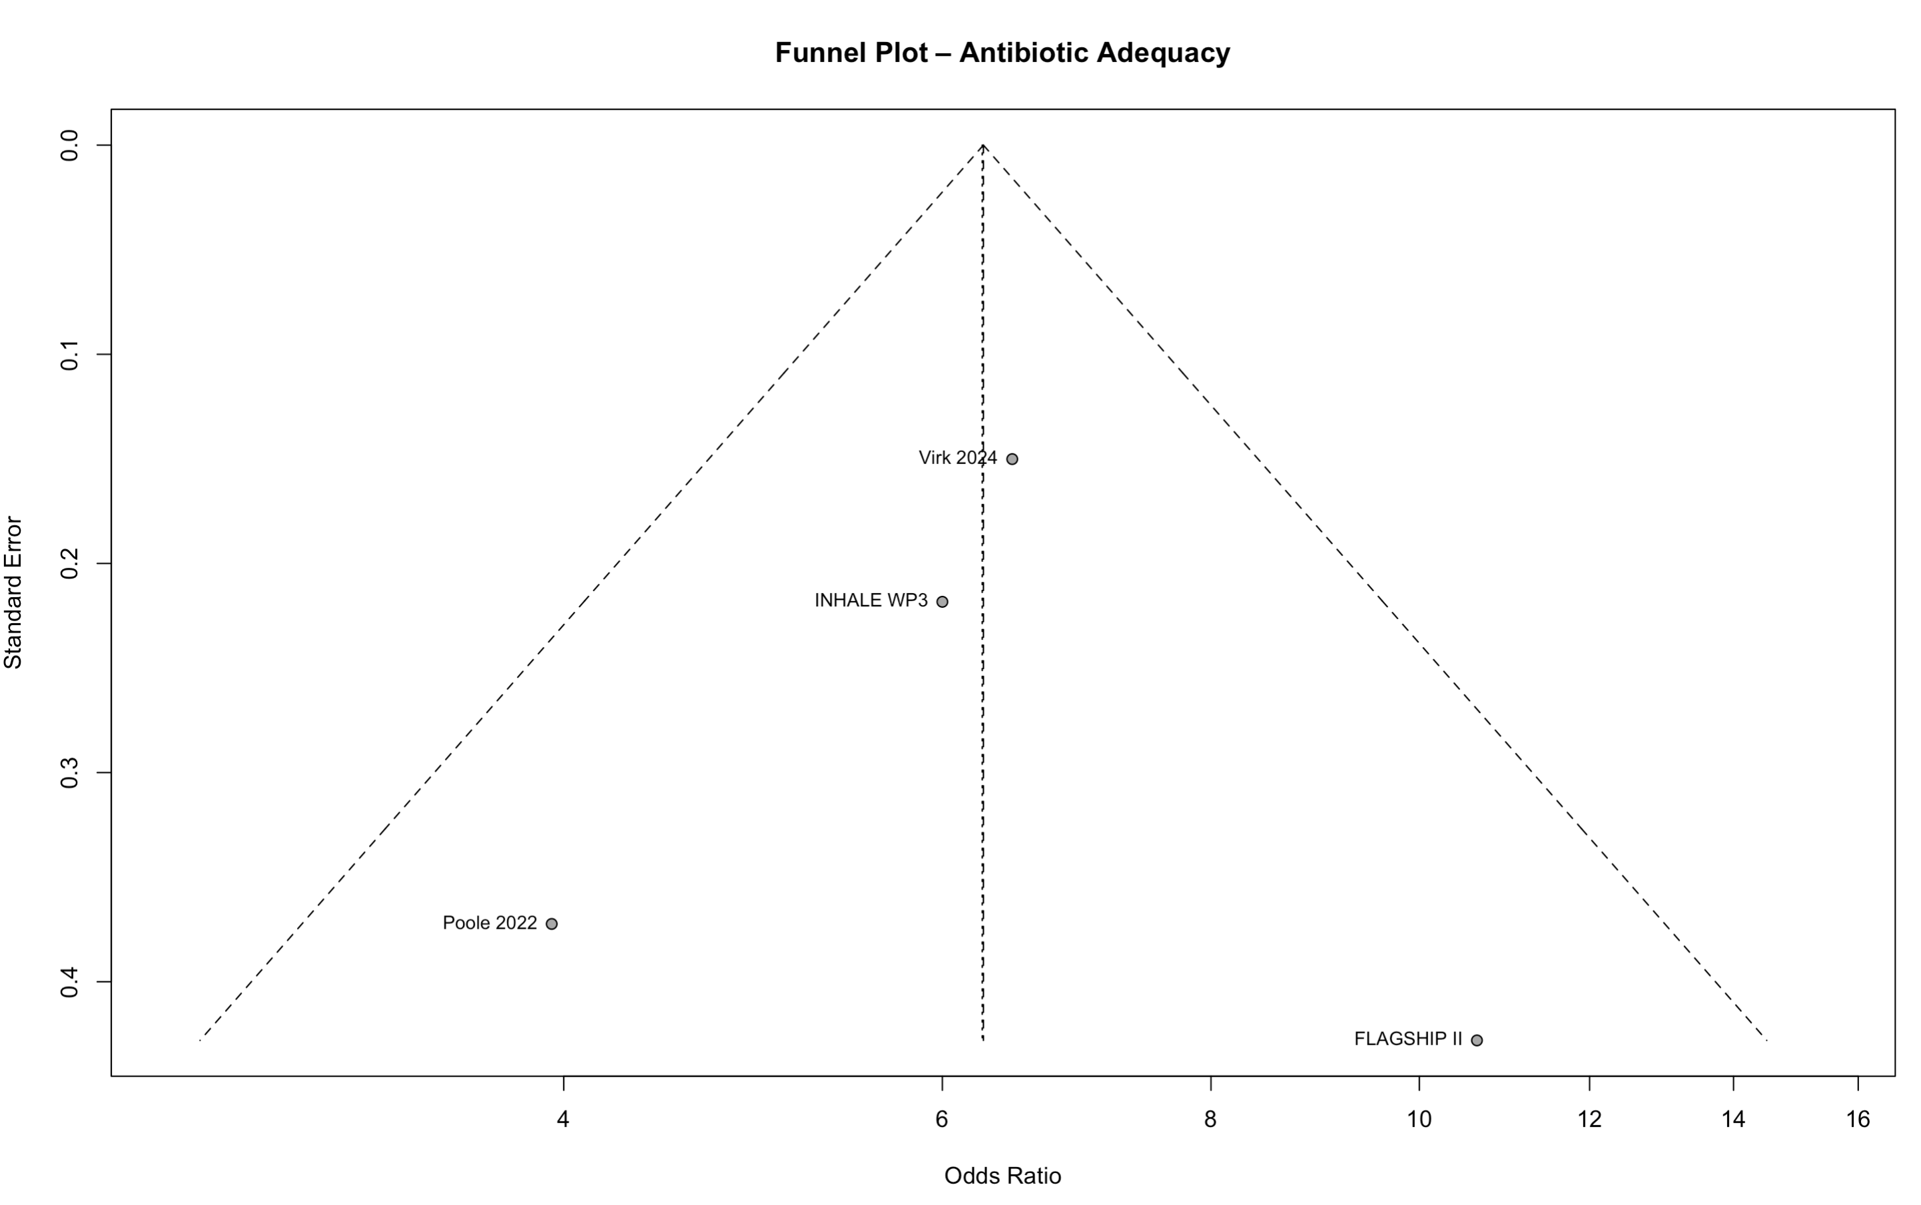

Supplementary Figure S2. Funnel plot for the outcome of time to targeted therapy.
The plot displays mean differences in hours (x-axis) against their standard errors (y-axis). Study labels are shown adjacent to their corresponding data points. Interpretation of symmetry is limited by the small number of included studies (n = 4).
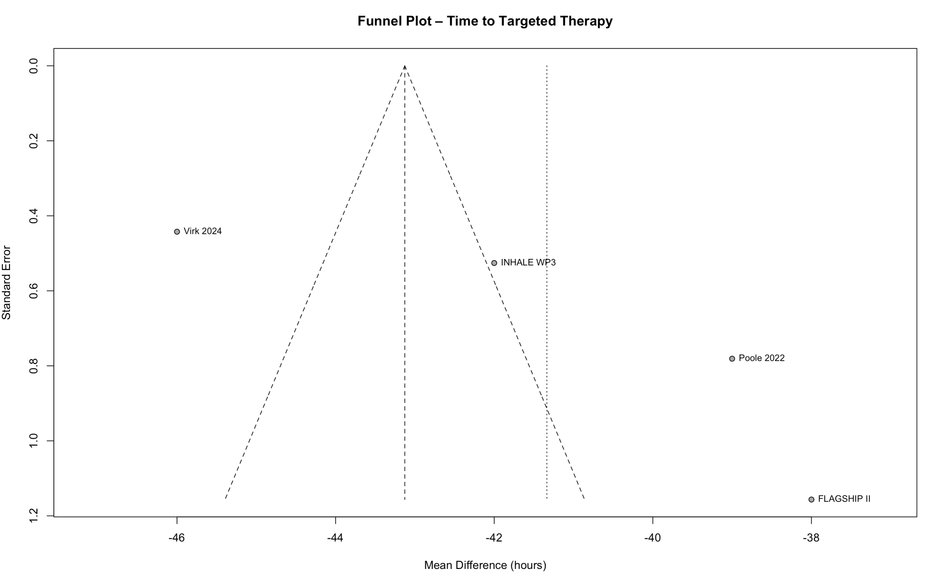

Supplementary Figure S3. Sensitivity Analysis for antibiotic adequacy without inhale WP3.
Pooled analysis including the FLAGSHIP II and Poole studies demonstrated a significant benefit for syndromic PCR panels (OR 7.92; 95% CI 4.83–13.00; I² = 0%).

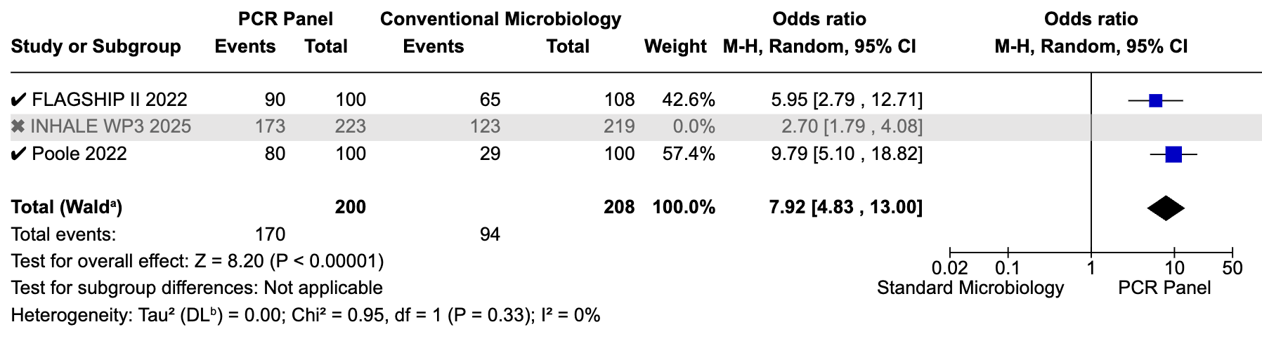

Supplementary Figure S4. Sensitivity analysis for antibiotic adequacy without the FLAGSHIP II trial.
The pooled effect including the INHALE WP3 and Poole studies remained significant (OR 5.01; 95% CI 1.42–17.69), although with substantial heterogeneity (I² = 91%).
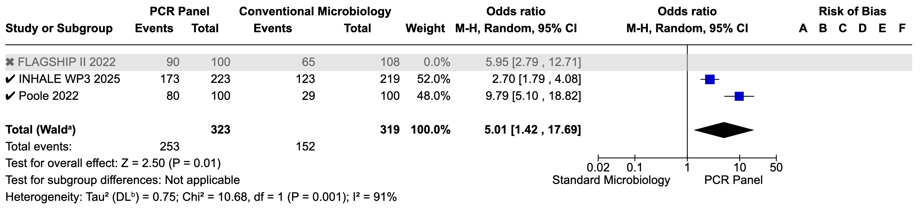

Supplementary Figure S5. Sensitivity analysis for antibiotic adequacy without the Poole study
Pooled effect from FLAGSHIP II and INHALE WP3 remained significant (OR 3.75; 95% CI 1.75–8.06), with moderate heterogeneity (I² = 69%).

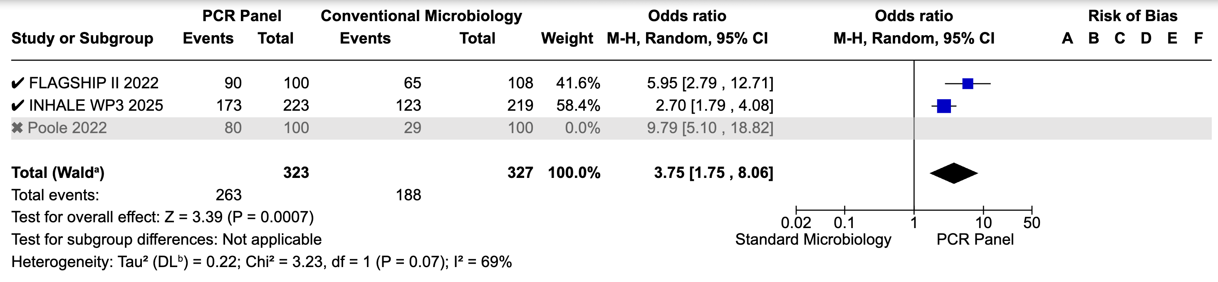

Supplementary Figure S6. Sensitivity analysis for time to effective therapy without the INHALE WP3 study.
Results from FLAGSHIP II, Poole, and Virk trials continued to favor PCR testing, with a pooled mean difference of –26.76 hours (95% CI –47.84 to –5.68), despite high heterogeneity (I² = 100%).

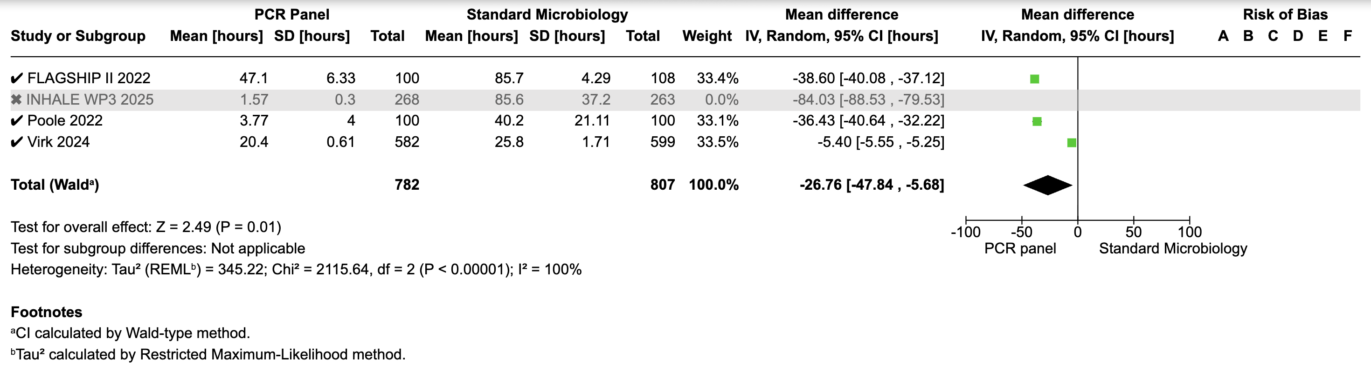

Supplementary Figure S7. Sensitivity analysis for time to effective therapy without the Virk et al trial.
The pooled result of the FLAGSHIP II, INHALE WP3, and Poole studies showed a significantly shorter time to effective antibiotic therapy in the PCR group compared to standard microbiology (mean difference –52.98 hours; 95% CI –83.36 to –22.61; I² = 100%).

