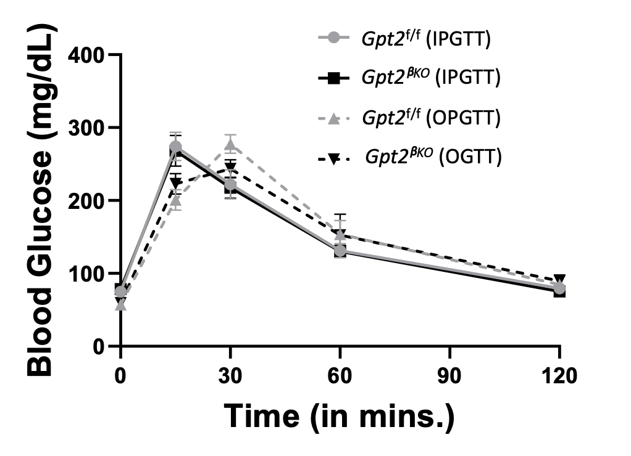

Supplementary Fig.1. IP and oral glucose tolerance of 10–12-week-old normal chow-fed, female Gpt2^{f/f} and Gpt2^{βKO} mice. Mean ± SE, N=5-7/group.

Supplementary Fig. 2. a. GLP-1 and b. GIP concentrations were measured by ELISA in mouse serum after an overnight fast, followed by an oral glucose injection of 3g/kg per Kg body weight. Data is means ± SEM.2-way ANOVA followed by Tukey’s multiple test: *, P < 0.05, **, P < 0.005 Relative to corresponding Control Diet. #, P < 0.05, ##, P < 0.005 , relative to 0 time point in respective diet group. $, P < 0.05, relative to diet matched Gpt2f/f littermates. N=6-8 in each group. c. Insulin tolerance test performed on male 33-week-old Gpt2^{f/f} and Gpt2^{βKO} mice after 29 weeks of 45 kcal% HFD or matched CD by injecting 0.75U/Kg body weight. Mean ± SE, **P< 0.01 compared to corresponding Control Diet (CD)—significance calculated using two-way ANOVA and Tukey’s Post-test. N= 8 (Gpt2^{f/f}), 7(Gpt2^{βKO}).

Supplementary Fig. 3. a. Upset plot showing overlap of DEGs between four datasets: GLT (Gpt2^{βKO} vs. Gpt2^{f/f}), Gpt2^{f/f} (Cont vs. GLT), T2D_1, T2D_2, and db/db. ( Significance calculated using hypergeometric test, *P< 0.01, **P<0.001). b. Clustering heatmap showing relative expression of cell cycle and chromosomal maintenance genes from GLT (Gpt2^{βKO} vs. Gpt2^{f/f}) dataset. Each column represents a biological replicate, and colors indicate the degree of enrichment, with red being upregulated and blue being downregulated. c. Volcano plot showing differentially expressed genes (DEGs, defined as genes having adjusted P-value ≤ 0.05 and absolute Log₂ fold change ≥ 0.27) from Cont (Gpt2^{βKO} vs. Gpt2^{f/f}) data group, that are upregulated(red), downregulated(blue) genes, or no significant change (grey). d. Top five Reactome pathways identified through DAVID GO analysis using upregulated or downregulated DEGs between Gpt2^{βKO} vs. Gpt2^{f/f} dataset.

Supplementary Fig.4. a. Representative WB showing GPT2 protein levels (left) of islets from 2 non-diabetic (ND) donors and 2 type-2 diabetic donors (T2D). b. Western blot analysis of HEK293 cells transiently transfected with non-targeting shNA (NT), or 3 different shRNA constructs targeting human GPT2 mRNA. c.Control non-diabetic human islets under baseline culture conditions were lentivirally transduced with human beta cells expressed GPT2 shRNA or non-targeting shRNA and stained for Hoechst(blue), insulin (red), and GFP (green) on the left, or Hoechst(blue), glucagon (red), and GFP (green) on the right. d. Quantification of % of Ins⁺GFP⁺ over Ins+ cells. Atleast 500 Ins+ or Gcg+ cells were quantified from two independent donors (right). Scale bar is 30μm. e. GSIS in batch incubations of un-transduced, non-diabetic donor islets exposed to indicated secretagogues, normalized as percentage of total insulin content, and presented as fractional insulin secretion. Mean± SE, n=3 (technical replicates of islets from a single donor). Significance was calculated using 2-way ANOVA with multiple comparisons ( *P< 0.05).

