Additional Information
Appendices
Appendix 1. Some pictures of Indigenous Knowledge used in crop production
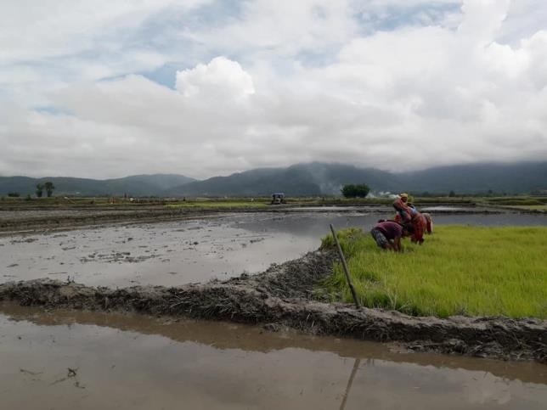
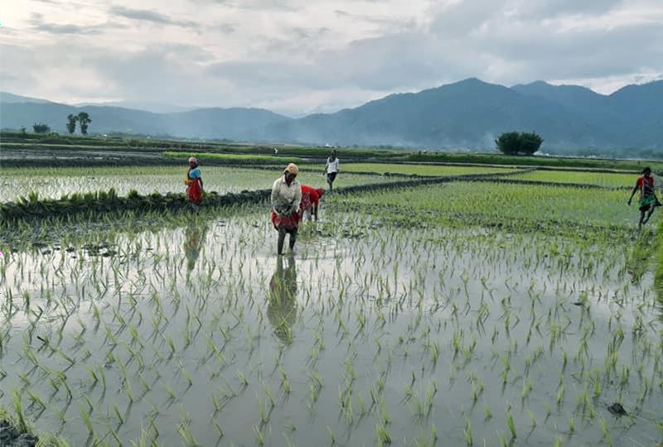
Puddling and uprooting of rice
Transplanting of rice

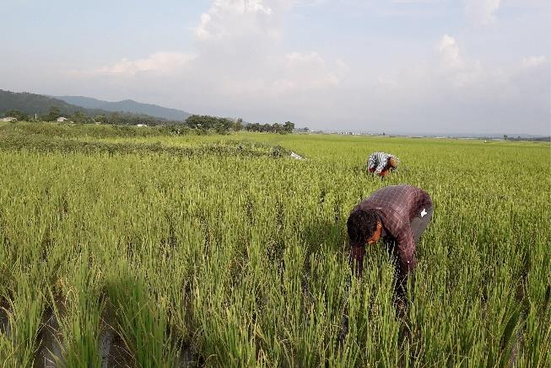
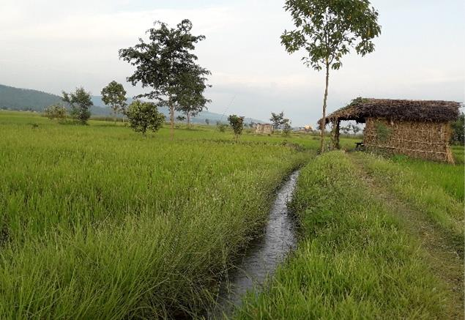

Hand weeding of rice crop
Indigenous irrigation
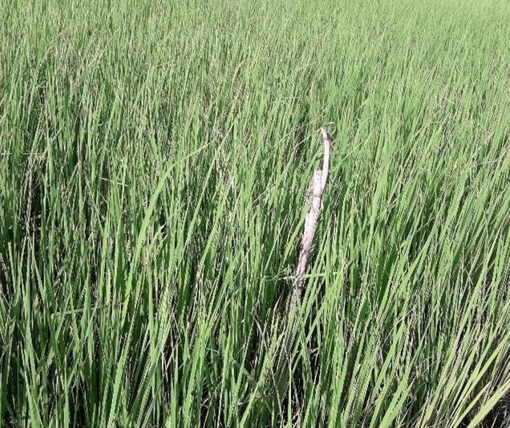
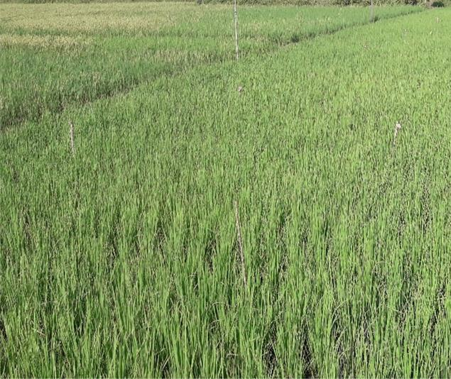
Indigenous crop insect-pest and disease control by placing maize stalk (Tona taapar)

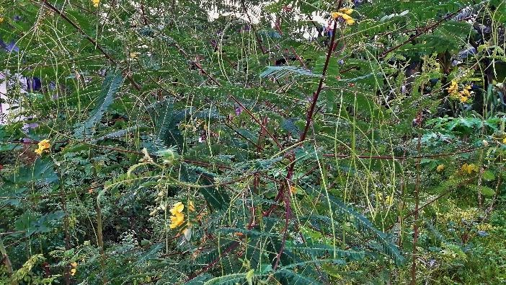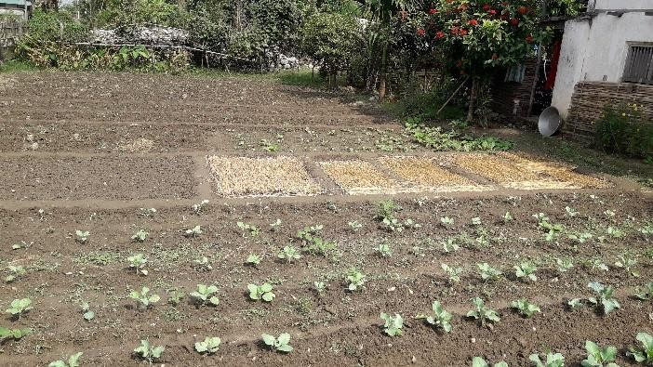
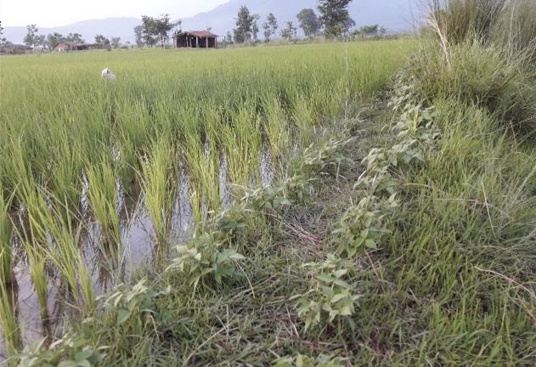
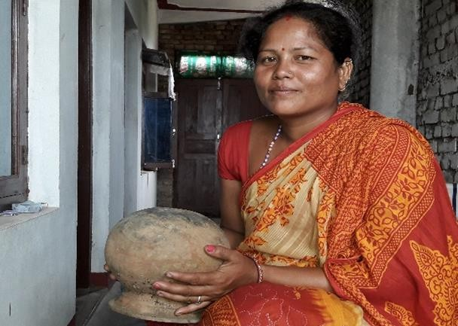
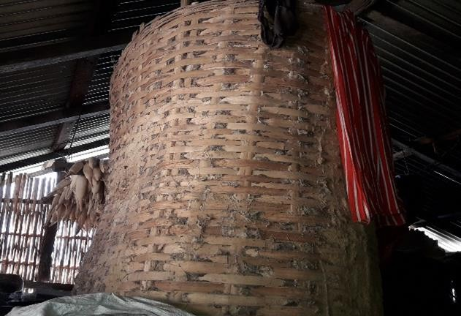
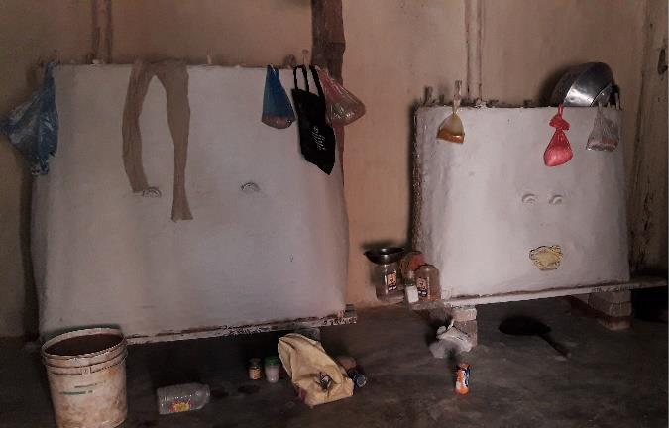
Dhainchaa for green manure
Staw mulching
Green and black gram grown on bunds
Indigenous clay seed/grain storing pot
Indigenous bamboo grain /seed storage

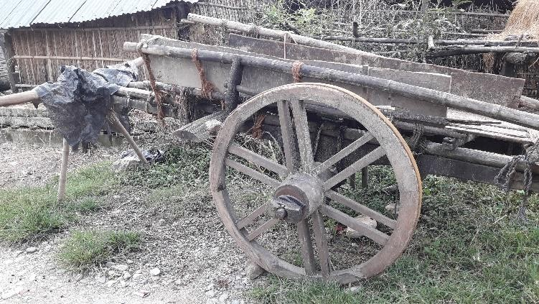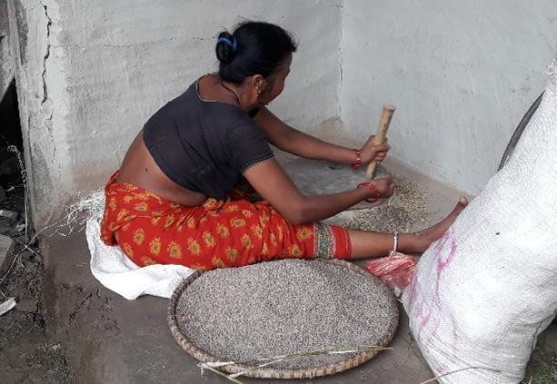
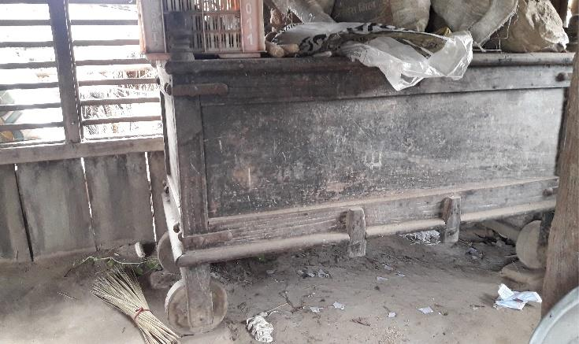
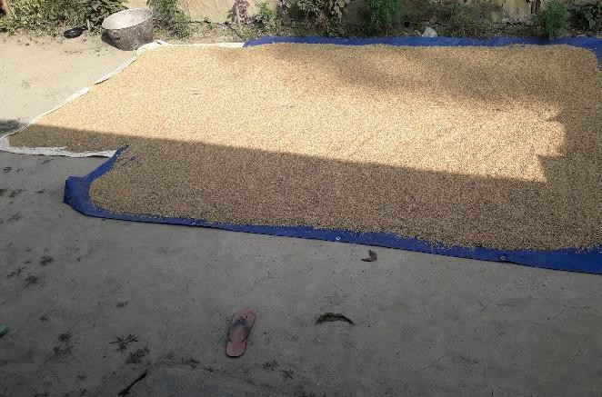
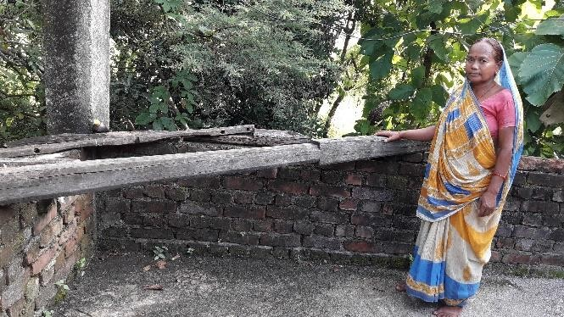
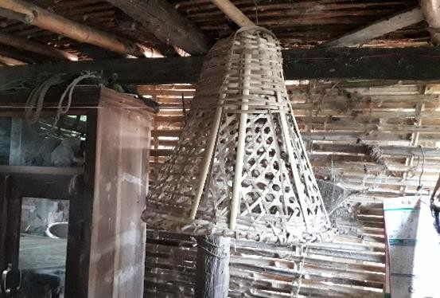
Indigenous animal driven vehicle (Bael gaadaa)
Farmer crushing grain in Jaato
Indigenous wood storage (Sanduk)
Sun drying of rice grains
Indigenous foot grain milling machine
Bamboo made Doko

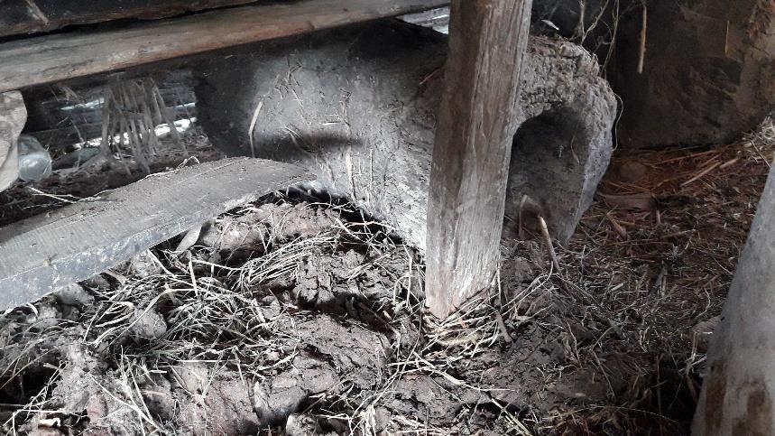
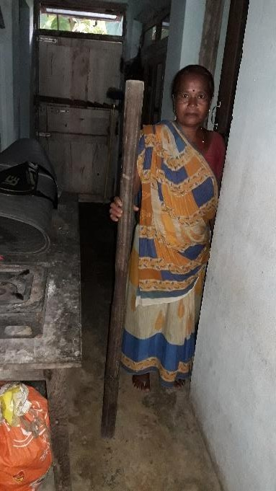
Indigenous hand grain milling machine (Okhal)

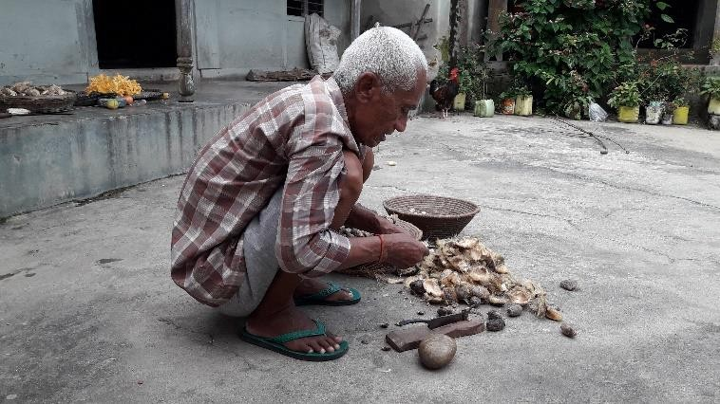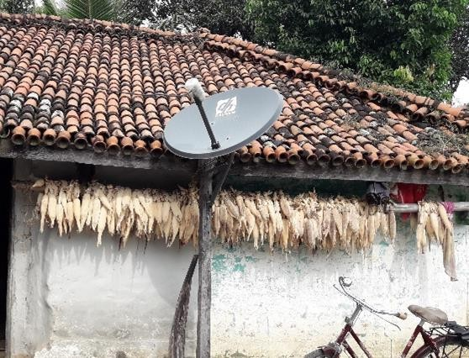
Mannual removing of Areca nut (Supaadi)
Storing maize cobs by hanging on frame

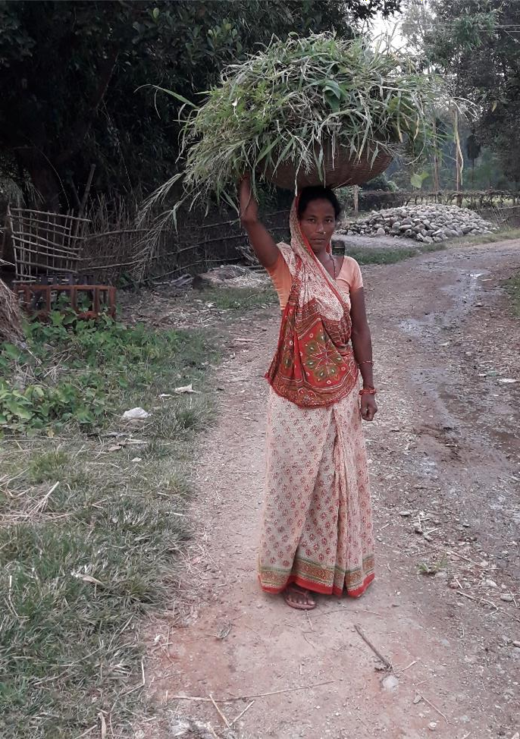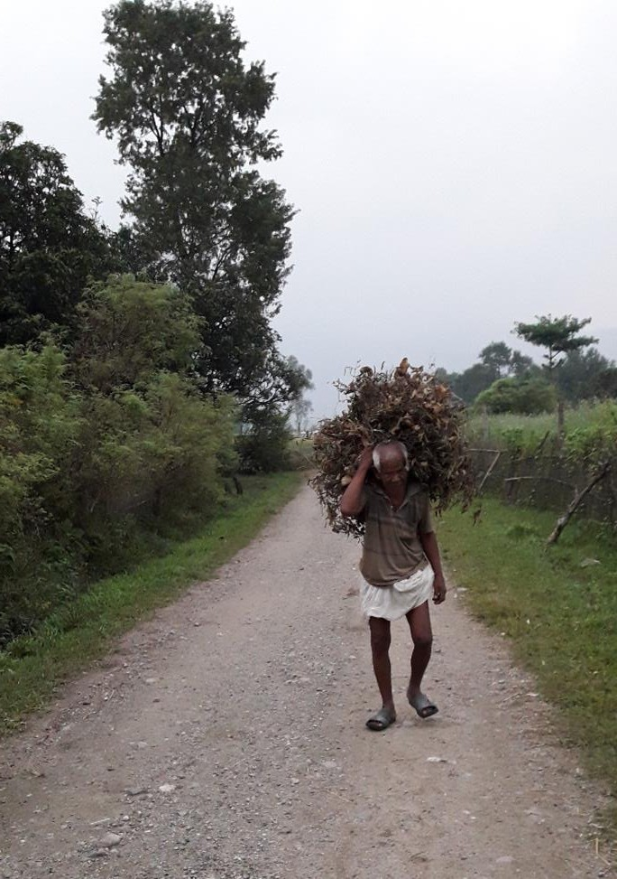
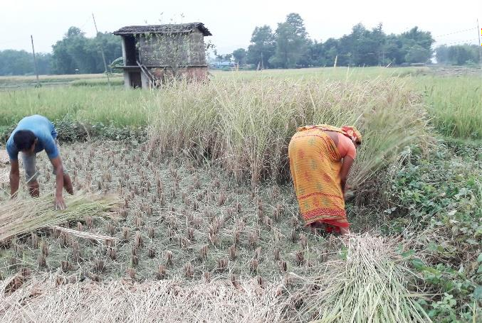
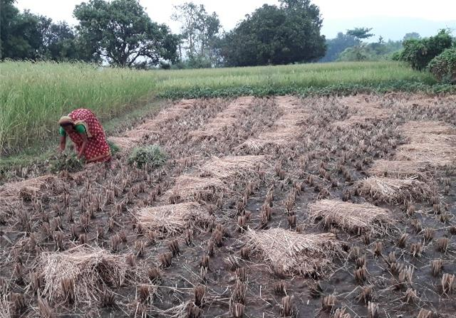
A Tharu man carrying Lathyrus on his
back
A Tharu women carrying grass in
Dhakiya
Local farmer harvesting
Sun dried harvested paddy ready to take home

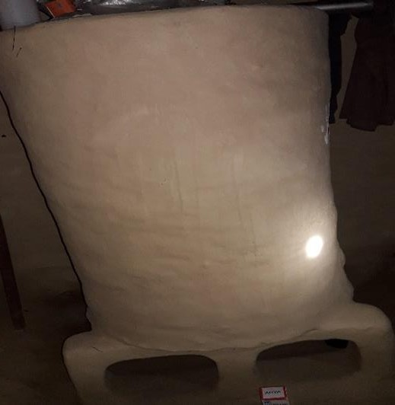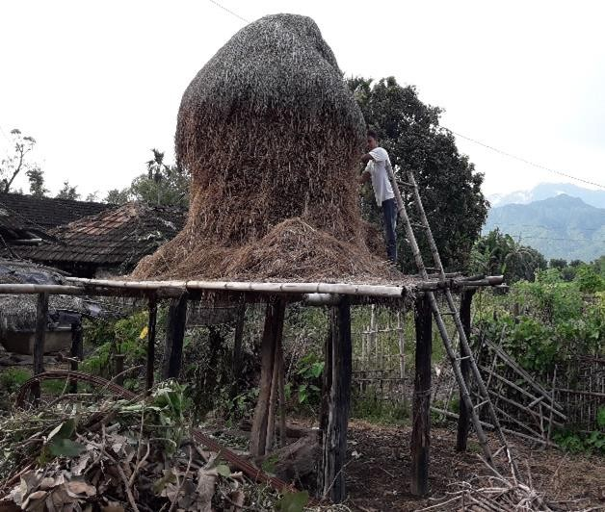
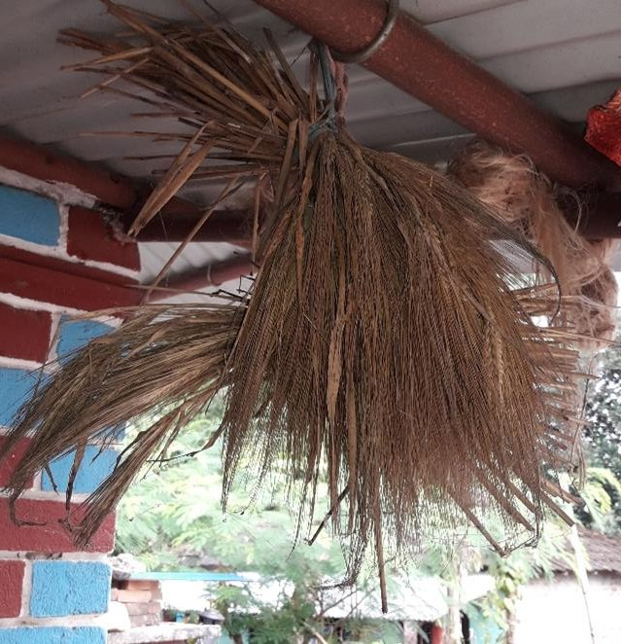
Indigenous clay grain/seed storage
Indigenous straw storage (Chhaat)
Barley (Jaun) stored in bundle

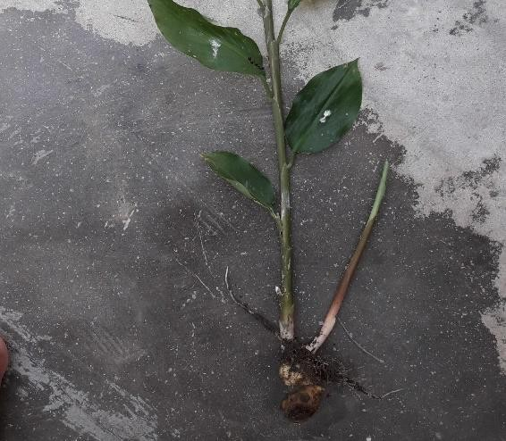
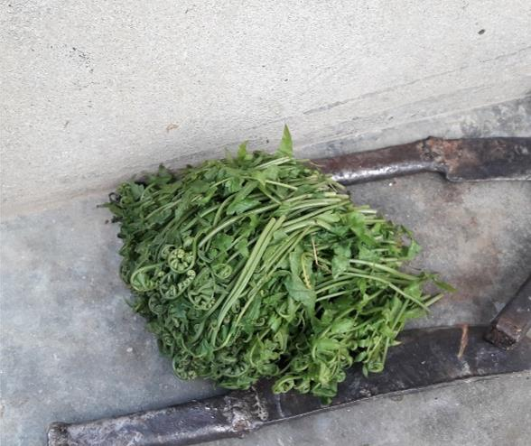
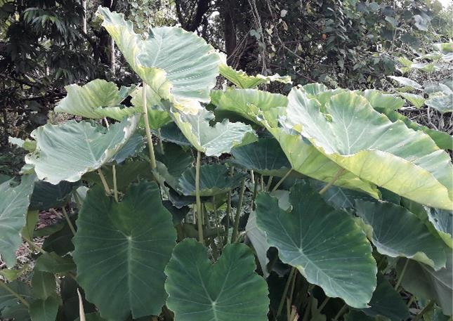
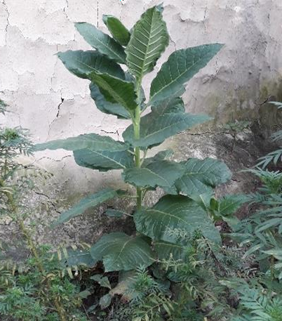
Appendix 2. Some Indigenous and Underutilized Crops utilized by respondents of Triyuga municipality in 2020
Wild ginger plant (Swostha saag)
Edible wild fern (Dhakiya saag)
Taro in home garden (Kacchu)
Tobbacco (Surti)

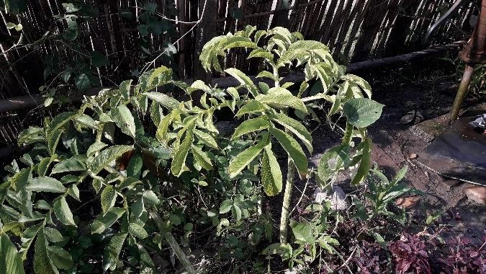
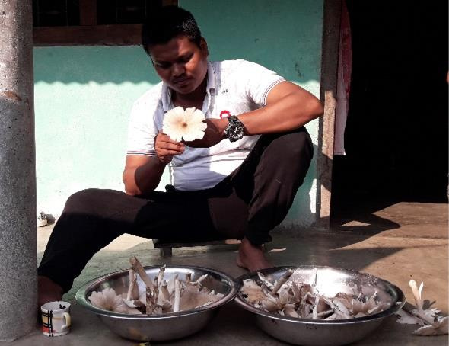
Elephant foot yam at home garden
Farmer observing wild collected mushroom

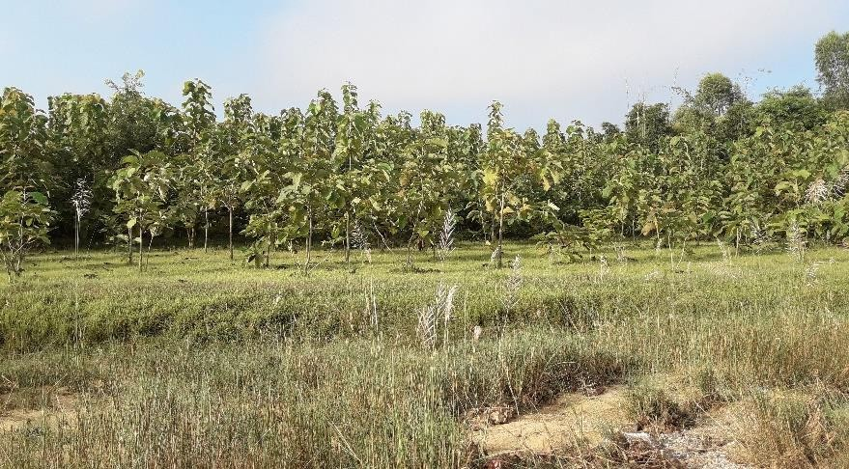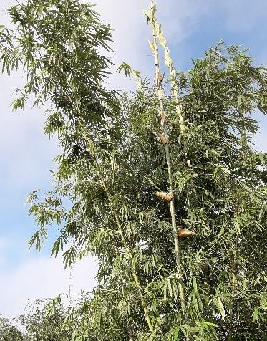
Teak tree orchard
Bamboo trees

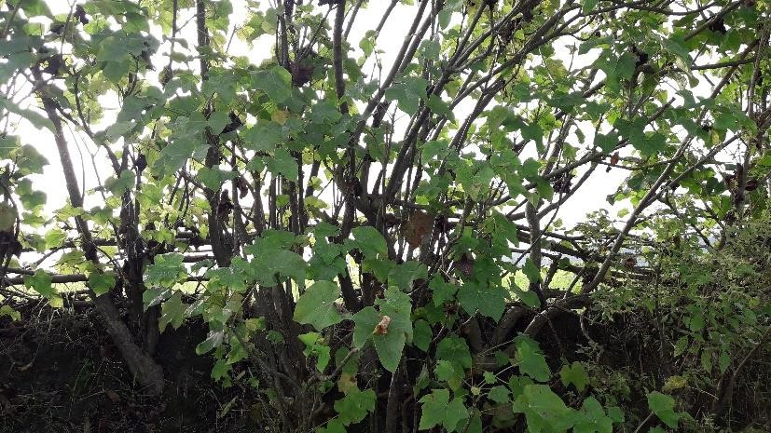
Jatropa plant used as bund barrier

Appendix 3. Some indigenous tools used by respondents of Triyuga Municipality in 2020
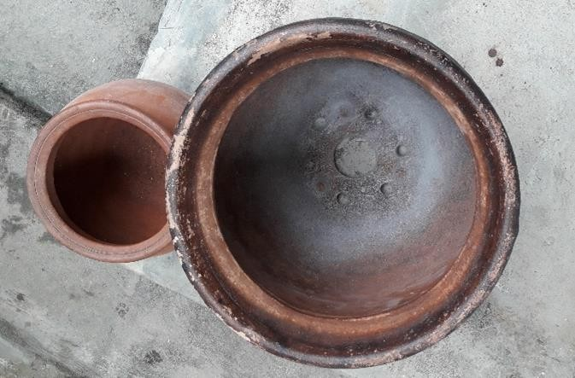
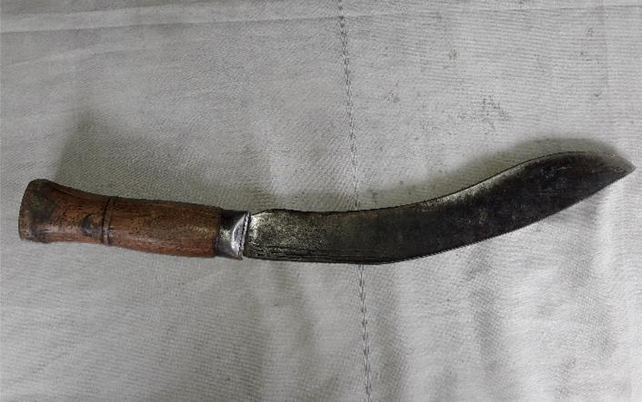
Indigenous acohol making tool (Atani)
Indigenous knife (Khukuri/Dabiyaa)

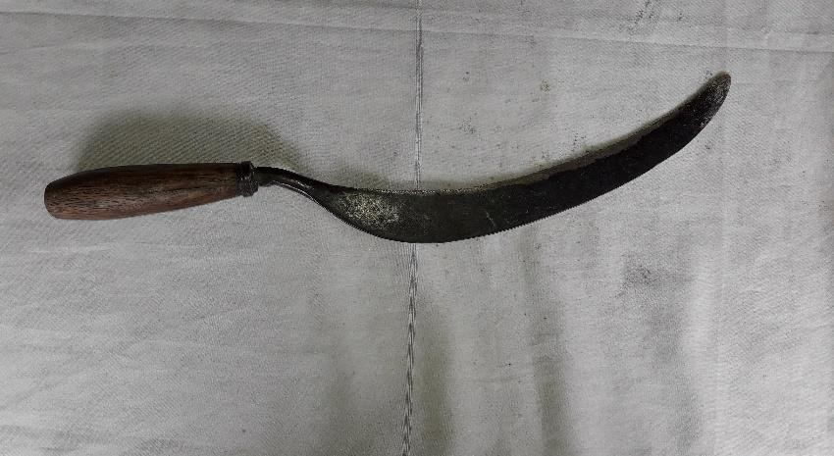
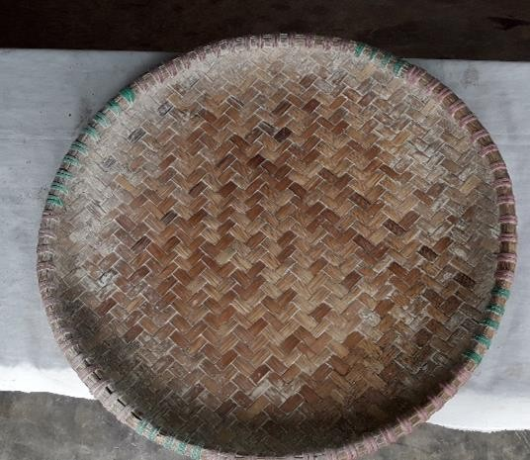
Indigenous serrated knife (Haansu)
Winnower (Supa/Naanglo)

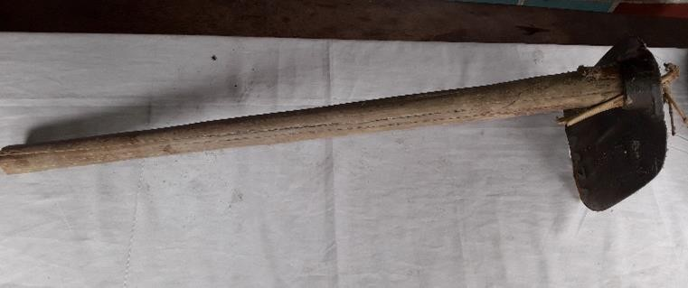
Desi hoe ((Kodaalo/Kodaair)

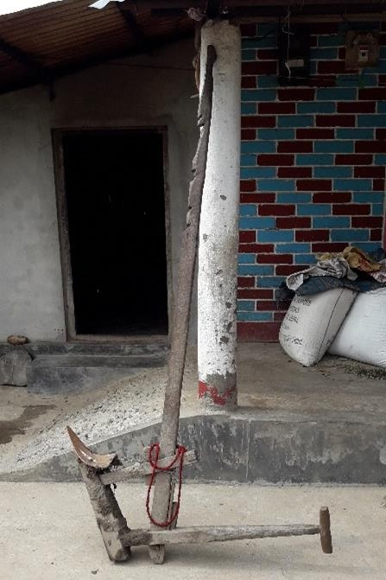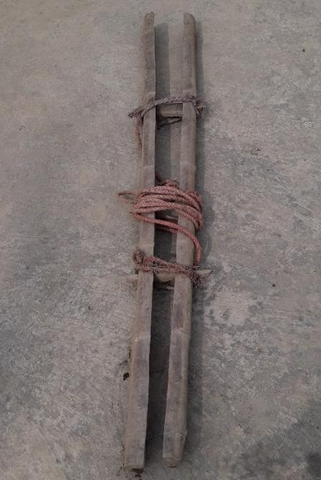
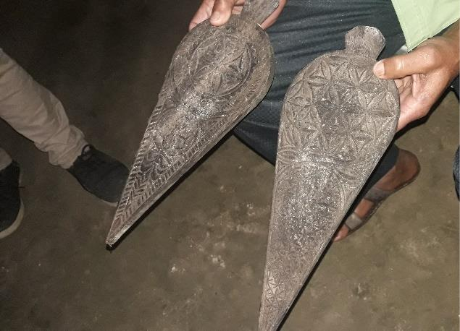
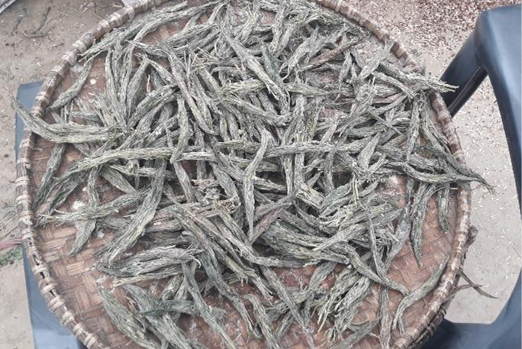
Local Plough
Plough component
Thekuwa making Indigenous tool
Adauri made of Lathyrus leaves

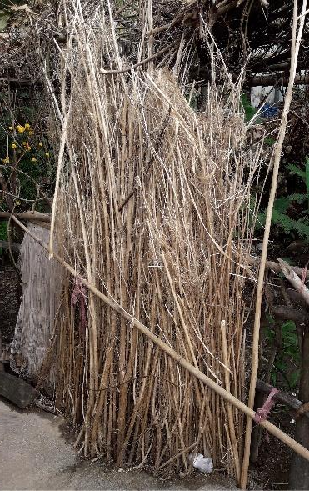
Appendix 4. Some locally grown crops grown at crop field of respondents of Triyuga Municipality in 2020
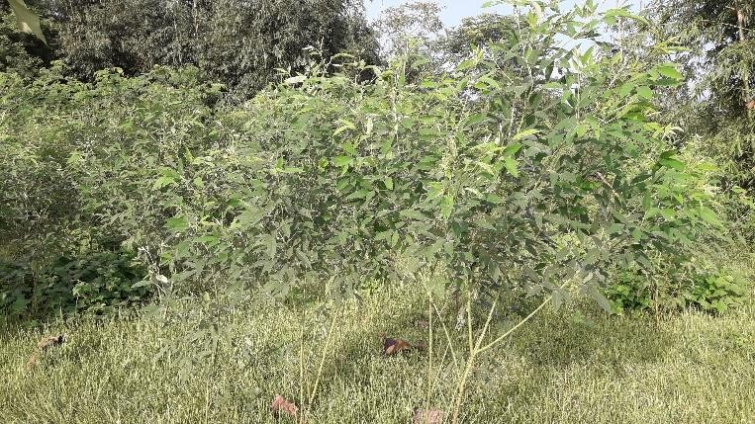
Pigeon pea in marginal land
Retted and sun dried jute stalk (Shanthi)

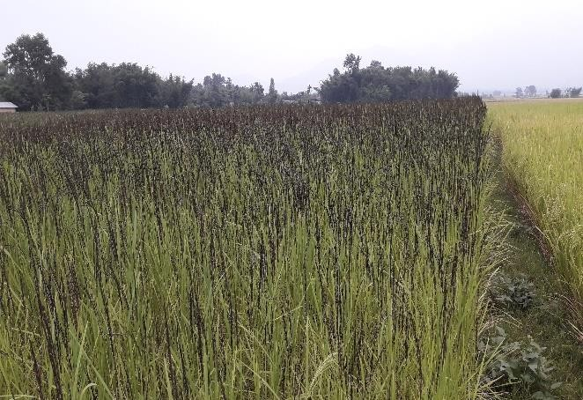
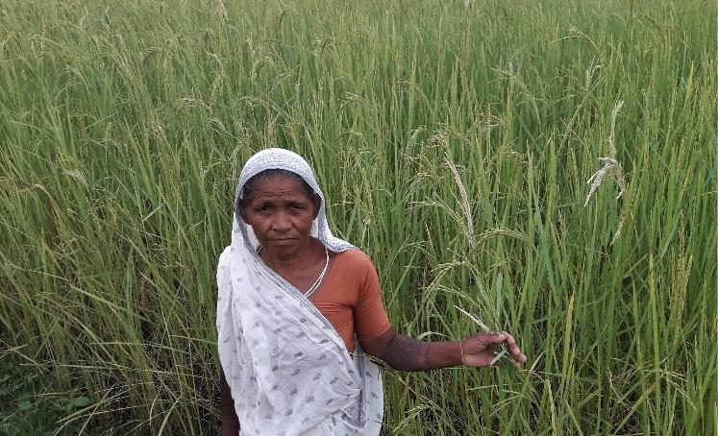
Black Basmati (Karya Baasmati) rice
Local farmer showing White basmati rice

Appendix 5. Some indigenous building structure utilized by respondents of Triyuga municipality in 2020
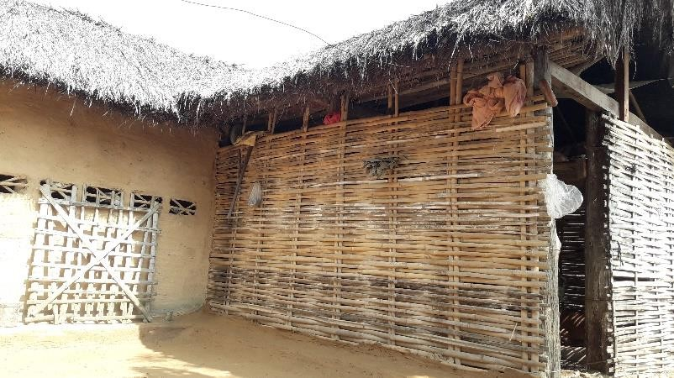
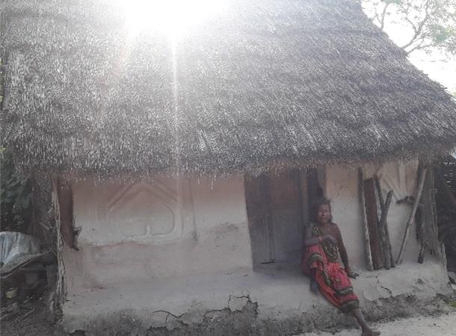
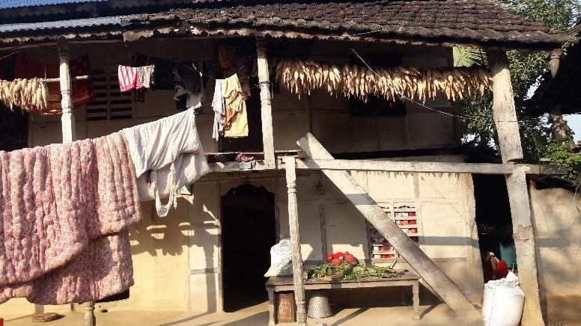
Bamboo house with thatch roof
Old clay house with thatch roof
Wooden house with clay tiles roof

