Supplementary Material

Supplementary Table 1. Ambient dry-ball and wet-bulb temperatures at different processing stages during sampling.

Supplementary Table 2. The alpha diversity index of ITS sequencing samples

Supplementary Table 3. Alpha diversity index of 16S rDNA sequencing samples
Supplementary Table 4. Permanova results of 16S rDNA sequencing samples
Supplementary Table 5. permanova results of ITS sequencing samples
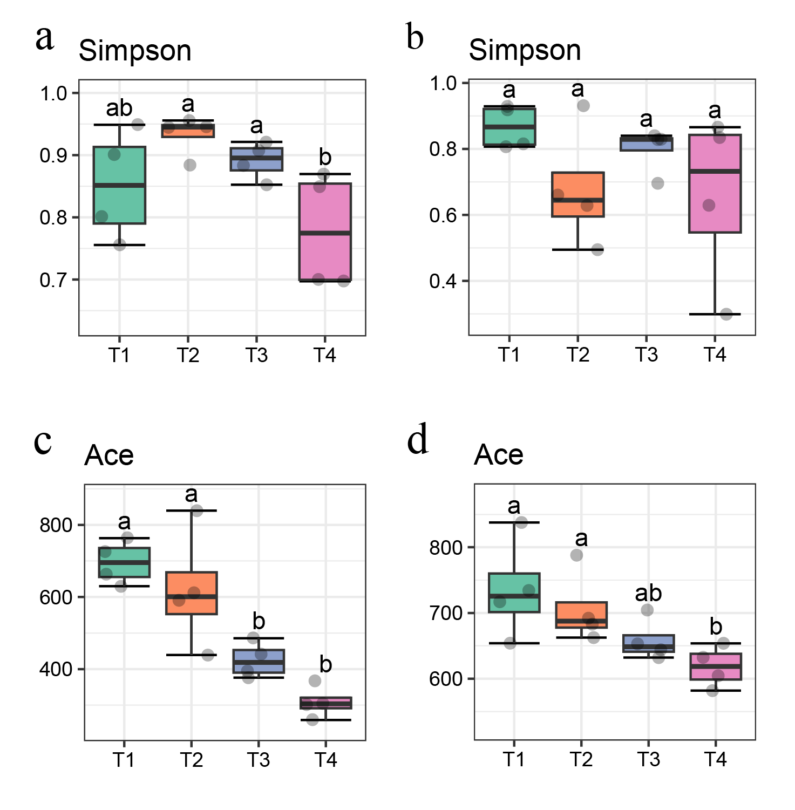
Supplementary Figure 1. Comparison of microbial community diversity at different stages. Simpson (a), Ace (c) diversity box plot, and Wilcox test for 16S rDNA sequencing samples, Simpson (b), Ace (d) diversity box plot, and Wilcox test for ITS sequencing samples
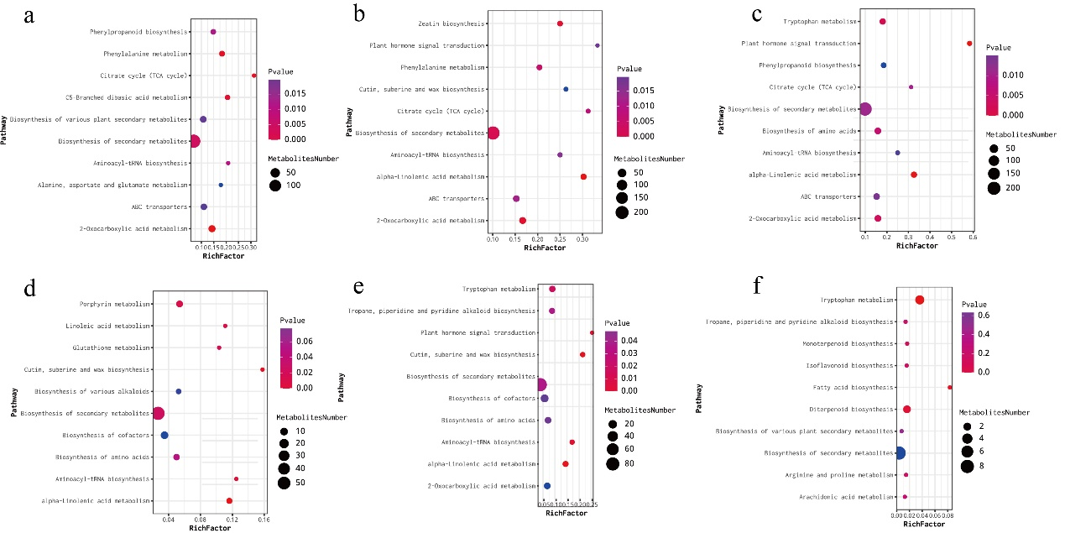
Supplementary Figure 2. KEGG pathways significantly enriched in the four stages. (a)T1 vs T2, (b)T1vs T3, (c)T1 vs T4, (d)T2 vs T3, (e)T2vs T4, (f)T3 vs T4. The degree of enrichment was measured by RichFactor, p-value, and the number of differential metabolites enriched in each KEGGPathway. The RichFactor is the number of differential metabolites annotated to the Pathway divided by the number of all metabolites in the Pathway. The larger the value, the greater the proportion of differential metabolites annotated to the Pathway. Dot size represents the number of differential metabolites annotated to this Pathway.

