Table 1. Definition of variables
Variable | Definition
Hypertension | History of hypertension and use of antihypertensive medication; systolic blood pressure ≥130 mmHg and/or diastolic blood pressure ≥80 mmHg on three occasions at rest after admission to hospital and diagnosed as hypertensive by the cardiology department.
CAD | History of coronary artery disease; clinical symptoms, cardiac ultrasound, coronary angiography or elevated cTnT or cTnI after admission to hospital and diagnosis as coronary artery disease by cardiology department.
Diabetes | History of diabetes mellitus and use of glucose-lowering medication; hospitalized and diagnosed with diabetes mellitus by endocrinologist department [1]
Stroke | History of stroke or CT or MRI findings of stroke after admission to hospital
Lung diseases | History of asthma, COPD, lung infections, bronchitis, and interstitial lung changes; Coughing and sputum on admission to hospital and the presence of lung disease was confirmed after respiratory medicine department
Hypoxemia | Preoperative arterial blood gases with partial pressure of oxygen between 80 and 60 mmHg
Hypercapnia | Carbon dioxide partial pressure in preoperative arterial blood gas >40 mmHg
Hepatic insufficiency | alanine aminotransferase＞35IU/L and aspartate aminotransferase>30IU/L
Hypoproteinemia | Albumin between 35-30g/L
Renal insufficiency | Previously diagnosed with renal insufficiency, creatinine greater than 120 µmol/L or glomerular filtration rate between 30-80 ml/min on admission and diagnosed with renal insufficiency after consultation with an endocrinologist
Intraoperative hypothermia | The patient's core body temperature is less than 36°C during surgery.
Intraoperative hypotension | Intraoperative systolic blood pressure <90 mmHg and/or mean arterial pressure <60 mmHg for 5 minutes
natural cavitation | Transurethral resection of bladder tumor, transanal endoscopic surgery, hysteroscopic surgery, endoscopic submucosal dissection.
Others surgery | Stripping of great saphenous vein，Axillary lymph node dissection.
PACU rescue non-opioid analgesics | Tramadol was administered to patients when the NRS score ≥4 following extubation in the PACU.
PACU rescue non-opioid analgesics | If patients continued to exhibit an NRS score of 4 or higher following tramadol administration, 5 μg of fentanyl was subsequently administered in the PACU.
[1] ElSayed NA, Aleppo G, Aroda VR, Bannuru RR, Brown FM, Bruemmer D, et al. 2. Classification and Diagnosis of Diabetes: Standards of Care in Diabetes-2023. Diabetes care. 2023;46:S19-s40.

Table2. Definition of PPCs
PPCs | Definition
Postoperative pneumonia | The patient has received antibiotics for suspected respiratory infection and met one or more of the following criteria: new or changed sputum, new or changed lung opacities, fever, white blood cell count >12×10⁹/L
Postoperative hypoxemia | Postoperative PaO2 <8 kPa (60 mm Hg) on room air, PaO₂:FiO₂ ratio <40 kPa (300 mm Hg), or arterial oxyhemoglobin saturation measured with pulse oximetry <90% and needing oxygen therapy
Pleural effusion | Chest radiograph showing blunting of costophrenic angle, loss of sharp silhouette of ipsilateral hemidiaphragm in the upright position, evidence of displacement of adjacent anatomical structures, or (in supine position) hazy opacity in one hemithorax with preserved vascular shadows.
Atelectasis | Lung opacification with the shift of mediastinum, hilum, or hemidiaphragm towards the affected area, and compensatory over-inflation in adjacent non-atelectatic lung
Pneumothorax | Air in pleural space with no vascular bed surrounding visceral pleura
Note: Postoperative pneumonia and hypoxemia were diagnosed by the surgeon, while pleural effusion, atelectasis, and pneumothorax were identified by the imaging physician based on radiological findings.

Variables | GVIF | Df | GVIF^(1/(2*Df))
ASA | 1.402 | 2 | 1.088
STOP-Bang scores≥3 | 1.087 | 1 | 1.043
Hypertension | 1.138 | 1 | 1.067
Diabetes | 1.071 | 1 | 1.034
Stroke | 1.081 | 1 | 1.04
Lung diseases | 1.023 | 1 | 1.012
Alcohol abuse | 1.009 | 1 | 1.005
Hypoxemia | 1.043 | 1 | 1.021
Hepatic insufficiency | 1.02 | 1 | 1.01
Hypoproteinemia | 1.024 | 1 | 1.012
Anesthesia method | 1.052 | 1 | 1.026
Intraoperative hypothermia | 1.009 | 1 | 1.005
Intraoperative hypotension | 1.011 | 1 | 1.005
Age | 1.374 | 1 | 1.172
BMI | 1.078 | 1 | 1.038
Intraoperative bleeding | 1.011 | 1 | 1.005
Time of last of sufentanil | 1.031 | 1 | 1.023
Table 3. VIF plot of risk factors for the RD in PACU (VIF: variance inflation factor)

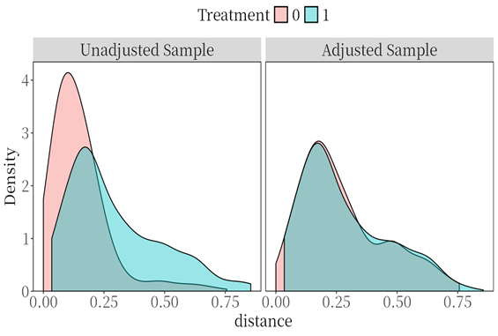
Figure 2. Plot of distributional balance for distance in PSM（0:no respiratory depression;1：respiratory depression）

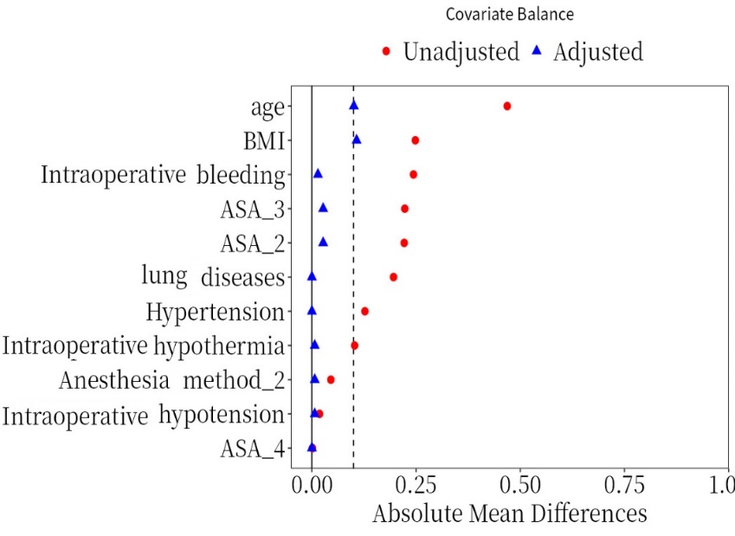
Figure 3. Plot of covariate balance in PSM

Table 4. VIF plot of effect of RD in PACU on PPCs (VIF: variance inflation factor)
Outcomes | VIF
Unplanned transfer to ICU (%) | 1.041
PPCs (%) | 4.972
Postoperative pneumonia (%) | 2.344
Postoperative hypoxemia (%) | 1.197
Pleural effusion (%) | 1.892
Atelectasis (%) | 3.032
Average length of stay(days) | 1.062

