Appendix 4: Number of factors to extract
Table 1: Minimum average partial correlation of principal components
Minap | Number of factors | average partial correlation
m=0 | f=0 | 0.27045299
m=1 | f=1 | 0.02465678
m=2 | f=2 | 0.0224226
m=3 | f=3 | 0.02400917
m=4 | f=4 | 0.003006254
Minap – Velicer’s minimum average partial correlation suggests 2 factors to extract (average partial correlation 0.022)
Figure 1: Scree plot of eigenvalues
The scree plot seen in figure 1 shows eigenvalues before rotation. This figure suggests a 1 factor-solution.
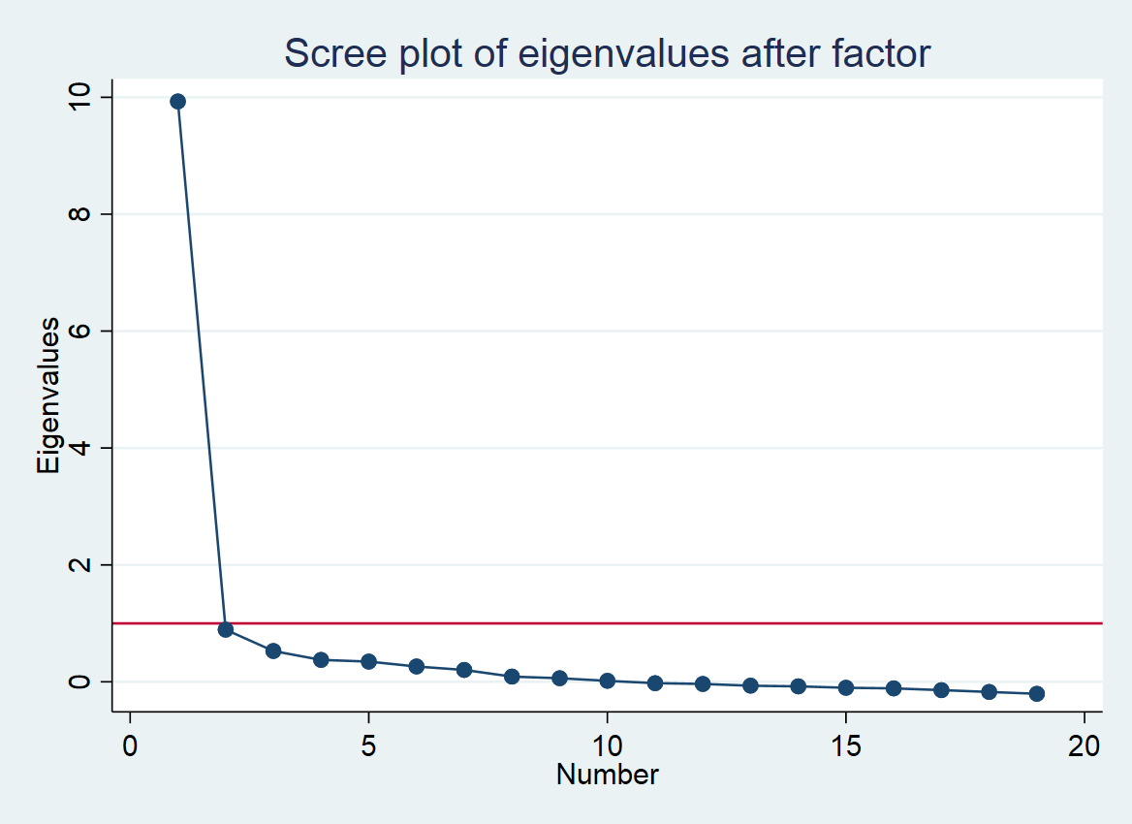

Figure 2: Parallel analysis
The parallel analysis depicted below suggests extracting 2 factors.
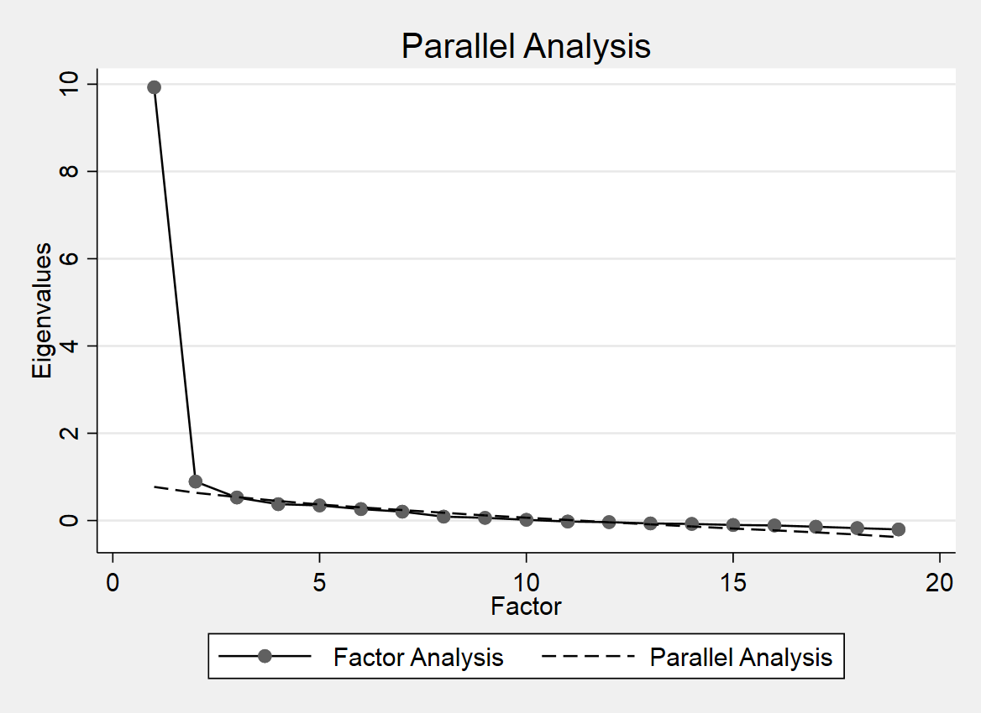

Minus fit correlation matrix
After rotation and removal of items “waiting times” and “know story”. Approximately 7% of the items have values greater than 0.05 in the minus fit correlation matrix (estat residuals).

