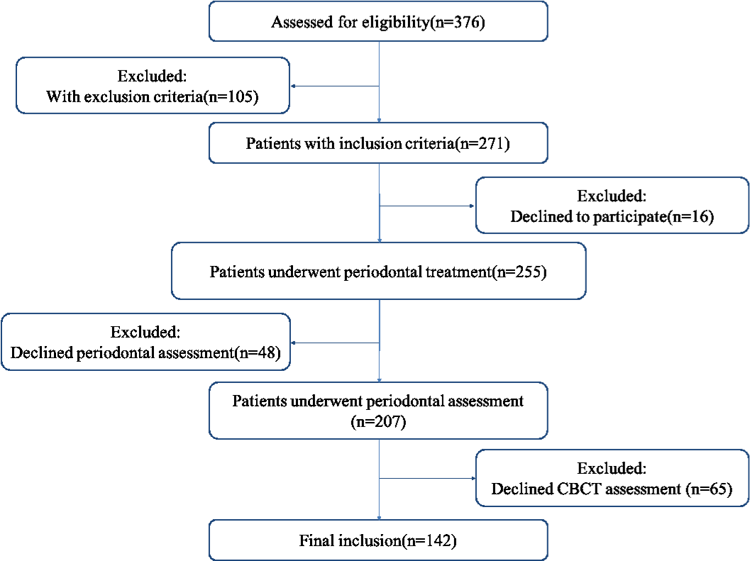
Supplementary figure 1: Flowchart of the number of patients enrolled

