Climate change has increased genotype-environment interactions in wheat breeding

Wei Xiong¹, Matthew P. Reynolds², Jose Crossa², Thomas Payne², Urs Schulthess³, Kai Sondor⁴, Nicoletta Addimando⁵, Ravi P. Singh², Karim Ammar², Bruno Gerard¹

¹ Sustainable Intensification Program, International Maize and Wheat Improvement Center
² Global Wheat Program, International Maize and Wheat Improvement Center
³ CIMMYT-Henan Innovation Center, Henan Agricultural University, Zhengzhou, 450000, China
⁴ Social-Economical Program, International Maize and Wheat Improvement Center
⁵ Meteoblue AG, Basel, Swchitzerland.

Supplementary Materials:
Supplementary Method
Supplementary Figures [S1- S8]
Supplementary Tables [S1 – S3]
Supplementary References

Supplementary Method
Weather data
The input weather data used in the present work were provided by Meteoblue, a Swiss specialist company producing high precision weather data for the entire world. They provide adapted weather data for the needs of different user groups by using observation data, high-resolution Numerical Weather Predictions (NWP), and specialized data output methods (Meteoblue, 2008).
The weather variables used in this study were generated from ERA5, a global reanalysis dataset in 30 km resolution, providing consistent data sequences since 1980, in hourly to 3-hourly intervals. ERA5 was produced using 4DVar data assimilation in CY41R2 of ECMWF’s Integrated Forecast System (IFS), with 137 hybrid sigma/pressure (model) levels in the vertical, with the top level at 0.01 hPa. Atmospheric data are available on these levels and they are also interpolated to 37 pressure, 16 potential temperature and one potential vorticity level(s). "Surface or single level" data are also available, containing 2D parameters such as precipitation, 2m temperature, top of atmosphere radiation and vertical integrals over the entire atmosphere (ECMWF, 2013).
The weather variables used are site specific daily values, including
- Temperature: it is referred to 2 meters above the ground and expressed in degrees Celsius (°C), including Daily maximum and minimum values for each site.
- Solar radiation: amount of total short-wave radiation energy reaching the horizontal Earth surface. Daily sum values are at surface level for each site and expressed in watt per square meter (W/m²).
- Precipitation: deposition of water to the Earth's surface, in form of rain, snow, ice or hail. It is expressed in millimeters (mm) of liquid water. Values for each site are daily sums at Earth’s surface level.
- Vapor pressure deficit (VPD): the difference between the saturation vapor pressure and the actual pressure of the water vapor in the air.
It is derived from temperature and relative humidity, according to Wexler formula (Wexler, 1976):
$$VPD={vp}_{sat}\left(1-\frac{RH}{100}\right)$$
Where:
$${vp}_{sat}=saturation vapor pressure \left[hPa\right] = 0.01e^{-2991.27 T^{-2}-6017.01 T^{-1}+18.88-0.03T+0.18e^{-4}T^{2}-0.84e^{-9}T^{3}+0.44e^{-12}T^{4}+2.86log⁡(T)}$$T = Temperature [K]
RH = relative humidity [%]
VPD is expressed in hectopascal (hPa) and is provided for each site as the daily mean value at 2 m above ground.
- Relative humidity: percent (%) of air saturated with moisture, with daily mean values at 2m above ground.
- Wind speed: the rate at which air is moving horizontally. It is in a unit of kilometers per hour (km/h) as a daily mean value, referred to 10 m above ground.
All variable aggregations (sums, averages, maxima, or minima) are calculated backward in time. Data quality was conducted by comparing the data with actual measurement in nearby observations, with quality verification results are available on meteoblue website (Meteoblue, 2008).

Yield variation – climate regression model
A regression between yield variation and climate factors was conducted separately for each combination of genotype, trial, and year. Yield variation ($y_{ijk}^{'}$) of genotype i in environment j at year k is $y_{ijk}-(μ_{k}+G_{ik}+E_{jk})$ , in which $μ$ is the grand mean, G and E are the genotypic and environmental effects, respectively. The climate vector included maximum and minimum temperature, shortwave radiation, vapor pressure deficit, relative humidity, and wind speed, split into three growing stages - vegetation (sowing-heading), reproduction (heading-flowering), and grain filling (flowering – maturity). The quadratic terms for each climatic variable were also included to take into account the non-linear effects.
In total, there were 36 climatic predictors, whilst many predictors exhibited insignificant (p<0.05) correlation to yield variation. We therefore used a L1 regularization method, namely Lasso regression (Least Absolute Shrinkage and Selection Operator) to obtain a best subset of predictors that minimizes prediction errors (Tibshirani 1996). Comparing to standard linear regression, the Lasso Regression adds “absolute value of magnitude” of coefficient as a penalty term to the loss function as equation (1), imposing a constraint on the model parameters that causes regression coefficients for small affecting factors to shrink toward zero.
$\sum_{i=1}^{n}{{(Y_{i}-\sum_{j=1}^{p}{X_{ij}β_{j}})}^{2}}+λ\sum_{j=i}^{p}{|β_{j}|}$ (1)
If $λ$ is zero the regression goes back to standard linear model, while large value of $λ$ will make model more coefficients zero, likely cause underfitting. We tested a range of values of $λ$ (10, 1, 0, 0.1, 0.01, 0.001) and evaluated its impacts on the prediction. A final value of 0.1 was chosen because of the reasonable R² between real and modeled yield variation, and also between the actual and simulated final yield after replacing the GEI component of equation (1) in the main text by the model.

Estimate missing heading date for sites
To untangle genotypic and environmental effects on GEI, we applied the equation (5) in the main text for all line-location-years combinations with climate variables of the trials. The climatic variables in each trial and year were identical across genotypes, estimated from the daily weather, and median of reported phenologies (sowing, heading, and maturity) across years. Whereas for HTWYT, roughly 20% of the sites lack observation of heading date, obstructing the computation of climatic variables. We therefore estimated the heading date (h) for those sites by growing-season mean temperature ($T_{j}$) and genotypes’ mean degree-day requirement for heading ($GDD$). Previous study indicated crop phenologies are also impacted by management, such as day of sowing (Wu et al, 2020). To take into account the effects of management, we added the day of sowing (DOS) into the regression, leading to a model (2).
$h_{j}=α+β_{1}×T_{j}+β_{2}×GDD+β_{3}{×DOS}_{j}$ (2)
The model was trained by historical data that has observations, the R² between real and modelled heading date is over 0.8.

Supplementary Figures
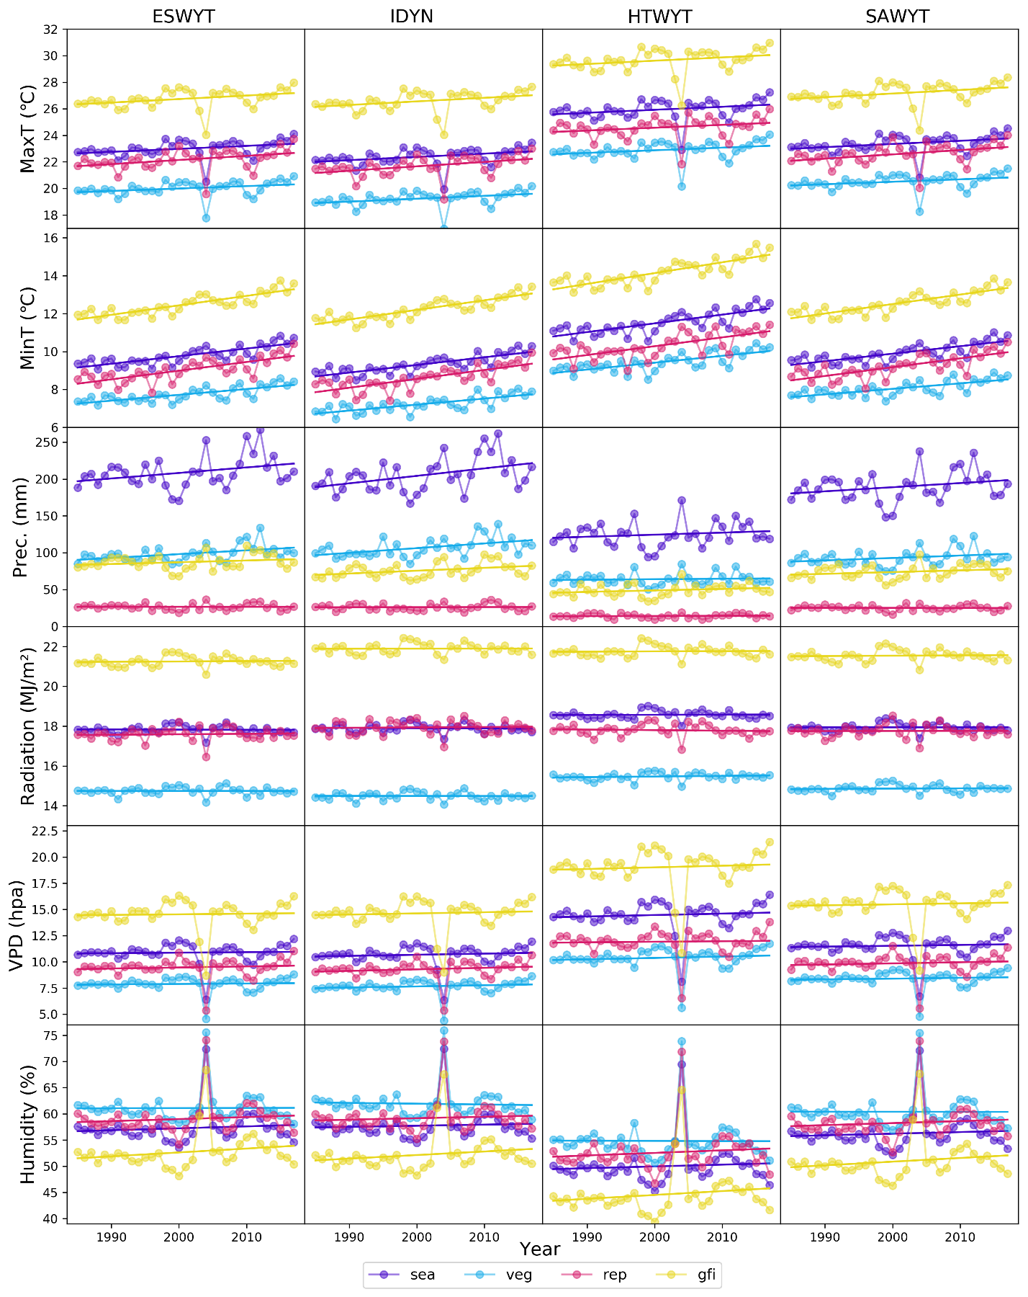
Figure S1. Changes in the six climatic variables averaged across testing sites in wheat growing season and the three stages (sea. Growing season; veg. vegetative; rep. reproductive; gfi. grain filling).
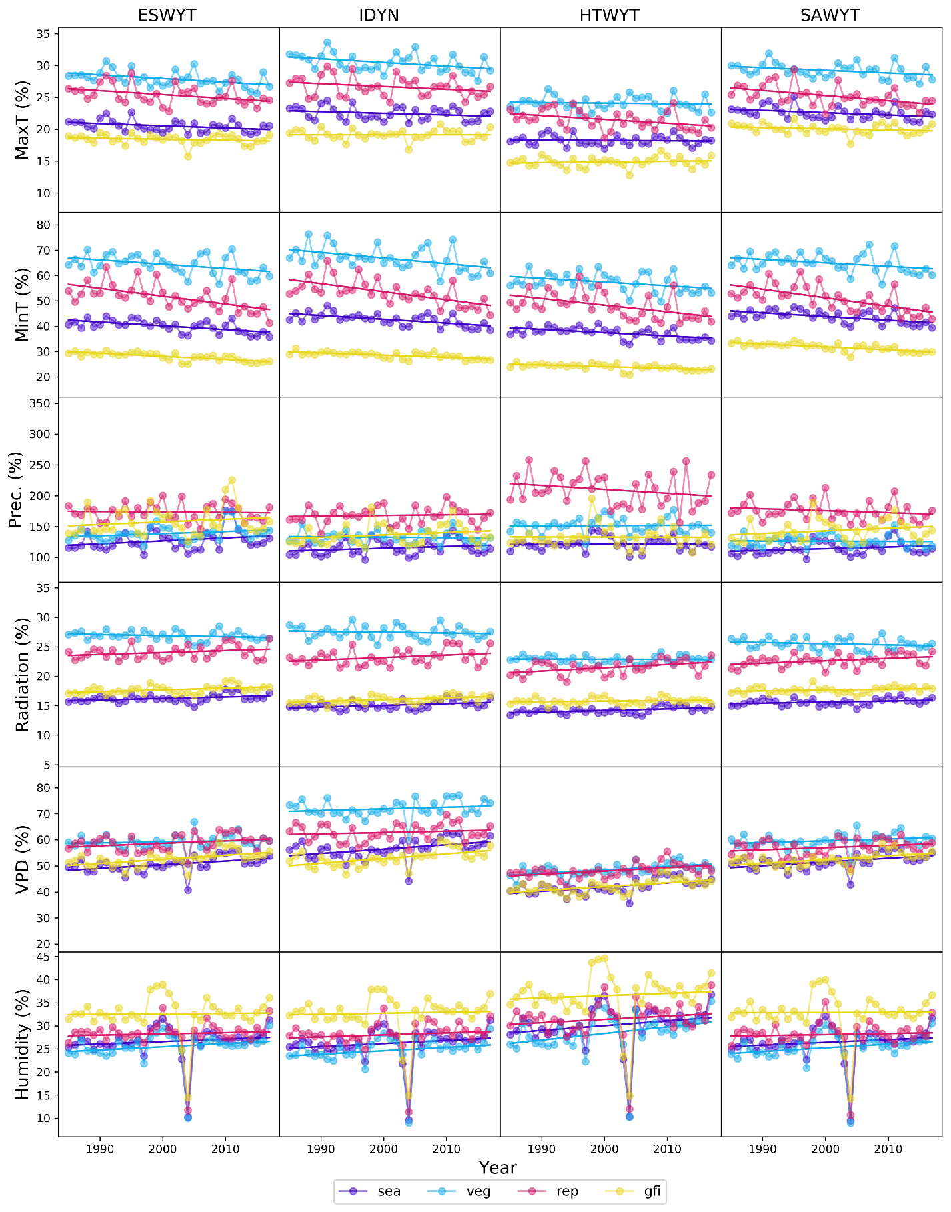
Figure S2. Changes in the variation of the six climatic variables among the sites represented by coefficient of variability. Growing stage abbreviations are as in Figure S1.

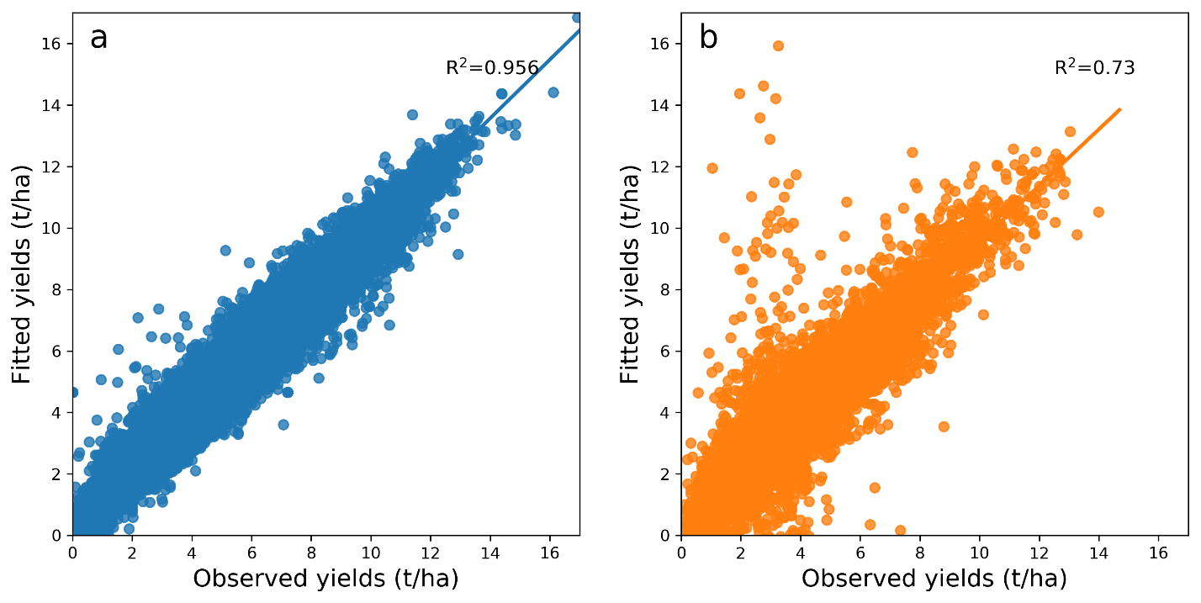
Figure S3. Yield prediction by model 3, in which climate is used as the only factor to predict G$×$E. (a) Model performance with training data (90% of the datasets); (b) Model performance with testing data (10% of the datasets).

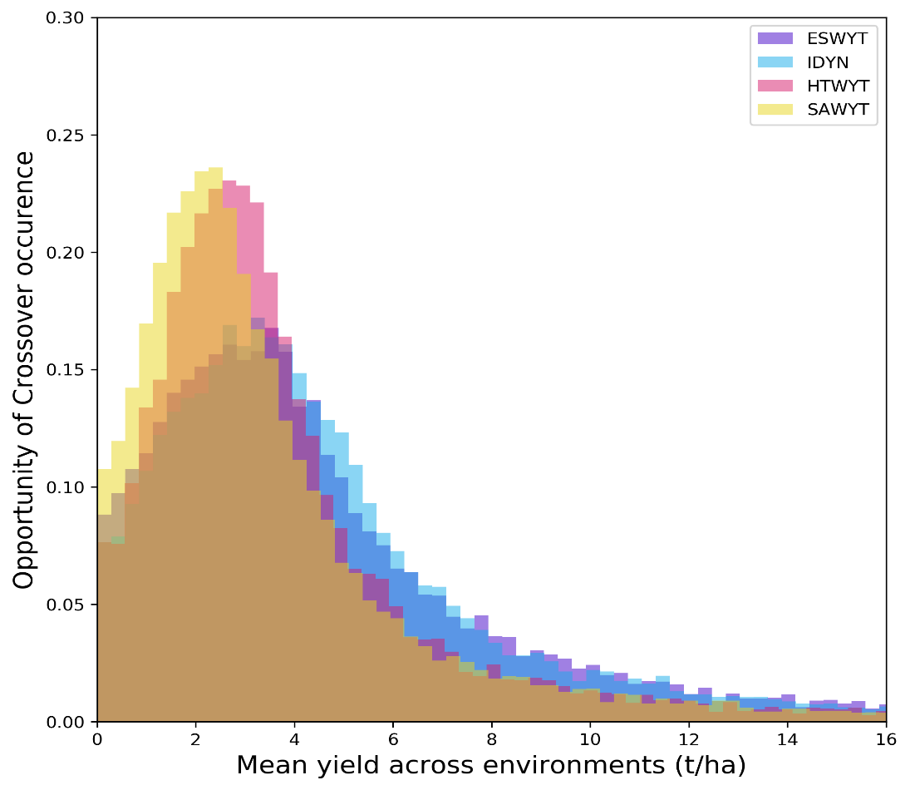
Figure S4. Possibility distribution of crossover occurrence across environments.

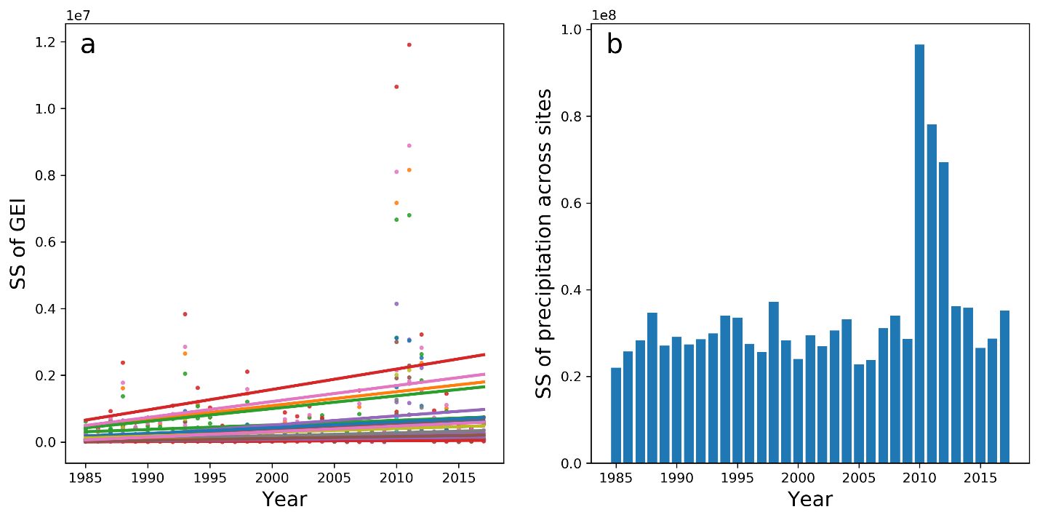
Figure S5. Extreme values of GEI and association with climate variable. (a) Modeled sum of square of GEI for different line groups; (b) sum of square of growing-season precipitation across all ESWYT sites. Only show data of ESWYT.

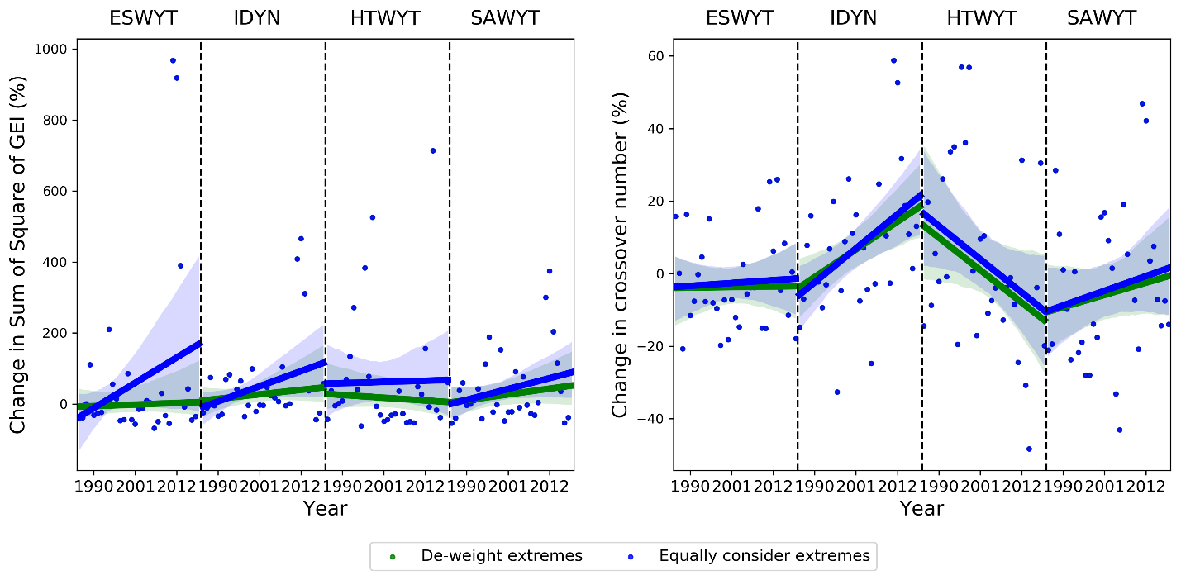
Figure S6. Estimated changing trends due to climate change by de-weighting extreme vs. equally considering extremes. (a) Changes in modeled sum of square of GEI; (b) Changes in modeled number of crossovers. Only means across all line groups are shown.

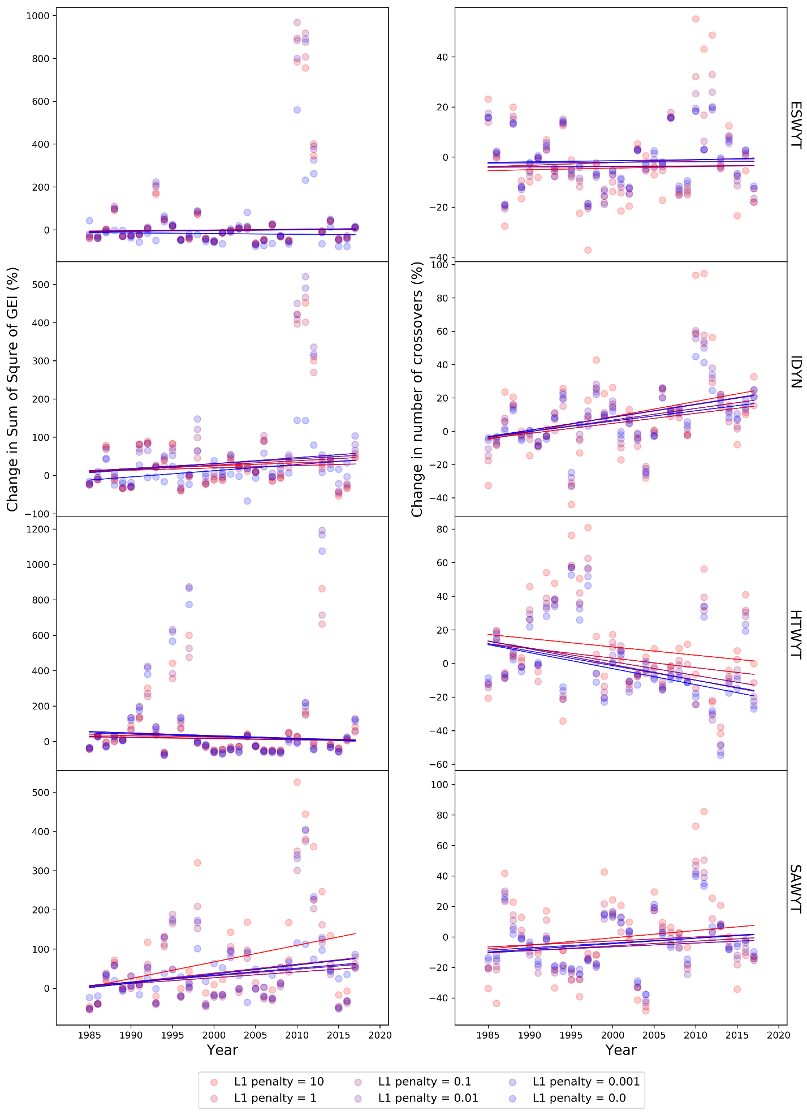
Figure S7. Results sensitivity to choosing of yield variation – climate relationship models. The left panel indicates the change of sum of square of GEI, while the right represents the change of crossover number. Plots from top to bottom denote results from ESWYT, IDYN, HTWYT, and SAWYT.

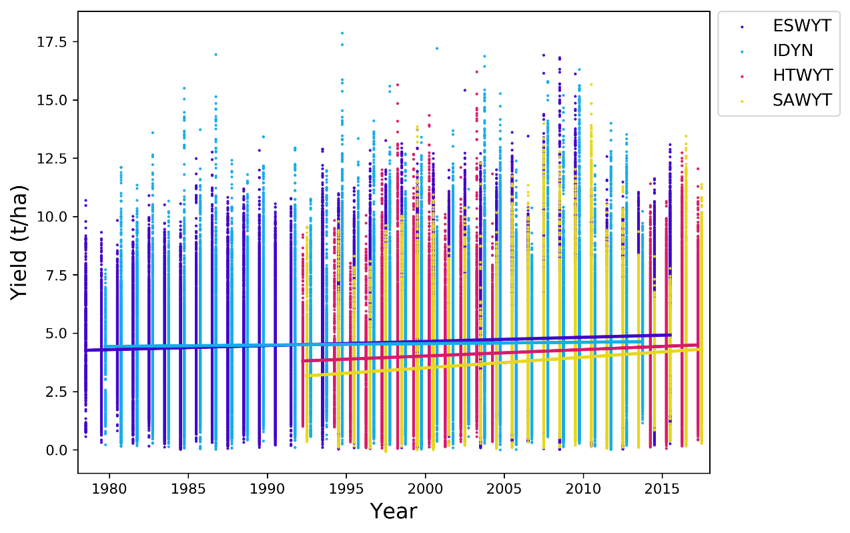
Figure S8. Reported wheat yield and changing trends for each of the four nurseries.

Supplementary Tables
Table S1. Summary table of the four spring wheat trials in the International Wheat Improvement Network (IWIN).
Nursery name | Breeding goals | Years | Number of genotypes | Number of testing sites | Notes
ESWYT - the Elite Spring Wheat Yield Trials | High-yielding in ideal environment and management | 1979 - 2016 | 20 (1986), 30 (1979 - 1985, 1987 - 1993), 50 (1994 - 2016) | Varying from 17 (1979) to 97 (2000), with a mean of 66 and a total of 537
IDYN - the International Durum Yield Nursery | High-yielding for durum wheat | 1980 - 2017 | 25 (1987 - 1994), 30 (1980 - 1986), 50 (1995 - 2017) | Varying from 8 (1980) to 61 (2001), with a mean of 45 and a total of 357
HTWYT - The High Temperature Wheat Yield Trial | High temperature under irrigated environment | 1992 - 2017 | 30 (1992 – 1995, 2003), 35 (2001), 40 (2004), 45 (1998, 2000), 50 (1996 – 1997, 1999, 2002 – 2003, 2014 – 2017) | Varying from 13 (1996) to 68 (2015), with a mean of 26 and a total of 241 | No data for 2005 – 2013
SAWYT - The Semi-Arid Wheat Yield Trial | Maintain yields under dry conditions | 1992 - 2017 | 30 (1992), 35 (1994), 40 (1995), 50 (1996 - 2017) | Varying from 9 (2003) to 75 (2009), with a mean of 41 and a total of 342

Table 2. Performance of the yield variation - climate models in predicting GEI and number of crossover.
No. of model | L1 penalty coefficient¹ | R² between real and simulated SS of GEI | The proportion of SS of GEI captured by the model (%)² | R² between the real and simulated number of crossover/line | Accuracy in predicting ranking change (%)³
1 | 0 | 0.873 | 84.7  (68.2 ESWYT  ~ 94.5 IDYN) | 0.954 | 90.6 (81.7 ESWYT ~ 96.7 HTWYT))
2 | 0.0001 | 0.855 | 86.6 (71.7 ESWYT  ~ 98.4 HTWYT) | 0.967 | 91.8 (84.2 ESWYT  ~ 100 HTWYT)
3 | 0.001 | 0.839 | 81.0 (65.2 ESWYT  ~ 89.6 HTWYT) | 0.953 | 89.2 (81.2 ESWYT  ~ 95.2 HTWYT)
4 | 0.01 | 0.798 | 69.5 (53.8 ESWYT  ~ 80.0 HTWYT) | 0.917 | 84.1 (78.2 ESWYT  ~ 89.8 HTWYT)
5⁴ | 0.1 | 0.714 | 56.8 (42.0 ESWYT  ~ 69.1 HTWYT) | 0.845 | 77.7 (73.8 ESWYT  ~ 83.8 HTWYT)
6 | 1 | 0.673 | 42.2 (30.8 ESWYT  ~ 54.0 HTWYT) | 0.810 | 72.7 (70.2 ESWYT  ~ 78.3 HTWYT)
7 | 10 | 0.482 | 22.7 (15.7 ESWYT  ~ 30.2 HTWYT) | 0.615 | 62.5 (61.2 ESWYT  ~ 66.1 HTWYT)
¹ We use a regression model that uses the L1 regularization technique called Lasso (Least Absolute Shrinkage and Selection Operator) regression to address over-fitting and feature selection. The L1 is a model coefficient controlling the strength of the penalty. A larger L1 indicates a simpler model with less unimportant features, with a value of 0 denoting regular linear model. ² The proportion represents the portion of GEI being captured, computed by dividing the SS of modeled yield variation by SS of real yield variation. ³ The accuracy is represented in percent by counting the number of line pairs with correct predictions (either with or without ranking change), divided by the total number of line pairs. ⁴ The model that we choose in the study.

Table 3. Statistics of trend analysis for the sum of square of GEI and number of crossover in the four trials against climate change and breeding progress, each GEI/cross value was estimated from independent climate variables split for three growth stages (vegetative, reproductive, and grain filling).
Series type | GEI Types | Nursery | Trend equation | Changing ratio (%) | R² | P value
Years (climate change) | Sum of square of the GEI | ESWYT | Y=0.41x-913.9 | 0.41 | 0.257 | 0.148
Years (climate change) | Sum of square of the GEI | IDYN | Y=1.15*x-2264.3 | 1.15 | 0.317 | 0.072
Years (climate change) | Sum of square of the GEI | HTWYT | Y=-0.71x+1437.0 | -0.71 | 0.017 | 0.923
Years (climate change) | Sum of square of the GEI | SAWYT | Y=1.47x-2922.4 | 1.47 | 0.262 | 0.140
Years (climate change) | Number of crossover | ESWYT | Y=0.01x-31.9 | 0.01 | 0.054 | 0.767
Years (climate change) | Number of crossover | IDYN | Y=0.70**x-1384.0 | 0.70 | 0.439 | 0.010
Years (climate change) | Number of crossover | HTWYT | Y=-0.81*x+1628.0 | -0.81 | 0.332 | 0.058
Years (climate change) | Number of crossover | SAWYT | Y=0.31x-619.2 | 0.31 | 0.172 | 0.338
Line groups (breeding progress) | Sum of square of the GEI | ESWYT | Y=-2.33x+11.9 | -2.32 | 0.134 | 0.504
Line groups (breeding progress) | Sum of square of the GEI | IDYN | Y=6.53**x-65.4 | 6.53 | 0.414 | 0.044
Line groups (breeding progress) | Sum of square of the GEI | HTWYT | Y=-3.60**x-12.4 | -3.60 | 0.567 | 0.043
Line groups (breeding progress) | Sum of square of the GEI | SAWYT | Y=-2.53*x+50.5 | -2.53 | 0.379 | 0.074
Line groups (breeding progress) | Number of crossover | ESWYT | Y=0.63x+10.1 | 0.63 | 0.259 | 0.191
Line groups (breeding progress) | Number of crossover | IDYN | Y=0.78x+2.9 | 0.78 | 0.305 | 0.146
Line groups (breeding progress) | Number of crossover | HTWYT | Y=-0.59x+9.7 | -0.59 | 0.209 | 0.491
Line groups (breeding progress) | Number of crossover | SAWYT | Y=-0.88x+11.1 | 0.88 | 0.331 | 0.123
*. Significant at a 90% confidence level, **. Significant at a 95% confidence level.

Supplementary References
Meteoblue, 2008. Verification. Retrieved from meteoblue https://content.meteoblue.com/en/verified-quality/verification
Wexler, A, 1976. Vapor Pressure Formulation for Water in Range 0 to 100°C. A Revision. J. Res. Natl. Bur. Stand. A Phys. Chem., 80a, 775-785.
Tibshirani R, 1996. Regression shrinkage and selection via the Lasso. J. R. Statist. Soc. B, 58, 267-288.
Wu DR, et al. 2020. Use of a plastic temperature response function reduces simulation error of crop maturity date by half. Agri.Forest Metorol. 280, 107770.

