Development of a multiplex PCR for detection of pathogenic Mycobacterium orygis in cattle tissues harboring tuberculous-like lesions

Sukhen Samanta¹, Premanshu Dandapat², Molla Zakirul Haque³, Partha Sarathi Jana³, Samiran Bandyopadhyay⁴, Arnab Sen⁴, Pramod Kumar Nanda⁴, Subhasree Das³, Keka Sarkar^{1,*}, Prasad Thomas², Abhishek², Ayan Mukherjee^{3,*}, Sachinandan De^{5,*}

Corresponding authors’ email:
keka@klyuniv.ac.in (ORCID ID: 0000-0002-0700-2207)
dramukherjee@wbuafscl.ac.in (ORCID id: 0000-0002-5364-2141),
sachinandan@gmail.com (ORCID id: 0000-0002-3182-0904)

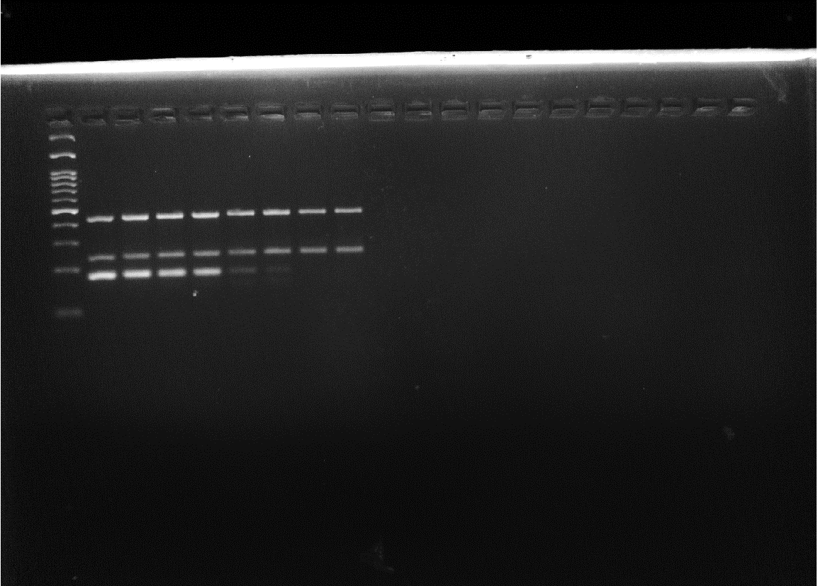
Fig.1 Uncropped gel photograph of Fig. 4

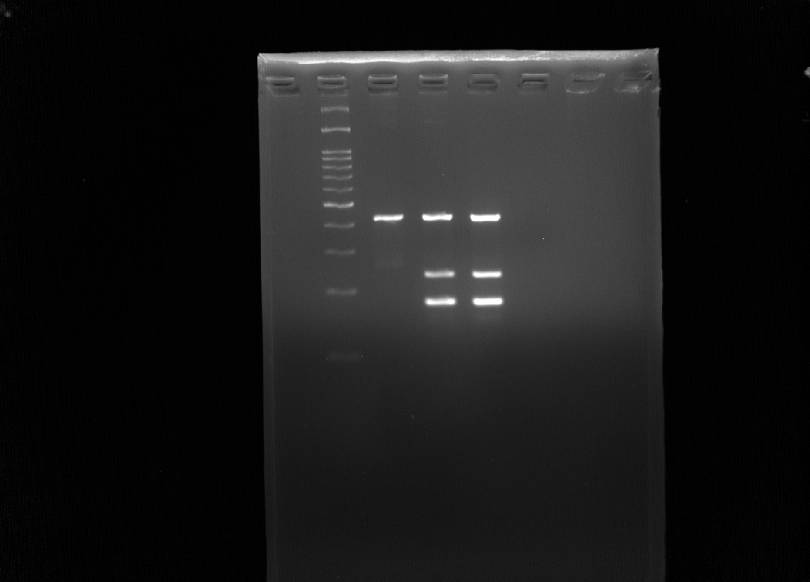
Fig.2 Uncropped gel photograph of Fig. 5

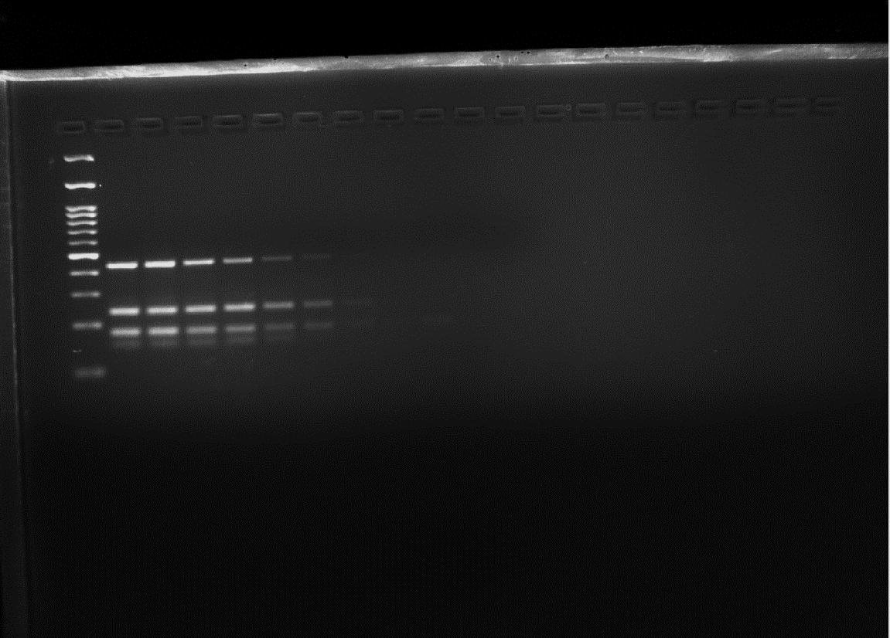
Fig.3 Uncropped gel photograph of Fig. 6

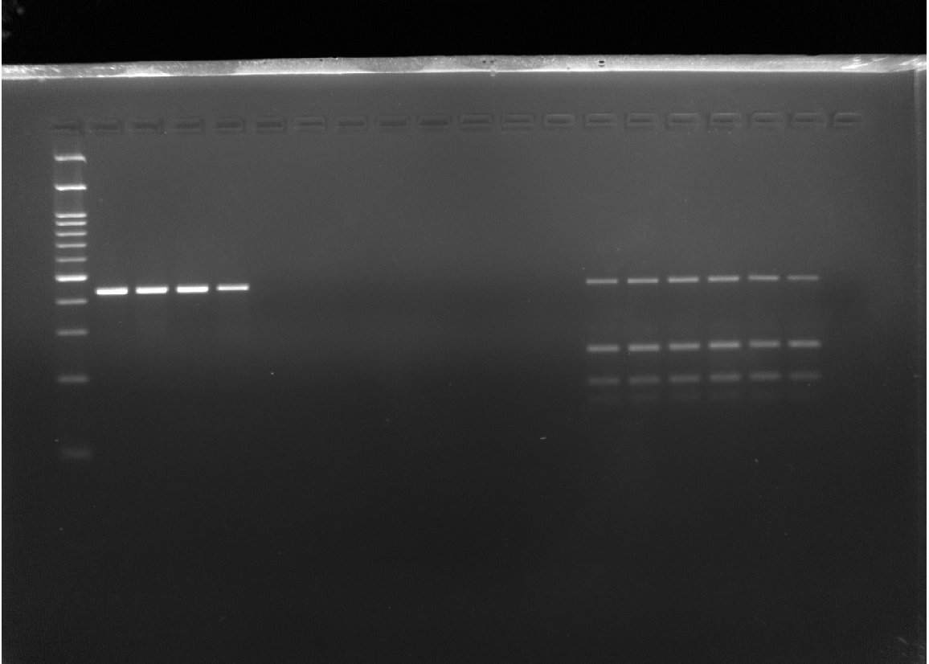

Fig.4 Uncropped gel photograph of Fig. 7

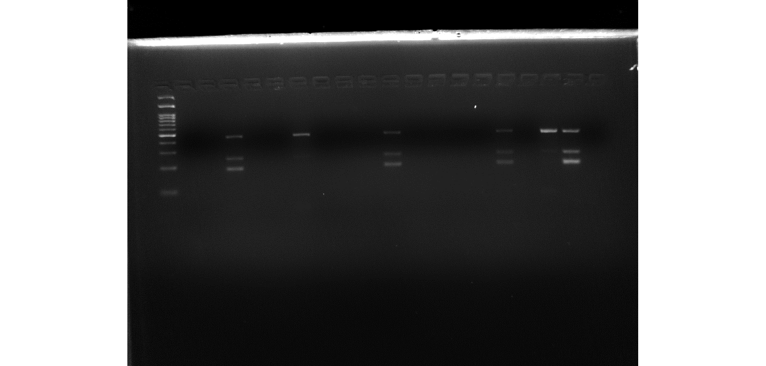
Fig.5 Uncropped gel photograph of Fig. 8

