Development of a multiplex PCR for detection of pathogenic Mycobacterium orygis in cattle tissues harboring tuberculous-like lesions

Sukhen Samanta¹, Premanshu Dandapat², Molla Zakirul Haque³, Partha Sarathi Jana³, Samiran Bandyopadhyay⁴, Arnab Sen⁴, Pramod Kumar Nanda⁴, Subhasree Das³, Keka Sarkar^{1,*}, Prasad Thomas², Abhishek², Ayan Mukherjee^{3,*}, Sachinandan De^{5,*}

Corresponding authors’ email:
keka@klyuniv.ac.in (ORCID ID: 0000-0002-0700-2207)
dramukherjee@wbuafscl.ac.in (ORCID id: 0000-0002-5364-2141),
sachinandan@gmail.com (ORCID id: 0000-0002-3182-0904)

Fig. 1: Nucleotide BLAST analysis of fadD23 amplicon shows the presence of single copy gene in M. orygis genome

>fadD23 amplicon
ACGGCATTCACTTACATCGATTACGAACGGGATTCGGAGGGCATAAGTGAAAGCCTGACGTGGTCGCAGGTGTATCGGCGAACCCTAAAC
GTTGCAGCAGAAGTCCGCCGCCATGCCGCAATTGGTGACCGTGCAGTGATATTGGCCCCACAAGGACGCGATTATATTGTTGCTTTTCTG
G

Nucleotide BLAST result
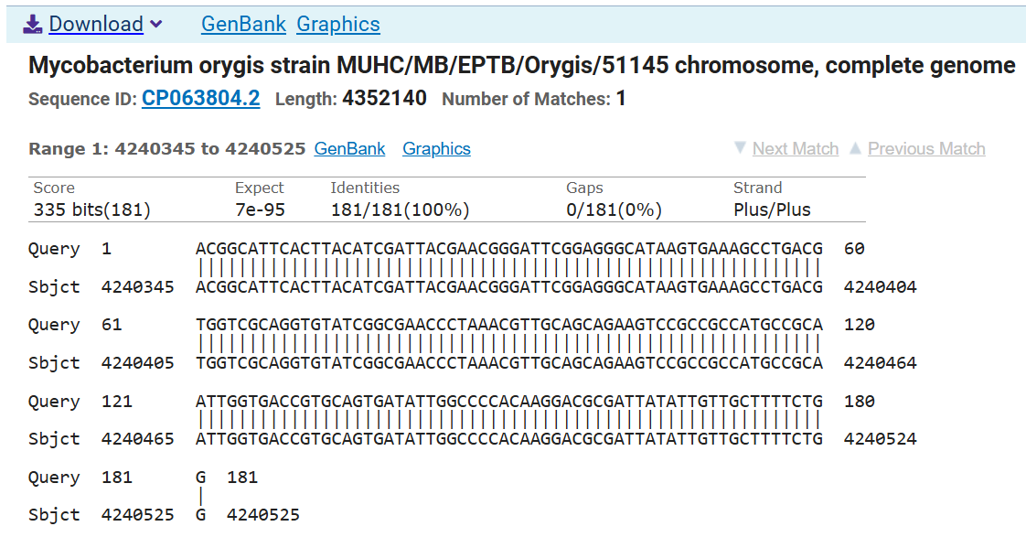

Fig. 2: Nucleotide BLAST analysis of mbtG amplicon shows the presence of single copy gene in M. orygis genome

>mbtG amplicon
CTGTTCAGTCAGCACACCCTCGACCTGCTCGAGCTGGGACTGGGTGGACCGCTGACCGCCGACCGCCTGCAGGAAGCGATCGGCTACGAC
TTGGCAGTCACCGACGTCACGCCCAAGCTGTTCCTGCCCACCCTGTCCGGACTCACCCAGGGGCCCGGGTTCCCCAACCTGAGCTGCCTC
GGCTTGTTGTCGGACCGGGTGCTCGGCGCCGGCATCTATACGCCGACCAAACACAACGAC

Nucleotide BLAST result
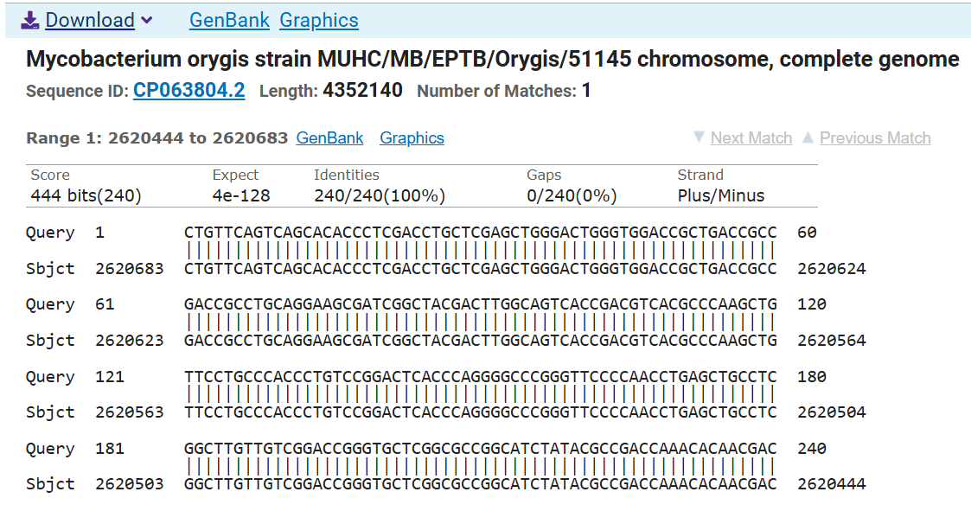

Fig. 3: Nucleotide BLAST analysis of IS1081 amplicon shows the presence of multiple copies in M. orygis genome
>IS1081 amplicon
AAGGAAATGACGCAATGACCTCTTCTCATCTTATCGACACCGAGCAGCTTCTGGCTGACCAACTCGCACAGGCGAGCCCGGATCTGCTGC
GCGGGCTGCTCTCGACGTTCATCGCCGCCTTGATGGGGGCTGAAGCCGACGCCCTGTGCGGGGCGGGCTACCGCGAACGCAGCGATGAGC
GGTCCAATCAGCGCAACGGCTACCGCCACCGTGATTTCGACACCCGTGCCGCAACCATCGACGTCGCGATCCCCAAGCTGCGCCAGGGCA
GCTATTTCCCGGACTGGCTGCTGCAGCGCCGCAAGCGAGCTGAACGCGCACTGACCAGCGTGGTGGCGACCTGCTACCTGCTGGGAGTAT
CCACTCGCCGGATGGAGCGCCTGGTCGAAACACTTGGTGTGACAAAGCTTTCCAAGTCGCAAGTGTCGATCATG

Nucleotide BLAST result
