Supplementary Materials for:
High-density inclined polar skyrmions with giant piezoelectricity

Xiang-Wei Guo^{1,†}, Hui-Mei Li^{1,2,†}, Yun-Long Tang¹, Yin-Lian Zhu^{3,4}, Xiu-Liang Ma^{3,5,6}, Yu-Jia Wang^{1,2,*}

¹Shenyang National Laboratory for Materials Science, Institute of Metal Research, Chinese Academy of Sciences, Shenyang, 110016, China.
²School of Materials Science and Engineering, University of Science and Technology of China, Shenyang, 110016, China.
³Bay Area Center for Electron Microscopy, Songshan Lake Materials Laboratory, Dongguan, 523808, China.
⁴Hunan University of Science and Technology, Xiangtan, 411201, China.
⁵Institute of Physics, Chinese Academy of Sciences, Beijing, 100190, China.
⁶Quantum Science Center of Guangdong-HongKong-Macau Greater Bay Area (Guangdong), Shenzhen, 510290, China.
†These authors contributed equally: Xiang-Wei Guo, Hui-Mei Li
*Email: yjwang@imr.ac.cn.

This file includes:

Supplementary Fig. 1 to 4
Supplementary Note 1
Tables S1 and S2

Supplementary Figures:

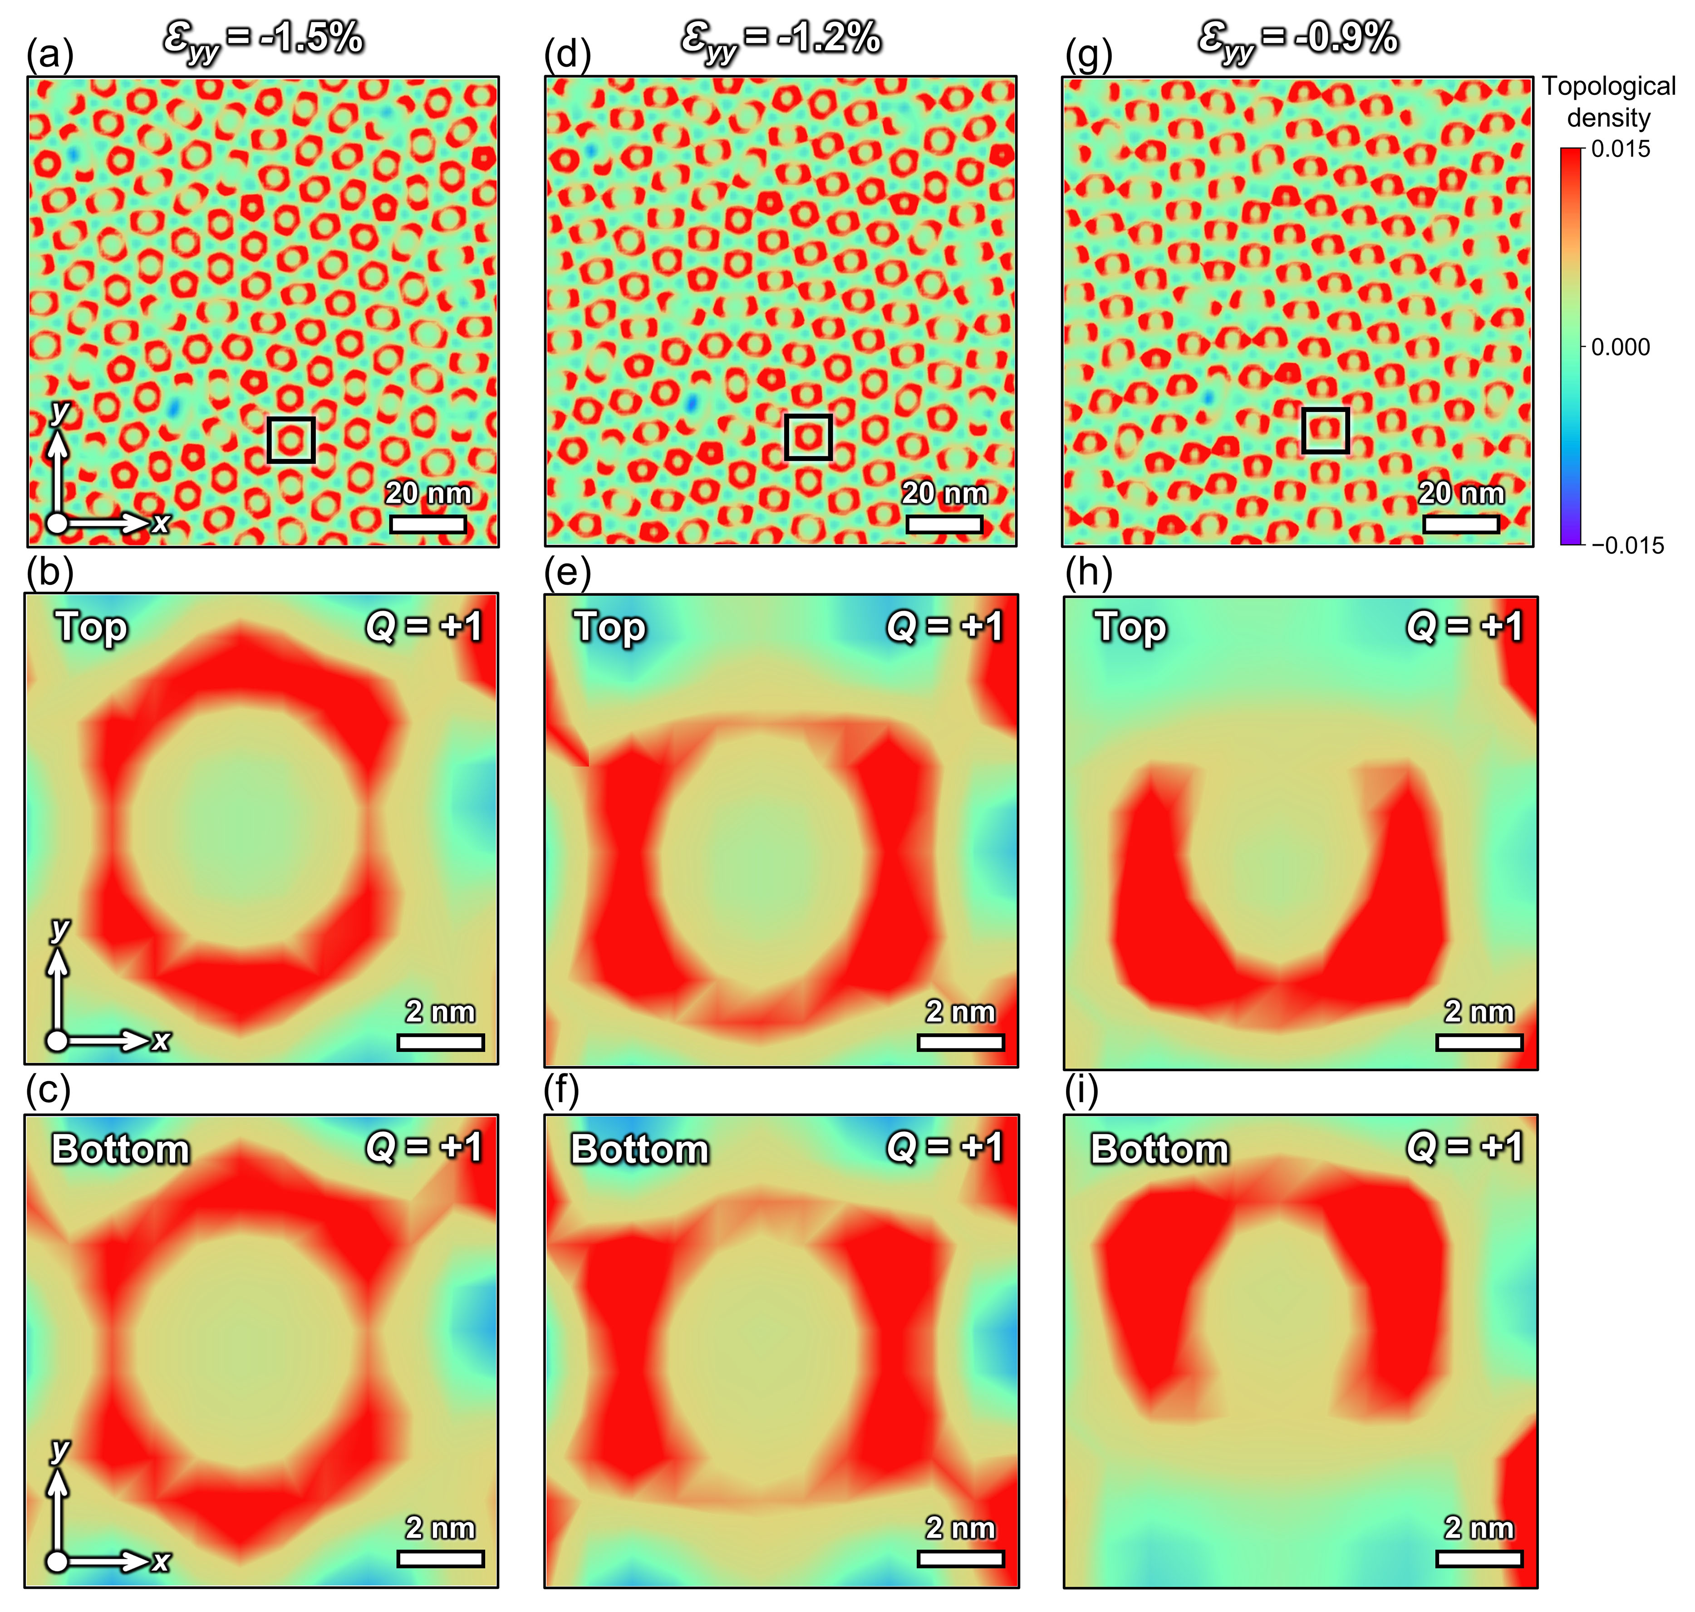
Supplementary Fig. 1. Topological charge analysis of polar skyrmions under anisotropic epitaxial strain modulation in the PTO/STO superlattices. (a, d, g) Planar views of the topological charge distribution corresponding to polar skyrmions shown in Fig. 2(a, d, g) under ε_{yy} = -1.5%, -1.2%, and -0.9%, respectively, with a fixed ε_{xx} = -1.5%. (b, e, h) Enlarged planar views of the topological charge distribution for the three polar topological states in (a), (d), and (g) at the top surface of the PTO layer highlighted by black boxes, respectively. (c, f, i) Enlarged planar views of the topological charge distribution for the three polar topological states in (a), (d), and (g) at the bottom surface of the PTO layer highlighted by black boxes, respectively.

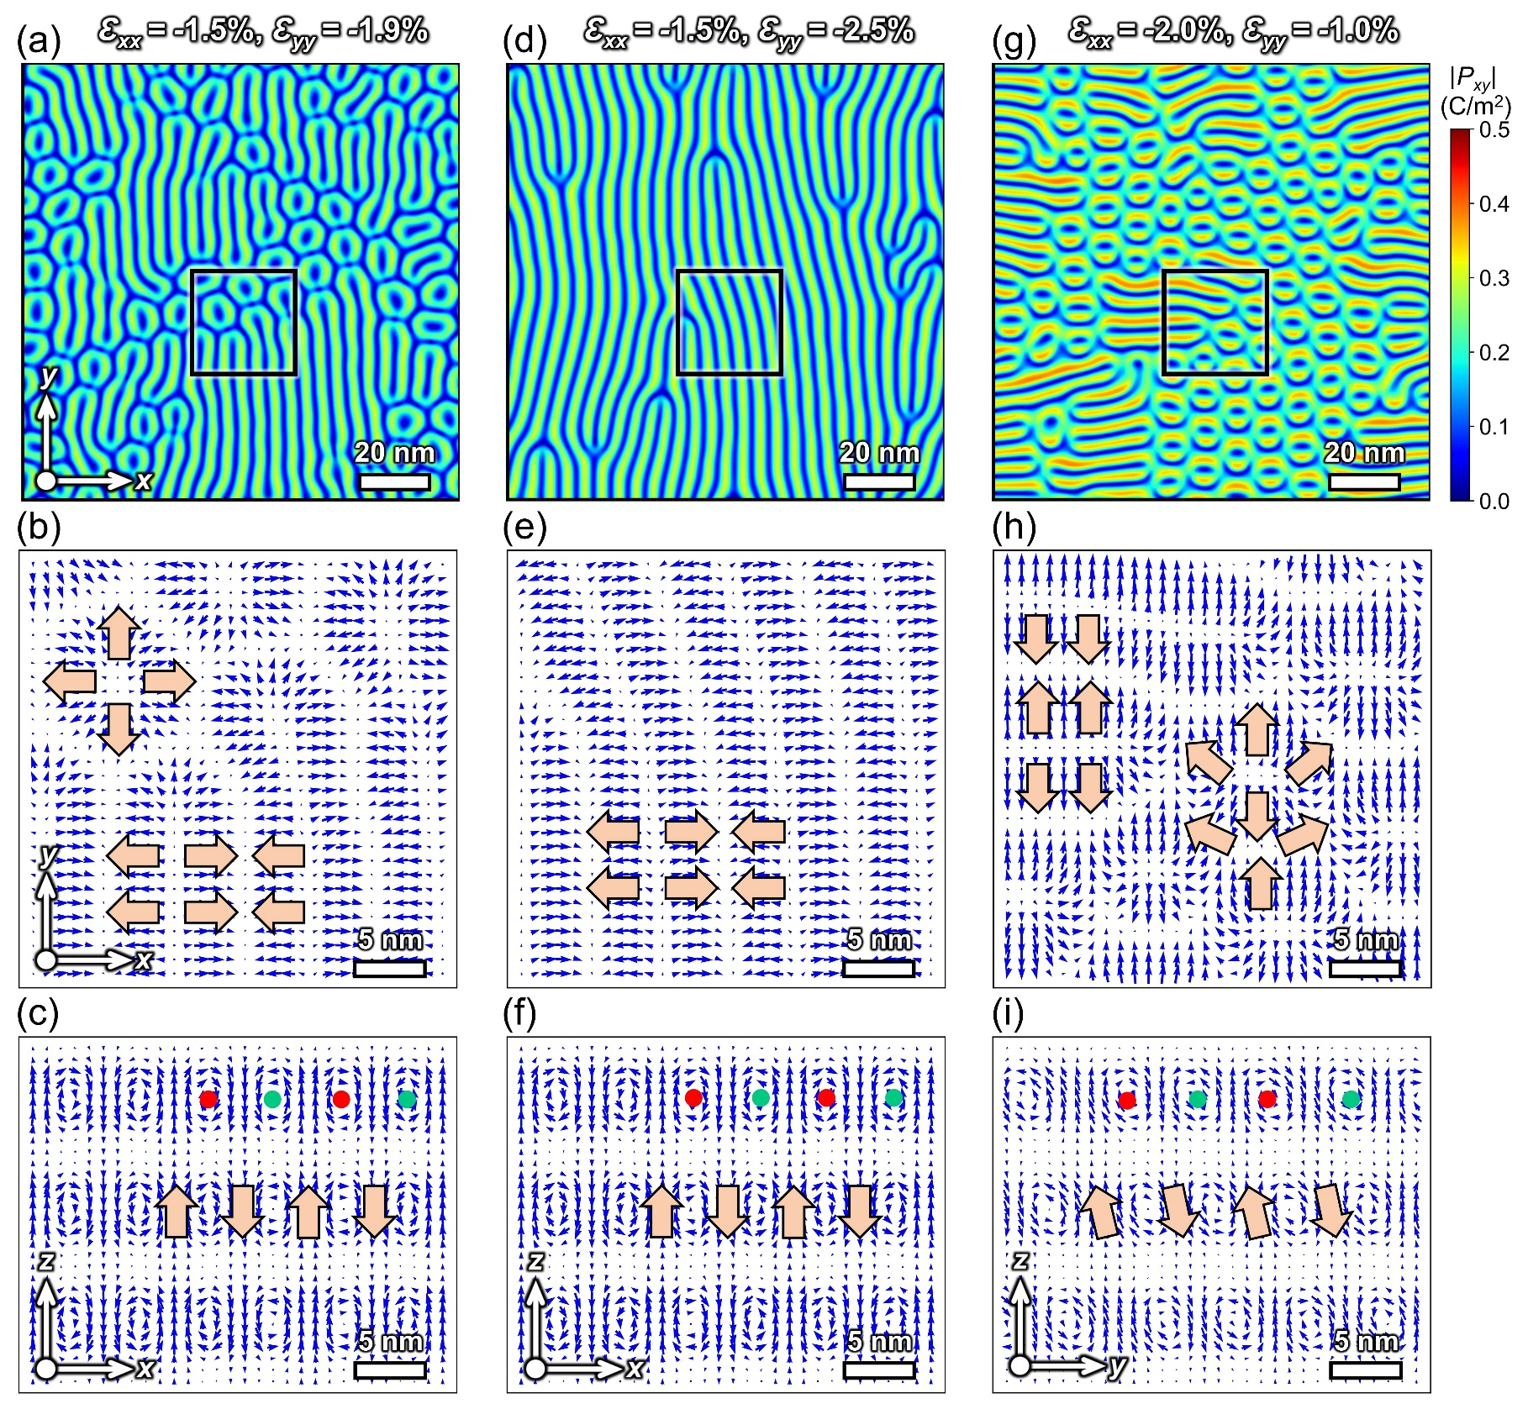
Supplementary Fig. 2. More typical polar topological states in the phase diagram. (a, d, g) Planar view of the ferroelectric polarization magnitude for three representative polar topological states: (a) a mixed state of polar skyrmions and vortex tubes under ε_{xx} = -1.5% and ε_{yy} =-1.9%; (d) a pure polar vortex tube state under ε_{xx} = -1.5% and ε_{yy} = -2.5%; (g) a mixed state of inclined skyrmions and vortex tubes under ε_{xx} = -2.0% and ε_{yy} = -1.0%. (b, e, h) Enlarged planar views of the polarization vector distributions for the three polar topological states highlighted by black boxes in (a), (d), and (g), respectively. (c, f, i) Corresponding enlarged cross-sectional views of the polarization vector distributions in the PTO/STO superlattices. The positions of the vortex cores are indicated by red and green dots.

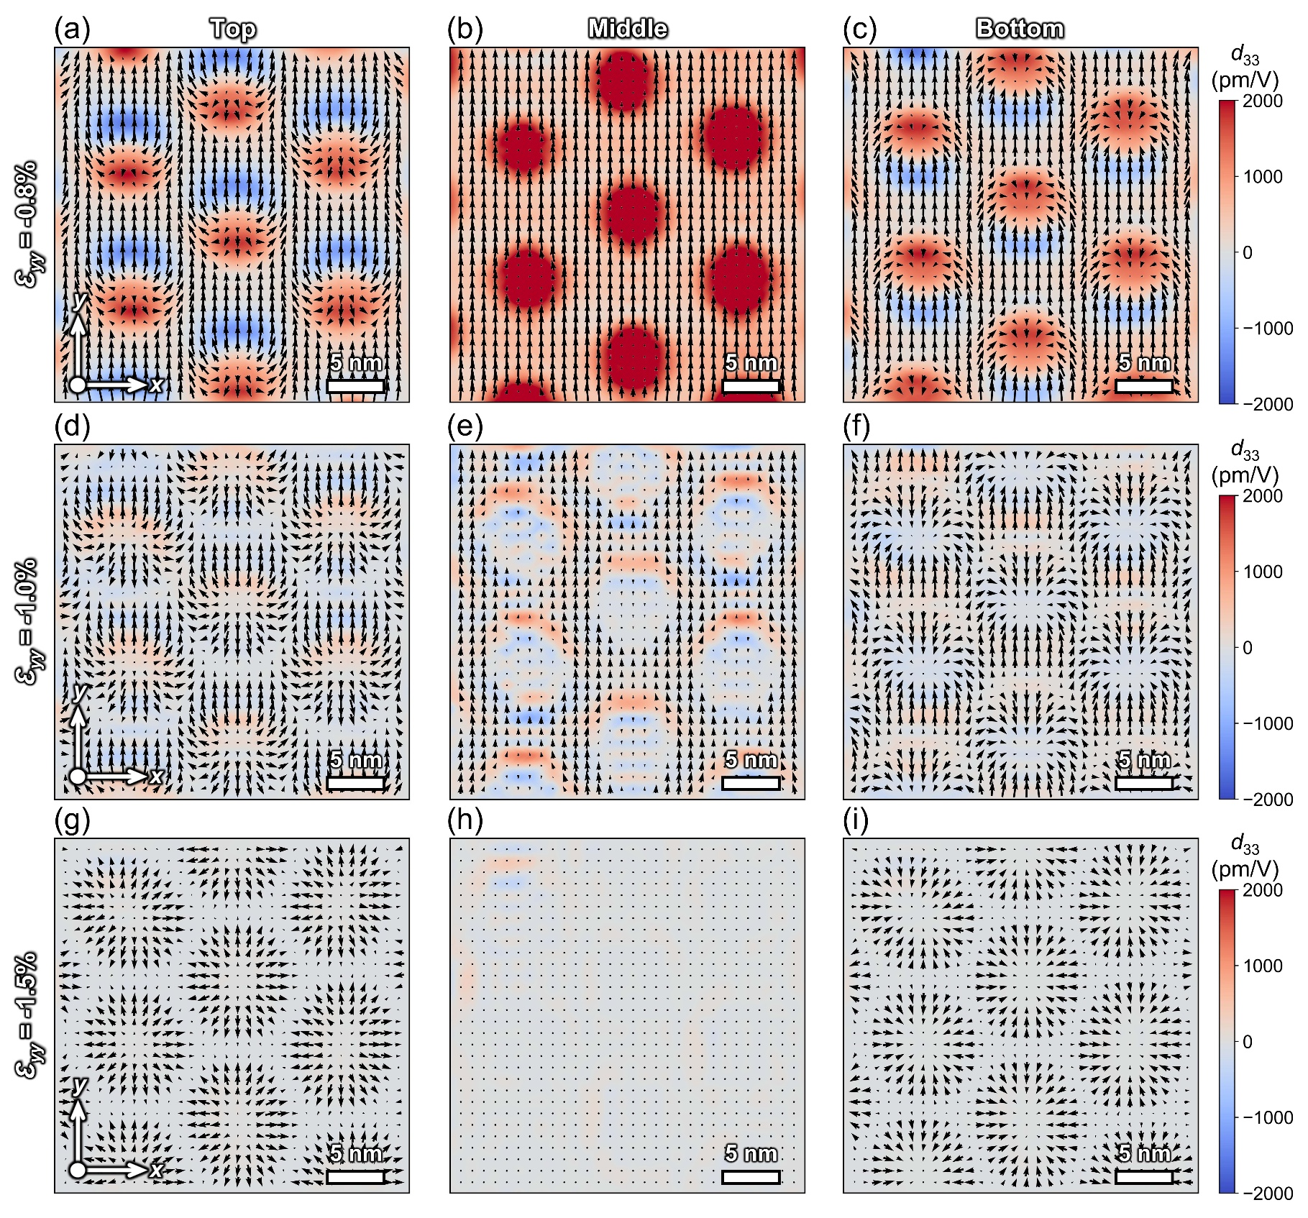
Supplementary Fig. 3. Local piezoelectric response of polar skyrmions under different anisotropic epitaxial strains. (a-c) Planar distribution of the local piezoelectric coefficient d₃₃ and polarization vectors for inclined skyrmions at the top, middle, and bottom of the PTO layer under ε_{xx} = -1.5% and ε_{yy} = -0.8%. (d-f) Corresponding results for a transitional state between upright and inclined skyrmions under ε_{xx} = -1.5% and ε_{yy} = -1.0%. (g-i) Corresponding results for upright skyrmions under ε_{xx} = -1.5% and ε_{yy} = -1.5%.

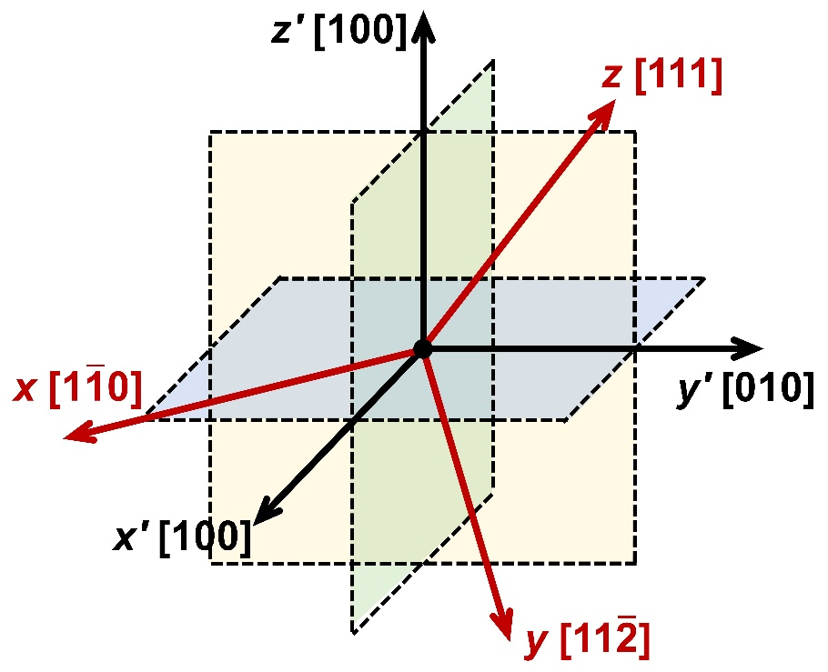
Supplementary Fig. 4. Schematic of geometric transformation from the (001)-oriented coordinate system (x', y', z') to the (111)-oriented coordinate system (x, y, z).

Supplementary Note 1. The expressions for the different energy density terms
The total free energy F of the entire system contains contributions from the bulk, gradient, elastic, and electrostatic energies:
$F=\int{\left[f_{bulk}\left(T,P_{i}\right)+f_{grad}(P_{i,j})+f_{elec}\left(E_{i},P_{i}\right)+f_{elas}\left(ε_{ij},P_{i}\right)\right]dV}$ (S1)
The first term is the bulk energy density:
$f_{bulk}=α_{1}\left(P_{1}^{2}+P_{2}^{2}+P_{3}^{2}\right)+α_{11}\left(P_{1}^{4}+P_{2}^{4}\right)+α_{12}P_{1}^{2}P_{2}^{2}+α_{13}\left(P_{1}^{2}P_{3}^{2}+P_{2}^{2}P_{3}^{2}\right)+α_{14}P_{1}^{2}{P_{2}P}_{3}+α_{24}P_{2}^{3}P_{3}+α_{33}P_{3}^{4}+α_{111}P_{1}^{6}+α_{222}P_{2}^{6}+α_{333}P_{3}^{6}+α_{112}P_{1}^{4}P_{2}^{2}+α_{122}P_{2}^{4}P_{1}^{2}+α_{113}\left(P_{1}^{4}P_{3}^{2}+P_{2}^{4}P_{3}^{2}\right)+α_{133}\left(P_{3}^{4}P_{1}^{2}+P_{3}^{4}P_{2}^{2}\right)+α_{123}P_{1}^{2}P_{2}^{2}P_{3}^{2}+α_{243}P_{2}^{3}P_{3}^{3}+α_{143}P_{1}^{2}P_{2}P_{3}^{3}+α_{224}P_{2}^{5}P_{3}+α_{124}P_{1}^{2}P_{2}^{3}P_{3}+α_{114}P_{1}^{4}P_{2}P_{3}$ (S2)
where $α_{i}$, $α_{ij}$, and $α_{ijk}$ are the Landau expansion coefficients. Here, $α_{1}=α_{0}\left(T-T_{c}\right)$, with $T_{c}$ being the Curie temperature.
The second term is the gradient energy density:
$f_{grad}=\frac{1}{2}G_{11}\left(P_{1,1}^{2}+P_{2,2}^{2}\right)+\frac{1}{2}G_{33}P_{3,3}^{2}+G_{12}P_{1,1}P_{2,2}+G_{13}\left(P_{1,1}P_{3,3}+P_{2,2}P_{3,3}\right)+G_{14}\left(P_{1,1}P_{3,2}+P_{1,1}P_{2,3}-P_{2,2}P_{3,2}-P_{2,2}P_{2,3}+P_{2,1}P_{3,1}+P_{3,1}P_{1,2}+P_{2,1}P_{1,3}+P_{1,2}P_{1,3}\right)+\frac{1}{2}G_{44}\left[{\left(P_{2,3}+P_{3,2}\right)}^{2}+{\left(P_{3,1}+P_{1,3}\right)}^{2}\right]+\frac{1}{2}G_{66}{\left(P_{1,2}+P_{2,1}\right)}^{2}+\frac{1}{2}G_{44}^{'}\left[{\left(P_{2,3}-P_{3,2}\right)}^{2}+{\left(P_{3,1}-P_{1,3}\right)}^{2}+{\left(P_{1,2}-P_{2,1}\right)}^{2}\right]$ (S3)
where $G_{ij}$ is the gradient energy coefficients and $P_{i,j}$ is the spatial differentiation of the polarization components.
The third term is the elastic energy density:
$f_{elas}=\frac{1}{2}C_{11}\left(e_{11}^{2}+e_{22}^{2}\right)+\frac{1}{2}C_{33}e_{33}^{2}+C_{12}e_{11}e_{22}+C_{13}\left(e_{11}e_{33}+e_{22}e_{33}\right)+2C_{44}\left(e_{23}^{2}+e_{31}^{2}\right)+2C_{66}e_{12}^{2}+2C_{14}e_{11}e_{23}+2C_{24}e_{22}e_{23}+4C_{56}e_{31}e_{12}$ (S4)
where $C_{ij}$ denotes the elastic stiffness tensor, and $e_{ij}$ is the elastic strain. The elastic strain is defined as the difference between the total strain $ε_{ij}$ and eigenstrain the $ε_{ij}^{0}$, i.e., $e_{ij}=ε_{ij}-ε_{ij}^{0}$. The eigenstrain $ε_{ij}^{0}$ is associated with spontaneous polarizations through the electrostrictive coefficient $Q_{ij}$:
$$ε_{11}^{0}=Q_{11}P_{1}^{2}+Q_{12}P_{2}^{2}+Q_{13}P_{3}^{2}+Q_{14}P_{2}P_{3}$$
$$ε_{22}^{0}=Q_{12}P_{1}^{2}+Q_{22}P_{2}^{2}+Q_{23}P_{3}^{2}+Q_{24}P_{2}P_{3}$$
$$ε_{33}^{0}=Q_{13}P_{1}^{2}+Q_{23}P_{2}^{2}+Q_{33}P_{3}^{2}$$
$$ε_{23}^{0}=Q_{14}P_{1}^{2}+Q_{24}P_{2}^{2}+Q_{44}P_{2}P_{3}$$
$$ε_{31}^{0}=Q_{55}P_{1}P_{3}+Q_{56}P_{1}P_{2}$$
$ε_{12}^{0}=Q_{56}P_{1}P_{3}+Q_{66}P_{1}P_{2}$ (S5)
The last term is the electrostatic energy density:
$f_{elec}=-\frac{1}{2}κ_{0}κ_{b}E_{i}E_{j}-E_{i}P_{i}$ (S6)
where $κ_{0}$ is the vacuum permittivity, $κ_{b}$ is the background dielectric constant, and $E_{i}$ is the ith component of the total electric field. The electric field is the sum of the applied electric field $E_{i}^{app}$ and the depolarization field $E_{i}^{d}$.
It is assumed that the equilibrium of mechanical stress and electrical field is much faster than the relaxation of domain structures. Accordingly, the following mechanical and electrical equilibrium equations are solved for each polarization configuration to obtain the corresponding elastic and electrostatic driving forces:
$σ_{ij,j}=0$ (S7)
$D_{i,i}=0$ (S8)

Table S1. Relationships between energy coefficients in the global (x, y, z) and local (x', y', z') coordinate systems. A superscript “#” is used to indicate coefficients defined in the local system.

Landau energy coefficients $α_{i}$,$α_{ij}$,$α_{ijk}$ | $α_{1}=α_{1}^{\#}$, $α_{11}=\frac{1}{2}α_{11}^{\#}+\frac{1}{4}α_{12}^{\#}$, $α_{33}=\frac{1}{3}α_{11}^{\#}+\frac{1}{3}α_{12}^{\#}$,
Landau energy coefficients $α_{i}$,$α_{ij}$,$α_{ijk}$ | $α_{12}=α_{11}^{\#}+\frac{1}{2}α_{12}^{\#}$, $α_{13}=2α_{11}^{\#}$,
Landau energy coefficients $α_{i}$,$α_{ij}$,$α_{ijk}$ | $α_{24}=-\frac{2\sqrt{2}}{3}α_{11}^{\#}+\frac{\sqrt{2}}{3}α_{12}^{\#}$, $α_{14}=2\sqrt{2}α_{11}^{\#}-\sqrt{2}α_{12}^{\#}$,
Landau energy coefficients $α_{i}$,$α_{ij}$,$α_{ijk}$ | $α_{111}=\frac{1}{4}α_{111}^{\#}+\frac{1}{4}α_{112}^{\#}$, $α_{222}=\frac{11}{36}α_{111}^{\#}+\frac{7}{36}α_{112}^{\#}+\frac{1}{54}α_{123}^{\#}$,
Landau energy coefficients $α_{i}$,$α_{ij}$,$α_{ijk}$ | $α_{333}=\frac{1}{9}α_{111}^{\#}+\frac{2}{9}α_{112}^{\#}+\frac{1}{27}α_{123}^{\#}$, $α_{112}=\frac{5}{4}α_{111}^{\#}+\frac{1}{4}α_{112}^{\#}+\frac{1}{6}α_{123}^{\#}$,
Landau energy coefficients $α_{i}$,$α_{ij}$,$α_{ijk}$ | $α_{122}=\frac{5}{12}α_{111}^{\#}+\frac{13}{12}α_{112}^{\#}-\frac{1}{9}α_{123}^{\#}$, $α_{113}=\frac{5}{2}α_{111}^{\#}+\frac{1}{12}α_{123}^{\#}$,
Landau energy coefficients $α_{i}$,$α_{ij}$,$α_{ijk}$ | $α_{133}=\frac{5}{3}α_{111}^{\#}+\frac{2}{3}α_{112}^{\#}-\frac{1}{9}α_{123}^{\#}$, $α_{123}=5α_{111}^{\#}+\frac{1}{6}α_{123}^{\#}$,
Landau energy coefficients $α_{i}$,$α_{ij}$,$α_{ijk}$ | $α_{243}=-\frac{10\sqrt{2}}{9}α_{111}^{\#}+\frac{4\sqrt{2}}{9}α_{112}^{\#}-\frac{\sqrt{2}}{27}α_{123}^{\#}$,
Landau energy coefficients $α_{i}$,$α_{ij}$,$α_{ijk}$ | $α_{143}=\frac{10\sqrt{2}}{3}α_{111}^{\#}-\frac{4\sqrt{2}}{3}α_{112}^{\#}+\frac{\sqrt{2}}{9}α_{123}^{\#}$,
Landau energy coefficients $α_{i}$,$α_{ij}$,$α_{ijk}$ | $α_{224}=-\frac{5\sqrt{2}}{6}α_{111}^{\#}+\frac{\sqrt{2}}{6}α_{112}^{\#}+\frac{\sqrt{2}}{18}α_{123}^{\#}$,
Landau energy coefficients $α_{i}$,$α_{ij}$,$α_{ijk}$ | $α_{124}=\frac{5\sqrt{2}}{3}α_{111}^{\#}-\frac{\sqrt{2}}{3}α_{112}^{\#}-\frac{\sqrt{2}}{9}α_{123}^{\#}$,
Landau energy coefficients $α_{i}$,$α_{ij}$,$α_{ijk}$ | $α_{114}=\frac{5\sqrt{2}}{2}α_{111}^{\#}-\frac{\sqrt{2}}{2}α_{112}^{\#}-\frac{\sqrt{2}}{6}α_{123}^{\#}$.
Gradient energy coefficients $G_{ij}$ | $G_{11}=\frac{1}{2}G_{11}^{\#}+\frac{1}{2}G_{12}^{\#}+G_{44}^{\#}$, $G_{33}=\frac{1}{3}G_{11}^{\#}+\frac{2}{3}G_{12}^{\#}+\frac{4}{3}G_{44}^{\#}$,
Gradient energy coefficients $G_{ij}$ | $G_{12}=\frac{1}{6}G_{11}^{\#}+\frac{5}{6}G_{12}^{\#}-\frac{1}{3}G_{44}^{\#}$, $G_{13}=\frac{1}{3}G_{11}^{\#}+\frac{2}{3}G_{12}^{\#}-\frac{2}{3}G_{44}^{\#}$,
Gradient energy coefficients $G_{ij}$ | $G_{44}=\frac{1}{3}G_{11}^{\#}-\frac{1}{3}G_{12}^{\#}+\frac{1}{3}G_{44}^{\#}$, $G_{66}=\frac{1}{6}G_{11}^{\#}-\frac{1}{6}G_{12}^{\#}+\frac{2}{3}G_{44}^{\#}$,
Gradient energy coefficients $G_{ij}$ | $G_{44}^{'}=G_{44}^{'\#}$, $G_{14}=\frac{\sqrt{2}}{6}G_{11}^{\#}-\frac{\sqrt{2}}{6}G_{12}^{\#}-\frac{\sqrt{2}}{3}G_{44}^{\#}$.
Elastic stiffness coefficients $C_{ij}$ | $C_{11}=\frac{1}{2}C_{11}^{\#}+\frac{1}{2}C_{12}^{\#}+C_{44}^{\#}$, $C_{33}=\frac{1}{3}C_{11}^{\#}+\frac{2}{3}C_{12}^{\#}+\frac{4}{3}C_{44}^{\#}$,
Elastic stiffness coefficients $C_{ij}$ | $C_{12}=\frac{1}{6}C_{11}^{\#}+\frac{5}{6}C_{12}^{\#}-\frac{1}{3}C_{44}^{\#}$, $C_{13}=\frac{1}{3}C_{11}^{\#}+\frac{2}{3}C_{12}^{\#}-\frac{2}{3}C_{44}^{\#}$,
Elastic stiffness coefficients $C_{ij}$ | $C_{44}=\frac{1}{3}C_{11}^{\#}-\frac{1}{3}C_{12}^{\#}+\frac{1}{3}C_{44}^{\#}$, $C_{66}=\frac{1}{6}C_{11}^{\#}-\frac{1}{6}C_{12}^{\#}+\frac{2}{3}C_{44}^{\#}$,
Elastic stiffness coefficients $C_{ij}$ | $C_{14}=\frac{\sqrt{2}}{6}C_{11}^{\#}-\frac{\sqrt{2}}{6}C_{12}^{\#}-\frac{\sqrt{2}}{3}C_{44}^{\#}$, $C_{24}=-C_{14}$, $C_{56}=C_{14}$.
Electrostrictive coefficients $Q_{ij}$ | $Q_{11}=\frac{1}{2}Q_{11}^{\#}+\frac{1}{2}Q_{12}^{\#}+\frac{1}{4}Q_{44}^{\#}$, $Q_{22}=Q_{11}$, $Q_{12}=\frac{1}{6}Q_{11}^{\#}+\frac{5}{6}Q_{12}^{\#}-\frac{1}{12}Q_{44}^{\#}$,
Electrostrictive coefficients $Q_{ij}$ | $Q_{13}=\frac{1}{3}Q_{11}^{\#}+\frac{2}{3}Q_{12}^{\#}-\frac{1}{6}Q_{44}^{\#}$, $Q_{23}=Q_{13}$, $Q_{14}=\frac{\sqrt{2}}{3}Q_{11}^{\#}-\frac{\sqrt{2}}{3}Q_{12}^{\#}-\frac{\sqrt{2}}{6}Q_{44}^{\#}$, $Q_{24}=-Q_{14}$,
Electrostrictive coefficients $Q_{ij}$ | $Q_{33}=\frac{1}{3}Q_{11}^{\#}+\frac{2}{3}Q_{12}^{\#}+\frac{1}{3}Q_{44}^{\#}$, $Q_{44}=\frac{4}{3}Q_{11}^{\#}-\frac{4}{3}Q_{12}^{\#}+\frac{1}{3}Q_{44}^{\#}$,
Electrostrictive coefficients $Q_{ij}$ | $Q_{55}=Q_{44}$, $Q_{56}=\frac{2\sqrt{2}}{3}Q_{11}^{\#}-\frac{2\sqrt{2}}{3}Q_{12}^{\#}+\frac{\sqrt{2}}{3}Q_{44}^{\#}$, $Q_{66}=\frac{2}{3}Q_{11}^{\#}-\frac{2}{3}Q_{12}^{\#}+\frac{2}{3}Q_{44}^{\#}$.

Table S2. Material parameters used for the PTO/STO superlattice in the local (x', y', z') coordinate system.

Parameter (SI units) | PTO | STO
$α_{11}^{\#}$ (C⁻²$\text{∙}$m²$\text{∙}$N) | −1.73$\text{×}$10⁸ | 1.85$\text{×}$10⁸
$α_{11}^{\#}$ (C⁻⁴$\text{∙}$m⁶$\text{∙}$N) | −7.3$\text{×}$10⁷ | 1.7$\text{×}$10⁹
$α_{12}^{\#}$ (C⁻⁴$\text{∙}$m⁶$\text{∙}$N) | 7.5$\text{×}$10⁸ | 1.37$\text{×}$10⁹
$α_{111}^{\#}$ (C⁻⁶$\text{∙}$m¹⁰$\text{∙}$N) | 2.6$\text{×}$10⁸ | 0
$α_{112}^{\#}$ (C⁻⁶$\text{∙}$m¹⁰$\text{∙}$N) | 6.1$\text{×}$10⁸ | 0
$α_{123}^{\#}$ (C⁻⁶$\text{∙}$m¹⁰$\text{∙}$N) | −3.7$\text{×}$10⁹ | 0
$Q_{11}^{\#}$ (C⁻²$\text{∙}$m⁴) | 0.089 | 0.089
$Q_{12}^{\#}$ (C⁻²$\text{∙}$m⁴) | −0.026 | −0.026
$Q_{44}^{\#}$ (C⁻²$\text{∙}$m⁴) | 0.0675 | 0.0675
$C_{11}^{\#}$ (m⁻²$\text{∙}$N) | 1.746$\text{×}$10¹¹ | 1.746$\text{×}$10¹¹
$C_{12}^{\#}$ (m⁻²$\text{∙}$N) | 7.937$\text{×}$10¹⁰ | 7.937$\text{×}$10¹⁰
$C_{44}^{\#}$ (m⁻²$\text{∙}$N) | 1.111$\text{×}$10¹¹ | 1.111$\text{×}$10¹¹
$G_{11}^{\#}$ (C⁻²$\text{∙}$m⁴$\text{∙}$N) | 1.035$\text{×}$10⁻¹⁰ | 1.035$\text{×}$10⁻¹⁰
$G_{12}^{\#}$ (C⁻²$\text{∙}$m⁴$\text{∙}$N) | −1.035$\text{×}$10⁻¹⁰ | −1.035$\text{×}$10⁻¹⁰
$G_{44}^{\#}$ (C⁻²$\text{∙}$m⁴$\text{∙}$N) | 1.035$\text{×}$10⁻¹⁰ | 1.035$\text{×}$10⁻¹⁰
$G_{110}^{\#}$ (C⁻²$\text{∙}$m⁴$\text{∙}$N) | 1.73$\text{×}$10⁻¹⁰ | 1.73$\text{×}$10⁻¹⁰
$$κ_{b}$$ | 40 | 40

