Appendix
In the present analysis, we averaged each of N_{sa} epoch MEG data that were bandpass filtered and sorted by semantic distance to obtain subaveraged MEG data. A linear trend was subtracted from the subaveraged data—estimated using latencies from −198 ms to 0 ms and from 800 ms to 1,000 ms—to perform detrending. Major dipole moments were then fitted to these detrended data. After projection onto the all-average moments, the subaveraged moments were used as a measure of activation to assess dependence on semantic distance. Although a larger N_{sa} is preferable for accurate detrending, it also influences the statistical power to detect semantic distance dependence. To determine the optimal N_{sa}, we evaluated detection power as a function of N_{sa} using the following model.
Assuming a linear dependence of activation on semantic distance, activation y is expressed as:
y = xβ + ε, (A1)
where x is a vector representing relative semantic distance for the stimuli (the ith component is (i–1)/(n–1) for i=1~n), n is the number of subaverage activations, β is the regression slope, and ε is a vector of random noise following a normal distribution with mean zero and standard deviation σ_{ε}. Under the null hypothesis (no dependence), and assuming large n, the F-value of the F-distribution can be approximated as:
F(1, n–1) ≈ $\frac{n(n+1)・β^{２}}{12(n-1)・σ_{ε}^{２}}$ , (A2)
which corresponds to Equation (A5) in Fujimaki et al. (2014). The minimum detectable slope β_{th} at a significance level α is then given by:
β_{th}=$\sqrt{\frac{12(n-1)・F_{1-α}(1, n-1)}{n(n+1)}}$・σ_{ε}. (A3)
In the previous study, we conducted a simulation of visual word processing. The results showed that the value of σ_{ε}, normalized by mean activation, was for example 0.151 in the left ATL when n = 10 and N_{sa} = 10, resulting in a β_{th} of 0.49 at a significance level of α = 0.01 (Fujimaki et al. 2014). This indicates that a relative change in activation exceeding 49% (±24.5%) over a relative semantic distance range of 0–1 can be detected at the significance level of 0.01.
Here, we derive the minimum detectable change in activation, explicitly incorporating the number of N_{sa} and the measured signal-to-noise ratio (SNR) as shown below. Let K denote the number of participants, N₁ the number of measured epochs per participant, n₁ (=N₁/N_{sa}) the number of subaverages per participant, and n (=K・n₁=K・N₁/N_{sa}) the total number of subaverages. Let A be the average activation magnitude (root-mean-square value), and C_{th} be the minimum detectable relative change in activation over a relative semantic distance range of 0$-$1, where n data have the distance from 1/2n to 1$-$1/2n with a step 1/n. Then:
C_{th}・($1-\frac{1}{n}$)= $\frac{1}{A}$・β_{th} . (A4)
If we denote the SNR of subaverage activation as snr(N_{sa}), and the SNR of the all-average per participant as snr(N₁), we have:
snr(N_{sa}) = $\frac{A}{σ_{ε}}$・$\sqrt{\frac{n}{n-1}}$ = snr(N₁)・$\sqrt{\frac{K}{n}}$. (A5)
By substituting equations (A3) and (A5) into equation (A4), we obtain:
C_{th} = $\frac{n}{(n-1)・snr(N_{1})}$・ $\sqrt{\frac{12n・F_{1-α}(1, n-1)}{K(n+1)}}$. (A6)
For the present dataset, K=9, N₁≈1,000, snr (N₁) ≈ 5 (with 6.1 for the left ATL and 4.4 for the left IFC; see Online Resource, Table S4b). Figure 9 illustrates the relationship between C_{th} and N_{sa} (= K・N₁/n) at a significance level of α = 0.05. The value of C_{th} remains nearly constant when N_{sa} < 10, but increases rapidly as N_{sa} increases beyond 10. For n>>1, the value for N_{sa} < 10 is approximately:
C_{th} ≈ $\frac{1}{snr(N_{1})}$・$\sqrt{\frac{12F_{1-α}(1, n-1)}{K}}$ ≈ 0.45.
Based on this result, we chose N_{sa}=10 in our analysis. A relative change of more than 45% (±22.5%) can be detected using regression analysis.

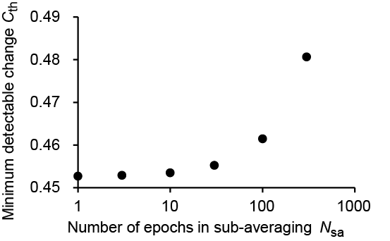
Fig. 9

