African digital health strategic plans: key weaknesses in contextualization, intervention focus, and technological foresight

Author Information
Bry Sylla* ^{a,b}, Pascal Somda^{c}, Jean Noel Nikiema^{d}, Leon Gueswende Blaise Savadogo^{b}, Gayo Dialloª & Nicolas Meda^{c}.

Affiliations
ªTeam AHeaD, Bordeaux Population Health INSERM-U1219, Univ. Bordeaux, F-33000, France
Gayo Dialloª, Bry Sylla* ^{a,b}
^{b}Public Health Department, Nazi Boni University Bobo Dioulasso, BF
Leon Gueswende Blaise Savadogo^{b}, Bry Sylla* ^{a,b}
^{c}Public Health Department, Joseph Ki Zerbo University Ouagadougou, BF
Pascal Somda^{c}, Nicolas Meda^{c}
^{d}Department of Management, Evaluation and Health Policy, School of Public Health, Université de Montréal, Canada
Jean Noel Nikiema^{d}

Contribution
BS and PS designed the research project. BS and PS conducted data compilation and analysis. PS and BS drafted the first version of the manuscript. NM, GD, and LGBS validated the methodological approach. NM, GD, JNN, and LGBS improved the manuscript. All authors participated in the final revision of the manuscript, corrected it, and approved it for submission.
Corresponding author
Correspondence to: Bry SYLLA

Supplementary Information

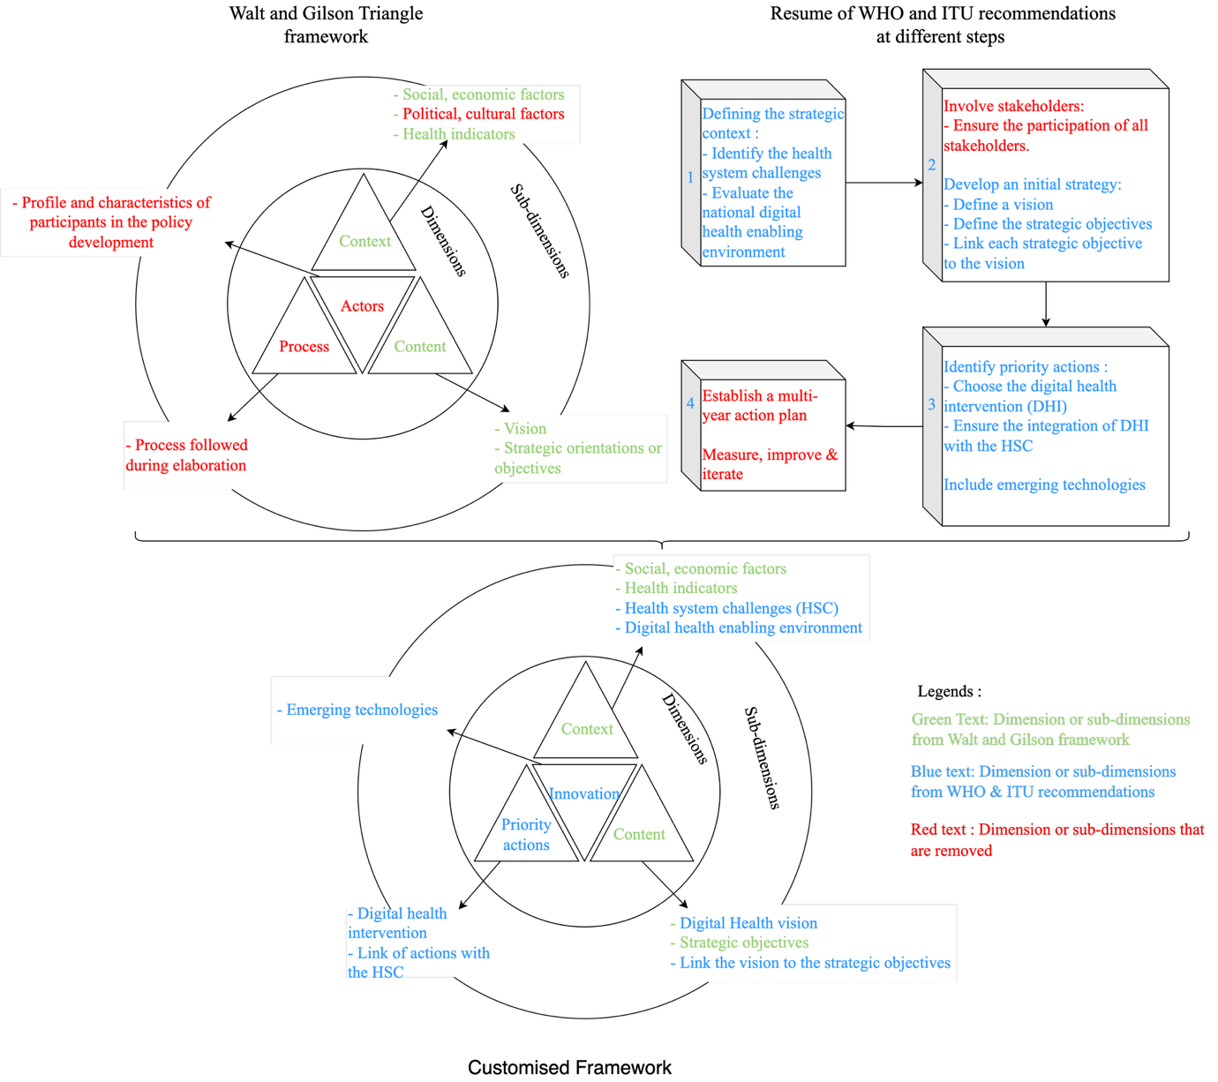

Supplementary Fig. 1 Customization of the Conceptual framework of the study.

Table 1 country contextual information
Country | Period covered by the PS | Total population (inhabitants) | GDP/capita (USD/capita) or Poverty rate | Life expectancy at birth (years) | Infant mortality rate (per 1,000 live births) | Maternal mortality rate (per 100,000 live births) | Number of doctors/inhabitant (per 10,000 inhabitants)
Guinea | 2021-2025 | 12,559,623 in 2020 | 848 USD;  Poverty rate: 43.7% | 59 on average | 67 | 724 | 6.32
Cameroon | 2020-2024 | 25,492,353 in 2019 | Poverty rate: 40.2% in 2001, 39.9% in 2007, 37.5% in 2014 | 52 on average | NA | NA | NA
DRC | 2020-2024 | NA | NA | 56.5 for men  59.7 for women | NA | NA | NA
Tunisia | NA | NA | NA | 74.4 on average | NA | NA | NA
Malawi | 2020-2025 | 17,600,000 in 2018 | 327 USD | 63.9 on average | NA | 439 | NA
Burundi | 2020-2024 | NA | NA | NA | NA | NA | NA
Botswana | 2020-2024 | NA | NA | 54.4 years (48.8 males: and 60 females) | 57 | 193 | NA
Ethiopia | 2021-2030 | NA | NA | NA | NA | NA | NA
Ghana | 2023-2027 | NA | NA | NA | NA | NA | NA
Namibia | 2021-2025 | 2,480,000 in 2016 | NA | 61 years for males and 66 years for females | 44 (under the age of five) | NA | NA
Zambia | 2022-2026 | 18.4 million in 2021 (population growth rate of 2.8 percent) | In 2010, Over half (61%) of the population lived below the poverty line | NA | 278 | 41 | NA

Supplementary Table 2. Comparative analysis of the Strategic orientations
Approach | Strategic axis and objectives | Goal
focus on the enabling institutional environment | Cameroon: seven axes, four of which are strictly institutional and planned to be implemented before digital infrastructure and services.  Namibia: The axes are the WHO's seven pillars; the strategic objectives are divided by pillar, but the country is planning short-term pillars for governance and leadership, strategy and investment, and skills development.  Tunisia: The axes are the seven pillars of the WHO, the objectives are divided into three phases: the first phase plans to establish the foundations and governance for digital health, the second phase plans to develop and deploy digital services, and the third phase will continue implementation and consolidation.  Botswana: The axes are the seven pillars, with institutional strengthening priorities according to the plan. According to the established timeframes, digital solutions, infrastructure, and interoperability are secondary priorities. | These countries believe that without a solid institutional foundation, any digitalization would remain fragmented.
focus on the deployment of digital health interventions, interoperability, and data | Burundi: three axes and 11 objectives; all axes and objectives focus on the deployment of digital health interventions and infrastructure improvement. Only two objectives in axis 2 provide for institutional strengthening through leadership/governance and adequate financing.  DRC: all objectives focus on interoperability and skills building, infrastructure, and digital health interventions.  Guinea: proposes two axes with five objectives. One with four objectives for strengthening the health system through digital health interventions, and the other with a single objective for an enabling environment for digital health.  Malawi: 7 axes proposed with 18 strategic objectives; only one axis aims to strengthen the institutional framework by improving the coordination of investments in digital health. | The perceived urgency is to quickly develop clinical tools and integrated data, with governance being adjusted as deployment progresses.
Hybrid | Ghana: Out of 10 objectives, five relate to enabling (governance, environment, resources, financing), and five relate to digital health interventions and data. These objectives do not have a time horizon in the SP.  Ethiopia: Two of the four pillars are "Data Hub" and "Solutions and Services," with the governance axis appearing only as a supporting component.  Zambia: The axes are the 7 pillars of the WHO. Depending on the timeframe, the plan plans to implement initiatives from all axes in a balanced manner. | The two approach advance together, with balanced objectives.

Supplementary Table 3. alignment of digital health interventions with health system challenges
Country | Main DHI planned | Stated challenges | Alignment level
Cameroon | Targeted/untargeted client communication;  EHR; Telemedicine;  Clinical decision support; HR management; Supply-chain; Civil Registration and Vital Statistics (CRVS). | Reduction of mortality & morbidity  Improving the quality of care  Institutional capacity building  Improving access to care | High
DR Congo | EHR ; Telemedicine; Health provider training ;  Imaging; HR; health-financing; Supply-chain; Data warehouse & GIS. | Reduction mortality & morbidity | High
Burundi | EHR & disease-specific modules;  Clinical decision support; referral coordination; HR & supply-chain; health financing | Improving the quality of care  Improving access to care  Optimised management of resources | Moderate
Botswana | EHR ; Health provider scheduling ; data collection/visualisation. | Improving the quality of care  Institutional capacity building  Optimised management of resources  Health information management  Development of technological infrastructures | Low
Namibia | Untargeted client communication ; EHR | Reduction of mortality and morbidity  Institutional capacity building  Optimised management of resources  Improving access to care  Development of technological infrastructures | Low

