Supplementary Information File
Harnessing CoS@MoS2 Heterostructures for High Performance Glucose Biosensors: Towards Next-Generation Glucometers
Israr U. Hassan¹, Mustri Bano*¹, Fatima Ba Omar¹, Aarif H. Pinjari², Gowhar A. Naikoo*¹
¹Department of Mathematics and Sciences, College of Arts and Applied Sciences, Dhofar University, PC 211, Salalah, Oman
²Government College Harsud, District Khandwa, M. P. 450116, India
Correspondence at: mustribano1@gmail.com and gahmed@du.edu.om

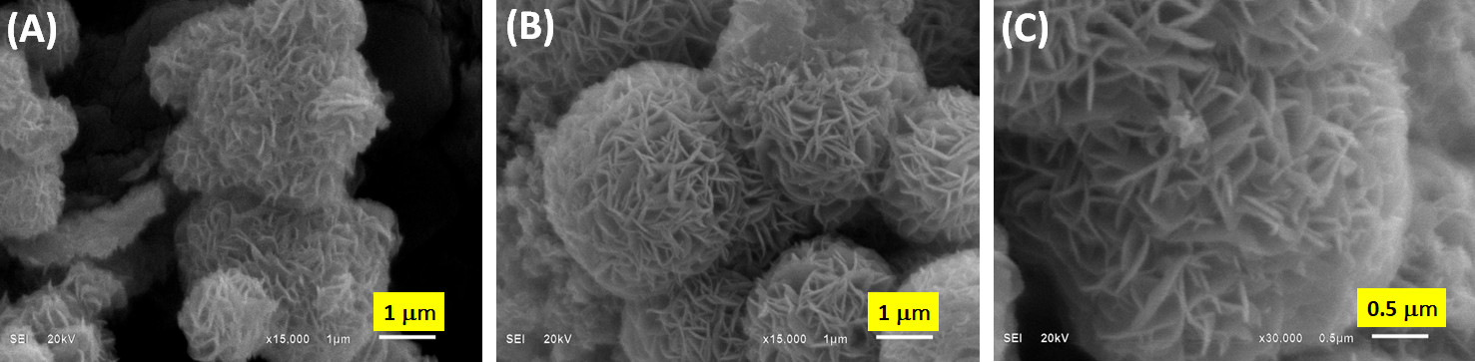
Figure S1. SEM images for (A) MoS₂ (B) 2D–CoS@MoS₂ (C) 2D–CoS@MoS₂.
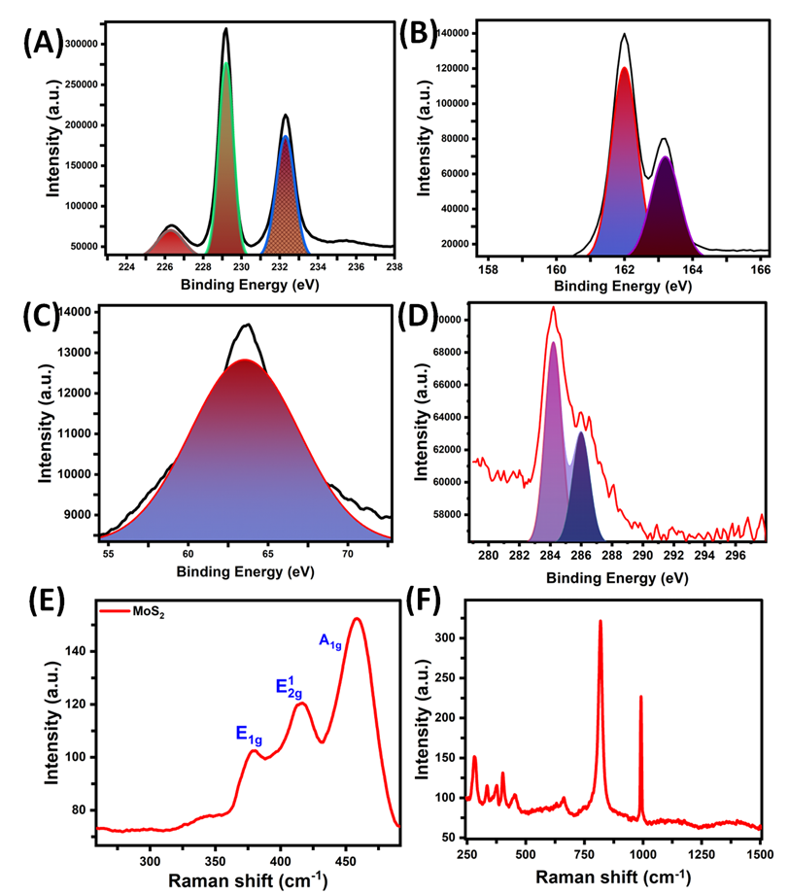
Figure S2. XPS (A) Mo 3d, (B) S 2p (C) Co 3d, (D) C 2p and in CoS@MoS₂ spectra, Raman Spectra of (E) MoS₂ and (F) CoS@MoS₂.
Table S1. Summarizes the results of glucose infusions into blood serum samples from diabetic and non-diabetic people, and its recovery data.
Blood serum sample response of diabatic person | Added (mM) | Found Concentration (mM) | Mean Recovery (%) | RSD  (%, n=3)
Blood serum sample response of diabatic person | 0.01 | 0.0142 | 96.30 | 0.0266
Blood serum sample response of diabatic person | 0.05 | 0.0514 | 94.50 | 0.0078
Blood serum sample response of diabatic person | 0.10 | 0.1023 | 99.92 | 0.0034
Blood serum sample response of diabatic person | 0.15 | 0.1495 | 99.58 | 0.0019
Blood serum sample response of diabatic person | 0.2 | 0.1989 | 99.30 | 0.0093
Blood serum sample response of non-diabatic person | Added (mM) | Found Concentration (mM) | Mean Recovery (%) | RSD  (%, n=3)
Blood serum sample response of non-diabatic person | 0.01 | 0.0093 | 99.99 | 0.0036
Blood serum sample response of non-diabatic person | 0.05 | 0.0492 | 99.98 | 0.0025
Blood serum sample response of non-diabatic person | 0.1 | 0.0976 | 99.77 | 0.0036
Blood serum sample response of non-diabatic person | 0.15 | 0.1485 | 99.63 | 0.0014
Blood serum sample response of non-diabatic person | 0.2 | 0.1972 | 99.99 | 0.0010
Table S2. Summarizes the results of glucose infusions into urine samples from diabetic and non-diabetic persons, and its recovery data.
Urine sample response of diabatic person | Added (mM) | Found Concentration (mM) | Mean Recovery (%) | RSD  (%, n=3)
Urine sample response of diabatic person | 0.01 | 0.0096 | 99.98 | 0.0001
Urine sample response of diabatic person | 0.05 | 0.0789 | 99.97 | 0.0019
Urine sample response of diabatic person | 0.09 | 0.1006 | 99.98 | 0.0026
Urine sample response of diabatic person | 0.13 | 0.1965 | 99.99 | 0.0019
Urine sample response of diabatic person | 0.15 | 0.1485 | 99.99 | 0.0015
Urine sample response of non-diabatic person | Added (mM) | Found Concentration (mM) | Mean Recovery (%) | RSD  (%, n=3)
Urine sample response of non-diabatic person | 0.01 | 0.0120 | 99.98 | 0.0002
Urine sample response of non-diabatic person | 0.05 | 0.0512 | 99.96 | 0.0005
Urine sample response of non-diabatic person | 0.09 | 0.0868 | 99.95 | 0.0012
Urine sample response of non-diabatic person | 0.13 | 0.1004 | 99.99 | 0.0018
Urine sample response of non-diabatic person | 0.18 | 0.1795 | 99.97 | 0.0019

