Fig. S1
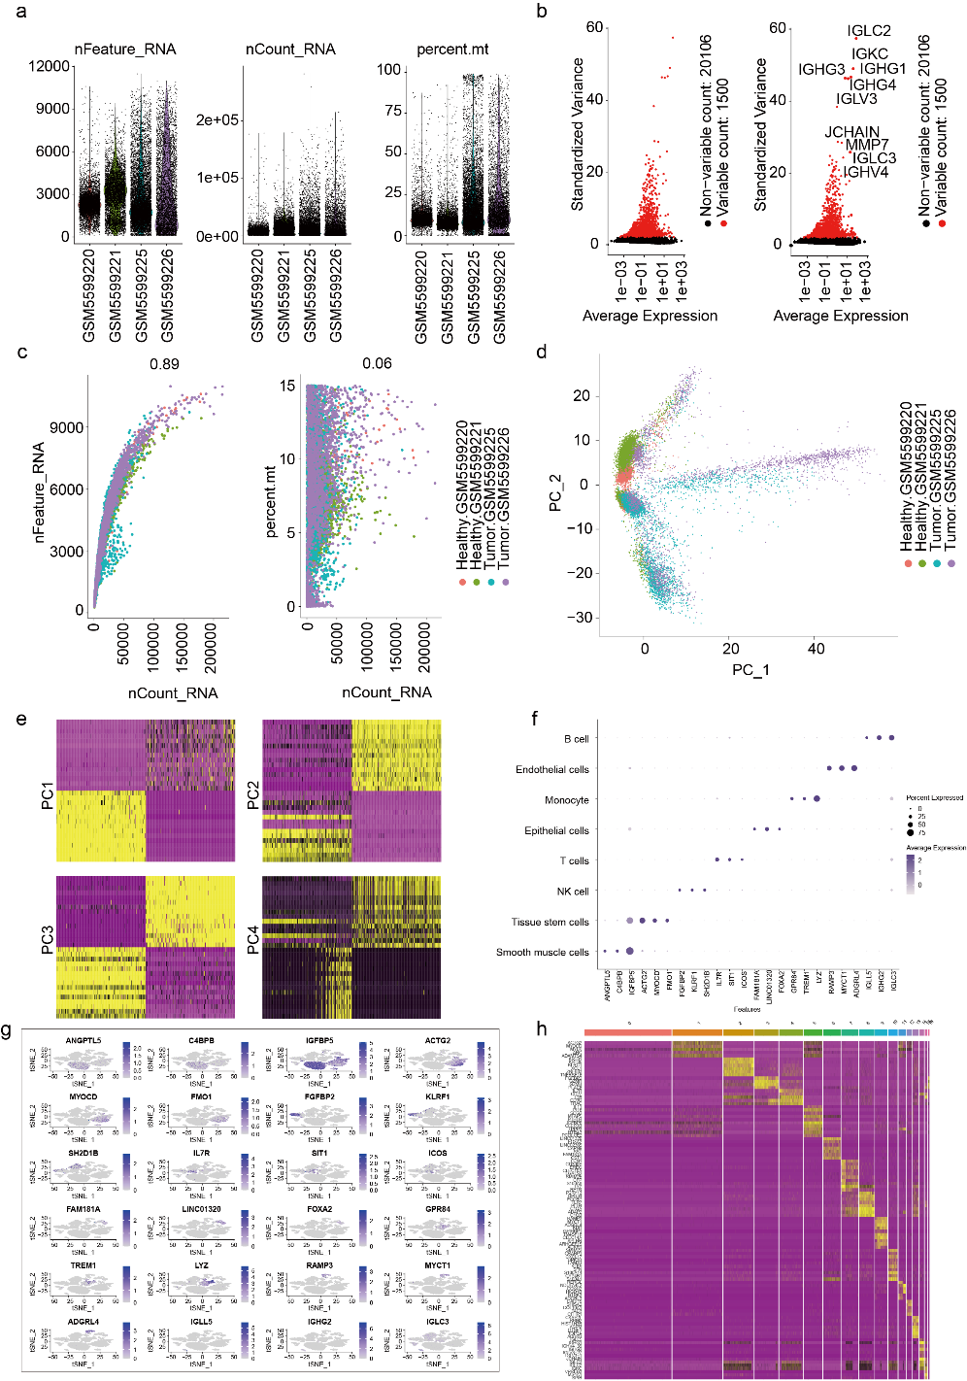
Fig. S1. Quality control, normalization, and cell-type annotation of single-cell RNA-seq data.
a, Quality control metrics of each sample, including number of detected genes (nFeature_RNA), total UMI counts (nCount_RNA), and percentage of mitochondrial genes (percent.mt).
b, Identification of highly variable genes across cells based on average expression and standardized variance.
c, Relationships between UMI counts and gene counts (left), and between UMI counts and mitochondrial gene percentage (right), color-coded by sample and condition (Healthy vs Tumor).
d, Principal component analysis (PCA) of all cells, showing sample clustering in PC1–PC2 space.
e, Heatmaps of top loading genes from PC1 to PC4, showing gene contributions to each principal component.
f, Dot plot showing the expression of canonical marker genes across cell clusters, supporting cell-type annotation.
g, Feature plots displaying expression of selected marker genes in t-SNE space for different cell types.
h, Heatmap of top marker genes per cluster used for final cell-type identification.

Fig. S2
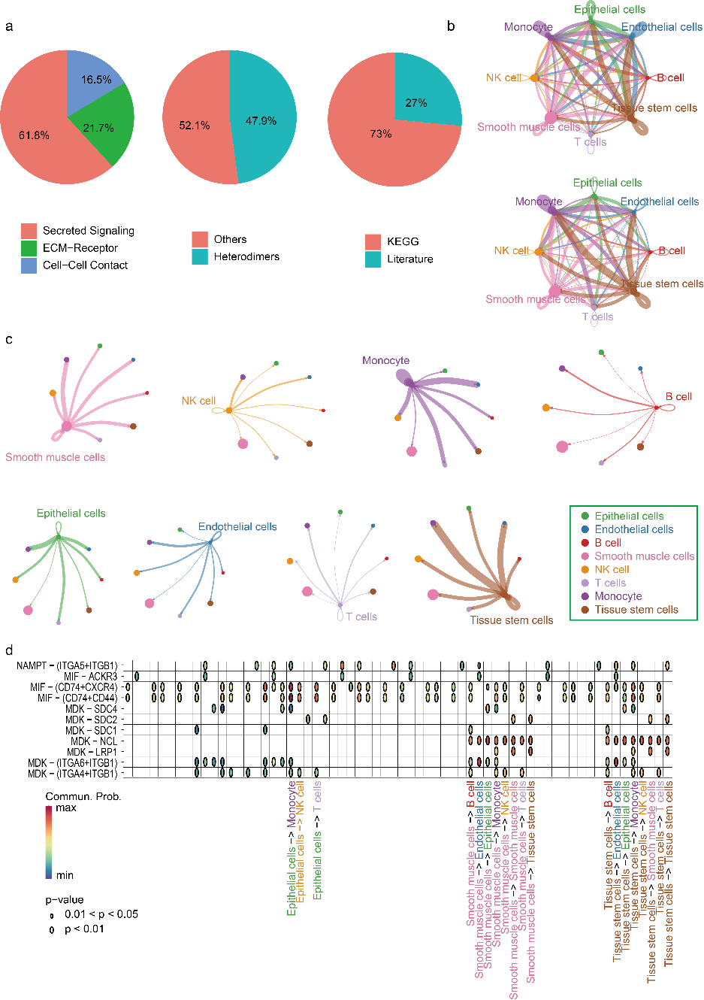
Fig. S2. Intercellular communication network analysis in ovarian cancer microenvironment.
a, Pie charts showing the distribution of inferred signaling pathways based on CellChat classification: secreted signaling, ECM–receptor interaction, and cell–cell contact (left); interaction source classification as heterodimers or others (middle); and evidence source classification as KEGG or literature-supported (right).
b, Circle plots displaying the overall intercellular communication networks among eight major cell types, with line thickness representing communication probability.
c, Cell-type–specific communication networks highlighting outgoing interactions from each cell type to others, indicating their influence within the microenvironment.
d, Heatmap of ligand–receptor pairs (e.g., MIF, MDK, NAMPT pathways) mediating significant interactions between cell types. Dot size indicates statistical significance (P < 0.05 or P < 0.01), and color represents communication probability.

Fig. S3
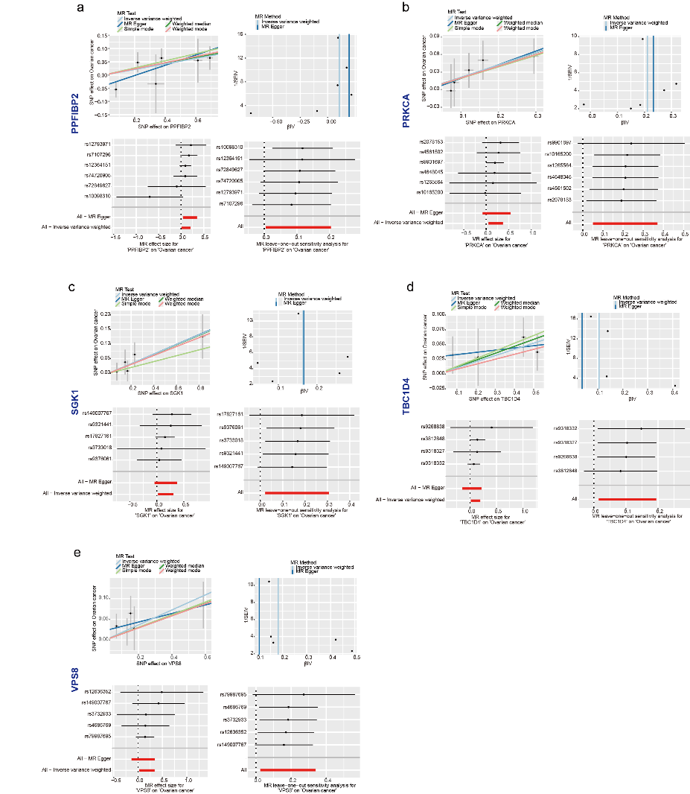
Fig. S3. Sensitivity analysis and robustness assessment of Mendelian Randomization (MR) for monocyte causal genes.
a–e, MR sensitivity analyses for PPFIBP2 (a), PRKCA (b), SGK1 (c), TBC1D4 (d), and VPS8 (e) using four MR methods: inverse variance weighted (IVW), MR Egger, weighted median, and weighted mode.
Each panel shows a scatter plot of SNP effect sizes on gene expression (x-axis) versus ovarian cancer risk (y-axis) with regression lines for different MR methods (top left), a funnel plot to assess directional pleiotropy (top right), a leave-one-out analysis evaluating the influence of individual SNPs (bottom left), and a forest plot of individual SNP effect sizes with confidence intervals (bottom right). These results confirm the robustness of MR findings and help exclude bias from horizontal pleiotropy or single-variant influence.

Fig. S4
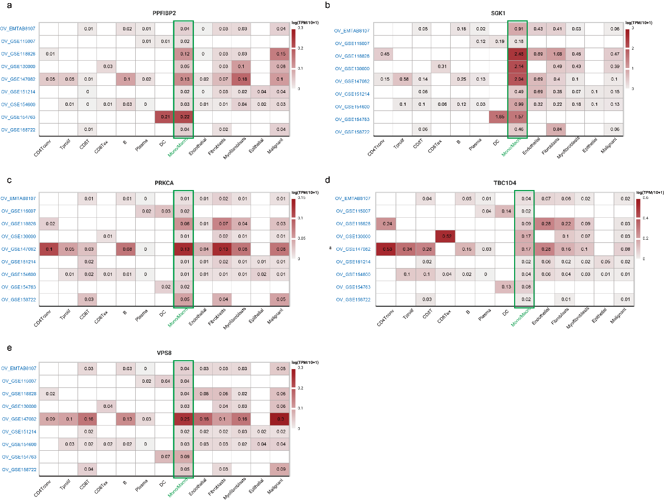
Fig. S4. Expression profiles of candidate causal genes across ovarian cancer immune microenvironment cell types.
a–e, Heatmaps showing the expression of PPFIBP2 (a), SGK1 (b), PRKCA (c), TBC1D4 (d), and VPS8 (e) across various immune and stromal cell types in ovarian cancer, based on multiple GEO datasets (listed on the left). Expression levels are represented as log(TPM/10 + 1), with numeric values within each cell indicating gene abundance in the corresponding cell type. Monocyte expression columns are highlighted in green. These results indicate that several candidate genes are consistently expressed in monocytes across datasets, supporting their functional relevance in the ovarian cancer microenvironment.

