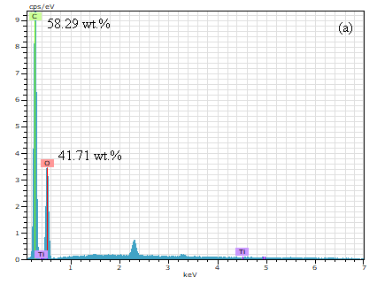
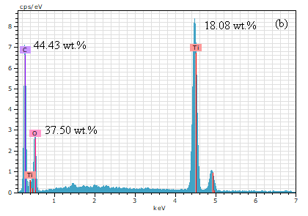
Fig. S1. EDX spectra of (a) GO and (b) TGP-50 samples.

Fig. S2. (a) The nitrogen adsorption-desorption isotherm and (b) Pore size distribution of bare TiO₂ and TGP-50 samples.

