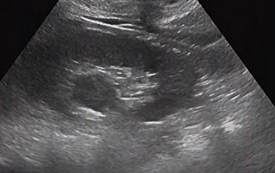  A | 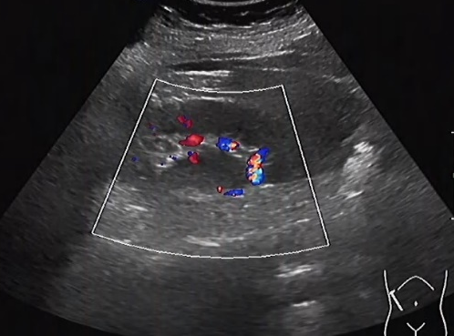  B | 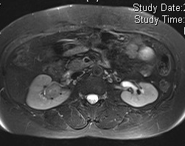  C
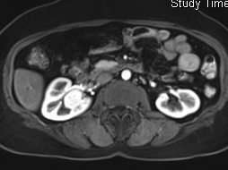  D | 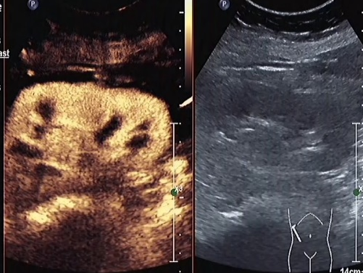  E | 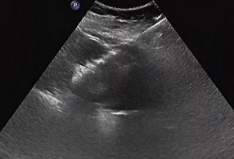  F
Suppl. Fig. 1 Multimodal imaging and interventional diagnosis of an eosinophilic renal adenoma in a 58-year-old female patient.
(A) Two-dimensional ultrasound (convex probe, 4 MHz) demonstrated a well-defined, round hypoechoic mass (24 mm × 23 mm, arrow) in the right renal sinus with homogeneous internal echoes, initially suspected to be a benign lesion.
(B) Color Doppler imaging (PRF 550 Hz, gain 60%) revealed a few short rod-like peripheral flow signals with no central perfusion, consistent with the vascular characteristics of a benign renal tumor.
(C) MRI T2-weighted imaging with fat suppression (slice thickness: 3 mm) showed a mildly hyperintense lesion with poorly defined margins, leading to an initial misdiagnosis of malignancy.
(D) Dynamic contrast-enhanced MRI (arterial phase) demonstrated homogeneous enhancement with persistent enhancement in the delayed phase, mimicking the enhancement pattern of renal cell carcinoma and resulting in radiologic misdiagnosis.
(E) Contrast-enhanced ultrasound using SonoVue® (mechanical index 0.09) showed uniform hyperenhancement in the arterial phase (arrow) followed by gradual washout in the portal and delayed phases, forming a “slow-in, slow-out” pattern consistent with eosinophilic adenoma.
(F) Ultrasound-guided percutaneous biopsy combined with radiofrequency ablation was performed using a 17G coaxial needle (ablation power: 30 W for 4 minutes). The ablation needle path (triangle marker) was visualized in real time. Pathological analysis confirmed eosinophilic adenoma (WHO grade I).
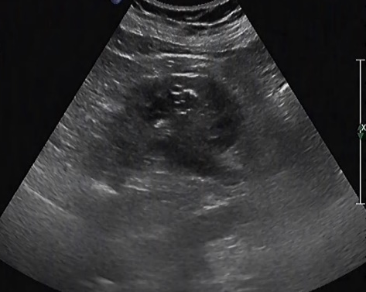  A | 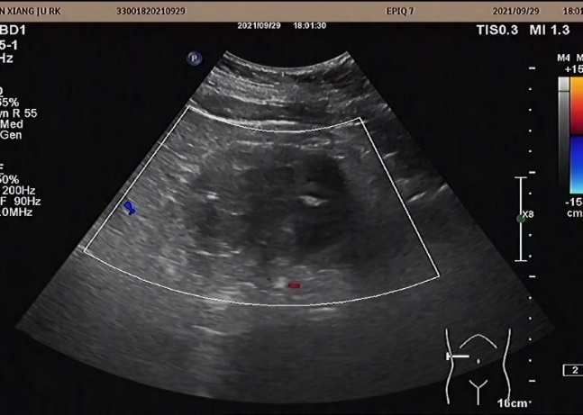  B | 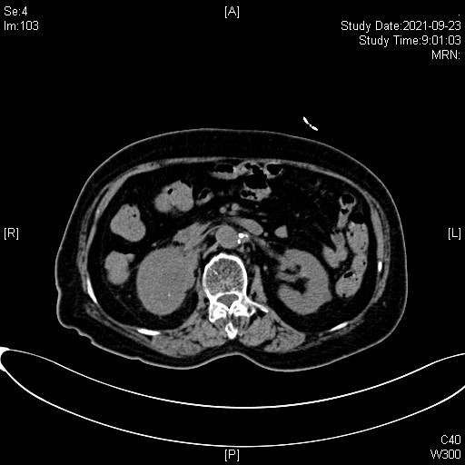  C
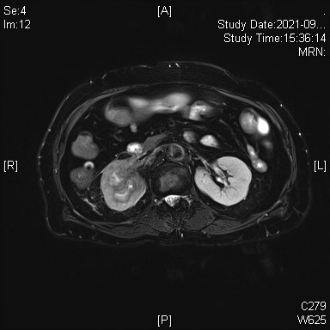  D | 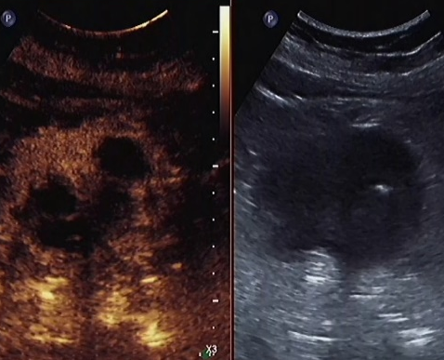  E | 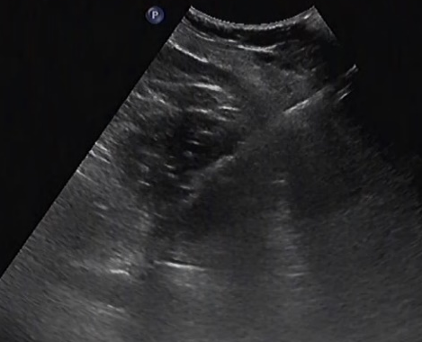  F
Suppl. Fig. 2 Multimodal imaging and diagnostic workflow of a 79-year-old female patient with renal pelvic carcinoma misdiagnosed as renal infection prior to biopsy.
(A) Two-dimensional ultrasound (linear probe, 7.5 MHz) revealed an irregular hypoechoic mass (31 mm × 25 mm, arrow) in the right renal sinus with poorly defined margins and an indistinct interface with the renal pelvis. The lesion was initially interpreted as an inflammatory process.
(B) Color Doppler imaging (PRF 600 Hz, gain 65%) showed scattered punctate flow signals within the lesion, with no apparent feeding vessels, suggesting a vascular pattern consistent with inflammation.
(C) Non-contrast-enhanced renal CT (slice thickness: 1 mm) demonstrated a hypodense lesion (CT value ~35 HU) in the right renal sinus with blurred surrounding fat planes (arrow), leading to a misdiagnosis of renal infection.
(D) Contrast-enhanced T1-weighted MRI (fat-suppressed sequence, slice thickness: 3 mm) revealed a low-signal lesion with ring-like enhancement of the adjacent renal pelvic wall. DWI showed restricted diffusion (ADC = 0.92 × 10⁻³ mm²/s).
(E) Contrast-enhanced ultrasound using SonoVue® (mechanical index 0.10) demonstrated persistently low enhancement throughout the lesion. The enhancement pattern was inconsistent with typical renal pelvic carcinoma, indicating overlapping imaging features.
(F) Ultrasound-guided percutaneous biopsy of the right renal sinus was performed using an 18G semi-automatic core needle at a 15° angle. The needle tip (triangle marker) and its trajectory were clearly visualized in real time. Pathology confirmed high-grade urothelial carcinoma (pT2N0M0).
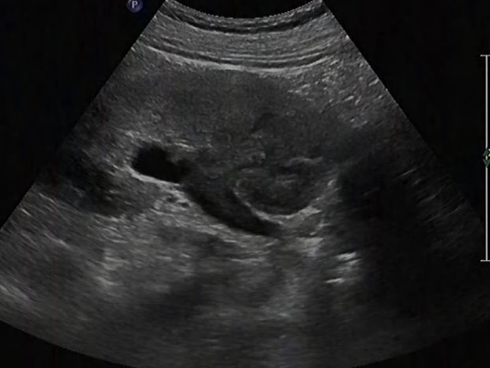  A | 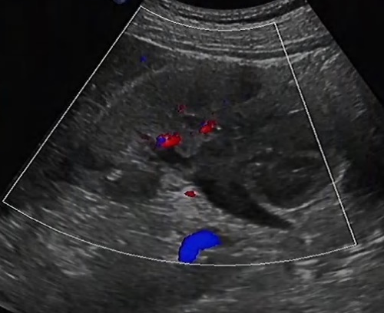  B | 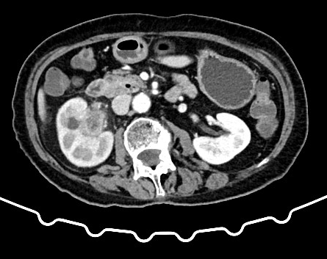  C
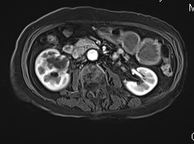  D | 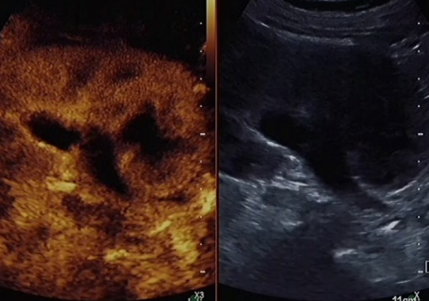  E | 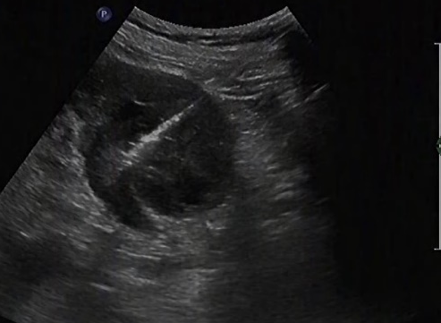  F
Suppl. Fig. 3 Multimodal imaging and interventional diagnosis of a right renal pelvic carcinoma in an 80-year-old female patient, confirmed by surgical pathology.
(A) Two-dimensional ultrasound (convex probe, 3.5 MHz) revealed an irregular hypoechoic mass (35 mm × 20 mm) in the right renal sinus with poorly defined margins and an indistinct interface with the renal pelvis. The lesion demonstrated an infiltrative growth pattern.
(B) Color Doppler imaging (PRF 700 Hz, gain 70%) showed scattered short rod-like flow signals within the lesion, suggesting moderate vascularity and a potential malignant nature.
(C) Contrast-enhanced CT (arterial phase, slice thickness: 1 mm, iodinated contrast agent) demonstrated a hypovascular lesion in the right renal sinus with a “fast-in, slow-out” enhancement pattern (arrow), accompanied by thickening of the adjacent renal pelvic wall, raising suspicion for renal pelvic carcinoma.
(D) MRI T1-weighted imaging with fat suppression (slice thickness: 3 mm) showed a mildly hyperintense lesion with infiltration into the surrounding fat space, further supporting a malignant diagnosis.
(E) Contrast-enhanced ultrasound using SonoVue® (mechanical index 0.12) demonstrated heterogeneous hypoenhancement of the lesion (arrow), with internal non-enhancing necrotic areas, consistent with the typical imaging features of renal pelvic carcinoma.
(F) Ultrasound-guided percutaneous biopsy of the right renal sinus was performed using an 18G fully automatic core needle at a 20° angle. The needle tip (triangle marker) and its trajectory were visualized in real time. Pathological analysis confirmed high-grade urothelial carcinoma (pT3N0M0).
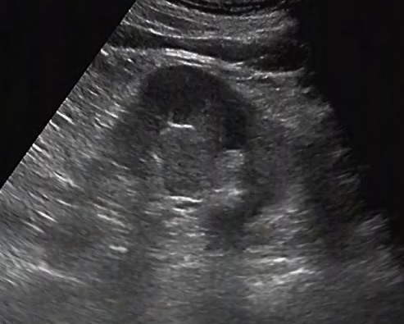  A | 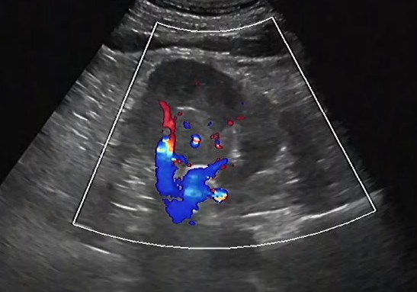  B | 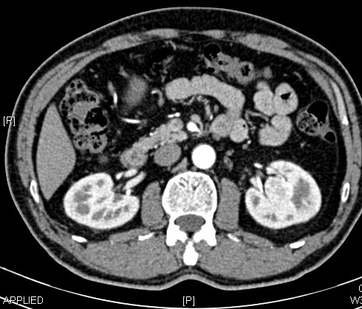  C
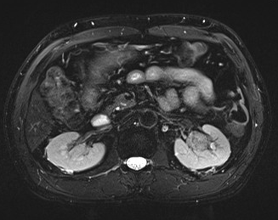  D | 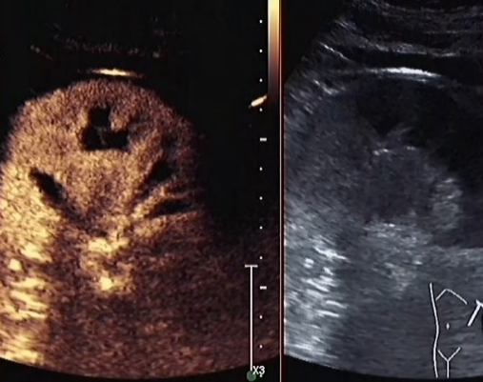  E | 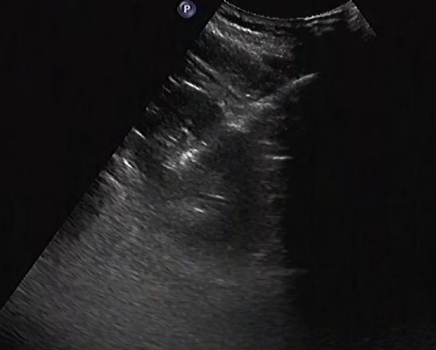  F
Suppl. Fig. 4 Multimodal imaging and interventional management of a 61-year-old male patient with clear cell renal cell carcinoma in the left kidney.
(A) Two-dimensional ultrasound (convex probe, 5 MHz) revealed a solid hypoechoic mass (25 mm × 20 mm, arrow) in the left renal sinus. The lesion had relatively well-defined margins and heterogeneous internal echoes with tiny calcifications. It was initially suspected to be malignant.
(B) Color Doppler imaging (PRF 750 Hz, gain 60%) demonstrated abundant branching intralesional blood flow, forming a characteristic "ball-of-vessels" sign, consistent with the typical vascular pattern of clear cell renal cell carcinoma (ccRCC).
(C) Contrast-enhanced CT (cortical phase, slice thickness: 1 mm, iodixanol contrast agent) showed marked heterogeneous enhancement of the lesion, with enhancement exceeding that of the renal cortex, displaying a “fast-in, fast-out” pattern suggestive of malignancy.
(D) MRI T2-weighted imaging with fat suppression (slice thickness: 3 mm) demonstrated a mixed-signal lesion with focal areas of incomplete fat suppression, leading to a misdiagnosis of angiomyolipoma (AML).
(E) Contrast-enhanced ultrasound using SonoVue® (mechanical index 0.15) revealed rapid arterial phase hyperenhancement (arrow) followed by swift washout in the portal phase, consistent with the enhancement profile of ccRCC.
(F) Ultrasound-guided percutaneous biopsy combined with microwave ablation was performed using an 18G coaxial needle. The ablation needle path (triangle marker) was monitored in real time. Pathological analysis confirmed clear cell renal cell carcinoma (Fuhrman grade III).

