Gene | Primer | Sequence (5'-3')
ZDHHC18-homo | Forward | ACCGGCCTCTTCTTCGTCT
ZDHHC18-homo | Reverse | AACTGCCTGTGTTGTCGATCT
ZDHHC9-homo | Forward | CCTGGGTGGGGAATTGTGTT
ZDHHC9-homo | Reverse | ACGACGGACCAGAGTGTAAAG
ZDHHC8-homo | Forward | CTGTTCCCGTCTACAATGGCA
ZDHHC8-homo | Reverse | GACCTGGATACCTCGCACAT
ZDHHC5-homo | Forward | CACCTGCCGCTTTTACCGT
ZDHHC5-homo | Reverse | CGGCGACCAATACAGTTATTCAC
ZDHHC20-homo | Forward | CGCACCCACGTTTTCATACG
ZDHHC20-homo | Reverse | TCTGGCATACTCATTCTGGTTTG
ZDHHC12-homo | Forward | GTGCTGACCTGGGGAATCAC
ZDHHC12-homo | Reverse | CTGCACATTCACGTAGCCA
ZDHHC11-homo | Forward | AGTGAACGGCTGGTCGTTAC
ZDHHC11-homo | Reverse | CCACGTAGGCAATGTATTTCCA
ZDHHC4-homo | Forward | TGATGGGTCTTGTTCTTATCTGC
ZDHHC4-homo | Reverse | AGGTGTGGTTTCTCGTATGGAA
ZDHHC24-homo | Forward | CTGGCACAGTTTGCCTTGG
ZDHHC24-homo | Reverse | CAGGGACCCAGGTCATAGGAG
ZDHHC16-homo | Forward | ACTCCGGGGTCTAGTACAGC
ZDHHC16-homo | Reverse | CCAGCGGATCACGTTGTCT
ZDHHC7-homo | Forward | CTGACCGGGTCTGGTTCATC
ZDHHC7-homo | Reverse | CATGACGAAAGTCACCACGAA
ZDHHC3-homo | Forward | CCACTTCCGAAACATTGAGCG
ZDHHC3-homo | Reverse | CCACAGCCGTCACGGATAAA
ZDHHC22-homo | Forward | GGGGCGCTCTTCCTATTCC
ZDHHC22-homo | Reverse | GCAGAAGTGGGTGCTAGGTG
ZDHHC13-homo | Forward | ACCCCACTCTTATTGATGGAGA
ZDHHC13-homo | Reverse | TGTCTGCCCATTTACATCTGTC
ZDHHC6-homo | Forward | ATGGGTACGTTCTGTTCGGTT
ZDHHC6-homo | Reverse | AAGGGCCAATACCACAACACA
ZDHHC2-homo | Forward | GTCTGGAGCCATCCGATACTG
ZDHHC2-homo | Reverse | AATCTGTTGCCGCAATAAAAAGG
ZDHHC15-homo | Forward | ATTGTCCTCGTCGTGCTCTG
ZDHHC15-homo | Reverse | ACTTCTGGTTTGGCTGCTGT
ZDHHC19-homo | Forward | TTGCTGCCTTCAATGTGGTG
ZDHHC19-homo | Reverse | CGGAGCCTTGATGTAAGATGC
ZDHHC1-homo | Forward | CAAGCCCTCCAACAAGACG
ZDHHC1-homo | Reverse | CCAAAGCCGATCACAGCAAAG
ZDHHC23-homo | Forward | TCTGGATGAAGGGTGTGATCG
ZDHHC23-homo | Reverse | GCTCCCCTAAGCCAAGGAA
ZDHHC17-homo | Forward | GGCCCGGATGAGTACGATAC
ZDHHC17-homo | Reverse | TCCAAGAGGTTCACCATATCCA
ZDHHC14-homo | Forward | TGTGATAACTGCGTAGAACGGT
ZDHHC14-homo | Reverse | CGTGGGTGATAACGAATGCAA
ZDHHC21-homo | Forward | TGTTGTTGACCCACATGGTTG
ZDHHC21-homo | Reverse | GAGGCCCTCACTAAGGCAA
LYPLA1-homo | Forward | CCTTTGCAGGTATCAGAAGTTCA
LYPLA1-homo | Reverse | GCTGCCTGTTTAATCCCAGAT
LYPLA2-homo | Forward | AGGCAGCTAATGGCAGTGC
LYPLA2-homo | Reverse | AGGTGTGACAACAGACCGGA
ABHD17C-homo | Forward | ACTGTCCCCACGGTAGACTT
ABHD17C-homo | Reverse | TGTCAATGCTGGGGAAAGCA
ABHD17A-homo | Forward | GAGGCTCACTTCCGTCCG
ABHD17A-homo | Reverse | GCAACCACAGGTCTCCATGT
ABHD17B-homo | Forward | TGCTTGGCTTGCTCTTAG
ABHD17B-homo | Reverse | CAGTAGGTCTTCTTGGTATCA
PPT2-hom | Forward | CCTCAAGGGGTGCATCTCATC
PPT2-hom | Reverse | TCAAGTAGTCCGTGTCTCCAT
PPT1-homo | Forward | TGTTTTTGGACTCCCTCGATG
PPT1-homo | Reverse | CATGCCAGTATTCGGCTTGC
AL031985.3- human | Forward | GTTTCGTTTGGCTCAAGGGC
AL031985.3- human | Reverse | GGCTCCAAGACAGCATTACA
NRAV-human | Forward | GGAGTTGATGCCTCCGAACA
NRAV-human | Reverse | ATGACCGGAGCTGAAAGGTG

Supplementary Table 1. The primer pairs utilized in Real-Time Quantitative PCR.
Supplementary Figure 1 includes a total of 24 images. To maintain image quality, individual images are supplied separately.
Effect of PPT1 expression level on LIHC patient survival

Effect of PPT2 expression level on LIHC patient survival
Effect of ZDHHC1 expression level on LIHC patient survival

Effect of ZDHHC2 expression level on LIHC patient survival
Effect of ZDHHC3 expression level on LIHC patient survival

Effect of ZDHHC4 expression level on LIHC patient survival
Effect of ZDHHC5 expression level on LIHC patient survival

Effect of ZDHHC6 expression level on LIHC patient survival

Effect of ZDHHC7 expression level on LIHC patient survival

Effect of ZDHHC8 expression level on LIHC patient survival
Effect of ZDHHC9 expression level on LIHC patient survival

Effect of ZDHHC11 expression level on LIHC patient survival
Effect of ZDHHC12 expression level on LIHC patient survival
Effect of ZDHHC13 expression level on LIHC patient survival Effect of ZDHHC14 expression level on LIHC patient survival

Effect of ZDHHC15 expression level on LIHC patient survival
Effect of ZDHHC16 expression level on LIHC patient survival

Effect of ZDHHC17 expression level on LIHC patient survival Effect of ZDHHC18 expression level on LIHC patient survival

Effect of ZDHHC19 expression level on LIHC patient survival Effect of ZDHHC20 expression level on LIHC patient survival

Effect of ZDHHC21 expression level on LIHC patient survival Effect of ZDHHC22 expression level on LIHC patient survival

Effect of ZDHHC23 expression level on LIHC patient survival Effect of ZDHHC24 expression level on LIHC patient survival

Effect of LYPLA1 expression level on LIHC patient survival Effect of LYPLA2 expression level on LIHC patient survival

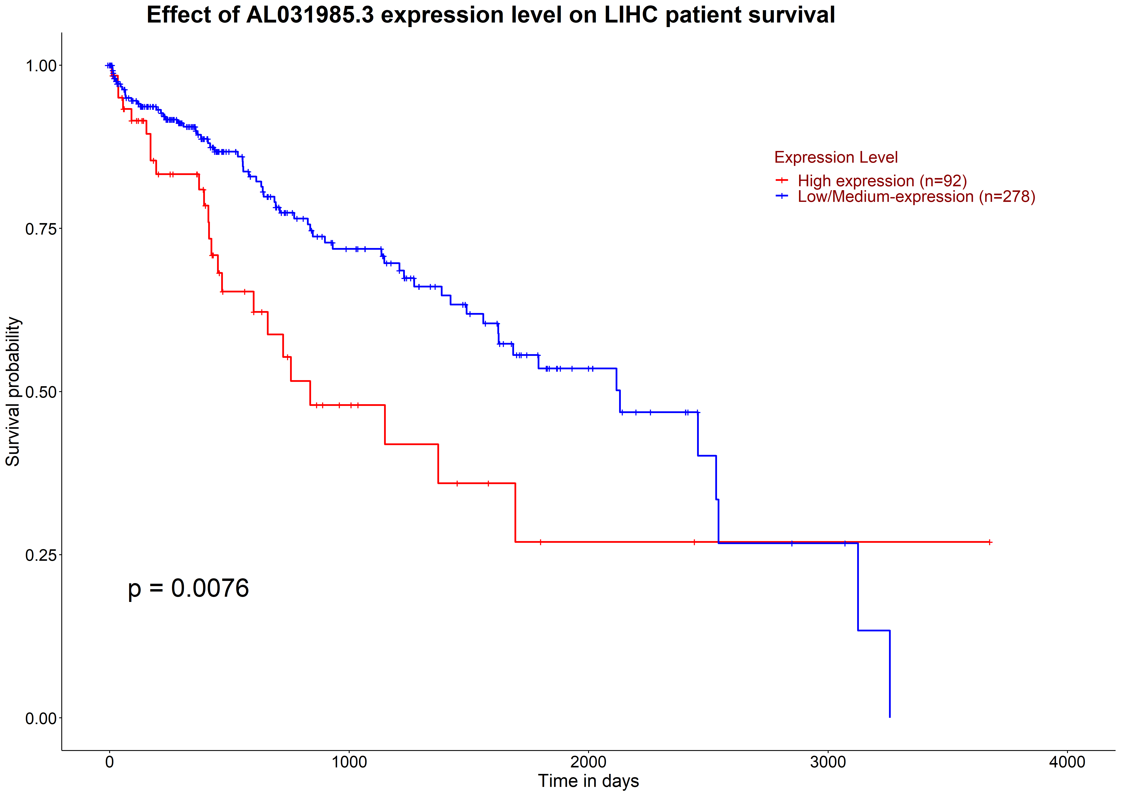 Effect of AL031985.3 expression level on LIHC patient survival
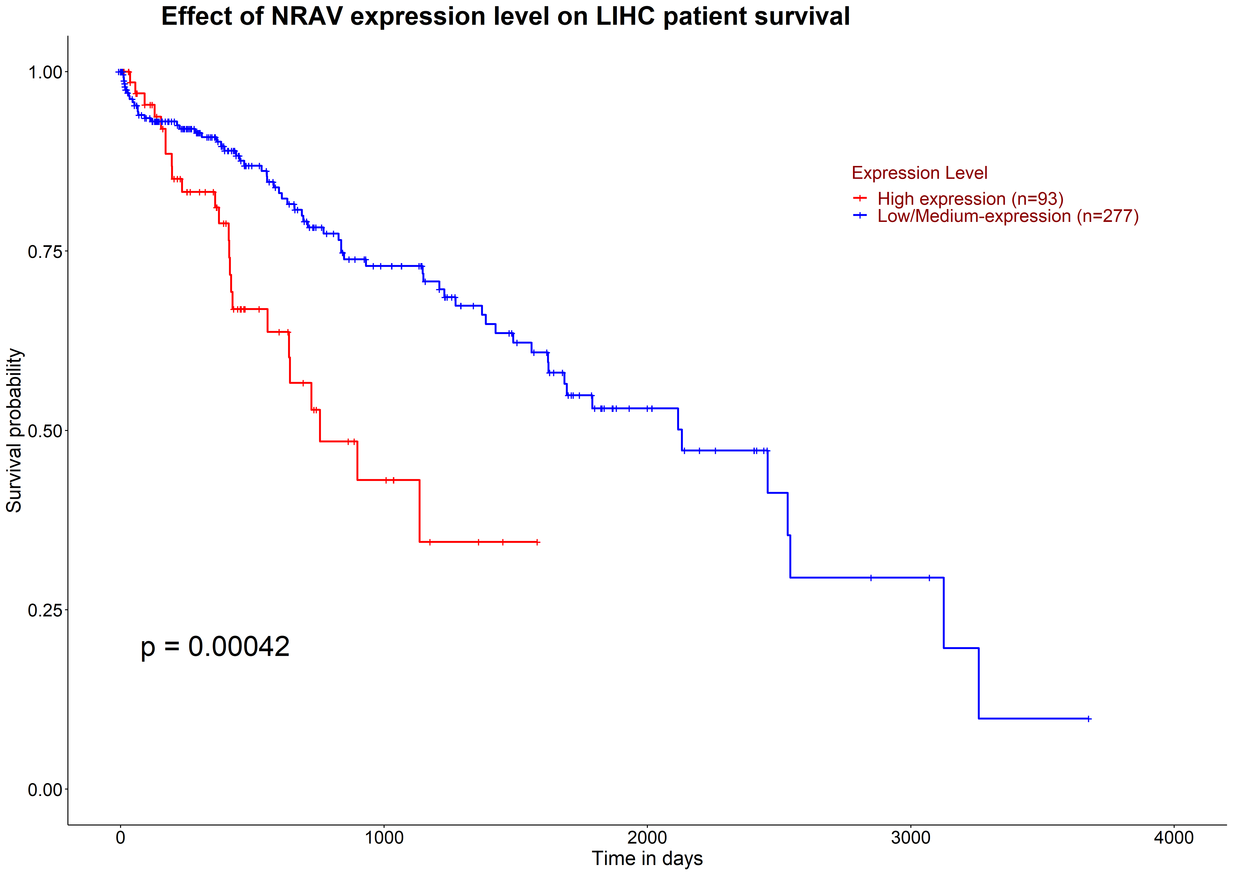 Effect of NRAV expression level on LIHC patient survival
Supplementary Figure 2: Differential analysis of drug sensitivity in HCC patients with different risk groups. Supplementary Figure 2 includes a total of 144 images. To maintain image quality, individual images are supplied separately.

