Encouraging the work process of oral health teams can favour the planning of their actions in Primary Health Care

Livia Fernandes Probst^{1,2}, Estêvão Azevedo Melo¹, Elaine Pereira da Silva Tagliaferro³, Alessandro Diogo De-Carli⁴, Antonio Carlos Pereira¹

¹Piracicaba Dental School. State University of Campinas (UNICAMP). Piracicaba, Brazil.
²Health Technology Assessment Unit. Hospital Alemão Oswaldo Cruz (HAOC). São Paulo, Brazil
³School of Dentistry. São Paulo State University (UNESP). Araraquara, Brazil.
⁴Faculty of Dentistry. Federal University of Mato Grosso do Sul (UFMS). Campo Grande, Brazil.

Supplementary Material
S1. Presentation of the definition of the analysed variables.
The information described here is available to the public through the link: https://aps.saude.gov.br/ape/pmaq/ciclo3/.
The PMAQ-AB, created in 2011, has a Cross-sectional Strategic Development axis, which comprises a continuous cycle of improved access and quality in Primary Health Care (PHC). In 2017, the External Evaluation of the 3rd cycle of the PMAQ took place, in partnership with Education and Research Institutions (ERI) across the country, of recognized experience in evaluation research in the organization and development of fieldwork. It was the responsibility of the associate ERIs to select and train the field work teams, consisting of supervisors and interviewers.
In total, data from 38,865 Family Health teams, 25,090 Oral Health teams, 4,110 Expanded Family Health and Primary Care Centers, 30,346 Family Health Units and 140,444 users were made available. For the purpose of this study, the Module VI data collection instrument (Interview with the Oral Health Team professional) of the external assessment and the Electronic Module data collection instrument, used to obtain additional information to that of the External Assessment, were utilized. In addition to these data, socioeconomic indicators of the municipalities were selected.
The variables were defined according to the model shown in Figure 1.
Figure 1 Guiding model for the definition of variables that could be associated with the outcome.
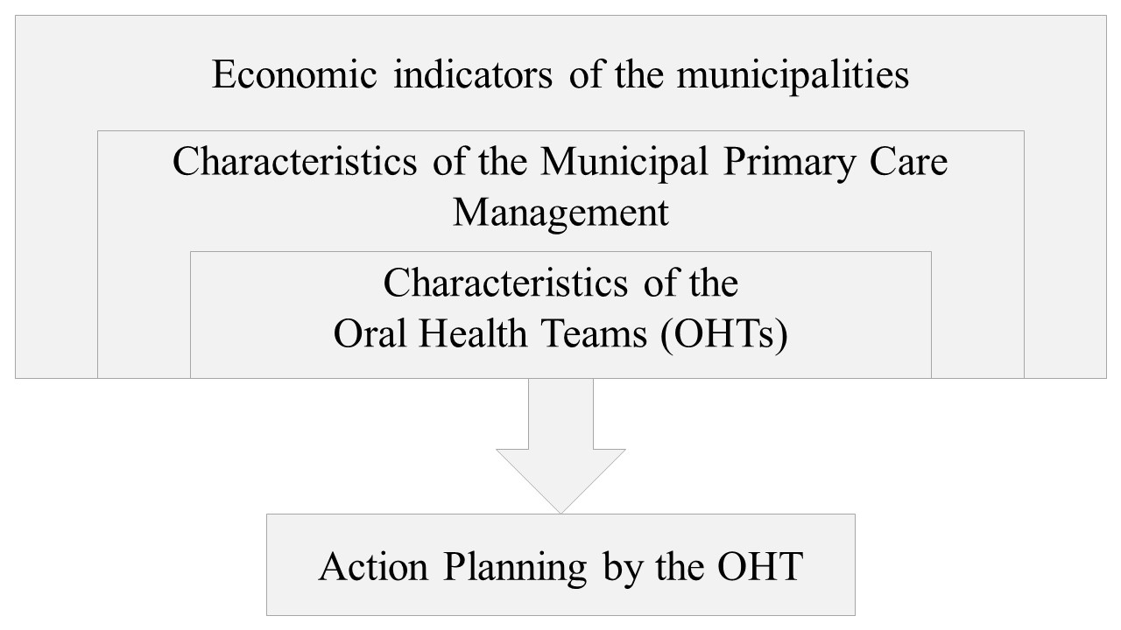

The choice of variables is more clearly presented below:
1. Definition of the outcome variable:
Question 3.3 of the Module VI instrument included the following statement: “Does the Oral Health Team carry out any activities for the planning of its actions?” For this question, the presentation of a supporting document was requested and, therefore, we considered as 'Yes' the teams that answered affirmatively and also proved the answer by presenting a document.
2. Definition of OHT-related variables:
We selected in the Module VI instrument the questions that could, hypothetically hinder or facilitate planning. For the questions in which a supporting document was requested for the answer, we considered as 'Yes' the teams that answered affirmatively and also proved the answer by presenting a document.
Questions from item 3 - Territorialization and Reference Population of the Oral Health Team:
• Number of assisted PHC teams
• Frequency with which the OHT attends users outside its coverage area
The greater the number of PHC teams that an OHT attends and the greater the frequency of assistance to users outside the coverage area, hypothetically more time is spent only in clinical care, making it more difficult to find opportune moments for planning. In these scenarios, we hypothesized that oral health actions were performed by improvisation and not through planning.
Questions from item 4 - Planning, Monitoring and Assessment:
• The OHT participates in meetings together with the PHC teams
• The OHT performs case and therapeutic project discussions
• eSB performs self-assessment process
• Self-assessment instrument used
Hypothetically, the more integrated into teamwork, participating in joint meetings and discussing cases and therapeutic projects, the more prepared the OHT will be to participate and develop activities for planning health actions. In turn, hypothetically, the self-assessment process can help the team to reflect on its actions and readjust what should be deemed appropriate and feasible in the local context.
Questions from item 7 - Organization of the Agenda and Offer of Team Actions:
• The OHT carries out actions together with other social facilities in the territory
• The OHT performs embracement together with PHC teams
• The OHT uses protocols/criteria for the embracement conduct
• The OHT professionals who carry out the embracement were trained to assess and classify the users’ risk and vulnerability
Hypothetically, performing the embracement together with the PHC teams and training to assess and classify the users’ risk and vulnerability can provide the professional with the necessary knowledge to identify and prioritize the perceived oral health needs.
3. Definition of variables related to PHC municipal management:
For the variables related to the PHC municipal management, we selected in the Electronic Module instrument the questions that could hypothetically stimulate or discourage the OHT from developing planning activities.
Questions from item 1 - Primary Health Care Management:
• It defines the number of patients under the responsibility of the primary health care team based on the risk and vulnerability criteria
Hypothetically, when the management plans the number of patients under the responsibility of the primary health care team based on risk and vulnerability criteria, the manager understands the importance of adjusting the number of professionals to places of greater vulnerability, preventing professionals from working only in care.
Questions from item 4 - Permanent Education:
• Offers Permanent Health Education at the municipal level that includes primary health care
• Has financial resources aimed at Permanent Education
• Stimulates actions of the Education Program through Work for Health (PET Saúde)
• Stimulates actions of the National Program for the Reorientation of Professional Training in Health (PRO-Saúde)
• Defines Permanent Education actions based on the demands of professionals/teams
• Defines Permanent Education actions based on the needs of the population
• Defines Permanent Education actions based on the State government offers
• Defines Permanent Education actions based on the Federal government offers
• Has representation in Teaching-Service Integration Commissions (CIES)

The Ministry of Health in Brazil defines Permanent Health Education (PHE) as learning at work, where learning and teaching are incorporated into the daily routines of organizations and work [1]. PHE is based on meaningful learning and on the possibility of transforming professional practices and takes place during the daily routine of work [1]. Based on this definition and the fact that there is a National Policy on Permanent Education in Health since 2007 in Brazil, we hypothesize that municipalities in which the manager provides PHE actions have more prepared professionals to carry out the planning.
4. Definition of variables related to socioeconomic indicators of municipalities:
• Social Vulnerability Index (SVI): Ranges from 0 to 1 and the closer to 1, the greater the social vulnerability of a municipality
• Municipal Human Development Index (M-HDI): Ranges from 0 to 1 and the closer to 1, the greater the human development of the municipality
• Social Prosperity: Level of social prosperity of the territoriality, generated by crossing its M-HDI and SVI ranges.
• Illiteracy rate of the population aged 18 and over: Ratio between the population aged 18 and over who cannot read or write a simple note and the total number of people in this age group multiplied by 100
• Gini Index: A value equal to zero (0) represents a situation of total equality in terms of income. A value equal to one (1) is at the opposite extreme, that is, wealth is accumulated in one person/group.
The prevalence of major oral diseases is known to be associated with socioeconomic issues [2]. Therefore, we consider it relevant to include these variables, considering that scenarios of greater socioeconomic vulnerability can be more challenging for action planning.

References
1. Brasil. Política Nacional de Educação Permanente em Saúde: o que se tem produzido para o seu fortalecimento? 2018. https://bvsms.saude.gov.br/bvs/publicacoes/politica_nac_prom_saude.pdf.
2. Bernabe E, Marcenes W, Hernandez CR, Bailey J, Abreu LG, Alipour V, et al. Global, Regional, and National Levels and Trends in Burden of Oral Conditions from 1990 to 2017: A Systematic Analysis for the Global Burden of Disease 2017 Study. J Dent Res. 2020;99:362–73.

