Supplementary Information
In vivo activation of pH-responsive oxidase-like graphitic-nanozymes for selective killing of Helicobacter pylori

Lufeng Zhang¹, Liang Zhang¹, Hui Deng¹, Huan Li², Wentao Tang¹, Luyao Guan¹, Ye Qiu¹, Michael J Donovan¹, Zhuo Chen¹ & Weihong Tan^{1,3}

¹Molecular Science and Biomedicine Laboratory, State Key Laboratory of Chemo/Bio-Sensing and Chemometrics, College of Chemistry and Chemical Engineering, College of Biology, Hunan Provincial Key Laboratory of Biomacromolecular Chemical Biology, Hunan University, Changsha, 410082, China
²Department of Gastroenterology, the Third Xiangya Hospital of Central South University, Changsha, 410013, China
³The Cancer Hospital of the University of Chinese Academy of Sciences, Institute of Basic Medicine and Cancer (IBMC), Chinese Academy of Sciences, Hangzhou, Zhejiang, 310022, China
These authors contributed equally: Lufeng Zhang, Liang Zhang.

*E-mail: zhuochen@hnu.edu.cn

Supplementary Figures
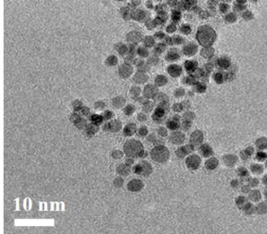
Supplementary Figure 1. TEM image of PtCo@G.
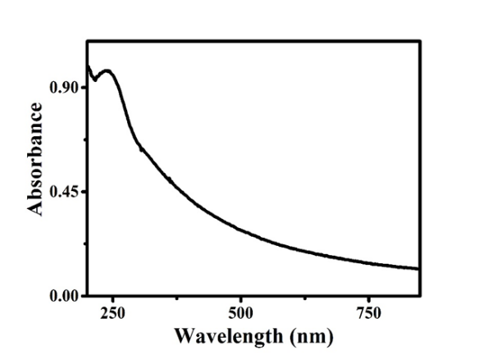
Supplementary Figure 2. UV-Vis absorbance of PtCo@G solution.
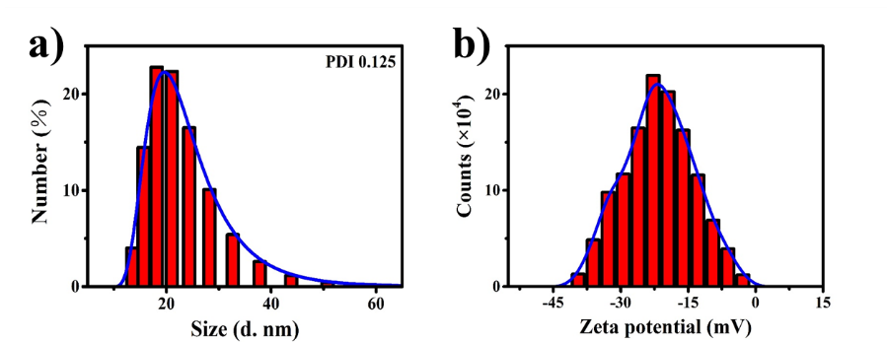
Supplementary Figure 3. (a) Hydrodynamic diameter and (b) Zeta potential of PtCo@G characterized by dynamic light scattering.

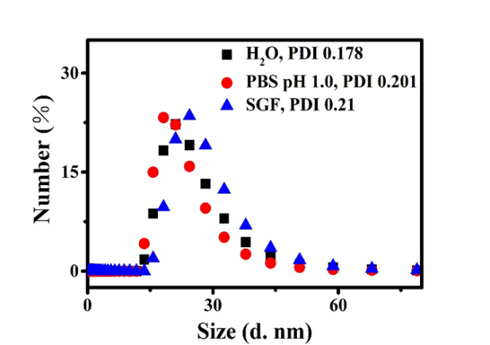
Supplementary Figure 4. Hydrodynamic diameter of PtCo@G in H₂O, PBS (pH 1.0), and SGF after 12 h incubation.
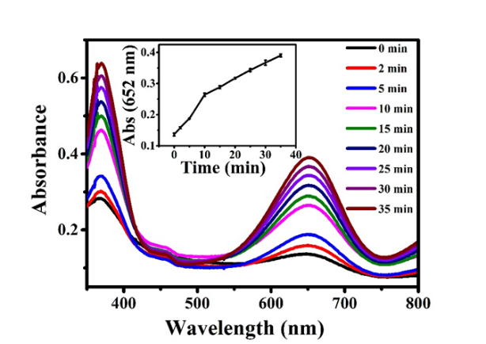
Supplementary Figure 5. Time-dependent absorbance spectra of TMB catalyzed by PtCo@G.
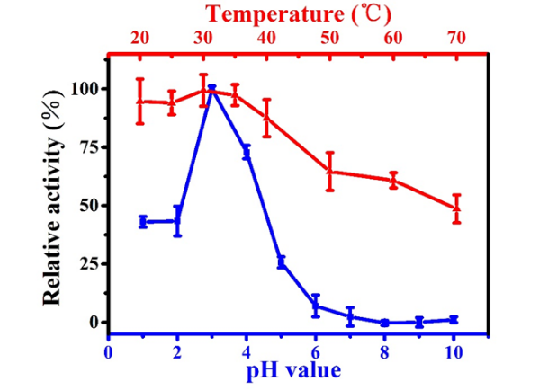
Supplementary Figure 6. The oxidase-like activity of PtCo@G is dependent on pH and temperature. The data indicate the means and SD from three parallel experiments.

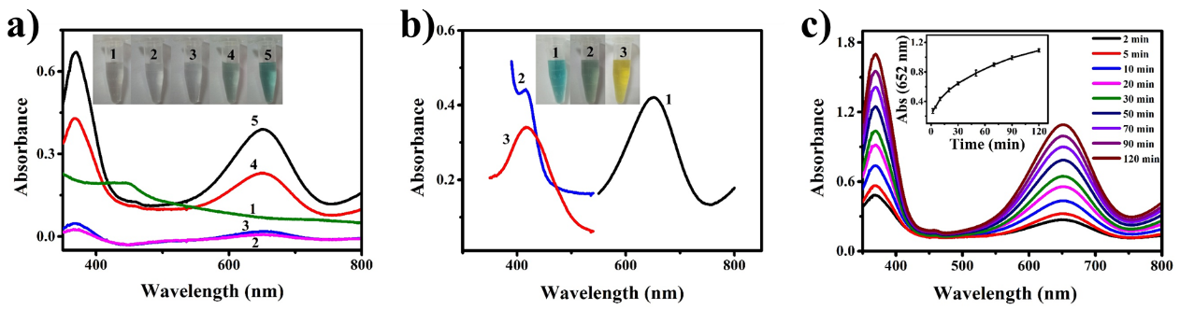
Supplementary Figure 7. Peroxidase-like activity of PtCo@G nanocrystals. (a) The UV-Vis absorbance spectra and visual color changes of TMB in different reaction systems: (1) PtCo@G, (2) TMB, (3) TMB+H₂O₂, (4) PtCo@G+TMB, and (5) PtCo@G+TMB+H₂O₂ in a pH 4.0 PBS buffer after 10 min incubation. (b) PtCo@G catalyzes oxidation of various peroxidase substrates in the presence of H₂O₂ to produce different color reactions. (1) TMB, (2) ABTS, (3) OPD. Insert images show corresponding visual color changes. (c) Time-dependent absorbance spectra of TMB catalyzed by PtCo@G in the presence of H₂O₂. Data are presented as means ± standard deviation (s.d.). Error bars were based on s.d. of three independent experiments.
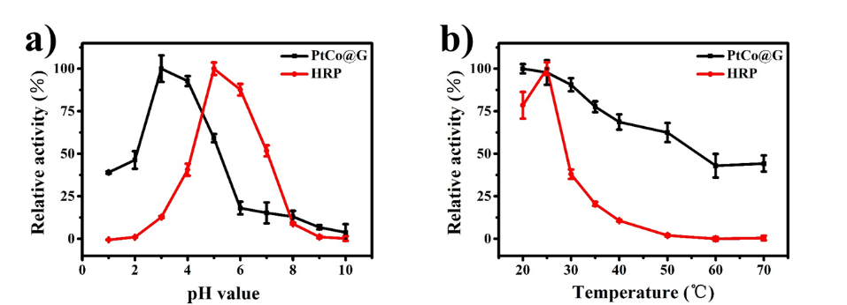
Supplementary Figure 8. Peroxidase-like activity of PtCo@G nanocrystals. (a) and (b) show that the peroxidase-like activity of PtCo@G is dependent on pH and temperature. Data are presented as means ± s.d. Error bars were taken from three independent experiments.
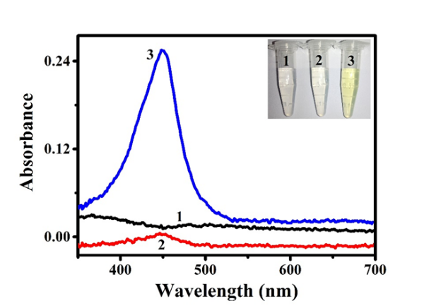
Supplementary Figure 9. Oxidase-like activity of the PtCo@G nanocrystals in PBS (pH 1.0) buffer: (1) PtCo@G, (2) TMB, (3) PtCo@G+TMB. Insert images show corresponding visual color changes.
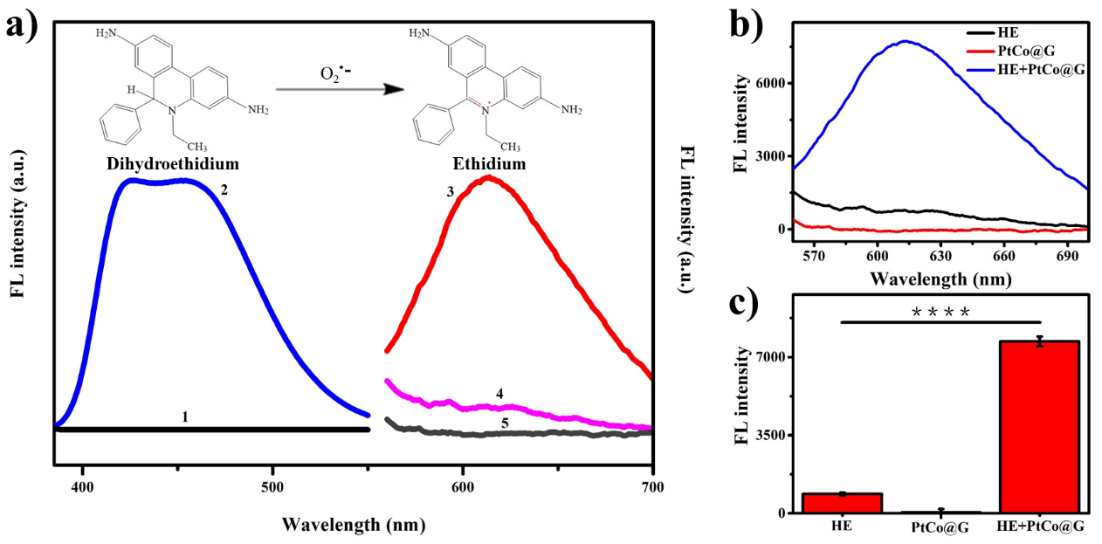
Supplementary Figure 10. (a) Fluorescence spectra of hydroethidine (HE) in different reaction systems: (1) PtCo@G+HE, (2) HE, (Excitation: 370 nm) (3) PtCo@G+HE, (4) HE, (5) PtCo@G (Excitation: 535 nm) in pH 1.0 PBS buffer after 30 min incubation. Insert shows the reaction of HE as a fluorescence probe for trapping the superoxide radical (O₂^{•-}). (b) Fluorescence spectra of hydroethidine (HE) before and after the addition of PtCo@G nanocrystals. (c) Histograms of FL intensity show the fluorescence product ethidium catalyzed by PtCo@G nanocrystals. P values were calculated by the Student’s t test: ****p < 0.0001. Data are presented as means ± s.d. Error bars were taken from three independent experiments.
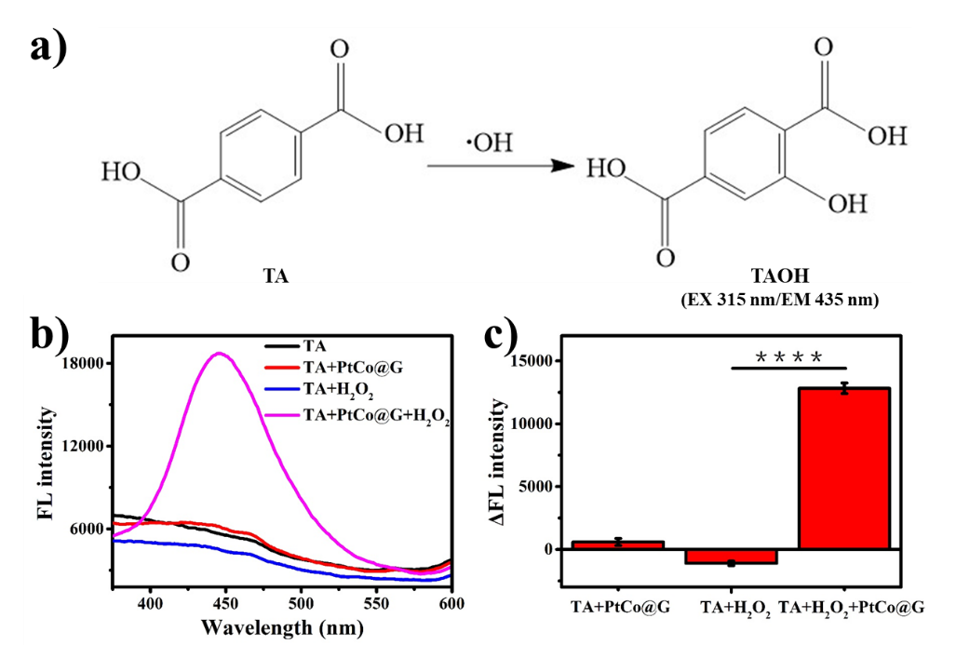
Supplementary Figure 11. (a) The reaction between terephthalic acid (TA) and hydroxyl radical (•OH). The fluorescence product is 2-hydroxy terephthalic acid (TAOH). (b) Fluorescence spectra of the PBS (pH 1.0) solution include only TA; TA and PtCo@G; TA and H₂O₂; TA, PtCo@G and H₂O₂. (c) Histograms of ΔFL intensity show the fluorescence product, 2-hydroxy terephthalic acid (TAOH) catalyzed by PtCo@G nanocrystals. P values were calculated by the Student’s t test: ****p < 0.0001. Data are presented as means ± s.d. Error bars were taken from three independent experiments.
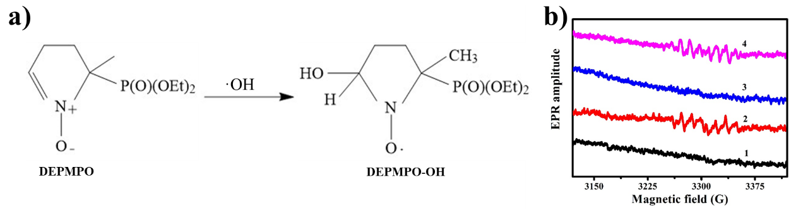
Supplementary Figure 12. (a) The reaction of DEPMPO trapping hydroxyl radical (•OH). (b) EPR spectra of DEPMPO-OH obtained by trapping •OH with the spin-trap agent DEPMPO in different reaction systems: (1) Fe²⁺+H₂O₂, (2) Fe²⁺+H₂O₂+DEPMPO, (3) PtCo@G+H₂O₂, (4) PtCo@G+H₂O₂+DEPMPO in pH 1.0 PBS buffer.
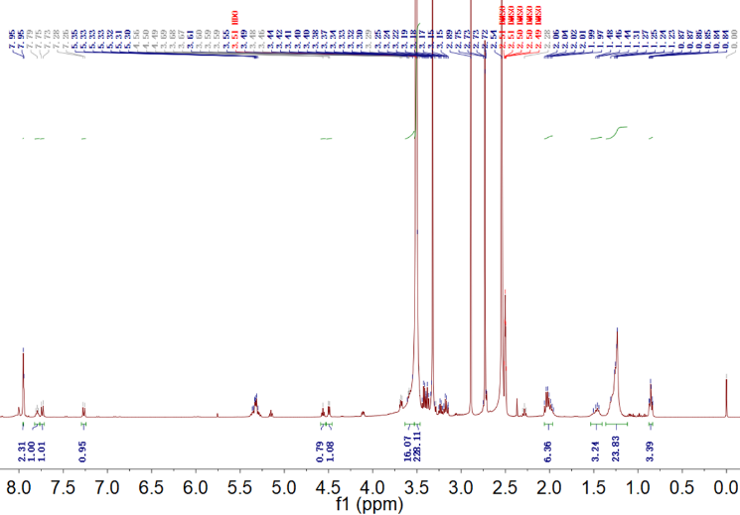
Supplementary Figure 13. ¹H-NMR characterization of C₁₈-PEGn-Benzeneboronic acid (CPB) with MQ 400 MHz.
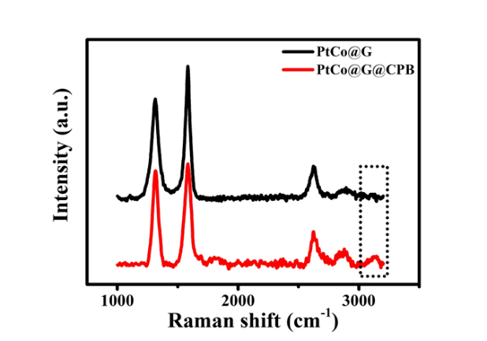
Supplementary Figure 14. Raman spectra characterization of CPB functionalized PtCo@G.
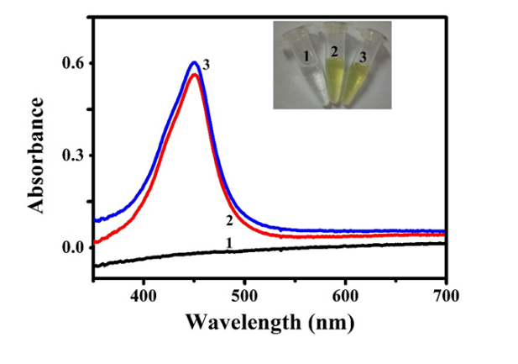
Supplementary Figure 15. The oxidase-like property comparison of PtCo@G and PtCo@G@CPB in SGF: (1) TMB, (2) PtCo@G+TMB, (3) PtCo@G@CPB+TMB. Insert images show corresponding visual color changes.
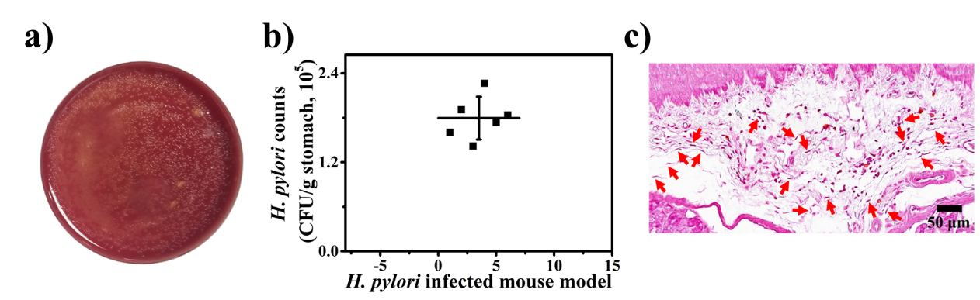
Supplementary Figure 16. Characterization of H. pylori-infected mouse model. (a) Photographs of H. pylori colonies after gastric mucosa reculture. (b) Quantification of bacterial burden in the stomach of H. pylori-infected mouse. (c) The gram staining of a slice from the gastric mucosa of H. pylori-infected mouse. Slice thickness, 5 μm.
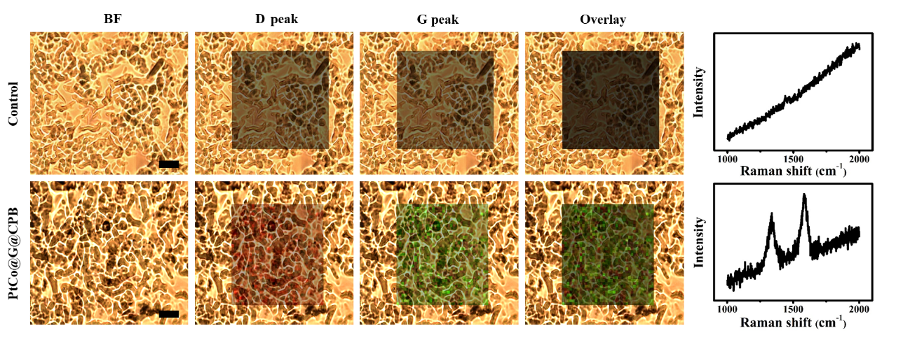
Supplementary Figure 17. Raman imaging and spectra of slice from the gastric mucosa. Scale bar: 20 μm, Slice thickness, 5 μm.

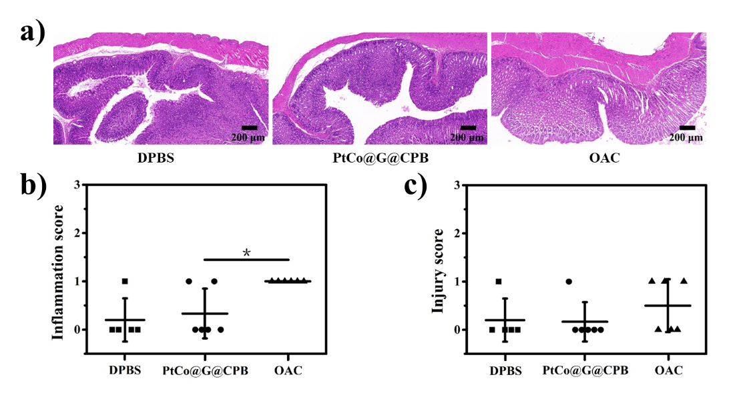
Supplementary Figure 18. (a) H&E staining of slice from the gastric mucosa after treatment with PBS, PtCo@G@CPB and OAC. Slice thickness, 5 μm. The inflammation score (b) and injury score (c) of gastric mucosa, according to the images of H&E staining.
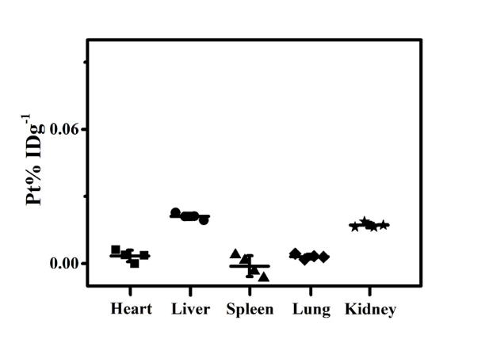
Supplementary Figure 19. The distribution of PtCo@G@CPB in organs (72 h) after treatment (n=4).

