Trimeric superoxide dismutase 1 antibody as a universal biomarker for ALS
Brianna Hnath^{1,2}, Rachel S. Dokholyan^{3,4}, Zachary Simmons⁴, and Nikolay V. Dokholyan^{1,2,5}

¹Department of Pharmacology, Penn State College of Medicine, Hershey, PA, USA
²Department of Biomedical Engineering, Pennsylvania State University, University Park, PA, USA
³Penn State Health Neuroscience Institute, Hershey, PA, USA
⁴Department of Neurology, Penn State College of Medicine, Hershey, PA, USA
⁵Department of Neurology, The University of Virginia, Charlottesville, VA, USA

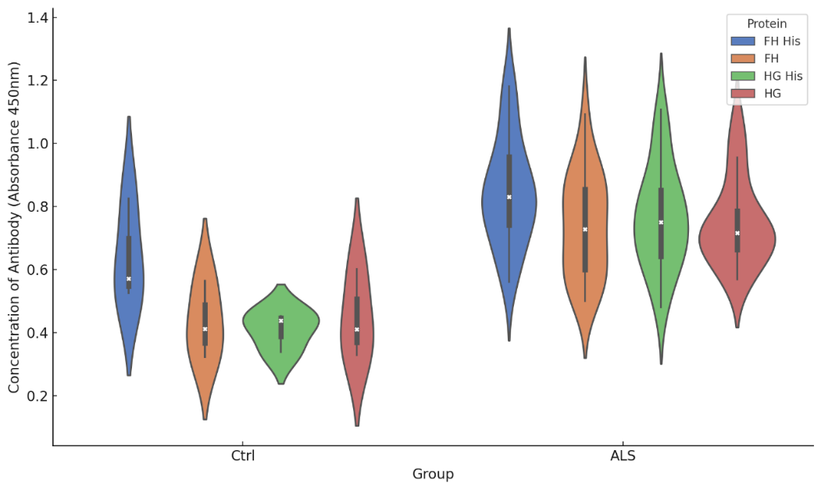
Figure S1. The presence of a 6X his tag on the purified protein does not affect the binding of ALS patient antibodies to trimer SOD1. (Ctrl n=3, ALS n=20)

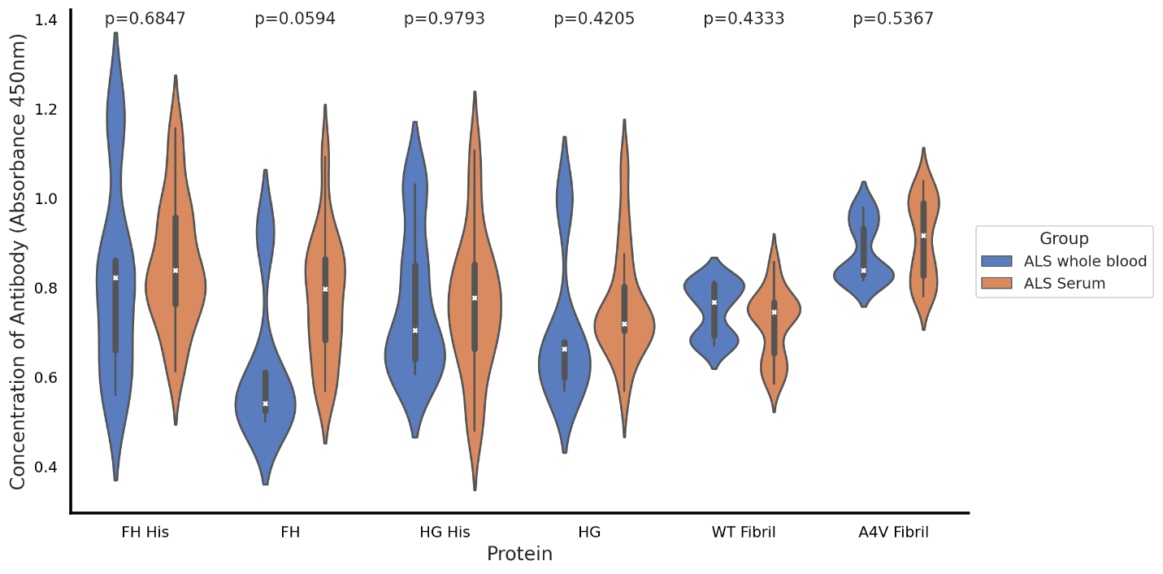
Figure S2. There was no significant difference in ALS patient antibody binding to whole blood versus serum (whole blood n=5, serum n=15).
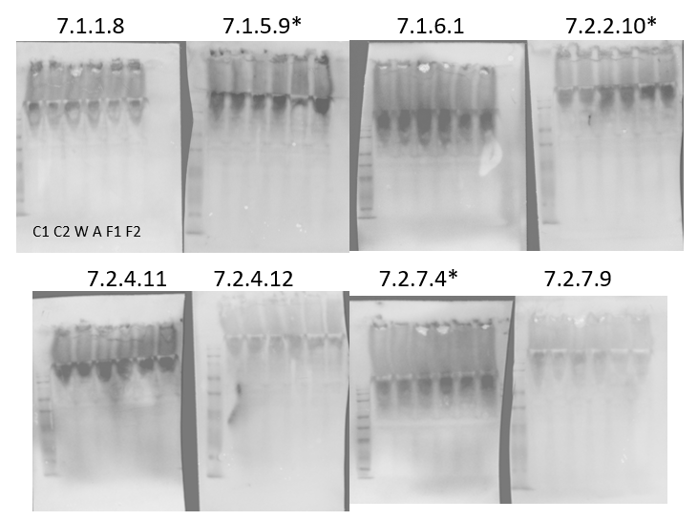

Figure S3. Native PAGE of motor neuron-like (NSC-34) cell lysate with no overexpression (C1 & C2), or overexpressing SOD1 WT (W), A4V (A), or F20L-H46Q (F1 & F2). 7.1.5.9, 7.2.2.10, and 7.2.7.4 have an observable increase in antibody signal with trimer stabilization and were selected for further testing.

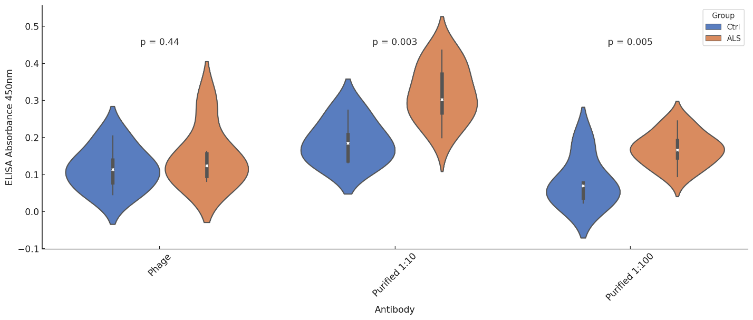
Figure S4. Removing the phage portion of the antibody improved non-specific binding allowing a significance difference in signal to be observed between the healthy control and ALS groups (n=5).
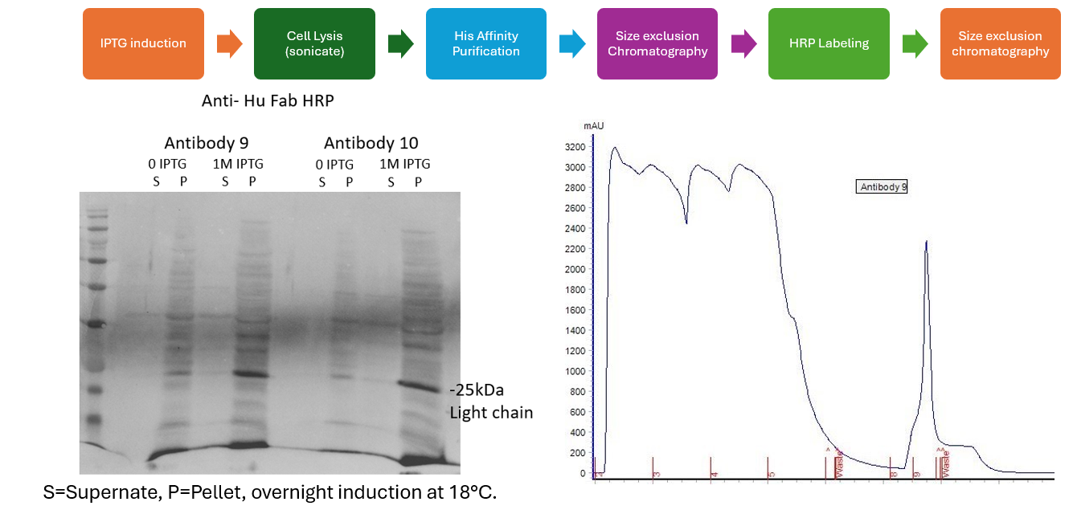
Figure S5. Antibody purification process, including the western blot showing the initial IPTG induced expression of the antibody and the chromatograph for the purification of the antibody using a His-tag affinity column (Cytiva HisTrap High Performance column, 5mL).

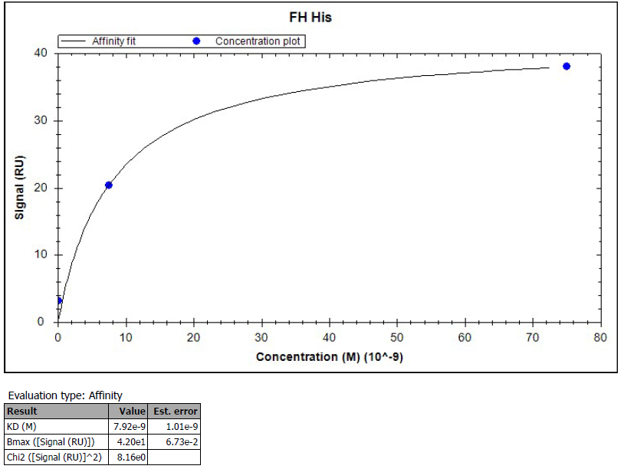
Figure S6. Surface plasmon resonance affinity curve for the steady-state binding of trimeric SOD1 FH-His to antibody 9. (57pM, 7.5nM, 75nM)

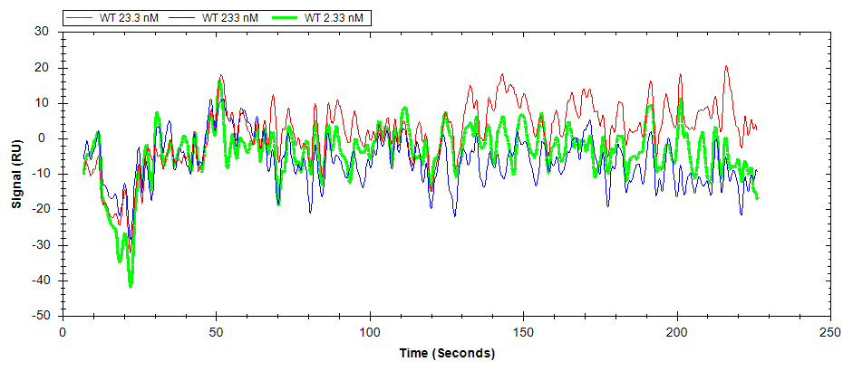
Figure S7. Surface plasmon resonance fitted and reference curves for the binding of WT dimeric SOD1 to antibody 9. (green = 2.33nM, red = 23.3nM, blue = 233nM)
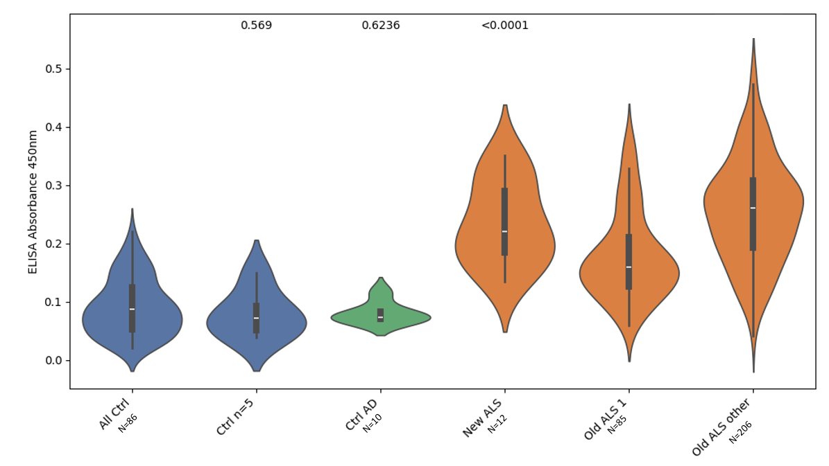
Figure S8. Comparison of newly collected ALS patient samples (collected 2024-2025 n=12) to stored older ALS patient samples (collected 2014-2020) both at the patients first visit to the clinic (Old ALS 1, n=85) and at their 2nd-5th visit (Old ALS other, n=206). Healthy control samples were collected within the last year (All Ctrl n=86, Ctrl n=5 is a subset of five of the main group of control samples tested in triplicate).

Panning Round | Eliminate | Bind
1 | WT His Dimer | HG His Trimer
2 | WT His Dimer | FH His Trimer
3 | WT His Dimer, A4V insoluble fibrils | HG His Trimer
4 | WT His Dimer, A4V insoluble fibrils | FH His Trimer
5 | WT His Dimer, A4V insoluble fibrils | HG His Trimer
6 | WT His Dimer, A4V insoluble fibrils | FH His Trimer, HG His Trimer
7 | WT His Dimer, A4V insoluble fibrils | FH His Trimer

Table S1. Panning rounds when isolating possible antibody “hits”.

