A sustainable bias-free photoelectrochemical system for CO₂ reduction into formate coupled with aldehyde synthesis
Madasamy Thangamuthu*, Emerson C. Kohlrausch, Tara Lemercier, Tom Burwell, Matthew Young, Jesum Alves Fernandes, Andrei N. Khlobystov*
School of Chemistry, University of Nottingham, University Park, Nottingham NG7 2RD, United Kingdom
Madasamy.thangamuthu1@nottingham.ac.uk
Andrei.khlobystov@nottingham.ac.uk

Supporting information

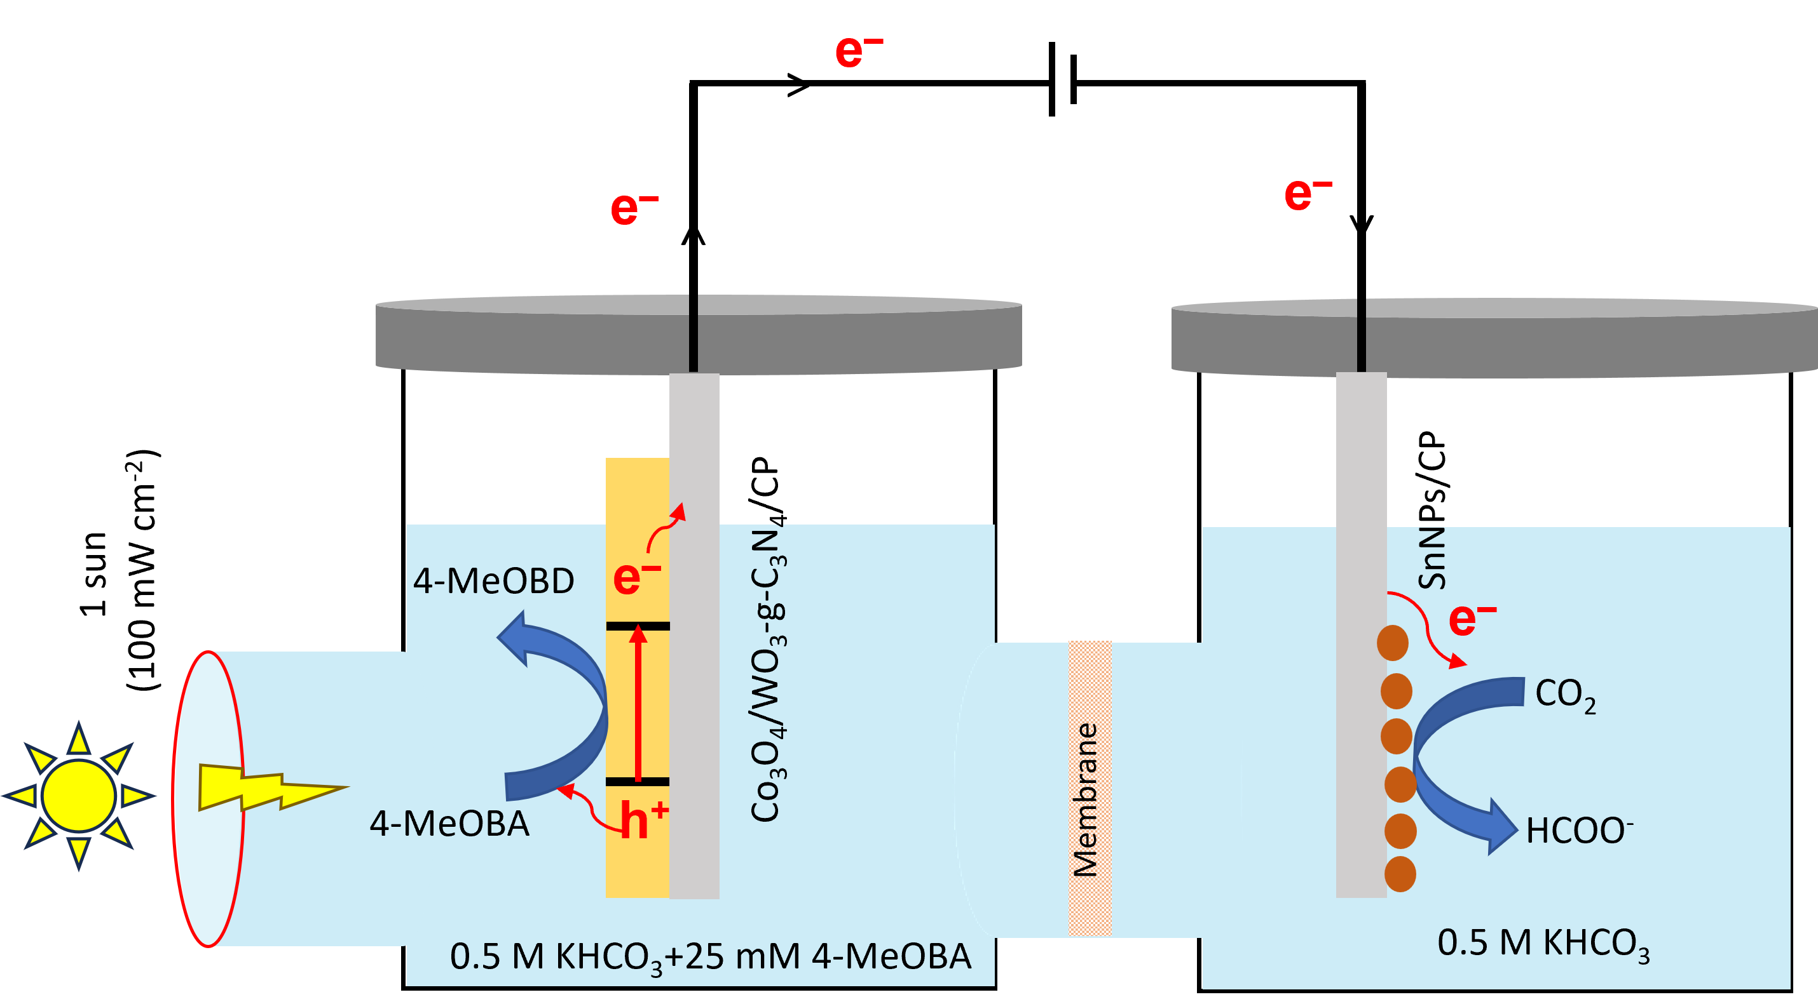
Fig. S1 Schematic representation of the bias-free Co₃O₄/WO₃-g-C₃N₄/CP |SnNPs/CP tandem PEC system performing CO₂ reduction at the cathode and 4-MeOBA oxidation at the photoanode under simulated solar light irradiation.
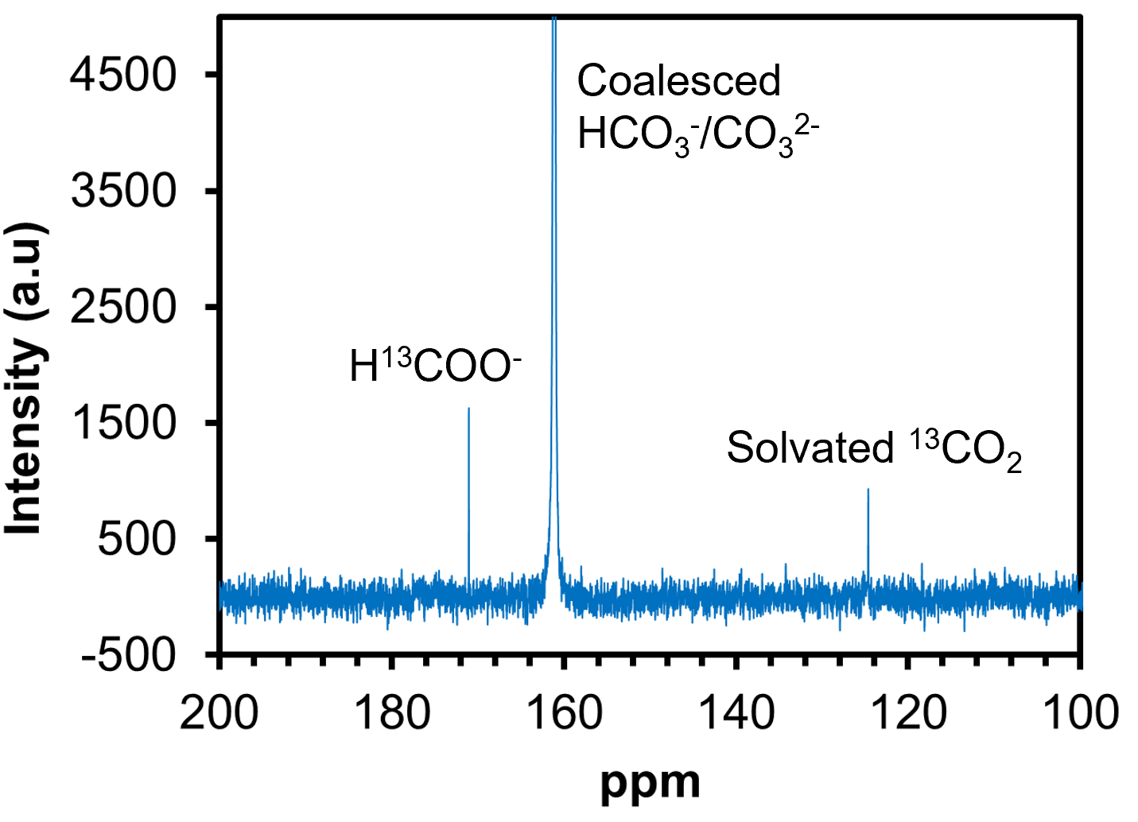
Fig. S2 ¹³C NMR spectrum of the liquid product from the PEC CO₂ reduction experiment in 0.5 M KHCO₃ electrolyte fed with ¹³CO₂ gas. The characteristic ¹³C signal at ~171 ppm confirms the formation of ¹³C-labeled formate, indicating that formate originates from the reduction of CO₂.

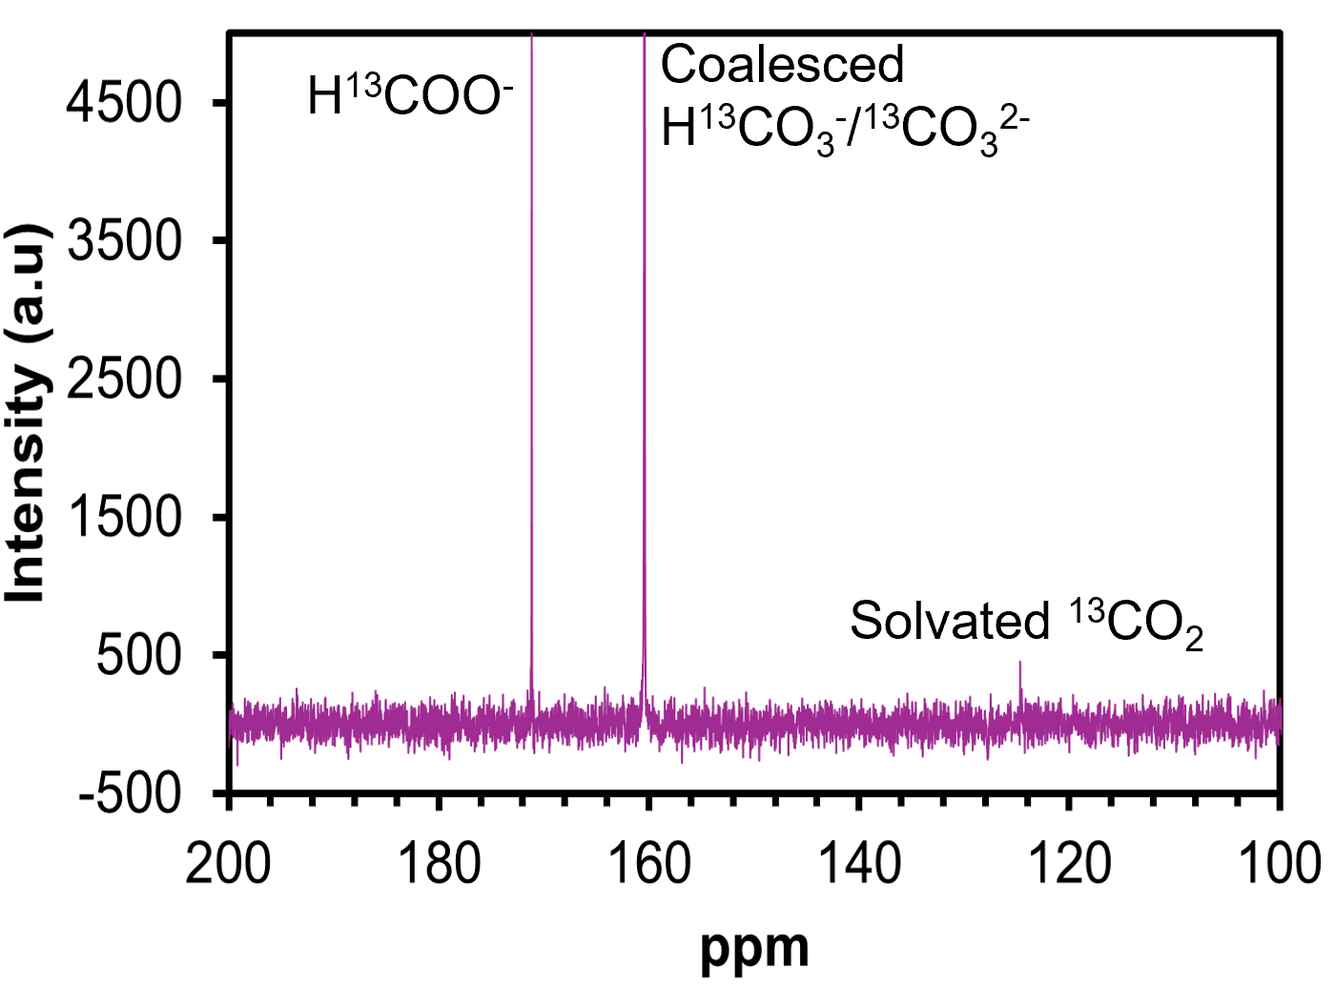
Fig. S3 ¹³C NMR spectrum of the liquid product from the PEC CO₂ reduction experiment in 0.5 M Na₂SO₄ electrolyte fed with ¹³CO₂ gas. The characteristic ¹³C signal at ~171 ppm confirms the formation of ¹³C-labeled formate, indicating that formate originates from the reduction of CO₂.

XRD analysis of g-C₃N₄/WO₃ hybrid material
X-ray diffraction (XRD) analysis confirmed the coexistence of both components in the hybrid material. A sharp diffraction peak at 27.8° (Fig. S4) corresponds to the (002) plane of g-C₃N₄ (JCPDS 87-1526), indicative of an interlayer spacing of 0.325 nm²⁰. A smaller peak at 12.9° corresponds to the (100) plane, associated with an in-plane periodicity of 0.68 nm attributed to the tri-s-triazine units. The presence of WO₃ was confirmed by three intense peaks at 23.1°, 23.6°, and 24.3°, corresponding to the (002), (020), and (200) planes, respectively (JCPDS: 01-083-0951)²¹. These results indicate that both semiconductors retain crystalline structures within the hybrid material.
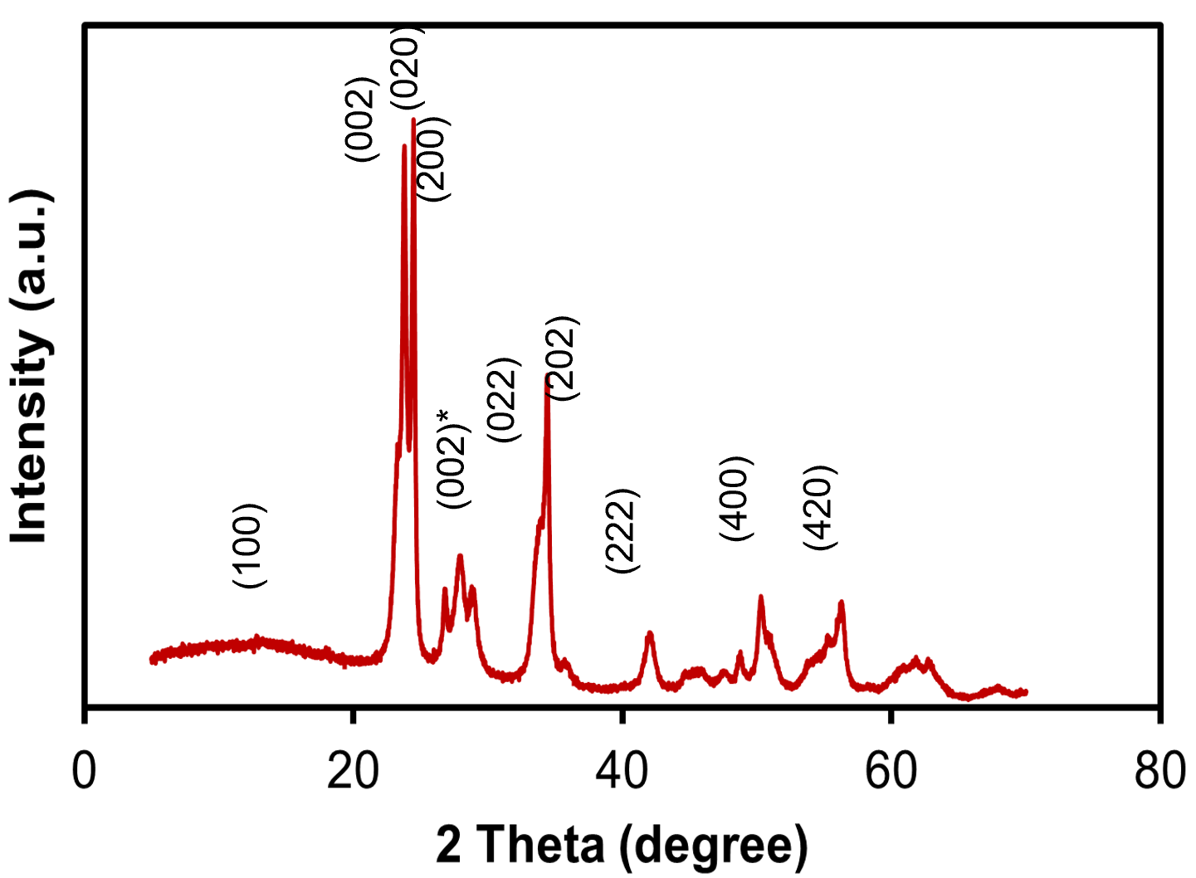
Fig. S4 XRD pattern of the g-C₃N₄/WO₃ hybrid material

FTIR analysis of g-C₃N₄/WO₃ hybrid material
The FTIR spectrum of the g-C₃N₄/WO₃ hybrid displayed characteristic bands from both components. A prominent peak at 810 cm⁻¹ corresponds to the triazine ring breathing mode of g-C₃N₄, while bands between 1150-1750 cm⁻¹ are assigned to the in-plane stretching vibrations of aromatic rings, indicating the intact g-C₃N₄ framework. A broad band between 3100-3500 cm⁻¹ suggests the presence of terminal NH and NH₂ groups on the edges of g-C₃N₄ (Fig. S5). For the WO₃ component, characteristic bands were observed at 750 cm⁻¹, corresponding to the O–W–O stretching mode and at 991 cm⁻¹, attributed to the W–OH bending mode.
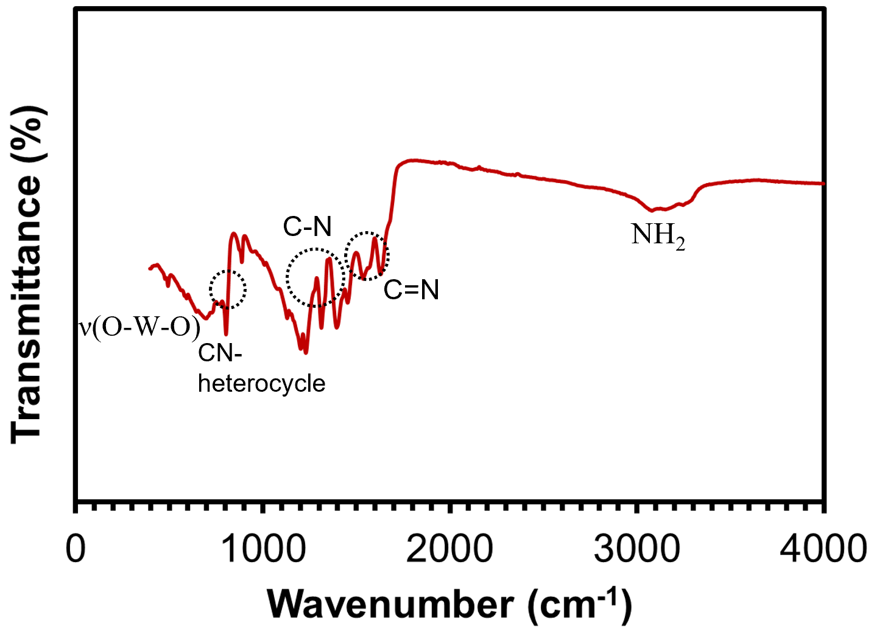
Fig. S5 FTIR spectra of the g-C₃N₄/WO₃ hybrid material

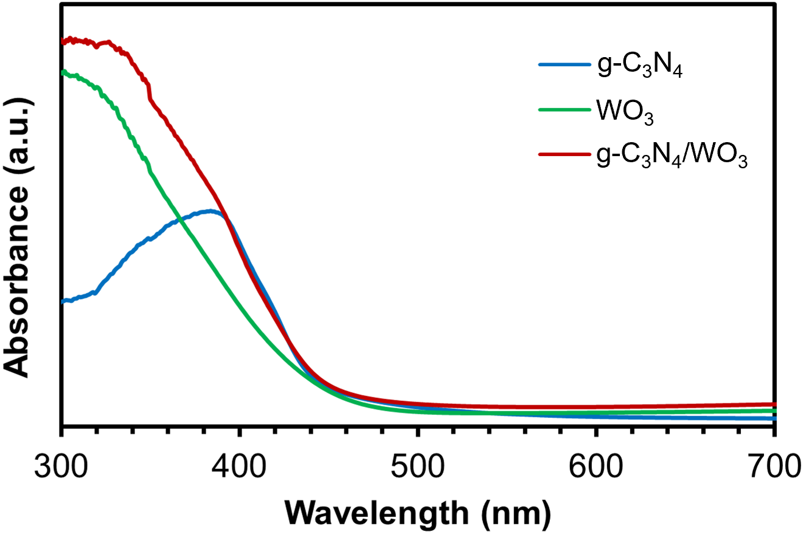
Fig. S6 UV-Visible absorbance spectra of the g-C₃N₄, WO₃ and g-C₃N₄/WO₃ hybrid materials

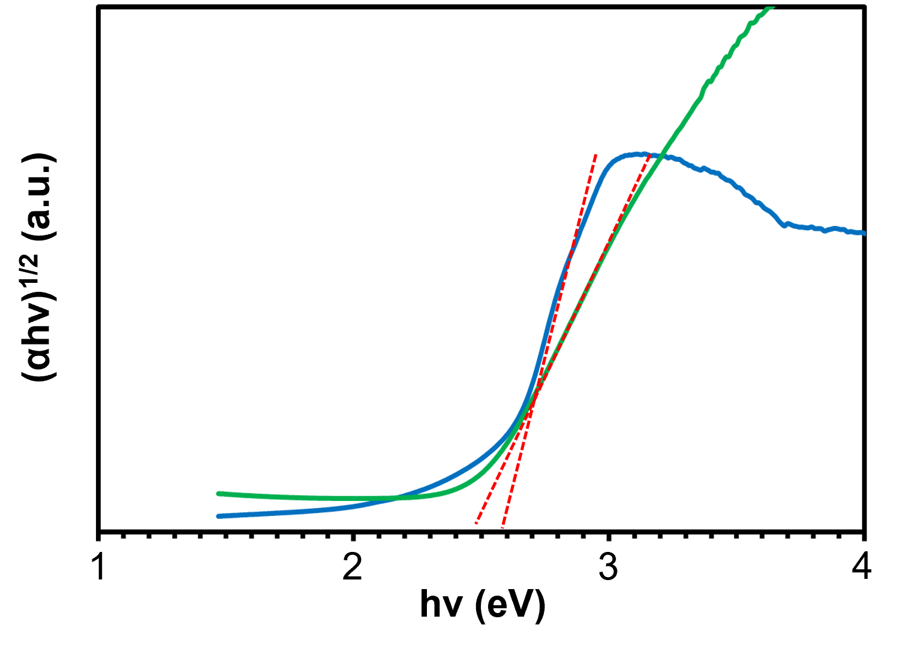
Fig. S7 Tauc plot of the g-C₃N₄ and WO₃

HR-TEM analysis of g-C₃N₄/WO₃ hybrid material
High-resolution transmission electron microscopy (HR-TEM) was employed to investigate the interfacial structure of the g-C₃N₄/WO₃ hybrid material in detail. The imaging reveals direct and intimate contact between the two phases, confirming the successful formation of a heterojunction at the nanoscale (Fig. S8a). The WO₃ phase exhibits higher contrast in HR-TEM images due to the higher atomic number of W. Lattice fringes corresponding to the (100) planes of WO₃ are observed to align parallel to the interface with g-C₃N₄, indicating a well-ordered crystalline structure. The g-C₃N₄ phase at the interface appears nanocrystalline, comprising randomly oriented domains with sizes on the order of tens of nanometers (Fig. S8b). This direct physical contact between g-C₃N₄ and WO₃ domains is expected to be critical in facilitating efficient photoinduced charge transfer across the n-n heterojunction. Such interfacial connectivity is essential for enhancing charge separation and reducing recombination losses, thereby improving the overall performance of the photoelectrode.
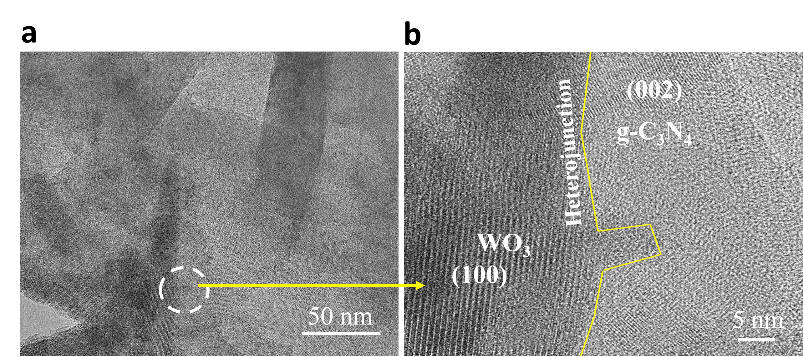
Fig. S8 a) low magnification and b) high magnification HR-TEM images of the g-C₃N₄/WO₃ hybrid material.

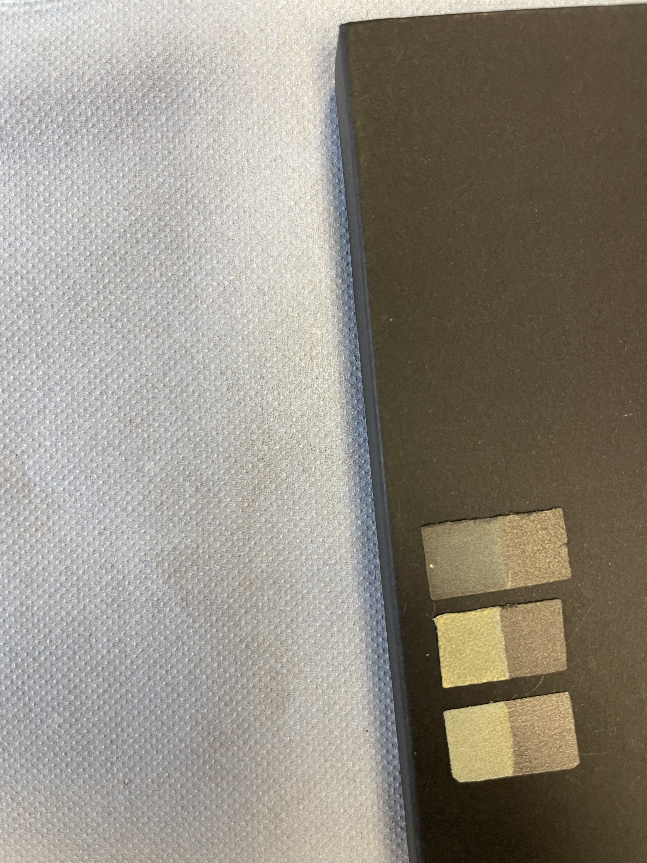
Fig. S9 EPD-coated thin film of g-C₃N₄/WO₃

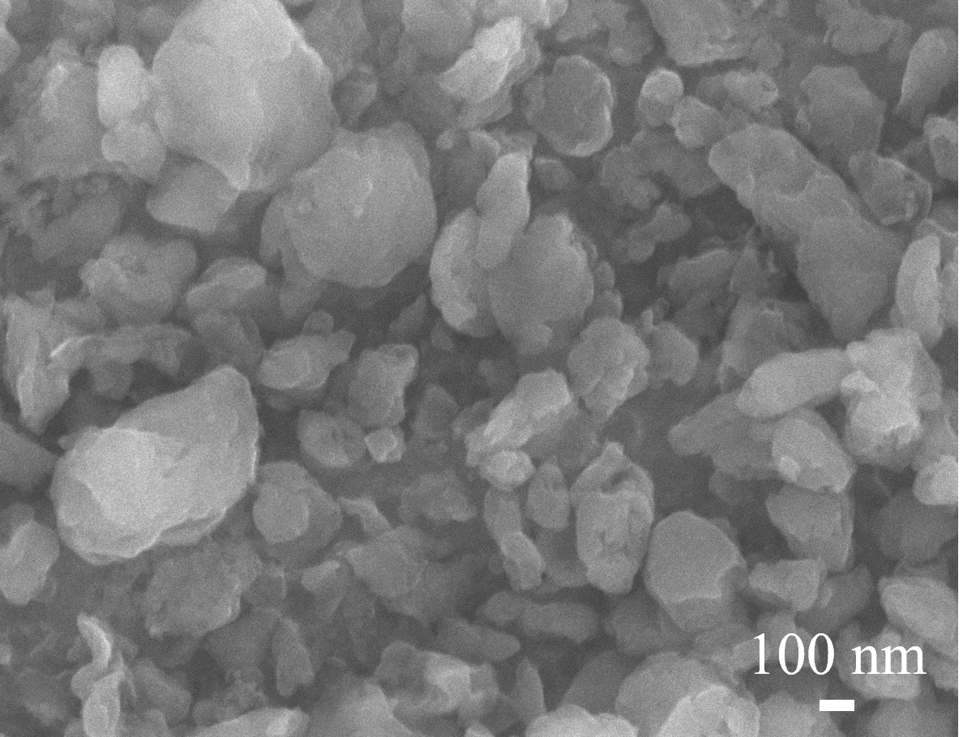
Fig. S10. SEM image of g-C₃N₄ thin film on CP

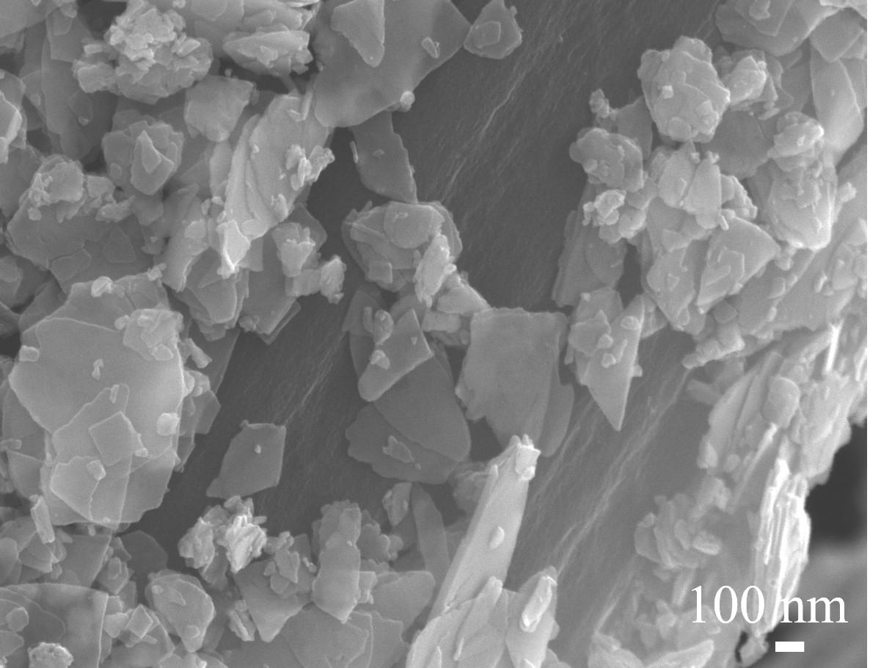
Fig. S11. SEM image of WO₃ thin film on CP

X-ray photoelectron spectroscopy (XPS)
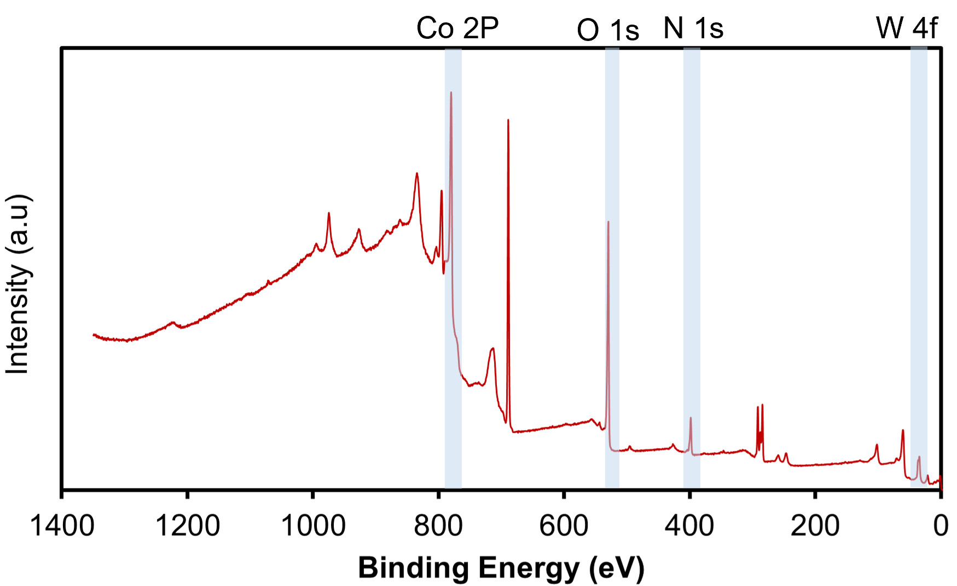
Fig. S12 XPS survey spectra of Co₃O₄/WO₃/g-C₃N₄/CP
X-ray photoelectron spectroscopy measurements were performed using a Thermo Scientific K-Alpha spectrometer equipped with a monochromatic Al Kα radiation source operating at 72 W (6 mA × 12 kV). The analysis area was approximately 400 × 600 microns, and all experimental conditions are detailed in Table S1. All samples were analysed using a dual ion-electron charge compensation detector, operating at an argon background pressure of 10⁻⁷ mbar. Samples were mounted by pressing them onto silicone-free, double-sided adhesive tape. Data processing was conducted using CASAXPS (Version 2.3.27), with charge correction applied to the reference C 1s peak.
Table S1. Experimental parameters used for the XPS measurements.
Region | Pass Energy (eV) | Dwell time (s) | Number of scans | Step energy (eV)
Survey | 160 | 150 | 2 | 0.2
C 1s | 20 | 60 | 20 | 0.1
O 1s | 20 | 60 | 20 | 0.1
N 1s | 20 | 60 | 20 | 0.1
W 4f | 20 | 150 | 2 | 0.1

Peak model
The peak model for carbon nitride (g-C₃N₄) follows the previous work from our group². A two-parameter Touggard (U2) background was used to determine fitting parameters for the satellite structure to the higher binding energy. The N 1s core level spectra, we use the three characteristic peaks for g-C₃N₄ ascribed to the sp² hybridised pyridine nitrogen in triazine rings (C=N–C), tertiary nitrogen N–(C)3, and sp³ terminal N (C–N–H), respectively. Also, the bulk material presents 4 satellite peaks observed at higher binding energies. A Lorentzian asymmetric (LA) Voigt type line shapes were used for the analysis of general form LA (α, β, m), where α and β define the spread of the tail on either side of the Lorentzian components and m is an integer between 0 and 499 specifying the width of the Gaussian used to convolute the Lorentzian peak (note the β parameter may be omitted). The fitting parameters used are as follows: LA(1.3, 243) for all peaks, including the satellite structure with the exception of N(1s) peak at 398.7 eV, where LA(1.03,1.24,243) was used. For W 4f and Sn 3d spectra, a simple double separation was attributed. For the C 1s region, due to the dominant contributions of C–C from graphitic carbon and C–F bonds originating from PTFE on the carbon paper, the C 1s spectra were not fitted. Instead, they were used exclusively as an internal reference, using the 284.5 eV peak corresponding to graphitic carbon. The Co 2p follow the previous peak model applied by Biesinger et.al.³ where we used the peak models for Co₃O₄ and Co(OH)₂. We summarised the peak model and the fitting outcome in Tables S2-S4.
Table S2: Peak model of N 1s spectra for the g-C₃N₄/CP and WO₃/g-C₃N₄/CP
 | Assignment | Positions Constraints | FWHM  Constraints | Line shape
A | N in C–N–C | 398.8 , 398.3 | 0.8 , 1.2 | LA(1.03,1.24,243)
B | N in N–[C]₃ | A + 1.34 (±0.2) | 0.8 , 1.5 | LA(1.3, 243)
C | N in C–N–H | A + 2.43 (±0.2) | B * 1 | LA(1.3, 243)
D | Satellite | 418.9 , 391.8 (±0.2) | 2.0 , 2.7 | LA(1.3, 243)
E | Satellite | D + 3.1 | C*1 | LA(1.3, 243)
F | Satellite | D + 5.7 | C*1 | LA(1.3, 243)
G | Satellite | D + 7.9 | C*1 | LA(1.3, 243)

Table S3: Co 2p peak model used for the Co₃O₄/CP and Co₃O₄/WO₃/g-C₃N₄/CP
 | Assignment | Positions Constraints | Area Constraints | FWHM  Constraints | Line shape
A | Co₃O₄ | 779 (±0.6) | - | 0.8 , 1.2 | LA(1.13, 243)
B | Co₃O₄ | A + 1.32 (±0.2) | A*0.71 | A*1.55 | LA(1.13, 243)
C | Co₃O₄ | A + 2.6 (±0.2) | A*0.35 | B * 1 | LA(1.13, 243)
D | Co₃O₄ | A + 5.6 (±0.2) | A*0.28 | A*3.2 | LA(1.13, 243)
E | Co₃O₄ | A + 9.9 (±0.2) | A*0.21 | A*2.37 | LA(1.13, 243)
F | Co(OH)₂ | 780.7 (±0.3) | - | 0.8 , 2 | LA(1.13, 243)
G | Co(OH)₂ | F + 1.8 | F*0.15 | F*1.25 | LA(1.13, 243)
H | Co(OH)₂ | F + 5.8 | F*0.23 | F*2.2 | LA(1.13, 243)
J | Co(OH)₂ | F+ 9.9 | F*0.06 | F*1.15 | LA(1.13, 243)

Table S4: Peak position, FWHM and percentage of different components from the N 1s for the g-C₃N₄/CP and WO₃/g-C₃N₄/CP.
Component ↓ | Sample → | g-C₃N₄/CP | WO₃/g-C₃N₄/CP | Co₃O₄/WO₃/g-C₃N₄/CP
N in C–N–C | Position (eV) | 398.27 | 398.45 | 398.6
N in C–N–C | FWHM (eV) | 1.3 | 1.26 | 1.3
N in C–N–C | Area (%) | 59.0 | 64.0 | 56.6
N in N–[C]₃ | Position (eV) | 399.43 | 399.79 | 399.96
N in N–[C]₃ | FWHM (eV) | 1.47 | 1.32 | 1.5
N in N–[C]₃ | Area (%) | 17.0 | 12.3 | 18.1
N in C–N–H | Position (eV) | 400.73 | 400.89 | 401.06
N in C–N–H | FWHM (eV) | 1.47 | 1.32 | 1.5
N in C–N–H | Area (%) | 11.2 | 10.2 | 10.0
Satellite | Position (eV) | 404.1 | 404.09 | 404.7
Satellite | FWHM (eV) | 2.7 | 2.7 | 2.7
Satellite | Area (%) | 7.6 | 8.3 | 8.4
Satellite | Position (eV) | 407.05 | 407.2 | 407.8
Satellite | FWHM (eV) | 2.7 | 2.7 | 2.7
Satellite | Area (%) | 2.6 | 3.0 | 3.1
Satellite | Position (eV) | 409.84 | 409.79 | 410.4
Satellite | FWHM (eV) | 2.54 | 2.3 | 2.3
Satellite | Area (%) | 0.8 | 0.4 | 1.0
Satellite | Position (eV) | 412.04 | 411.99 | 412.6
Satellite | FWHM (eV) | 2.7 | 2.7 | 2.7
Satellite | Area (%) | 1.8 | 1.8 | 2.9

Table S5: Peak position, FWHM and percentage of different components from the W 4f 1s for WO₃/CP and WO₃/g-C₃N₄/CP
Component ↓ | Sample → | WO₃/CP | WO₃/g-C₃N₄/CP | Co₃O₄/WO₃/g-C₃N₄/CP
W 4f 7/2 (W⁶⁺) | Position (eV) | 35.89 | 35.22 | 34.9
W 4f 7/2 (W⁶⁺) | FWHM (eV) | 0.1.02 | 1.29 | 1.36
W 4f 7/2 (W⁶⁺) | Area (%) | 48.83 | 47.6 | 41.9
W 4f 5/2 | Position (eV) | 38.03 | 37.36 | 37.0
W 4f 5/2 | FWHM (eV) | 1.03 | 1.21 | 1.49
W 4f 5/2 | Area (%) | 37.39 | 34.4 | 37.9
W 4f 7/2 (W⁵⁺) | Position (eV) | 34.73 | 33.22 | 33.08
W 4f 7/2 (W⁵⁺) | FWHM (eV) | 1.36 | 2.0 | 2.0
W 4f 7/2 (W⁵⁺) | Area (%) | 5.98 | 8.3 | 10.0
W 4f 5/2 | Position (eV) | 37.07 | 35.72 | 35.38
W 4f 5/2 | FWHM (eV) | 1.33 | 2.1 | 2.03
W 4f 5/2 | Area (%) | 4.48 | 6.2 | 6.9
W 3p | Position (eV) | 41.60 | 41.43 | 40.56
W 3p | FWHM (eV) | 1.91 | 1.68 | 2.5
W 3p | Area (%) | 3.3 | 3.5 | 3.3
Summary | %W ⁶⁺ | 89.1 | 85.15 | 80.7
Summary | % W ⁵⁺ | 10.9 | 14.85 | 19.3

Table S6: Peak position, FWHM and percentage of different components from the Co 2p for Co₃O₄/CP and Co₃O₄/WO₃/g-C₃N₄/CP
Component ↓ | Sample → | Co₃O₄/CP | Co₃O₄/WO₃/g-C₃N₄/CP
Co₃O₄ | Position (eV) | 779.6 | 779.7
Co₃O₄ | FWHM (eV) | 1.41 | 1.42
Co₃O₄ | Area (%) | 32.15 | 29.07
Co₃O₄ | Position (eV) | 780.9 | 780.96
Co₃O₄ | FWHM (eV) | 2.22 | 2.23
Co₃O₄ | Area (%) | 22.75 | 20.57
Co₃O₄ | Position (eV) | 782.18 | 782.26
Co₃O₄ | FWHM (eV) | 2.22 | 2.24
Co₃O₄ | Area (%) | 11.45 | 10.35
Co₃O₄ | Position (eV) | 785.1 | 785.26
Co₃O₄ | FWHM (eV) | 4.53 | 4.55
Co₃O₄ | Area (%) | 9.13 | 8.25
Co₃O₄ | Position (eV) | 789.58 | 789.56
Co₃O₄ | FWHM (eV) | 2.37 | 3.37
Co₃O₄ | Area (%) | 6.68 | 6.04
Co(OH)₂ | Position (eV) | 780.74 | 780.72
Co(OH)₂ | FWHM (eV) | 1.73 | 1.87
Co(OH)₂ | Area (%) | 15.35 | 17.71
Co(OH)₂ | Position (eV) | 782.56 | 782.52
Co(OH)₂ | FWHM (eV) | 2.17 | 2.34
Co(OH)₂ | Area (%) | 0.97 | 2.79
Co(OH)₂ | Position (eV) | 786.6 | 786.55
Co(OH)₂ | FWHM (eV) | 3.80 | 4.10
Co(OH)₂ | Area (%) | 1.21 | 4.10
Co(OH)₂ | Position (eV) | 790.74 | 790.70
Co(OH)₂ | FWHM (eV) | 1.98 | 2.14
Co(OH)₂ | Area (%) | 0.1 | 1.11
Summary | % Co₃O₄ | 82.2 | 74.3
Summary | % Co(OH)₂ | 17.8 | 25.7

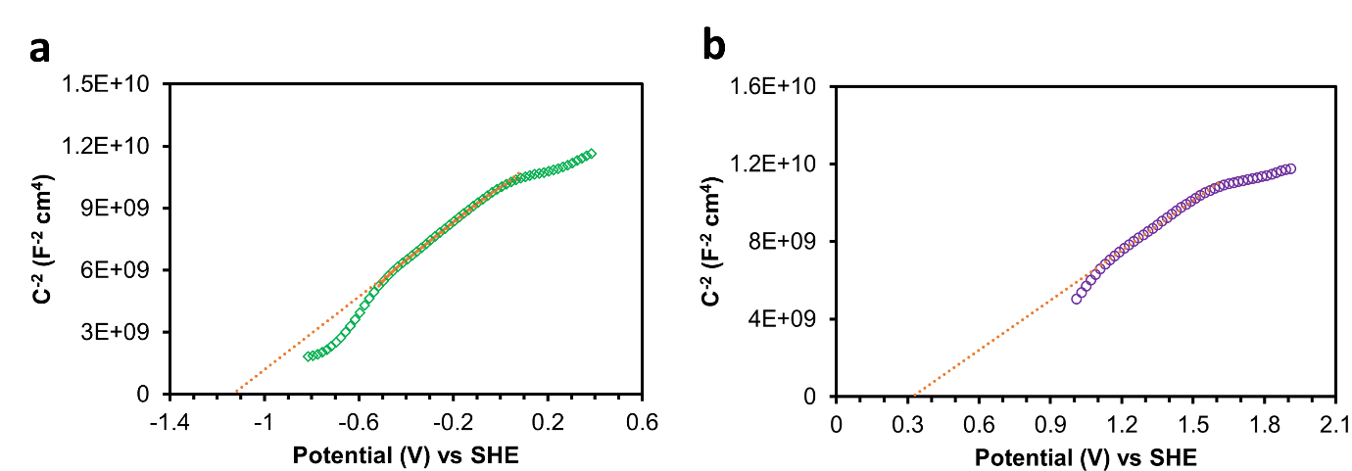
Fig. S13 Mott-Schottky plot of g-C₃N₄ obtained by measuring the impedance at the interface by sweeping the potential from negative to positive with a stepping voltage of 50 mV within the frequency range 1000-10000 in degassed 0.5 M Na₂SO₄ electrolyte.

Fig. S14 Mott-Schottky plot of WO₃ obtained by measuring the impedance at the interface by sweeping the potential from negative to positive with a stepping voltage of 50 mV within the frequency range 1000-10000 in degassed 0.5 M Na₂SO₄ electrolyte.

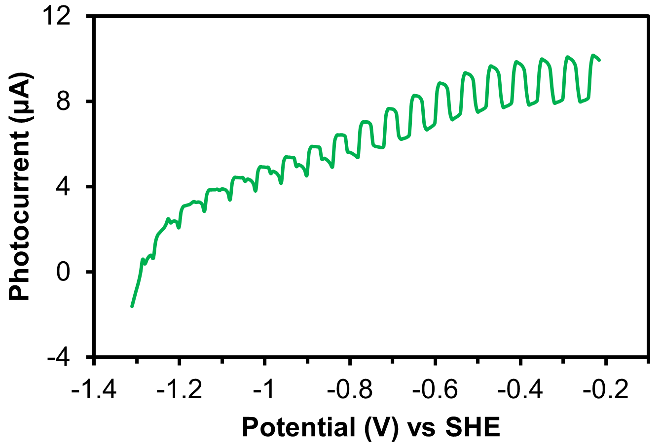
Fig. S15 Photocurrent onset potential measurements of g-C₃N₄/CP measured by running linear sweep voltammetry in cathodic direction under chopped light irradiation (100 mW cm⁻²) in degassed 0.5 M Na₂SO₄ electrolyte containing 10% TEOA. Note: Due to the nanocrystalline nature of the g-C₃N₄, this measurement requires a hole scavenger because, in this case, the charge separation is not controlled by the space-charge region²⁰.

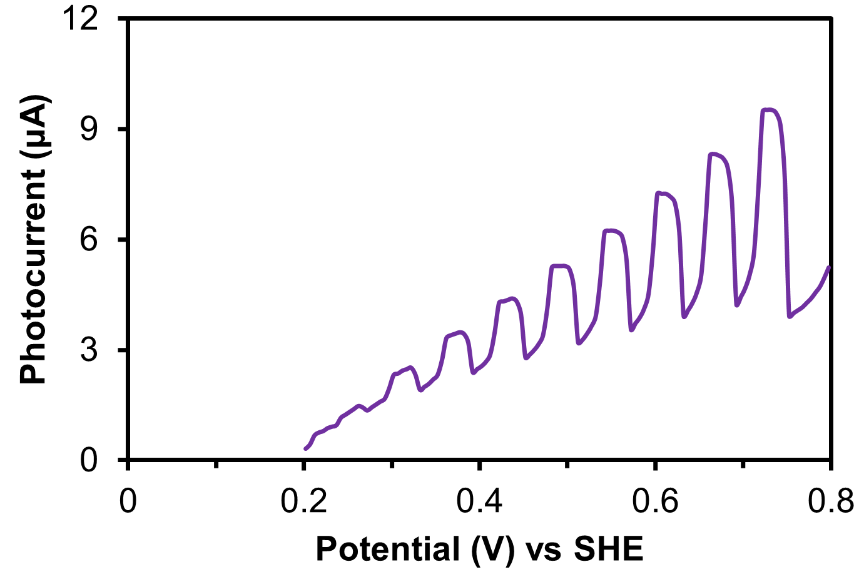
Fig. S16 Photocurrent onset potential measurements of WO₃/CP measured by running linear sweep voltammetry in cathodic direction under chopped light irradiation (100 mW cm⁻²) in degassed 0.5 M Na₂SO₄ electrolyte containing 10% TEOA. Note: Due to the nanocrystalline nature of the WO_{3,} this measurement requires a hole scavenger because in this case, the charge separation is not controlled by the space-charge region²⁰.

Estimation of conduction band potential of g-C₃N₄
The CB potential of the materials was estimated analytically using equation 1, by following the earlier report¹.
$\frac{E_{A}}{e}=-(U_{CB}-∆∅_{H}+U_{SHE}^{0} (vac))$ (1)
Where, E_{A} = Electron affinity
U_{CB} = Conduction band potential
U⁰_{SHE} = standard potential of physical scale to absolute scale = 4.44 eV
ΔφH = Helm-Holtz potential drop

The conduction band potential can be obtained by rewriting equation 1
$$U_{CB}=-\frac{E_{A}}{e}+∆∅_{H}-U_{SHE}^{0} (vac)$$
The Helm-Holtz potential drop is calculated by

$$∆∅_{H}=0.059 ×{pH}_{pzc}-0.059×pH$$
The point of zero charge (pH pzc) for g-C₃N₄ is pH 6.5. Therefore,
$$∆∅_{H}=0.059 ×6.5-0.059×7=0.03$$
The electron affinity of g-C₃N₄ is approximately -3.2 eV, which is independent of pH.
$$U_{CB}=-\left(-3.2\right)+0.03-4.44=-1.21 V$$

Estimation of conduction band potential of WO₃
The electron affinity of WO₃ is -4.8 eV, which is independent of pH
The point of zero charge (pH pzc) for WO₃ is pH 0.5.
$$∆∅_{H}=0.059 ×0.5-0.059×7=-0.383$$
$$U_{CB}=-\left(-4.8\right)+\left(-0.383\right)-4.44=+0.023 V$$

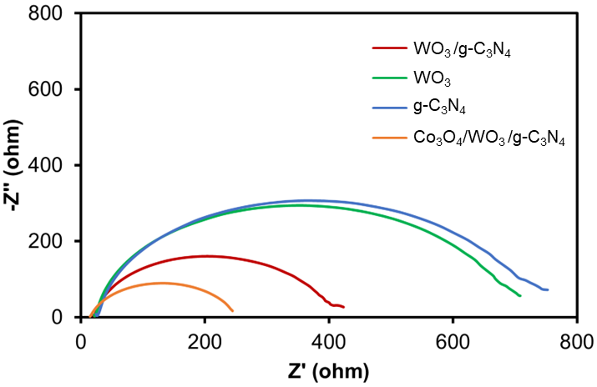
Fig. S17 Nyquist plots of g-C₃N₄, WO₃, WO₃/g-C₃N₄ and Co₃O₄/WO₃/g-C₃N₄ obtained in 0.5 M KHCO₃ electrolyte at a constant potential of 1.1 V vs Ag/AgCl within the frequency range from 100 kHz to 1 Hz and amplitude of 10 mV.

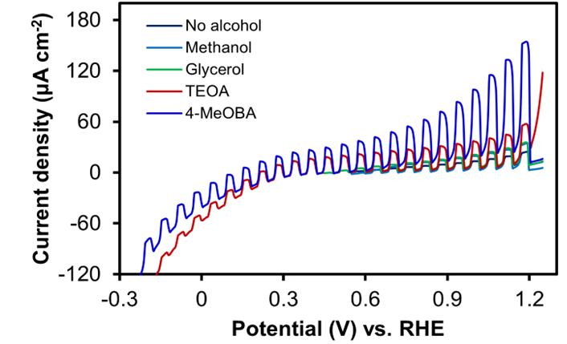
Fig. S18 a) LSV of Co₃O₄/WO₃/g-C₃N₄/CP obtained in 0.5 M KHCO₃ containing 25 mM of methanol, glycerol, TEOA, and 4-MeOBA.

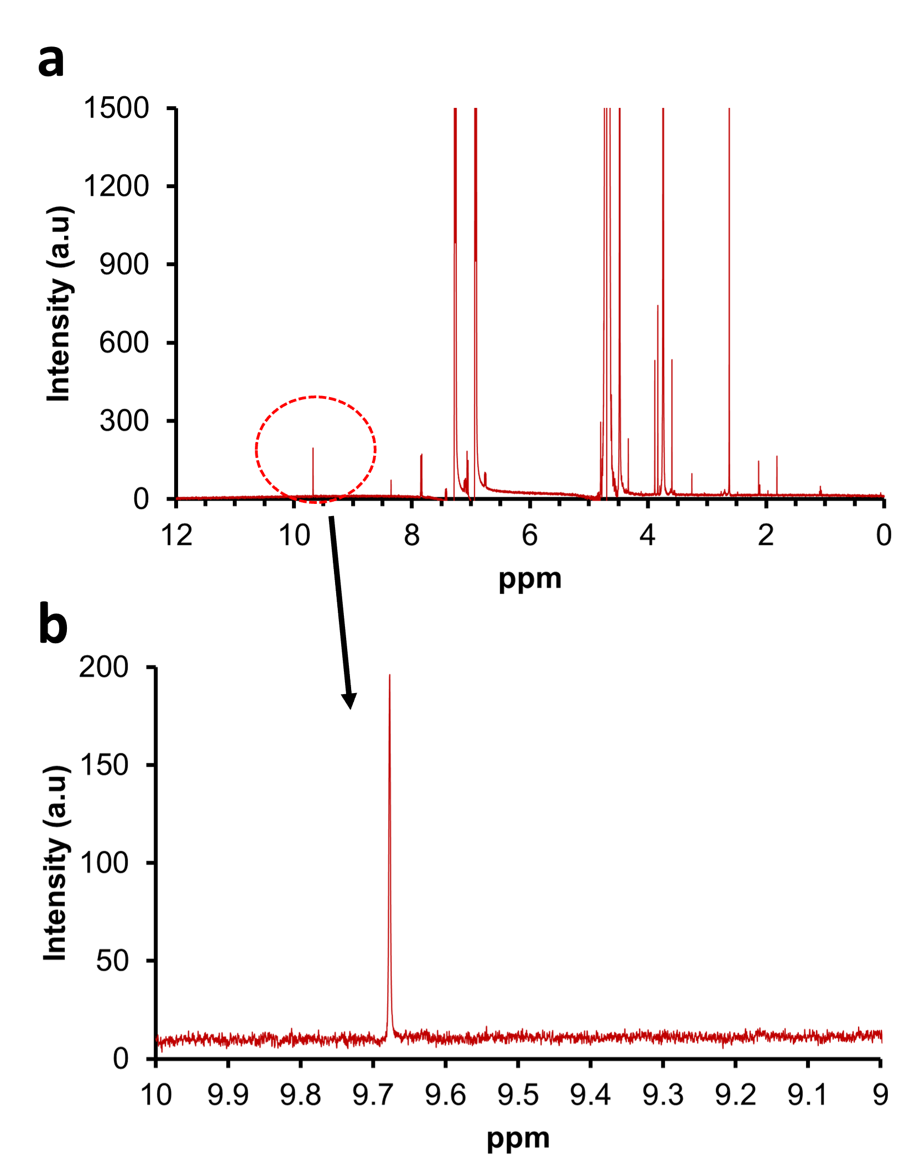
Fig. S19 ¹H NMR spectra of the 4-MeOBA oxidation product analysis, a) full spectrum, and b) aldehyde peak highlighted.

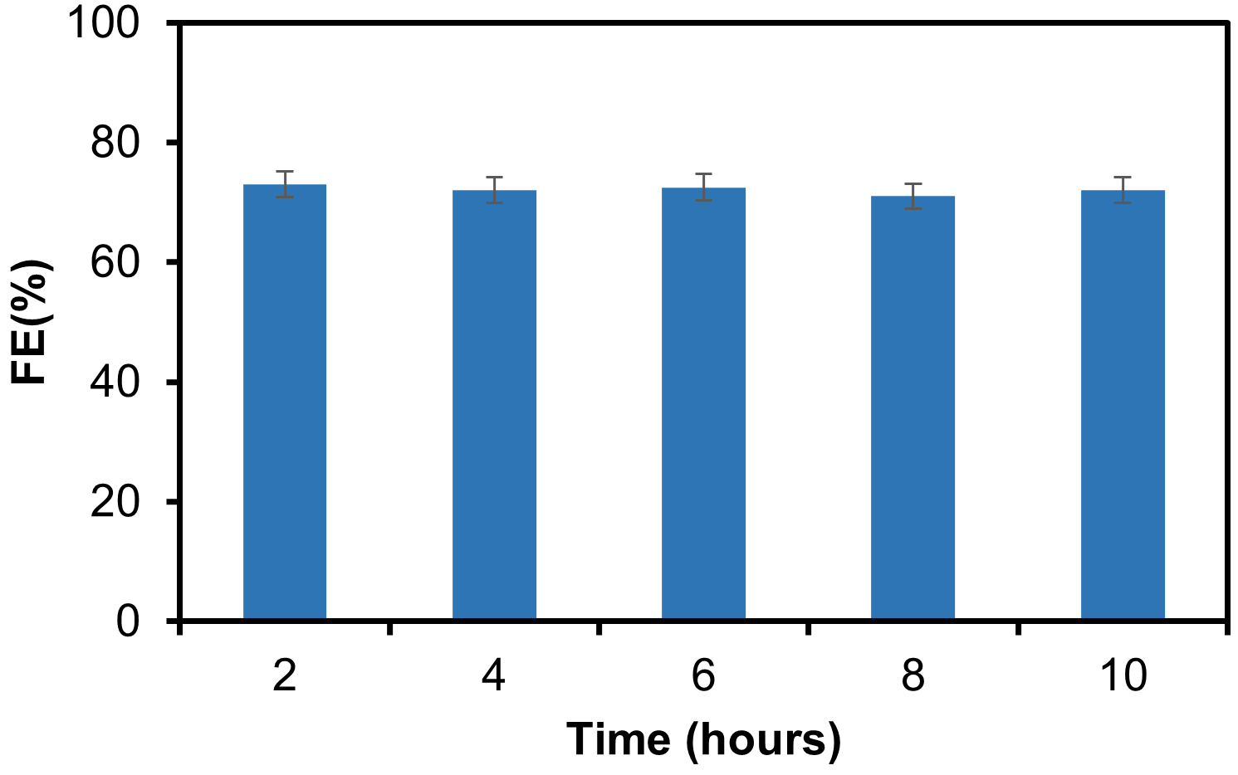
Fig. S20. The faradaic efficiency of 4-MeOBD formation during the stability test of Co₃O₄/WO₃/g-C₃N₄/CP photoanode at +0.6 V vs RHE measured in 0.5 M KHCO₃ containing 25 mM 4-MeOBA. The FE remains stable at over 70% throughout the stability test.

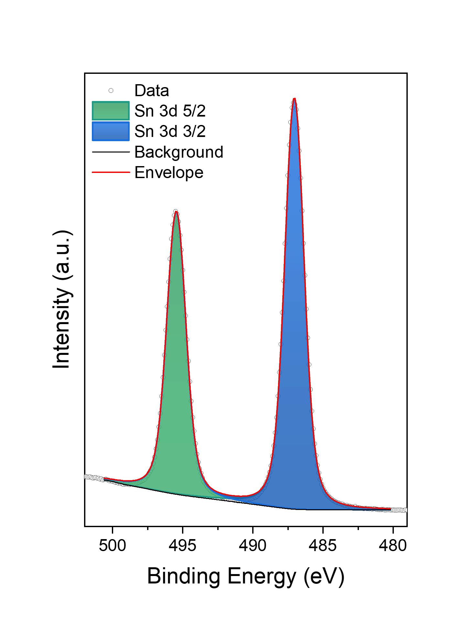
Fig. S21 XPS spectra of the sputter-deposited Sn on carbon paper

Table S7: Comparison of the present external bias-free photoanode-dark cathode system with similar PEC systems reported in the literature
Photoanode | Cathode | CO₂ reduction performance | Reference
CoPi/BiVO₄/FTO  Anode reaction: Water oxidation | NADH-FDH/EC-PDA/GC  Cathode reaction: CO₂ reduction into formate (100% FE) | Photocurrent density:  0.1 μA cm⁻² | ⁴
TiO₂/FTO  Anode reaction: Water oxidation | FDH/MV/CFP  Cathode reaction: CO₂ reduction into formate (27% FE) | Formate production rate: 31.9 nmol h⁻¹ | ⁵
STEMPO/DPP-CA/mTiO₂/FTO  Anode reaction: 4-methylbenzyl alcohol oxidation into 4-methylbenzaldehyde (100% FE) | FHD/mITO/FTO  Cathode reaction: CO₂ reduction into formate (92% FE) | Photocurrent density: 30 μA cm⁻²  Formate production rate: 2.46 μmol cm⁻² | ⁶
RuOx/Ni/Ge/GaAs/InGaP  (photovoltaic absorber)  Anode reaction: Water oxidation | Sn-Bi₂O₃  Cathode reaction: CO₂ reduction into formate (88% FE) | Solar-to-fuel conversion efficiency 12% | ⁷
NiOOH/α-Fe₂O₃/FTO  Anode reaction: Glucose oxidation | Bi/GaN/Si (solar cell-photocathode)  CO₂ reduction into formate  (85% FE) | Formate production rate: 23.3 μmol cm⁻² | ⁸
Co₃O₄/WO₃/g-C₃N₄/CP  Anode reaction: 4-methoxybenzyl alcohol oxidation into 4-methoxybenzaldehyde (72% FE) | Sn/CP  Cathode reaction: CO₂ reduction into formate  (97% FE) | Photocurrent density: 10 μA cm⁻²  Formate production rate: 1.2 ± 0.1 μmol cm⁻² | Present work

References
1. Hankin, A., Alexander, J. C. & Kelsall, G. H. Constraints to the flat band potential of hematite photo-electrodes. Physical Chemistry Chemical Physics 16, 16176–16186 (2014).
2. Thangamuthu, M. et al. Unlocking photoanode performance through a roadmap for electrophoretic deposition of carbon nitride/tungsten oxide heterojunction thin films. Mater Adv (2025) doi:10.1039/D5MA00301F.
3. Biesinger, M. C. et al. Resolving surface chemical states in XPS analysis of first row transition metals, oxides and hydroxides: Cr, Mn, Fe, Co and Ni. Appl Surf Sci 257, 2717–2730 (2011).
4. Lee, S. Y., Lim, S. Y., Seo, D., Lee, J.-Y. & Chung, T. D. Light-Driven Highly Selective Conversion of CO2 to Formate by Electrosynthesized Enzyme/Cofactor Thin Film Electrode. Adv Energy Mater 6, 1502207 (2016).
5. Ishibashi, T., Higashi, M., Ikeda, S. & Amao, Y. Photoelectrochemical CO2 Reduction to Formate with the Sacrificial Reagent Free System of Semiconductor Photocatalysts and Formate Dehydrogenase. ChemCatChem 11, 6227–6235 (2019).
6. Antón-García, D. et al. Photoelectrochemical hybrid cell for unbiased CO2 reduction coupled to alcohol oxidation. Nature Synthesis 1, 77–86 (2022).
7. Khan, B. et al. Unassisted photoelectrochemical CO2-to-liquid fuel splitting over 12% solar conversion efficiency. Nat Commun 15, 6990 (2024).
8. Pan, Y. et al. Renewable formate from sunlight, biomass and carbon dioxide in a photoelectrochemical cell. Nat Commun 14, 1013 (2023).

