ADDITIONAL FILE 1
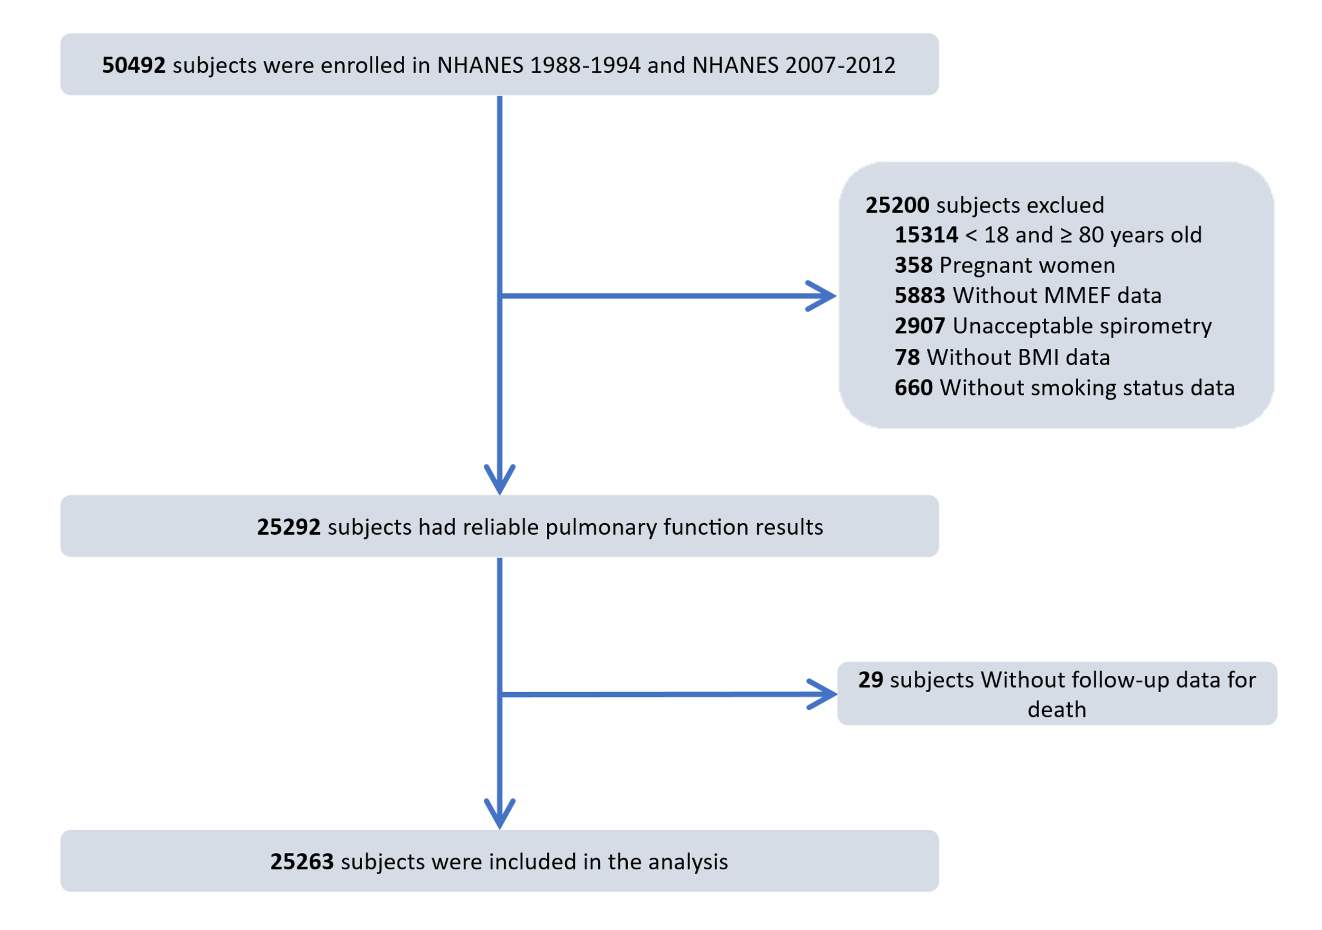
Figure S1. Study flow chart.
Abbreviation: MMEF: maximal mid-expiratory flow; BMI: body mass index.
Figure S2. Subgroup analysis of the multivariate association between small airways obstruction and risk of all-cause mortality in the overall population. Abbreviation: NO.: numbers; HR: hazard ratio; CI: confidence interval; BMI: body mass index. Adjusted for sex, age, race, body mass index, education level, poverty income ratio, smoking status, hypertension, diabetes, congestive heart failure, stroke, asthma, emphysema, chronic bronchitis, and cancer.
Figure S3. Subgroup analysis of the multivariate association between small airways obstruction and risk of all-cause mortality among the participants with normal spirometry. Abbreviation: NO.: numbers; HR: hazard ratio; CI: confidence interval; BMI: body mass index. Adjusted for sex, age, race, body mass index, education level, poverty income ratio, smoking status, hypertension, diabetes, congestive heart failure, stroke, asthma, emphysema, chronic bronchitis, and cancer.

