Supplementary information: Figures and Tables

First-in-Class SAM-Competitive G9a Inhibitor FLAV-27 as a Disease-Modifying Therapy for Alzheimer’s Disease

Aina Bellver-Sanchis¹, David Valle-Garcia², Carla Barbaraci³, Fernando Romero-Becerra^{3,4}, Rohit Kumar Singh⁵, Foteini Vasilopoulou⁶, Alba Irisarri¹, Carmen Martínez-Fernández¹, Juan A. Fafián-Labora⁷, María C. Arufe⁷, Carolin Wüst¹, Aida Castellanos⁸, David Soto^{8,9}, Núria Casals^{10,11}, Rut Fadó^{10,11}, Jennifer M Pocock⁶, Gemma Navarro^{12,13,14}, Cristina Val¹⁵, José Brea¹⁵, M. Isabel Loza¹⁵, Albert Lleó^{12,16}, Juan Fortea^{12,16}, Daniel Alcolea^{12,16}, Anna Perez-Bosque^{11,17}, Lluïsa Miró^{11,17}, Belén Pérez¹⁸, Sajid Rashid¹⁹, Muhammad Ali¹⁹, Manahil Saqib¹⁹, Marcel·lí Carbó^{1,4}, Ana Guerrero^{1,12}, Santiago Vázquez^{3,4}, Bhanwar Singh Choudhary²⁰, Shaodong Dai⁵, Carmen Escolano^{3,4}, Rafael Franco^{11,12} , Mercè Pallàs^{1,12}, Christian Griñán-Ferré*^{1,12}

¹Department of Pharmacology, Toxicology and Therapeutic Chemistry, Institut de Neurociències-Universitat de Barcelona, Barcelona, Spain.
E-mail: christian.grinan@ub.edu
²Laboratorio de Epigenómica del Envejecimiento, Centro de Investigación sobre el Envejecimiento, Cinvestav Sede Sur, 14330, Mexico City, Mexico.
³Laboratory of Medicinal Chemistry. Department of Pharmacology, Toxicology and Medicinal Chemistry, Faculty of Pharmacy and Food Sciences, University of Barcelona, Av. Joan XXIII, 27-31, 08028 Barcelona, Spain.
⁴Institute of Biomedicine of the University of Barcelona (IBUB), Universitat de Barcelona, 08028 Barcelona, Spain.
⁵Department of Pharmaceutical Sciences, Skaggs School of Pharmacy and Pharmaceutical Sciences, University of Colorado Anschutz Medical Campus, Aurora, CO 80045, USA
⁶Department of Neuroinflammation, UCL Queen Square Institute of Neurology, University College London, London, WC1N 1PJ, UK.
⁷Grupo de Terapia Celular y Medicina Regenerativa, Dpto. de Fisioterapia, Medicina y Ciencias Biomédicas. Facultad de Ciencias de la Salud, Universidad de da Coruña, INIBIC-CHUAC, Centro Interdisciplinar de Química y Biología (CICA), 15006, A Coruña, Spain.
⁸Neurophysiology Laboratory, Department of Biomedicine, Faculty of Medicine and Health Sciences, Institute of Neurosciences, University of Barcelona, 08036 Barcelona, Spain.
⁹August Pi i Sunyer Biomedical Research Institute (IDIBAPS), Barcelona, 08036 Spain.
¹⁰Basic Sciences Department, Faculty of Medicine and Health Sciences, Universitat Internacional de Catalunya, E-08195 Sant Cugat del Vallès, Spain.
¹¹Centro de Investigación Biomédica en Red de Fisiopatología de la Obesidad y la Nutrición (CIBEROBN), Instituto de Salud Carlos III, E-28029 Madrid, Spain.
¹²Centro de Investigación en Red, Enfermedades Neurodegenerativas (CIBERNED), Instituto de Salud Carlos III, Madrid, Spain.
¹³Department of Biochemistry and Physiology, School of Pharmacy and Food Sciences, Universitat de Barcelona, 08028 Barcelona, Spain.
¹⁴Institut de Neurociències UB, Campus Mundet, Passeig de la Vall d’Hebron 171, 08035 Barcelona, Spain.
¹⁵Drug screening Platform/Biofarma Research Group, CIMUS Research Center, University of Santiago de Copostela (USC), Santiago de Compostela 15782, Spain.
¹⁶Sant Pau Memory Unit, Department of Neurology, IR SANT PAU, Hospital de la Santa Creu i Sant Pau, 08041 Barcelona, Spain.
¹⁷Institut de Nutrició I Seguretat Alimentària de la Universitat de Barcelona, Av. Prat de la Riba, 171, 08921 Santa Coloma de Gramenet, Spain
¹⁸Department of Pharmacology, Therapeutic and Toxicology, Universitat Autònoma de Barcelona, 08193 Barcelona, Spain.
¹⁹Functional Informatics Lab, National Center for Bioinformatics, Quaid-i-Azam University, Islamabad, Pakistan.
²⁰Department of Pharmacy, Central University of Rajasthan, Ajmer, Rajasthan, India 305817.

Christian Griñán-Ferré
e-mail: Christian.grinan@ub.edu
phone: +34 934 024 531

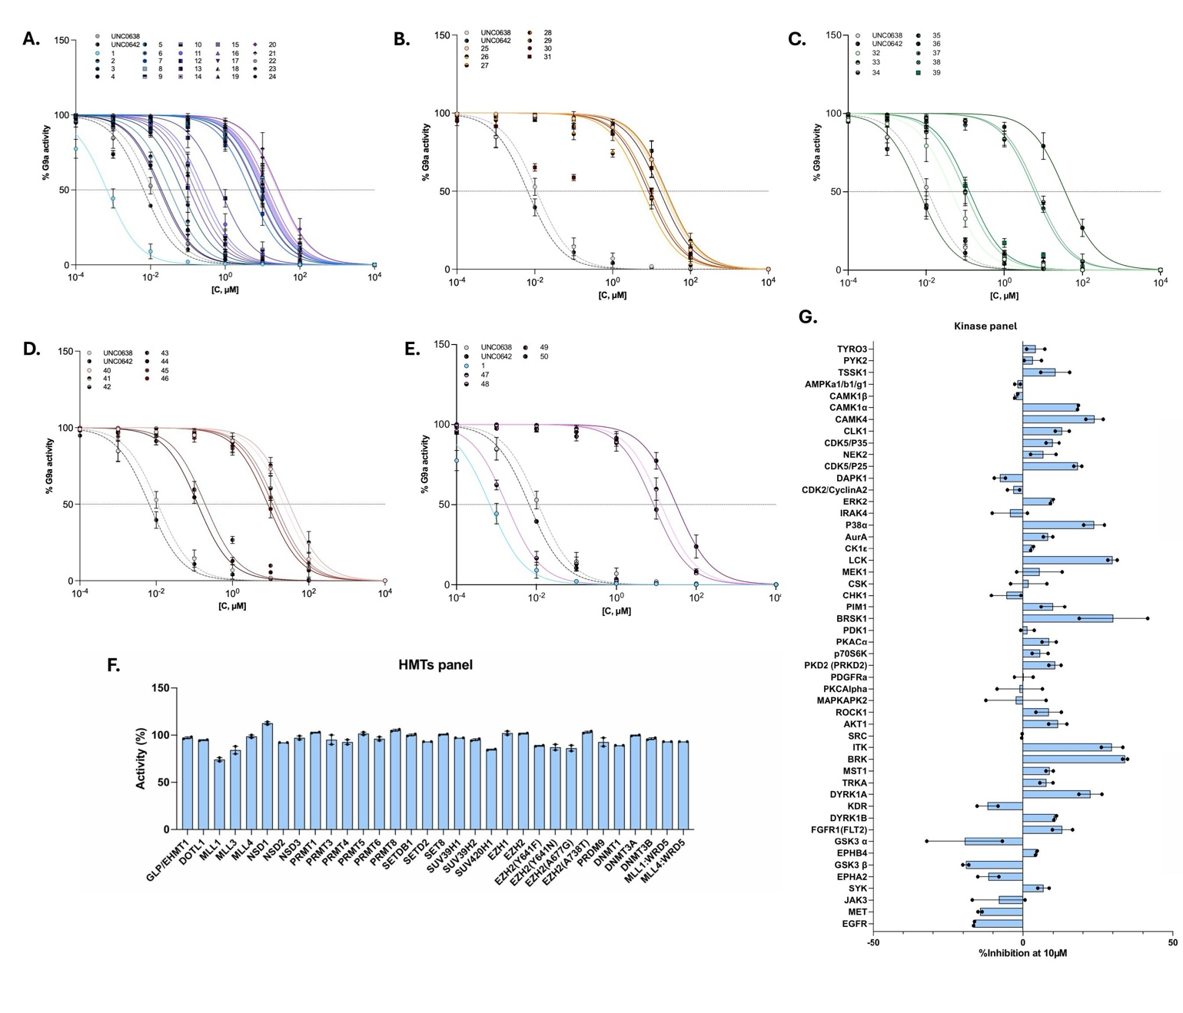
Figure S1. Representative IC_{50.} graph against G9a of the FLAV families. A. Compounds with alternative substituents on the phenyl ring of piperidine. B. Analogs of FLAV-27 with replacement of the m-hydroxyphenyl group by heterocyclic rings. C. Compounds with 1,3-oxazepane ring contracted to a morpholine ring. D. Compounds with a methyl group on the nitrogen atom of the 1,3-oxazepan ring. E. Analogs of FLAV-27 with alternative substituted benzyl ring on the nitrogen of the 1,3-oxazepane. F. Selectivity of FLAV-27 against histone methyltransferase enzymes targets at 1 µM.G. Selectivity of FLAV-27 against kinase targets at 10 µM.

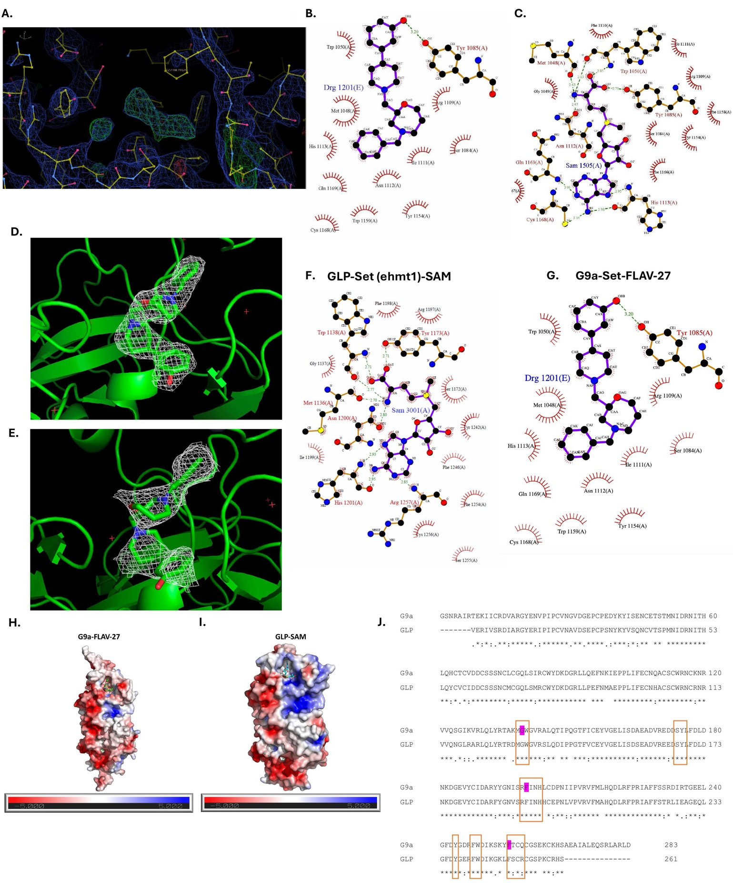
Figure S2. A. An initial fo-fc map in their SAM binding pocket of G9a after molecular replacement solution. B.-C. The ligplot view of FLAV-27 and SAM in the SAM binding pocket of G9a. D.-E. Composite (2Fo - Fc, white, contoured at 1σ) and difference (Fo - Fc, white, contoured at 1σ) electron density maps of the FLAV-27 of the refined G9a structure. F. Ligplot of GLP and G9a protein. A) Showing the interaction map of SAM ligand with its neighbouring amino acids in the GLP structure. Image is prepared using 5TUZ pdb ID. G. Showing the interaction map of FLAV 27 (label as Drg 1201) ligand with its neighbouring amino acids in the G9a structure. Image is prepared using our FLAV27-G9a complex. H. Electrostatic potential maps show differences in surface charge distribution. Electrostatic maps for G9a-FLAV27 complex, FLAV27 showing in stick I. GLP-SAM (PDB ID; 5TUZ), SAM showing in stick. The surface potentials are represented from anionic (red) to cationic (blue). J. Multiple alignments of deduced amino acid sequences of human G9a and GLP. Residues interacting with SAM and FLAV27 are in the boxes, residues heighted in blue are not participating in interacting with FLAV27 in G9a-FLA27 complex. Dots and colons indicate conserved amino acid substitutions. Dashes indicate gaps. Asterisks indicate identical amino acids. Protein sequences were aligned using the CLUSTAL omega program.

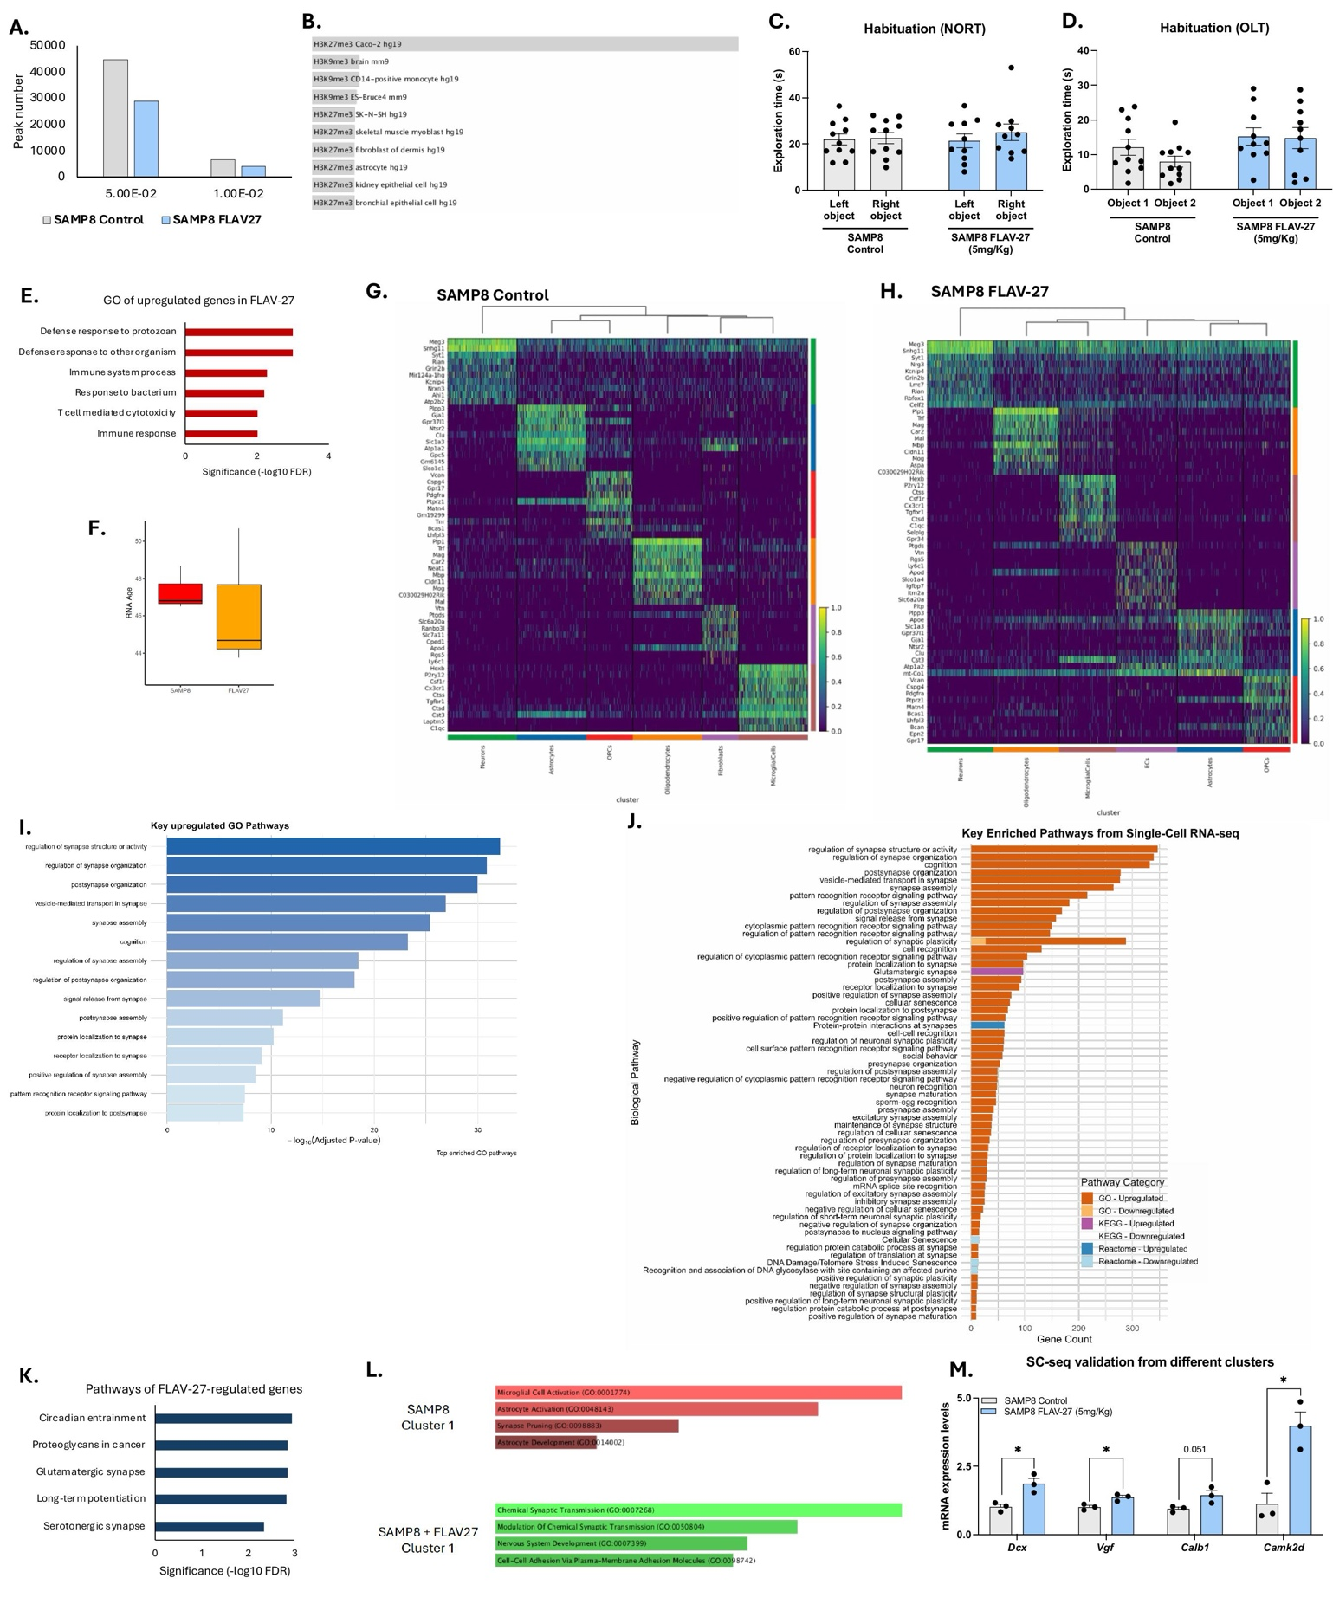
Figure S3. A. Number of H3K9me2 peaks calculated in control and FLAV-27-treated samples with different cut-offs. B. Gene set enrichment of genes close to H3K9me2 peaks that are decreased with FLAV-27 compared to Encode histone dataset. C. NORT and D. OLT habituation. Values presented as mean ± SEM; (SAMP8 Control n = 10, and SAMP8 FLAV-27 (5mg/Kg) n = 10); Statistics analysis: Student’s t-test analysis. E. Gene Ontology analysis of over-expressed genes in bulk RNA-seq. F. RNA Age calculation from bulk RNA-seq from Control SAMP8 and FLAV-27-treated SAMP8 mice. Median and SD deviations are shown. G. Heatmap of representative (top 10) genes from each cell-type cluster from control and H. FLAV27-treated (bottom) from single-cell RNA-seq data. I. Bar plot of GO enrichment analysis of upregulated genes according to single-cell RNA-seq data. J. Key enriched pathways from single-cell RNA-seq data.
K. Pathway enrichment from genes regulated by FLAV-27 according to single-cell RNA-seq data. L. GO of representative genes from cluster 1 derived from single-cell RNA-seq from SAMP8 control and SAMP8 FLAV-27-treated mice. M. qPCR validation of genes with significant changes in different single-cell clusters: Dcx, Vgf, Calb1 and Camk2d, respectively. Values presented as mean ± SEM; (N = 2 groups; SAMP8 Control n = 5, and SAMP8 FLAV-27 (5mg/Kg) n = 5); Statistics: Student’s t-test analysis; *p<0.05; **p<0.001.

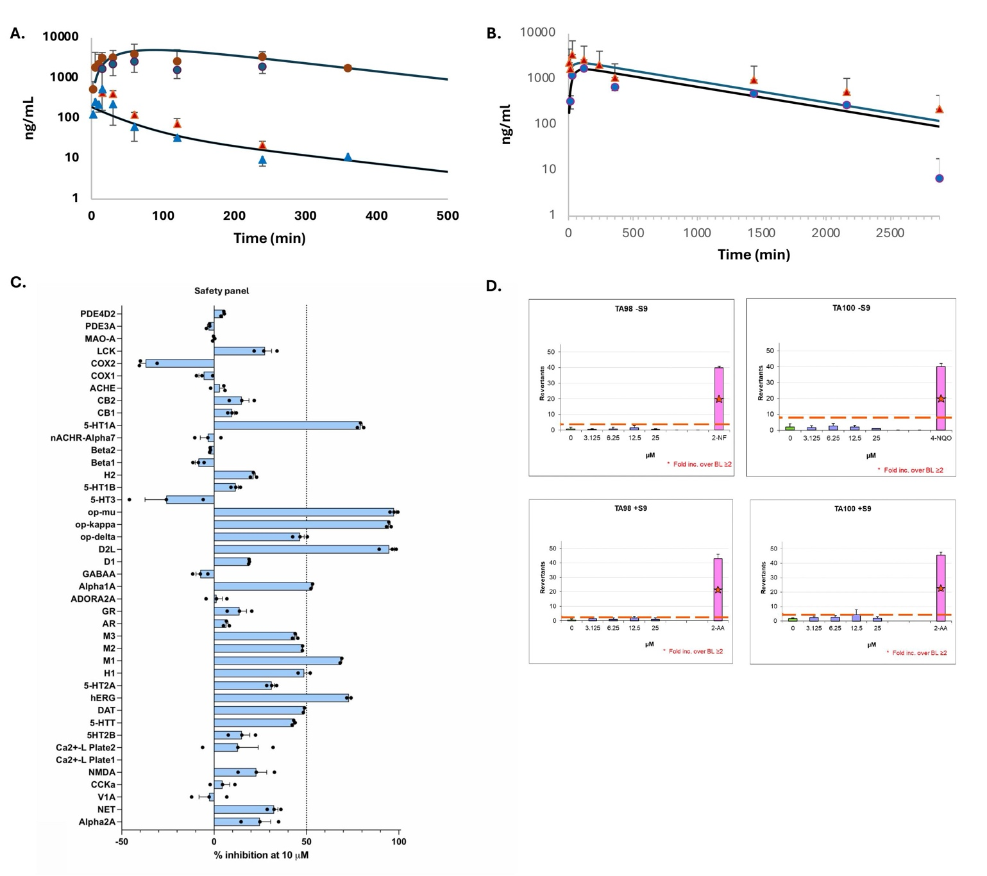

Figure S4. A. Base FLAV-27 plasma concentrations (ng/mL) observed (mean±sd) and predicted after oral (red triangles) and i.p. (red cercles) administration and pharmacokinetic predicted profile (solid black line). FLAV27 brain concentrations (ng/mL) observed (mean±sd) and predicted after oral (red circles) and i.p. (blue circles) administration and pharmacokinetic data fitting (solid black line). B. FLAV-27 plasma concentrations (ng/mL) observed (mean±sd; red triangles) and predicted (blue line) and brain concentrations (ng/mL) observed (blue circles) and predicted (black line) after FLAV-27 salt oral administration 5mg/kg. C. Safety panel of FLAV-27 at 10 µM. D. Number of positive mutated wells of FLAV-27using Salmonella typhimurium (S. typhimurium) TA98 and TA100 without S9 activation (Right column). Number of positive mutated wells of FLAV-27using S. typhimurium TA98 and E. TA100 with S9 activation (Left column).

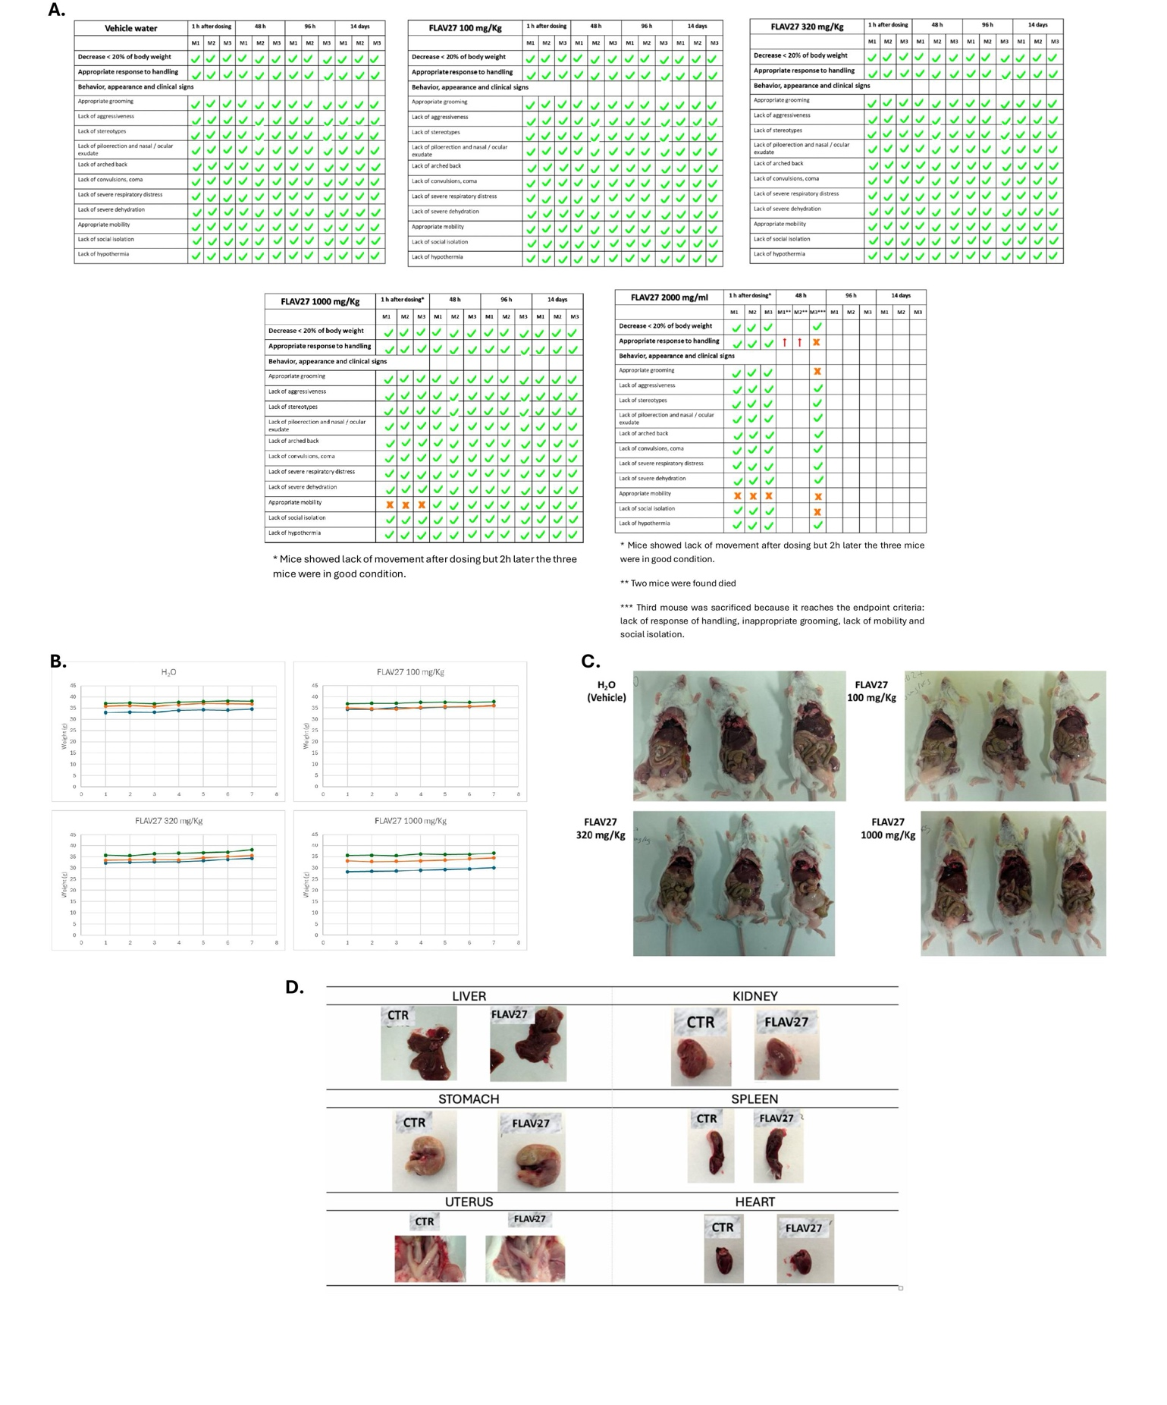
Figure S5. A. The results of supervision protocol observation are summarized in the figure. B. Weights of mice during 14 days of treatment with FLAV-27. The weight (g) of the mice is represented (every 2 days). C. Mice were sacrificed 14 days after treatment and gross necropsy were performed, photographs of necropsy are collected. D. Mice treated with 1000 mg/Kg FLAV-27 compound after sacrificing compared to control mice: organs comparison.

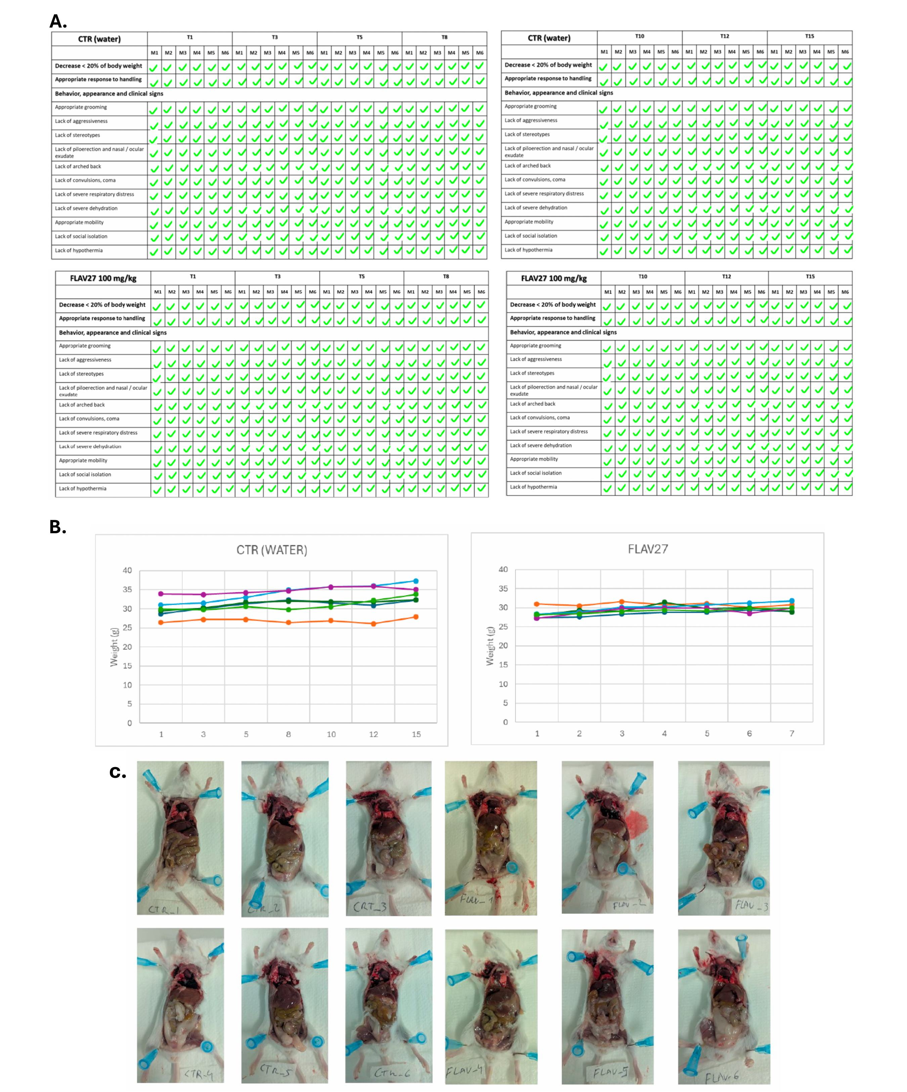

Figure S6. A. The results of supervision protocol observation are summarized in the following figure. Besides, weights of mice during 14 days of treatment with vehicle and FLAV27. B. The weight (g) of the mice is represented (every 2 days). C. Mice were sacrificed 72h after last treatment and gross necropsy were performed, photographs of necropsy are collected.

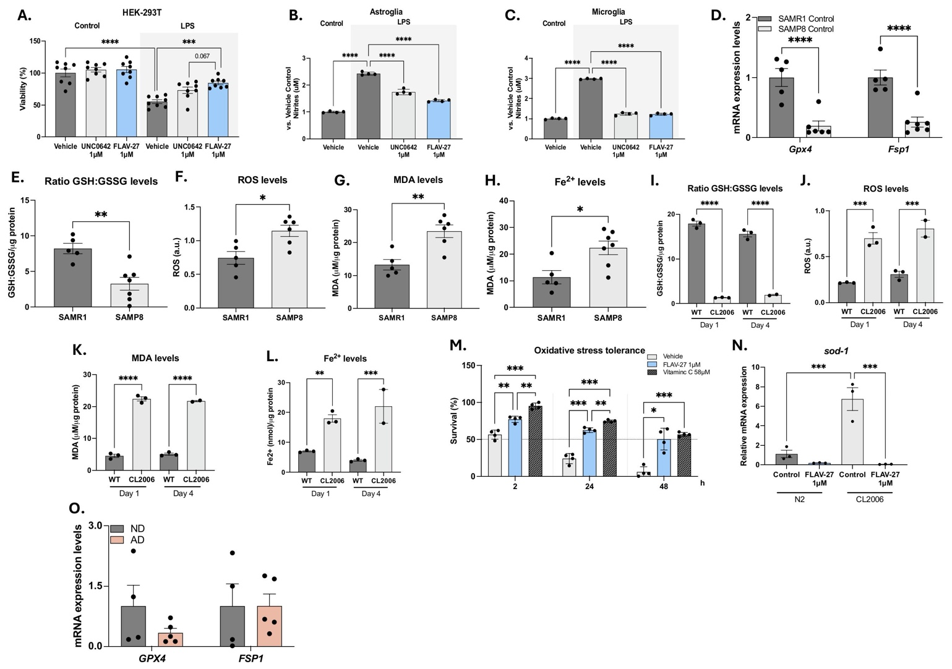
Figure S7. A. Viability of HEK-293T after LPS insult. Prior to damage, cells were treated with FLAV-27 and UNC0642 at 1µM. Values represented are mean ± SEM; n = 3. Statistical analysis: Two-Way ANOVA. ***p<0.001; ****p<0.0001. B. Nitrites levels in Astroglia and C. Microglia cells after LPS insult. Prior to damage cells were treated with FLAV-27 and UNC0642 at 1µM. Values represented are mean ± SEM; n = 3. Statistical analysis: One-way ANOVA, followed by Tukey post-hoc analysis. ****p<0.0001. Data are presented as mean ± SEM. Statistical significance was addressed using One-way ANOVA or Two-way ANOVA with Tukey post-hoc analysis; *p<0.05 (n≥3). D. Gen expression of Gpx4, and Fsp1. E. Levels of the the ratio GSG:GSSG levels F. ROS, G. MDA, and H. Fe²⁺ in SAMP8 and SAMR1 control groups. Values presented as mean ± SEM. (N = 2 groups; SAMP8 Control n = 5-6, and SAMR1 Control n = 5). Statistics analysis: Student’s t-test analysis; *p<0.05; **p<0.01; ***p<0.001. I. Levels of the the ratio GSG:GSSG levels J. ROS, K. MDA, and L. Fe²⁺ in CL2006 worms, a AD transgenic strain, in comparison with N2. M. Summary of the OS response after vehicle, FLAV-27 or Vitamin C treatment. Values represented are mean ± SEM; (N = 3 groups; Four technical replicates with 30 worms/each). *p<0.05; ** p<0.01; ** p<0.001. N. Gene expression of sod-1 of N2 and CL2006 in control and treated conditions. The total transcript amount was measured in triplicate. Statistics: Student’s t-test analysis with Welch correction were performed, ***p<0.001 and ***p<0.001. O. Gene expression levels of GPX4 and FSP1 in the brains of AD patients compared to non-demented controls. Values presented are the mean ± SEM; (N = 2 groups; Non demented n = 3-4, AD dementia n = 4-5); Statistics analysis: Student’s t-test analysis; *p<0.05; **p<0.01.
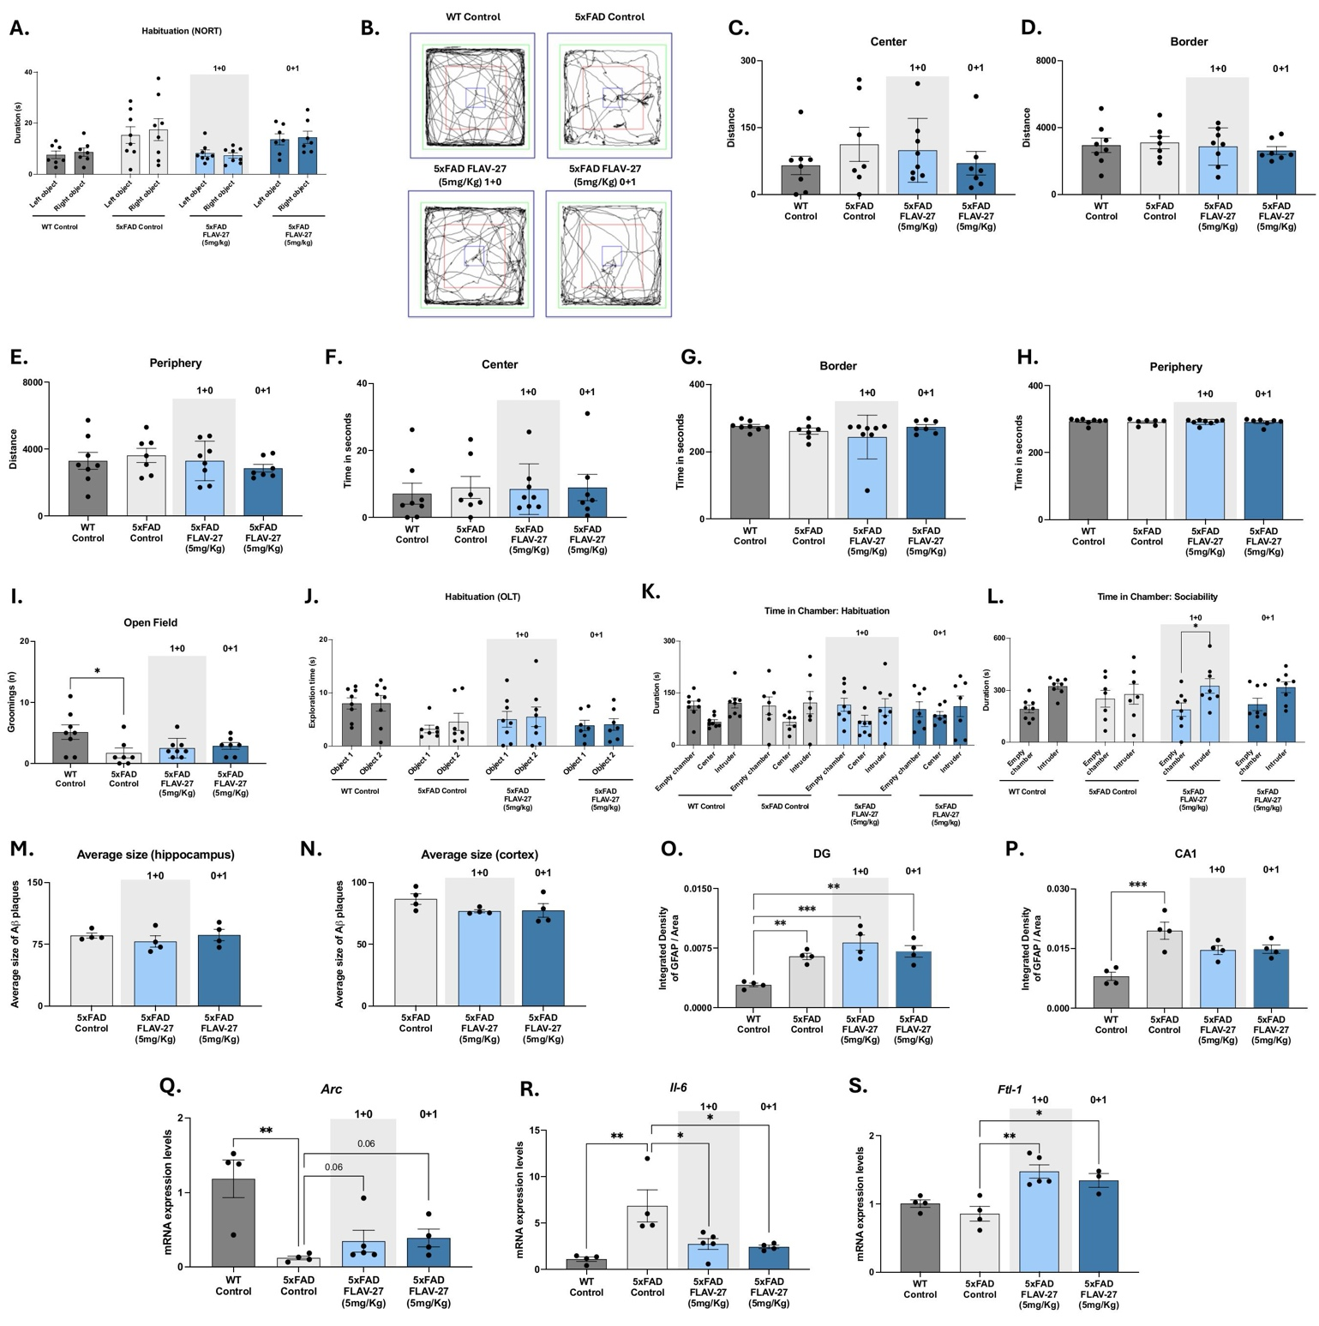
Figure S8. A. NORT: habituation. B. OF: traces representation of the distance travelled, C.-E. distance and F.-H. time in senconds in center, border and periphery, respectively. I. Groomings in OF. J. OLT: habituation. K. TCT: habituation and L. sociability time. M.-N. Average of Aβ size in hippocampus and cortex, respectively. O. Quantification of GFAP levels is also shown specifically in the DG, and P. CA1 areas. The mean intensity of GFAP staining is hereby indicated. Q. Gene expression levels of Arc, R. Il-6, and S. Ftl-1. Values presented as the mean ± SEM; (N = 4 groups; WT Control n = 4, 5xFAD Control n = 4, 5xFAD FLAV-27 1+0 (5mg/Kg) n = 4, and 5xFAD FLAV-27 0+1 (5mg/Kg) n = 4); Statistics analysis: One-way ANOVA followed with Tukey post-hoc analysis; *p<0.05; **p<0.01.

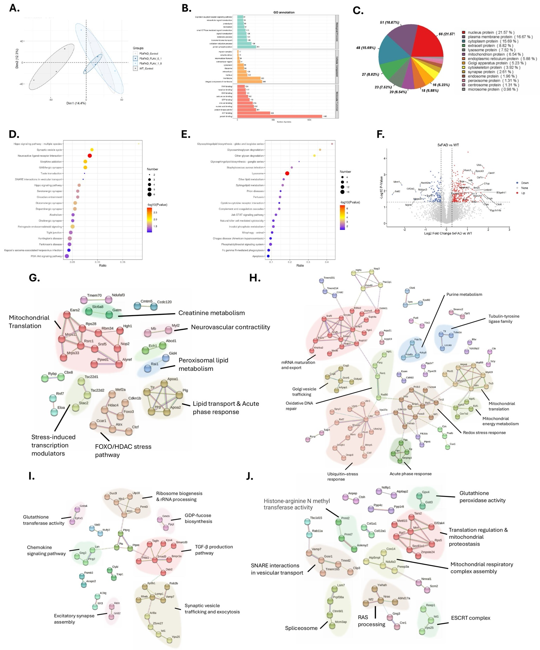
Figure S9. Overview of proteomic alterations and treatment effects in 5xFAD mice.
A. Principal component analysis (PCA) plot of all identified proteins, illustrating the global separation among WT (dark grey), 5xFAD (light grey), and treated groups (light and dark blue ellipses). B. Global enrichment analysis of biological processes (GO terms) when considering all groups together. C. Pie chart showing the proportion of up- and down-regulated proteins in 5xFAD versus WT. D.- E. Pathway and GO enrichment for down-regulated and up-regulated proteins in 5xFAD versus WT. The size and color of the dots represent the number of proteins mapped to each pathway and the statistical significance, respectively. F. Volcano plots depicting differential protein expression in 5XFAD mice respect to WT mice. Proteins with significant up- or down-regulation (based on adjusted p-value and fold-change thresholds) are shown in red and blue, respectively. G. Protein–protein interaction networks of differentially downregulated proteins in 5XFAD treated mice with FLAV27_1_0 and FLAV27_0_1. The map displays distinct functional groups involved in neuronal and synaptic signaling, cellular metabolism, proteostasis, as well as membrane trafficking and signal transduction. Proteins with a minimum interaction score of 0.4 were included, and clustering was performed using the MCL algorithm with an inflation parameter of 1.2. H. Distinct clusters center on processes such as synaptic pruning, phosphatidylinositol signaling, B cell signaling, and cytoskeletal organization. Here, proteins were included at a minimum interaction score of 0.4, and MCL clustering was conducted with an inflation parameter of 1.7. Proteins significantly reversed by treatment are also indicated with frames. These data suggest that both increases and decreases in protein levels contribute to disease-related alterations in metabolic pathways, vesicle trafficking, immune function, and neuronal signaling.Clustering performed using the MCL algorithm (Enright et al., 2002). I. Protein–protein interaction networks of differentially upregulated proteins in 5XFAD treated mice with FLAV27_1_0 and FLAV27_0_1. The map displays distinct functional groups involved in neuronal and synaptic signaling, cellular metabolism, proteostasis, as well as membrane trafficking and signal transduction. Proteins with a minimum interaction score of 0.4 were included, and clustering was performed using the MCL algorithm with an inflation parameter of 2.0. J. Protein clusters in this panel are enriched in mitochondrial respiratory complex assembly, translation regulation and mitochondrial proteostasis, SNARE-mediated vesicular transport, and the ESCRT complex. Additional modules include glutathione peroxidase activity, histone-arginine methylation, splicing, and RAS processing. STRING confidence cutoff was set to 0.4 and MCL clustering used an inflation parameter of 2.0.
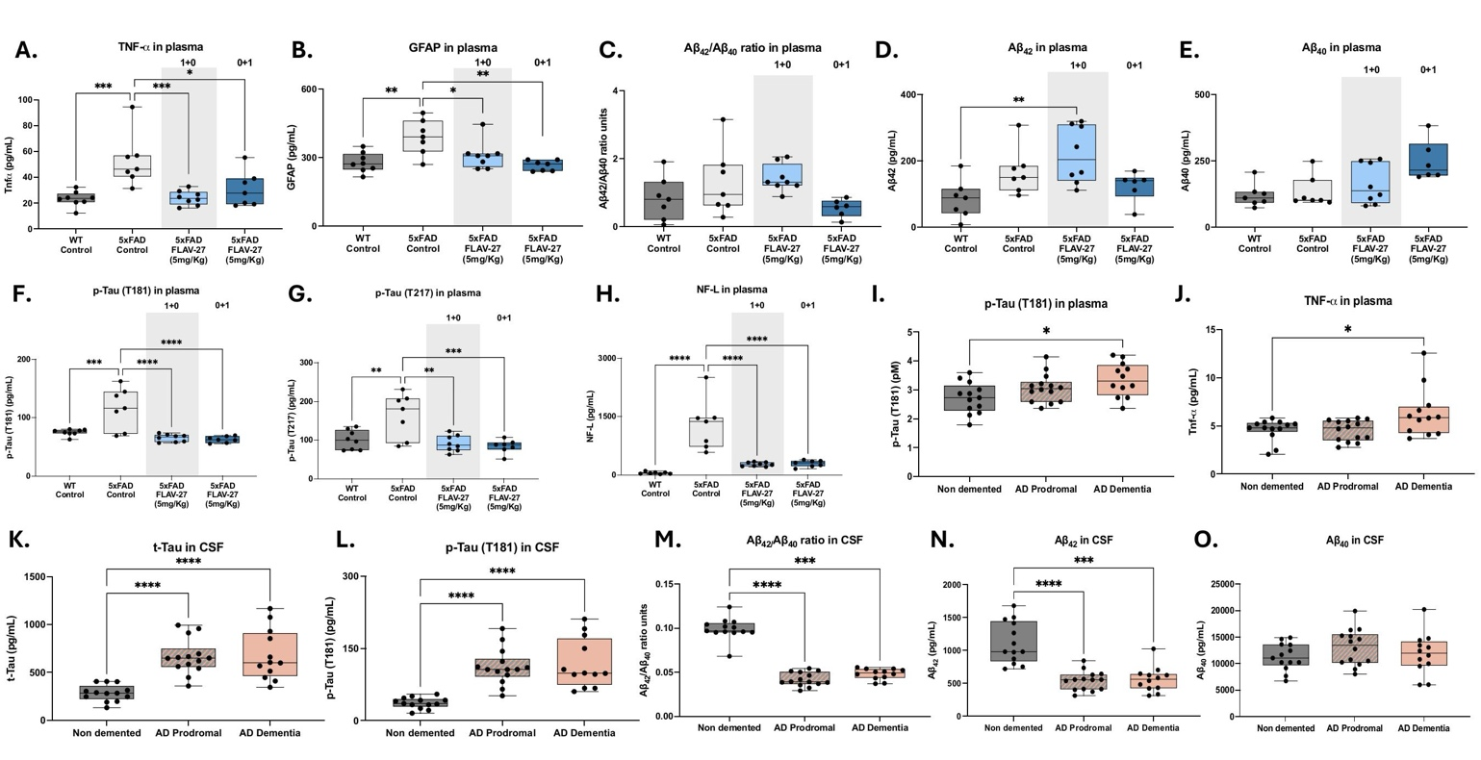
Figure S10. Fluids biomarker after FLAV-27 treatment in 5xFAD mice. A. Plasma levels of TNF-α, B. GFAP, C. ratio of Aβ₄₂/Aβ₄₀, D. Aβ₄₂, E. Aβ₄₀, F. p-TauT181, G. p-TauT217, and H. NF-L.Values presented as the mean ± SEM; (N = 4 groups; WT Control n = 8, 5xFAD Control n = 7, 5xFAD FLAV-27 1+0 (5mg/Kg) n = 8, and 5xFAD FLAV-27 0+1 (5mg/Kg) n = 7); Statistics analysis: One-way ANOVA followed with Tukey post-hoc analysis. In some cases, student’s t-test analysis was also performed ; */#p<0.05; **p<0.01; ***p<0.001. I. Plasma levels of p-Tau (T181) and J. TNF-α. K. CSF levels of t-Tau, L. p-Tau (T181) M. Aβ₄₂/Aβ₄₀ ration, N. Aβ₄₂, O. Aβ₄₀. Values presented are the mean ± SEM; (N = 3 groups; Non demented n = 13, AD Prodromal n = 14, AD dementia n = 12); Statistics analysis: One-way ANOVA followed with Tukey post-hoc analysis. In some cases, student’s t-test analysis was also performed ; *p<0.05; **p<0.01; ***p<0.001; ****p<0.0001.

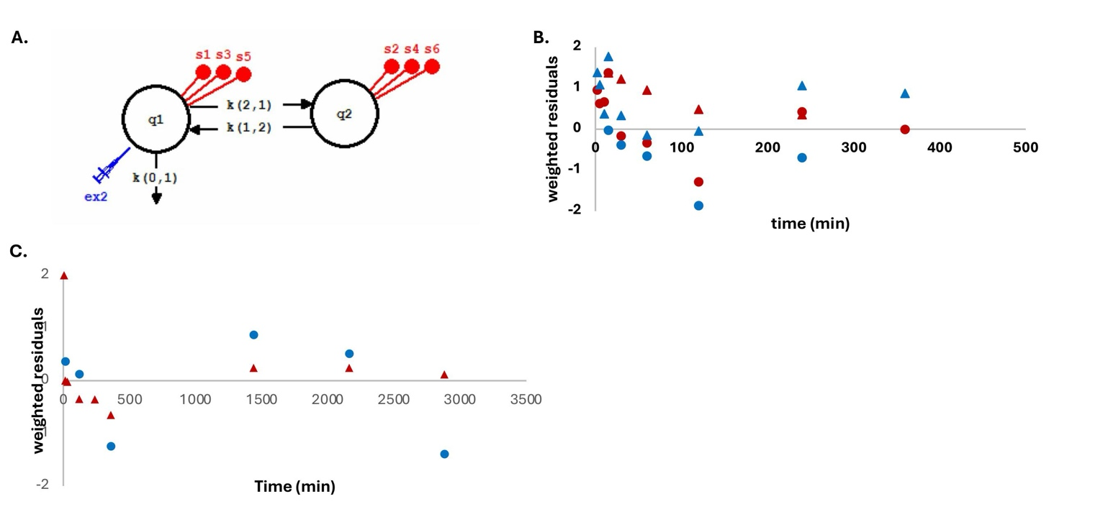

Figure S11. A. Pharmacokinetic model used for the assessment of plasma and brain FLAV-27 concentrations after oral and i.p. administration of FLAV27 base. Amounts of FLAV-27 in plasma are linked to plasma concentrations after i.p. (s1) and oral (s2) simultaneously coupled to the brain concentrations after i.p. (s3) and oral (s4) routes. FLAV27 salt oral route is represented as s5 when data is associated to plasma concentrations and s6 to brain concentrations. The volume of distribution in central (Vc/F) compartment is determined as s1=q1/Vc/F and s2=q1/Vc/F. The volume of distribution in peripheral (Vp/F) compartment is assessed as s3=q2/Vp/F and also s4=q2/Vp/F, being F an unknown oral bioavailability. B. Plot of weighted residuals in all the experimental time points obtained in plasma and brain observations estimating the prediction errors of the model for plasma (triangles) and brain concentrations (circles) after oral (blue) and i.p. (red) administration of 5mg/Kg of FLAV-27 base formulated in oil. C. Plot of weighted residuals in all the experimental time points obtained in plasma and brain observations estimating the prediction errors of the model for plasma (red triangles) and brain concentrations (blue circles) after oral administration of 5mg/Kg of FLAV-27 salt formulation.

Table S1. Compounds with alternative substituents on the phenyl ring of piperidine.

Compound | R | IC₅₀ G9a ± SD  (nM) | % inh GLP ± SDª  (1 µM)
1 | m-OH | 0.6 ± 0.001 | 3.2 ± 0.3
2 | m-NH₂ | 30.1 ± 0.01 | 20.8 ± 5.9
3 | m-Cl | 60.1 ± 0.01 | <1
4 | m-CO₂CH₃ | 19.1 ± 0.002 | <1
5 | m-CH₃ | >1 µM | 28.8 ± 1.2
6 | m-CN | >1 µM | 27.2 ± 1.9
7 | m-CF₃ | >1 µM | 89.1 ± 0.6
8 | m-SO₂CH₃ | >1 µM | 53.8 ± 2.5
9 | m-Br | >1 µM | 36.1 ± 0.7
10 | p-OH | 21.3 ± 0.03 | 21.9 ± 3.9
11 | p-NH₂ | 266 ± 0.01 | 17.6 ± 3.7
12 | p-Cl | 12.3 ± 0.03 | 60.0 ± 0.9
13 | p-OCH₃ | 754 ± 0.07 | 77.2 ± 1.4
14 | p-Br | >1 µM | 69.5 ± 0.7
15 | p-F | >1 µM | 71.9 ± 1.7
16 | p-CH₃ | >1 µM | 53.3 ± 2.7
17 | o-OH | 16.7 ± 0.001 | <1
18 | o-NH₂ | >1 µM | 52.8 ± 0.2
19 | o-CH₃ | >1 µM | 14.1 ± 0.5
20 | o-F | >1 µM | 35.1 ± 0.6
21 | o-OH, p-CH₃ | >1 µM | 9.2 ± 0.7
22 | o-OH, p-F | >1 µM | 35.7 ± 1.1
23 | m,m-diCl | 165.6 ± 0.04 | 77.2 ± 1.3
24 | H | >1 µM | 43.9 ± 2.5
ªEach value is the mean ± SD of at least two experiments performed in duplicate.

Table S2. Analogs with replacement of the m-hydroxyphenyl group by heterocyclic rings.

Compound | R | IC₅₀ G9a ± SD | % Inh GLP ± SDª  (1 µM)
25 |  | >1 µM | 97.3 ± 0.3
26 |  | >1 µM | 72.8 ± 0.1
27 |  | >1 µM | 14.6 ± 1.2
28 |  | >1 µM | 57.7 ± 1.4
29 |  | >1 µM | <1
30 |  | >1 µM | 4.2 ± 0.4
31 |  | >1 µM | 9.3 ± 0.03
ªEach value is the mean ± SD of at least two experiments performed in duplicate.
Table S3. Compounds with 1,3-oxazepane ring contracted to a morpholine ring.

Compound | R | IC₅₀ G9a ± SD  (nM) | % Inh GLP ± SDª  (1 µM)
32 | m-OH | 45 ± 0.012 | 35.4 ± 0.9
33 | m-NH₂ | 97.8 ± 0.02 | 4.18 ± 1.9
34 | m-CF₃ | >1 µM | 23.2 ± 0.5
35 | p-OH | 6.7 ± 0.1 | <1
36 | p-NH₂ | >1 µM | 64.6 ± 0.5
37 | p-Cl | 100 ± 0.02 | 6.1 ± 0.9
38 | o-CH₃ | >1 µM | 4.9 ± 0.1
39 | m,m-diCl | 128.3 ± 0.01 | 11.1 ± 0.5
ªEach value is the mean ± SD of at least two experiments performed in duplicate.
Table S4. Compounds with a methyl group on the nitrogen atom of the 1,3-oxazepan ring.

Compound | R | IC₅₀ G9a ± SD  (nM) | % Inh GLP ± SDª  (1 µM)
40 | m-NH₂ | >1 µM | 36.5 ± 1.0
41 | m-OCH₃ | >1 µM | 6.5 ± 0.03
42 | p-OH | 192.8 ± 0.04 | <1
43 | p-OCH₃ | 122.5 ± 0.01 | 0.8 ± 1
44 | p-NH₂ | >1 µM | 19.7 ± 1
45 | o-CH₃ | >1 µM | 14.7 ± 0.8
ªEach value is the mean ± SD of at least two experiments performed in duplicate.

Table S5. Analogs with alternative substituted benzyl ring on the nitrogen of the 1,3-oxazepane.

Compound | R | IC₅₀ G9a ± SD  (nM) | % Inh GLP ± SDª  (1 µM)
1 | Ph | 0.6 ± 0.1 | 3.24 ± 0.3
46 | p-CH₃Ph | >1 µM | 6.7 ± 0.7
47 | p-ClPh | 1.7 ± 0.1 | 32.6 ± 1.2
48 | p-CH₃OPh | >1 µM | 30.5 ± 0.6
49 | m,p-diClPh | >1 µM | 40.5 ± 2.3
ªEach value is the mean ± SD of at least two experiments performed in duplicate.

Table S6. Data collection and refinement statistics for the structure determination of SET domain of G9a with FLAV-27 inhibitor.
Data Collection
Space group | P1
Cell dimensions
a, b, c (Å) | 44.123 55.705 67.126
α, β, γ (°) | 89.35 73.18 67.04
Beamline | ALS-Berkley
Wavelength (Å) | 1.000
Resolution (Å)* | 42.33-2.70 (2.83-2.70)
Observed reflections* | 51563 (6200)
Unique reflections* | 14539 (1849)
Rmeas* | 0.088 (0.642)
CC1/2* | 0.996 (0.857)
<I/σ(I)>* | 7.4 (1.7)
Completeness (%) * | 94.4 ((90.4)
Redundancy* | 3.5 (3.4)
Refinement
Resolution (Å) | 42.33-2.70
Reflection used in refinement | 13787
Rwork/Rfree | 0.26/0.30
Number of non-hydrogen atoms | 4282
Macromolecules | 4183
Solvent | 39
Ligand | 56
Protein residues | 532
Average B factor | 62.8
RMS (Bond length) | 0.0035
RMS (Bond angles) | 1.1597
Ramachandran favored (%) | 92.4
Ramachandran allowed (%) | 7.6
Ramachandran outliers (%) | 0
*Number in parenthesis refer to values in outer shells. Rfree was calculated using a dataset in which a randomly selected 5% of the reflections were removed prior to refinement.

Table S7. Permeability (Pe 10-6 cm s-1) in the PAMPA-BBB assay of the 14 commercial drugs predictive penetration in the CNS used as Preference.
Compound | Bibliography value^{(a)} | Experimental value (n=3) ± S.D. | CNS Prediction
Verapamil | 16.0 | 25.3±0.8 | CNS+
Testosterone | 17.0 | 28.0±0.5 | CNS+
Costicosterone | 5.1 | 6.7±0.1 | CNS+
Clonidine | 5,3 | 6.5±0.1 | CNS+
Ofloxacin | 0.8 | 0.1±0.1 | CNS-
Lomefloxacin | 0.0 | 0.9±0.3 | CNS-
Progesterone | 9.3 | 16.8±0.3 | CNS+
Promazine | 8.8 | 13.8±0.3 | CNS+
Imipramine | 13.0 | 12.5±0.2 | CNS+
Hidrocortisone | 1.9 | 1.4±0.1 | CNS-
Piroxicam | 2.5 | 2.4±0.1 | CNS-
Desipramine | 12.0 | 17.8±0.1 | CNS+
Cimetidine | 0.0 | 0.7±0.03 | CNS-
Norfloxacine | 0.1 | 8.8±0.5 | CNS+
a)Taken from Di et al.^{[2]}

Table S8. Permeability results (Pe 10-6 cm s-1) from the PAMPA-BBB assay for new report compounds and their
prediction of BBB permeation.

Compound | Experimental value (n=3) ± S.D. | CNS Prediction
1 | >30 | CNS+
Enantiomer 1A | 9.2±0.9 | CNS+
Enantiomer 1B | 11.7±1.0 | CNS+
2 | 15.7±0.6 | CNS+
3 | 9.2±3.2 | CNS+
4 | 15.3±1.7 | CNS+
5 | 10.3±0.3 | CNS+
6 | 11.9±3.8 | CNS+
7 | 4.3±0.4 | CNS ±
8 | 6.8±0.2 | CNS+
9 | 3.05±0.4 | CNS ±
10 | >30 | CNS+
11 | 13.8±0.7 | CNS+
12 | 4.9±0.6 | CNS ±
13 | 11.5±0.8 | CNS+
14 | >30 | CNS+
15 | 6.35±0.5 | CNS+
16 | 14.3±1.1 | CNS+
17 | 7.5±0.5 | CNS+
18 | 26.1±1.2 | CNS+
19 | ND** | ND**
20 | 19.4±1.1 | CNS+
21 | 3.8±.1.4 | CNS ±
22 | 5.9±0.6 | CNS+
23 | 1.55±0.3 | CNS−
24 | 14.5±1.2 | CNS+
25 | 11.8±2.1 | CNS+
26 | 10.6±0.6 | CNS+
27 | 14.8±1.1 | CNS+
28 | 11.7±0.7 | CNS+
29 | 13.8±0.7 | CNS+
30 | 5.9±0.15 | CNS+
31 | 18.5±1.7 | CNS+
32 | 5.1±0.1 | CNS+/−
33 | 11.4±1.2 | CNS+
34 | 14.8±1.9 | CNS+
35 | 14.4±0.9 | CNS+
36 | 11.3±1.5 | CNS+
37 | 11.4±1.1 | CNS+
38 | 21.2±0.8 | CNS+
39 | 18.7±2.5 | CNS+
40 | 3.5±0.4 | CNS+/−
41 | 1.8±0.2 | CNS+/−
42 | 0.04±0.003 | CNS−
43 | 3.35±1.2 | CNS+/−
44 | 1.1±0.2 | CNS−
45 | 16.4±4.5 | CNS+
46 | 12.3±2.2 | CNS+
47 | 12.4±0.9 | CNS+
48 | 0.2±0.03 | CNS−
49 | 9.8±1.0 | CNS+

Table S9. Pharmacokinetic parameters obtained in mice after 5 mg/Kg of FLAV-27. FLAV-27 base formulation was administered by oral and i.p administration and FLAV-27 salt only by oral route. A and B are plasma compound concentrations at time 0 in the central and peripheral compartments respectively. The parameters  and  are macroconstants corresponding to the rate of compound elimination from central and peripheral compartments respectively. Constants k_{(0,1)} is the elimination constant from the plasma compartment, and k_{(2,1)} with k_{(1,2)} are intercompartimental rate constants. Vc/F is the volume of distribution obtained in the plasma compartment and Vp/F the volume of distribution in the brain. AUC_{0-∞} is the calculated area under the concentration time curve of plasma concentrations from time 0 to infinity, CL/F is the plasma clearance, t_{1/2} the plasma halflife, and MRT the mean residence time in plasma. Cmax_{p.o.} concentration is the maximun plasma concentration observed at Tmax after oral administration and Cmax_{i.p.} is the maximum plasma concentrations after i.p. administration. Brain Cmax _{p.o.} and Cmax _{i.p.} are brain concentrations after oral and i.p. observed at the corresponding times of respective values in plasma. B/R ratio is the relationship between observed brain and plasma maximum concentrations Cmax. Objective Function (OF), Akaike information criteria (AIC) and Bayesian information criterion (BIC) values are estimates corresponding to the selected model. (nd = not determined)
FLAV-27 |  | Base |  | Salt
Plasma |  | estimate | IC95% | estimate | IC95%
a | min⁻¹ | 0.03 | 0.02-0.04 | 0.1 | 0.13-0.13
b | min⁻¹ | 0.01 | 0.01-0.01 | 0.04 | 0.04-0.05
A | ng/mL | 116.6 | 71.9-161.2 | 2800.3 | 2295.8-3304.9
B | ng/mL | 21.8 | 15.1-28.3 | 3225.5 | 2839.8-3611.1
Vc/F | mL | 675.2 | 426.4-923.9 | 15.4 | 15.1-15.7
Vp/F | mL | 10 | 6.9-13.11 | 6.5 | 1.9-11.04
k_{(0,1)} | min⁻¹ | 0.01 | 0.002-0.01 | 0.002 | 0.002-0.002
k_{(1,2)} | min⁻¹ | 0.01 | 0.002-0,01 | 0.07 | 0.07-0.07
k_{(2,1)} | min⁻¹ | 0.01 | 0.08-0.02 | 0.02 | 0.01-0.02
AUC_{0-∞ po} | ng.min/mL | 32450.9 | 20567-44334 | 3335200 | 3061322-3609077
AUC_{0-last po} | ng.min/mL | 26983 | 22832-52547 | 2741811.9 | 1874249-3581490
AUC_{0-last ip} | ng.min/mL | 20799 | 8386-33211 | nd | -
CL/F | mL/min | 3.9 | 2.4-5.3 | 0.03 | 0.03-0.03
t_{1/2} | min | 105.3 | 63.1-179.8 | 45.5 | 42.1-48.9
MRT | min | 175.2 | 91.1-259.4 | 413 | 373.5-452.4
V_{ss/F} | mL | 675.2 | 426.3-923.9 | 15.5 | 15.2-15.8
Cmax _{p.o.} | ng/mL | 441.2 | 364.3-805.5 | 3497.3 | 2593.7-4400.9
Tmax _{p.o.} | min | 15 |  | 30-120
Cmax _{i.p.} | ng/mL | 538.7 | 422.6-654.6 | nd | -
Brain
Cmax _{p.o.} | ng/mL | 2246.7 | 1017.7-3475.6 | 1730.4 | 1663.5-1797.2
AUC_{0_last po} | ng.min/mL | 450149.2 | 250725-649572 | 1324477.1 | 1160255-1488698
Cmax _{i.p.} | ng/mL | 3914.3 | 2385-7428 | nd
AUC_{0_last ip} | ng.min/mL | 2080718 | 709903-2996778 | nd
B/P ratio
Cmax i.p. B/P Ratio | unitless | 5.9 |  | nd
Cmax p.o. B/P Ratio | unitless | 3.8 |  | 0.5
Model selection
OF | unitless | 11.9 |  | 12.1
AIC | unitless | 7.1 |  | 7.4
BIC | unitless | 7.3 |  | 7.6

Table S10. A. Mutagenic activity of FLAV-27 using S. typhimurium TA98 and TA100 without S9 activation. B. Mutagenic activity of FLAV-27 using S. typhimurium TA98 and TA100 with S9 activation. Abbreviations: 2-NF: 2-nitrofluorene; 4-NQO: 4-nitroquinoline-N-oxide; 2-AA: 2- aminoanthracene.
 |  | TA98 - S9 |  |  | TA98 + S9 |  |  | Mutagenic Conc./  Cytotoxic effect
 |  | Number positive wells |  |  | Number positive wells |  |  | Mutagenic Conc./  Cytotoxic effect
Sample | Concetration  (µM) | Replicate #1 | Replicate #2 | Replicate #3 | Replicate #1 | Replicate #2 | Replicate #3 | Mutagenic Conc./  Cytotoxic effect
FLAV-27 | 0  3.125  6.25  12.5  25 | 2  0  0  0  0 | 0  1  2  3  1 | 0  0  0  1  0 | 0  2  0  3  2 | 1  2  2  1  0 | 1  0  1  2  1
2-NF | 2 µg/mL | 39 | 41 | 40 |  |  |  | Mutagenic Conc.
2-AA | 1 µg/mL |  |  |  | 46 | 40 | 43 | Mutagenic Conc.

 |  | TA100 - S9 |  |  | TA100 + S9 |  |  | Mutagenic Conc./  Cytotoxic effect
 |  | Number positive wells |  |  | Number positive wells |  |  | Mutagenic Conc./  Cytotoxic effect
Sample | Concetration  (µM) | Replicate #1 | Replicate #2 | Replicate #3 | Replicate #1 | Replicate #2 | Replicate #3 | Mutagenic Conc./  Cytotoxic effect
FLAV-27 | 0  3.125  6.25  12.5  25 | 4  3  4  1  1 | 0  1  3  2  1 | 2  1  1  3  1 | 2  3  4  1  3 | 1  3  2  4  1 | 2  1  2  8  2
2-NQO | 0.1 µg/mL | 38 | 40 | 42 |  |  |  | Mutagenic Conc.
2-AA | 2.5 µg/mL |  |  |  | 45 | 48 | 44 | Mutagenic Conc.

Table S11. Results of compound and positive control (CTR+) in MNT test. Compound is assayed at different concentrations and results are calculated in terms of number of binucleate cells, cytostasis percentage ± SD and percentage of micronuclei in binucleate cells ± SD.

Sample | Concentration | No. binucleate cells | % Cytostasis | % MN
FLAV-27 | 200 μM | 725 | 11.7 | 6.3
FLAV-27 | 100 μM | 1188 | 0 | 7.7
FLAV-27 | 50 μM | 1244 | 0 | 6.9
FLAV-27 | 25 μM | 1378 | 0 | 6.6
FLAV-27 | 12.5 μM | 1659 | 0 | 6.5
CTR- |  | 1487 | - | 7.2
CTR + (MitoC) | 1 μM | 411 | 37.7 | 28.9
CTR + (MitoC) | 0.5 μM | 815 | 16.8 | 19.0

Table S12. Antibodies used in Western Blot and IHC studies.

Antibody | Host | Source/Catalog | WB Dilution
H3K9me2 | Rabbit | Epigentek/A-4035 | 1:1000
H3K18me1 | Rabbit | Epigentek/A-68374 | 1:1000
H3K18me2 | Rabbit | Novus/NB21-1142SS | 1:1000
H3K18me3 | Rabbit | Novus/NB21-1143SS | 1:1000
H3K23me1 | Rabbit | MyBioSource/MBS3388469 | 1:1000
H3K23me2 | Rabbit | MyBioSource/MBS388528 | 1:1000
H3K23me3 | Rabbit | MyBioSource/MBS388924 | 1:1000
H3 Total | Rabbit | Cell signaling/#9715 | 1:1000
SMOC1 | Rabbit | Invitrogen/PA5-1134408 | 1:1000
GAPDH | Mouse | Millipore/MAB374 | 1:2500
Goat-anti-mouse HRP conjugated | Goat | Biorad/170-5047 | 1:2000
Goat-anti-rabbit HRP conjugated | Goat | Biorad/170-6515 | 1:2000
Antibody | Host | Source/Catalog | ICH Dilution
GFAP | Rabbit | Dako/Z0334 | 1:1000
SMOC1 | Rabbit | Invitrogen/PA5-1134408 | 1:100
Alexa Fluor 647 donkey anti-rabbit | Donkey | Invitrogen/A31573 | 1:200
Alexa Fluor Plus 555 donkey-anti rabbit | Donkey | Invitrogen/A32794 | 1:200

Table S13. Primer sequences of real-time qPCR (SYBR Green primers).
Target | Forward Primer (5’-3’) | Reverse Primer (5’-3’)
Syt4 | CCGCGTGGAATTCGATGAAA | CTGACAGCAGATCCAGGCAA
Arc | GCCCCCAGCAGTGATTCATA | GGAACCCATGTAGGCAGCTT
Tnf-α | GCTGCACTTTGGAGTGATCG | GGGAGAGTGGATGAAGGCTG
Il-6 | ATCCAGTTGCCTTCTTGGGACTGA | TAAGCCTCCGACTTGTGAAGTGGT
Elavl4 | ACCAGAGTTTGATGAGAGCAACT | TCCATGGTGCTAATTATCTGGC
Syt7 | CGAAGGGGACCATGTACCG | TCTTGTAGCGTTTGCCCAGT
Dcx | AGGTAACGACCAAGACGCAAA | TACCTTGTGCTTCCGCAGAC
Camk2d | AGATCCTGGAGGCTGTGCTA | GTGCCAGCAAAACCAAACCA
Vgf | GTCAGACCCATAGCCTCCC | CTCGGACTGAAATCTCGAAGTTC
Ftl-1 | GCGGACCCTCATCTCTGTGA | GAGCCCCTTGGAAGGTACAG
Fth-1 | CTTCCCTCCCGACCTTTGTT | GTCTCTTTGGCAGGTCGTGA
Gpx4 | CCCTGTACTTATCCAGGCAGA | GATGGAGCCCATTCCTGAACC
Fsp1 | TGGTTGGTCAGTCTCTCGAC | AAGAACCGGATGGTGTTGCT
β-actin | CAACGAGCGGTTCCGAT | GCCACAGGTTCCATACCCA

Table S14. Patient data of the parietal brain samples from the Institute of Neuropathology-IDIBELL Brain Bank, Hospitalet de Llobregat.
Gender | Age | Postmortem delay | Diagnosis
Male | 85 | 5 h 45 min | Control
Male | 78 | 2 h 15 min | Control
Male | 79 | 7h | Control
Male | 52 | 3 h 20 min | Control
Female | 72 | 2 h 45 min | Control
Female | 49 | 5 h | Control
Male | 93 | 7 h 20 min | AD BRAAK STAGE V/C
Male | 85 | 5 h 15 min | AD BRAAK STAGE V/C
Male | 74 | 6 h 30 min | AD BRAAK STAGE V/C
Female | 83 | 3 h 20 min | AD BRAAK STAGE V/C
Female | 82 | 1 h 45 min | AD BRAAK STAGE V/B
Female | 72 | 9 h 30 min | AD BRAAK STAGE V/B
Female | 75 | 4 h 15 min | AD BRAAK STAGE V/B
Female | 85 | 2 h 10 min | AD BRAAK STAGE V/B

Table S15. Patient data of the plasma and CSF samples from Sant Pau Initiative on Neurodegeneration.
Gender | Age | ASTATUS | GDS | MMSE | Diagnostic
Male | 53 | Aneg | 1 | 27 | Control
Male | 57 | Aneg | 1 | 29 | Control
Male | 72 | Aneg | 1 | 28 | Control
Female | 60 | Aneg | 1 | 29 | Control
Female | 64 | Aneg | 1 | 29 | Control
Female | 71 | Aneg | 1 | 30 | Control
Male | 76 | Apos | 4 | 23 | AD
Male | 76 | Apos | 4 | 24 | AD
Male | 79 | Apos | 4 | 26 | AD
Female | 78 | Apos | 4 | 22 | AD
Male | 55 | Aneg | 1 | 27 | Control
Male | 81 | Apos | 4 | 22 | AD
Female | 77 | Apos | 4 | 22 | AD
Female | 76 | Apos | 4 | 24 | AD
Female | 66 | Aneg | 1 | 29 | Control
Female | 62 | Aneg | 1 | 30 | Control
Female | 76 | Apos | 4 | 27 | AD
Male | 77 | Apos | 4 | 19 | AD
Female | 78 | Apos | 4 | 22 | AD
Male | 80 | Apos | 3 | 23 | AD - Prodromal
Female | 76 | Apos | 3 | 15 | AD - Prodromal
Female | 81 | Apos | 3 | 26 | AD - Prodromal
Male | 76 | Apos | 3 | 29 | AD - Prodromal
Female | 80 | Apos | 3 | 26 | AD - Prodromal
Male | 79 | Apos | 3 | 26 | AD - Prodromal
Male | 79 | Apos | 3 | 25 | AD - Prodromal
Female | 80 | Apos | 3 | 29 | AD - Prodromal
Female | 80 | Apos | 3 | 26 | AD - Prodromal
Male | 77 | Apos | 3 | 22 | AD - Prodromal
Male | 61 | Aneg | 1 | 28 | Control
Male | 52 | Aneg | 1 | 30 | Control
Female | 62 | Aneg | 1 | 30 | Control
Female | 53 | Aneg | 1 | 29 | Control
Female | 68 | Apos | 5 | 11 | AD
Female | 75 | Apos | 3 | 26 | AD - Prodromal
Male | 84 | Apos | 3 | 27 | AD - Prodromal
Male | 71 | Apos | 3 | 25 | AD - Prodromal
Female | 78 | Apos | 3 | 26 | AD - Prodromal
Male | 74 | Apos | 4 | 21 | AD

