Supplementary information: Synthetic, characterization and structure-activity relationships details

First-in-Class SAM-Competitive G9a Inhibitor FLAV-27 as a Disease-Modifying Therapy for Alzheimer’s Disease

Aina Bellver-Sanchis¹, David Valle-Garcia², Carla Barbaraci³, Fernando Romero-Becerra^{3,4}, Rohit Kumar Singh⁵, Foteini Vasilopoulou⁶, Alba Irisarri¹, Carmen Martínez-Fernández¹, Juan A. Fafián-Labora⁷, María C. Arufe⁷, Carolin Wüst¹, Aida Castellanos⁸, David Soto^{8,9}, Núria Casals^{10,11}, Rut Fadó^{10,11}, Jennifer M Pocock⁶, Gemma Navarro^{12,13,14}, Cristina Val¹⁵, José Brea¹⁵, M. Isabel Loza¹⁵, Albert Lleó^{12,16}, Juan Fortea^{12,16}, Daniel Alcolea^{12,16}, Anna Perez-Bosque^{11,17}, Lluïsa Miró^{11,17}, Belén Pérez¹⁸, Sajid Rashid¹⁹, Muhammad Ali¹⁹, Manahil Saqib¹⁹, Marcel·lí Carbó^{1,4}, Ana Guerrero^{1,12}, Santiago Vázquez^{3,4}, Bhanwar Singh Choudhary²⁰, Shaodong Dai⁵, Carmen Escolano^{3,4}, Rafael Franco^{11,12} , Mercè Pallàs^{1,12}, Christian Griñán-Ferré*^{1,12}

¹Department of Pharmacology, Toxicology and Therapeutic Chemistry, Institut de Neurociències-Universitat de Barcelona, Barcelona, Spain.
E-mail: christian.grinan@ub.edu
²Laboratorio de Epigenómica del Envejecimiento, Centro de Investigación sobre el Envejecimiento, Cinvestav Sede Sur, 14330, Mexico City, Mexico.
³Laboratory of Medicinal Chemistry. Department of Pharmacology, Toxicology and Medicinal Chemistry, Faculty of Pharmacy and Food Sciences, University of Barcelona, Av. Joan XXIII, 27-31, 08028 Barcelona, Spain.
⁴Institute of Biomedicine of the University of Barcelona (IBUB), Universitat de Barcelona, 08028 Barcelona, Spain.
⁵Department of Pharmaceutical Sciences, Skaggs School of Pharmacy and Pharmaceutical Sciences, University of Colorado Anschutz Medical Campus, Aurora, CO 80045, USA
⁶Department of Neuroinflammation, UCL Queen Square Institute of Neurology, University College London, London, WC1N 1PJ, UK.
⁷Grupo de Terapia Celular y Medicina Regenerativa, Dpto. de Fisioterapia, Medicina y Ciencias Biomédicas. Facultad de Ciencias de la Salud, Universidad de da Coruña, INIBIC-CHUAC, Centro Interdisciplinar de Química y Biología (CICA), 15006, A Coruña, Spain.
⁸Neurophysiology Laboratory, Department of Biomedicine, Faculty of Medicine and Health Sciences, Institute of Neurosciences, University of Barcelona, 08036 Barcelona, Spain.
⁹August Pi i Sunyer Biomedical Research Institute (IDIBAPS), Barcelona, 08036 Spain.
¹⁰Basic Sciences Department, Faculty of Medicine and Health Sciences, Universitat Internacional de Catalunya, E-08195 Sant Cugat del Vallès, Spain.
¹¹Centro de Investigación Biomédica en Red de Fisiopatología de la Obesidad y la Nutrición (CIBEROBN), Instituto de Salud Carlos III, E-28029 Madrid, Spain.
¹²Centro de Investigación en Red, Enfermedades Neurodegenerativas (CIBERNED), Instituto de Salud Carlos III, Madrid, Spain.
¹³Department of Biochemistry and Physiology, School of Pharmacy and Food Sciences, Universitat de Barcelona, 08028 Barcelona, Spain.
¹⁴Institut de Neurociències UB, Campus Mundet, Passeig de la Vall d’Hebron 171, 08035 Barcelona, Spain.
¹⁵Drug screening Platform/Biofarma Research Group, CIMUS Research Center, University of Santiago de Copostela (USC), Santiago de Compostela 15782, Spain.
¹⁶Sant Pau Memory Unit, Department of Neurology, IR SANT PAU, Hospital de la Santa Creu i Sant Pau, 08041 Barcelona, Spain.
¹⁷Institut de Nutrició I Seguretat Alimentària de la Universitat de Barcelona, Av. Prat de la Riba, 171, 08921 Santa Coloma de Gramenet, Spain
¹⁸Department of Pharmacology, Therapeutic and Toxicology, Universitat Autònoma de Barcelona, 08193 Barcelona, Spain.
¹⁹Functional Informatics Lab, National Center for Bioinformatics, Quaid-i-Azam University, Islamabad, Pakistan.
²⁰Department of Pharmacy, Central University of Rajasthan, Ajmer, Rajasthan, India 305817.

Christian Griñán-Ferré
e-mail: Christian.grinan@ub.edu
phone: +34 934 024 531

CONTENTS

Chemistry: Synthesis and spectroscopic data........................................................................................................S3
Enantiomeric separation of compound 1, FLAV-27................................................................................................S20
¹H and ¹³C NMR Spectra.......................................................................................................................................S22
Solubility ............................................................................................................................................................S74
Microsomal stability at human microsomes .........................................................................................................S74
Plasma stability ..................................................................................................................................................S76
Human plasma protein binding............................................................................................................................S77
CYP450 inhibition assay…………………..................................................................................................................S79
hERG ion channel inhibition………………………………..............................................................................................S82

Chemistry: Synthesis and spectroscopic data
General information. Reagents, solvents and starting products were acquired from commercial sources. Evaporation of solvents was achieved with a rotary evaporator. The reactions were monitored by thin-layer chromatography using silica gel (60 F254) plates. Compounds spots were based on their absorbance at 254 nm and/or spraying with 1% aqueous KMnO₄. Flash column chromatography was performed using PuriFlash 5.250 system equipped with autosampler, UV/Vis and ELSD detectors (Interchim, Montluçon, France) with 12g cartridges packed with monodisperse 50 μm spherical silica particles (Interchim_PF-50SIHP-F0012) using a solvent system of dichloromethane and methanol or ethyl acetate and methanol. IR spectra were recorded on an FTIR Perkin-Elmer Spectrum RX I spectrophotometer (Waltham, MA, USA), using the attenuated total reflectance (ATR) technique; significant absorption peaks are given as wavenumbers (cm⁻¹). NMR spectra were recorded in CDCl₃ at 400 or 500 MHz (¹H) and 101 or 126 MHz (¹³C), and chemical shifts are reported in δ values downfield from TMS or relative to residual solvent (7.26 ppm and 77.0 ppm for CDCl₃, 3.31ppm and ppm 49.0 for MeOD) as an internal standard. Data are reported in the following manner: chemical shift, multiplicity, coupling constant (J) in hertz (Hz), integrated intensity. Multiplicities are reported using the following abbreviations: s, singlet; d, doublet; dd, doublet of doublets; t, triplet; q, quadruplet; m, multiplet; br, broad; ovlp, overlapped. Mass Spectrometry was performed using LC/MSD TOF Agilent Technologies G1969A spectrometer by the Mass Spectrometry for Molecular Characterization Unit (Biomolecular Analysis Unit), from Scientific and Technological Centers (CCiTUB), Universitat de Barcelona. The elemental analyses were carried out in a Flash 1112 series Thermofinnigan elemental microanalyzer (A5) to determine C, H, and N. HPLC-MS spectra were recorded on HPLC-MS (Agilent 1260 Infinity II) analysis was conducted on a Poroshell 120 EC-C15 (4.6 mm × 50 mm, 2.7 μm) at 40 °C with mobile phase A (H₂O + 0.05% formic acid) and B (ACN + 0.05% formic acid) using a gradient elution and flow rate 0.6 mL/min. The DAD detector was set at 254, the injection volume was 5 µl, and oven temperature was 40 °C. All tested compounds possessed a purity of at least 95%.

General procedure. To a solution of 4-substituted piperidine (1 mmol) in MeCN, KHCO₃ (3 mmol) and NaI (catalytic amount) were added. The solution was warmed up at 40°C and, after a few minutes, a solution of 4-benzyl-2-(chloromethyl)-1,4-oxazepane (1.31 mmol), 4-benzyl-2-(chloromethyl)morpholine (1.31 mmol), 2-(chloromethyl)-4-methyl-1,4-oxazepane (1.31 mmol) in MeCN was added dropwise. The temperature was raised to 80 °C and the reaction mixture was stirred overnight at 80ºC. Then, a saturated solution of NaHCO₃ and EtOAc were added, and the phases were separated. The organic phase was washed with a saturated solution of NaHCO₃, dried over anh. Na₂SO₄, filtered and evaporated. The crude mixture was purified by flash column chromatography (PuriFlash 5.250) using as eluent system DCM/MeOH or EtOAc/MeOH, furnishing the desired compounds as coloured oils.

Synthesis of 3-{1-[(4-benzyl-1,4-oxazepan-2-yl)methyl]piperidin-4-yl}phenol, 1 (FLAV-27)
Following the general procedure, 3-(piperidin-4-yl)phenol (96 mg, 0.54 mmol) in MeCN (4 mL), KHCO₃ (211 mg, 2.10 mmol), NaI (cat.), and a solution of 4-benzyl-2-(chloromethyl)-1,4-oxazepane (168 mg, 0.70 mmol) in MeCN (4 mL), gave compound 1 (88 mg, 43 % yield) after column chromatography DCM/MeOH (95:5). ¹H NMR (400 MHz, CDCl₃) δ 1.69– 1.80 (m, 4H, CH₂)), 1.83 – 1.90 (m, 1H, CH₂), 1.90 – 2.00 (m, 1H, CH₂), 2.02 – 2.16 (m, 2H, CH₂), 2.26 (dd, J = 13.0, 5.0 Hz, 1H, CH₂), 2.37 – 2.51 (m, 3H, CH₂), 2.61 – 2.64 (m, 1H, CH), 2.78 – 2.85 (m, 1H, CH₂), 2.88 – 2.98 (m, 2H, CH₂), 3.04 (br. d, J = 11.0 Hz, 1H, CH₂), 3.65 (d, J = 14.0 Hz, 1H, CH₂), 3.68 (d, J = 14.0 Hz, 1H, CH₂), 3.75 – 3.85 (m, 1H, CH), 3.85 – 3.99 (m, 2H, CH₂), 6.63 – 6.71 (m, 2H, ArH), 6.72 – 6.76 (d, J = 8.0 Hz, 1H, ArH), 7.14 (t, J = 8.0 Hz, 1H, ArH), 7.21 – 7.25 (m, 1H, ArH), 7.28 – 7.37 (m, 4H, ArH). ¹³C NMR (126 MHz, CDCl₃) δ 30.3 (CH₂), 31.7 (CH₂), 33.1 (CH₂), 33.2 (CH₂), 42.4 (CH), 54.0 (CH₂), 54.7 (CH₂), 55.0 (CH₂), 60.8 (CH₂), 61.9 (CH₂), 62.8 (CH₂), 67.4 (CH₂), 76.4 (CH), 113.5 (CAr), 114.2 (CAr), 119.0 (CAr), 127.2 (CAr), 128.4 (CAr), 129.1 (2CAr), 129.6 (2CAr), 139.2 (C-ipso), 148.3 (C-ipso), 156.4 (C-ipso). IR (ATR): ν 3027, 2934, 2813, 1599, 1585, 1452, 1353, 1271, 1155, 1067, 1028, 952, 867, 784, 733, 697 cm⁻¹. HRMS (ESI) m/z calcd for C₂₄H₃₃N₂O₂+H⁺: 381.2537 [M+H]⁺; found: 381.2537. Purity 100% (t_{R} = 2.97 min).
Compound 1 was dissolved in DCM, the solution was cooled to 0ºC, and a 2M solution of HCl in diethyl ether was added dropwise to give 1.2HCl. ¹H NMR (400 MHz, MeOD) δ 1.95 – 2.19 (m, 4H, CH₂), 2.20 – 51 (m, 2H, CH₂), 2.83 (m 1H, CH₂), 3.15 – 3.36 (m, 5H, CH₂), 3.42 – 3.57 (m, 2H, CH₂), 3.58 – 3.75 (m, 3H, CH₂), 3.91 – 4.14 (m, 2H, CH₂), 4.50 (br s, 2H, CH₂), 4.67 (br s, 1H, CH₂), 6.67 (dd, J = 8.2, 2.5 Hz, 1H, ArH), 6.71 – 6.77 (m, 2H, ArH), 7.7 (t, J = 7.7 Hz, 1H, ArH), 7.48 – 7.52 (m, 3H, ArH), 7.63 – 7.68 (m, 2H, ArH). ¹³C NMR (101 MHz, MeOD) δ 26.3 (CH₂), 31.4 (2CH₂), 40.6 (CH), 54.0 (2CH₂), 54.2 (CH₂), 56.3 (CH₂), 59.2 (CH₂), 62.7 (CH₂), 68.8 (CH₂), 114.6 (2CAr), 114.8 (2CAr), 118.8 (2CAr), 130.5 (CAr), 130.8 (CAr), 132.6 (C-ipso), 146.5 (C-ipso), 158.8 (C-ipso). IR (ATR): ν 3342, 2950, 2813, 1695, 1598, 1585, 1450, 1409, 1273, 1227, 1216, 1158, 1140, 1108, 996, 940, 867, 784, 757 cm⁻¹. Elemental Analysis calcd (%) for C₂₄H₃₂N₂O₂·2HCl·H₂O: C, 61.14; H, 7.70; N, 5.94; found: C, 61.33; H, 7.80; N, 5.76. Purity 100% (t_{R} = 2.93 min).
Compound 1 (FLAV27) was separated from the racemic sample, into the respective enantiomers named enantiomer 1A and enantiomer 1B. See Page S21 for HPLC separation conditions.

Synthesis of 3-{1-[(4-benzyl-1,4-oxazepan-2-yl)methyl]piperidin-4-yl}aniline, 2
Following the general procedure, 3-(piperidin-4-yl)aniline (57 mg, 0.32 mmol) in MeCN (4 mL), KHCO₃ (96 mg, 0.96 mmol), NaI (cat.), and a solution of 4-benzyl-2-(chloromethyl)-1,4-oxazepane (100 mg, 0.42 mmol) in MeCN (4 mL), gave compound 2 (86 mg, 71% yield) after column chromatography, DCM/MeOH (94:6). ¹H NMR (400 MHz, CDCl₃) δ 1.65 – 1.79 (m, 4H, CH₂), 1.81 – 1.95 (m, 2H, CH₂), 1.99 – 2.14 (m, 2H, NH₂), 2.17 (s, 1H, CH₂), 2.23 – 2.26 (m, 1H, CH₂), 2.31 – 2.50 (m, 3H, CH₂), 2.55 – 2.66 (m, 1H, CH), 2.76 – 2.86 (m, 1H, CH₂), 2.91 (d, J = 13.0 Hz, 2H, CH₂), 2.99 – 3.02 (m, 1H, CH₂), 3.67 (s, 2H, CH₂), 3.97 – 3.75 (m, 3H, CH), 6.57 – 6.48 (m, 2H, ArH), 6.61 (d, J = 8.0 Hz, 1H, ArH), 7.08 (t, J = 8.0 Hz, 1H, ArH), 7.25 (d, J = 7.5 Hz, 1H, ArH), 7.40 – 7.28 (m, 4H, ArH). ¹³C NMR (101 MHz, CDCl₃) δ 30.2 (CH₂), 32.9 (CH₂), 33.1 (CH₂), 42.4 (CH), 53.9 (CH₂), 54.4 (CH₂), 54.9 (CH₂), 60.4 (CH₂), 61.6 (CH₂), 62.5 (CH₂), 67.2 (CH₂), 76.3 (CH), 112.8 (CAr), 113.5 (2CAr), 117.1 (2CAr), 126.8 (2CAr), 128.0 (2CAr), 128.7 (C-ipso), 129.1 (C-ipso), 146.2 (C-ipso). IR (ATR): ν 3339, 2933, 1710, 1597, 1543, 1508, 1446, 1411, 1311, 1259, 1235, 1054, 1017, 953, 790,735, 699, 580 cm⁻¹. HRMS (ESI) m/z calcd for C₂₄H₃₄N₃O+H⁺: 380.2696 [M+H]⁺; found: 380.2695. Purity 100% (t_{R} = 1.08 min).

Synthesis of 4-benzyl-2-{[4-(3-chlorophenyl)piperidin-1-yl]methyl}-1,4-oxazepane, 3
Following the general procedure, 4-(3-chlorophenyl)piperidine (63 mg, 0.32 mmol) in MeCN (4 mL), KHCO₃ (96 mg, 0.96 mmol), NaI (cat.), and a solution of 4-benzyl-2-(chloromethyl)-1,4-oxazepane (100 mg, 0.42 mmol) in MeCN (4 mL), gave compound 3 (85 mg, 66% yield) after column chromatography DCM/MeOH (95:5). ¹H NMR (500 MHz, CDCl₃) δ 1.73 – 1.77 (m, 4H, CH₂), 1.81 – 1.89 (m, 1H, CH₂), 1.90 – 1.98 (m, 1H, CH₂), 2.11 – 2.20 (m, 2H, CH₂), 2.29 (dd, J = 13.2, 5.2 Hz, 1H, CH₂), 2.41 – 2.52 (m, 3H, CH₂), 2.61 – 2.66 (m, 1H, CH₂), 2.81 – 2.86 (m, 1H, CH₂), 2.92 – 2.96 (m, 2H, CH₂), 3.06 – 3.08 (m, 1H, CH), 3.69 (s, 2H, CH₂), 3.79 – 3.84 (m, 1H, CH₂), 3.88 –3.94 (m, 2H, CH₂), 7.08 (dt, J = 7.6 Hz, 1.5 Hz, 1H, ArH), 7.15 – 7.26 (m, 4H, ArH), 7.30 – 7.39 (m, 4H, ArH). ¹³C NMR (126 MHz, CDCl₃) δ 30.7 (CH₂), 33.1 (CH₂), 33.3 (CH₂), 42.5 (CH), 54.6 (CH₂), 55.2 (CH₂), 60.6 (CH₂), 61.8 (CH₂), 63.1 (CH₂), 67.7 (OCH₂), 76.5 (OCH), 125.4 (2CAr), 126.7 (CAr), 127.5 (CAr), 127.5 (CAr), 128.7 (2CAr), 129.4 (CAr), 130.1 (CAr), 134.5 (CCl), 139.4 (C-ipso), 148.6 (C-ipso). IR (ATR) ν 2934, 2809, 1596, 1452, 1137, 1088, 1028, 997, 909, 780, 737, 695 cm⁻¹. HRMS (ESI) m/z calcd for C₂₄H₃₂ClN₂O+H⁺: 399.2198 [M+H]⁺; found: 399.2200. Purity 98% (t_{R} = 3.28 min).

Synthesis of methyl 3-{1-[(4-benzyl-1,4-oxazepan-2-yl)methyl]piperidin-4-yl}benzoate, 4
Following the general procedure, methyl 3-(piperidin-4-yl)benzoate (70 mg, 0.32 mmol) in MeCN (4 mL), KHCO₃ (96 mg, 0.96 mmol), NaI (cat.), and a solution of 4-benzyl-2-(chloromethyl)-1,4-oxazepane (100 mg, 0.42 mmol) in MeCN (4 mL), gave compound 4 (97 mg, 72% yield) after column chromatography DCM/MeOH (94:6). ¹H NMR (500 MHz, CDCl₃) δ 1.73 – 1.79 (m, 4H),1.80 – 1.88 (m, 2H), 1.93 (br s, 1H, CH₂), 2.04 – 2.18 (m, 2H, CH₂), 2.23 – 2.31 (m, 1H, CH₂), 2.41 – 2.54 (m, 3H, CH₂), 2.60 – 2.65 (m, 1H, CH₂), 2.81 – 2.84 (m, 1H, CH₂), 2.93 (br.d, J = 13.0 Hz, 2H, CH₂), 3.04 (br.s, 1H, CH), 3.68 (s, 2H, CH₂), 3.79 – 3.84 (m, 1H, CH₂), 3.90 – 3.94 (m, 4H, OCH₃, CH), 7.23 – 7.27 (m, 1H ArH), 7.30 – 7.42 (m, 6H ArH), 7.87 (dt, J = 7.5, 1.5 Hz, 1H ArH), 7.90 (t, J = 1.5 Hz, 1H, ArH). ¹³C NMR (126 MHz, CDCl₃) δ 30.5 (CH₂), 33.1 (CH₂), 33.3 (CH₂), 42.4 (CH), 52.2 (CH₂), 54.3 (OCH₃), 54.5 (CH₂), 55.1 (CH₂), 60.5 (CH₂), 61.7 (CH₂), 62.9 (CH₂), 67.5 (OCH₂), 76.5 (OCH), 127.2 (CAr), 127.6 (CAr), 128.3 (2CAr), 128.4 (CAr), 128.6 (2CAr), 129.1 (CAr), 130.4 (CCO), 131.6 (CAr), 131.6 (C-ipso), 146.8 (C-ipso), 167.4 (CO). IR (ATR) ν 2933, 2849, 1720, 1443, 1283, 1241, 1196, 1095, 980, 752, 697 cm⁻¹. HRMS (ESI) m/z calcd for C₂₆H₃₅N₂O₃+H⁺: 423.2642 [M+H]⁺; found: 423.2633. Purity 100% (t_{R} = 3.37 min).

Synthesis of 4-benzyl-2-{[4-(m-tolyl)piperidin-1-yl]methyl}-1,4-oxazepane, 5
Following the general procedure, 4-(m-tolyl)piperidine (57 mg, 0.32 mmol) in MeCN (4 mL), KHCO₃ (96 mg, 0.96 mmol), NaI (cat.), and a solution of 4-benzyl-2-(chloromethyl)-1,4-oxazepane (100 mg, 0.42 mmol) in MeCN (4 mL), gave compound 5 (81 mg, 67% yield) after column chromatography EtOAc/MeOH (98:2). ¹H NMR (400 MHz, CDCl₃) δ 1.67 – 1.77 (m, 4H, CH₂), 1.82 – 1.95 (m, 2H, CH₂), 2.00 – 2.12 (m, 2H, CH₂), 2.23 (dd, J = 13.0, 6.0 Hz, 1H, CH₂), 2.34 (s, 3H, CH₃), 2.37 – 2.48 (m, 3H, CH₂), 2.57 – 2.65 (m, 1H, CH), 2.78 – 2.86 (m, 1H, CH₂), 2.87 – 2.95 (m, 2H, CH₂), 2.96 – 3.02 (m, 1H, CH₂), 3.68 (s, 2H, CH₂), 3.78 – 3.86 (m, 2H, CH₂), 3.88 – 3.96 (m, 1H, CH), 6.98 – 7.04 (m, 3H, ArH), 7.16 – 7.21 (m, 1H, ArH), 7.24 – 7.27 (m, 1H, ArH), 7.29 – 7.39 (m, 4H, ArH). ¹³C NMR (101 MHz, CDCl₃) δ 21.3 (CH₃), 30.2 (CH₂), 33.1 (CH₂), 33.3 (CH₂), 42.4 (CH₂), 54.0 (CH₂), 54.4 (CH₂), 54.9 (CH₂), 60.4 (CH₂), 61.6 (CH₂), 62.6 (CH₂), 67.2 (CH₂), 77.0 (CH), 123.7 (2CAr), 126.6 (CAr), 126.7 (CAr), 127.6 (CAr), 128.0 (CAr), 128.1 (CAr), 128.7 (2CAr), 137.7 (C-ipso), 139.3 (C-ipso), 146.4 (C-ipso). IR (ATR): ν 3025, 2934, 2809, 1607, 1588, 1493, 1452, 1353, 1137, 1089, 1067, 1028, 982, 784, 736, 698 cm⁻¹. HRMS (ESI) m/z calcd for C₂₅H₃₅N₂O+H⁺: 379.2744 [M+H]⁺; found: 379.2741. Purity 99% (t_{R} =3.19 min).

Synthesis of 3-{1-[(4-benzyl-1,4-oxazepan-2-yl)methyl]piperidin-4-yl}benzonitrile, 6
Following the general procedure, 3-(piperidin-4-yl)benzonitrile (60 mg, 0.32 mmol) in MeCN (3 mL), KHCO₃ (96 mg, 0.96 mmol), NaI (cat.) and a solution of 4-benzyl-2-chloro-1,4-oxazepane (100 mg, 0.42 mmol) in MeCN (3 mL),gave compound 6 (111 mg, 89% yield) after column chromatography DCM/MeOH (90:10).¹H NMR (400 MHz, CDCl₃) δ 1.60 – 1.78 (m, 4H, CH₂), 1.79 – 1.99 (m, 2H, CH₂), 2.07 (qd, J= 12.0, 4.0 Hz, 2H, CH₂), 2.23 (dd, J= 12.0, 6.0 Hz, 1H, CH₂), 2.37 – 2.53 (m, 3H, CH₂), 2.62 (m, 1H, CH), 2.79 – 2.95 (m, 2H, CH₂), 3.00 (d, J= 12.0 Hz, 1H, CH₂), 3.67 (s, 2H, CH₂), 3.77 –3.87 (m, 2H, CH₂), 3.92 (m, 1H, CH), 7.24 – 7.26 (m, 2H, ArH), 7.30 – 7.40 (m, 5H, ArH), 7.42 – 7.44 (m, 1H, ArH), 7.47 – 7.49 (m, 2H, ArH). ¹³C NMR (101 MHz, CDCl₃) δ 30.5 (CH₂), 33.0 (CH₂), 33.2 (CH₂), 42.2 (CH), 54.3 (CH₂), 54.4 (CH₂), 54.8 (CH₂), 60.5 (CH₂), 61.7 (CH₂), 62.9 (CH₂), 67.5 (CH₂), 76.6 (CH), 112.5 (C-ipso), 119.2 (C-ipso), 127.1 (CAr), 128.3 (2CAr), 129.0 (2CAr), 129.3 (CAr), 130.0 (CAr), 130.7 (CAr), 131.6 (CAr), 139.4 (C-ipso), 147.9 (C-ipso). IR (ATR): ν 3327, 2956, 2852, 1678, 1645, 1502, 1454, 1312, 1189, 1015, 821, 740, 634 cm⁻¹. HRMS (ESI) m/z calcd for C₂₅H₃₂N₃O+H⁺: 390.2545 [M+H]⁺; found: 390.2542. Purity 96% (t_{R} = 3.13 min).

Synthesis of 4-benzyl-2-{[4-(3-(trifluoromethyl)phenyl)piperidin-1-yl]methyl}-1,4-oxazepane, 7
Following the general procedure, 4-[3-(trifluoromethyl)phenyl]piperidine (53 mg, 0.23 mmol) in MeCN (2 mL), KHCO₃ (70 mg, 0.69 mmol), NaI (cat.) and a solution of 4-benzyl-2-chloro-1,4-oxazepane (72 mg, 0,301 mmol) in MeCN (2.5 mL), gave compound 7 (57 mg, 57% yield) after column chromatography DCM/MeOH (90:10). ¹H NMR (400 MHz, CDCl₃) δ 1.70 – 1.77 (m, 4H, CH₂), 1.81 – 1.98 (m, 2H, CH₂), 2.04 – 2.17 (m, 2H, CH₂), 2.25 (dd, J= 12.0, 6.0 Hz, 1H, CH₂), 2.39 – 2.55 (m, 3H, CH₂), 2.60 – 2.66 (m, 1H, CH), 2.81 – 2.87 (m, 1H, CH), 2.92 (d, J= 12.0 Hz, 2H, CH₂), 3.03 (d, J= 12.0 Hz, 1H, CH₂), 3.68 (s, 2H, CH₂), 3.78-3.95 (m, 3H, CH₂), 7.22 – 7.26 (t, 1H, ArH), 7.30-7.46 (m, 8H, ArH). ¹³C NMR (101 MHz, CDCl₃) δ 30.5 (CH₂), 33.1 (CH₂), 33.3 (CH₂), 42.5 (CH), 54.4 (2CH₂), 55.0 (CH₂), 60.5 (CH₂), 61.7 (CH₂), 62.9 (CH₂), 67.5 (CH₂), 76.5 (CH), 123.1 (q, J= 16.0 Hz, 1H, CAr), 123.8 (q, J= 16.0 Hz, 1H, C-ipso), 125.8 (CAr), 127.2 (CAr), 128.4 (2CAr), 128.9 (CAr), 129.1 (2CAr), 130.4 (CAr), 130.6 (CAr), 130.9 (C-ipso), 139.4 (C-ipso), 147.4 (C-ipso). IR (ATR) ν 2935, 2810, 1449, 1328, 1120, 1072, 914, 800, 738, 699, 675 cm⁻¹. HRMS (ESI) m/z calcd for C₂₅H₃₂F₃N₂O+H⁺: 433.2467 [M+H]⁺; found: 433.2461. Purity 97% (t_{R} = 3.32 min).

Synthesis of 4-benzyl-2-((4-(3-(methylsulfonyl)phenyl)piperidin-1-yl)methyl)-1,4-oxazepane, 8
Following the general procedure, 4-[3-(methylsulfonyl)phenyl]piperidine (57 mg, 0.24 mmol) in MeCN (2 mL), KHCO₃ (71 mg, 0.72 mmol), NaI (cat.) and a solution of 4-benzyl-2-chloro-1,4-oxazepane (74 mg, 0.31 mmol) in MeCN (2.5 mL), gave compound 8 (111 mg, 89% yield) after column chromatography DCM/MeOH (90:10).¹H NMR (400 MHz, CDCl₃) δ 1.76 – 1.91 (m, 5H, CH₂), 1.92 – 2.03 (m, 1H, CH₂), 2.13 – 2.26 (m, 2H, CH₂), 2.31 (dd, J= 12.0, 4.0 Hz, 1H, CH₂), 2.43 – 2.55 (m, 2H, CH₂), 2.59 – 2.67 (m, 2H, CH₂), 2.82 – 2.88 (m, 1H, CH), 2.96 – 2.99 (m, 2H, CH₂), 3.05 (s, 3H, CH₃), 3.11 (br. d, J= 8.0 Hz, 1H, CH₂), 3.71 (s, 2H, CH₂), 3.78 – 3.86 (m, 1H, CH), 3.87 – 3.97 (m, 2H, CH₂), 7.22 – 7.41 (m, 5H, ArH), 7.47 – 7.54 (m, 2H, ArH), 7.74 – 7.81 (m, 2H, ArH). ¹³C NMR (101 MHz, CDCl₃) δ 30.2 (CH₂), 32.7 (CH₂), 32.9 (CH₂), 42.2 (CH), 44.5 (CH₃), 54.2 (CH₂), 54.2 (CH₂), 54.8 (CH₂), 60.2 (CH₂), 61.4 (CH₂), 62.8 (CH₂), 67.4 (CH₂), 75.9 (CH), 125.2 (CAr), 125.8 (CAr), 127.3 (CAr), 128.4 (2CAr), 129.2 (2CAr), 129.6 (CAr), 132.3 (CAr), 138.8 (C-ipso), 140.7 (C-ipso), 148.03 (C-ipso). IR (ATR) ν 3420, 2927, 2811, 1451, 1298, 1141, 1087, 958, 762, 735, 696 cm⁻¹. HRMS (ESI) m/z calcd for C₂₅H₃₅N₂O₃S +H⁺: 443.2368 [M+H]⁺; found: 443.2364. Purity 100% (t_{R} = 3.03 min).

Synthesis of 4-benzyl-2-{[4-(3-bromophenyl)piperidin-1-yl]methyl}-1,4-oxazepane, 9
Following the general procedure, 4-(3-bromophenyl)piperidine (77 mg, 0.32 mmol) in MeCN (4 mL), KHCO₃ (96 mg, 0.96 mmol), NaI (cat.), and a solution of 4-benzyl-2-(chloromethyl)-1,4-oxazepane (100 mg, 0.42 mmol) in MeCN (4 mL), gave compound 9 (97 mg, 68 % yield) after column chromatography DCM/MeOH (95:5). ¹H NMR (400 MHz, CDCl₃) δ 1.62 – 1.72 (m, 4H, CH₂), 1.82 – 1.91 (m, 2H, CH₂), 1.98 – 2.11 (m, 2H, CH₂), 2.21 (dd, J = 13.0 Hz, 6.0 Hz, 1H, CH₂), 2.38 – 2.45 (m, 3H, CH₂), 2.58 – 2.64 (m, 1H, CH), 3.82 – 2.99 (m, 4H, CH₂), 3.67 (s, 2H, CH₂), 3.81 – 3.84 (m, 2H, CH₂), 3.88 – 3.95 (m, 1H, CH), 7.10 – 7.17 (m, 2H, ArH), 7.25 – 7.27 (m, 1H, ArH), 7.30 – 7.37 (m, 6H, ArH). ¹³C NMR (101 MHz, CDCl₃) δ 30.6 (CH₂), 33.3 (CH₂), 33.5 (CH₂), 42.5 (CH), 54.4 (CH₂), 54.5 (CH₂), 55.0 (CH₂), 60.6 (CH₂), 61.8 (CH₂), 62.9 (CH₂), 67.5 (CH₂), 76.8 (CH), 122.6 (C-ipso), 125.7 (CAr), 127.1 (2CAr), 128.4 (2CAr), 129.0 (CAr), 129.3 (CAr), 130.1 (CAr), 130.2 (CAr), 139.6 (C-ipso), 149.1 (C-ipso). IR (ATR): ν 2933, 2808, 1565, 1451, 1353, 1137, 1088, 1071, 995, 779, 743, 698 cm⁻¹. HRMS (ESI) m/z calcd for C₂₄H₃₂BrN₂O+H⁺: 443.1693 [M+H]⁺; found: 443.1693. Purity 97% (t_{R} =3.33 min).

Synthesis of 4-{1-[(4-benzyl-1,4-oxazepan-2-yl)methyl]piperidin-4-yl}phenol, 10
Following the general procedure, 4-(piperidin-4-yl)phenol (57 mg, 0.32 mmol) in MeCN (4 mL), KHCO₃ (96 mg, 0.96 mmol), NaI (cat.), and a solution of 4-benzyl-2-(chloromethyl)-1,4-oxazepane (100 mg, 0.42 mmol) in MeCN (4 mL), gave compound 10 (45 mg, 37% yield) as a white powder after column chromatography DCM/MeOH (95:5). ¹H NMR (400 MHz, CDCl₃) δ 1.62 – 1.76 (m, 3H, CH₂), 1.78 – 1.88 (m, 2H, CH₂), 1.90 – 2.02 (m, 1H, CH₂), 2.06 – 2.26 (m, 2H, CH₂), 2.28 – 2.46 (m, 3H, CH₂), 2.47 – 2.56 (m, 1H, CH₂), 2.57 – 2.65 (m, 1H, CH), 2.78 – 2.88 (m, 1H, CH₂), 2.91 – 3.02 (m, 2H, CH₂), 3.08 (d, J = 11.0 Hz, 1H, CH₂), 3.65 (d, J = 13.0 Hz, 1H, CH₂), 3.75 (d, J = 13.0 Hz, 2H, CH₂), 3.71– 3.78 (m, 2H, CH₂), 3.93 – 4.01 (m, 1H, CH), 6.78 (d, J = 8.5 Hz, 2H, ArH), 7.02 (d, J = 8.5 Hz, 2H, ArH), 7.22 - 7.26 (m, 1H, ArH), 7.29 – 7.36 (m, 4H, ArH). ¹³C NMR (101 MHz, CDCl₃) δ 29.9 (CH₂), 32.8 (CH₂), 41.0 (CH), 53.6 (CH₂), 54.3 (CH₂), 55.0 (CH₂), 60.4 (CH₂), 61.4 (CH₂), 62.5 (CH₂), 67.1 (CH₂), 75.3 (CH), 115.3 (CAr), 127.0 (2CAr), 127.6 (2CAr), 128.1 (2CAr), 128.9 (2CAr), 137.3 (C-ipso), 138.4 (C-ipso), 154.4 (C-ipso). IR (ATR): ν 2940, 2798, 1612, 1515, 1442, 1366, 1270, 1241, 1180, 1136, 1057, 973, 906, 827, 777, 731, 697, 592 cm⁻¹. HRMS (ESI) m/z calcd for C₂₄H₃₃N₂O₂+H⁺: 381.2537 [M+H]⁺, found: 381.2534. Purity 100% (t_{R} = 2.88 min).

Synthesis of 4-{1-[(4-benzyl-1,4-oxazepan-2-yl)methyl]piperidin-4-yl}aniline, 11
Following the general procedure, 4-(piperidin-4-yl)aniline (61 mg, 0.32 mmol) in MeCN (4 mL), KHCO₃ (96 mg, 0.96 mmol), NaI, and a solution of 4-benzyl-2-(chloromethyl)-1,4-oxazepane (100 mg, 0.42 mmol) in MeCN (4 mL), gave compound 11 (98 mg, 81% yield) after column chromatography DCM/MeOH (96:4). ¹H NMR (400 MHz, CDCl₃) δ 1.54 – 1.69 (m, 4H, CH₂), 1.76 – 1.90 (m, 2H, CH₂), 2.06 – 2.91 (m, 2H, CH₂), 2.10 (s, 1H, CH₂), 2.11 – 2.19 (m, 1H, CH₂), 2.20 – 2.31 (m, 1H, CH₂), 2.32 – 2.41 (m, 2H, CH₂), 2.50 – 2.58 (m, 1H, CH), 2.70 – 2.78 (m, 1H, CH₂), 2.78 – 2.86 (m, 2H, CH₂), 2.91 (d, J = 11.0 Hz, 1H, CH₂), 3.48 (s, 1H, NH₂), 3.60 (s, 2H, CH₂), 3.70 – 3.76 (m, 2H, CH₂), 3.81 – 3.88 (m, 1H, CH), 6.56 (d, J = 8.4 Hz, 2H, ArH), 6.93 (d, J = 8.4 Hz, 2H, ArH), 7.14 – 7.19 (m, 1H, ArH), 7.21 – 7.31 (m, 4H, ArH). ¹³C NMR (101 MHz, CDCl₃) δ 30.2 (CH₂), 33.3 (CH₂), 33.5 (CH₂), 41.5 (CH), 53.9 (CH₂), 54.5 (CH₂), 55.0 (CH₂), 60.4 (CH₂), 61.7 (CH₂), 62.5 (CH₂), 67.2 (CH₂), 77.0 (CH), 115.0 (2CAr), 119.5 (C-ipso), 126.8 (CAr), 127.4 (2CAr), 128.0 (2CAr), 128.7 (2CAr), 139.3 (C-ipso), 144.2 (C-ipso). IR (ATR): ν 3302, 2975, 2937, 1711, 1594, 1545, 1507, 1413, 1309, 1258, 1219, 1193, 1155, 1052, 1018, 962, 825, 733, 699, 580 cm⁻¹. HRMS (ESI) m/z calcd for C₂₄H₃₄N₃O+H⁺: 380.2702 [M+H]⁺; found: 380.2696. Purity 95% (t_{R} = 1.08 min).

Synthesis of 4-benzyl-2-{[4-(4-chlorophenyl)piperidin-1-yl]methyl}-1,4-oxazepane, 12
Following the general procedure, 4-(4-chlorophenyl)piperidine (63 mg, 0.32 mmol) in MeCN (4 mL), KHCO₃ (96 mg, 0.96 mmol), NaI (cat.), and a solution of 4-benzyl-2-(chloromethyl)-1,4-oxazepane (100 mg, 0.42 mmol) in MeCN (4 mL), gave compound 12 (89 mg, 70 % yield) after column chromatography DCM/MeOH (95:5). ¹H NMR (400 MHz, CDCl₃) δ 1.59 – 1.78 (m, 4H, CH₂), 1.80 – 1.96 (m, 2H, CH₂), 1.97 – 2.10 (m, 2H, CH₂), 2.21 (dd, J = 12.0 Hz, J = 4.0 Hz, 1H, CH₂), 2.37 – 2.47 (m, 3H, CH₂), 2.58 – 2.64 (m, 1H, CH₂), 2.78 – 2.85 (m, 1H, CH₂), 2.86 – 2.93 (m, 2H, CH₂), 2.97 (d, J = 12.0 Hz, 1H, CH), 3.67 (s, 2H, CH₂), 3.76 – 3.85 (m, 2H, CH₂), 3.89 – 3.95 (m, 1H, CH), 7.15 – 7.10 (m, 2H, ArH), 7.21 – 7.28 (m, 3H, ArH), 7.29 – 7.39 (m, 4H, ArH). ¹³C NMR (101 MHz, CDCl₃) δ 30.5 (CH₂), 33.4 (CH₂), 33.6 (CH₂), 42.1 (CH), 54.3 (CH₂), 54.6 (CH₂), 55.0 (CH₂), 60.7 (CH₂), 61.9 (CH₂), 62.9 (CH₂), 67.5 (CH₂), 76.7 (CH), 127.0 (CAr), 128.4 (2CAr), 128.6 (2CAr), 129.0 (4CAr), 131.8 (C-ipso), 139.6 (C-ipso), 145.1 (C-ipso). IR (ATR): ν 3026, 2929, 2849, 2809, 1602, 1493, 1452, 1353, 1259, 1137, 1091, 1066, 1028, 993, 738, 697 cm⁻¹. HRMS (ESI) m/z calcd for C₂₄H₃₂ClN₂O+H⁺: 399.2198 [M+H]⁺; found: 399.2196. Purity 100% (t_{R} =3.34 min).

Synthesis of 4-benzyl-2-{[4-(4-methoxyphenyl)piperidin-1-yl]methyl}-1,4-oxazepane, 13
Following the general procedure, 4-(4-methoxyphenyl)piperidine (61 mg, 0.32 mmol) in MeCN (4 mL), KHCO₃ (96 mg, 0.96 mmol), NaI (cat.), and a solution of 4-benzyl-2-(chloromethyl)-1,4-oxazepane (100 mg, 0.42 mmol) in MeCN (4 mL), gave compound 13 (117 mg, 93 % yield) after column chromatography DCM/MeOH (95:5). ¹H NMR (400 MHz, CDCl₃) δ 1.62 – 1.76 (m, 4H, CH₂), 1.79 – 1.98 (m, 2H, CH₂), 1.98 – 2.12 (m, 2H, CH₂), 2.23 (dd, J = 13.0 Hz, J = 5.0 Hz, 1H, CH₂), 2.33 – 2.49 (m, 3H, CH₂), 2.58 – 2.64 (m, 1H, CH), 2.77 – 2.87 (m, 1H, CH₂), 2.88 – 2.94 (m, 2H, CH₂), 2.98 (d, J = 8.0 Hz, 1H, CH₂), 3.67 (s, 2H, CH₂), 3.79 (s, 3H, OCH₃), 3.80 – 3.87 (m, 2H, CH₂), 3.89 – 3.96 (m, 1H, CH₂), 6.84 (d, J = 8.0 Hz, 2H, CH₂), 7.12 (d, J = 8.0 Hz, 2H, ArH), 7.22 – 7.25 (m, 1H, ArH), 7.29 – 7.38 (m, 4H, ArH). ¹³C NMR (101 MHz, CDCl₃) δ 30.5 (CH₂), 33.5 (CH₂), 33.7 (CH₂), 41.8 (CH), 54.2 (CH₂), 54.7 (CH₂), 55.2 (CH₂), 55.4 (CH₂), 60.7 (CH₂), 61.9 (CH₂), 62.9 (CH₂), 67.5 (CH₃), 76.7 (CH), 113.9 (2CAr), 127.1 (2CAr), 127.8 (2CAr), 128.4 (2CAr), 129.0 (2CAr), 138.8 (C-ipso), 139.5 (C-ipso), 158.0 (C-ipso). IR (ATR): ν 2932, 2809, 1611, 1583, 1512, 1452, 1244, 1177, 1090, 1037, 994, 827, 737, 698 cm⁻¹. HRMS (ESI) m/z calcd for C₂₅H₃₅N₂O₂+H⁺: 395.2693 [M+H]⁺; found: 395.2694. Purity 96% (t_{R} =3.15 min).

Synthesis of 4-benzyl-2-{[4-(4-bromophenyl)piperidin-1-yl]methyl}-1,4-oxazepane, 14
Following the general procedure, 4-(4-bromophenyl)piperidine (77 mg, 0.32 mmol) in MeCN (4 mL), KHCO₃ (125 mg, 1.25 mmol), NaI (cat.), and a solution of 4-benzyl-2-(chloromethyl)-1,4-oxazepane (100 mg, 0.42 mmol) in MeCN (4 mL), gave compound 14 (100 mg, 70% yield) after column chromatography DCM/MeOH (95:5).¹H NMR (400 MHz, CDCl₃) δ 1.65 – 1.77 (m, 4H, CH₂), 1.84 – 1.94 (m, 2H, CH₂), 1.99 – 2.10 (m, 2H, CH₂), 2.21 (dd, J = 13.0, 5.0 Hz, 1H, CH₂), 2.38 – 2.46 (m, 3H, CH₂), 2.58 – 2.65 (m, 1H, CH), 2.78 – 2.83 (m, 1H, CH₂), 2.88 – 2.93 (m, 2H, CH₂), 2.96 (br d, J = 11.0 Hz, 1H, CH), 3.67 (s, 2H, CH₂), 3.77 – 3.83 (m, 2H, CH₂), 3.88 – 3.94 (m, 1H, CH), 7.03 – 7.07 (m, 2H, ArH), 7.22 – 7.25 (m, 1H, ArH), 7.29 – 7.36 (m, 4H, ArH), 7.39 – 7.42 (m, 2H, ArH). ¹³C NMR (101 MHz, CDCl₃) δ 30.6 (CH₂), 33.3 (CH₂), 33.5 (CH₂), 42.2 (CH), 54.3 (CH₂), 54.6 (CH₂), 55.0 (CH₂), 60.7 (CH₂), 61.9 (CH₂), 62.9 (CH₂), 67.5 (CH₂), 76.8 (CH), 119.8 (CAr), 127.1 (2CAr), 128.4 (2CAr), 128.8 (2CAr), 129.0 (2CAr), 131.6 (C-ipso), 139.6 (C-ipso), 145.7 (C-ipso). IR (ATR): ν 3025, 2932, 2808, 1647, 1489, 1451, 1352, 1137, 1089, 1073, 1008, 819, 736, 697 cm⁻¹. HRMS (ESI) m/z calcd for C₂₄H₃₂BrN₂O+H⁺: 443.1693 [M+H]⁺; found: 443.1690. Purity 100% (t_{R} =3.34 min).

Synthesis of 4-benzyl-2-{[4-(4-fluorophenyl)piperidin-1-yl]methyl}-1,4-oxazepane, 15
Following the general procedure, 4-(4-fluorophenyl)piperidine (54 µL, 0.32 mmol) in MeCN (4 mL), KHCO₃ (125 mg, 1.25 mmol), NaI (cat.), and a solution of 4-benzyl-2-(chloromethyl)-1,4-oxazepane (100 mg, 0.42 mmol) in MeCN (4 mL), gave compound 15 (59 mg, 48 % yield) after chromatography DCM/MeOH (95:5). ¹H NMR (400 MHz, CDCl₃) δ 1.68 – 1.73 (m, 4H, CH₂), 1.84 – 1.93 (m, 2H, CH₂), 2.00 – 2.12 (m, 2H, CH₂), 2.22 (dd, J = 13.0 Hz, J = 6.0 Hz, 1H, CH₂), 2.39 – 2.47 (m, 3H, CH₂), 2.58 – 2.64 (m, 1H, CH₂), 2.79 – 2.85 (m, 1H, CH₂), 2.86 – 2.92 (m, 2H, CH₂), 2.98 (d, J = 11.0 Hz, 1H, CH), 3.67 (s, 2H, CH₂), 3.77 – 3.86 (m, 2H, CH₂), 3.89 – 3.95 (m, 1H, CH), 6.95 – 6.99 (m, 2H, ArH), 7.11 – 7.18 (m, 2H, ArH), 7.21 – 7.26 (m, 1H, ArH), 7.29 – 7.38 (m, 4H, ArH). ¹³C NMR (101 MHz, CDCl₃) δ 30.6 (CH₂), 33.6 (CH₂), 33.8 (CH₂), 42.0 (CH), 54.3 (CH₂), 54.6 (CH₂), 55.1 (CH₂), 60.7 (CH₂), 61.9 (CH₂), 62.9 (CH₂), 67.5 (CH₂), 76.7 (CH), 115.2 (d, J = 21.0 Hz, 2CAr), 127.1 (CAr), 128.3 (d, J = 8.0 Hz, 2CAr), 128.4 (2CAr), 129.0 (2CAr), 139.6 (C-ipso), 142.3 (C-ipso), 161.2 (d, J = 244.0 Hz, C-ipso). IR (ATR): ν 3038, 2933, 2813, 1603, 1510, 1441, 1352, 1250, 1216, 1162, 1097, 837, 738, 699 cm⁻¹. HRMS (ESI) m/z calcd for C₂₄H₃₂FN₂O+H⁺: 383.2493 [M+H]⁺; found: 383.2502. Purity 100% (t_{R} =3.18 min).

Synthesis of 4-benzyl-2-{[4-(p-tolyl)piperidin-1-yl]methyl}-1,4-oxazepane, 16
Following the general procedure, 4-(p-tolyl)piperidine (56 mg, 0.32 mmol) in MeCN (4 mL), KHCO₃ (96 mg, 0.96 mmol), NaI (cat.), and a solution of 4-benzyl-2-(chloromethyl)-1,4-oxazepane (100 mg, 0.42 mmol) in MeCN (4 mL), gave compound 16 (91 mg, 75 % yield) after column chromatography DCM/MeOH (95:5). ¹H NMR (400 MHz, CDCl₃) δ 1.65 – 1.77 (m, 4H, CH₂), 1.80 – 1.97 (m, 2H, CH₂), 1.98 – 2.12 (m, 2H, CH₂), 2.22 (dd, J = 13.0 Hz, J = 6.0 Hz, 1H, CH₂), 2.31 (s, 3H, CH₃), 2.37 – 2.48 (m, 3H, CH₂), 2.56 – 2.65 (m, 1H, CH), 2.78 – 2.85 (m, 1H, CH₂), 2.94 – 3.85 (m, 2H, CH₂), 2.96 (br. d, J = 11.0 Hz, 1H, CH), 3.67 (s, 2H, CH₂), 3.77 – 3.86 (m, 2H, CH₂), 3.89 – 3.95 (m, 1H, CH), 7.11 (m, 4H, ArH), 7.25 – 7.21 (m, 1H, ArH), 7.38 – 7.28 (m, 4H, ArH). ¹³C NMR (101 MHz, CDCl₃) δ 21.1 (CH₃), 30.6 (CH₂), 33.5 (CH₂), 33.7 (CH₂), 42.3 (CH), 54.3 (CH₂), 54.8 (CH₂), 55.2 (CH₂), 60.8 (CH₂), 62.0 (CH₂), 62.9 (CH₂), 67.5 (CH₂), 77.4 (CH), 126.9 (CAr), 127.1 (CAr), 128.4 (CAr), 129.0 (2CAr), 129.2 (2CAr), 135.6 (C-ipso), 139.6 (C-ipso), 143.7 (C-ipso). IR (ATR): ν 3024, 2933, 2808, 1514, 1494, 1452, 1353, 1137, 1090, 1067, 1029, 995, 812, 736, 698 cm⁻¹. HRMS (ESI) m/z calcd for C₂₅H₃₅N₂O+H⁺: 379.2744 [M+H]⁺; found: 379.2739. Purity 95% (t_{R} =3.25 min).

Synthesis of 2-{1-[(4-benzyl-1,4-oxazepan-2-yl)methyl]piperidin-4-yl}phenol, 17
Following the general procedure, 2-(piperidin-4-yl)phenol (57 mg, 0.32 mmol) in MeCN (4 mL), KHCO₃ (96 mg, 0.96 mmol), NaI (cat.), and a solution of 4-benzyl-2-(chloromethyl)-1,4-oxazepane (100 mg, 0.42 mmol) in MeCN (4 mL), gave compound 17 (78 mg, 64% yield) after column chromatography DCM/MeOH (94:6). ¹H NMR (500 MHz, CDCl₃) δ 1.78 – 1.84 (m, 5H, CH₂), 1.89 – 1.95 (m, 1H, CH₂), 2.21 (s, 2H, CH₂), 2.25 – 2.34 (m, 1H, CH₂), 2.43 (dd, J = 13.4, 8.4 Hz, 1H, CH₂), 2.55 (m, 1H, CH₂), 2.62 (m, 1H, CH₂), 2.80 – 2.95 (m, 3H, CH₂), 2.98 – 3.09 (m, 2H, CH₂), 3.66 (d, J = 13.5 Hz, 1H, CH₂), 3.70 (d, J = 13.5 Hz, 1H, CH₂), 3.77 – 3.82 (m, 1H, CH₂), 3.87 – 3.91 (m, 1H, CH₂), 3.96 (br s, 1H, CH₂), 6.72 (d, J = 8.0 Hz, 1H, ArH), 6.86 (t, J = 7.5 Hz, 1H, ArH), 7.03 (td, J = 7.5, 1.5 Hz, 1H, ArH), 7.14 (dd, J = 7.5, 1.5 Hz, 1H, ArH), 7.26 – 7.24 (m, 1H, ArH), 7.27 – 7.38 (m, 4H, ArH).¹³C NMR (126 MHz, CDCl₃) δ 30.0 (CH₂), 31.0 (CH₂), 31.3 (CH₂), 35.0 (CH), 53.8 (2NCH₂), 54.6 (CH₂), 54.8 (CH₂), 60.5 (CH₂), 61.5 (CH₂), 62.6 (CH₂), 67.2 (CH), 75.6 (OCH), 115.2 (CAr), 120.4 (CAr), 126.7 (CAr), 126.9 (CAr), 127.0 (C-ipso), 128.2 (2CAr), 129.0 (2CAr), 132.0 (CAr), 138.7 (C-ipso), 153.3 (COH). IR (ATR) ν 2940, 2815, 1593, 1454, 1361, 1279, 1249, 1235, 1108, 1070, 958, 737, 700 cm⁻¹. HRMS (ESI) m/z calcd for C₂₄H₃₃N₂O₂+H⁺: 381.2537 [M+H]⁺; found: 381.2526. Purity 98% (t_{R} = 3.01 min).

Synthesis of 2-{1-[(4-Benzyl-1,4-oxazepan-2-yl)methyl]piperidin-4-yl}aniline, 18
Following the general procedure, 2-(piperidin-4-yl)aniline (56 mg, 0.32 mmol) in MeCN (4 mL), KHCO₃ (96 mg, 0.96 mmol), NaI (cat.), and a solution of 4-benzyl-2-(chloromethyl)-1,4-oxazepane (100 mg, 0.42 mmol) in MeCN (4 mL), gave compound 18 (65 mg, 54% yield) after column chromatography DCM/MeOH (94:6). ¹H NMR (400 MHz, CDCl₃) 1.73 – 1.99 (m, 6H, CH₂), 2.09 – 2.22 (m, 2H, CH₂), 2.28 (dd, J = 13.0, 5.6 Hz, 1H, CH₂), 2.41 – 2.51 (m, 3H, CH₂), 2.63 – 2.66 (m, 1H, CH), 2.79 – 2.87 (m, 1H, CH₂), 2.88 – 3.01 (m, 2H, CH₂), 3.09 (br d, J = 11.6 Hz, 1H, CH₂), 3.68 (s, 2H, CH₂), 3.78 – 3.84 (m, 1H, CH), 3.87 – 3.96 (m, 2H, CH₂), 6.68 (dd, J = 8.0, 1.2 Hz, 1H, ArH), 6.78 (td, J = 7.6, 1.6 Hz, 1H, ArH), 7.02 (td, J = 7.6, 1.6 Hz, 1H, ArH), 7.11 (dd, J = 8.0, 1.6 Hz, 1H, ArH), 7.22 – 7.27 (m, 1H, ArH), 7.29 – 7.38 (m, 4H, ArH). ¹³C NMR (101 MHz, CDCl₃) δ 30.7 (CH₂), 31.6 (CH₂), 31.8 (CH₂), 37.0 (CH), 54.6 (CH₂), 55.1 (CH₂), 55.7 (CH₂), 60.8 (CH₂), 62.0 (CH₂), 63.1 (CH₂), 67.7 (CH), 76.6 (CH₂), 116.4 (CAr), 119.6 (CAr), 126.7 (CAr), 127.2 (CAr), 127.5 (CAr), 128.7 (2CAr), 129.4 (2CAr), 130.5 (C-ipso), 139.6 (C-ipso), 143.9 (CNH₂). IR (ATR) ν 3061, 3024, 2935, 2810, 1621, 1579, 1494, 1453, 1290, 1255, 1136, 1106, 1089, 994, 981, 926, 810, 742, 698 cm⁻¹. HRMS (ESI) m/z calcd for C₂₄H₃₄N₃O+H⁺: 380.2696 [M+H]⁺; found: 380.2701. Purity 97% (tR = 1.09 min).

Synthesis of 4-benzyl-2-{[4-(o-tolyl)piperidin-1-yl]methyl}-1,4-oxazepane, 19
Following the general procedure, 4-(o-tolyl)piperidine (56 mg, 0.32 mmol) in MeCN (4 mL), KHCO₃ (96 mg, 0.96 mmol), NaI (cat.), and a solution of 4-benzyl-2-(chloromethyl)-1,4-oxazepane (100 mg, 0.42 mmol) in MeCN (4 mL), gave compound 19 (60 mg, 50% yield) after column chromatography EtOAc/MeOH (98:2). ¹H NMR (400 MHz, CDCl₃) δ 1.64 – 1.77 (m, 4H, CH₂), 1.83 – 1.95 (m, 2H, CH₂), 2.01 – 2.16 (m, 2H, CH₂), 2.24 (dd, J = 13.0 Hz, 6.0 Hz, 1H, CH₂), 2.32 (s, 3H, CH₃), 2.40 – 2.49 (m, 2H, CH₂), 2.57 – 2.70 (m, 2H, CH₂), 2.79 – 2.86 (m, 1H, CH), 2.87 – 2.95 (m, 2H, CH₂), 3.01 (br. d, J = 11.0 Hz, 1H, CH₂), 3.68 (s, 2H, CH₂), 3.78– 3.86 (m, 2H, CH₂), 3.88 – 3.96 (m, 1H, CH), 7.06 – 7.16 (m, 2H, ArH), 7.28 – 7.17 (m, 3H, ArH), 7.30 – 7.39 (m, 4H, ArH). ¹³C NMR (101 MHz, CDCl₃) δ 19.5 (CH₃), 30.6 (CH₂), 32.6 (CH₂), 32.8 (CH₂), 38.3 (CH), 54.3 (CH₂), 54.9 (CH₂), 55.5 (CH₂), 60.7 (CH₂), 62.0 (CH₂), 62.9 (CH₂), 67.5 (CH₂), 76.8 (CH), 125.7 (CAr), 125.9 (CAr), 126.3 (CAr), 127.1 (CAr), 128.3 (CAr), 129.0 (2CAr), 130.4 (2CAr), 135.3 (C-ipso), 139.6 (C-ipso), 144.5 (C-ipso). IR (ATR) ν 2935, 2809, 1603, 1492, 1453, 1260, 1138, 1090, 1067, 1028, 803, 747, 725, 698 cm⁻¹. HRMS (ESI) m/z calcd for C₂₅H₃₅N₂O+H⁺: 379.2744 [M+H]⁺; found: 379.2742. Purity 97% (t_{R} =3.18 min).

Synthesis of 4-benzyl-2-{[4-(2-fluorophenyl)piperidin-1-yl]methyl}-1,4-oxazepane, 20
Following the general procedure, 4-(2-fluorophenyl)piperidine (57 mg, 0.32 mmol) in MeCN (4 mL), KHCO₃ (96 mg, 0.96 mmol), NaI (cat.), and a solution of 4-benzyl-2-(chloromethyl)-1,4-oxazepane (100 mg, 0.42 mmol) in MeCN (4 mL), gave compound 20 (112 mg, 92 % yield) after column chromatography EtOAc/MeOH (98:2). ¹H NMR (400 MHz, CDCl₃) δ 1.65 – 1.72 (m, 4H, CH₂), 1.84 – 1.93 (m, 2H, CH₂), 2.05 – 2.17 (m, 2H, CH₂), 2.23 (dd, J = 13.0 Hz, J = 5.0 Hz, 1H, CH₂), 2.39 – 2.49 (m, 2H, CH₂), 2.65 – 2.57 (m, 2H, CH₂), 2.79 – 2.85 (m, 1H, CH₂), 2.94 – 2.88 (m, 2H, CH₂), 3.00 (br. d, J = 12.0 Hz, 1H, CH₂), 3.67 (s, 2H, CH₂), 3.77 – 3.88 (m, 2H, CH₂), 3.88 – 3.97 (m, 1H, CH), 6.96 – 7.02 (m, 1H, ArH), 7.08 (td, J = 8.0 Hz, J = 2.0 Hz, 1H, ArH), 7.13 – 7.09 (m, 1H, ArH), 7.19 – 7.26 (m, 2H, ArH), 7.29 – 7.39 (m, 4H, ArH). ¹³C NMR (101 MHz, CDCl₃) δ 30.2 (CH₂), 31.7 (d, J = 19.0 Hz, CH₂), 34.7 (CH₂), 34.8 (CH), 53.9 (CH₂), 54.3 (CH₂), 54.8 (CH₂), 60.4 (CH₂), 61.6 (CH₂), 62.5 (CH₂), 67.2 (CH₂), 76.4 (CH), 115.0 (d, J = 23.0 Hz, CAr), 123.9 (d, J = 4.0 Hz, CAr), 126.8 (CAr), 127.1 (d, J = 120.0 Hz, CAr), 127.4 (d, J = 5.0 Hz, CAr), 128.0 (2CAr), 128.7 (2CAr), 132.8 (d, J = 15.0 Hz, C-ipso), 139.3 (C-ipso), 160.3 (d, J = 245.0 Hz, C-ipso). IR (ATR) ν 2936, 2810, 1583, 1490, 1453, 1223, 1138, 1091, 899, 796, 754, 737, 698 cm⁻¹. HRMS (ESI) m/z calcd for C₂₄H₃₂FN₂O+H⁺: 383.2493 [M+H]⁺; found: 383.2492. Purity 96% (t_{R} =3.16 min).

Synthesis of 5-{1-[(4-Benzyl-1,4-oxazepan-2-yl)methyl]piperidin-4-yl}-2-methylphenol, 21
Following the general procedure, 2-methyl-5-(piperidin-4-yl)phenol (61 mg, 0.32 mmol) in MeCN (4 mL), KHCO₃ (96 mg, 0.96 mmol), NaI (cat.), and a solution of 4-benzyl-2-(chloromethyl)-1,4-oxazepane (100 mg, 0.42 mmol) in MeCN (4 mL), gave compound 21 (86 mg, 68% yield) after column chromatography DCM/MeOH (94:6). ¹H NMR (400 MHz, CDCl₃) δ 1.72 – 1.81 (m, 2H, CH₂), 1.81 – 1.98 (m, 4H, CH₂), 2.20 (s, 3H, CH₃), 2.21 – 2.32 (m, 2H, CH₂), 2.35 – 2.48 (m, 3H, CH₂), 2.54 – 2.69 (m, 2H, CH₂), 2.76 – 2.85 (m, 1H, CH₂), 2.87 – 2.95 (m, 1H, CH), 3.03 (br.d, J = 11.5 Hz, 1H, CH₂), 3.19 (br.d, J = 11.5 Hz, 1H, CH₂), 3.65 (d, J = 13.6 Hz, 1H, CH₂), 3.70 (d, J = 13.6 Hz, 1H, CH₂), 3.78 – 3.83 (m, 1H, CH₂), 3.87 – 3.93 (m, 1H, CH₂), 3.97 – 4.06 (m, 1H, CH), 6.65 (dd, J = 7.6, 1.6 Hz, 1H, ArH), 6.69 (d, J = 1.6 Hz, 1H, ArH), 6.98 – 7.04 (dd, J = 7.6, 0.8 Hz, 1H, ArH), 7.23 – 7.27 (m, 1H, ArH), 7.27 – 7.37 (m, 4H, ArH). ¹³C NMR (101 MHz, CDCl₃) δ 15.7 (CH₃), 32.1 (CH₂), 32.5 (CH), 32.7 (CH₂ ), 41.6 (CH), 54.1 (NCH₂), 54.4 (NCH₂), 55.1 (CH₂), 60.4 (CH₂), 61.5 (CH₂), 62.7 (CH₂), 67.4 (CH₂), 75.7 (CH), 113.5 (CAr), 118.9 (CAr), 122.1 (CCH₃), 127.2 (CAr), 128.4 (CAr), 129.1 (2CAr), 130.9 (2CAr), 139.0 (C-ipso), 145.01 (C-ipso), 154.4 (COH). IR (ATR) ν 2922, 2852, 1732, 1617, 1590, 1452, 1420, 1374, 1290, 1242, 1119, 1107, 1074, 952, 867, 735, 698, 640 cm⁻¹. HRMS (ESI) m/z calcd for C₂₅H₃₅N₂O₂+H⁺: 395.2693 [M+H]⁺; found 395.2697. Purity 97% (t_{R} = 3.07 min).

Synthesis of 5-{1-[(4-Benzyl-1,4-oxazepan-2-yl)methyl]piperidin-4-yl}-2-fluorophenol, 22
Following the general procedure, 2-fluoro-5-(piperidin-4-yl)phenol (62 mg, 0.32 mmol) in MeCN (4 mL), KHCO₃ (96 mg, 0.96 mmol), NaI (cat.), and a solution of 4-benzyl-2-(chloromethyl)-1,4-oxazepane (100 mg, 0.42 mmol) in MeCN (4 mL), gave compound 22 (82 mg, 65% yield) after column chromatography DCM/MeOH (94:6). ¹H NMR (400 MHz, CDCl₃) δ 1.73 – 1.85 (m, 5H, CH₂), 1.90 – 1.97 (m, 1H, CH₂), 2.12 – 2.25 (m, 2H, CH₂), 2.31 – 2.45 (m, 3H, CH₂), 2.51 – 2.66 (m, 2H, CH₂), 2.80 – 2.86 (m, 1H, CH), 2.90 (dd, J = 13.2, 1.3 Hz, 1H, CH₂), 2.97 – 3.05 (br.d, J = 10.8 Hz, 1H, CH₂), 3.10 – 3.21 (br d, J = 10.8 Hz, 1H, CH₂), 3.65 (d, J = 13.6 Hz, 1H, CH₂), 3.70 (d, J = 13.6 Hz, 1H, CH₂), 3.75 – 3.91 (m, 2H, CH₂), 3.94 – 4.01 (m, 1H, CH), 6.57 – 6.61 (m, 1H, ArH), 6.89 – 6.94 (m, 1H, ArH), 6.92 (dd, J = 10.8, 8.3 Hz, 1H, ArH), 7.21 – 7.36 (m, 5H, ArH). ¹³C NMR (101 MHz, CDCl₃) δ 30.1 (CH₂), 32.6 (CH₂), 32.7 (CH₂), 41.5 (CH), 53.9 (CH₂), 54.4 (CH₂), 54.9 (CH₂), 60.5 (CH₂), 61.5 (CH₂), 62.6 (CH₂), 67.3 (CH₂), 75.6 (CH), 115.5 (d, J = 18.2 Hz, CAr), 116.5 (d, J = 2.3 Hz, CAr), 118.3 (d, J = 6.3 Hz, CAr), 127.3 (CAr), 128.4 (2CAr), 129.2 (2CAr), 138.7 (C-ipso), 142.6 (d, J = 3.3 Hz, C-ipso), 144.4 (d, J =13.4 Hz, COH), 150.3 (d, J = 242.2 Hz, CF). IR (ATR) ν 3670, 2936, 1602, 1528, 1514, 1494, 1451, 1431, 1375, 1353, 1297, 1275, 1241, 1106, 906, 868, 807, 769, 734, 698 cm⁻¹. HRMS (ESI) m/z calcd for C₂₄H₃₁FN₂O₂+H⁺: 399.2442 [M+H]⁺; found 399.2444. Purity 96% (t_{R} = 2.91 min).

Synthesis of 4-benzyl-2-{[4-(3,5-dichlorophenyl)piperidin-1-yl]methyl}-1,4-oxazepane, 23
Following the general procedure, 4-(3,5-dichlorophenyl)piperidine (74 mg, 0.32 mmol) in MeCN (4 mL), KHCO₃ (96 mg, 0.96 mmol), NaI (cat.), and a solution of 4-benzyl-2-(chloromethyl)-1,4-oxazepane (100 mg, 0.42 mmol) in MeCN (4 mL), gave compound 23 (101 mg, 73 % yield) after column chromatography DCM/MeOH (97:3). ¹H NMR (400 MHz, CDCl₃) δ 1.57 –1.64 (td, J = 12.0, 4.0 Hz, 2H, CH₂), 1.68 – 1.71 (m, 2H, CH₂), 1.84 – 1.93 (m, 2H, CH₂), 1.96 –2.09 (m, 2H, CH₂), 2.20 (dd, J = 13.0, 6.0 Hz, 1H, CH₂), 2.35 – 2.44 (m, 3H, CH₂), 2.57 –2.64 (m, 1H, CH), 2.80 – 2.93 (m, 4H, CH₂), 3.64 (d, J = 13.0 Hz, 1H, CH₂), 3.69 (d, J = 13.0 Hz, 1H, CH₂), 3.90 – 3.74 (m, 2H, CH₂), 3.88 – 3.94 (m, 1H, CH), 7.07 (d, J = 2.0 Hz, 2H, ArH), 7.18 (t, J = 2.0 Hz, 1H, ArH), 7.25 – 7.27 (m, 1H, ArH), 7.30 – 7.37 (m, 4H, ArH). ¹³C NMR (101 MHz, CDCl₃) δ 30.6 (CH₂), 33.1 (CH₂), 33.4 (CH₂), 42.4 (CH), 54.2 (CH₂), 54.5 (CH₂), 54.9 (CH₂), 60.5 (CH₂), 61.7 (CH₂), 62.9 (CH₂), 67.5 (CH₂), 77.4 (CH), 125.7 (2CAr), 126.4 (CAr), 127.1 (CAr), 128.4 (2CAr), 129.1 (2CAr), 134.9 (2C-ipso), 139.7 (C-ipso), 150.1 (C-ipso). IR (ATR) ν 2937, 2793, 1564, 1493, 1445, 1088, 795, 742, 698 cm⁻¹. HRMS (ESI) m/z calcd for C₂₄H₃₁Cl₂N₂O+H⁺: 433.1813 [M+H]⁺; found: 433.1807. Purity 99% (t_{R} =3.40 min).

Synthesis of 4-benzyl-2-[(4-phenylpiperidin-1-yl)methyl]-1,4-oxazepane, 24
Following the general procedure, 4-phenylpiperidine (52 mg, 0.32 mmol) in MeCN (4 mL), KHCO₃ (96 mg, 0.96 mmol), NaI (cat.), and a solution of 4-benzyl-2-(chloromethyl)-1,4-oxazepane (100 mg, 0.42 mmol) in MeCN (4 mL), gave compound 24 (77 mg, 66 % yield) after column chromatography DCM/MeOH (96:4). ¹H NMR (500 MHz, CDCl₃) δ 1.73 – 1.78 (m, 4H, CH₂), 1.82 – 1.88 (m, 1H, CH₂), 1.90 – 1.94 (m, 1H, CH₂), 2.03 – 2.13 (m, 2H, CH₂), 2.24 (dd, J = 13.0 , 6.0 Hz, 1H, CH₂), 2.40 – 2.48 (m, 3H, CH₂), 2.59 – 2.64 (m, 1H, CH₂), 2.80 – 2.84 (m, 1H, CH₂), 2.91 (br. d, J = 13.0 Hz, 2H, CH₂), 3.00 (d, J = 11.0 Hz, 1H, CH), 3.68 (s, 2H, CH₂), 3.78 – 3.86 (m, 2H, CH₂), 3.88 – 3.94 (m, 1H, CH₂), 7.17 – 7.22 (m, 3H, ArH), 7.23 – 7.25 (m, 1H, ArH), 7.27 – 7.34 (m, 4H, ArH), 7.35 – 7.38 (m, 2H, ArH). ¹³C NMR (126 MHz, CDCl₃) δ 30.5 (CH₂), 33.4 (CH₂), 33.6 (CH₂), 42.7 (CH), 54.3 (CH₂), 54.7 (CH₂), 55.2 (CH₂), 60.7 (CH₂), 61.9 (CH₂), 62.9 (CH₂), 67.5 (CH₂), 76.7 (CH), 126.2 (CAr), 127.0 (2CAr), 127.1 (CAr), 128.4 (2CAr), 128.5 (2CAr), 129.0 (2CAr), 139.6 (C-ipso), 146.7 (C-ipso). IR (ATR): ν 3026, 2929, 2849, 2809, 1602, 1493, 1452, 1353, 1259, 1137, 1091, 1066, 1028, 993, 738, 697 cm⁻¹. HRMS (ESI) m/z calcd for C₂₄H₃₃N₂O+H⁺: 365.2587 [M+H]⁺, found: 365.2586. Purity 100% (t_{R} =3.16 min).

Synthesis of 4-benzyl-2-[(4-morpholinopiperidin-1-yl)methyl]-1,4-oxazepane, 25
Following the general procedure, 4-(piperidin-4-yl)morpholine (14 mg, 0.08 mmol) in MeCN (4 mL), KHCO₃ (25 mg, 0.25 mmol), NaI (cat.), and a solution of 4-benzyl-2-(chloromethyl)-1,4-oxazepane (26 mg, 0.11 mmol) in MeCN (4 mL), gave compound 25 (12 mg, 39% yield) after column chromatography DCM/MeOH (97:3). ¹H NMR (400 MHz, CDCl₃) δ 1.45 – 1.54 (m, 2H, CH₂), 1.69 – 1.76 (m, 2H, CH₂), 1.84 – 2.02 (m, 5H, CH₂), 2.11 – 2.21 (m, 2H, CH₂), 2.36 – 2.42 (m, 2H, CH₂), 2.51– 2.54 (t, J = 5.0 Hz, 3H, CH₂), 2.56 – 2.62 (m, 1H, CH), 2.77 – 2.294 (m, 4H, CH₂), 3.65 (s, 2H, CH₂), 3.71 (t, J = 5.0 Hz, 4H, CH₂), 3.75 – 3.81 (m, 2H, CH₂), 3.86 – 3.92 (m, 1H, CH), 7.23 – 7.35 (m, 5H, ArH). ¹³C NMR (101 MHz, CDCl₃) δ 27.9 (CH₂), 28.1 (CH₂), 30.5 (CH₂), 49.8 (CH₂), 53.4 (CH₂), 54.0 (CH₂), 54.2 (CH₂), 60.6 (CH₂), 61.4 (CH), 62.9 (CH₂), 67.4 (CH₂), 76.7 (CH), 127.1 (CAr), 128.3 (2CAr), 129.0 (2CAr), 139.5 (C-ipso). IR (ATR) ν 2924, 2851, 2808, 1727, 1660, 1451, 1353, 1268, 1116, 1067, 1026, 983, 877, 737, 698 cm⁻¹. HRMS (ESI) m/z calcd for C₂₂H₃₆N₃O₂+H⁺: 374.2802 [M+H]⁺, found: 374.2804. Purity 96% (t_{r} = 1.10 min).

Synthesis of 2-{[4-(1H-pyrazol-1-yl)piperidin-1-yl]methyl}-4-benzyl-1,4-oxazepane, 26
Following the general procedure, 4-(1H-pyrazol-1-yl)piperidine (48 mg, 0.32 mmol) in MeCN (4 mL), KHCO₃ (96 mg, 0.96 mmol), NaI (cat.) and a solution of 4-benzyl-2-(chloromethyl)-1,4-oxazepane (100 mg, 0.42 mmol) in MeCN (4 mL), gave compound 26 (39 mg, 34% yield) after column chromatography DCM/MeOH (95:5). ¹H NMR (400 MHz, CDCl₃) δ 1.80 – 1.99 (m, 4H, CH₂), 2.04 – 2.07 (m, 2H, CH₂), 2.10 – 2.19 (m, 2H, CH₂), 2.22 (dd, J = 12.0 Hz, J = 4.0 Hz, 1H, CH₂), 2.39 – 2.46 (m, 2H, CH₂), 2.57 – 2.64 (m, 1H, CH), 2.77 – 2.83 (m, 1H, CH₂), 2.84 – 2.92 (m, 2H, CH₂), 2.97 (d, J = 12.0 Hz, 1H, CH₂), 3.66 (s, 2H, CH₂), 3.76 – 3.82 (m, 2H, CH₂), 3.88 – 3.94 (m, 1H, CH₂), 4.06 – 4.14 (m, 1H, CH), 6.25 (t, J = 2.4 Hz, 1H, ArH), 7.21 – 7.26 (m, 1H, ArH), 7.28 – 7.36 (m, 4H, ArH), 7.40 (d, J = 2.4 Hz, 1H, ArH), 7.49 (d, J = 2.0 Hz, 1H, ArH). ¹³C NMR (101 MHz, CDCl₃) δ 30.5 (CH₂), 32.6 (2CH₂), 32.8 (2CH₂), 52.9 (CH₂), 53.4 (CH₂), 54.4 (CH₂), 59.4 (CH), 60.4 (CH₂), 61.2 (CH₂), 62.9 (CH₂), 67.5 (CH₂), 76.7 (CH), 105.2 (CAr), 126.2 (CAr), 127.1 (CAr), 128.3 (2CAr), 129.1 (2CAr), 138.7 (C-ipso), 139.5 (CAr). IR (ATR) ν 2933, 2886, 2811, 1510, 1494, 1452, 1396, 1371, 1308, 1286, 1260, 1137, 1089, 1045, 1028, 963, 741, 698, 622 cm⁻¹. HRMS (ESI) m/z calcd for C₂₁H₃₁N₄O+H⁺: 355.2492 [M+H]⁺, found: 355.2488. Purity 95% (t_{r} = 1.12 min).

Synthesis of 4-benzyl-2-{[4-(pyridin-3-yl)piperidin-1-yl]methyl}-1,4-oxazepane, 27
Following the general procedure, 3-(piperidin-4-yl)pyridine (52 mg, 0.32 mmol) in MeCN (4 mL), KHCO₃ (96 mg, 0.96 mmol), NaI (cat.), and a solution of 4-benzyl-2-(chloromethyl)-1,4-oxazepane (100 mg, 0.42 mmol) in MeCN (4 mL), gave compound 27 (75 mg, 64% yield) after column chromatography DCM/MeOH (94:6). ¹H NMR (500 MHz, CDCl₃) δ 1.72 –1.79 (m, 4H, CH₂), 1.81 – 1.88 (m, 1H, CH₂), 1.90 – 1.98 (m, 1H, CH), 2.06 – 2.18 (m, 2H, CH₂), 2.23 – 2.27 (m, 1H, CH₂), 2.40 – 2.49 (m, 3H, CH₂), 2.60 – 2.65 (m, 1H, CH), 2.78 – 2.88 (m, 1H, CH₂), 2.89 – 2.94 (m, 2H, CH₂), 3.04 (br.s, 1H, CH), 3.68 (s, 2H, CH₂), 3.78 – 3.83 (m, 1H, CH₂), 3.87 – 3.94 (m, 2H, CH₂), 7.20 – 7.25 (m, 2H, ArH), 7.29 – 7.34 (m, 2H, ArH), 7.34 – 7.38 (m, 2H, ArH), 7.51 (dt, J = 8.0, 2.0 Hz, 1H, ArH), 8.44 (dd, J = 5.0, 1.5 Hz, 1H, ArH), 8.46 (br.d, J = 2.0 Hz, 1H, ArH). ¹³C NMR (126 MHz, CDCl₃) δ 30.4 (CH₂), 32.9 (CH₂), 33.1 (CH₂), 40.1 (CH), 54.3 (2CH₂), 54.4 (CH₂), 54.9 (CH₂), 60.5 (CH₂), 61.7 (CH₂), 62.9 (CH₂), 67.5 (CH), 123.6 (CH), 127.2 (CAr), 128.4 (CAr), 129.1 (CH), 134.3 (C-ipso), 141.5 (C-ipso), 147.8 (CH), 149.1 (CH). IR (ATR) ν 2934, 2811, 1593, 1453, 1360, 1279, 1235, 1085, 1069, 958, 897, 736, 699, 620 cm⁻¹. HRMS(ESI) m/z calcd for C₂₃H₃₂N₃O+H⁺: 366.2540[M+H]⁺; found: 366.2538. Purity 96% (t_{R} = 1.10 min).

Synthesis of 4-benzyl-2-{[4-(pyridin-4-yl)piperidin-1-yl]methyl}-1,4-oxazepane, 28
Following the general procedure, 4-(piperidin-4-yl)pyridine (52 mg, 0,327 mmol) in MeCN (3 mL), KHCO₃ (96 mg, 0,963 mmol), NaI and a solution of 4-benzyl-2-chloro-1,4-oxazepane (100 mg, 0,417 mmol) in MeCN (3 mL), gave compound 28 (79 mg, 67% yield) after column chromatography DCM/MeOH (90:10). ¹H NMR (400 MHz, CDCl₃) δ 1.64 – 1.75 (m, 4H, CH₂), 1.81 – 1.96 (m, 2H, CH₂), 2.01 – 2.13 (m, 2H, CH₂), 2.23 (dd, J= 12.0, 6.0 Hz, 1H, CH₂), 2.37 – 2.49 (m, 3H, CH₂), 2.65 – 2.58 (m, 1H, CH₂), 2.79 – 2.84 (m, 1H, CH), 2.90 (d, J= 12.0 Hz, 2H, CH₂), 3.00 (d, J= 12.0 Hz, 1H, CH₂), 3.67 (s, 2H, CH₂), 3.76 – 3.87 (m, 2H, CH₂), 3.88 – 3.94 (m, 1H, CH), 7.11 (d, J= 6.0 Hz, 2H, ArH), 7.24 – 7.37 (m, 5H, ArH), 8.49 (d, J= 6.0 Hz, 2H, ArH). ¹³C NMR (101 MHz, CDCl₃) δ 30.5 (CH₂), 32.4 (CH₂), 32.6 (CH₂), 41.9 (CH), 54.2 (CH₂), 54.3 (CH₂), 54.7 (CH₂), 60.5 (CH₂), 61.7 (CH₂), 62.9 (CH₂), 67.4 (CH₂), 76.6 (CH), 122.4 (2CAr), 127.1 (CAr), 128.3 (2CAr), 129.0 (2CAr), 139.4 (C-ipso), 149.9 (2CAr), 155.3 (C-ipso). IR (ATR) ν 3393, 3025, 2934, 2810, 1598, 1451, 1353, 1135, 1089, 991, 817, 736, 698, 651 cm⁻¹. HRMS (ESI) m/z calcd for C₂₃H₃₂N₃O+H⁺: 366.2545 [M+H]⁺; found: 366.2538. Purity 100% (t_{R} = 1.03 min).

Synthesis of 4-benzyl-2-{4-(pyrimidin-2-yl)piperidin-1-yl)methyl}-1,4-oxazepane, 29
Following the general procedure, 2-(piperidin-4-yl)pyrimidine (52 mg, 0.32 mmol) in MeCN (4 mL), KHCO₃ (96 mg, 0.96 mmol), NaI (cat.), and a solution of 4-benzyl-2-(chloromethyl)-1,4-oxazepane (100 mg, 0.42 mmol) in MeCN (4 mL), gave compound 29 (67 mg, 58% yield) after column chromatography DCM/MeOH (94:6). ¹H NMR (500 MHz, CDCl₃) δ 1.83 – 1.85 (m, 1H, CH₂), 1.92 (br.s, 1H, CH₂), 1.99 – 2.10 (m, 4H, CH₂), 2.28 (t, J = 13.0 Hz, 1H, CH₂), 2.38 (br.s, 2H, CH₂), 2.48 (dd, J = 13.0, 8.3 Hz, 1H, CH₂), 2.54 (br.s, 1H, CH₂), 2.58 – 2.65 (m, 1H, CH₂), 2.77 – 2.82 (m, 1H, CH), 2.89 – 2.99 (m, 3H, CH₂), 3.12 (br.s, 1H, CH), 3.65 (d, J = 13.0 Hz, 1H, CH₂), 3.71 (d, J = 13.0 Hz, 1H, CH₂), 3.77 – 3.82 (m, 1H, CH₂), 3.87 – 3.92 (m, 1H, CH₂), 3.97 (br.s, 1H, CH₂), 7.12 (t, J = 4.5 Hz, 1H, ArH), 7.23 – 7.26 (m, 1H, ArH), 7.29 – 7.36 (m, 4H, ArH), 8.67 (d, J = 4.5 Hz, 2H, NCH). ¹³C NMR (126 MHz, CDCl₃) δ 29.5 (CH₂), 29.8 (CH₂), 29.8 (CH), 30.4 (CH₂), 53.7 (CH₂), 54.0 (CH₂), 60.6 (CH₂), 61.3 (CH₂), 62.8 (CH₂), 67.4 (CH), 118.8 (CH ), 127.3 (CAr), 128.4 (2CAr), 129.2 (2CAr), 138.9 (C-ipso), 157.1 (NCH), 173.2 (NCN). IR (ATR) ν 3387, 2922, 2852, 2811, 1570, 1559, 1424, 1143, 1088, 1002, 803, 737, 698, 633 cm⁻¹. HRMS (ESI) m/z calcd for C₂₂H₃₁N₄O+H⁺: 367.2492 [M+H]⁺; found: 367.2491. Purity 97% (t_{R} = 1.08 min).

Synthesis of 2-{[4-(1H-benzo[d]imidazol-2-yl)piperidin-1-yl]methyl}-4-benzyl-1,4-oxazepane, 30
Following the general procedure, 2-(piperidin-4-yl)-1H-benzo[d]imidazole (64 mg, 0.32 mmol) in MeCN (4 mL), KHCO₃ (96 mg, 0.96 mmol), NaI (cat.), and a solution of 4-benzyl-2-(chloromethyl)-1,4-oxazepane (100 mg, 0.42 mmol) in MeCN (4 mL), gave compound 30 (89 mg, 69% yield) after column chromatography DCM/MeOH (94:6). ¹H NMR (500 MHz, CDCl₃) δ 1.80 – 1.87 (m, 1H, CH₂), 1.88 – 2.00 (m, 3H, CH₂), 2.04 – 2.08 (m, 2H, CH₂), 2.16 – 2.29 (m, 3H, CH₂), 2.44 (dd, J = 13.5, 8.1 Hz, 1H, CH₂), 2.51 (dd, J = 12.9, 7.2 Hz, 1H, CH₂), 2.60 – 2.65 (m, 1H, CH₂), 2.78 – 2.81 (m, 1H, CH), 2.86 – 2.98 (m, 3H, CH₂), 3.02 – 3.08 (m, 1H, CH), 3.65 (d, J = 13.0 Hz, 1H, CH₂), 3.68 (d, J = 13.0 Hz, 1H, CH₂), 3.77 – 3.81 (m, 1H, CH₂), 3.85 – 3.92 (m, 2H, CH₂), 7.19 –7.22 (m, 2H, ArH), 7.23 – 7.26 (m, 1H ArH), 7.29 – 7.37 (m, 4H, ArH), 7.54 – 7.56 (m, 2H, ArH). ¹³C NMR (126 MHz, CDCl₃) δ 30.8 (CH₂), 30.9 (CH₂), 36.6 (CH₂), 54.0 (CH), 54.2 (CH₂), 54.6 (CH₂), 60.6 (CH₂), 61.8 (CH₂), 63.2 (CH₂), 67.7 (CH₂), 76.4 (CH), 122.6 (CAr), 127.5 (4CAr), 128.7 (4CAr), 129.4 (2C-ipso), 139.5 (NC), 157.8 (NCN ). IR (ATR) ν 2933, 1595, 1453, 1361, 1235, 1074, 953, 897, 803, 737, 699, 645 cm⁻¹. HRMS(ESI) m/z calcd for C₂₅H₃₃N₄O+H⁺: 405.2649 [M+H]⁺; found: 405.2644. Purity 98% (t_{R} = 1.08 min).

Synthesis of 2{[4-(1H-indol-3-yl)piperidin-1-yl]methyl}-4-benzyl-1,4-oxazepane, 31
Following the general procedure, 3-(piperidin-4-yl)-1H-indole (64 mg, 0.32 mmol) in MeCN (4 mL), KHCO₃ (96 mg, 0.96 mmol), NaI (cat.), and a solution of 4-benzyl-2-(chloromethyl)-1,4-oxazepane (100 mg, 0.42 mmol) in MeCN (4 mL), gave compound 31 (86 mg, 67% yield) after column chromatography DCM/MeOH (94:6). ¹H NMR (500 MHz, CDCl₃) δ 1.83 –1.98 (m, 2H, CH₂), 2.11 (br.s, 2H, CH₂), 2.19 – 2.29 (m, 2H, CH₂), 2.50 – 2.54 (m, 1H, CH₂), 2.66 – 2.83 (m, 4H, CH₂), 2.84 – 2.97 (m, 4H, CH₂), 3.29 – 3.42 (m, 1H, CH), 3.60 – 3.76 (m, 3H, CH₂), 3.84 – 3.93 (m, 2H, CH₂), 4.33 (br.s, 1H, CH), 6.98 (s, 1H, ArH), 7.09 (t, J = 7.5 Hz, 1H, ArH), 7.17 (t, J = 7.5 Hz, 1H, ArH), 7.28 – 7.37 (m, 5H, ArH), 7.40 (d, J = 8.5 Hz, 1H, ArH), 7.58 (d, J = 8.0 Hz, 1H, ArH), 8.50 (s, 1H, NCH). ¹³C NMR (126 MHz, CDCl₃) δ 29.8 (CH₂), 30.3 (CH₂), 31.8 (CH₂), 53.9 (CH), 54.3 (CH₂), 55.0 (CH₂), 59.4 (CH₂), 60.4 (CH₂), 62.7 (CH₂), 67.2 (CH₂), 74.0 (CH₂), 77.4 (CH), 111.7 (CAr), 118.7 (CAr), 119.4 (CAr), 120.5 (CAr), 122.2 (CAr), 126.3 (CAr), 127.6 (CAr), 128.6 (2CAr), 129.3 (CAr), 136.5 (CAr). IR (ATR) ν 2936, 1593, 1453, 1360, 1278, 1234, 1106, 1068, 1044, 955, 748, 736, 694, 644 cm⁻¹. HRMS (ESI) m/z calcd for C₂₆H₃₄N₃O+H⁺: 404.2696 [M+H]⁺; found: 404.2697. Purity 97% (t_{R} = 3.22 min).

Synthesis of 3-{1-[(4-benzylmorpholin-2-yl)methyl]piperidin-4-yl}phenol, 32
Following the general procedure, 4-(3-hydroxyphenyl)piperidine (60 mg, 0.34 mmol) in MeCN (3 mL), KHCO₃ (103 mg, 1.03 mmol), NaI and a solution of 4-benzyl-2-chloromethyl-morpholine (100 mg, 0.44 mmol) in MeCN (3 mL), gave compound 32 (25 mg, 16% yield) after column chromatography DCM/MeOH (95:5). ¹H NMR (400 MHz, CDCl₃) δ 1.74 – 1.91 (m, 5H, CH₂), 2.13 (dd, J = 12.0 Hz, J = 4.0 Hz, 1H, CH₂), 2.16 – 2.24 (m, 2H, CH₂), 2.38 – 2.46 (m, 2H, CH₂), 2.57 – 2.67 (m, 2H, CH₂), 2.76 (d, J = 12.0 Hz, 1H, CH₂), 3.09 – 3.17 (m, 2H, CH₂), 3.50 (q, J = 12.0 Hz, 2H, CH₂), 3.65 (td, J = 12.0, 4.0 Hz, 1H, CH), 3.81 – 3.90 (m, 2H, CH₂), 6.64 – 6.71 (m, 2H, ArH), 6.70 (d, J = 8.0 Hz, 1H, ArH), 7.10 (t, J = 8.0 Hz, 1H, ArH), 7.24 – 7.31 (m, 5H, ArH). ¹³C NMR (101 MHz, CDCl₃) δ 32.6 (2CH₂), 42.0 (CH), 52.8 (CH₂), 54.9 (CH₂), 55.0 (CH₂), 57.1 (CH₂), 61.6 (CH₂), 63.4 (CH₂), 66.7 (CH₂), 72.8 (CH), 113.7 (CAr), 114.1 (CAr), 118.9 (CAr), 127.4 (CAr), 128.4 (2CAr), 129.4 (2CAr), 129.6 (CAr), 137.3 (C-ipso), 147.7 (C-ipso), 156.5 (C-ipso). IR (ATR) ν 2933, 2886, 2811, 1510, 1494, 1452, 1396, 1371, 1308, 1286, 1260, 1137, 1089, 1045, 1028, 963, 741, 698, 622 cm⁻¹. HRMS (ESI): m/z calcd for C₂₃H₃₁N₂O₂+H⁺: 367.2380 [M+H]⁺, found: 367.2383. Purity 96% (t_{R} = 3.01 min).

Synthesis of 3-{1-[(4-benzylmorpholin-2-yl)methyl]piperidin-4-yl}aniline, 33
Following the general procedure, 3-(piperidin-4-yl)aniline (60 mg, 0.34 mmol) in MeCN (3 mL), Cs₂CO₃ (289mg, 0.89 mmol), NaI and a solution of 4-benzyl-2-chloromorpholine (59 mg, 0.26 mmol) in MeCN (3 mL), gave compound 33 (32 mg, 33% yield) after column chromatography DCM/MeOH (90:10). ¹H NMR (400 MHz, CDCl₃) δ 1.75 - 1.91 (m, 5H, CH₂), 2.13 (qd, J= 12., 4.0 Hz, 3H, CH₂), 2.33 (dd, J= 12.0, 4.0 Hz, 1H, CH₂), 2.37 – 2.43 (m, 1H, CH), 2.56 (dd, J=12.0, 8.0 Hz, 1H, CH₂), 2.65 (d, J= 12.0 Hz, 1H, CH₂), 2.75 (d, J= 12.0 Hz, 1H, CH₂), 3.09 (t, J= 12.0 Hz, 2H, CH₂), 3.34 (br.s, 2H, NH₂), 3.50 (q, J= 12.0 Hz, 2H, CH₂), 3.66 (td, J= 12.0, 4.0 Hz, 1H, CH), 3.78 – 3.90 (m, 2H, CH₂), 6.49 – 6.56 (m, 2H, ArH), 6.62 (d, J= 8.0 Hz, 1H, ArH), 7.07 (t, J= 8.0 Hz, 1H, ArH), 7.23 – 7.35 (m, 5H, ArH). ¹³C NMR (101 MHz, CDCl₃) δ 32.9 (2CH₂), 42.5 (CH), 53.0 (CH₂), 54.9 (CH₂), 55.2 (CH₂), 57.4 (CH₂), 61.9 (CH₂), 63.4 (CH₂), 66.8 (CH₂), 73.1 (CH), 113.2 (CAr), 113.8 (CAr), 117.4 (CAr), 127.3 (CAr), 128.4 (2CAr), 129.3 (2CAr), 129.4 (CAr), 137.7 (C-ipso), 146.5 (C-ipso), 148.0 (C-ipso). IR (ATR) ν 3345, 2918, 2806, 1604, 1453, 1294, 1104, 1027, 866, 781, 735, 697 cm⁻¹. HRMS (ESI) m/z calcd for C₂₃H₃₂N₃O+H⁺: 366.2545 [M+H]⁺; found: 366.2546. Purity 98% (t_{R} = 1.07 min).

Synthesis of 4-benzyl-2-{[4-(3-trifluoromethylphenyl)piperidin-1-yl]methyl}morpholine, 34
Following the general procedure, 4-(3-(trifluoromethyl)phenyl)piperidine (73 mg, 0.32 mmol) in MeCN (4 mL), KHCO₃ (96 mg, 0.96 mmol), NaI (cat.), and a solution of 4-benzyl-2-(chloromethyl)morpholine (95 mg, 0.42 mmol) in MeCN (4 mL), gave compound 34 (100 mg, 75% yield) after column chromatography DCM/MeOH (94:6). ¹H NMR (500 MHz, CDCl₃) δ 1.79 – 1.84 (m, 3H, CH₂), 1.89 (t, J = 10.5 Hz, 2H, CH₂), 2.16 (td, J = 11.0, 3.0 Hz, 3H, CH₂), 2.28 – 2.36 (m, 1H, CH), 2.52 – 2.60 (m, 2H, CH₂), 2.67 (dq, J = 11.0, 2.0 Hz, 1H, CH₂), 2.77 (dt, J = 11.0, 2.0 Hz, 1H, CH₂), 3.10 (br.d, J = 11.0 Hz, 2H, CH₂), 3.48 (d, J = 13.0 Hz, 1H, CH₂), 3.54 (d, J = 13.0 Hz, 1H, CH₂), 3.67 (td, J = 11.0, 2.0 Hz, 1H, CH₂), 3.82 (br.s, 1H, CH₂), 3.88 (ddd, J = 11.0, 3.0, 1.5 Hz, 1H, CH), 7.25 – 7.28 (m, 1H, ArH), 7.33 (d, J = 4.5 Hz, 4H, ArH), 7.38 – 7.41 (m, 2H, ArH), 7.42 – 7.46 (m, 1H, ArH), 7.46 – 7.48 (m, 1H, ArH). ¹³C NMR (126 MHz, CDCl₃) δ 29.8 (CH₂), 33.1 (CH₂), 42.5 (CH), 53.1 (CH₂), 54.7 (CH₂), 55.1 (CH₂), 57.4 (CH₂), 62.0 (CH₂), 63.5 (CH₂), 66.9 (OCH₂), 73.3 (OCH), 123.2 (CAr), 123.9 (q, J = 4.0 Hz, CAr), 124.4 (q, J = 272.8 Hz, CF₃), 125.5 (CAr), 127.3 (CAr), 128.4 (2CAr), 129.0 (CAr), 129.3 (2CAr), 130.3 (CAr), 130.7 (q, J = 32.0 Hz, CCF₃), 137.8 (C-ipso), 147.3 (C-ipso). IR (ATR) ν 2933, 2854, 2810, 1738, 1611, 1513, 1450, 1328, 1245, 1161, 1111, 1026, 911, 800, 746, 675, 654 cm⁻¹. HRMS (ESI) m/z calcd for C₂₄H₃₀ F₃N₂O+H⁺: 419.2305 [M+H]⁺; found: 419.2300. Purity 95% (t_{R} = 3.42 min).

Synthesis of 4-{1-[(4-benzylmorpholin-2-yl)methyl]piperidin-4-yl}phenol, 35
Following the general procedure, 4-(piperidin-4-yl)phenol (57 mg, 0.32 mmol) in MeCN (4 mL), KHCO₃ (96 mg, 0.96 mmol), NaI (cat.), and a solution of 4-benzyl-2-(chloromethyl)morpholine (95 mg, 0.42 mmol) in MeCN (4 mL), gave compound 35 (92 mg, 78% yield) after column chromatography DCM/MeOH (94:6). ¹H NMR (500 MHz, CDCl₃) δ 1.66 –1.87 (m, 5H, CH₂), 2.06 – 2.22 (m, 3H, CH₂), 2.34 – 2.41 (m, 2H, CH₂), 2.56 (dd, J = 13.0, 8.0 Hz, 1H, CH), 2.62 (dq, J = 11.0, 2.0 Hz, 1H, CH₂), 2.75 (dt, J = 11.0, 2.0 Hz, 1H, CH₂), 3.06 – 3.11 (m, 2H, CH₂), 3.42 (d, J = 13.0 Hz, 1H, CH₂), 3.51 (d, J = 13.0 Hz, 1H, CH), 3.62 (td, J = 11.0, 2.0 Hz, 1H, CH₂), 3.75 – 3.87 (m, 2H, CH₂), 6.70 (d, J = 8.5 Hz, 2H, ArH), 6.98 (d, J = 8.5 Hz, 2H, ArH), 7.19 – 7.24 (m, 2H, ArH), 7.27 –7.25 (m, 3H, ArH). ¹³C NMR (126 MHz, CDCl₃) δ 33.0 (2CH₂), 41.3 (CH ), 52.9 (CH₂), 55.0 (CH₂), 55.1 (CH₂), 57.2 (CH₂), 61.6 (CH₂), 63.4 (CH₂), 66.7 (CH₂), 72.8 (CH), 115.6 (2CAr), 127.5 (CAr), 127.9 (2CAr), 128.5 (2CAr), 129.4 (2CAr), 137.3 (C-ipso), 137.6 (C-ipso), 154.6 (COH). IR (ATR) ν 2945, 2818, 2780, 1611, 1513, 1465, 1442, 1266, 1239, 1110, 1022, 909, 828, 746, 697 cm⁻¹. HRMS (ESI) m/z calcd for C₂₃H₃₁N₂O₂+H⁺ :367.2380 [M+H]⁺; found: 367.2378. Purity 96% (t_{R} = 2.95 min).

Synthesis of 4-{1-[(4-Benzylmorpholin-2-yl)methyl]piperidin-4-yl}aniline, 36
Following the general procedure, 4-(piperidin-4-yl)aniline (56 mg, 0.32 mmol) in MeCN (4 mL), KHCO₃ (96 mg, 0.96 mmol), NaI (cat.), and a solution of 4-benzyl-2-(chloromethyl)morpholine (95 mg, 0.42 mmol) in MeCN (4 mL), gave compound 36 (82 mg, 71% yield) after column chromatography DCM/MeOH (94:6). ¹H NMR (400 MHz, CDCl₃) δ 1.17 – 1.23 (m, 3H, CH₂), 1.70 – 1.77 (m, 2H, CH₂), 1.83 (t, J = 10.5 Hz, 2H, CH₂), 2.09 (td, J = 11.0, 3.5 Hz, 2H, CH₂), 2.17 – 2.28 (m, 1H, CH₂), 2.31 – 2.43 (s, 2H, CH₂), 2.51 – 2.64 (m, 2H CH₂), 2.68 – 2.74 (m, 1H, CH), 3.02 – 3.23 (m, 2H, CH₂), 3.42 (d, J = 13.0 Hz, 1H, CH₂), 3.48 (d, J = 13.0 Hz, 1H, CH₂), 3.62 (td, J = 11.0, 2.0 Hz, 1H, CH), 3.74 – 3.90 (m, 2H, CH₂), 6.54 – 6.61 (d, J = 8.0 Hz, 2H, ArH), 6.96 (d, J = 8.0 Hz, 2H, ArH), 7.20 – 7.29 (m, 5H, ArH). ¹³C NMR (101 MHz, CDCl₃) δ 29.8 (CH₂), 29.9 (CH₂), 30.3 (CH), 31.6 (CH₂), 32.1 (CH₂) , 41.2 (CH₂), 52.9 (CH₂), 55.0 (CH₂), 57.2 (CH₂), 63.4 (CH₂), 66.8 (CH), 115.4 (2CAr), 127.4 (CAr), 127.8 (4CAr), 128.4 (2CAr), 129.3 (C-ipso), 137.7 (C-ipso), 144.8 (CNH₂). IR (ATR) ν 2920, 2851, 2808, 1731, 1615, 1517, 1452, 1289, 1248, 1107, 972, 821, 773, 738, 698 cm⁻¹. HRMS(ESI) m/z calcd for C₂₃H₃₂N₃O+H⁺: 366.2540 [M+H]⁺; found: 366.2543. Purity 98% (t_{R} = 1.10 min).

Synthesis of 4-benzyl-2-{[4-(4-chlorophenyl)piperidin-1-yl]methyl}morpholine, 37
Following the general procedure, 4-(4-chlorophenyl)piperidine (63 mg, 0.32 mmol) in MeCN (4 mL), KHCO₃ (96 mg, 0.96 mmol), NaI (cat.), and a solution of 4-benzyl-2-(chloromethyl)morpholine (95 mg, 0.42 mmol) in MeCN (4 mL), gave compound 37 (95 mg, 77% yield) after column chromatography DCM/MeOH (94:6). ¹H NMR (500 MHz, CDCl₃) δ 1.68 – 1.84 (m, 5H, CH₂), 2.08 (td, J = 11.0, 3.0 Hz, 3H, CH₂), 2.21 – 2.28 (m, 1H, CH₂), 2.36 – 2.43 (m, 1H, CH), 2.47 – 2.52 (m, 1H, CH₂), 2.59 (dq, J = 11.0, 2.0 Hz, 1H, CH₂), 2.69 (dt, J = 11.0, 2.0 Hz, 1H, CH₂), 2.98 – 3.08 (m, 2H, CH₂), 3.40 (d, J = 13.0 Hz, 1H, CH₂), 3.46 (d, J = 13.0 Hz, 1H, CH₂), 3.60 (td, J = 11.5, 2.5 Hz, 1H, CH₂), 3.75 (br.s, 1H, CH₂), 3.80 (ddd, J = 11.5, 3.0, 1.5 Hz, 1H, CH), 7.06 – 7.09 (m, 2H, ArH), 7.16 – 7.21 (m, 4H, ArH), 7.23 – 7.25 (m, 3H, ArH). ¹³C NMR (126 MHz, CDCl₃) δ 33.1 (2CH₂), 42.0 (CH), 53.1 (CH₂), 54.8 (CH₂), 55.2 (CH₂), 57.4 (CH₂), 62.0 (CH₂), 63.4 (CH₂), 66.9 (CH₂), 73.2 (CH), 127.3 (CAr), 128.3 (2CAr), 128.4 (2CAr), 128.6 (2CAr), 129.3 (2CAr), 131.9 (CCl), 137.8 (C-ipso), 144.8 (C-ipso). IR (ATR) ν 3397, 2928, 2805, 1732, 1492, 1452, 1293, 1105, 1090, 1026, 999, 822, 778, 738, 697, 655 cm⁻¹. HRMS (ESI) m/z calcd for C₂₃H₃₀ClN₂O+H⁺: 385.2041[M+H]⁺; found: 385.2039. Purity 99% (t_{R} = 3.31 min).

Synthesis of 4-benzyl-2-{[4-(o-tolyl)piperidin-1-yl]methyl}morpholine, 38
Following the general procedure, 4-(o-tolyl)piperidine (56 mg, 0.32 mmol) in MeCN (4 mL), KHCO₃ (96 mg, 0.96 mmol), NaI (cat.), and a solution of 4-benzyl-2-(chloromethyl)morpholine (95 mg, 0.42 mmol) in MeCN (4 mL), gave compound 38 (84 mg, 72% yield) after column chromatography DCM/MeOH (94:6). ¹H NMR (400 MHz, CDCl₃) δ 1.79 (dq, J = 13.7, 2.6 Hz, 2H, CH₂), 1.91 (dd, J = 11.2, 10.1 Hz, 1H, CH₂), 2.03 (t, J = 12.4 Hz, 2H, CH₂), 2.12 – 2.20 (m, 2H, CH₂), 2.33 (s, 3H, CH₂), 2.41 (br, s, 1H, CH₂), 2.59 (br, s, 1H, CH₂), 2.65 – 2.72 (m, 2H, CH₂), 2.73 – 2.84 (m, 2H, CH₂), 3.26 (d, J = 11.4 Hz, 1H, CH), 3.34 (d, J = 8.4 Hz, 1H, CH₂), 3.52 (q, J = 13.0 Hz, 2H, CH₂), 3.69 (td, J = 11.4, 2.4 Hz, 1H, CH₂), 3.87 (ddd, J = 11.4, 3.3, 1.6 Hz, 1H, CH), 3.96 (s, 1H, CH₂), 7.07 – 7.15 (m, 2H, ArH), 7.18 (td, J = 7.6, 7.2, 2.1 Hz, 1H, ArH), 7.21 – 7.29 (m, 2H, ArH), 7.32 (d, J = 3.6 Hz, 4H, ArH). ¹³C NMR (101 MHz, CDCl₃) δ 14.3 (CH₃), 19.5 (CH₂), 29.8 (CH₂), 37.4 (CH), 52.7 (CH₂), 54.8 (CH₂), 55.3 (CH₂), 56.9 (CH₂), 61.0 (CH₂), 63.3 (CH₂), 66.7 (OCH₂), 72.4 (OCH), 116.1 (CAr), 123.6 (CAr), 125.8 (CAr), 126.3 (CAr), 126.6 (CAr), 127.4 (CAr), 128.5 (CAr), 129.3 (CAr), 130.5 (CAr), 135.1 (CCH₃), 137.5 (C-ipso), 143.1 (C-ipso). IR (ATR) ν 3380, 2920, 2855, 2806, 2457, 1452, 1291, 1110, 1074, 1035, 955, 826, 749, 699, 674 cm⁻¹. HRMS (ESI) m/z calcd for C₂₄H₃₃N₂O+H⁺ : 365.2587 [M+H]⁺; found: 365.2585. Purity 97% (t_{R} = 3.21 min).

Synthesis of 4-benzyl-2-{[4-phenylpiperidin-1-yl]methyl}morpholine, 39
Following the general procedure, 4-(3,5-dichlorophenyl)piperidine (52 mg, 0.32 mmol) in MeCN (4 mL), KHCO₃ (96 mg, 0.96 mmol), NaI (cat.), and a solution of 4-benzyl-2-(chloromethyl)morpholine (95 mg, 0.42 mmol) in MeCN (4 mL), gave compound 39 (87 mg, 77% yield) after column chromatography DCM/MeOH (94:6). ¹H NMR (400 MHz, CDCl₃) δ 1.75 – 1.93 (m, 5H, CH₂), 2.01 – 2.19 (m, 3H, CH₂), 2.27 (dd, J = 13.0, 3.7 Hz, 1H, CH₂), 2.41 – 2.60 (m, 1H, CH₂), 2.66 (dq, J = 11.3, 2.0 Hz, 1H, CH₂), 2.73 – 2.79 (m, 1H, CH₂), 3.02 – 3.12 (m, 2H, CH₂), 3.44 – 3.57 (m, 1H, CH), 3.67 (td, J = 11.4, 2.4 Hz, 1H, CH), 3.79 (tt, J = 10.2, 2.7 Hz, 1H, CH₂), 3.84 – 3.89 (m, 1H, CH₂), 7.15 – 7.24 (m, 2H, ArH), 7.24 – 7.30 (m, 2H, ArH), 7.33 (d, J = 4.4 Hz, 3H, ArH). ¹³C NMR (101 MHz, Chloroform-d) δ 33.0 (CH₂), 42.5 (CH₂), 53.0 (CH), 54.8 (CH₂), 55.2 (CH₂), 57.3 (CH₂), 61.9 (CH₂), 63.3 (CH₂), 66.8 (CH₂), 73.1 (OCH₂), 77.2 (OCH),126.2 (CAr), 126.9 (CAr), 127.2 (2CAr), 128.3 (2CAr), 128.4 (2CAr), 129.2 (2CAr), 137.7 (C-ipso), 146.2 (2CCl). IR (ATR) ν 3028, 2944, 2779, 1610, 1513, 1452, 1267, 1239, 1104, 1023, 996, 827, 805, 746, 697 cm⁻¹. HRMS (ESI) m/z calcd for C₂₃H₃₁N₂O+H⁺: 351.2431 [M+H]⁺; found: 351.2427. Purity 96% (t_{R} = 3.16 min).

Synthesis of 3-{1-[(4-Methyl-1,4-oxazepan-2-yl)methyl]piperidin-4-yl}aniline, 40
Following the general procedure, 3-(piperidin-4-yl)aniline (56 mg, 0.32 mmol) in MeCN (4 mL), KHCO₃ (96 mg, 0.96 mmol), NaI (cat.), and a solution of 2-(chloromethyl)-4-methyl-1,4-oxazepane (69 mg, 0.42 mmol) in MeCN (4 mL), gave compound 40 (71 mg, 74% yield) after column chromatography DCM/MeOH (94:6). ¹H NMR (400 MHz, CDCl₃) δ 1.74 – 1.91 (m, 4H, CH₂), 1.91 – 2.19 (m, 4H, CH₂), 2.23 – 2.39 (m, 3H, CH₂), 2.43 (s, 3H, CH₃), 2.49 (dd, J = 12.8, 6.8 Hz, 1H, CH₂), 2.55 – 2.63 (m, 1H, CH), 2.77 – 2.88 (m, 1H, CH₂), 2.88 – 3.10 (m, 3H, CH₂), 3.74 – 3.85 (m, 1H, CH), 3.85 – 3.96 (m, 2H, CH₂), 6.50 – 6.55 (m, 1H, ArH), 6.54 – 6.57 (m, 1H, ArH), 6.61 – 6.65 (m, 1H, ArH), 7.04 – 7.11 (t, J = 7.6 Hz, 1H, ArH). ¹³C NMR (101 MHz, CDCl₃) δ 29.8 (CH₂), 33.3 (CH₂ ), 33.4 (CH₂ ), 42.7 (CH ), 47.1 (CH₃), 54.8 (CH₂ ), 55.3 (CH₂ ), 56.3 (CH₂), 62.1 (CH₂), 63.6 (CH₂), 67.6 (CH₂), 75.4 (CH), 113.1 (CAr), 113.9 (CAr), 117.5 (CAr), 129.4 (CAr), 146.5 (C-ipso), 147.9 (CNH₂). IR (ATR) ν 2935, 2799, 1605, 1585, 1459, 1391, 1348, 1293, 1248, 1131, 1106, 1078, 953, 866, 783, 699 cm⁻¹. HRMS (ESI) m/z calcd for C₁₈H₃₀N₃O+H⁺: 304.2383 [M+H]⁺; found: 304.2386. Purity 95% (t_{R} = 1.07 min).

Synthesis of 3-{1-[(4-Methyl-1,4-oxazepan-2-yl)methyl]piperidin-4-yl}aniline, 40
Following the general procedure, 3-(piperidin-4-yl)aniline (56 mg, 0.32 mmol) in MeCN (4 mL), KHCO₃ (96 mg, 0.96 mmol), NaI (cat.), and a solution of 2-(chloromethyl)-4-methyl-1,4-oxazepane (69 mg, 0.42 mmol) in MeCN (4 mL), gave compound 40 (71 mg, 74% yield) after column chromatography DCM/MeOH (94:6). ¹H NMR (400 MHz, CDCl₃) δ 1.74 – 1.91 (m, 4H, CH₂), 1.91 – 2.19 (m, 4H, CH₂), 2.23 – 2.39 (m, 3H, CH₂), 2.43 (s, 3H, CH₃), 2.49 (dd, J = 12.8, 6.8 Hz, 1H, CH₂), 2.55 – 2.63 (m, 1H, CH), 2.77 – 2.88 (m, 1H, CH₂), 2.88 – 3.10 (m, 3H, CH₂), 3.74 – 3.85 (m, 1H, CH), 3.85 – 3.96 (m, 2H, CH₂), 6.50 – 6.55 (m, 1H, ArH), 6.54 – 6.57 (m, 1H, ArH), 6.61 – 6.65 (m, 1H, ArH), 7.04 – 7.11 (t, J = 7.6 Hz, 1H, ArH). ¹³C NMR (101 MHz, CDCl₃) δ 29.8 (CH₂), 33.3 (CH₂ ), 33.4 (CH₂ ), 42.7 (CH ), 47.1 (CH₃), 54.8 (CH₂ ), 55.3 (CH₂ ), 56.3 (CH₂), 62.1 (CH₂), 63.6 (CH₂), 67.6 (CH₂), 75.4 (CH), 113.1 (CAr), 113.9 (CAr), 117.5 (CAr), 129.4 (CAr), 146.5 (C-ipso), 147.9 (CNH₂). IR (ATR) ν 2935, 2799, 1605, 1585, 1459, 1391, 1348, 1293, 1248, 1131, 1106, 1078, 953, 866, 783, 699 cm⁻¹. HRMS (ESI) m/z calcd for C₁₈H₃₀N₃O+H⁺: 304.2383 [M+H]⁺; found: 304.2386. Purity 95% (t_{R} = 1.07 min).

Synthesis of 2-{[4-(3-Methoxyphenyl)piperidin-1-yl]methyl}-4-methyl-1,4-oxazepane, 41
Following the general procedure, 4-(3-methoxyphenyl)piperidine (61 mg, 0.32 mmol) in MeCN (4 mL), KHCO₃ (96 mg, 0.96 mmol), NaI (cat.), and a solution of 2-(chloromethyl)-4-methyl-1,4-oxazepane (69 mg, 0.42 mmol) in MeCN (4 mL), gave compound 41 (84 mg, 83% yield) after column chromatography DCM/MeOH (94:6). ¹H NMR (400 MHz, CDCl₃) δ 1.76 – 1.92 (m, 3H, CH₂), 1.99 – 2.20 (m, 3H, CH₂), 2.27 – 2.38 (m, 2H, CH₂), 2.43 (s, 3H, CH₃), 2.45 – 2.53 (m, 2H, CH₂), 2.55 – 2.63 (m, 1H, CH₂), 2.81 (m, 1H, CH), 2.94 (dt, J = 13.0, 2.0 Hz, 1H, CH₂), 2.98 – 3.03 (m, 1H, CH₂), 3.05 – 3.10 (m, 1H, CH₂), 3.74 – 3.83 (m+s overlp, 4H, OCH+CH₃), 3.85 – 3.95 (m, 2H, OCH₂), 6.73 (ddd, J = 8.2, 2.5, 0.9 Hz, 1H, ArH), 6.77 (t, J = 2.5 Hz, 1H, ArH), 6.81 (dt, J = 7.8, 1.3 Hz, 1H, ArH), 7.20 (t, J = 7.8 Hz, 1H, ArH). ¹³C NMR (101 MHz, CDCl₃) δ 29.7 (CH₂), 33.3 (CH₂), 33.4 (CH₂), 42.7 (CH), 47.1 (CH₃), 54.8 (CH₂), 55.2 (CH₃), 55.3 (CH₂), 56.3 (CH₂), 62.1 (CH₂), 63.6 (CH₂), 67.6 (CH₂), 75.3 (CH), 111.4 (CAr), 112.8 (CAr), 119.4 (CAr), 129.4 (CAr), 148.2 (C-ipso), 159.7 (OCH₃). IR (ATR) ν 3392, 2936, 1731, 1608, 1601, 1582, 1484, 1464, 1452, 1262, 1241, 1152, 1131, 1107, 1094, 1043, 868, 781, 752 cm⁻¹. HRMS (ESI) m/z calcd for C₁₉H₃₁N₂O₂+H⁺: 319.2380 [M+H]⁺; found: 319.2383. Purity 98% (t_{R} = 1.10 min).

Synthesis of 4-{1-[(4-Methyl-1,4-oxazepan-2-yl)methyl]piperidin-4-yl}phenol, 42
Following the general procedure, 4-(piperidin-4-yl)phenol (57 mg, 0.32 mmol) in MeCN (4 mL), KHCO₃ (96 mg, 0.96 mmol), NaI (cat.), and a solution of 2-(chloromethyl)-4-methyl-1,4-oxazepane (69 mg, 0.42 mmol) in MeCN (4 mL), gave compound 42 (80 mg, 82% yield) after column chromatography DCM/MeOH (94:6). ¹H NMR (400 MHz, CDCl₃) δ 1.46 – 1.52 (m, 2H, CH₂), 1.69 – 1.79 (m, 2H, CH₂), 1.85 – 1.94 (m, 2H, CH₂), 2.12 – 2.42 (m, 7H, CH₂), 2.47 (s, 3H, CH₃), 2.61 (ddd, J = 13.0, 10.0, 2.0 Hz, 1H, CH), 2.87 – 2.96 (m, 3H, CH₂), 3.32 (d, J = 13.0 Hz, 1H, CH₂), 3.80 – 3.91 (m, 2H, CH₂), 3.91 – 3.99 (m, 1H, CH), 6.68 – 6.78 (m, 2H, ArH), 7.04 (d, J = 8.0 Hz, 2H, ArH). ¹³C NMR (101 MHz, CDCl₃) δ 28.6 (CH₂), 33.7 (CH₂), 34.1 (CH₂), 41.7 (CH), 46.8 (CH₃), 54.2 (CH₂), 56.2 (CH₂), 56.3 (CH₂), 62.0 (CH₂), 63.6 (CH₂), 67.7 (CH₂), 73.6 (CH), 115.5 (2CAr), 128.0 (2CAr), 137.4 (C-ipso), 155.4 (COH). IR (ATR) ν 2939, 2917, 2880, 2846, 2826, 2797, 1613, 1587, 1517, 1453, 1387, 1247, 1193, 1168, 1146, 1128, 1096, 848, 831, 818, 794, 779, 760 cm⁻¹. HRMS (ESI) m/z calcd for C₁₈H₂₉N₂O₂+H⁺: 305.2224 [M+H]⁺; found: 305.2230. Purity 96 % (t_{R} = 1.03 min).

Synthesis of 2-{[4-(4-Methoxyphenyl)piperidin-1-yl]methyl}-4-methyl-1,4-oxazepane, 43
Following the general procedure, 4-(4-methoxyphenyl)piperidine (61 mg, 0.32 mmol) in MeCN (4 mL), KHCO₃ (96 mg, 0.96 mmol), NaI (cat.), and a solution of 2-(chloromethyl)-4-methyl-1,4-oxazepane (69 mg, 0.42 mmol) in MeCN (4 mL), gave compound 43 (86 mg, 85% yield) after column chromatography DCM/MeOH (94:6). ¹H NMR (400 MHz, CDCl₃) δ 1.75 – 1.83 (m, 2H, CH₂), 1.83 – 1.95 (m, 2H, CH₂), 2.14 – 2.28 (m, 2H, CH₂), 2.34 – 2.75 (m+s, 11H, CH₂ + NCH₃), 2.93 – 2.98 (m, 1H, CH₂), 3.00 – 3.11 (m, 1H, CH₂), 3.15 (br.d, J = 11.6 Hz, 1H, CH₂), 3.78 (s, 3H, OCH₃), 3.80 – 3.94 (m, 2H, CH₂), 3.97 – 4.10 (m, 1H, CH), 6.81 – 6.87 (m, 2H, ArH), 7.10 – 7.18 (m, 2H, ArH). ¹³C NMR (101 MHz, CDCl₃) δ 29.8 (CH₂), 33.2 (CH₂, 33.5 (CH₂), 41.5 (CH), 46.6 (CH₃), 54.6 (CH₂), 55.3 (CH₂), 55.4 (OCH₃), 56.1 (CH₂), 61.7 (CH₂), 63.1 (CH₂), 67.4 (CH₂), 74.4 (CH), 113.9 (2CAr), 127.8 (2CAr), 138.4 (C-ipso), 158.1 (COCH₃). IR (ATR) ν 3395, 2935, 1611, 1512, 1244, 1178, 1131, 1107, 1094, 1034, 830, 716 cm⁻¹. HRMS (ESI) m/z calcd for C₁₉H₃₁N₂O₂+H⁺: 319.2380 [M+H]⁺; found: 319.2384. Purity 95% (t_{R} = 2.93 min).

Synthesis of 4-{1-[(4-Methyl-1,4-oxazepan-2-yl)methyl]piperidin-4-yl}aniline, 44
Following the general procedure, 4-(piperidin-4-yl)aniline (56 mg, 0.32 mmol) in MeCN (4 mL), KHCO₃ (96 mg, 0.96 mmol), NaI (cat.), and a solution of 2-(chloromethyl)-4-methyl-1,4-oxazepane (69 mg, 0.42 mmol) in MeCN (4 mL), gave compound 44 (71 mg, 74% yield) after column chromatography DCM/MeOH (94:6). ¹H NMR (400 MHz, CDCl₃) δ 1.73 – 1.79 (m, 4H, CH₂), 1.80 – 1.92 (m, 1H, CH₂), 1.98 – 2.21 (m, 3H, CH₂), 2.28 – 2.40 (m, 2H, CH₂), 2.44 (s, 3H, CH₃), 2.50 (dd, J = 13.0, 7.0 Hz, 1H, CH₂), 2.63 – 2.64 (m, 1H, CH₂), 2.78 – 2.85 (m, 1H, CH), 2.90 – 3.02 (m, 2H, CH₂), 3.04 – 3.09 (m, 1H, CH₂), 3.78 – 3.82 (m, 1H, CH), 3.86 – 3.96 (m, 2H, CH₂), 6.60 – 6.66 (m, 2H, ArH), 6.98 – 7.03 (m, 2H, ArH). ¹³C NMR (101 MHz, CDCl₃) δ 29.7 (CH₂), 33.5 (CH₂), 33.7 (CH₂), 41.7 (CH ), 47.1 (CH₃), 54.8 (CH₂), 55.4 (CH₂), 56.3 (CH₂), 62.1 (CH₂), 63.5 (CH₂), 67.6 (CH₂), 75.3 (CH), 115.4 (2CAr), 127.7 (2CAr), 136.7 (C-ipso), 144.6 (CNH₂). IR (ATR) ν 3416, 3313, 3187, 2936, 2797, 1639, 1614, 1517, 1454, 1281, 1251, 1131, 1106, 1096, 1069, 982, 857, 822, 775 cm⁻¹. HRMS (ESI) m/z calcd for C₁₈H₃₀N₃O+H⁺: 304.2383 [M+H]⁺; found: 304.2388. Purity 95% (t_{R} = 0.89 min).

Synthesis of 4-Methyl-2-{[4-(o-tolyl)piperidin-1-yl]methyl}-1,4-oxazepane, 45
Following the general procedure, 4-(o-tolyl)piperidine (56 mg, 0.32 mmol) in MeCN (4 mL), KHCO₃ (96 mg, 0.96 mmol), NaI (cat.), and a solution of 2-(chloromethyl)-4-methyl-1,4-oxazepane (69 mg, 0.42 mmol) in MeCN (4 mL), gave compound 45 (71 mg, 79% yield) after column chromatography DCM/MeOH (94:6). ¹H NMR (400 MHz, CDCl₃) δ 1.69 – 1.76 (m, 2H, CH₂), 1.77 – 1.84 (m, 2H, CH₂), 1.84 – 1.91 (m, 1H, CH₂), 1.94 – 2.05 (m, 1H, CH₂), 2.14 (dtd, J = 23.0, 11.0, 3.0 Hz, 2H, CH₂), 2.27 – 2.35 (m+s overlp, 5H, CH₂ + CH₃), 2.42 (s, 3H, CH₃), 2.47 – 2.58 (m, 2H, CH₂), 2.64 – 2.73 (m, 1H, CH), 2.75 – 2.82 (m, 1H, CH₂), 2.91 (dt, J = 13.0, 2.0 Hz, 1H, CH₂), 2.99 – 3.05 (m, 1H, CH₂), 3.08 (m, 1H, CH₂), 3.77 – 3.83 (m, 1H, CH), 3.84 – 3.95 (m, 2H, CH₂), 7.06 – 7.13 (m, 2H, ArH), 7.13 – 7.20 (m, 1H, ArH), 7.23 – 7.25 (m, 1H, ArH). ¹³C NMR (101 MHz, CDCl₃) δ 19.5 (CH₃), 30.0 (CH₂), 32.6 (CH), 32.7 (CH₂), 38.4 (CH), 47.3 (CH₃), 55.1 (CH₂), 55.5 (CH₂), 56.5 (CH₂), 62.3 (CH₂), 63.7 (CH₂), 67.6 (CH₂), 75.7 (CH), 125.6 (CAr), 125.9 (CAr), 126.3 (CAr), 130.4 (CAr), 135.3 (C-ipso), 144.4 (CCH₃). IR (ATR) ν 2935, 2792, 1460, 1133, 1107, 1094, 749, 724 cm⁻¹. HRMS (ESI) m/z calcd for C₁₉H₃₁N₂O+H⁺: 303.2431 [M+H]⁺; found: 303.2434. Purity 95% (t_{R} = 1.09 min).

Synthesis of 3-{1-[(4-(4-methylbenzyl)-1,4-oxazepan-2-yl)methyl]piperidin-4-yl}phenol, 46
Following the general procedure, 3-(piperidin-4-yl)phenol (57 mg, 0.32 mmol) in MeCN (4 mL), KHCO₃ (96 mg, 0.96 mmol) NaI (cat.) and a solution of 2-(chloromethyl)-4-(4-methylbenzyl)-1,4-oxazepane (107 mg, 0.42 mmol) in MeCN (4 mL), gave compound 46 (98 mg, 78% yield) after column chromatography DCM/MeOH (94:6). ¹H NMR (500 MHz, CDCl₃) δ 1.80 – 1.90 (m, 3H, CH₂), 1.99 (br.s, 1H, CH₂), 2.08 – 2.18 (m, 2H, CH₂), 2.33 (s, 3H, CH₃), 2.50 – 2.58 (m, 2H, CH₂), 2.59 – 2.65 (m, 1H, CH₂), 2.66 – 2.76 (td, J = 13.3, 7.4 Hz, 3H, CH₂), 2.79 – 2.92 (m, 2H, CH₂), 2.97 (d, J = 13.0 Hz, 1H, CH), 3.30 (d, J = 12.0 Hz, 1H, CH₂), 3.54 (d, J = 12.0 Hz, 1H, CH₂), 3.67 (d, J = 13.0 Hz, 1H, CH₂), 3.75 (d, J = 13.0 Hz, 1H, CH₂), 3.84 – 3.89 (m, 2H, CH₂), 4.26 (br.s, 1H, CH), 6.67 (d, J = 7.5 Hz, 1H, ArH), 6.78 (dd, J = 7.5, 2.5 Hz, 1H, ArH), 6.85 (t, J = 2.0 Hz, 1H, ArH), 7.09 (t, J = 7.5 Hz, 1H, ArH), 7.14 (d, J = 7.5 Hz, 2H, ArH), 7.24 (d, J = 8.0 Hz, 2H, ArH). ¹³C NMR (126 MHz, CDCl₃) δ 21.3 (CH₃), 29.8 (CH₂), 30.9 (CH₂), 31.0 (CH₂), 40.6 (CH), 54.0 (CH₂), 54.1 (CH₂), 54.9 (CH₂), 59.3 (CH₂), 60.4 (CH₂), 62.3 (CH₂), 67.2 (OCH₂), 73.4 (OCH), 114.0 (CAr), 114.2 (CAr), 118.7 (CAr), 129.4 (2CAr), 129.5 (2CAr), 129.8 (CAr), 134.1 (C-ipso), 137.6 (CCH₃), 145.8 (C-ipso), 157.0 (COH). IR (ATR) ν 3108, 2942, 2876, 1614, 1584, 1488, 1455, 1437, 1408, 1356, 1283, 1213, 1165, 1091, 940, 799, 705 cm⁻¹. HRMS (ESI) m/z calcd for C₂₅H₃₅N₂O₂+H⁺: 395.2693 [M+H]⁺; found: 395.2689. Purity 96% (t_{R} = 3.13 min).

Synthesis of 3-{1-[(4-(4-chlorobenzyl)-1,4-oxazepan-2-yl)methyl]piperidin-4-yl}phenol, 47
Following the general procedure, 3-(piperidin-4-yl)phenol (57 mg, 0.32 mmol) in MeCN (4 mL), KHCO₃ (96 mg, 0.96 mmol) NaI (cat.) and a solution of 4-(4-chlorobenzyl)-2-(chloromethyl)-1,4-oxazepane (115 mg, 0.42 mmol) in MeCN (4 mL) gave compound 47 (99 mg, 74% yield) after column chromatography DCM/MeOH (95:5). ¹H NMR (400 MHz, CDCl₃) δ 1.60 – 1.80 (m, 6H, CH₂), 1.94 – 2.11 (m, 1H, CH₂), 2.22 – 2.32 (m, 3H, CH₂), 2.33 – 2.54 (m, 3H, CH₂), 2.71 (t, J = 5.9 Hz, 2H, CH₂), 2.90 (d, J = 11.3 Hz, 1H, CH₂), 3.04 (d, J = 11.4 Hz, 1H, CH), 3.54 – 3.65 (m, 2H, CH₂), 3.74 (t, J = 5.3 Hz, 2H, CH₂), 3.85 – 3.96 (m, 1H, CH), 4.53 (s, 1H, OH), 6.64 – 6.70 (m, 3H, ArH), 7.12 (t, J = 7.9 Hz, 1H, ArH), 7.20 – 7.30 (m, 4H, ArH). ¹³C NMR (126 MHz, CDCl₃) δ 28.5 (CH₂), 33.2 (CH₂), 33.4 (CH₂), 42.2 (CH), 53.1 (CH₂), 53.8 (CH₂), 55.9 (CH₂), 58.3 (CH₂), 58.9 (CH₂), 62.5 (CH₂), 63.0 (CH₂), 65.1 (CH), 113.5 (CAr), 113.9 (CAr), 118.9 (CAr), 128.7 (2CAr), 129.7 (CAr), 130.6 (2CAr), 133.1 (C-ipso), 137.1 (C-ipso), 147.8 (CCl), 156.5 (COH). IR (ATR) ν 3124, 2941, 1615, 1584, 1488, 1407, 1284, 1213, 1166, 1087, 1013, 941, 817, 790, 704, 634 cm⁻¹. HRMS (ESI) m/z calcd for C₂₄H₃₂ClN₂O₂+H⁺: 415.2147 [M+H]⁺; found: 415.2147. Purity 95% (t_{R} = 3.12 min).

Synthesis of 3-{1-[(4-(4-Methoxybenzyl)-1,4-oxazepan-2-yl)methyl]piperidin-4-yl}phenol, 48
Following the general procedure, 3-(piperidin-4-yl)phenol (57 mg, 0.32 mmol) in MeCN (4 mL), KHCO₃ (96 mg, 0.96 mmol) NaI (cat.) and a solution of 2-(chloromethyl)-4-(4-methoxybenzyl)-1,4-oxazepane (113 mg, 0.42 mmol) in MeCN (4 mL) gave compound 48 (95 mg, 72% yield) after column chromatography DCM/MeOH (94:6). ¹H NMR (400 MHz, CDCl₃) δ 1.69 – 1.79 (m, 2H, CH₂), 1.81 – 1.91 (m, 3H, CH₂), 1.95 – 2.02 (m, 1H, CH₂), 2.21 – 2.36 (m, 2H, CH₂), 2.36 – 2.47 (m, 3H, CH₂), 2.57 – 2.68 (m, 2H, CH₂), 2.85 – 2.93 (m, 1H, CH), 2.97 (br.d, J = 13.2 Hz, 1H, CH₂), 3.04 (br.d, J = 11.6 Hz, 2H, CH₂), 3.20 (br.d, J = 11.6 Hz, 1H, CH₂), 3.65 (s, 2H, CH₂), 3.79 (s, 3H, OCH₃), 3.81 – 3.92 (m, 2H, CH₂), 3.99 – 4.07 (m, 1H, OCH), 6.65 – 6.77 (m, 3H, ArH), 6.84 – 6.91 (m, 2H, ArH), 7.10 (t, J = 7.6 Hz, 1H, ArH), 7.26 – 7.31 (m, 2H, ArH). ¹³C NMR (101 MHz, CDCl₃) δ 29.9 (CH₂), 32.2 (CH₂), 32.5 (CH₂), 41.7 (CH), 54.1 (CH₂), 55.0 (CH₂), 55.5 (CH₃), 59.7 (CH₂), 61.0 (CH₂), 62.0 (CH₂), 67.3 (CH₂), 70.7 (CH₂), 75.0 (CH), 113.8 (2CAr), 113.9 (CAr), 113.9 (CAr), 118.9 (CAr), 129.6 (CAr), 130.2 (2CAr), 130.6 (C-ipso), 147.3 (C-ipso), 156.8 (COH), 158.9 (COCH₃). IR (ATR) ν 3670, 2923, 1610, 1584, 1511, 1453, 1243, 1170, 1151, 1107, 1077, 1033, 952, 855, 834, 811, 783, 699 cm⁻¹. HRMS (ESI) m/z calcd for C₂₅H₃₅N₂O₃+H⁺: 411.2642 [M+H]⁺; found 411.2646. Purity 99% (t_{R} = 3.08 min).

Synthesis of 3-{1-[(4-(3,4-Dichlorobenzyl)-1,4-oxazepan-2-yl)methyl]piperidin-4-yl}phenol, 49
Following the general procedure, 3-(piperidin-4-yl)phenol (57 mg, 0.32 mmol) in MeCN (4 mL), KHCO₃ (96 mg, 0.96 mmol) NaI (cat.) and gave compound 49 (111 mg, 77% yield) after column chromatography DCM/MeOH (94:6). ¹H NMR (400 MHz, CDCl₃) δ 1.72 – 1.79 (m, 4H, CH₂), 1.80 – 1.95 (m, 2H, CH₂), 2.08 – 2.22 (m, 2H, CH₂), 2.28 (dd, J = 12.8, 5.2 Hz, 1H, CH₂), 2.39 – 2.45 (m, 2H, CH₂), 2.46 – 2.53 (m, 1H, CH₂), 2.58 – 2.64 (m, 1H, CH), 2.73 – 2.83 (m, 1H, CH₂), 2.85 (dd, J = 13.2, 2.5 Hz, 1H, CH₂), 2.96 (d, J = 10.8 Hz, 1H, CH₂), 3.07 (d, J = 11.6 Hz, 1H, CH₂), 3.60 (s, 2H, CH₂), 3.76 – 3,83 (m, 1H, CH), 3.85 – 3.95 (m, 2H, CH₂), 6.67 (d, J = 8.3 Hz, 2H, ArH), 6.73 (d, J = 7.7 Hz, 1H, ArH), 7.13 (t, J = 7.7 Hz, 1H ArH), 7.18 (dd, J = 8.2, 2.0 Hz, 1H, ArH), 7.37 (d, J = 8.2 Hz, 1H, ArH), 7.46 (d, J = 2.0 Hz, 1H, ArH). ¹³C NMR (101 MHz, CDCl₃) δ 30.4 (CH₂), 32.8 (CH₂ ), 33.1 (CH₂), 42.2 (CH), 54.2 (CH₂), 54.6 (CH₂), 55.2 (CH₂), 60.6 (CH₂), 61.5 (CH₂), 61.7 (CH₂), 67.5 (CH₂), 76.4 (CH), 113.5 (CAr), 114.0 (CAr), 119.2 (CAr), 128.2 (CAr), 129.6 (CAr), 130.4 (CAr), 130.7 (CAr), 130.9 (C-ipso), 132.4 (C-ipso), 140.0 (COH), 148.1 (CCl), 156.3 (CCl). IR (ATR) ν 3444, 2937, 1612, 1583, 1512, 1483, 1454, 1391, 1350, 1291, 1247, 1169, 1131, 1108, 1078, 1033, 997, 976, 954, 867, 830, 818, 783, 705, 669 cm⁻¹. HRMS (ESI) m/z calcd for C₂₄H₃₁Cl₂N₂O₂+H⁺: 449.1757 [M+H]⁺; found 449.1759. Purity 96% (t_{R} = 3.36 min).

Synthesis of 4-benzyl-2-[(3-morpholinopyrrolidin-1-yl)methy]-1,4-oxazepane, 50
Following the general procedure, 4-(pyrrolidin-3-yl)morpholine (50 mg, 0.32 mmol) in MeCN (4 mL), KHCO₃ (96 mg, 0.96 mmol) NaI (cat.) and a solution of 4-benzyl-2-(chloromethyl)-1,4-oxazepane (100 mg, 0.42 mmol) in MeCN (4 mL) gave compound 50 (44 mg, 38% yield) after column chromatography DCM/MeOH (97.5:2.5). ¹H NMR (400 MHz, CDCl₃) δ 1.64 – 1.71 (m, 1H, CH₂), 1.81 – 1.86 (m, 1H, CH₂), 1.87 – 1.99 (m, 2H, CH₂), 2.23 (br. s, 1H, CH₂), 2.28 – 2.41 (m, 5H, CH₂), 2.43 – 2.52 (m, 4H, CH₂), 2.58 (m, 1H, CH), 2.77 – 2.87 (m, 4H, CH₂), 3.65 (m, 2H, CH₂), 3.69 (t, J = 5.0 Hz, 4H, CH₂), 3.79 – 3.81 (m, 2H, CH₂), 3.86 – 3.90 (m, 1H, CH), 7.24 – 7.35 (m, 5H, ArH). ¹³C NMR (101 MHz, CDCl₃) δ 28.1 (CH₂), 28.3 (CH₂), 30.5 (CH_{2,} J = 4.0 Hz), 52.2 (CH₂), 52.3 (CH₂), 53.6 (CH₂), 53.8 (CH₂), 54.1 (CH₂, J = 4.0 Hz), 59.4 (CH₂, J = 8.0 Hz), 62.8 (CH₂, J = 4.0 Hz ), 64.8 (CH), 66.9 (CH₂), 67.0 (CH₂), 67.6 (CH₂, J = 6.0 Hz), 77.6 (CH), 127.1 (CAr), 128.3 (2CAr), 128.9 (CAr), 129.0 (CAr), 139.4 (C-ipso). IR (ATR): 2947, 2852, 2806, 1494, 1451, 1349, 1265, 1115, 1089, 1068, 1027, 899, 867, 737, 698 cm⁻¹. HRMS (ESI) m/z calcd for [C₂₁H₃₄N₃O₂+H]⁺: 360.2646 [M+H]⁺, found: 360.2639. Purity 95 % (t_{r} = 1.22 min).

Synthesis of 3-(1-((4-benzyl-1,4-oxazepan-2-yl)methyl)pyrrolidin-3-yl)phenol ,51
Following the general procedure, 3-(pyrrolidin-3-yl)phenol (50 mg, 0.32 mmol) in MeCN (4 mL), KHCO₃ (96 mg, 0.96 mmol) and NaI (cat.) and a solution of 4-benzyl-2-(chloromethyl)-1,4-oxazepane (100 mg, 0.42 mmol) in MeCN (4 mL) gave compound 51 (44 mg, 38% yield) after column chromatography DCM/MeOH (98:2). ¹H NMR (400 MHz, CDCl₃) δ 1.32 – 1.45 (m, 1H, CH₂), 1.79 – 1.88 (m, 1H, CH₂), 1.89 – 2.10 (m, 1H, CH₂), 2.25 – 2.37 (m, 1H, CH₂), 2.47 (dd, J = 13.5, 8.0 Hz, 1H, CH), 2.63 – 2.76 (m, 2H, CH₂), 2.75 – 2.89 (m, 2H, CH₂), 2.89 – 3.04 (m, 2H, CH₂), 3.14 (dtd, J = 18.1, 10.1, 4.2 Hz, 2H, CH₂), 3.30 – 3.50 (m, 2H, CH₂), 3.69 (dd, J = 29.6, 12.5 Hz, 2H, CH₂), 3.77 – 3.94 (m, 2H, CH₂), 4.10 (qd, J = 8.2, 4.8 Hz, 1H, CH₂), 4.72 (br, s, 1H, OH), 6.69 (d, J = 7.6 Hz, 1H, ArH), 6.72 – 6.77 (m, 1H, ArH), 6.90 (dt, J = 4.0, 2.0 Hz, 1H, ArH), 7.10 (td, J = 7.9, 1.1 Hz, 1H, ArH), 7.27 – 7.36 (m, 5H, ArH). ¹³C NMR (101 MHz, CDCl₃) δ 28.6 (d, J = 10.3 Hz, CH₂), 31.3 (d, J = 10.3 Hz, CH₂), 41.6 (d, J = 12.4 Hz, CH₂), 52.5 (d, J = 8.0 Hz, CH₂), 53.8 (CH₂), 54.2 (CH₂), 57.5 (CH₂), 57.6 (CH₂), 58.3 (d, J = 8.0 Hz CH₂), 59.8 (CH), 60.1 (CH₂), 61.2 (d, J = 3.5 Hz, CH₂), 66.1 (CH₂), 73.6 (d, J = 3.0 Hz, CH₂), 112.9 (d, J = 6.4 Hz, CAr), 113.1 (d, J = 7.8 Hz, CAr), 117.7 (d, J = 2.6 Hz, CAr), 126.2 (d, J = 5.5 Hz, CAr), 127.2 (d, J = 2.5 Hz, CAr), 128.0 (d, J = 4.1 Hz, CAr), 128.4 (d, J = 6.3 Hz, CAr), 136.6 (CAr), 136.7 (CAr), 142.0 (C-ipso), 142.5 (C-ipso), 155.8 (d, J = 2.0 Hz, CAr). IR (ATR): 2917 2834 1731 1599 1585 1556 1480 1452 1394 1375 1353 1279 1241 1148 1108 1072 1027 997 961 865 810 783 737 698 641 615 cm⁻¹. HRMS (ESI) m/z calcd for [C₂₃H₃₁N₂O₂+H]⁺: 367.2380 [M+H]⁺, found: 367.2387. Purity 96 % (t_{r} = 1.34 min).

Enantiomeric separation of compound 1, FLAV-27
The HPLC apparatus used for analytical enantioseparations consisted of an HPLC‐7‐NP with LPG-3400SD pump equipped with Dionex VWD‐3400‐RS detector. Sample concentration. Despite the good solubility of the compound, injecting larger amounts into the analytical column dramatically compromised the separation (Figure S2); different sample dilution conditions and modifications of the separation method were tried. Therefore, it was finally necessary to reduce the sample concentration to 2mg/ml and the injection volume to 50μl. The feed solution for milligram enantioseparation was prepared by dissolving 10 mg of racemic compound 10 to a final concentration of 2 mg/mL of the mixture hexane/ethanol (v/v). The injection volume was 50 μL. Chromatographic conditions. The column used was a Phenomenex Lux-Cellulose 4 (250 mm × 0.46 mm, 5 μm), with a constant flow of 1.0 mL/min. The volume injected was 50 μL in 20 injections, and the detection wavelength was set at λ = 272 nm. The mobile phase consisted of hexane and Ethanol + 0.1% EDA 97:3 (v/v). A gradient method was developed and is detailed in Table S1.

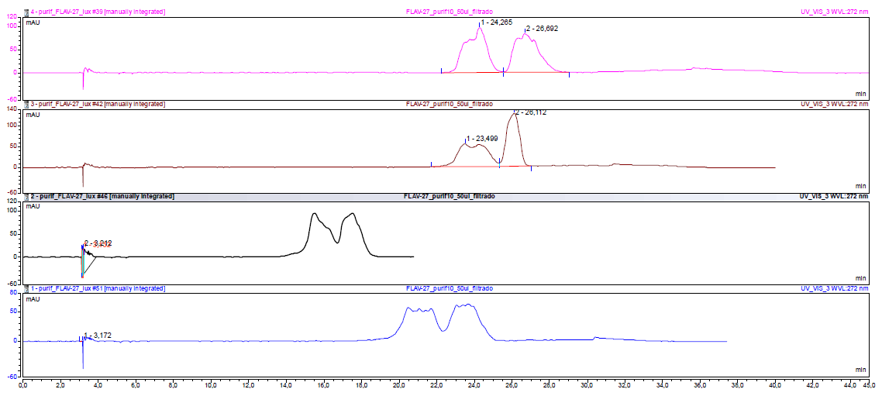

Figure 1. Chromatography study at UV 272 nm for compound 1 separation, using from 200 μL to 50 μL of sample injection and different separation conditions. Chromatographic conditions: Column, Phenomenex Lux-Cellulose 4 (250 mm × 0.46 mm, 5 μm); flow rate, 1.0 mL/min; detection, UV at 272 nm.
Time (min) | Flow (mL/min) | % Hexane | % Ethanol + EDA (0.1%) | Slope
0 | 1.0 | 97 | 3 | 5
25 | 1.0 | 97 | 3 | 5
30 | 1.0 | 90 | 10 | 5
32 | 1.0 | 90 | 10 | 5
35 | 1.0 | 97 | 3 | 5
45 | 1.0 | 97 | 3 | 5
Table 1. Detailed gradient for the method developed.

Filtration was performed in reverse-phase isolera-biotage and acidic conditions (H₂O/AcN + 0.05% HCOOH, 5 to 100% gradient of AcN in 5VCs) to remove ethylenediamine. The purifications was checked for the absence of ethylenediamine by ¹H-NMR (Figure S3), after freeze-drying of the fractions. Both enantiomeric separations gave 1.51 mg enantiomer 1A (eluted first) and 1.15 mg of enantiomer 1B (eluted second); and enantiomeric excess (ee) of both enantiomers >100% (Figure S4).

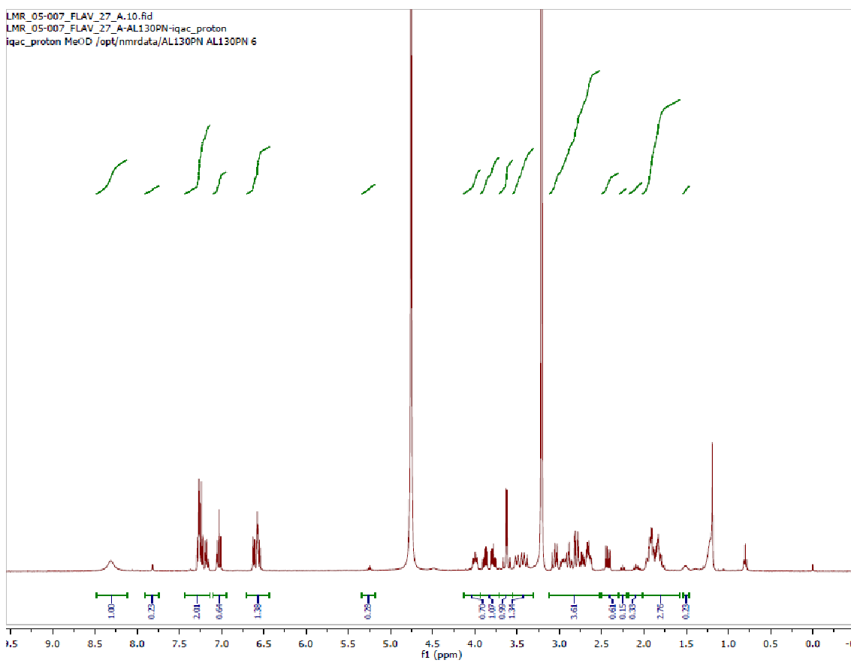
Figure 2. ¹H‐RMN in CD₃OD of compound 1 after purification in reverse-phase isolera-biotage and acidic conditions (H₂O/AcN + 0.05% HCOOH, 5 to 100% gradient of AcN in 5VCs).
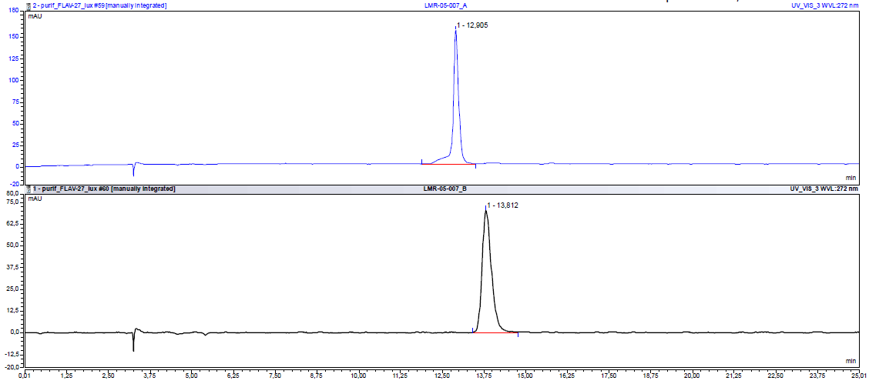
Figure 3. HPLC enantioseparation chromatogram of enantiomer 1A (top) and enantiomer 1B (bottom). Chromatographic conditions: Column, Phenomenex Lux-Cellulose 4 (250 mm × 0.46 mm, 5 μm); flow rate, 1.0 mL/min; detection, UV at 272 nm.

¹H and ¹³C NMR Spectra.
3-(1-((4-benzyl-1,4-oxazepan-2-yl)methyl)piperidin-4-yl)phenol, 1
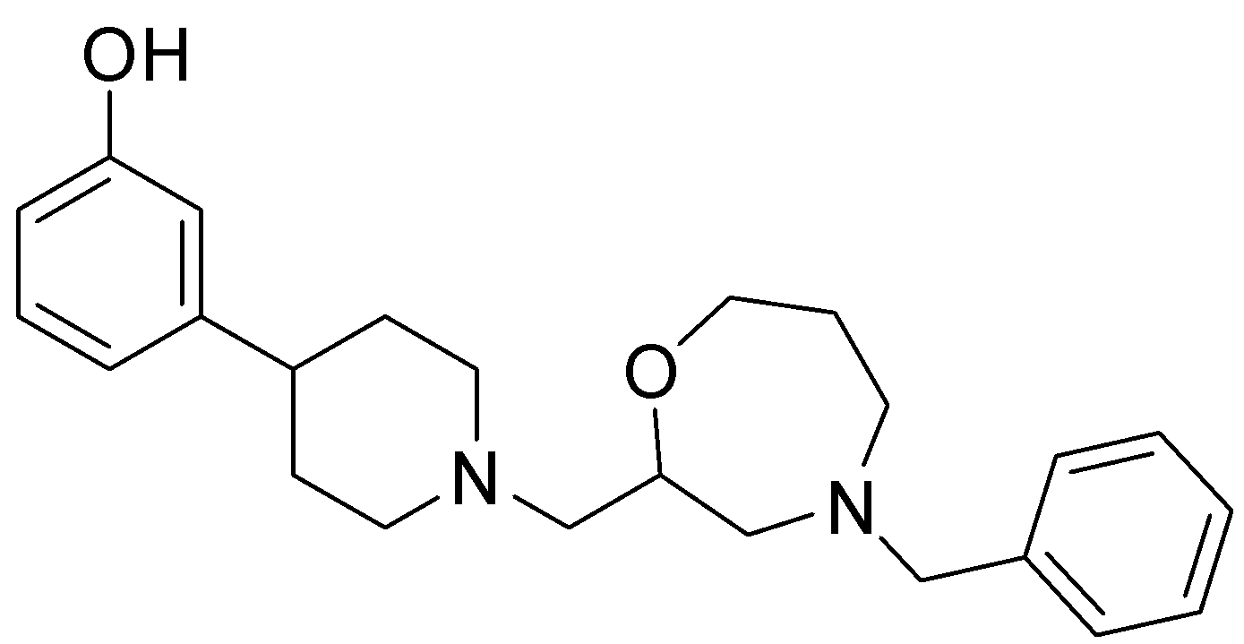
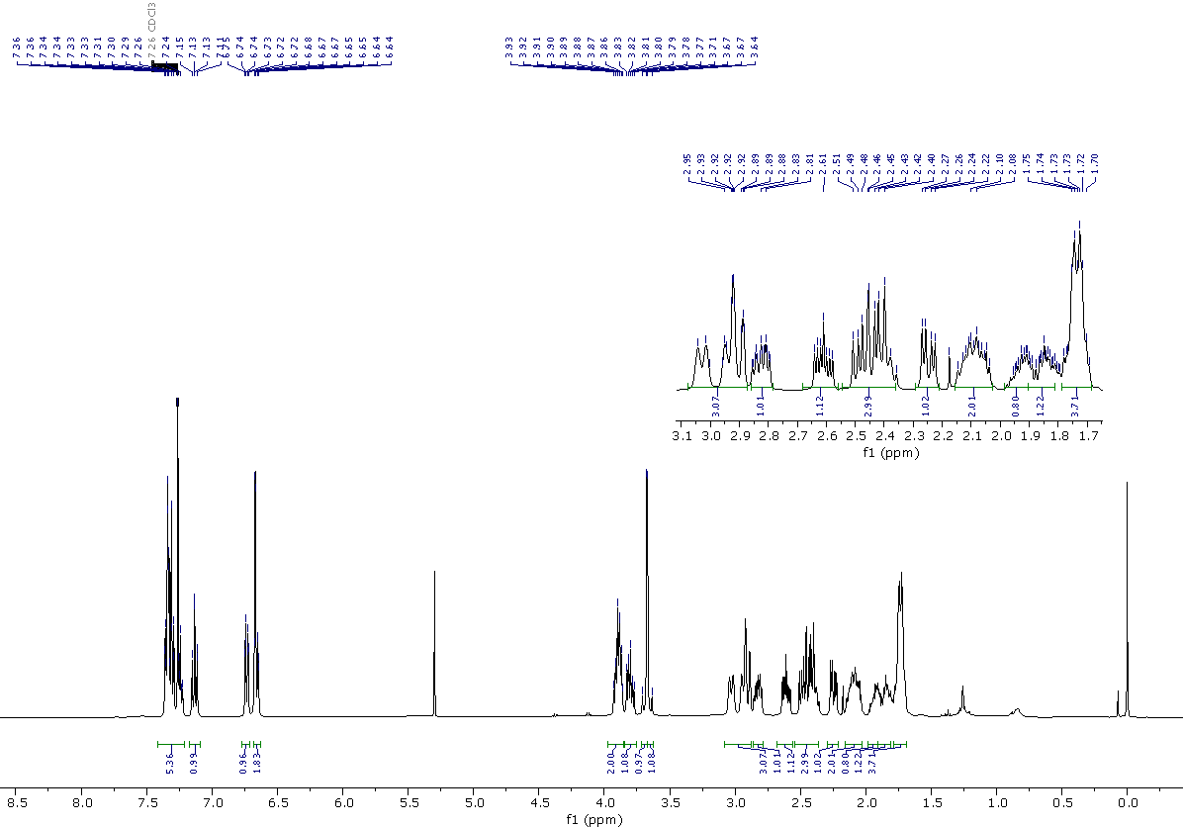
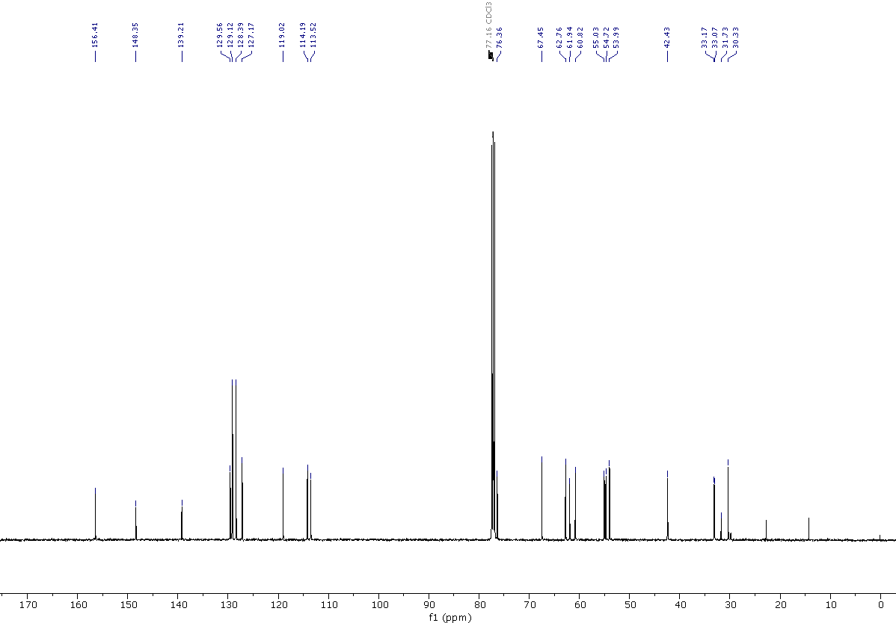

3-(1-((4-benzyl-1,4-oxazepan-2-yl)methyl)piperidin-4-yl)phenol dihydrochloride, 1·2HCl

3-{1-[(4-benzyl-1,4-oxazepan-2-yl)methyl]piperidin-4-yl}aniline, 2
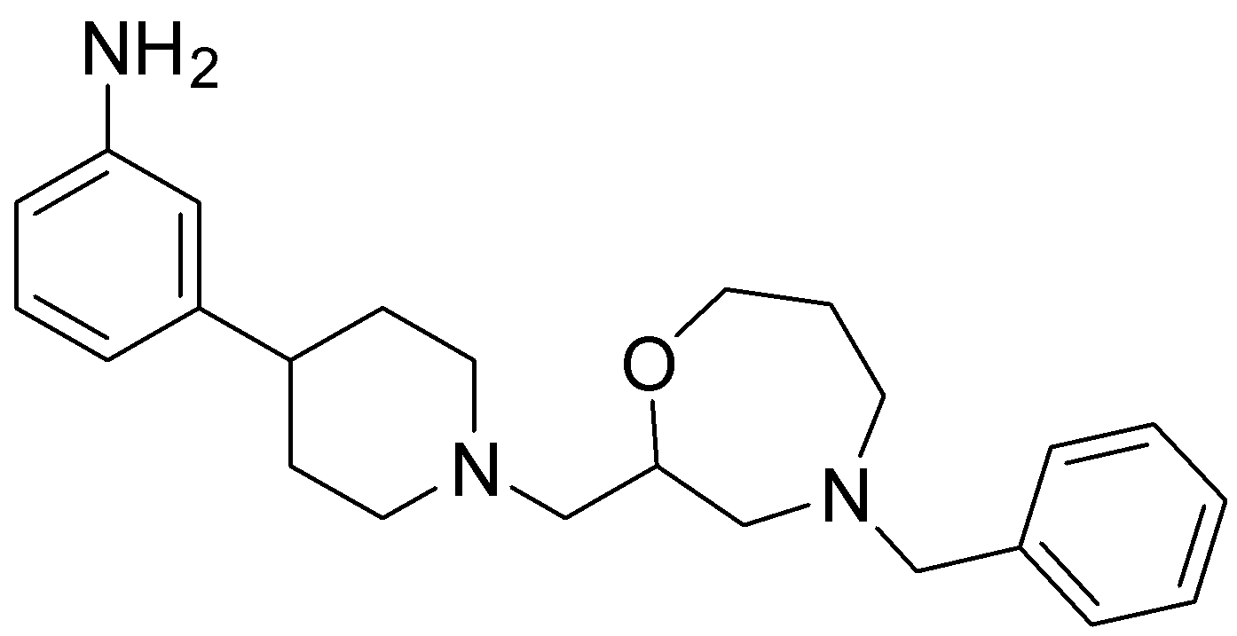
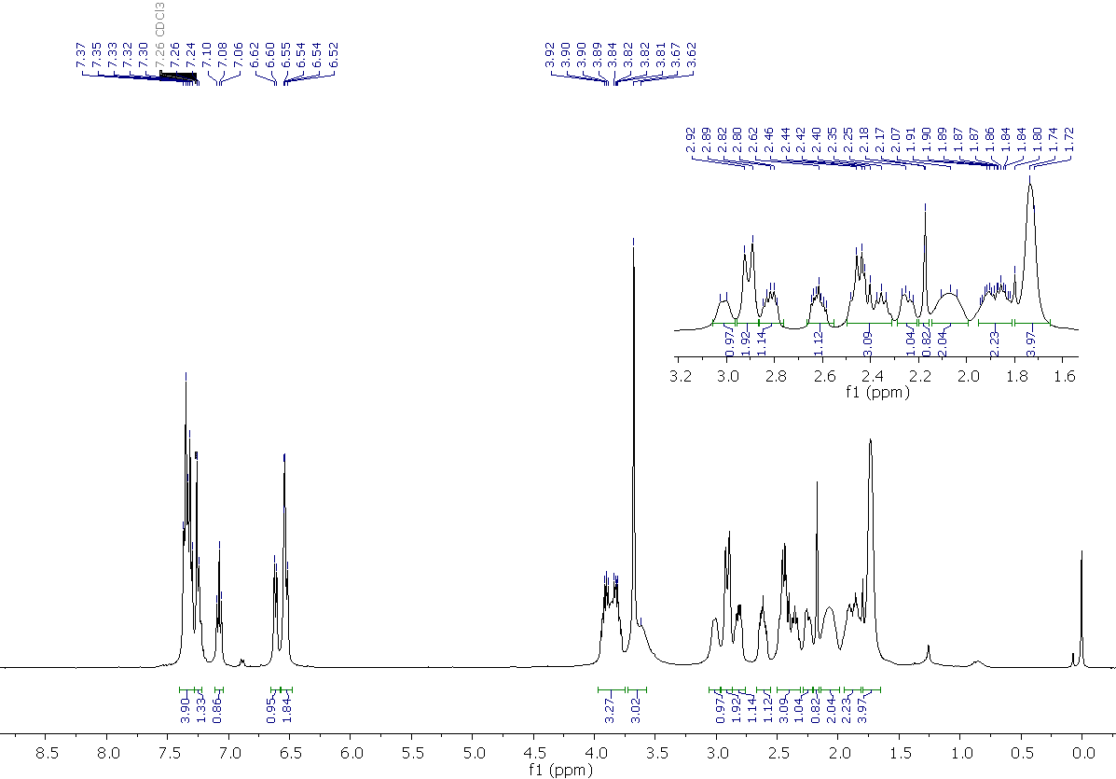
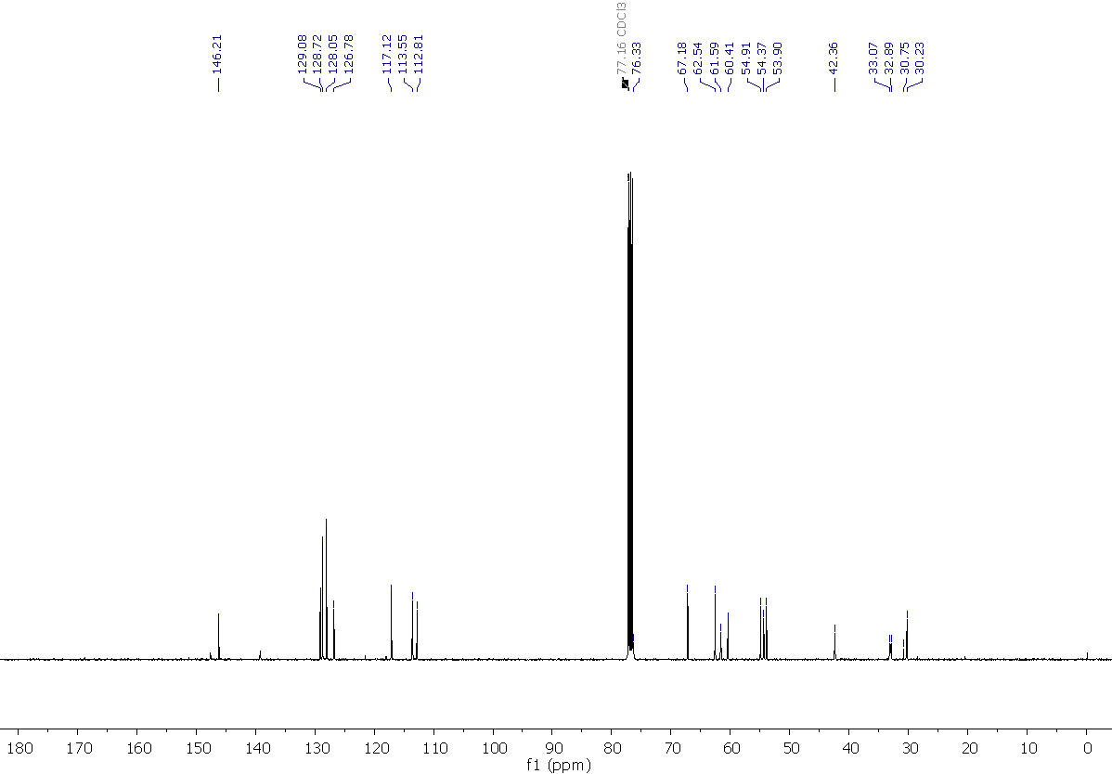
4-benzyl-2-{[4-(3-chlorophenyl)piperidin-1-yl]methyl}-1,4-oxazepane, 3
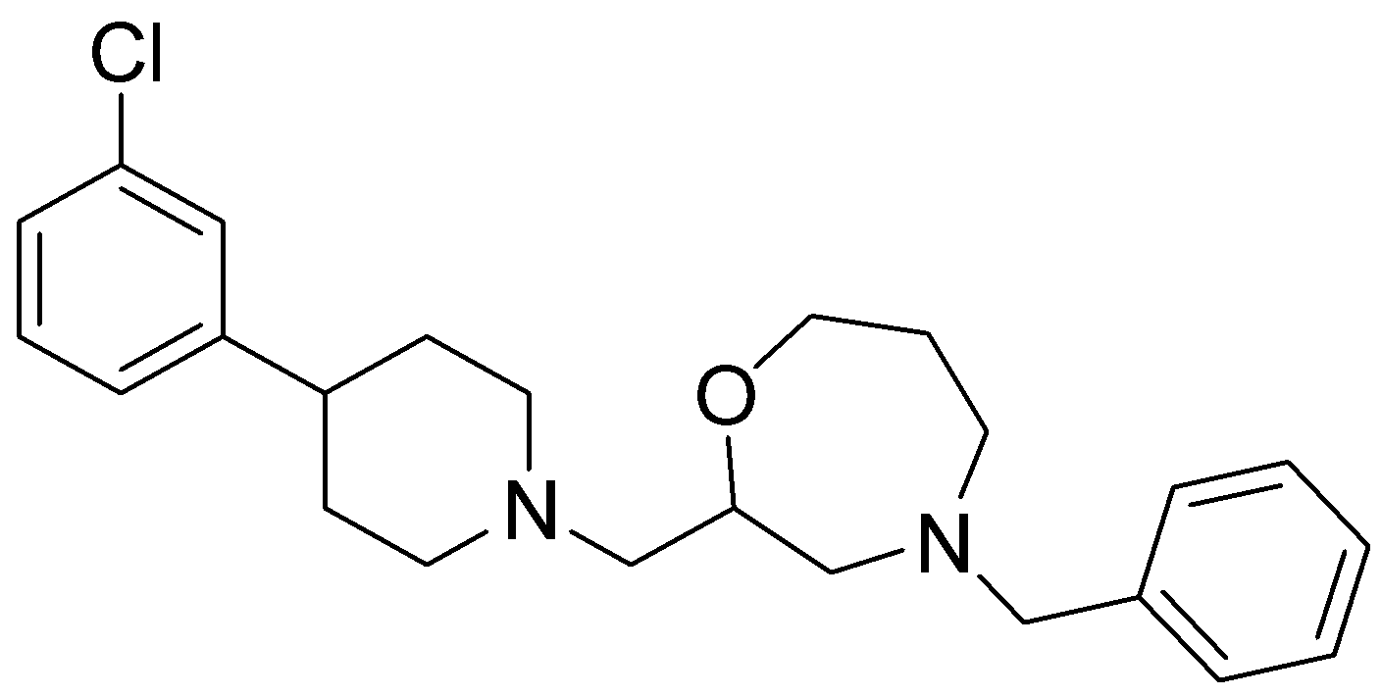
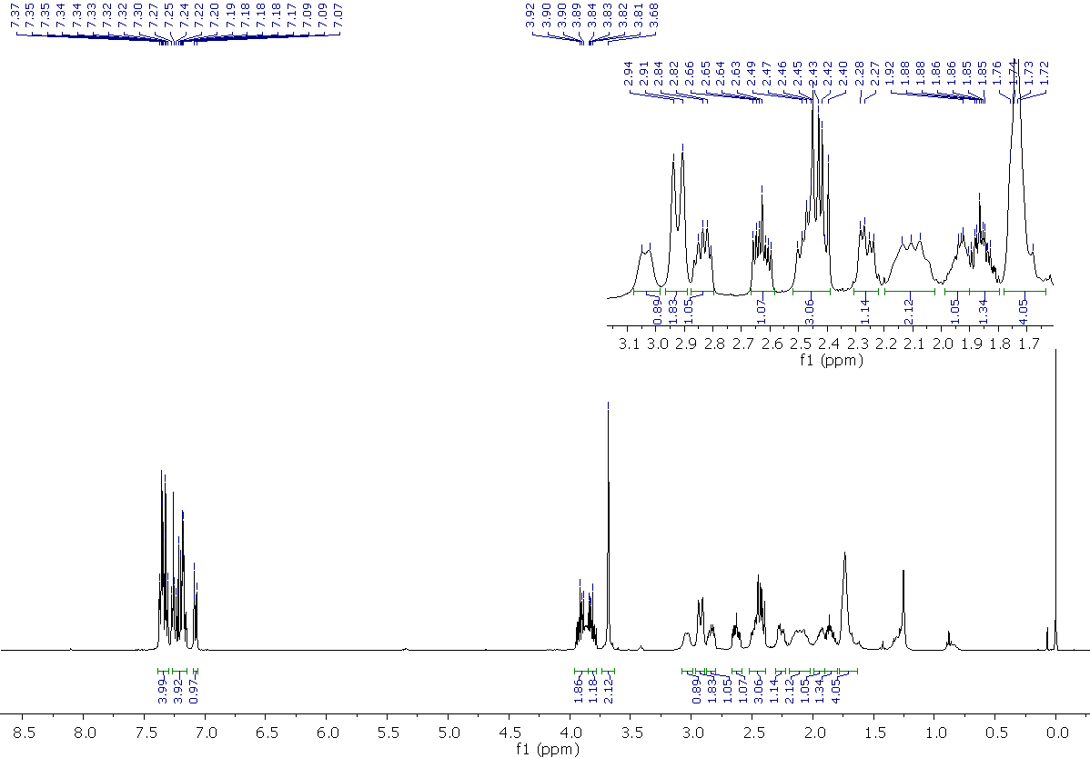
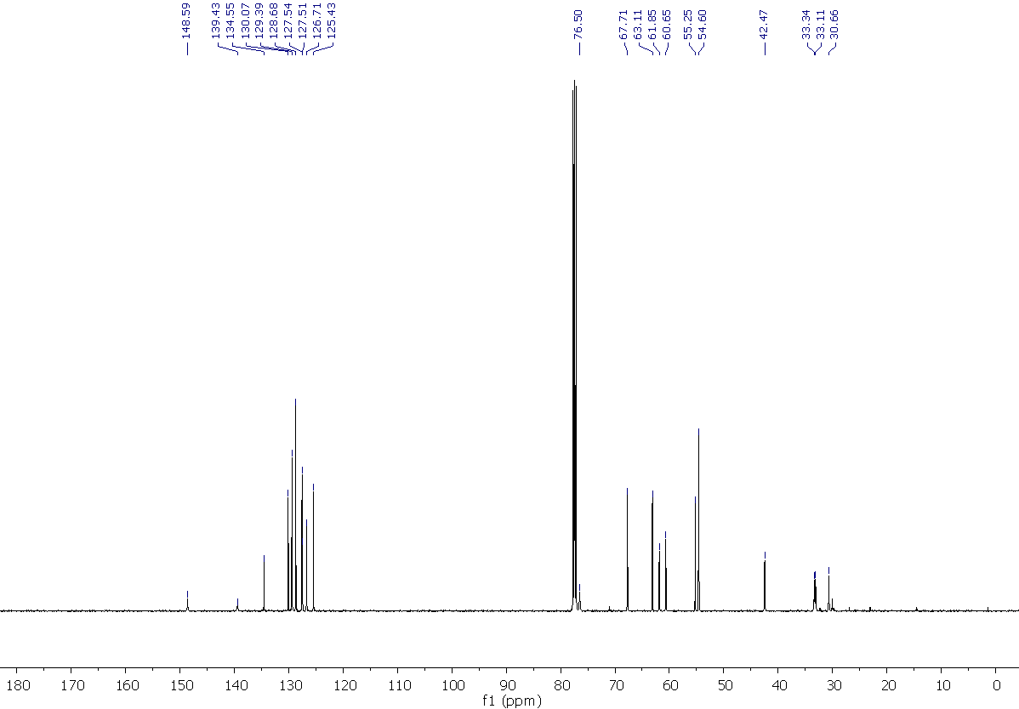

Methyl 3-{1-[(4-benzyl-1,4-oxazepan-2-yl)methyl]piperidin-4-yl}benzoate, 4
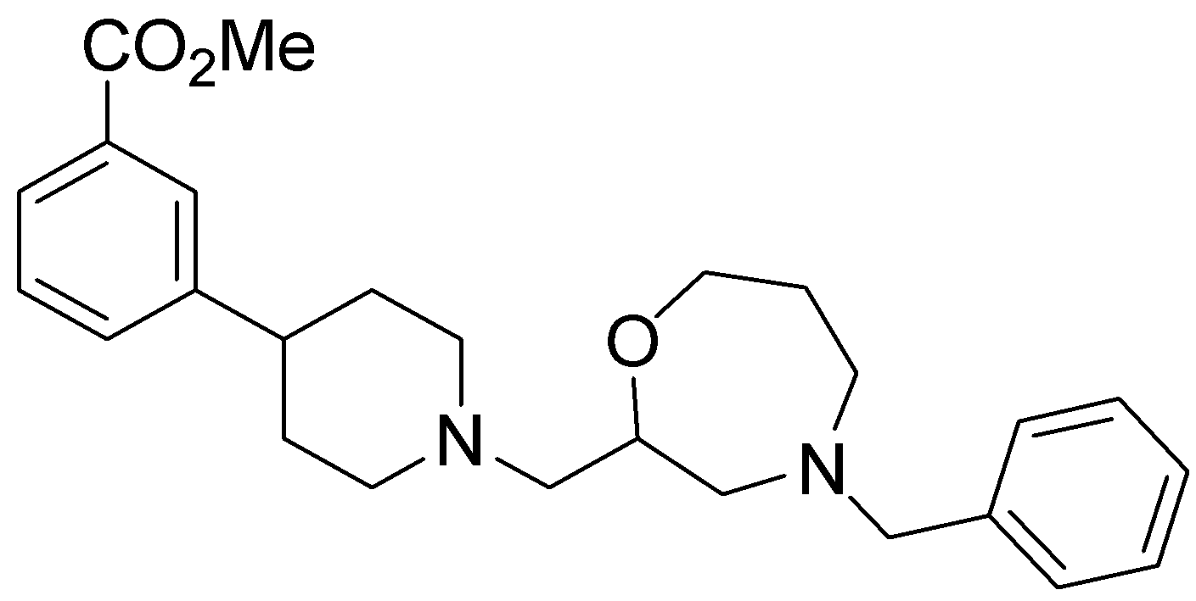
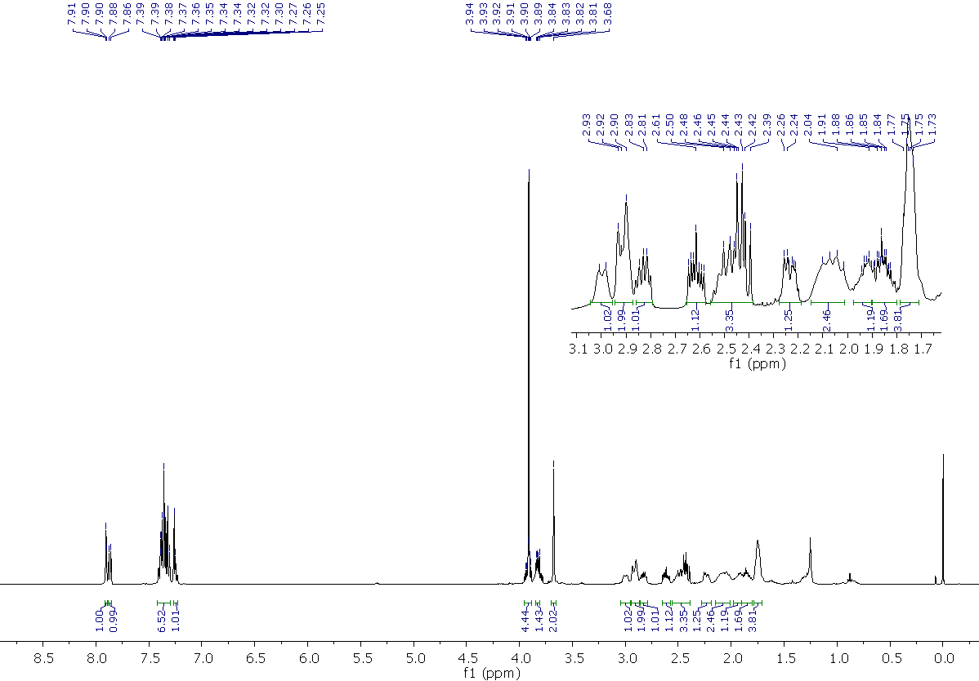
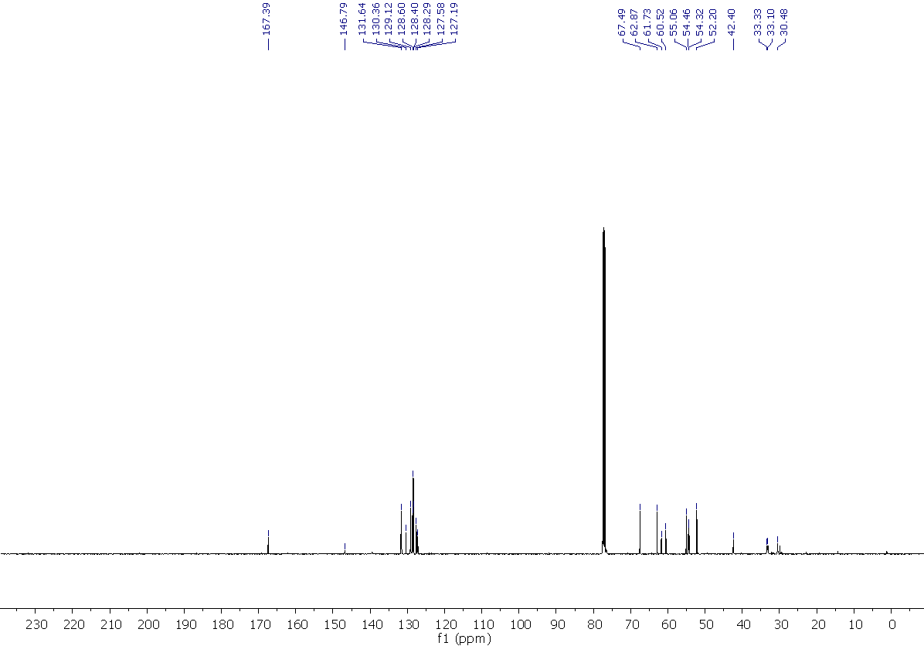

4-benzyl-2-{[4-(m-tolyl)piperidin-1-yl]methyl}-1,4-oxazepane, 5
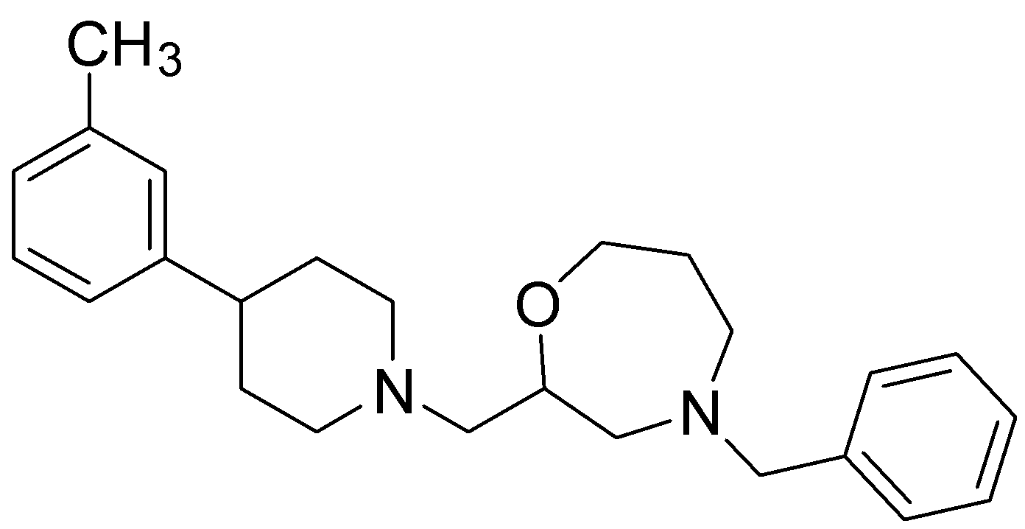
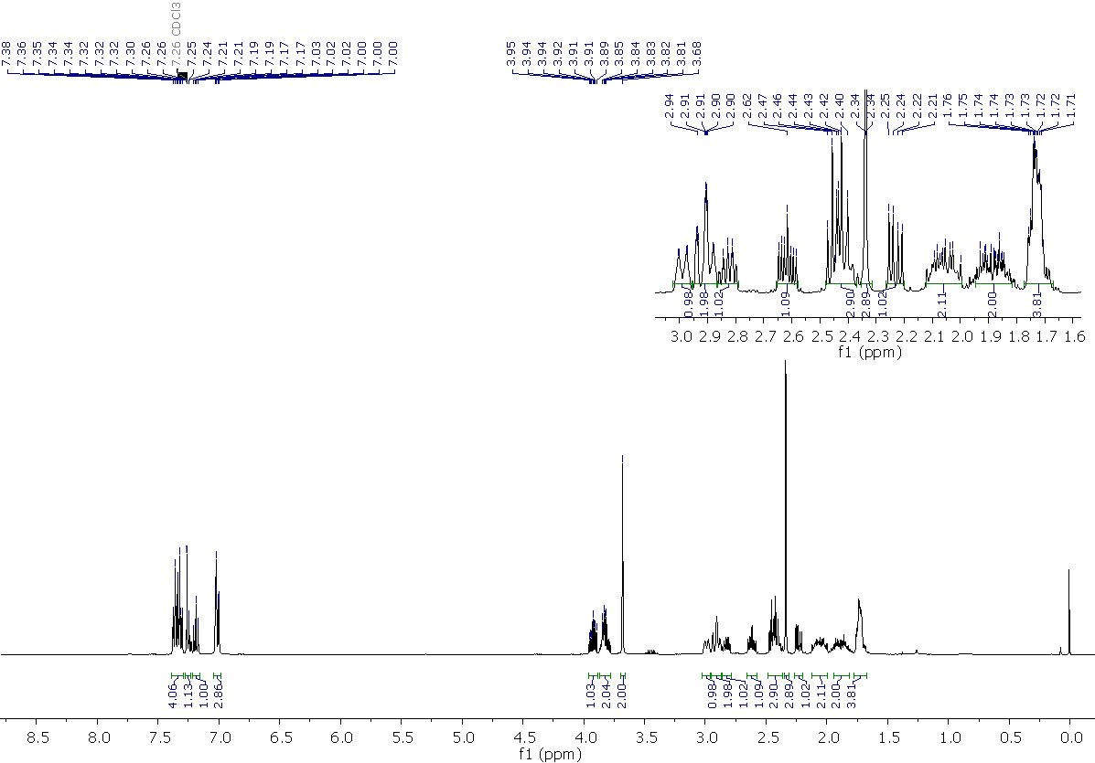
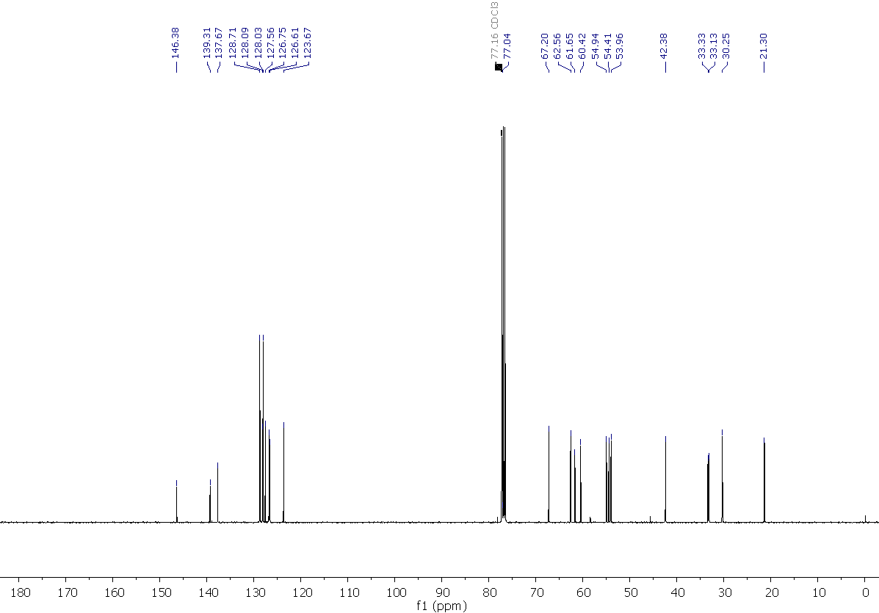

3-(1-((4-benzyl-1,4-oxazepan-2-yl)methyl)piperidin-4-yl)benzonitrile, 6
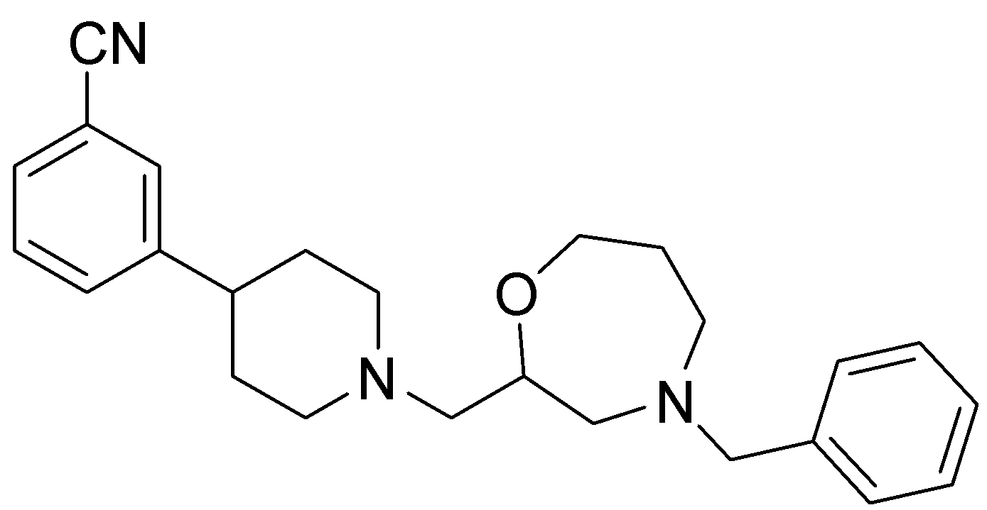
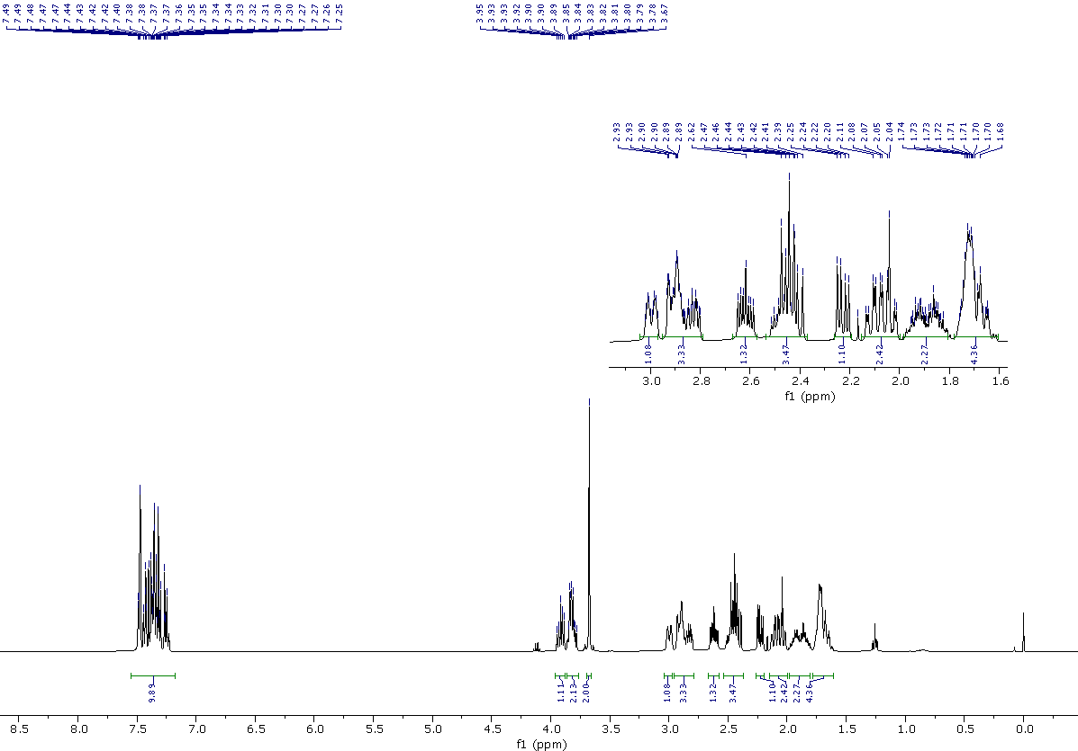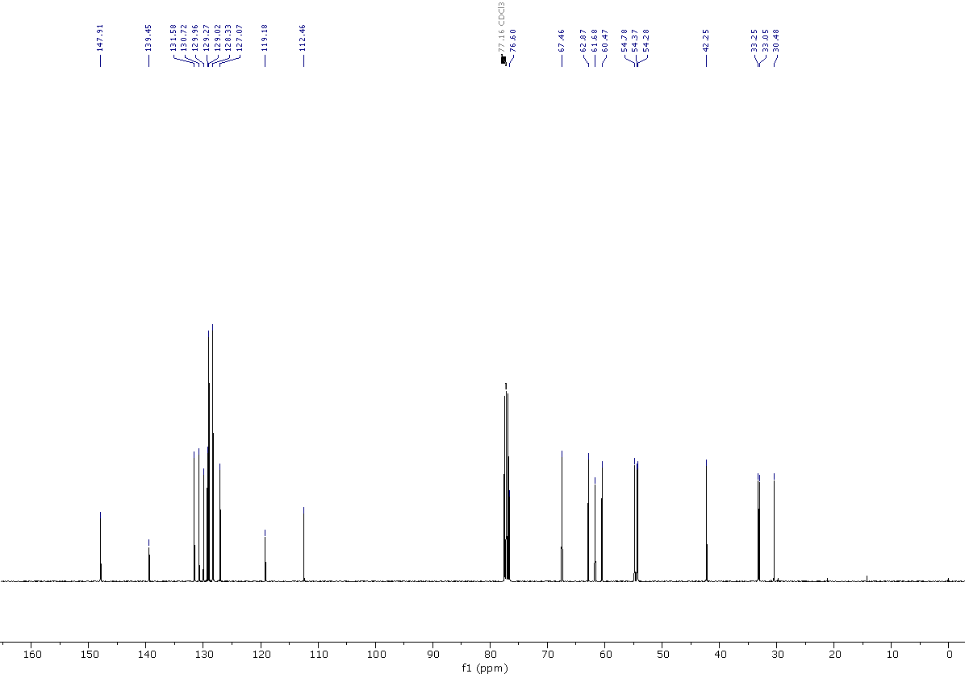

4-benzyl-2-((4-(3-(trifluoromethyl)phenyl)piperidin-1-yl)methyl)-1,4-oxazepane, 7
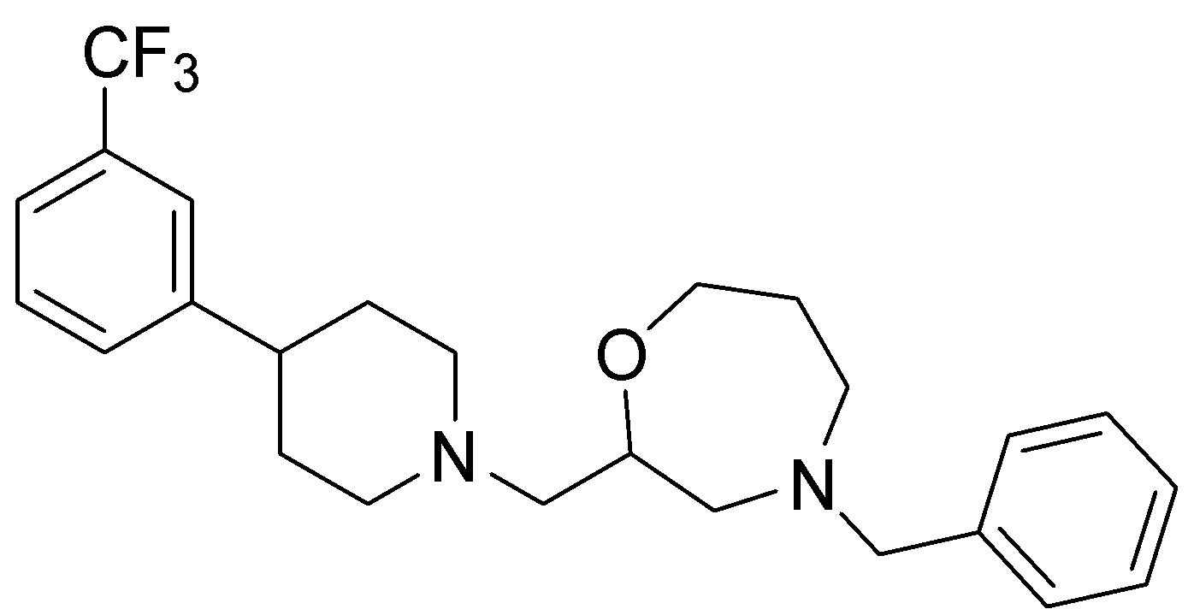
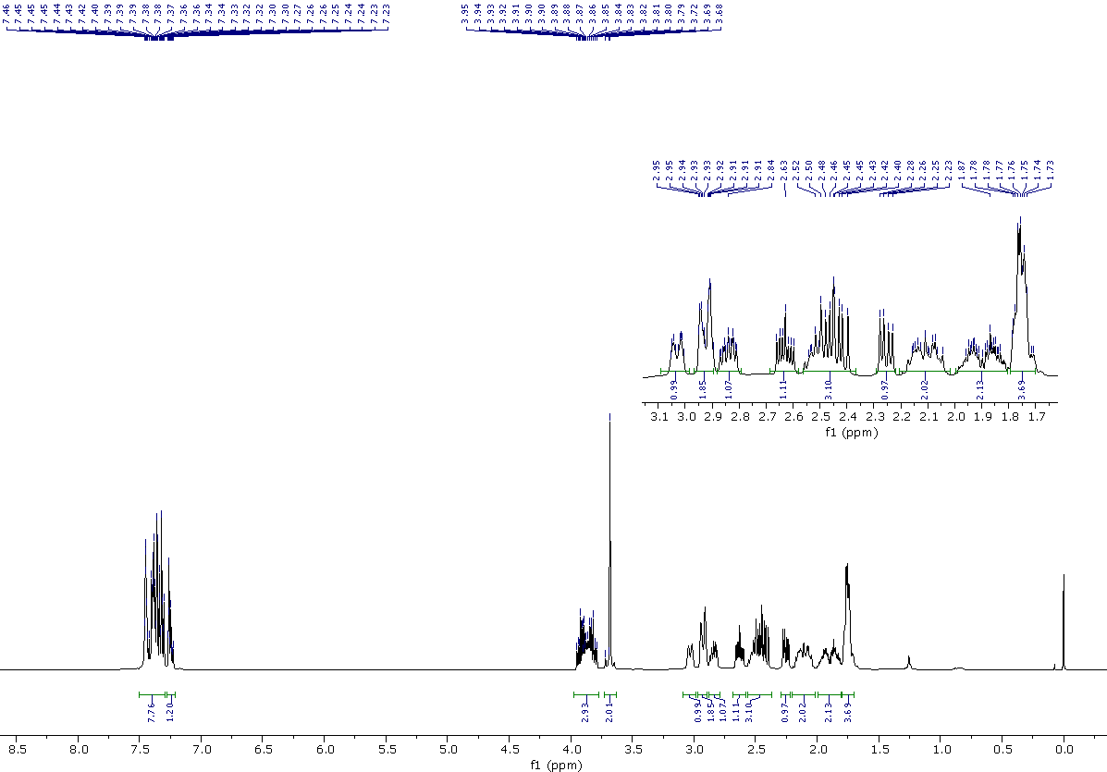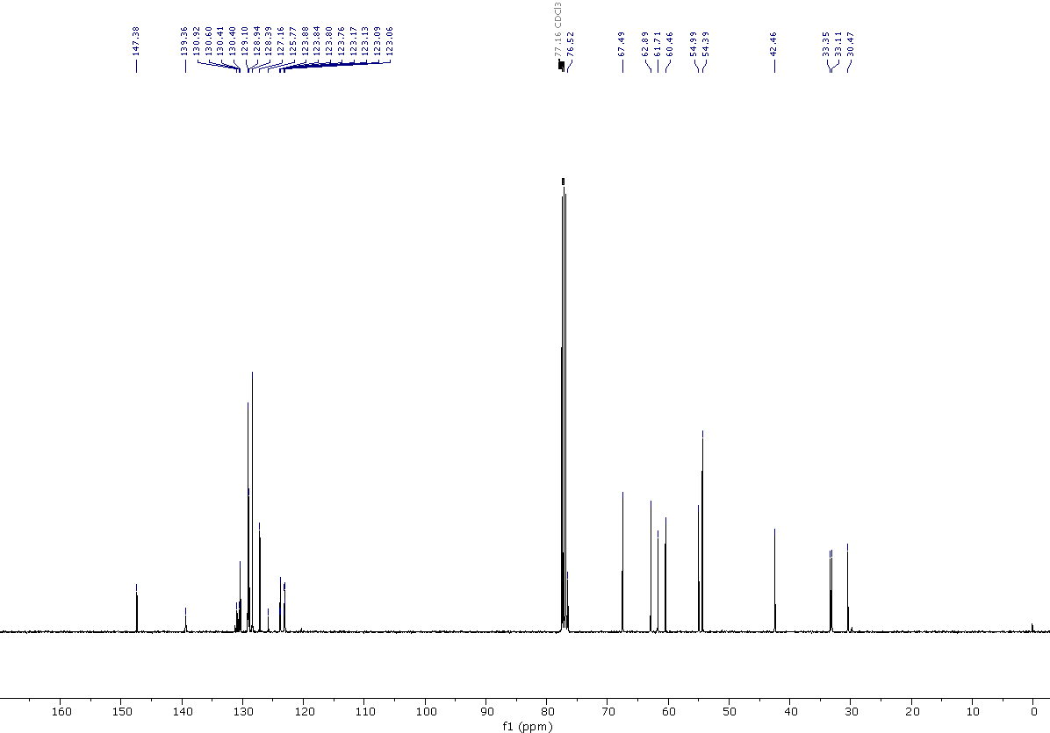
4-benzyl-2-((4-(3-(methylsulfonyl)phenyl)piperidin-1-yl)methyl)-1,4-oxazepane, 8
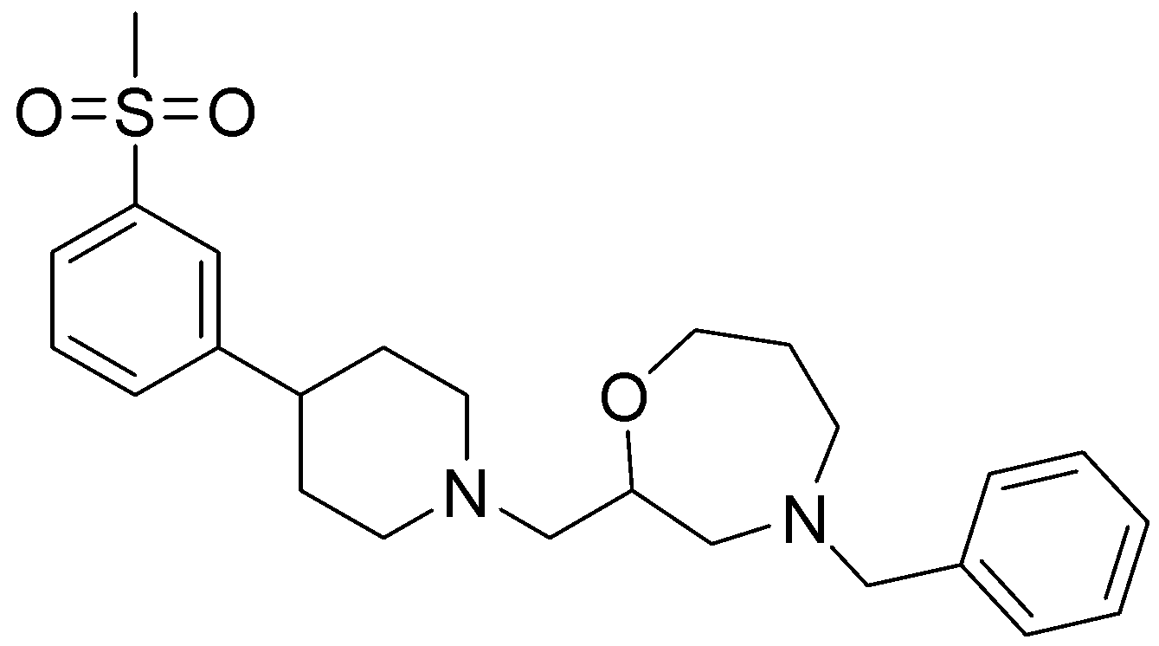
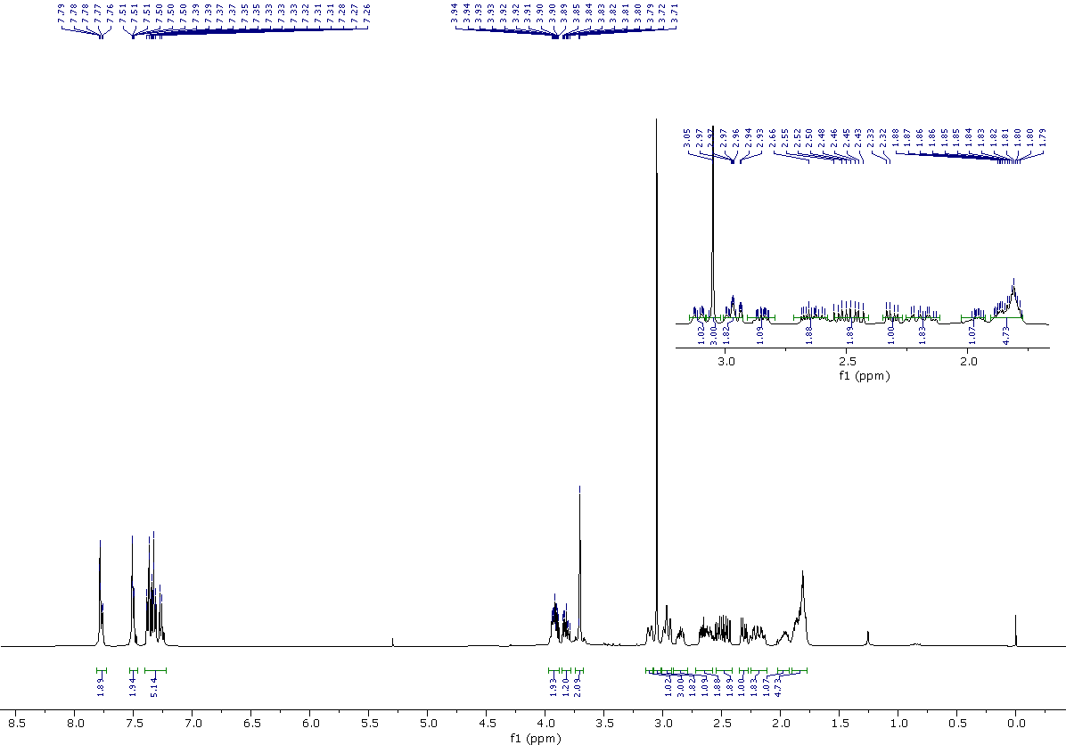

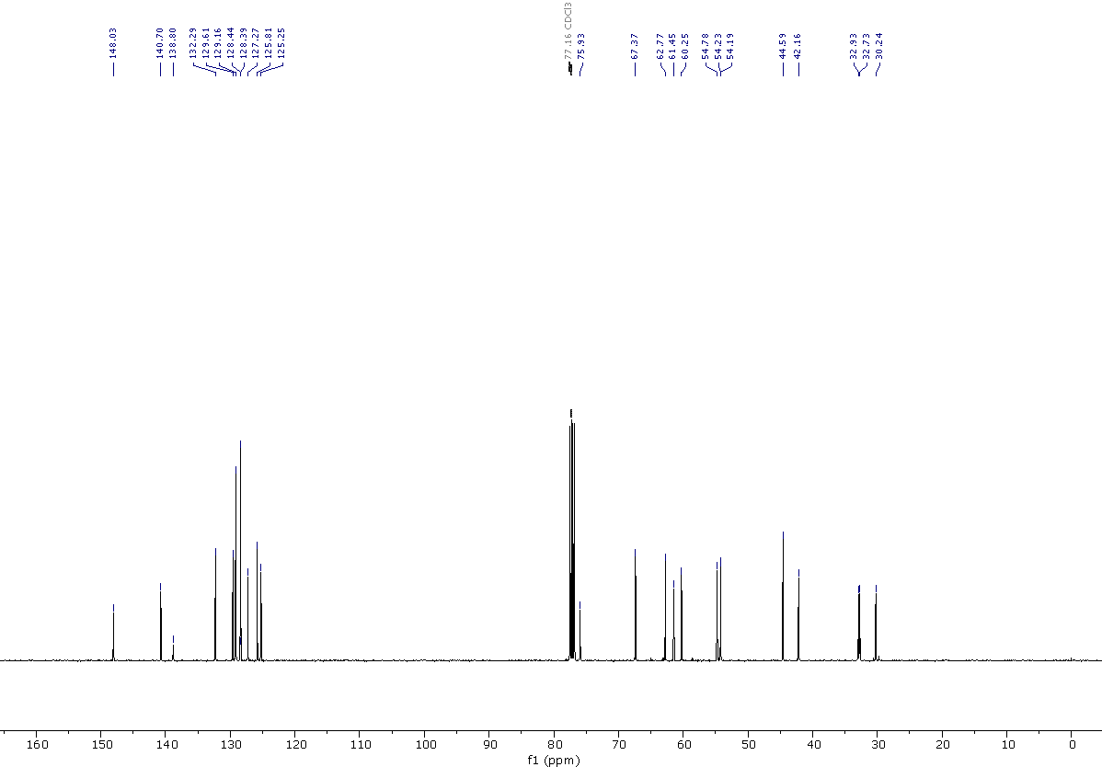

3-{1- 4-benzyl-2-{[4-(3-bromophenyl)piperidin-1-yl]methyl}-1,4-oxazepane, 9
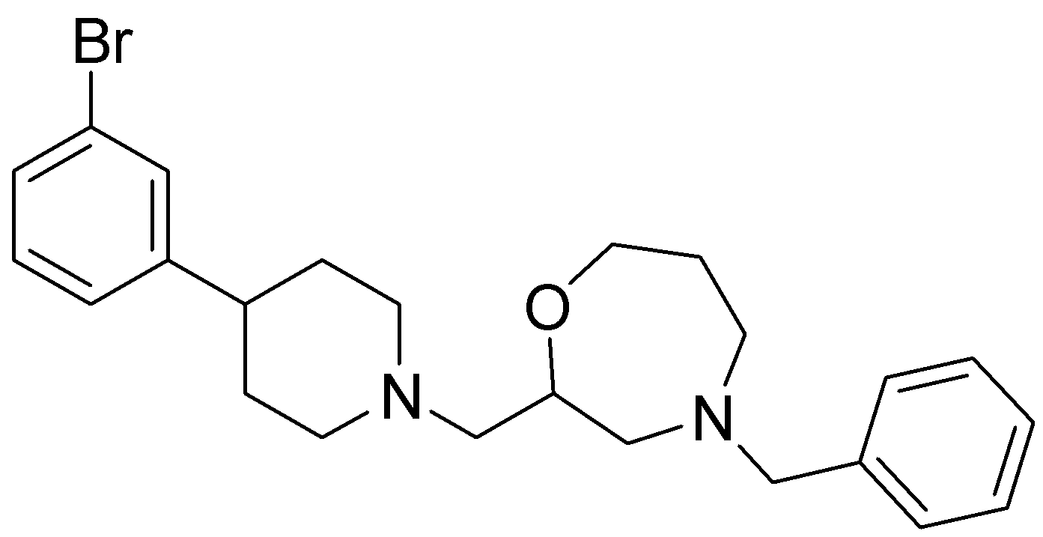
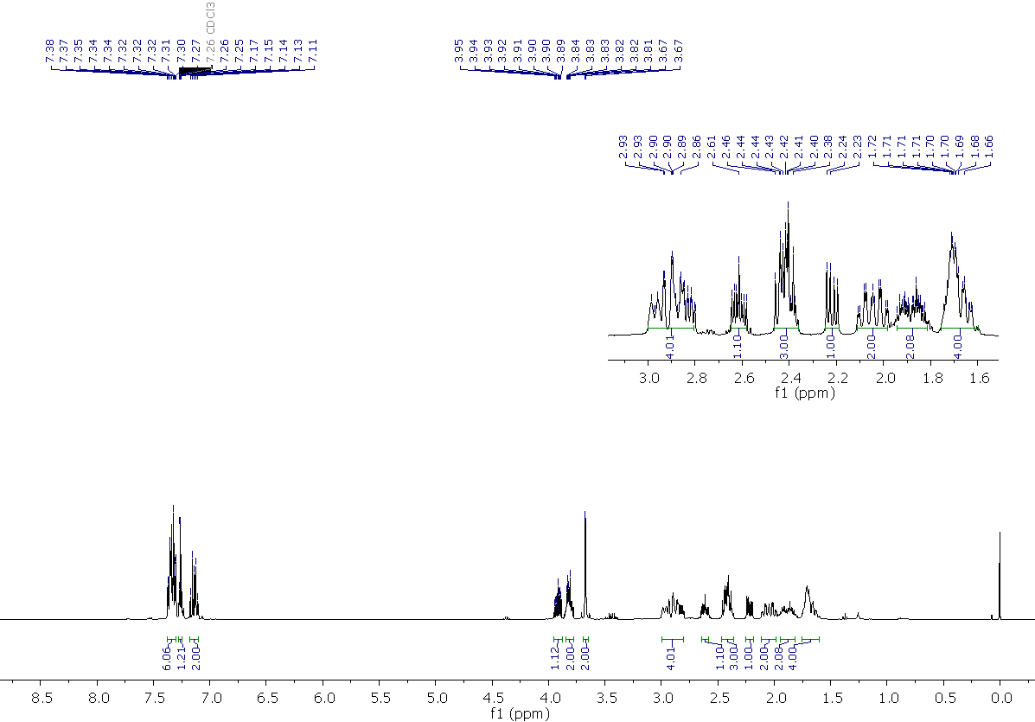
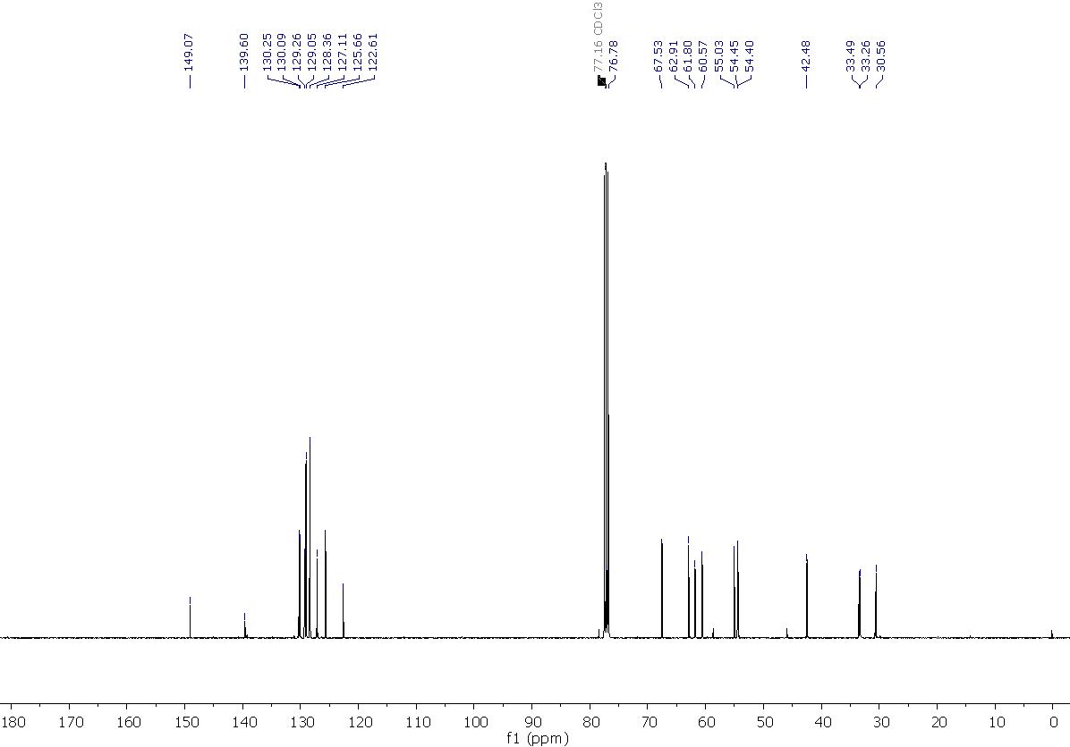
4-{1-[(4-benzyl-1,4-oxazepan-2-yl)methyl]piperidin-4-yl}phenol, 10
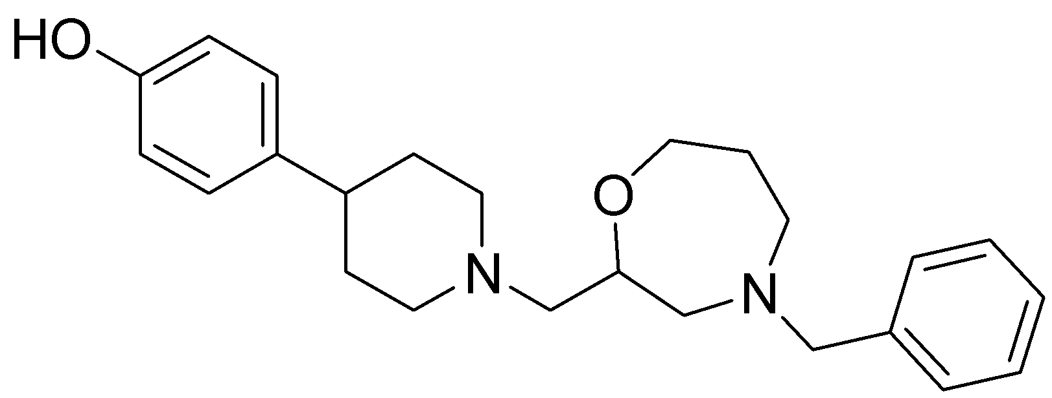
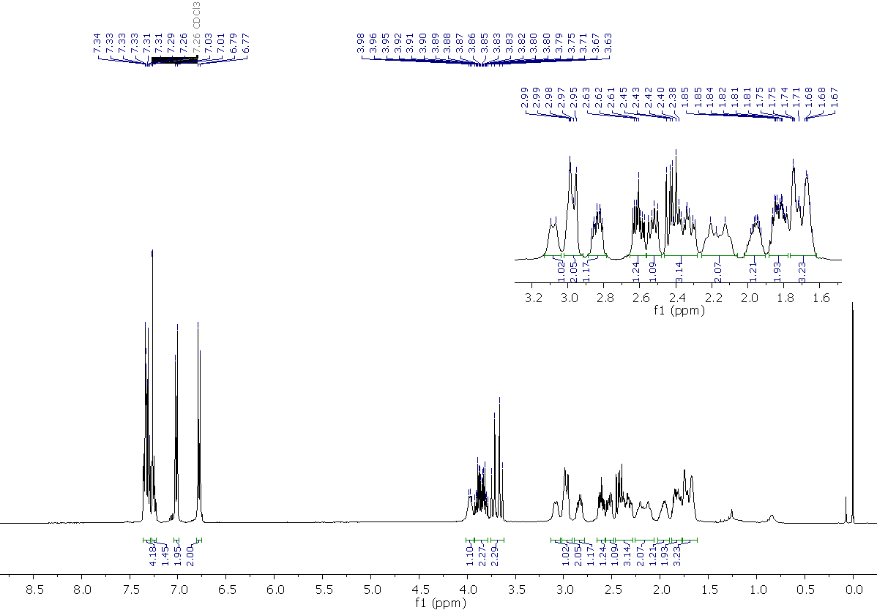
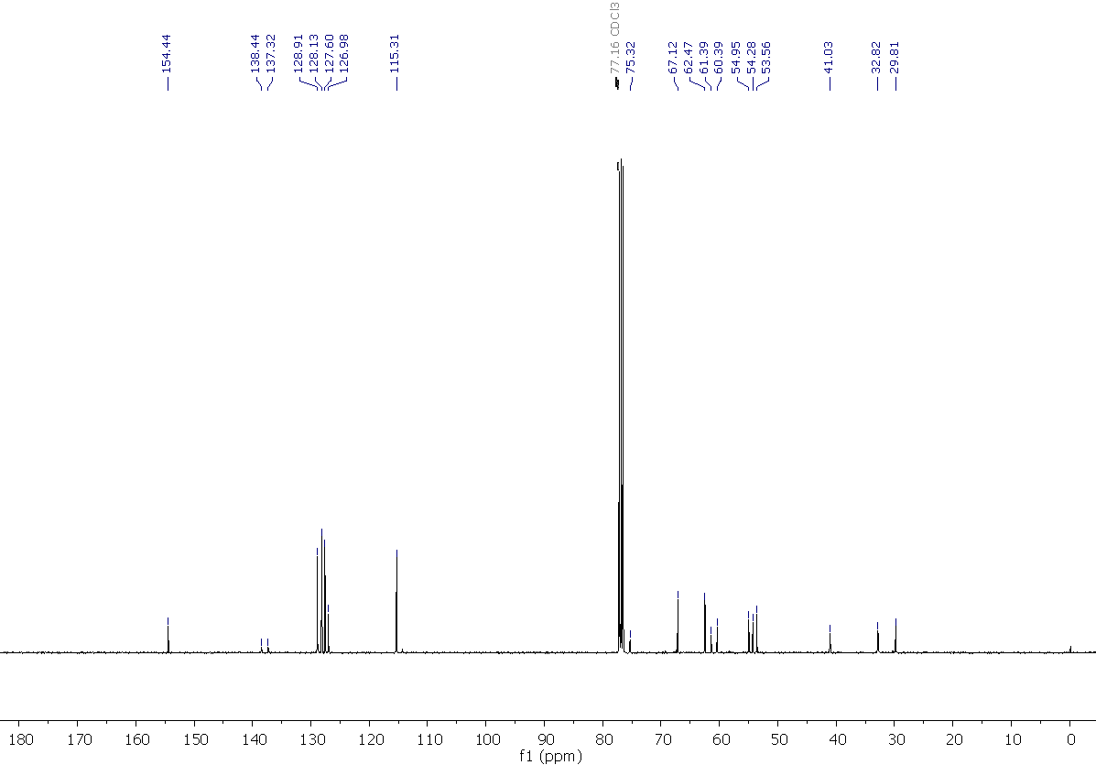
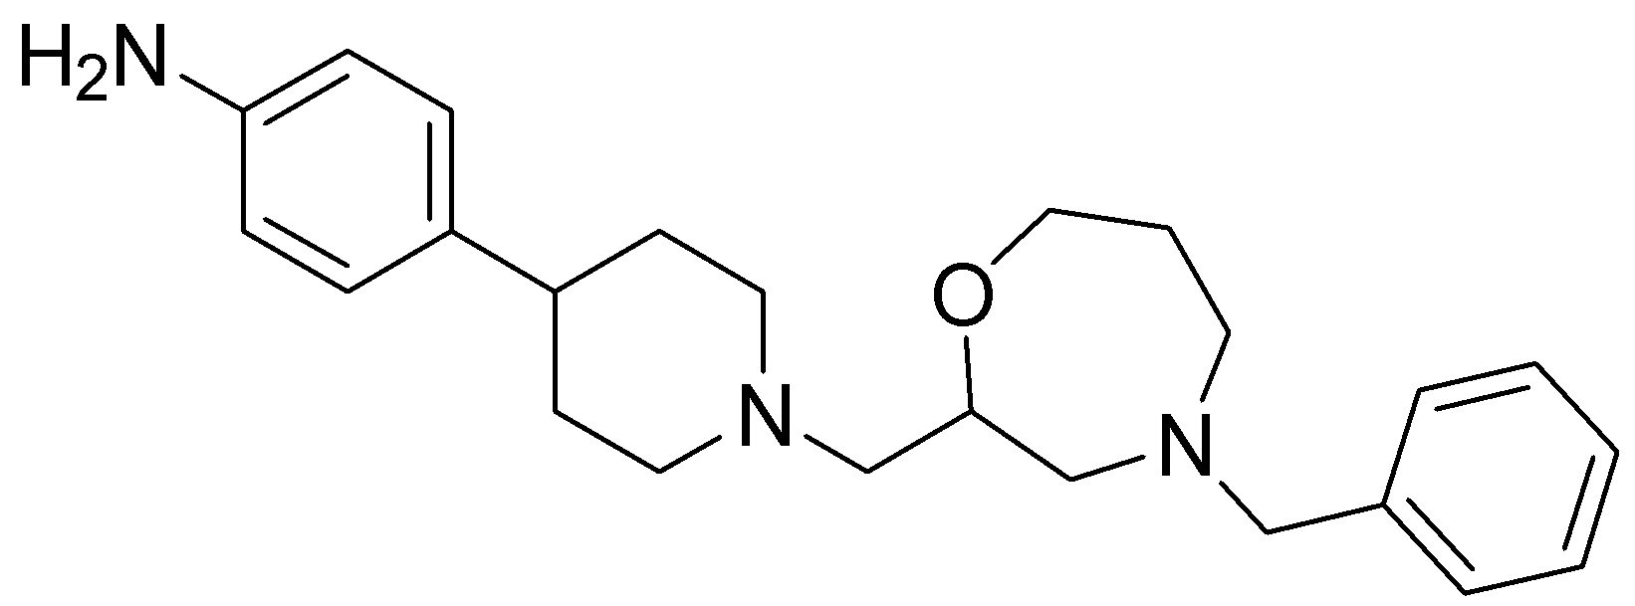
4-{1-[(4-benzyl-1,4-oxazepan-2-yl)methyl]piperidin-4-yl}aniline, 11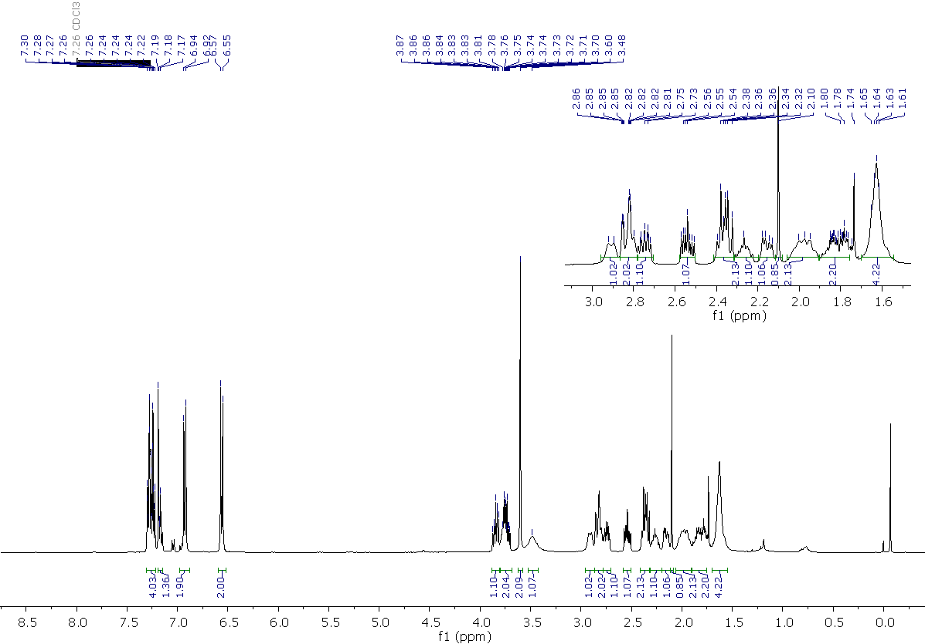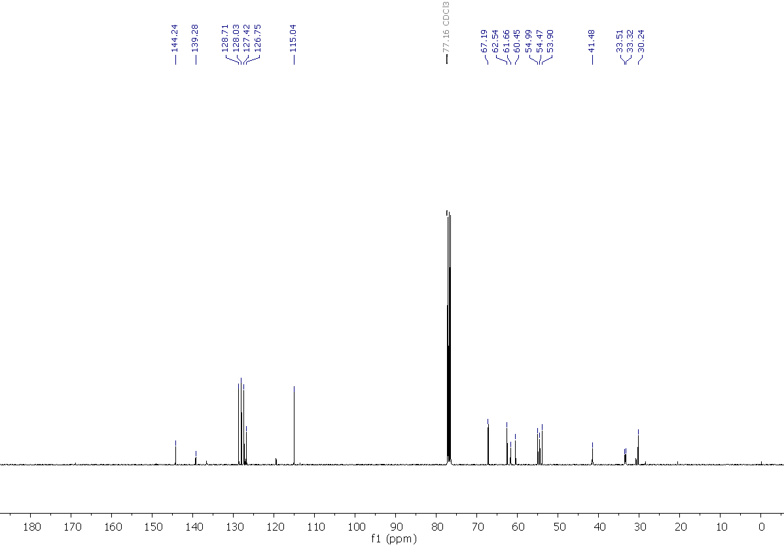

4-benzyl-2-{[4-(4-chlorophenyl)piperidin-1-yl]methyl}-1,4-oxazepane, 12
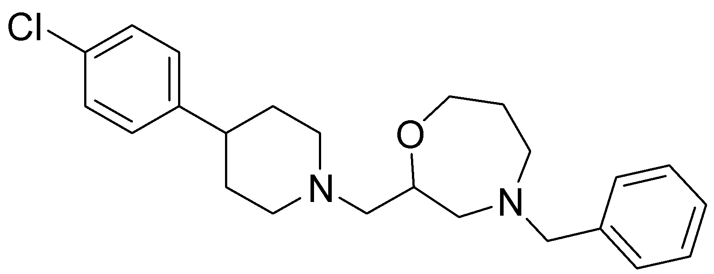
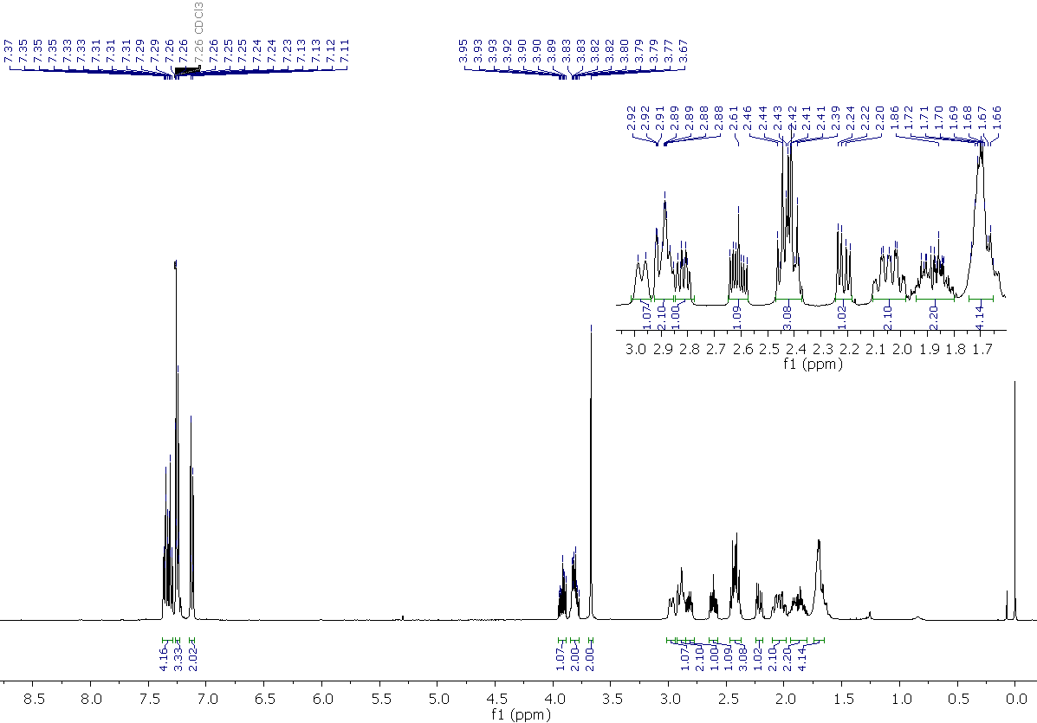
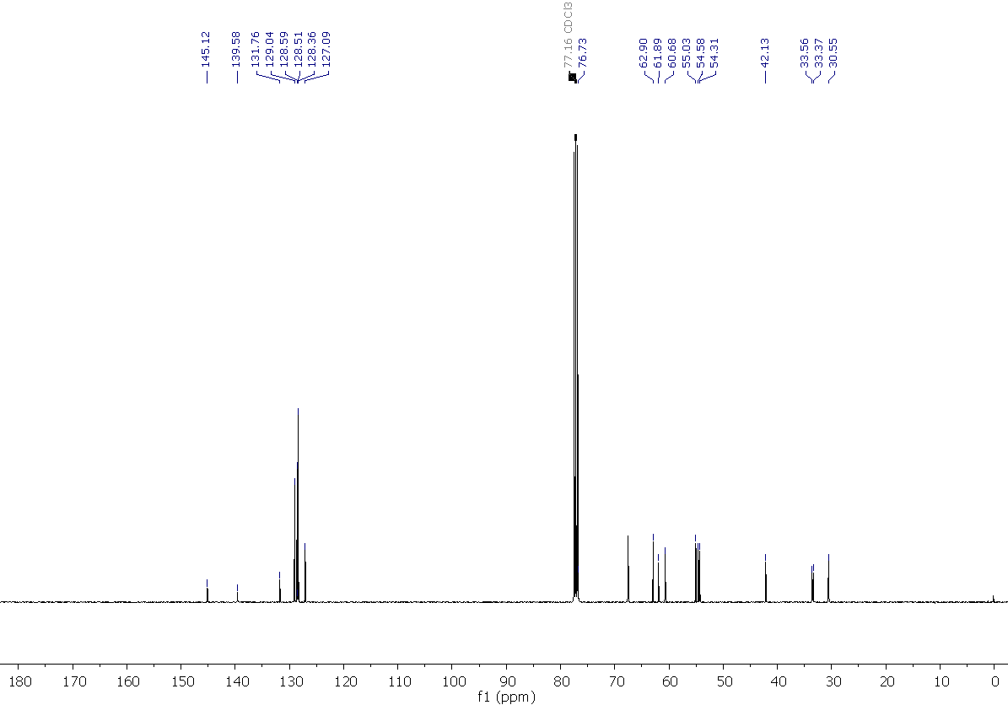
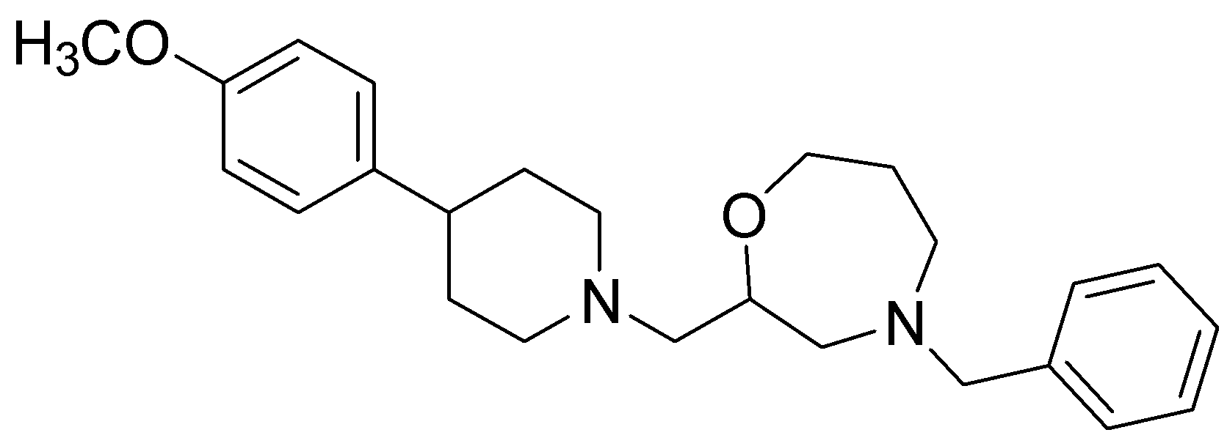
4-benzyl-2-{[4-(4-methoxyphenyl)piperidin-1-yl]methyl}-1,4-oxazepane, 13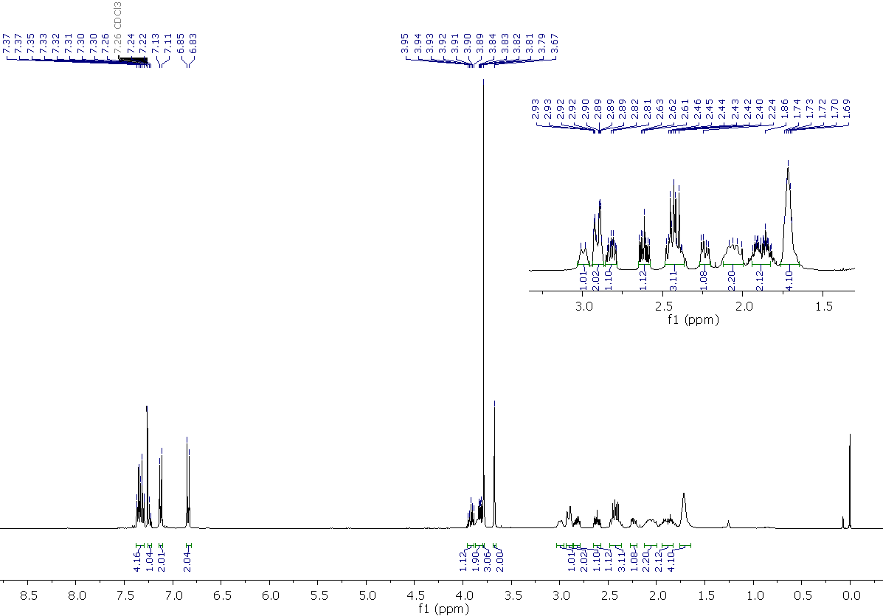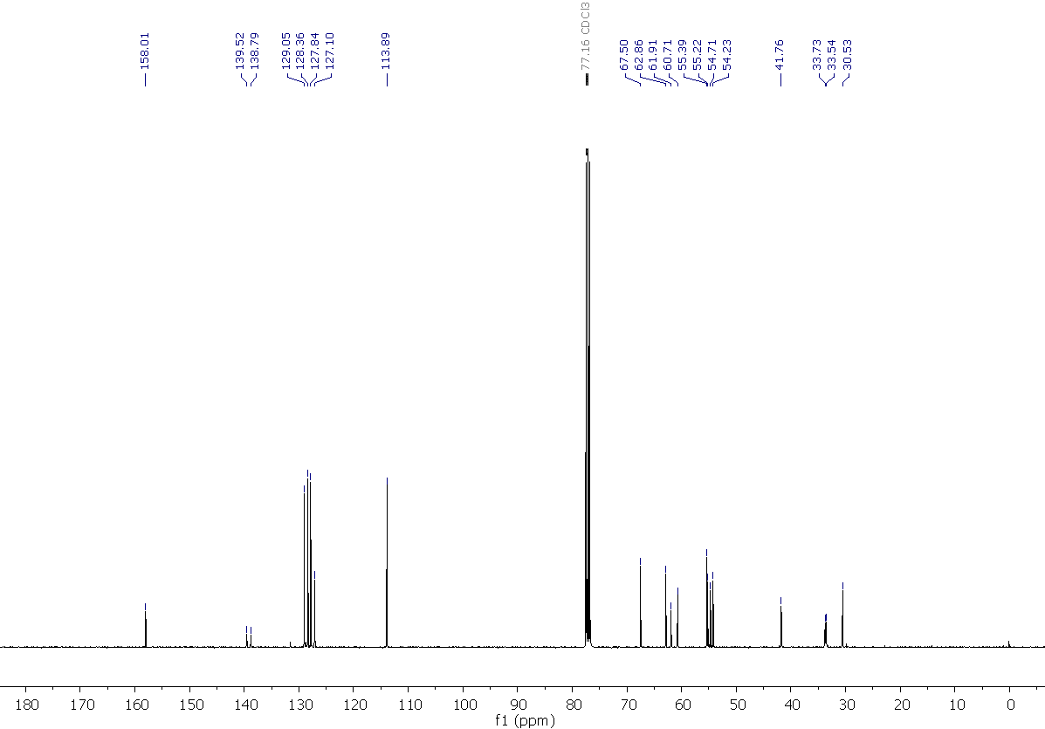

4-benzyl-2-{[4-(4-bromophenyl)piperidin-1-yl]methyl}-1,4-oxazepane, 14
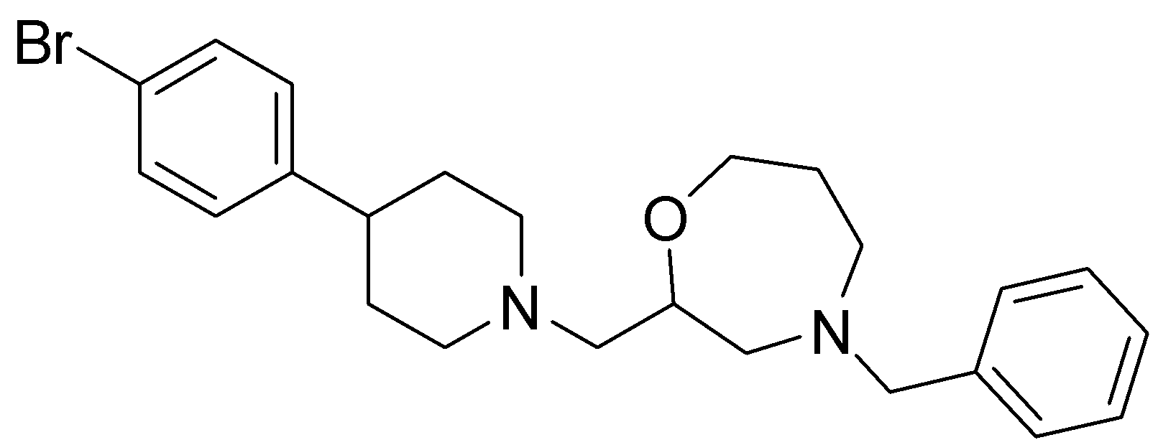
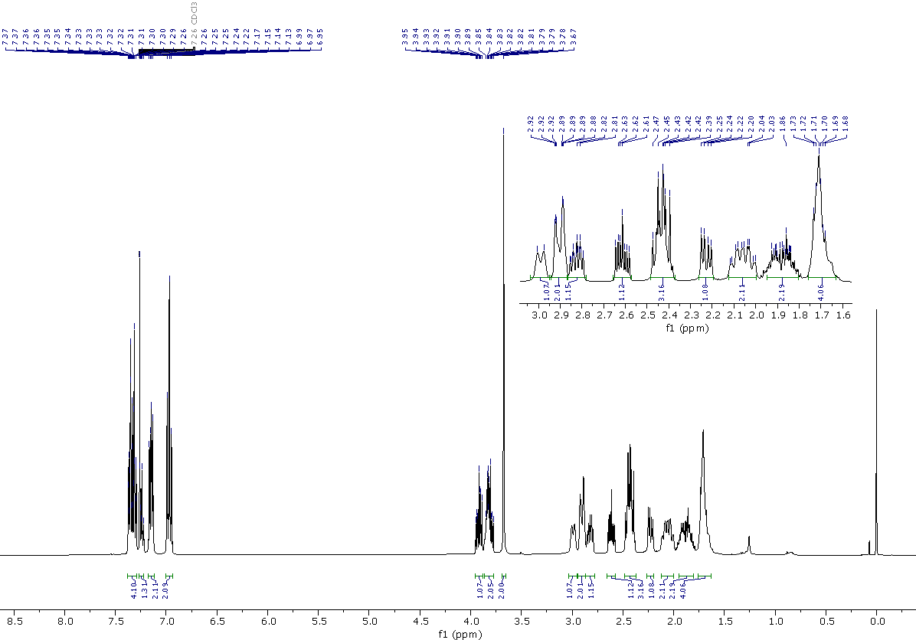

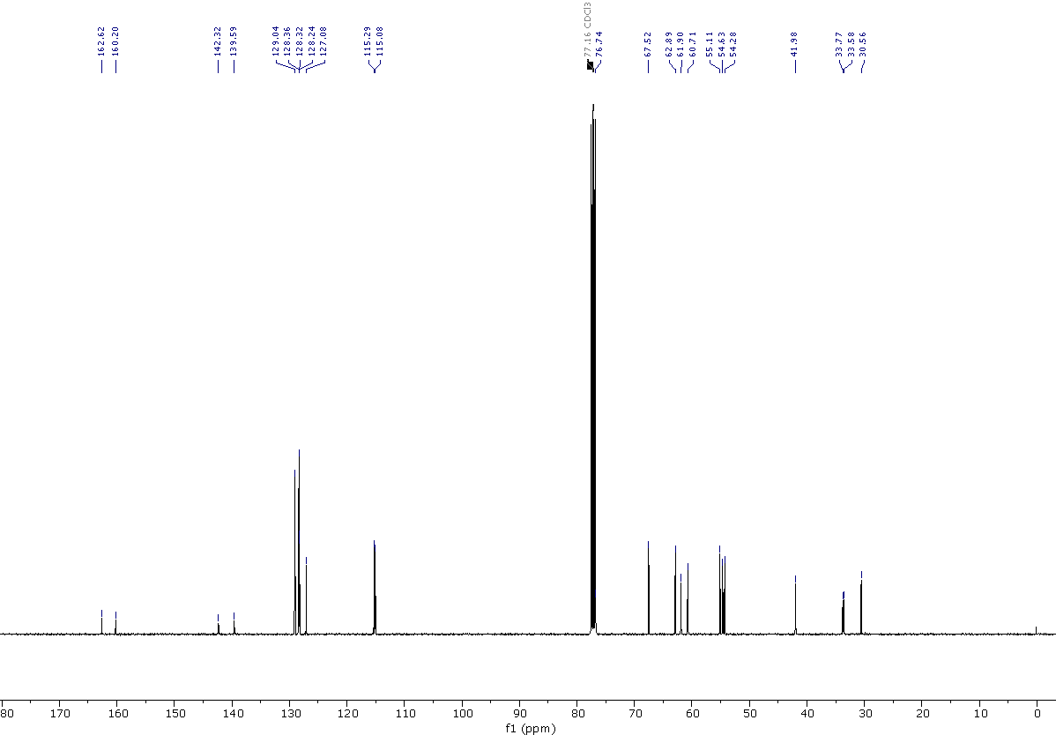

4-benzyl-2-{[4-(4-fluorophenyl)piperidin-1-yl]methyl}-1,4-oxazepane, 15
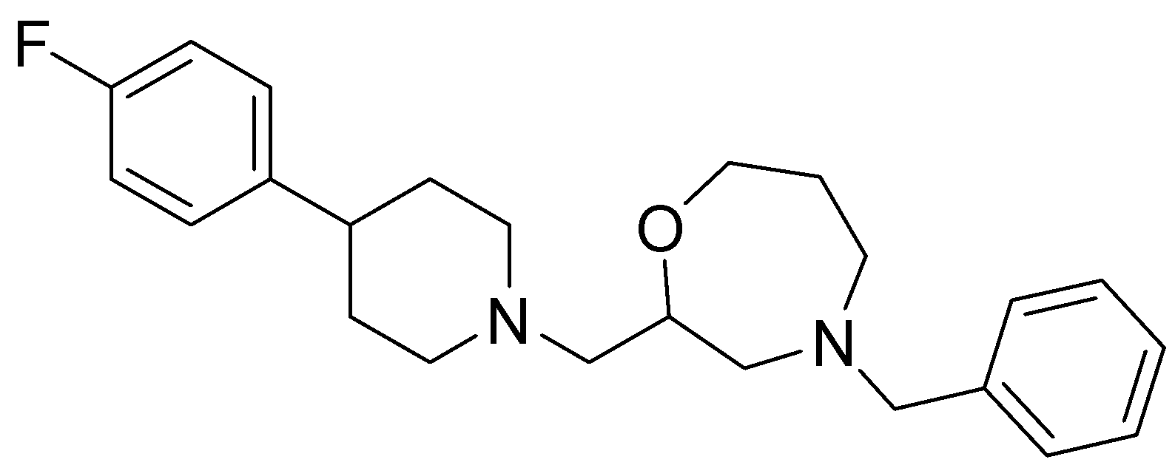
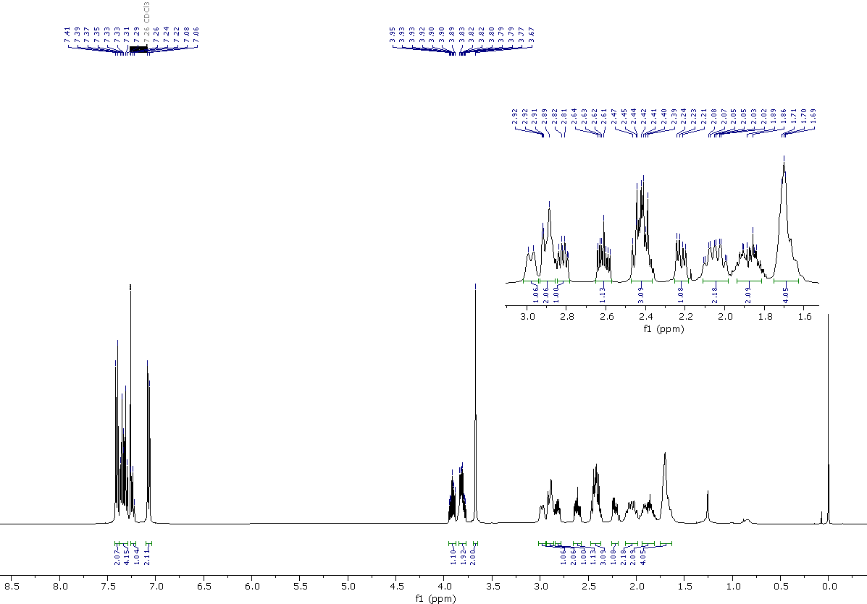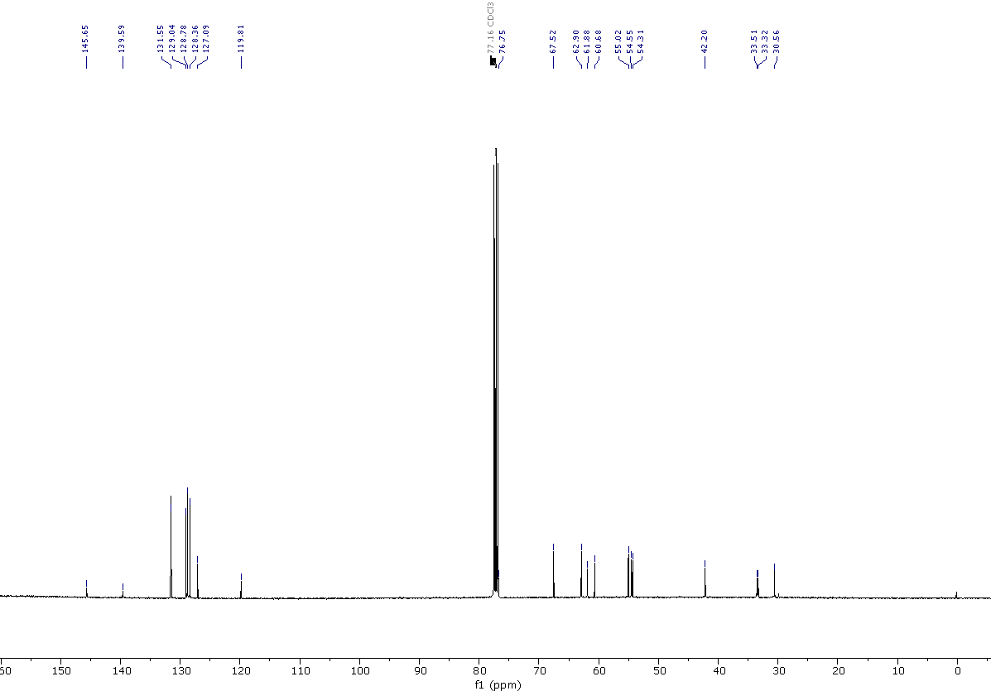

4-benzyl-2-{[4-(p-tolyl)piperidin-1-yl]methyl}-1,4-oxazepane, 16
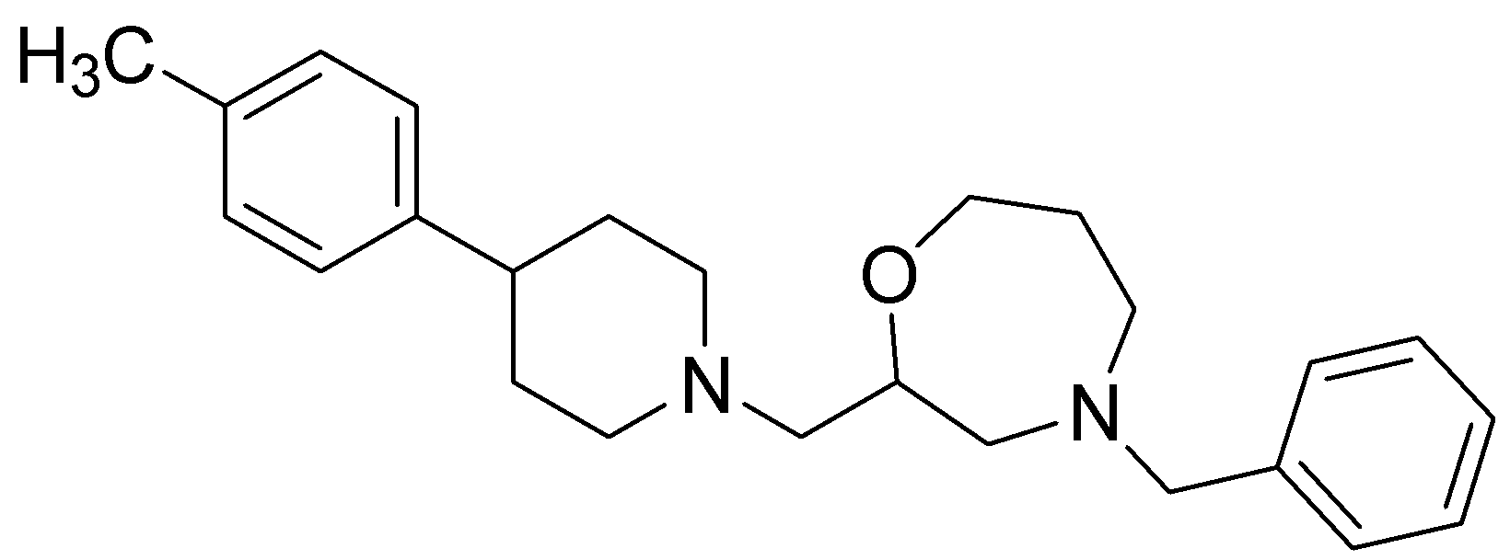
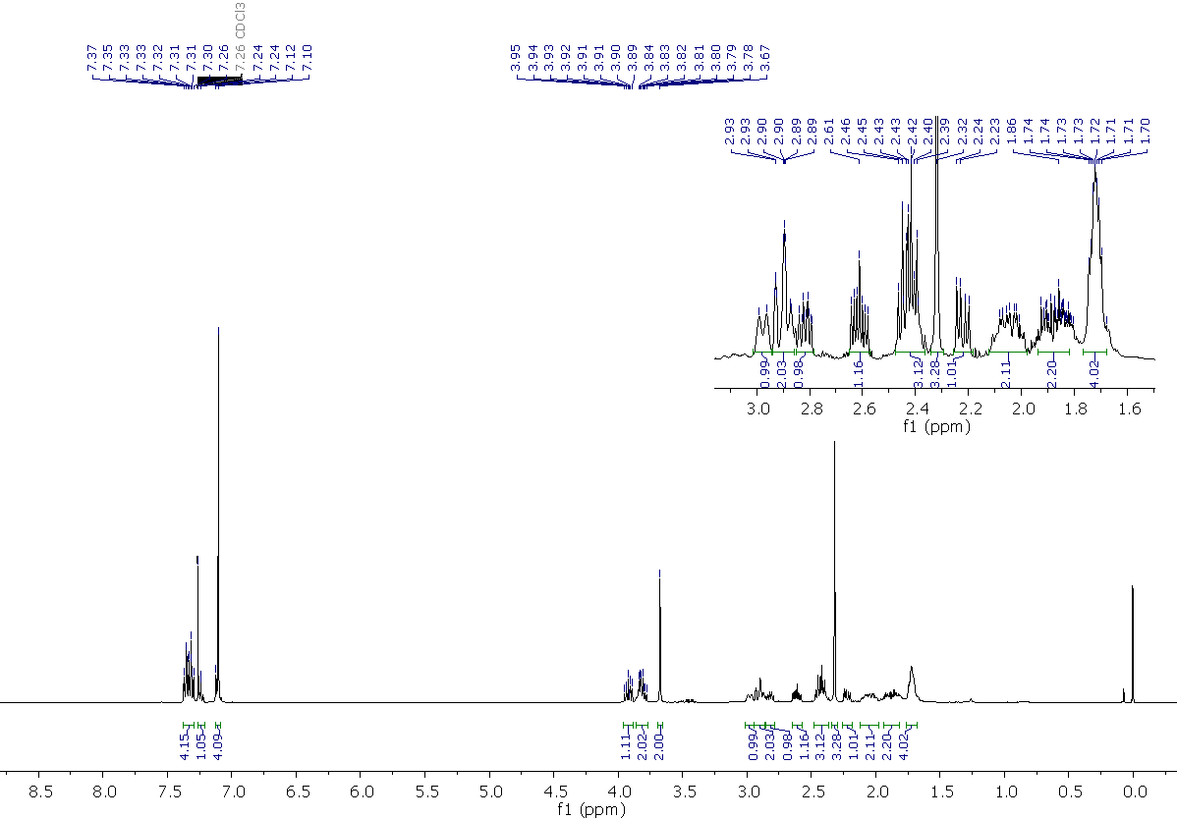
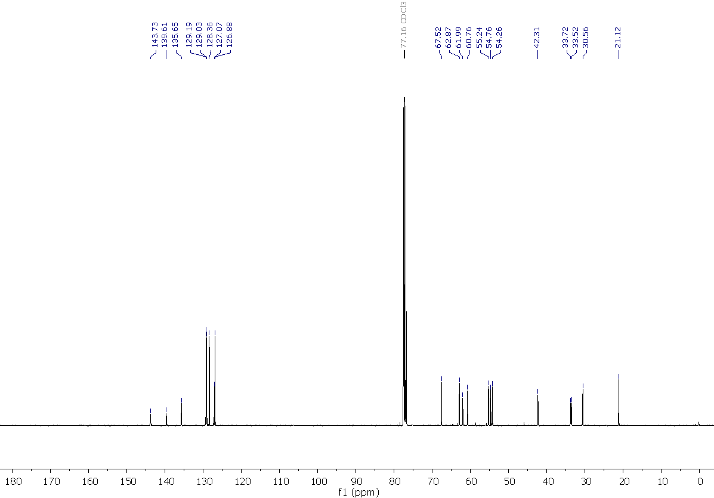

2-{1-[(4-benzyl-1,4-oxazepan-2-yl)methyl]piperidin-4-yl}phenol, 17
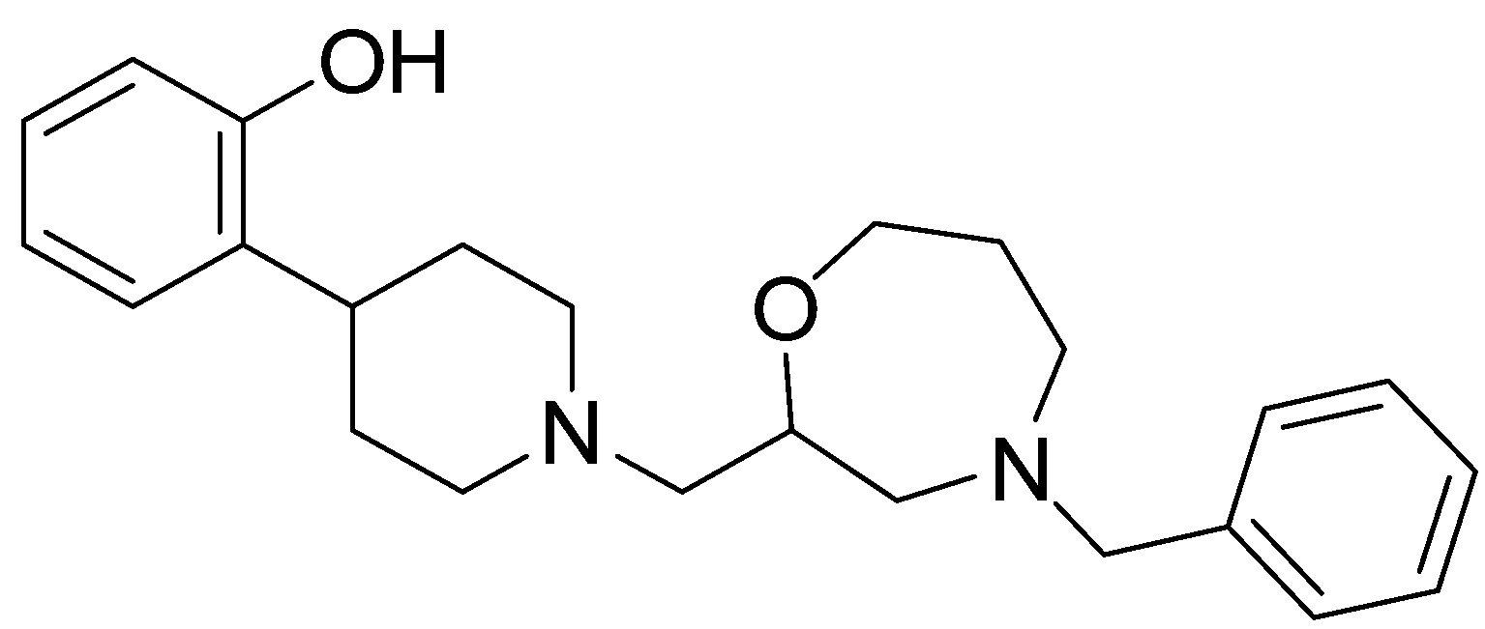
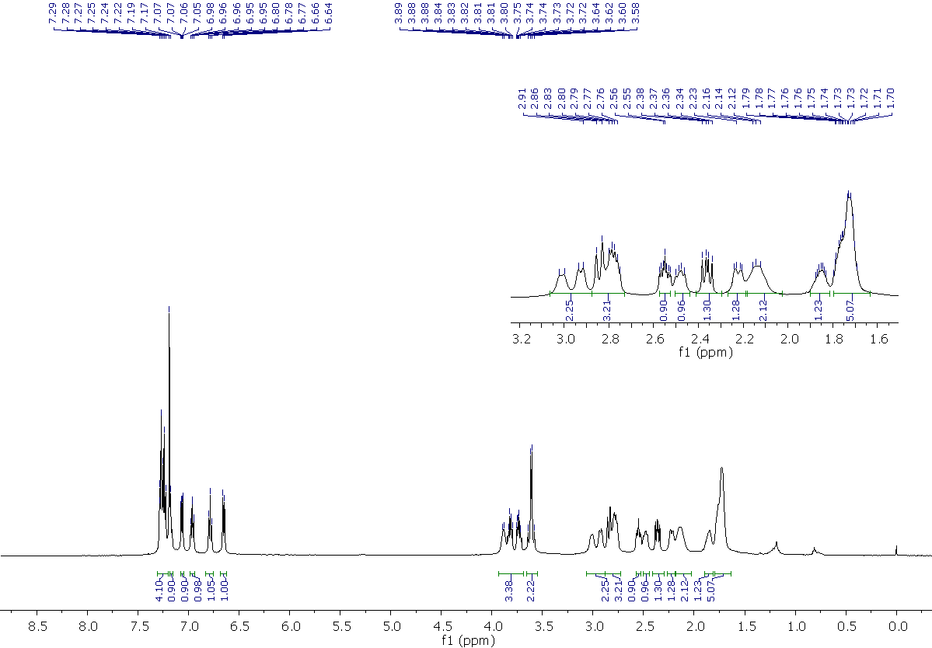
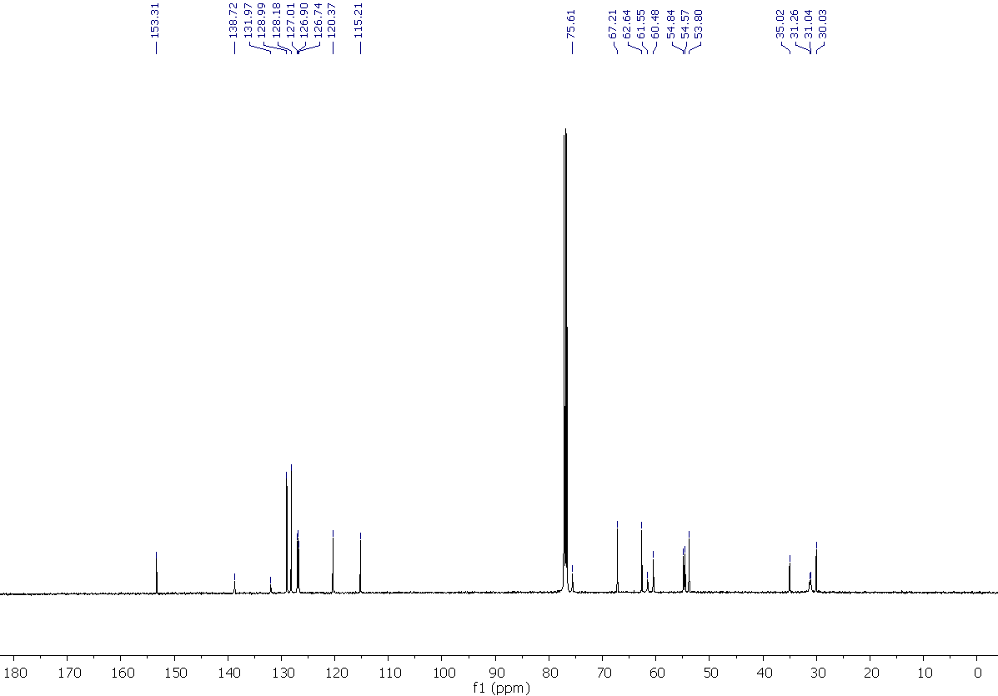

4-benzyl-1,4-oxazepan-2-yl)methyl]piperidin-4-yl}aniline, 18
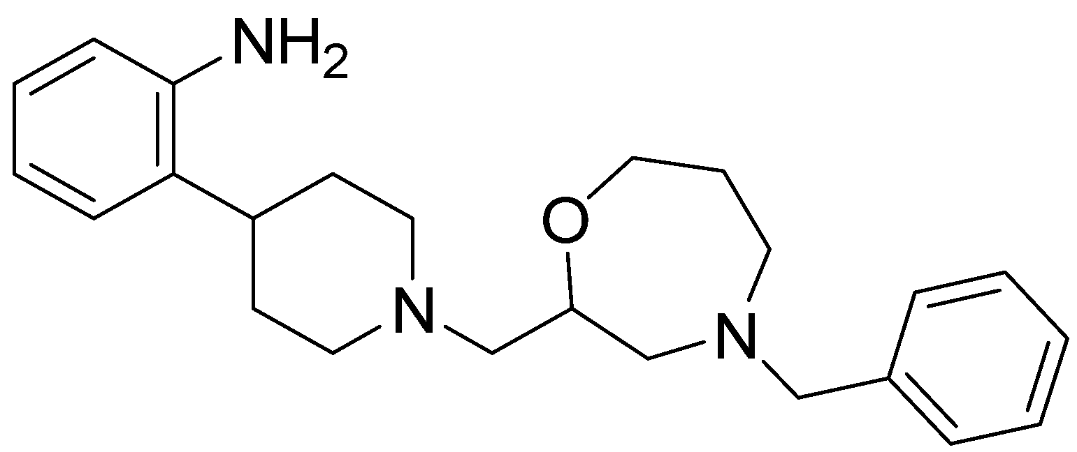
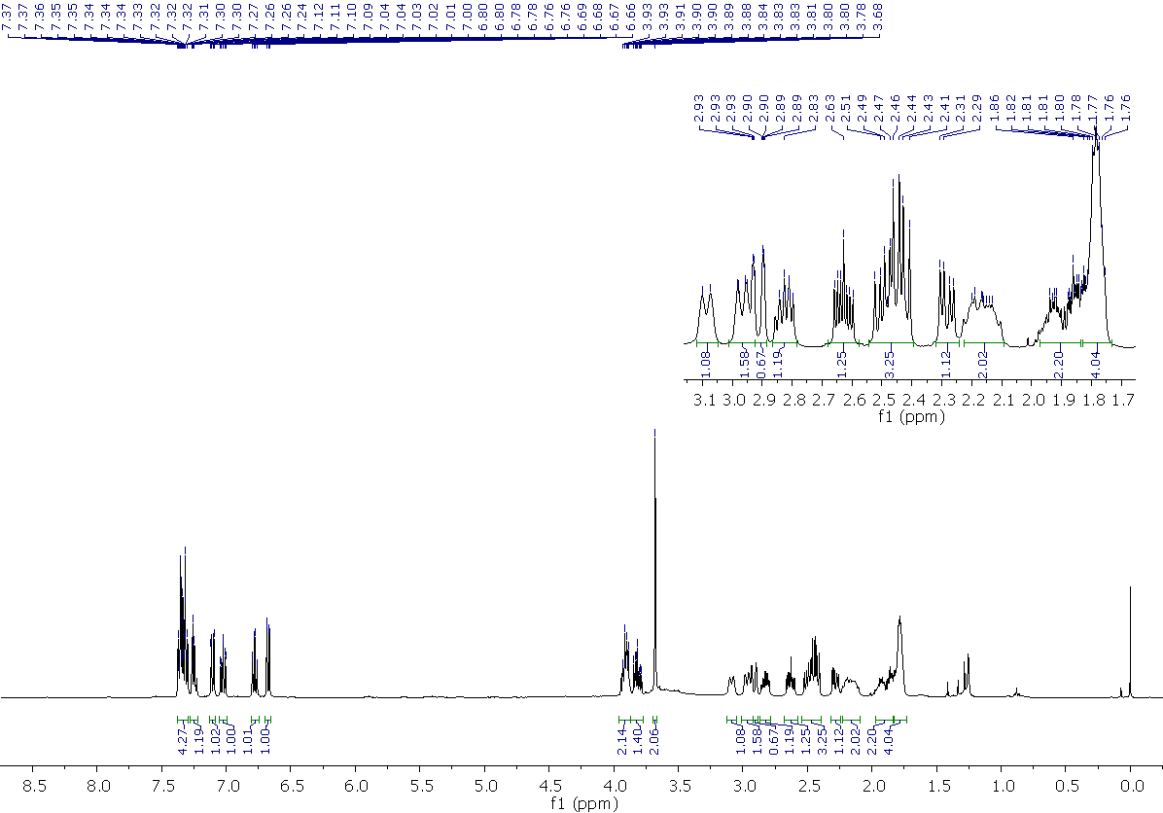
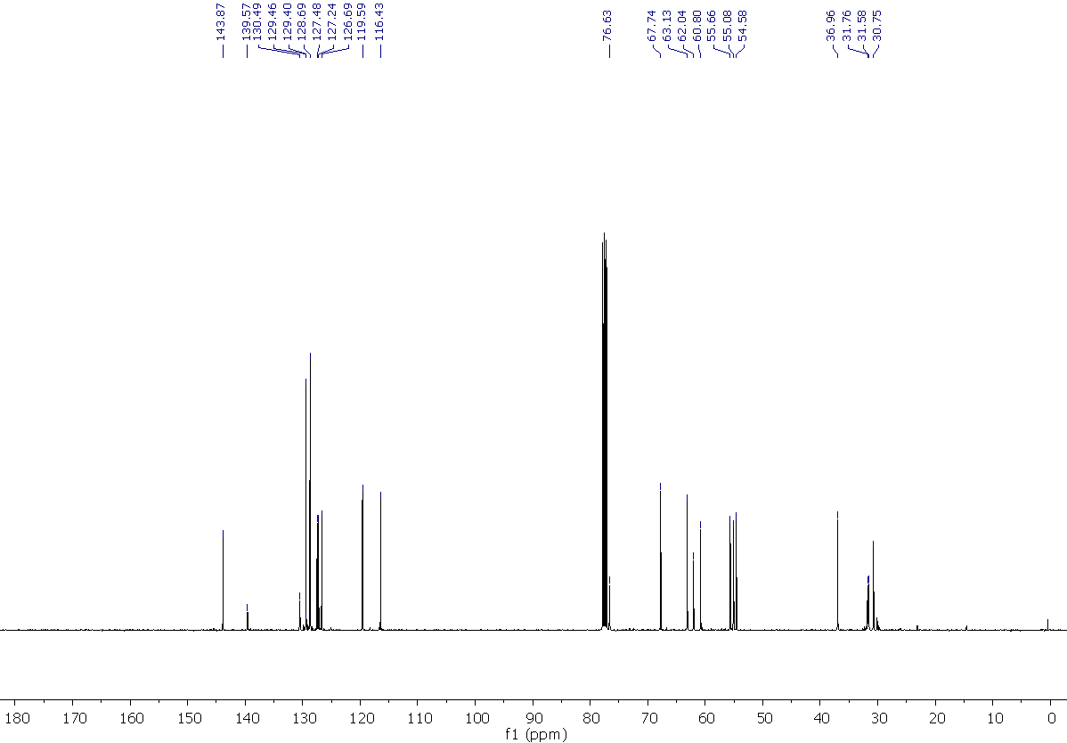

4-benzyl-2-{[4-(2-methylphenyl)piperidin-1-yl]methyl}-1,4-oxazepane, 19
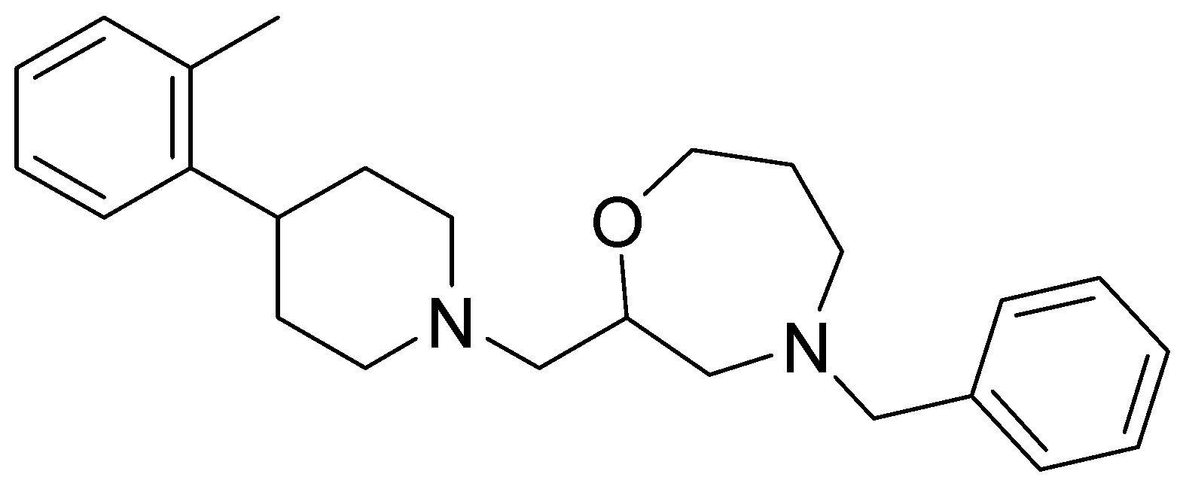
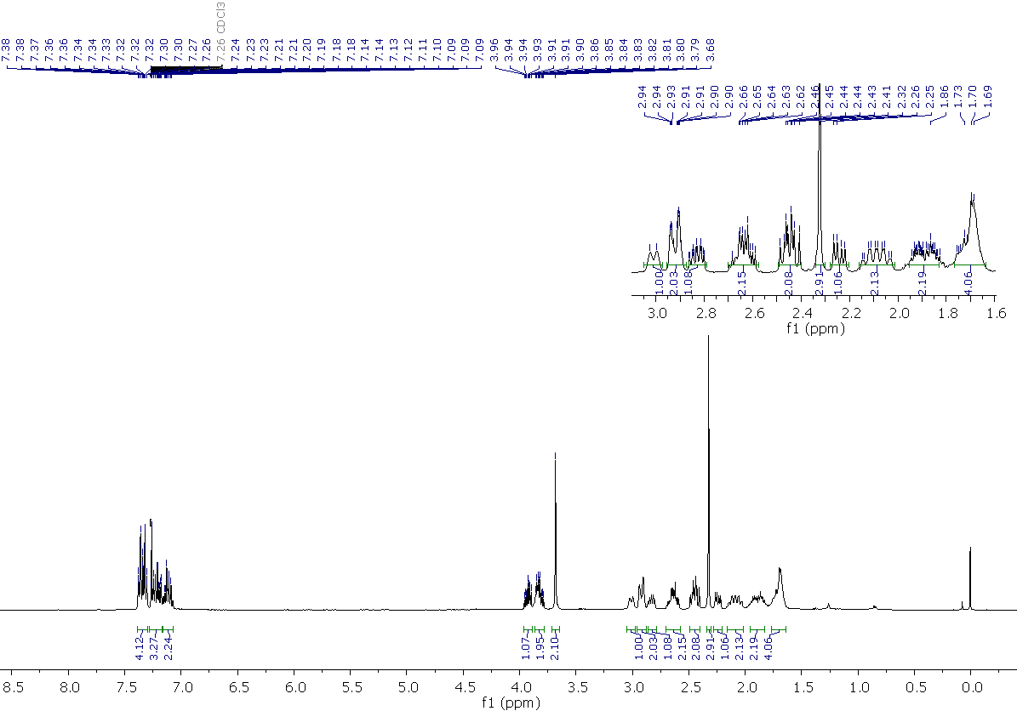
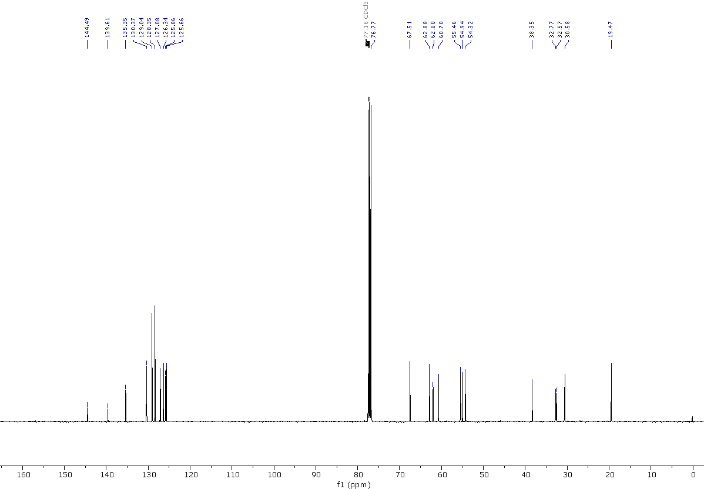
4-benzyl-2-{[4-(2-fluorophenyl)piperidin-1-yl]methyl}-1,4-oxazepane, 20
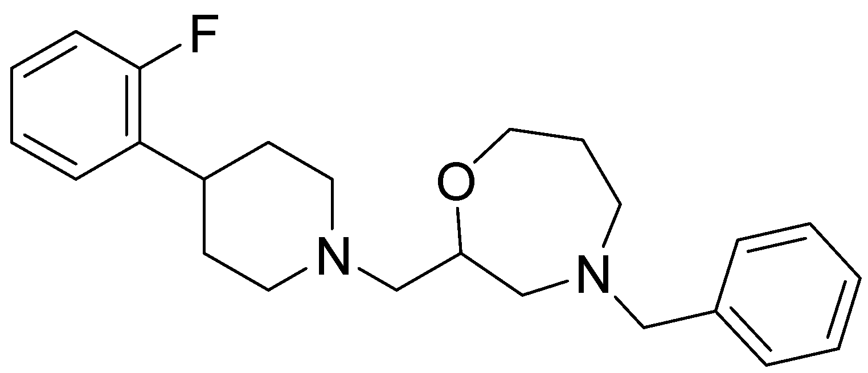
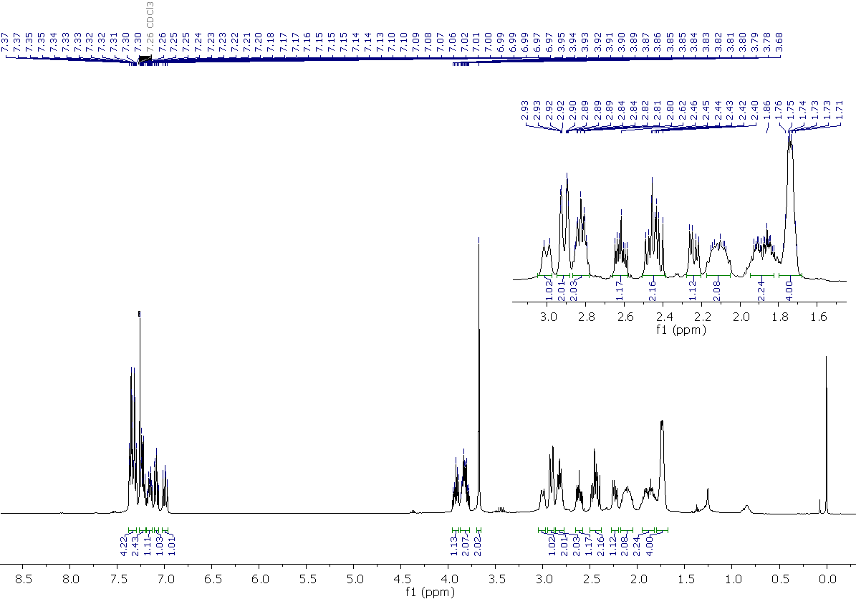
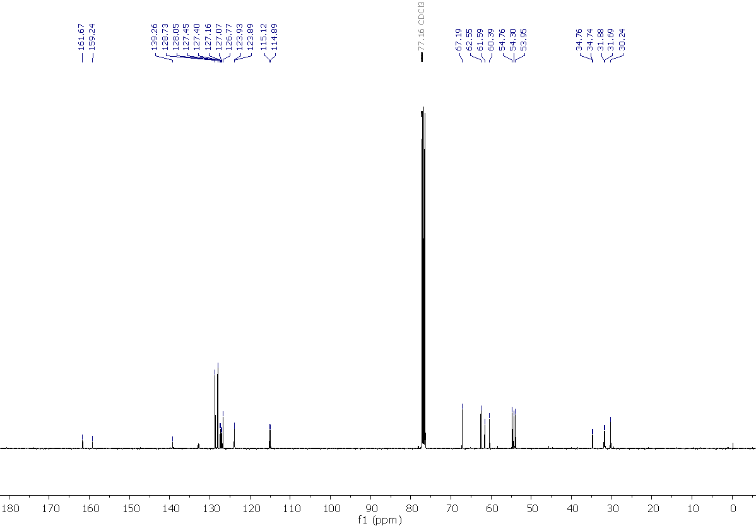

5-{1-[(4-Benzyl-1,4-oxazepan-2-yl)methyl]piperidin-4-yl}-2-methylphenol, 21
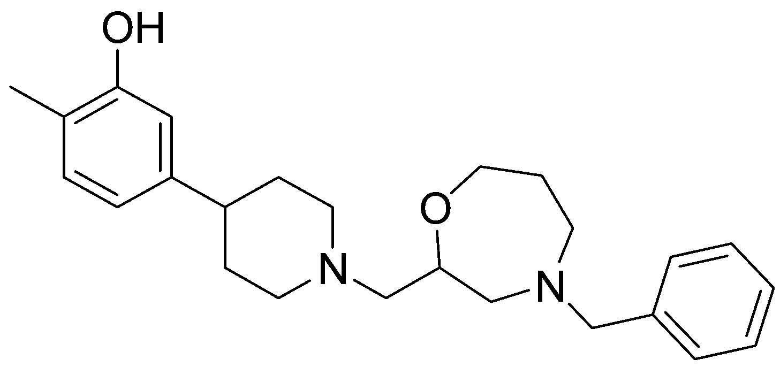
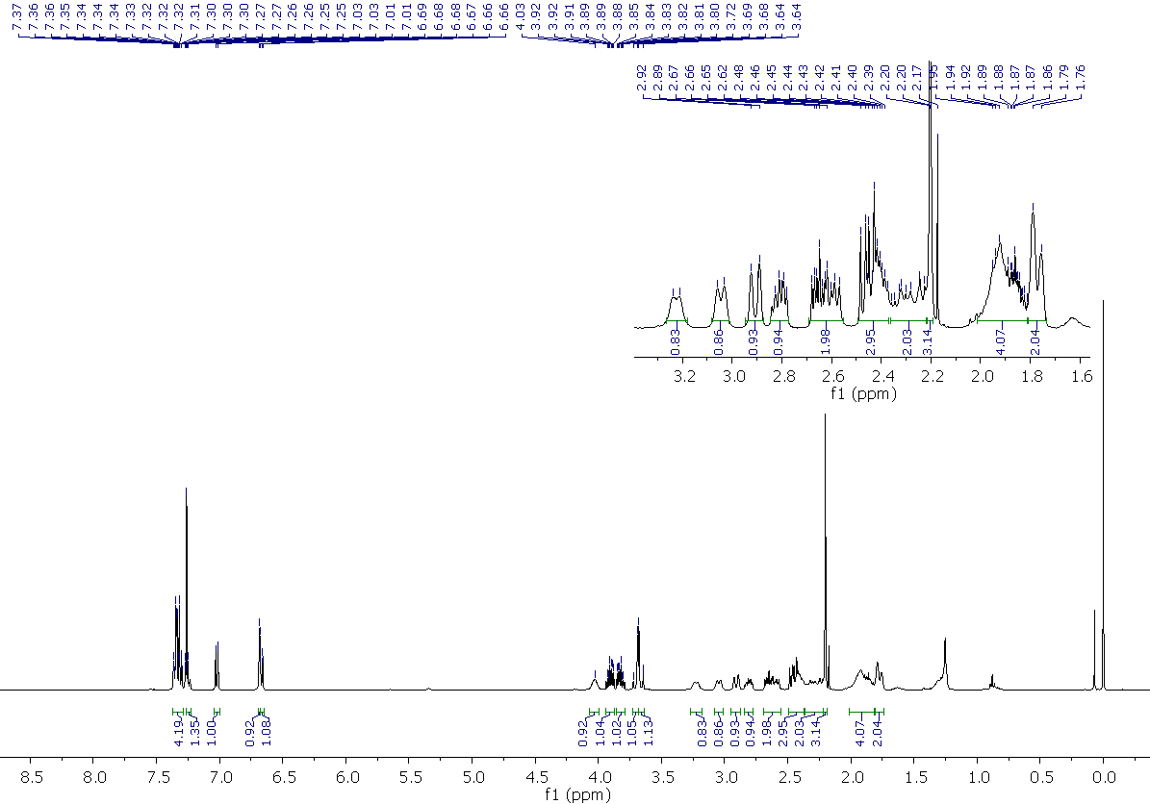
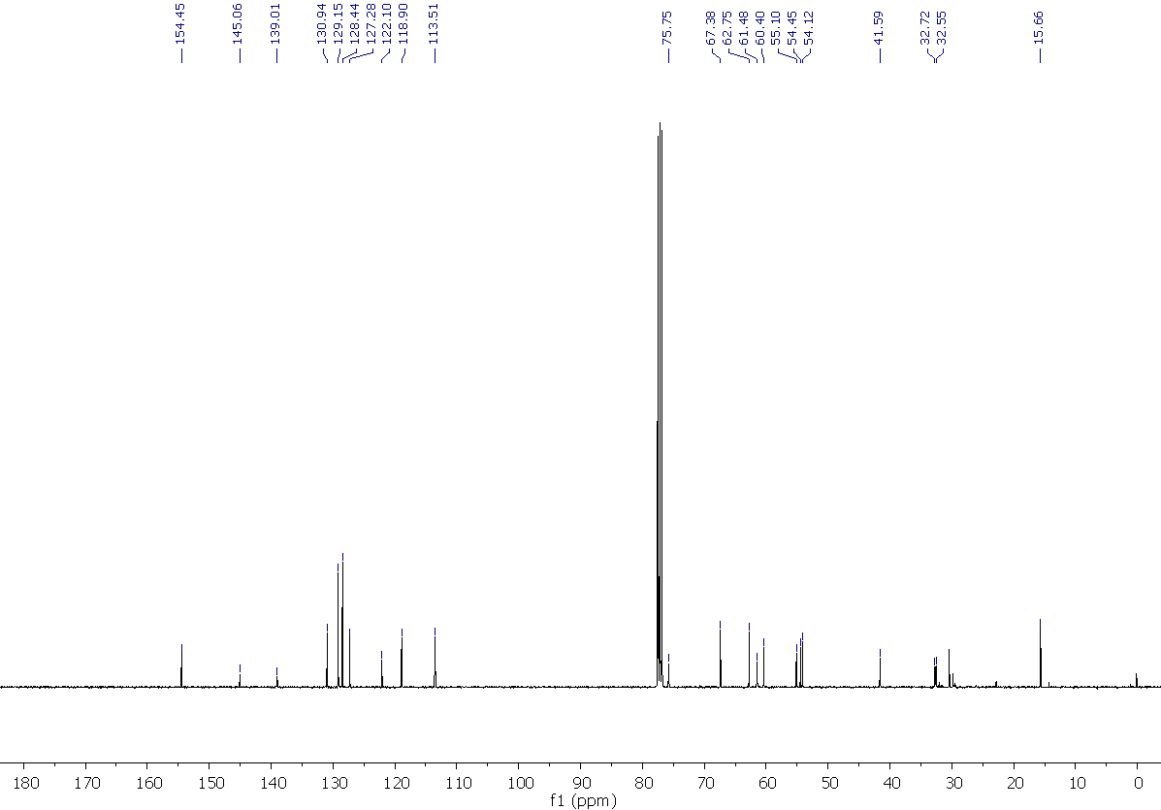

5-{1-[(4-Benzyl-1,4-oxazepan-2-yl)methyl]piperidin-4-yl}-2-fluorophenol, 22
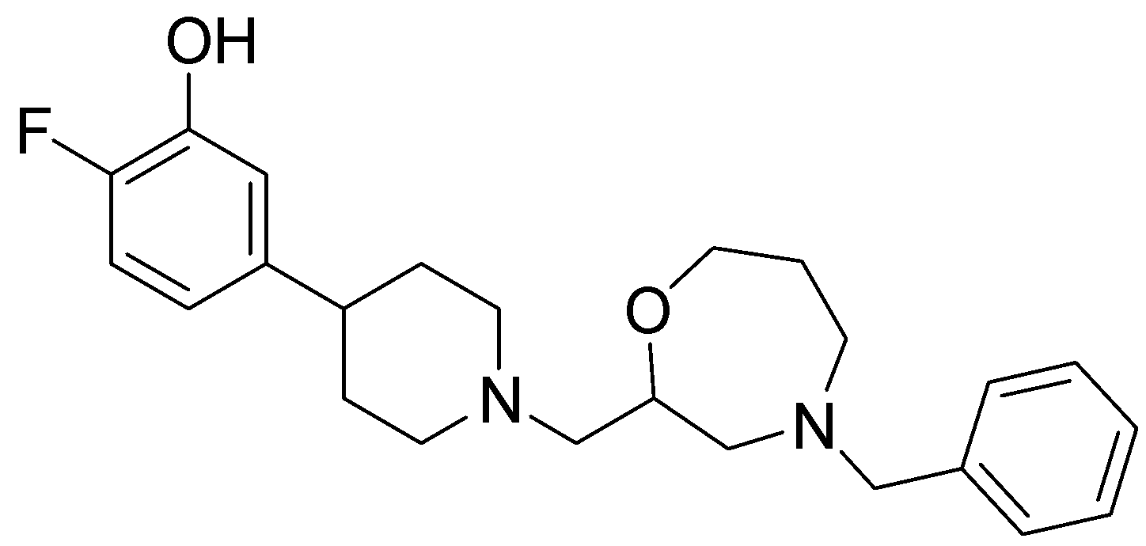
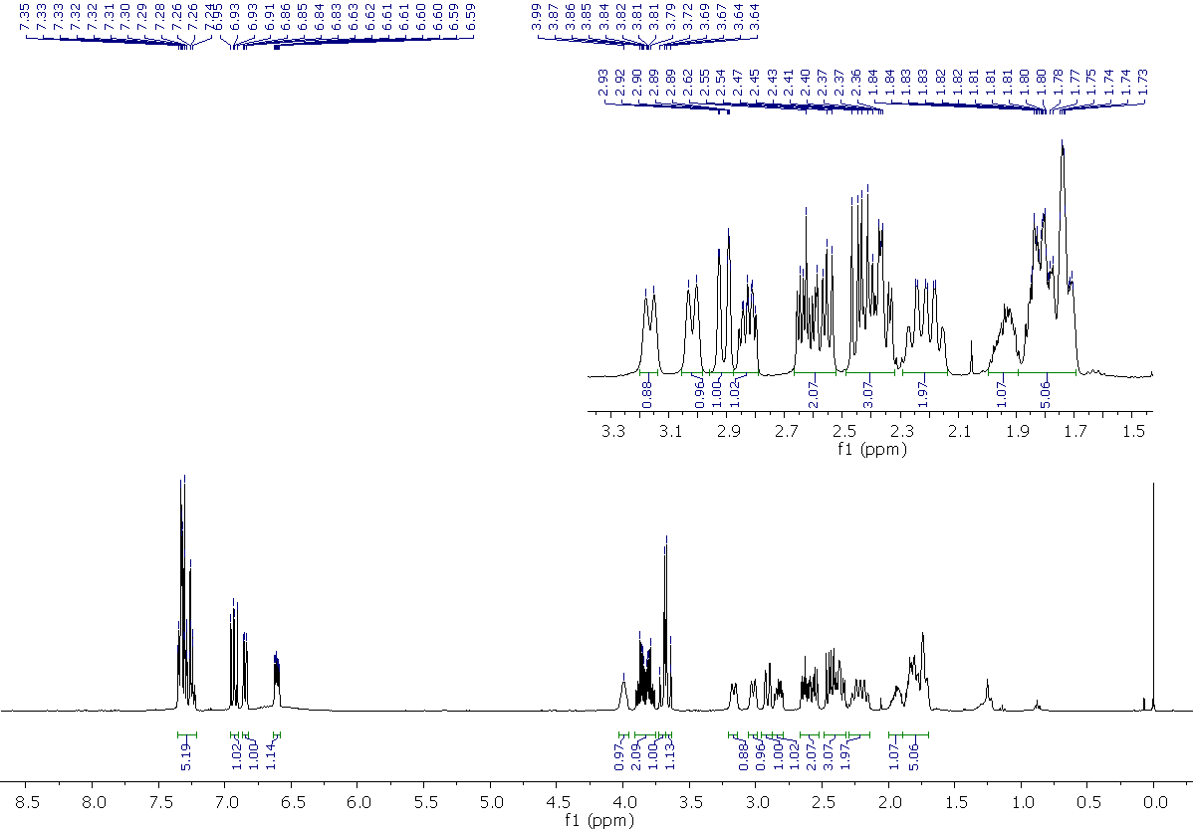
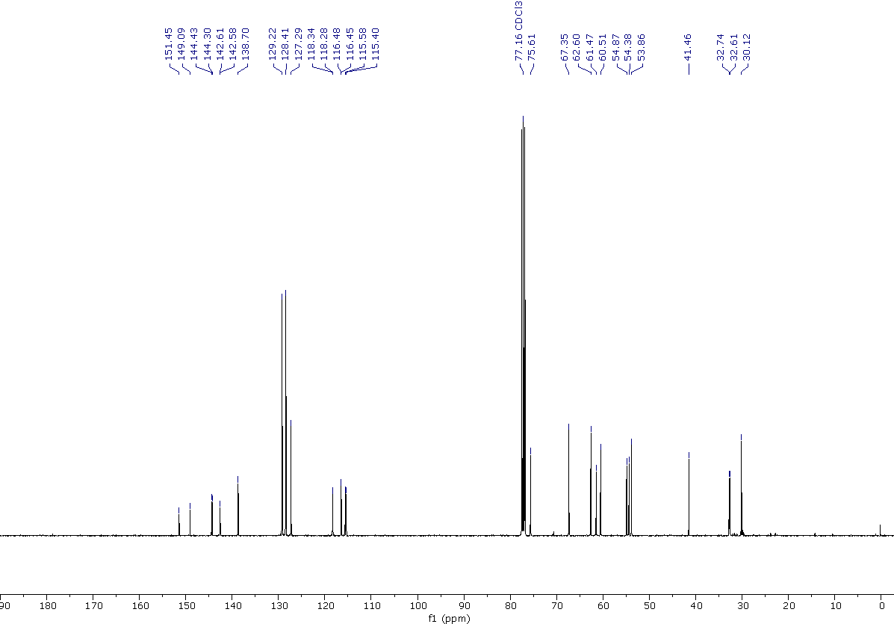

4-benzyl-2-{[4-(3,5-dichlorophenyl)piperidin-1-yl]methyl}-1,4-oxazepane, 23
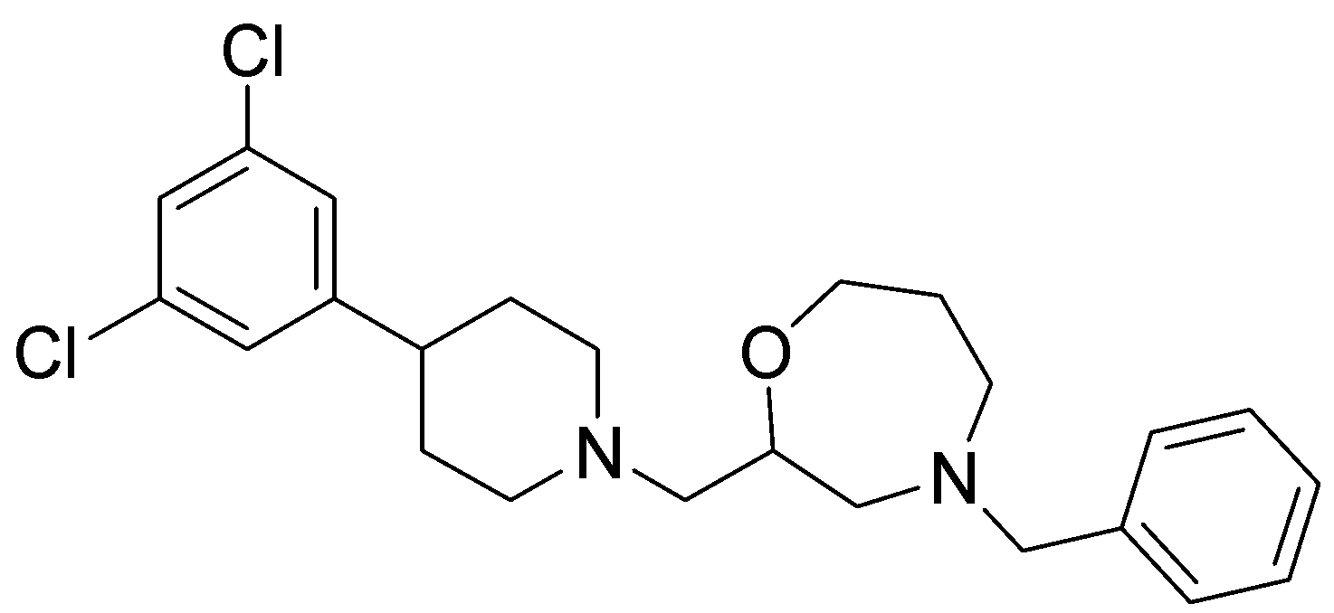
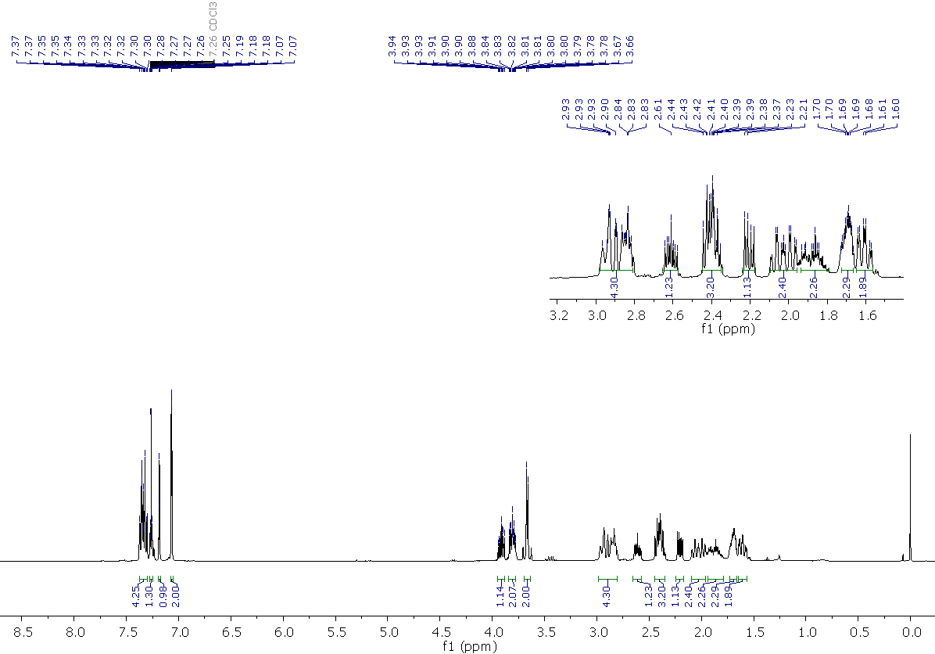
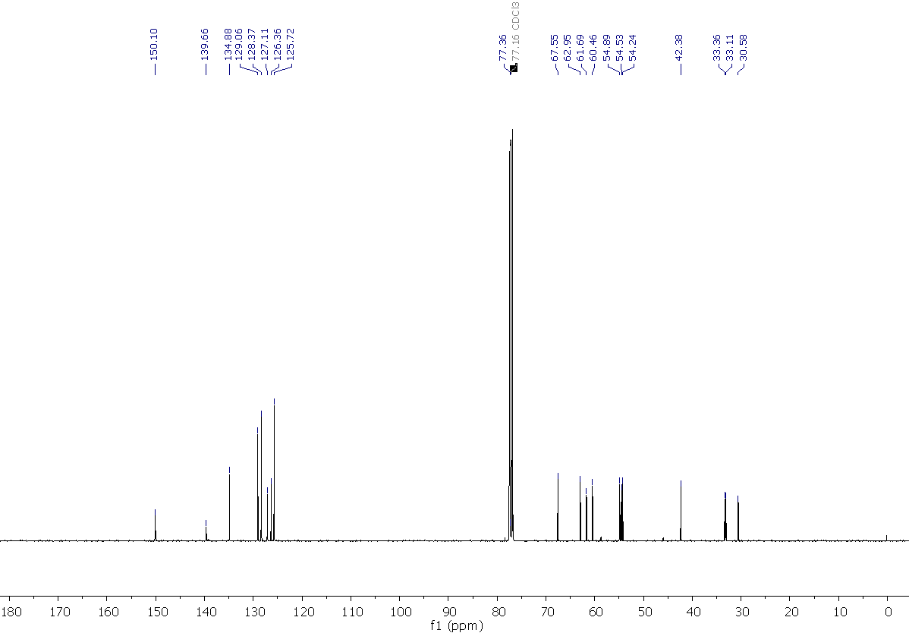

4-benzyl-2-((4-phenylpiperidin-1-yl)methyl)-1,4-oxazepane, 24

4-benzyl-2-((4-morpholinopiperidin-1-yl)methyl)-1,4-oxazepane, 25
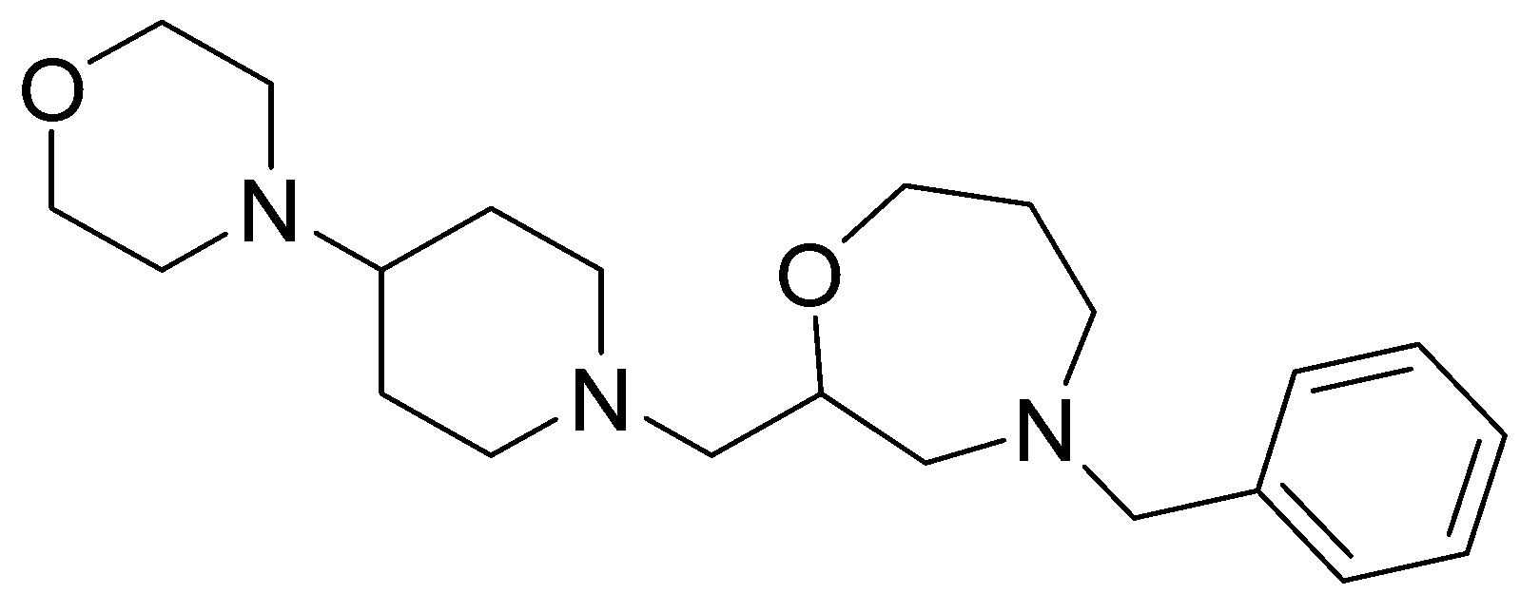
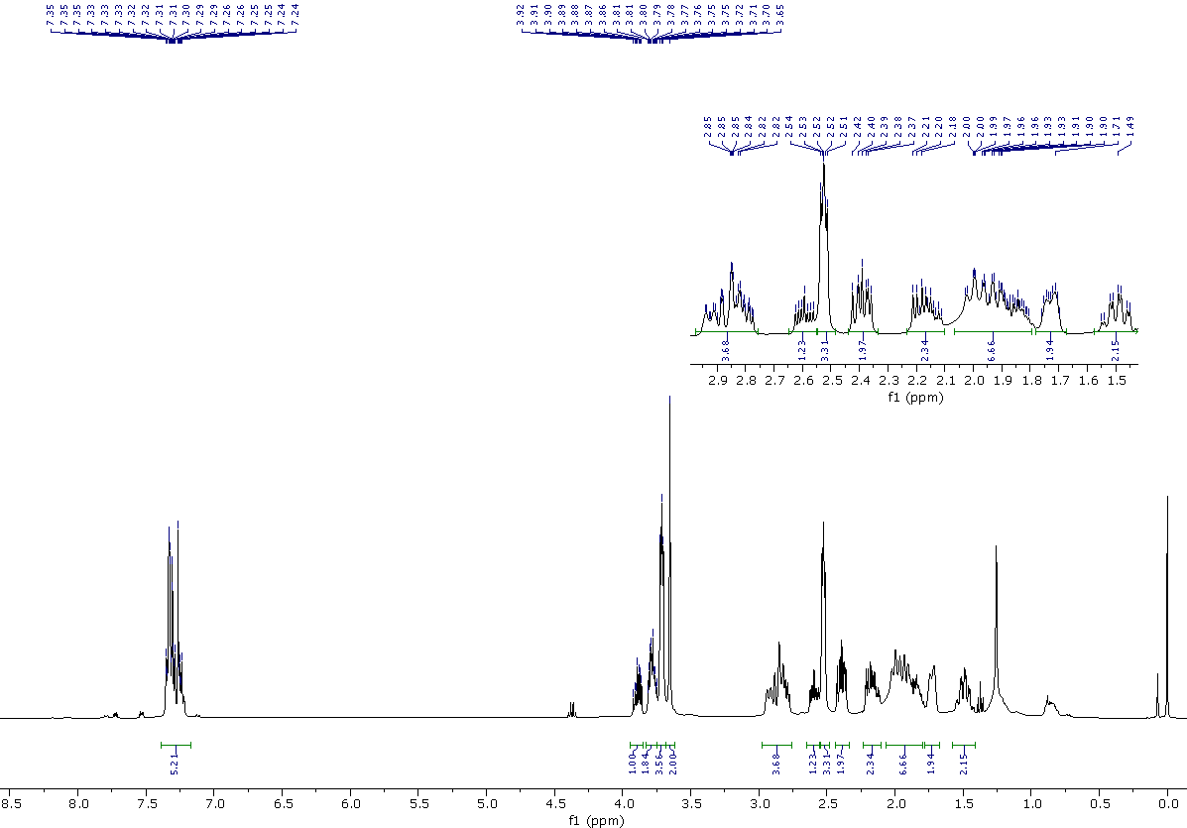
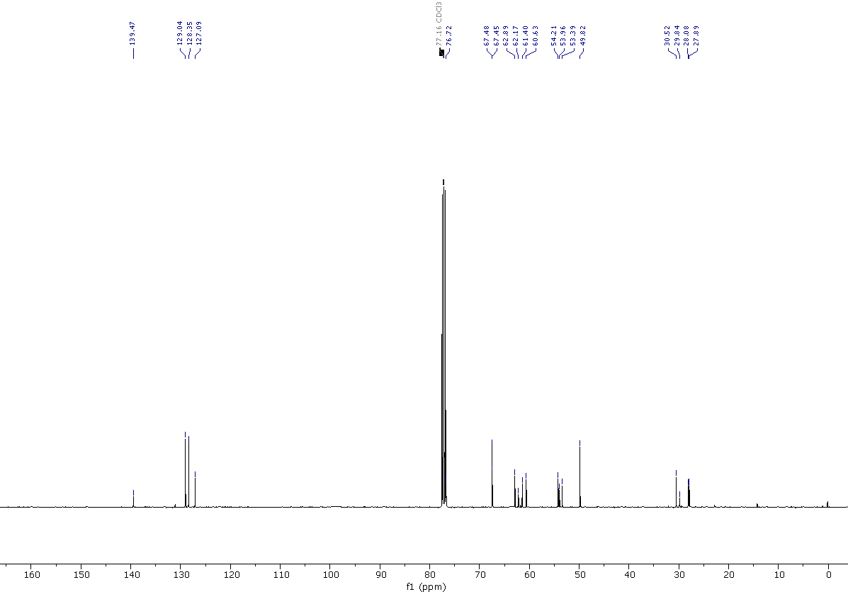

2-((4-(1H-pyrazol-1-yl)piperidin-1-yl)methyl)-4-benzyl-1,4-oxazepane, 26
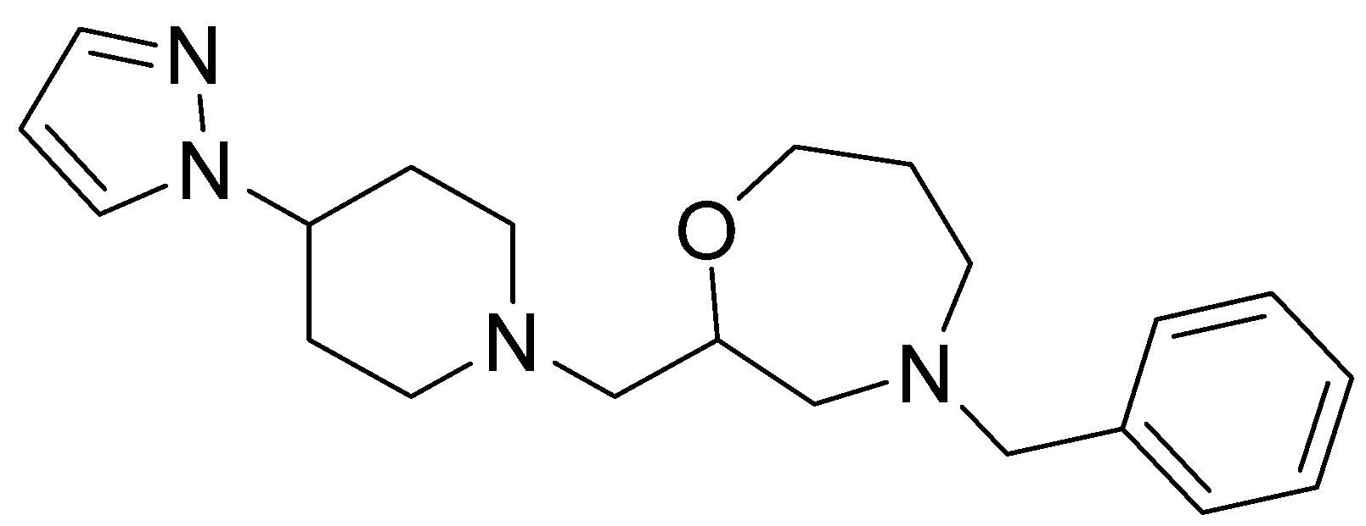
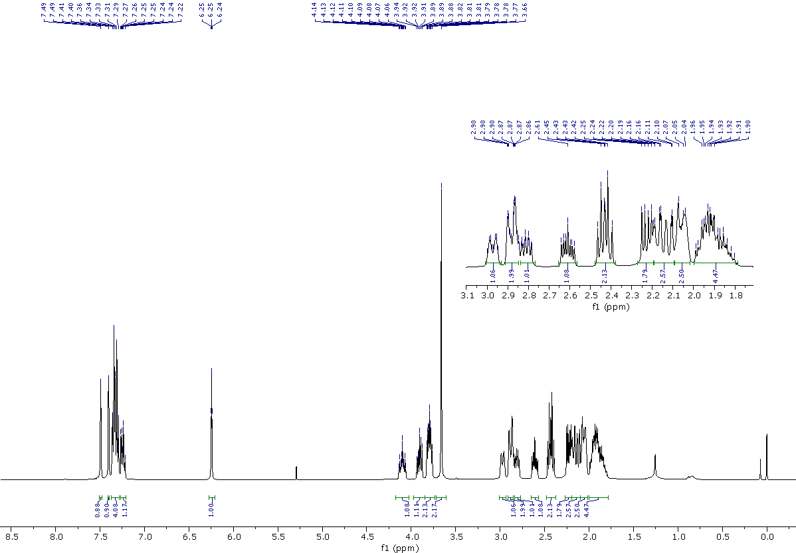
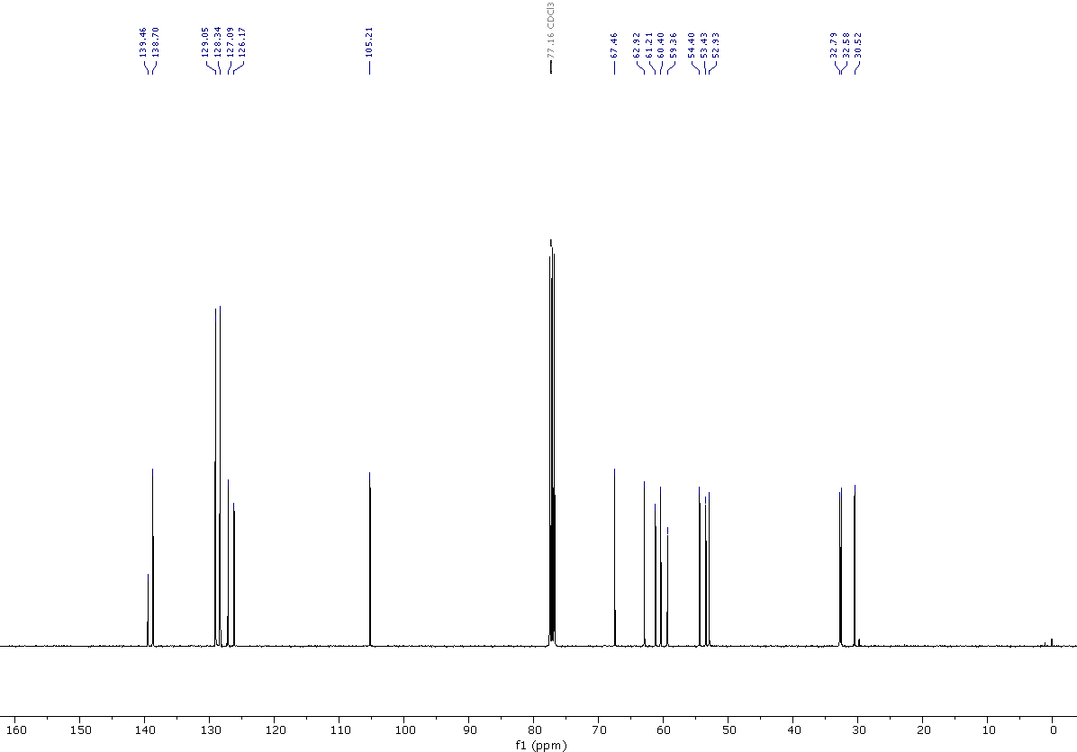

4-benzyl-2-{[4-(pyridin-3-yl)piperidin-1-yl]methyl}-1,4-oxazepane, 27
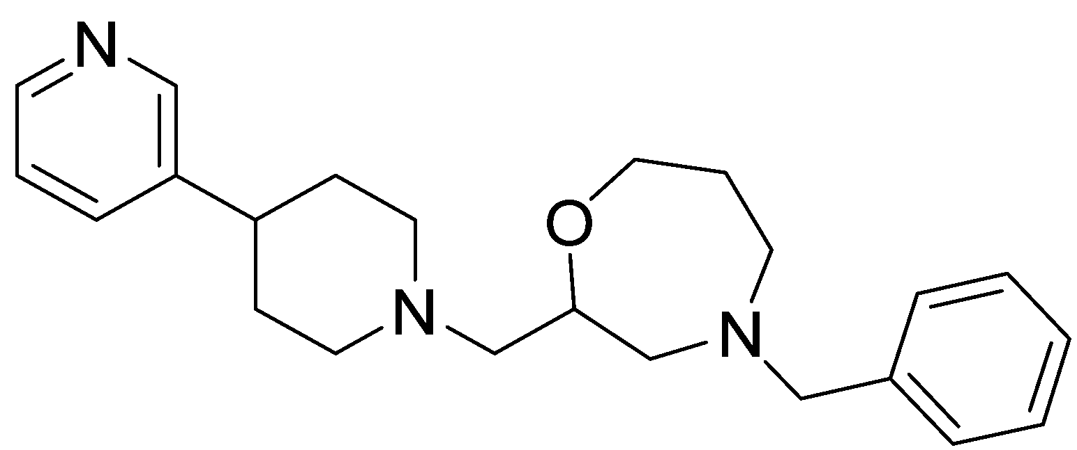
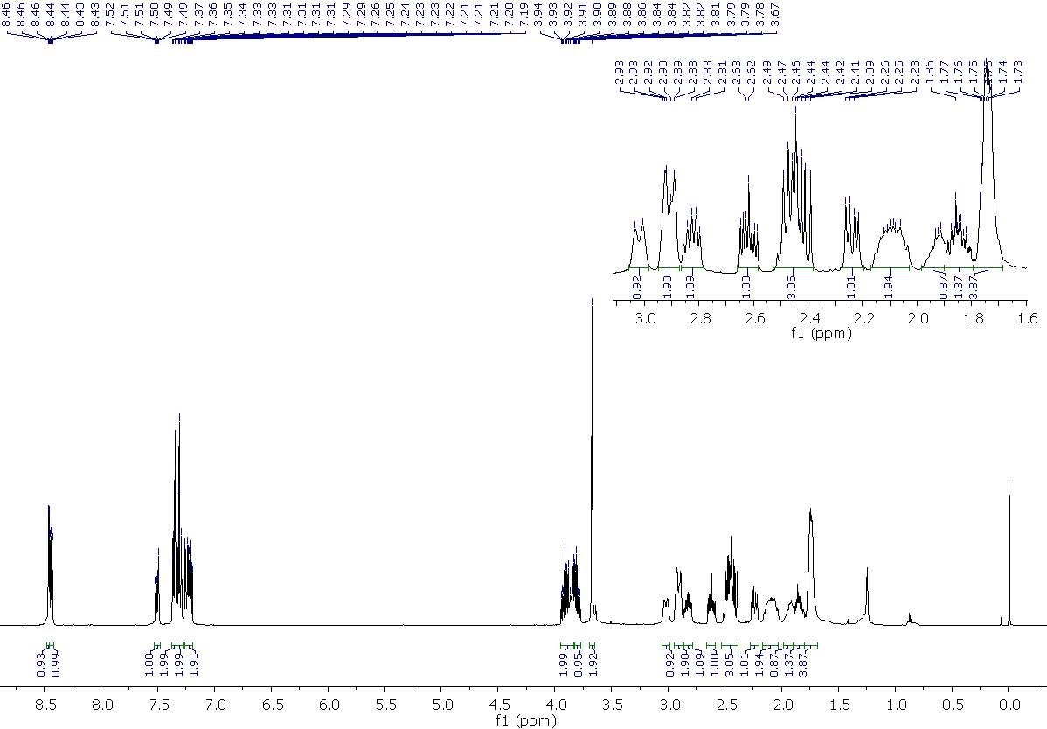
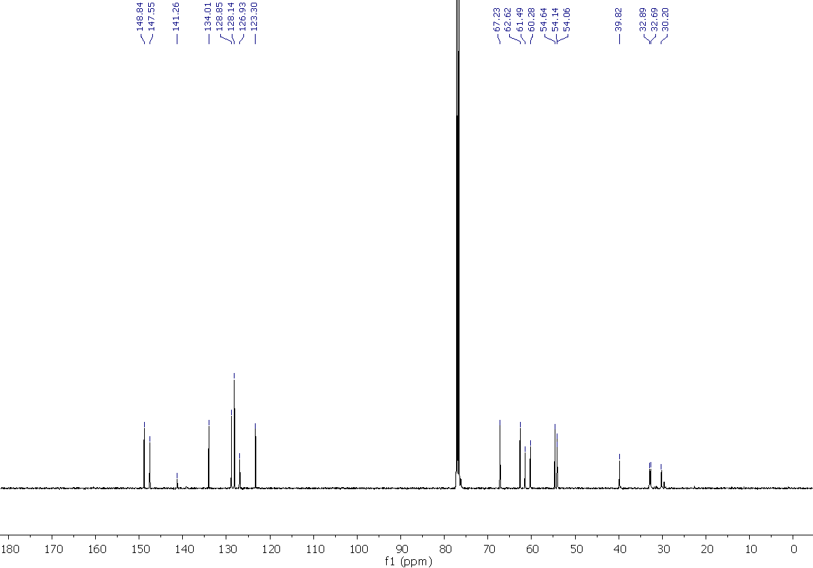

4-benzyl-2-((4-(pyridin-4-yl)piperidin-1-yl)methyl)-1,4-oxazepane, 28

4-benzyl-2-{4-(pyrimidin-2-yl)piperidin-1-yl)methyl}-1,4-oxazepane, 29
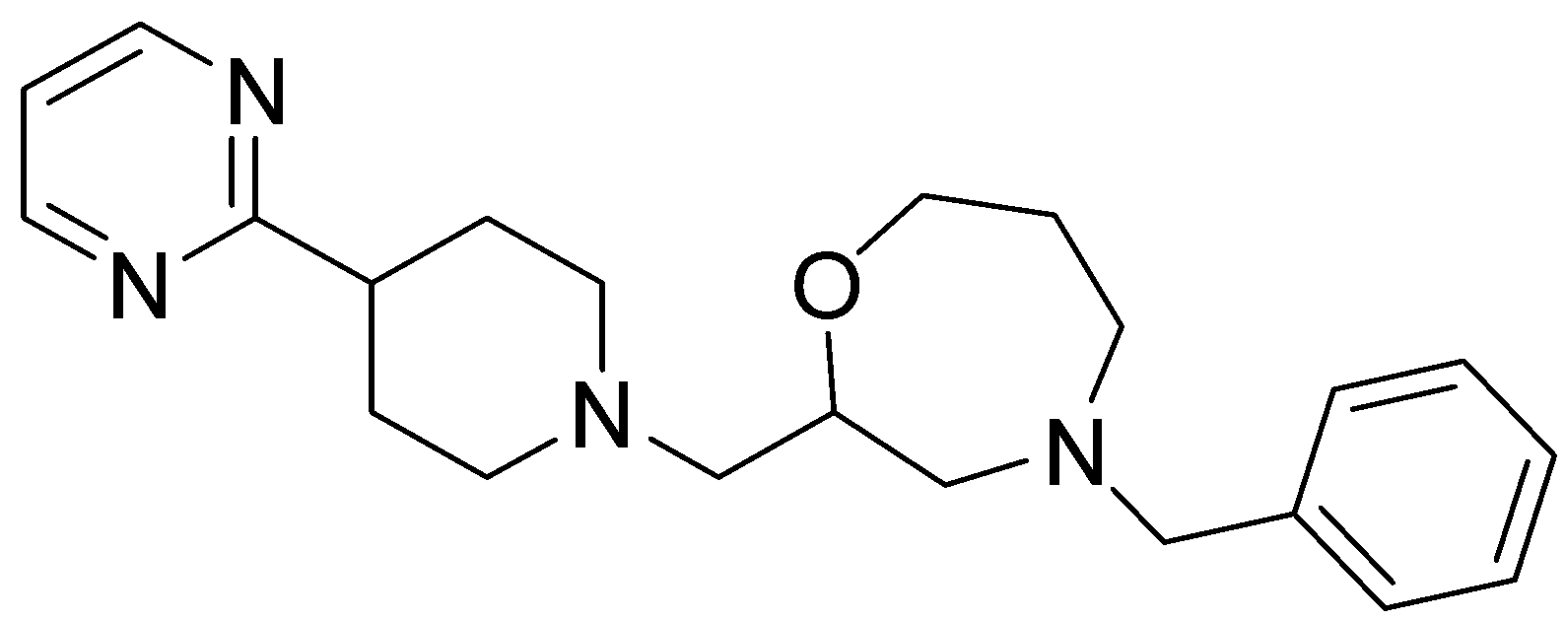
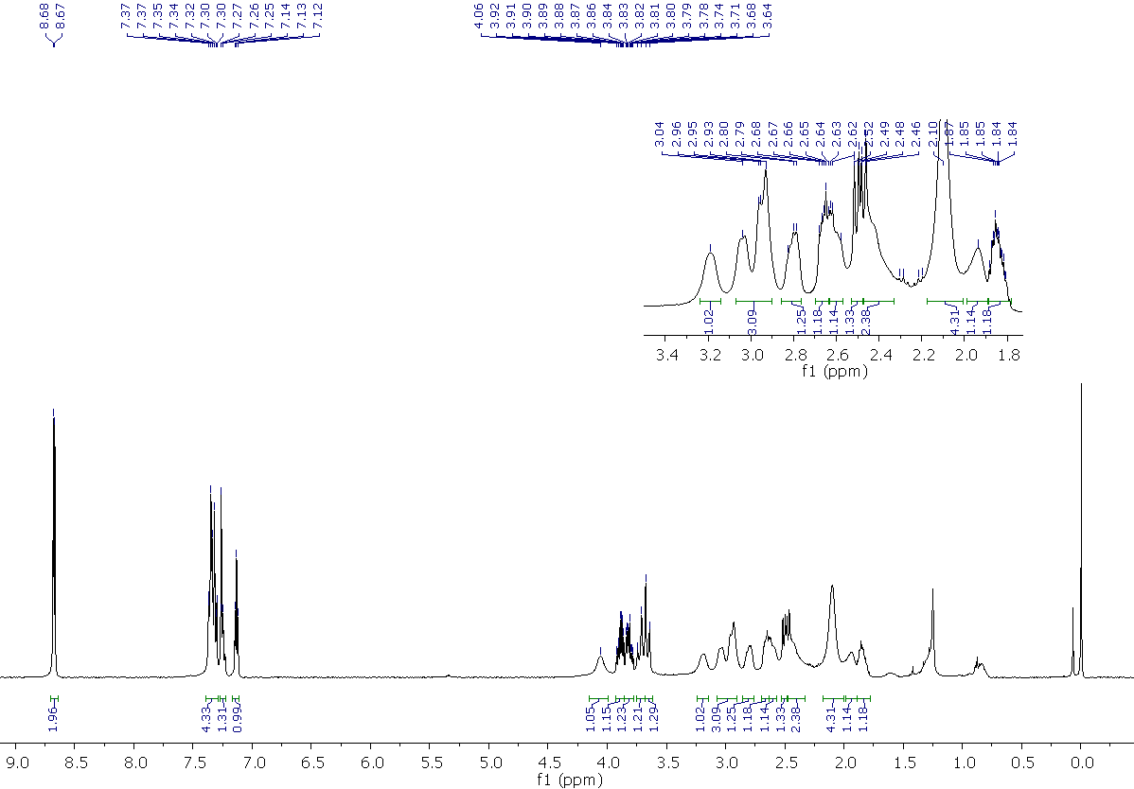
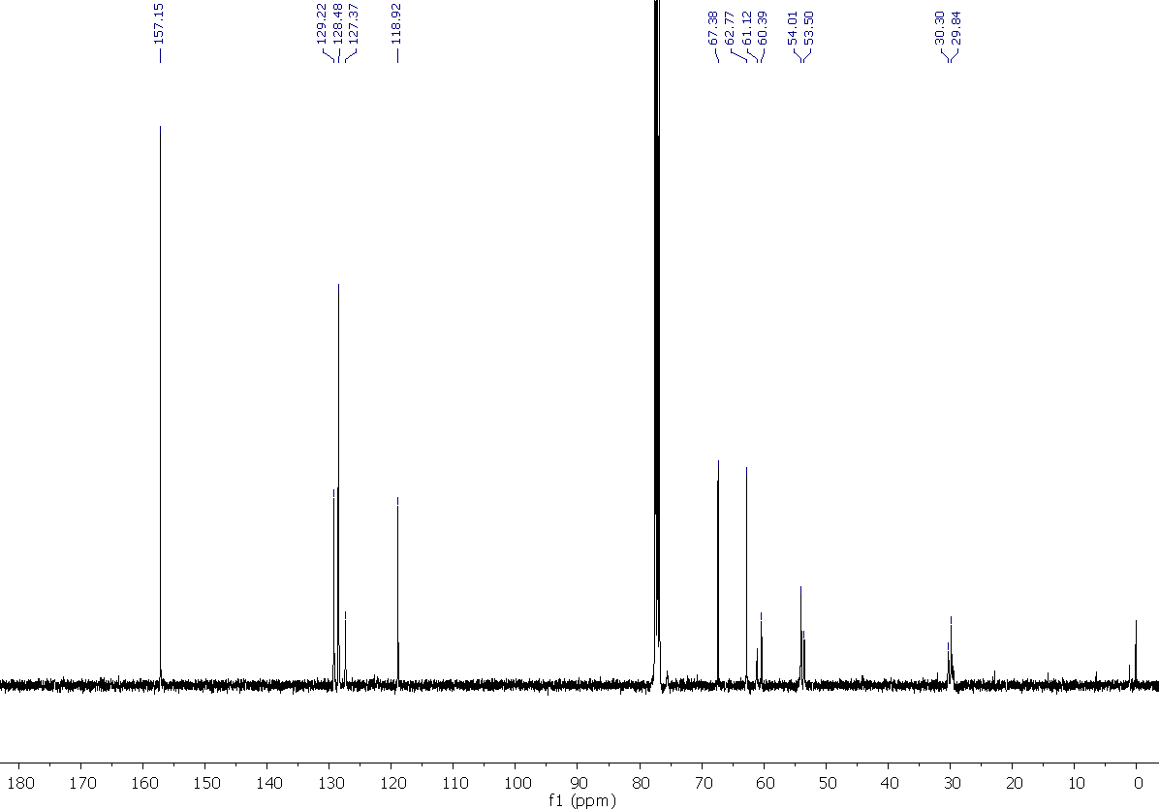

2-((4-(1H-benzo[d]imidazol-2-yl)piperidin-1-yl)methyl)-4-benzyl-1,4-oxazepane, 30
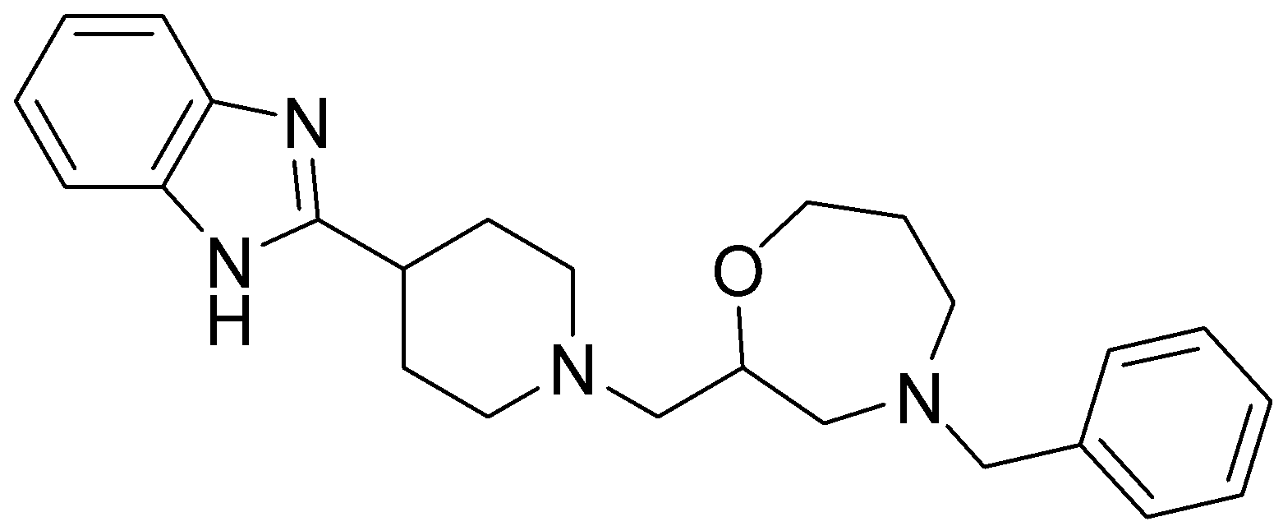
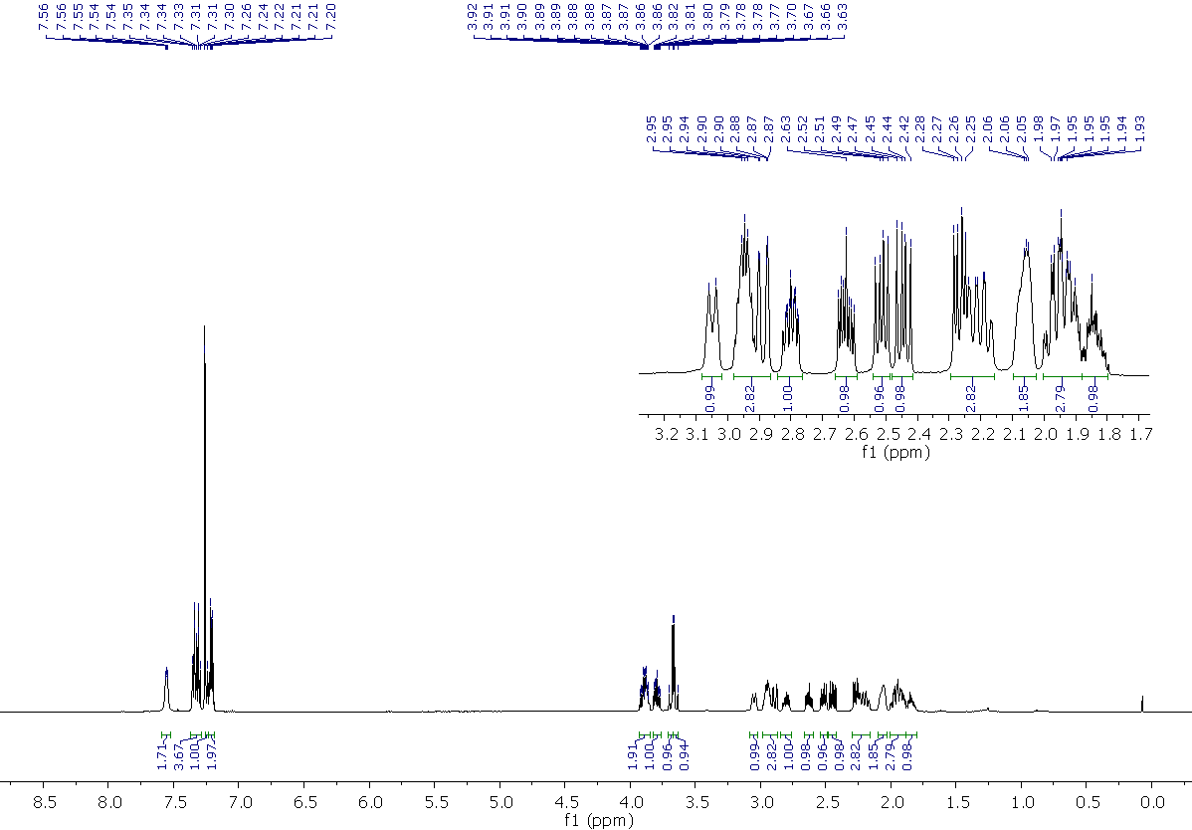
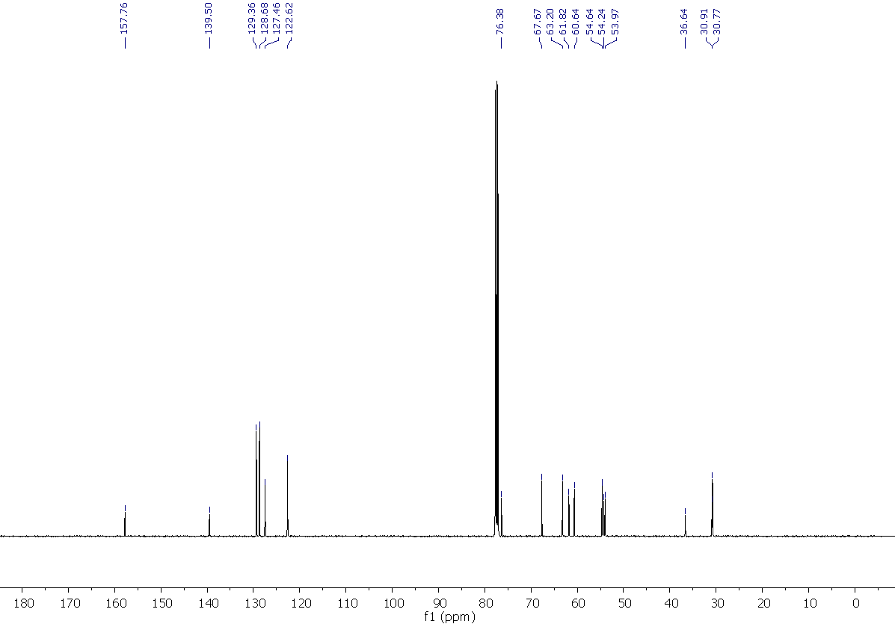

2{[4-(1H-indol-3-yl)piperidin-1-yl]methyl}-4-benzyl-1,4-oxazepane, 31
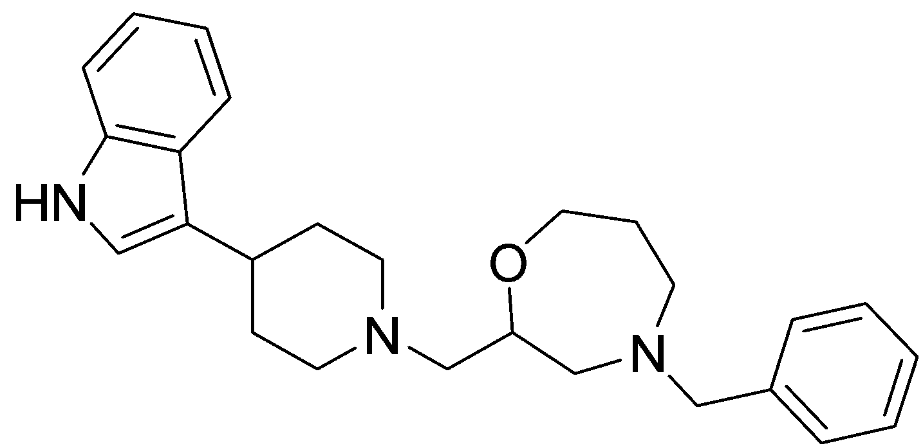
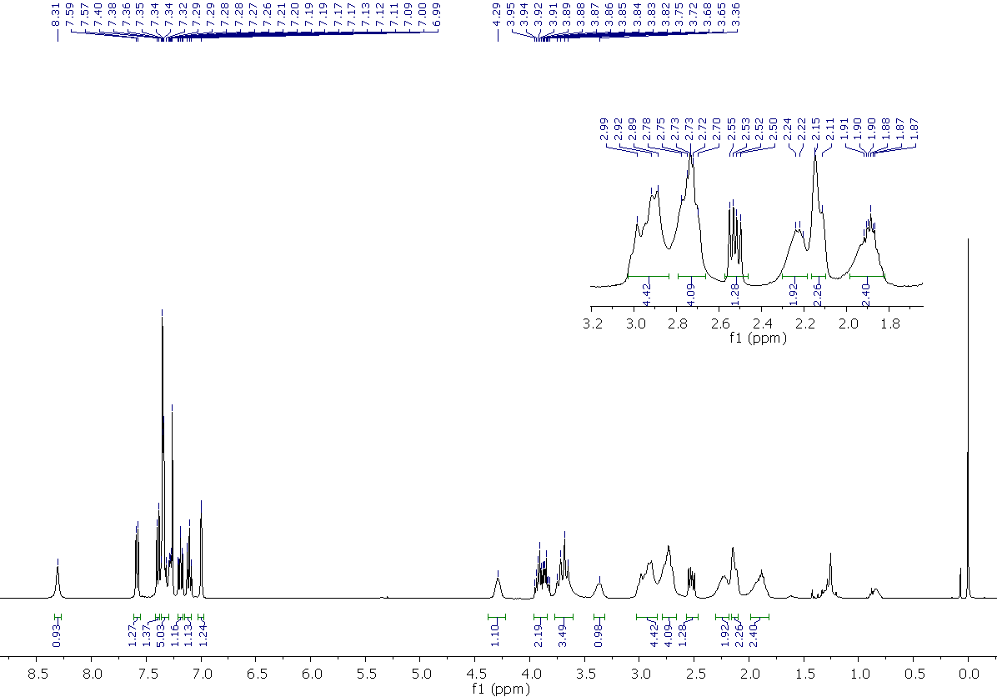
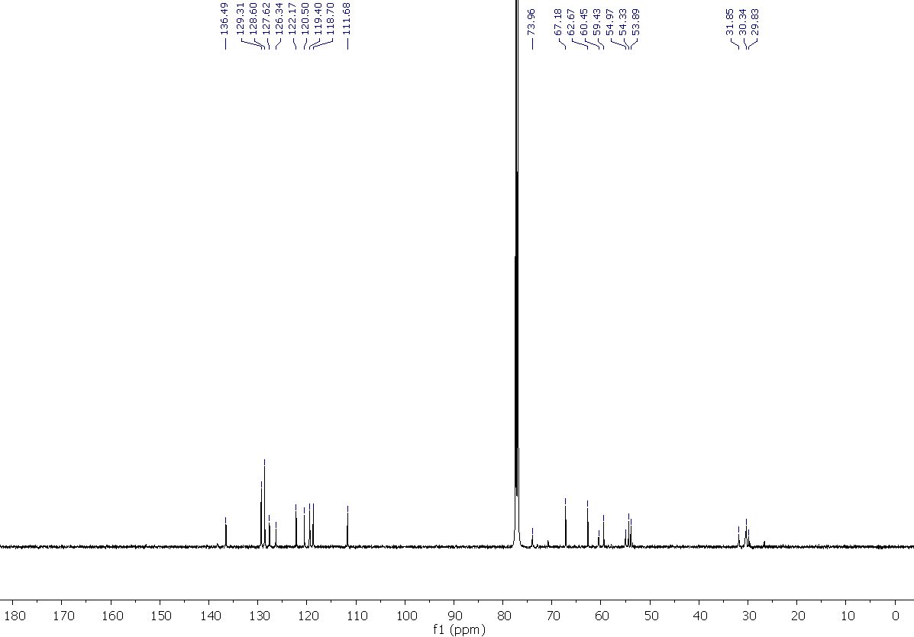

3-(1-((4-benzylmorpholin-2-yl)methyl)piperidin-4-yl)phenol, 32

3-(1-((4-benzylmorpholin-2-yl)methyl)piperidin-4-yl)aniline, 33

4-benzyl-2-{[4-(3-trifluoromethylphenyl)piperidin-1-yl]methyl}morpholine, 34
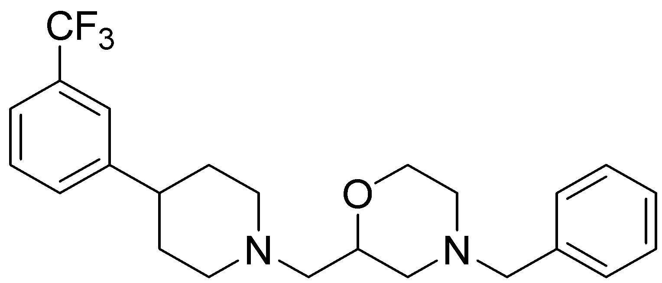
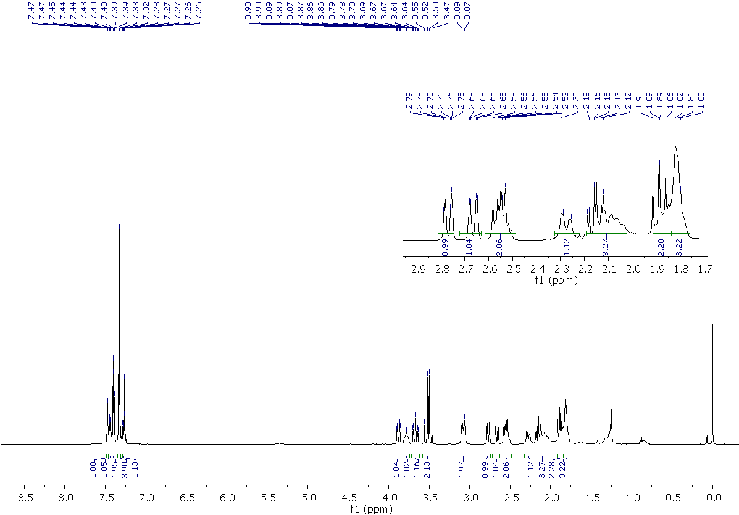
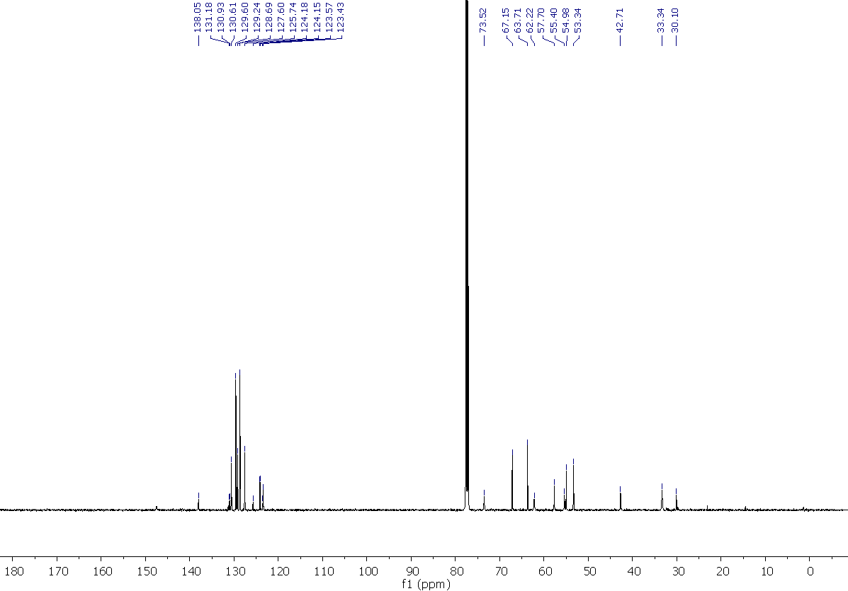

4-{1-[(4-benzylmorpholin-2-yl)methyl]piperidin-4-yl}phenol, 35
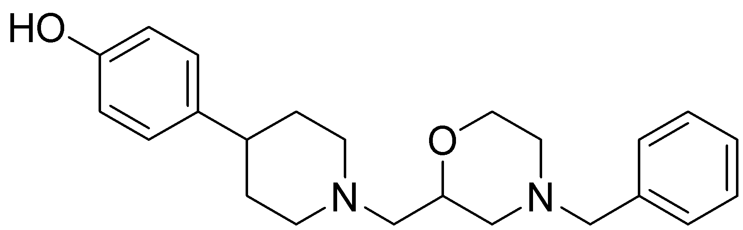
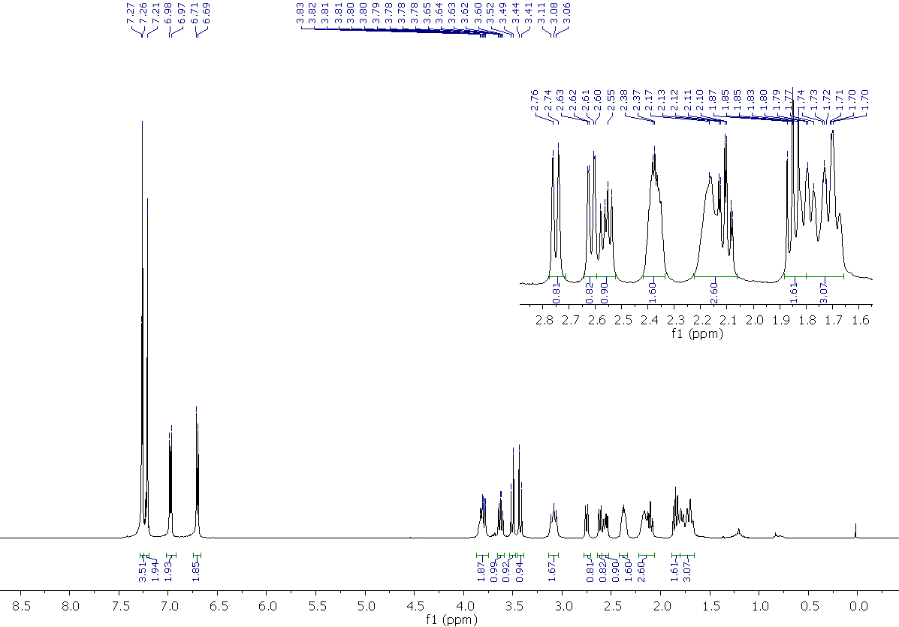
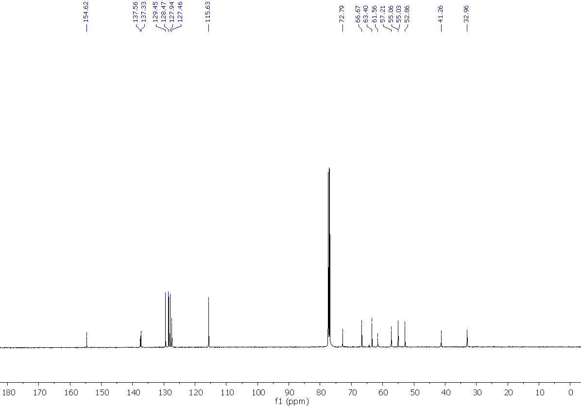

4-{1-[(4-Benzylmorpholin-2-yl)methyl]piperidin-4-yl}aniline, 36
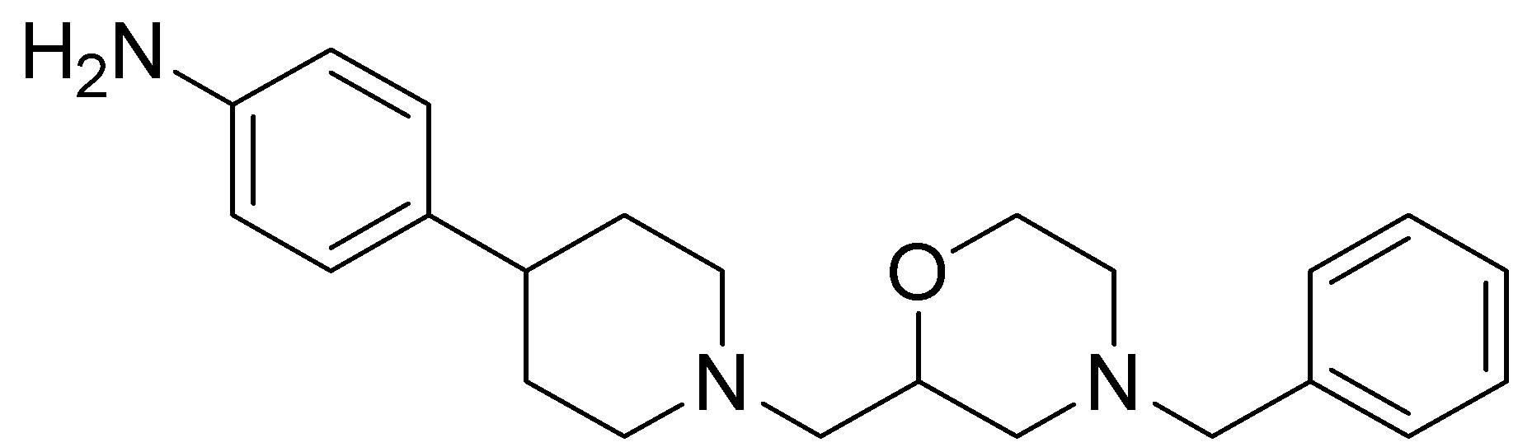
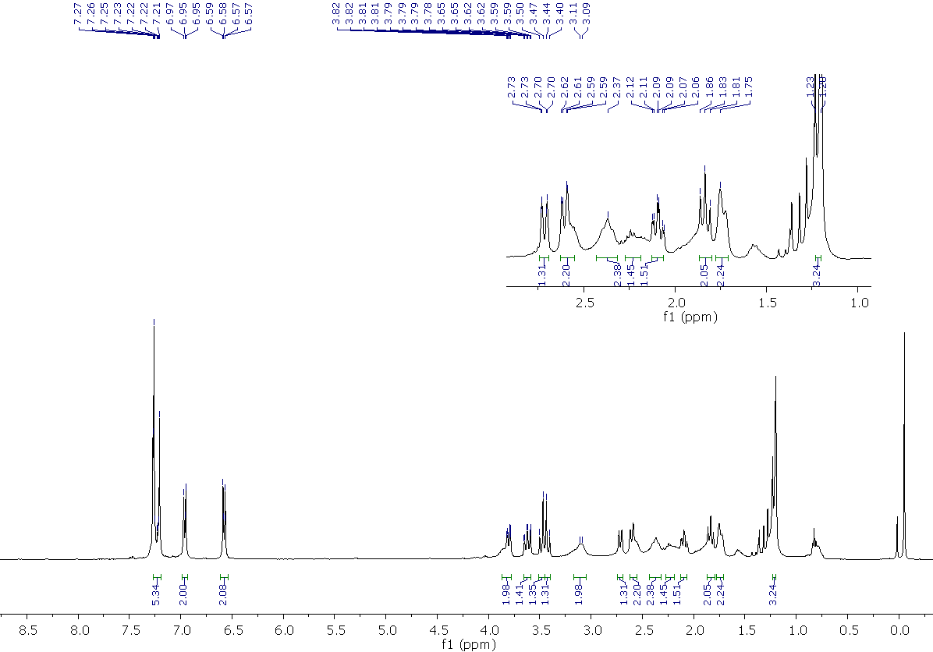
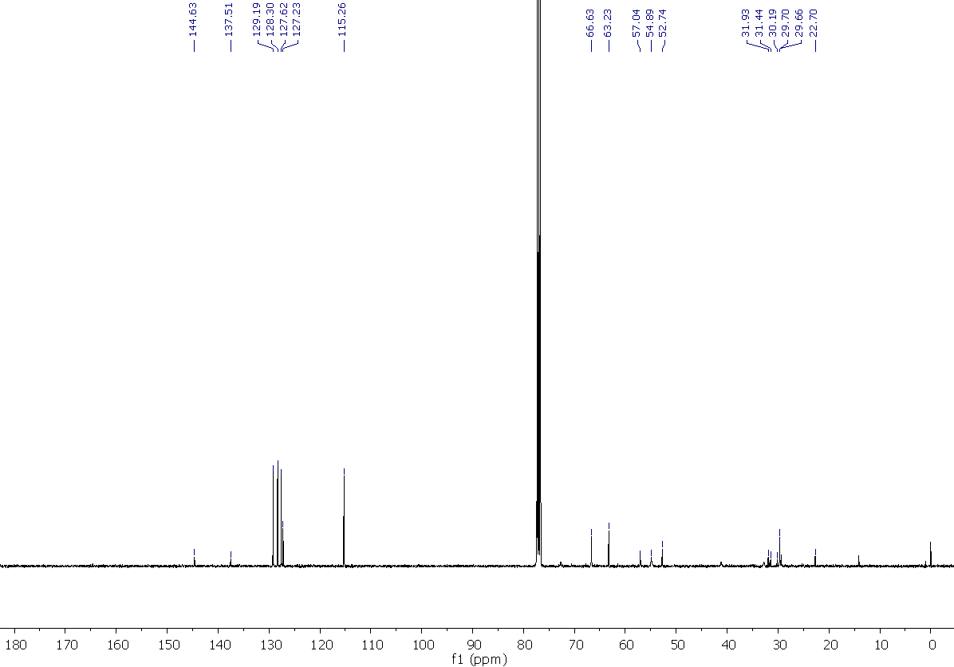

4-benzyl-2-{[4-(4-chlorophenyl)piperidin-1-yl]methyl}morpholine, 37
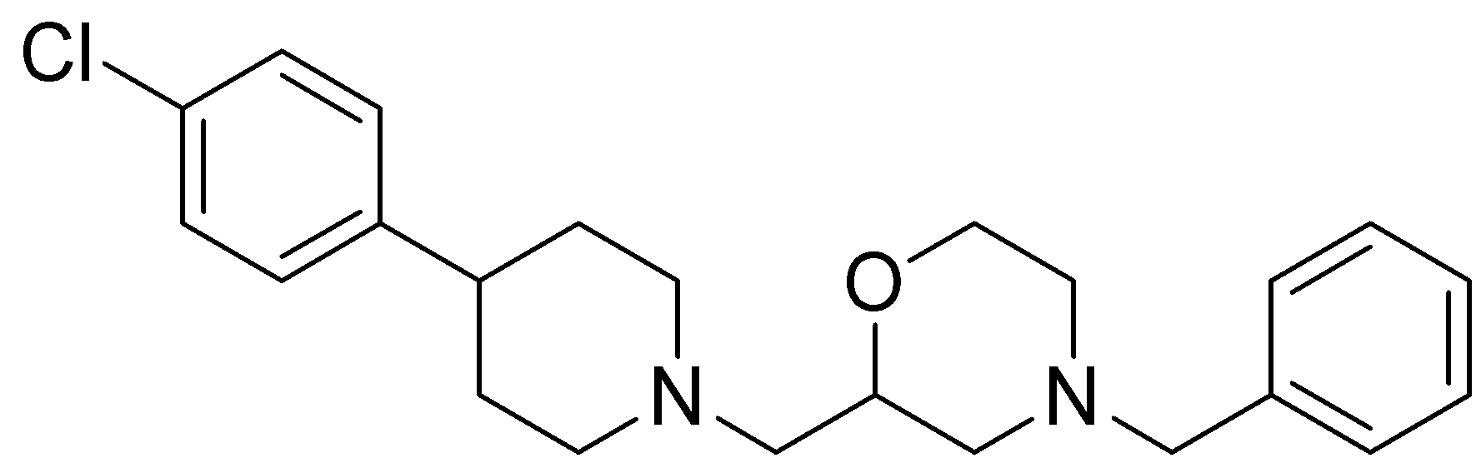
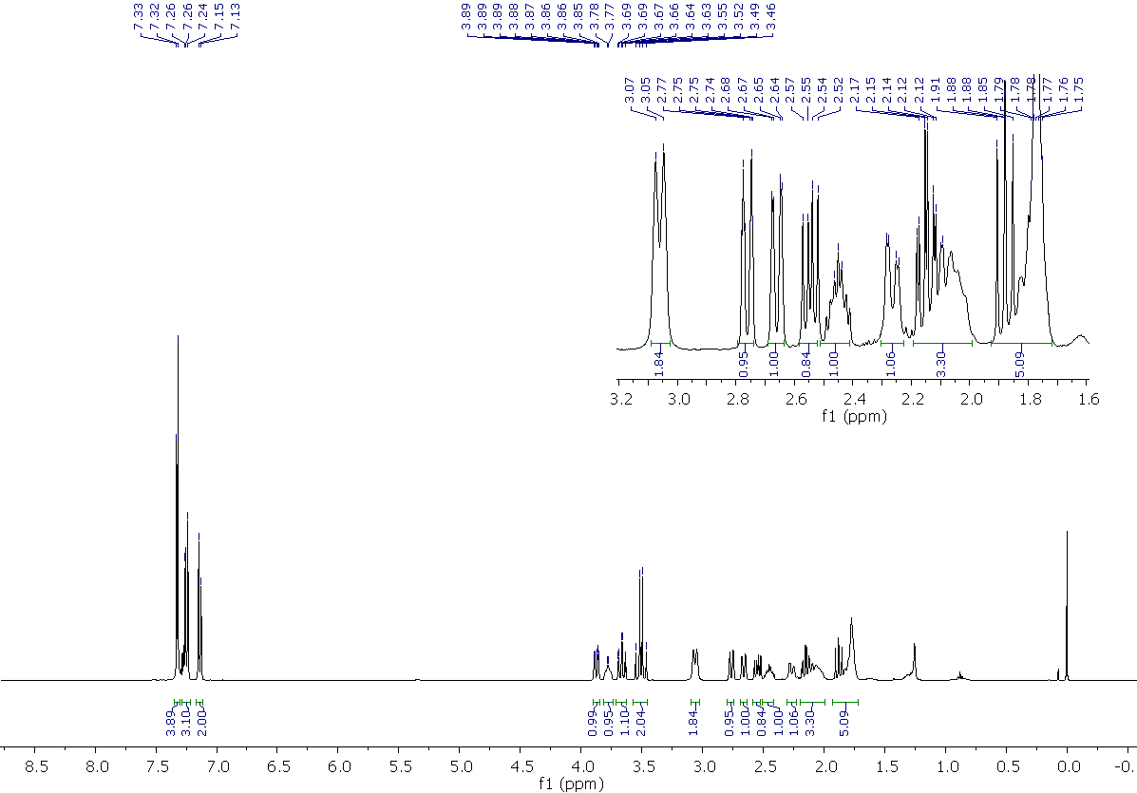
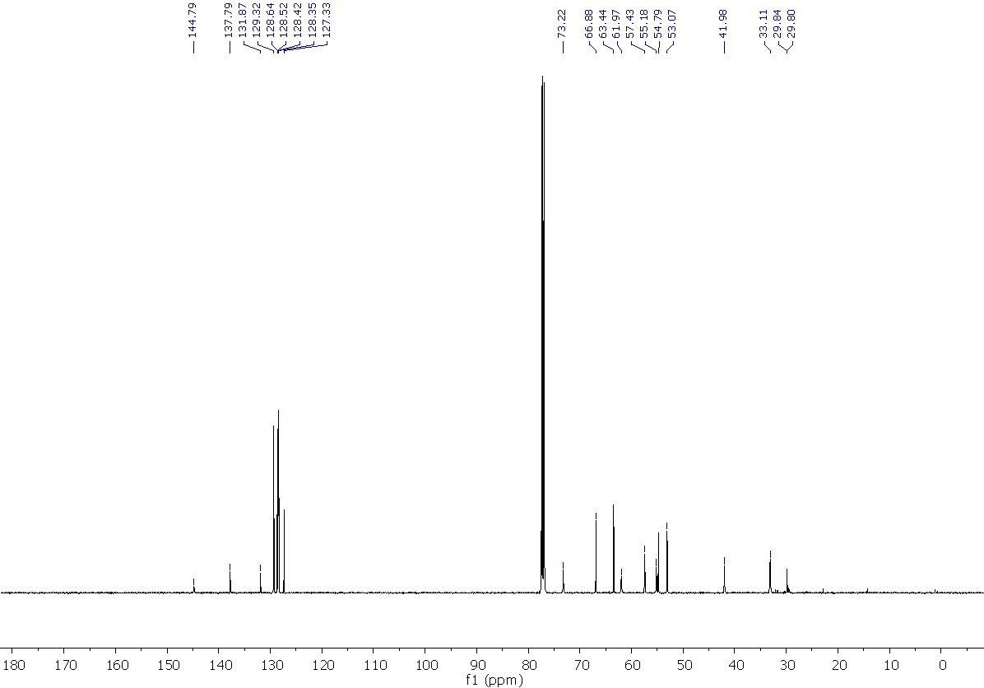

4-benzyl-2-{[4-(o-tolyl)piperidin-1-yl]methyl}morpholine, 38
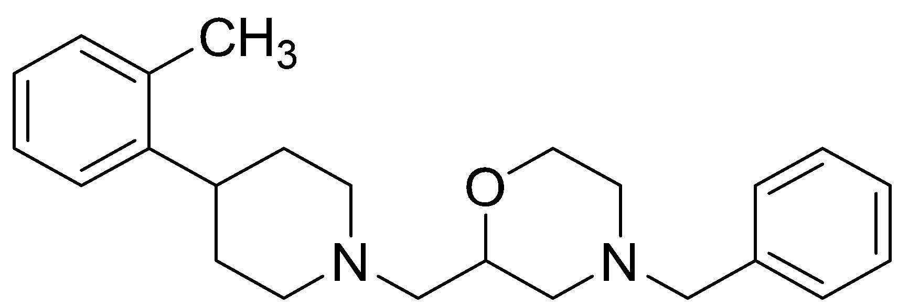
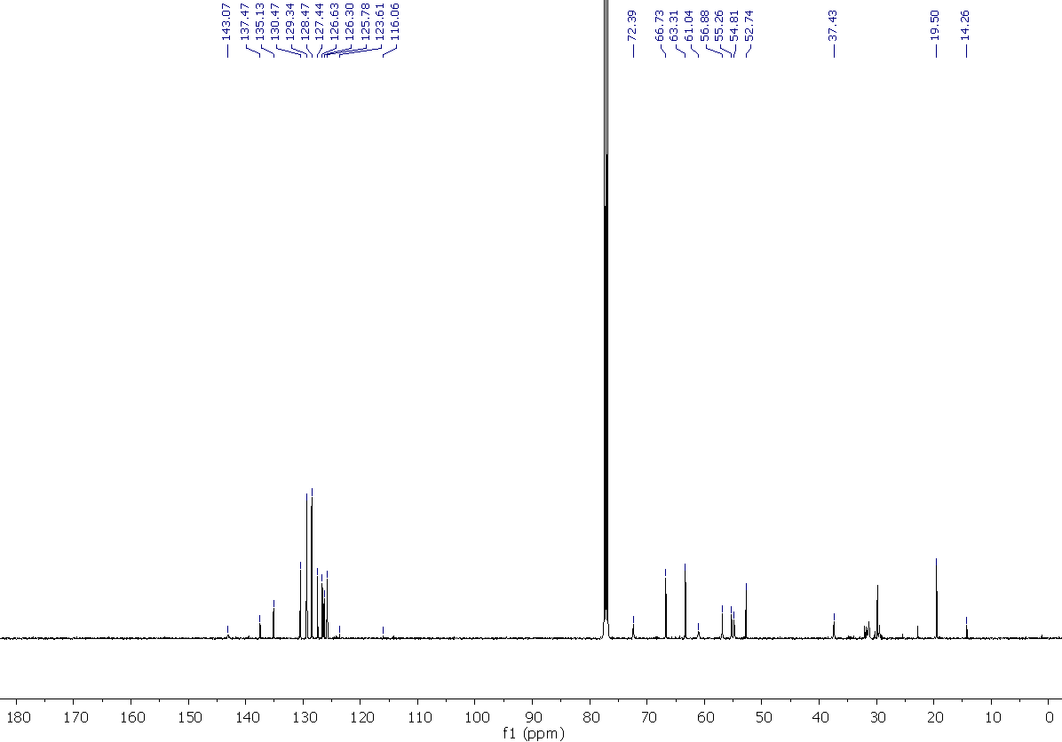

4-benzyl-2-((4-(2,5-dichlorophenyl)piperidin-1-yl)methyl)morpholine, 39
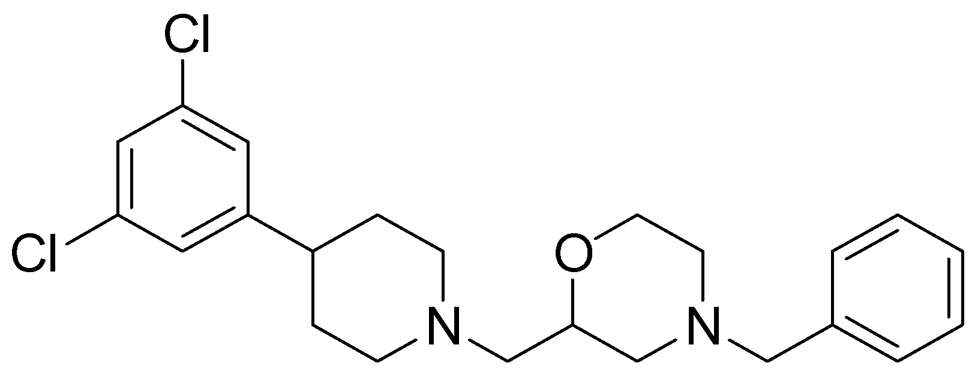
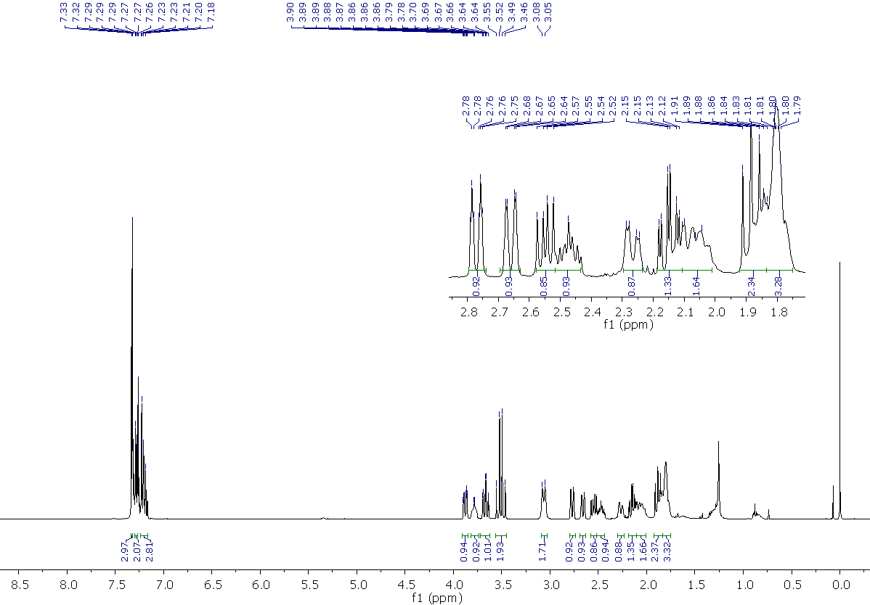
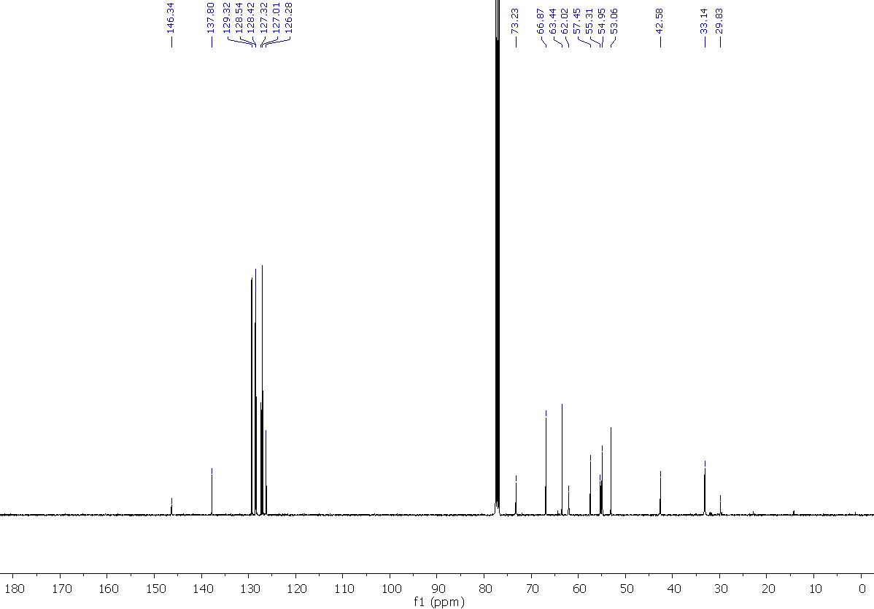

3-{1-[(4-Methyl-1,4-oxazepan-2-yl)methyl]piperidin-4-yl}aniline, 40
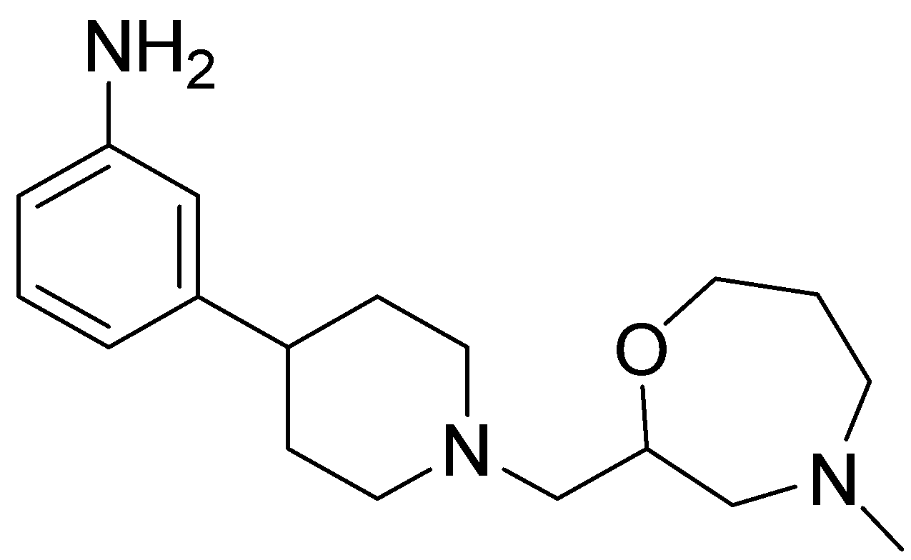
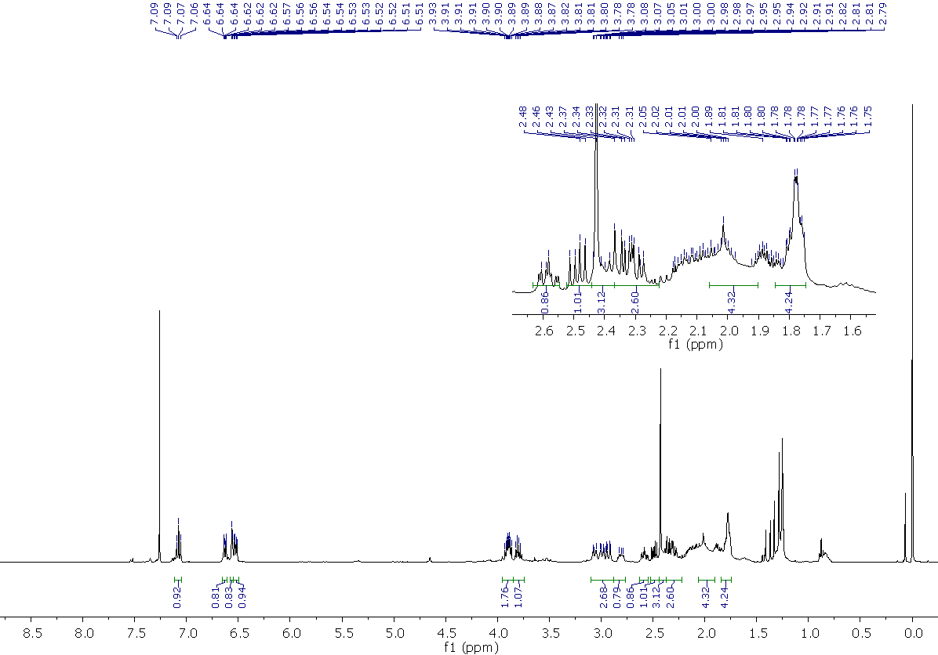
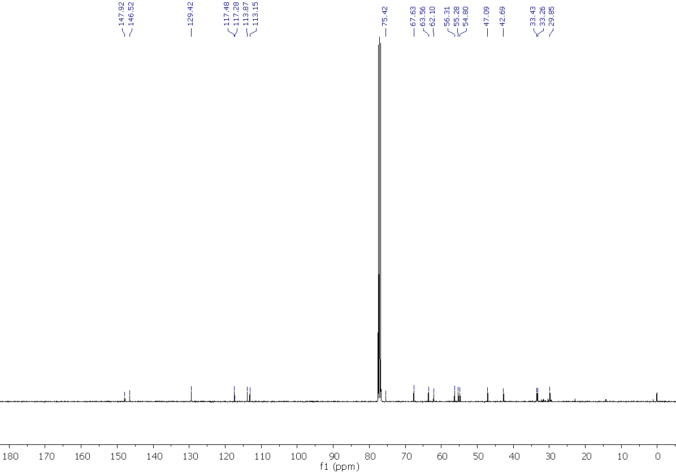

2-{[4-(3-Methoxyphenyl)piperidin-1-yl]methyl}-4-methyl-1,4-oxazepane, 41
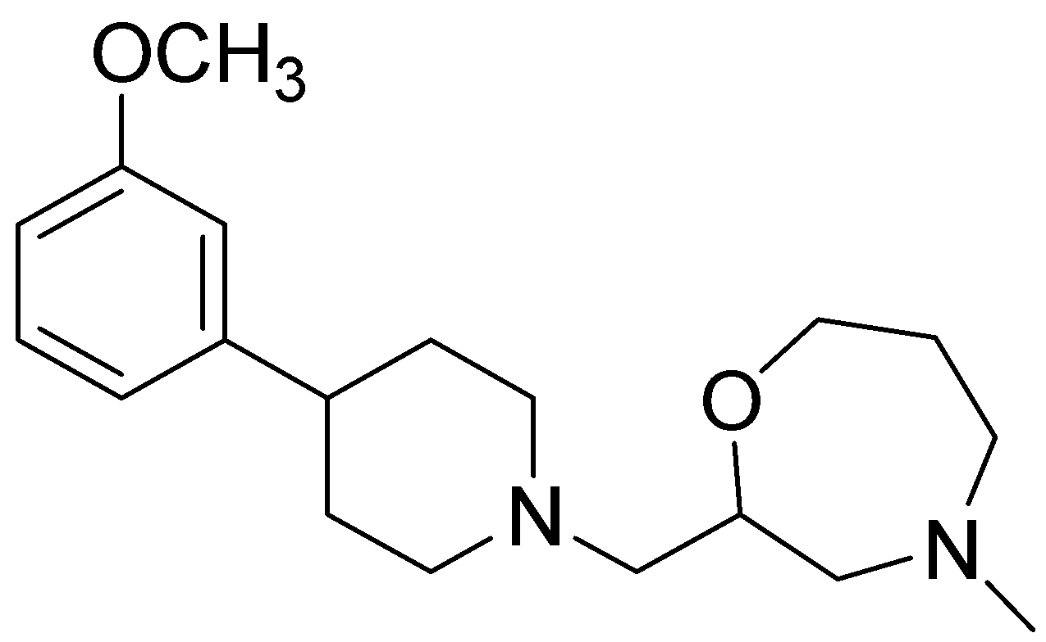
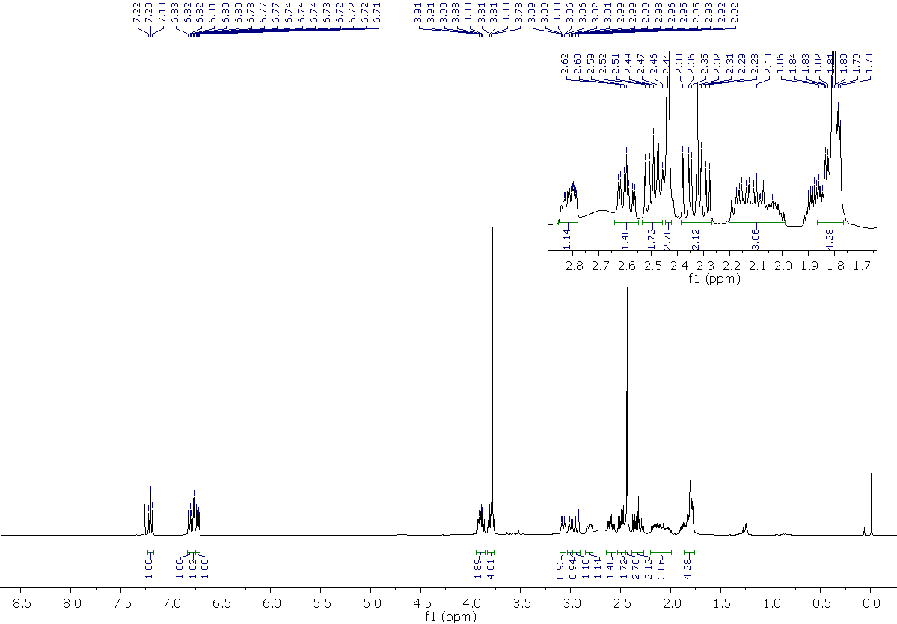
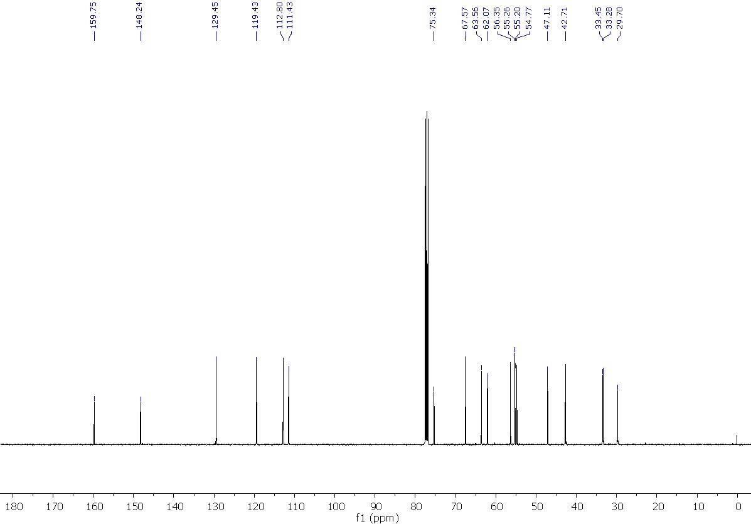

4-{1-[(4-Methyl-1,4-oxazepan-2-yl)methyl]piperidin-4-yl}phenol, 42
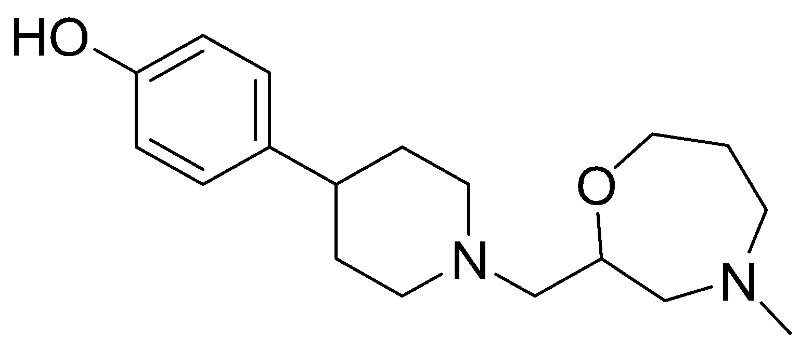
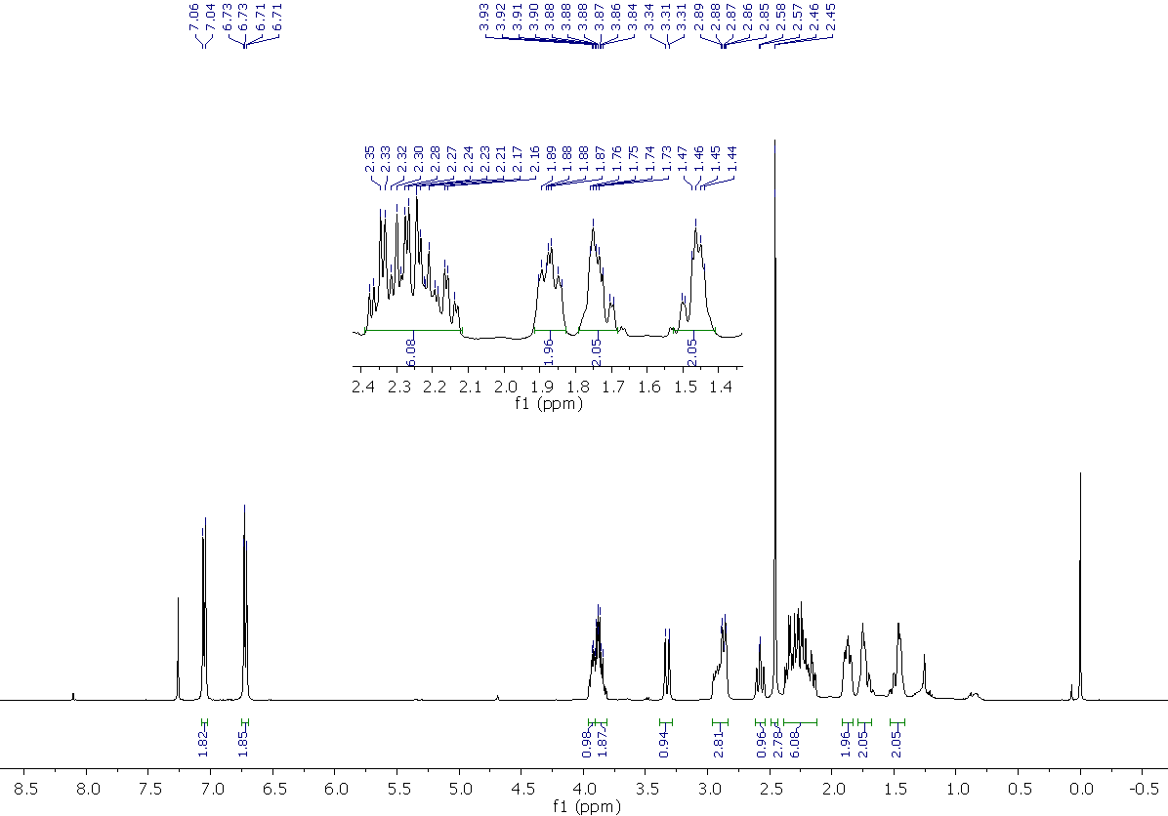
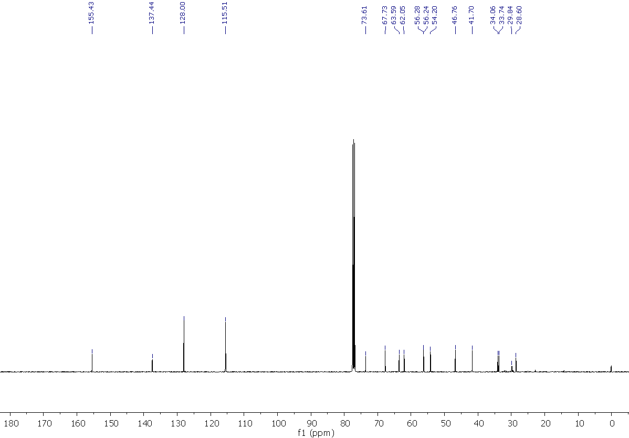

2-{[4-(4-Methoxyphenyl)piperidin-1-yl]methyl}-4-methyl-1,4-oxazepane, 43
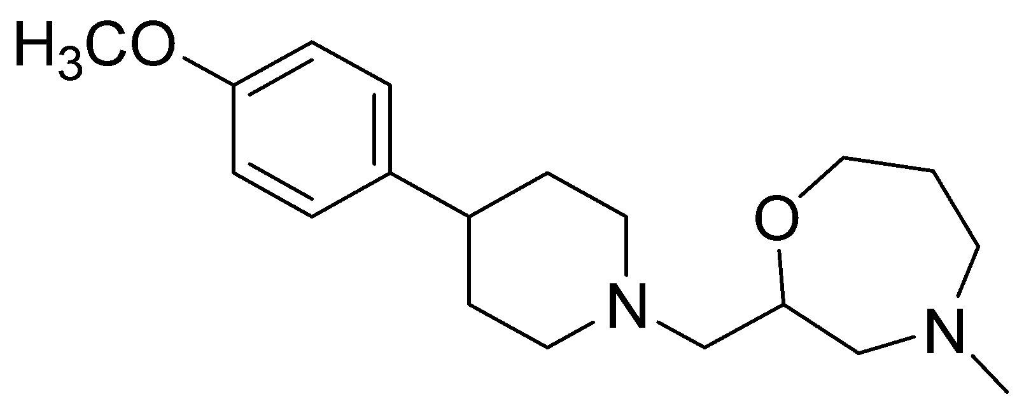
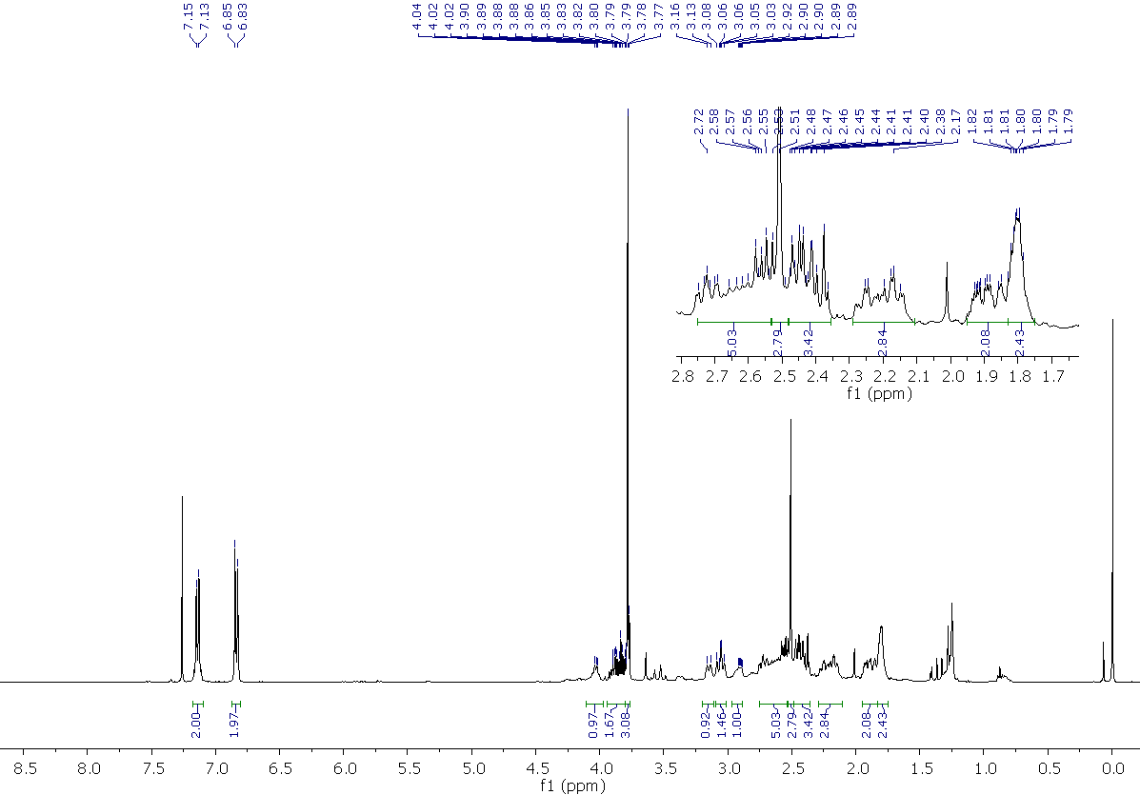
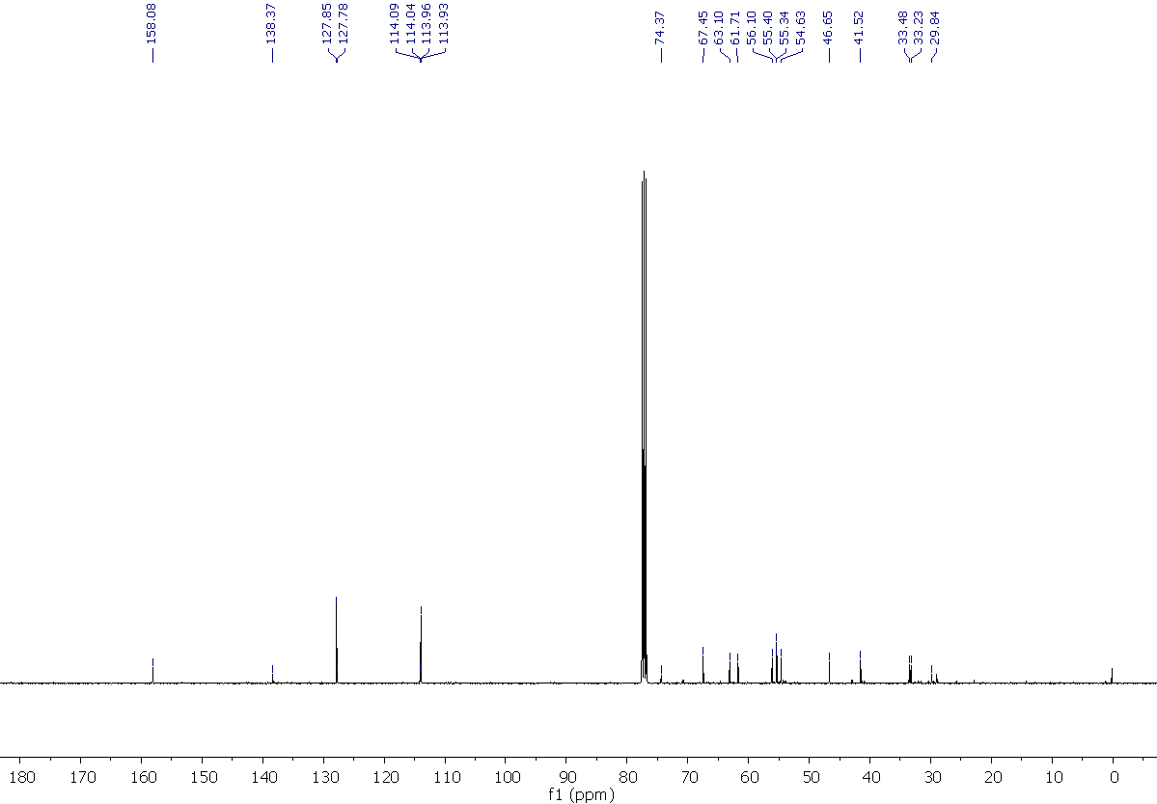

4-{1-[(4-Methyl-1,4-oxazepan-2-yl)methyl]piperidin-4-yl}aniline, 44
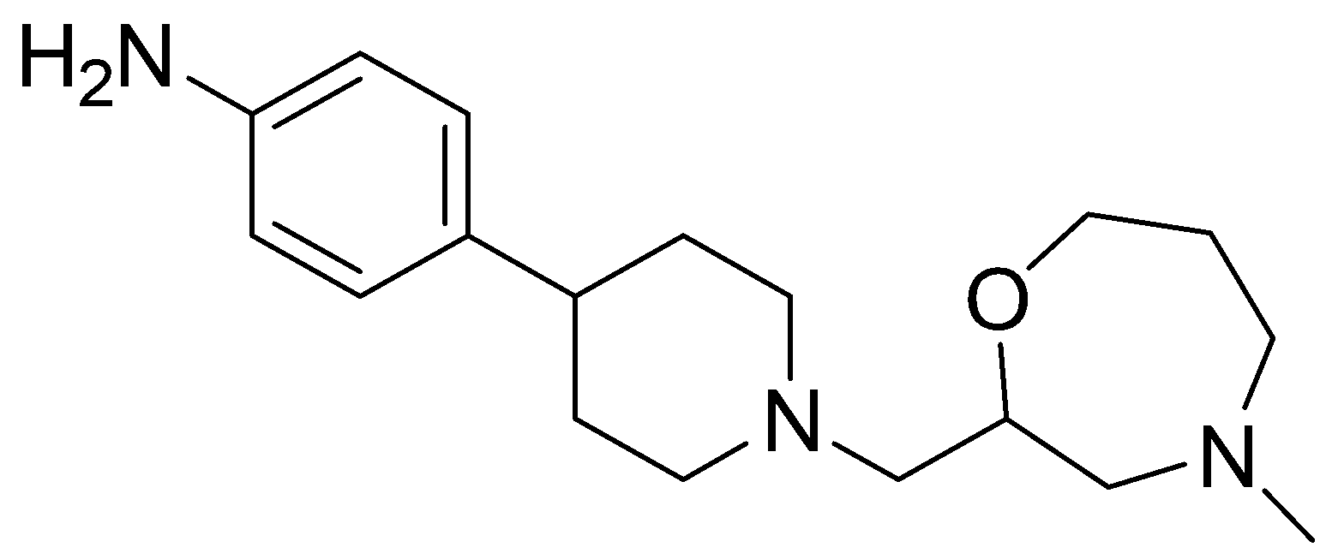
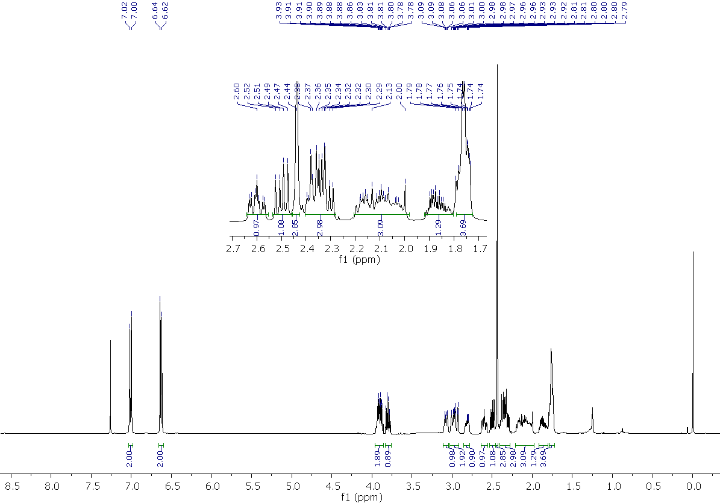
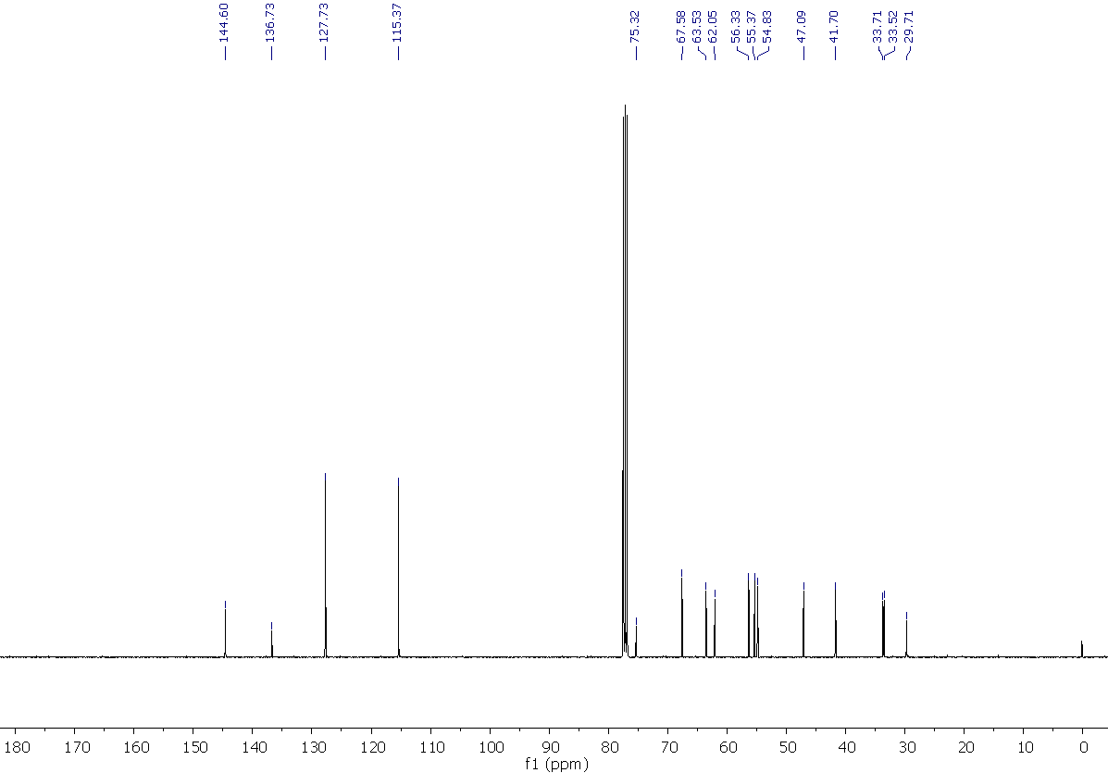

4-Methyl-2-{[4-(o-tolyl)piperidin-1-yl]methyl}-1,4-oxazepane, 45
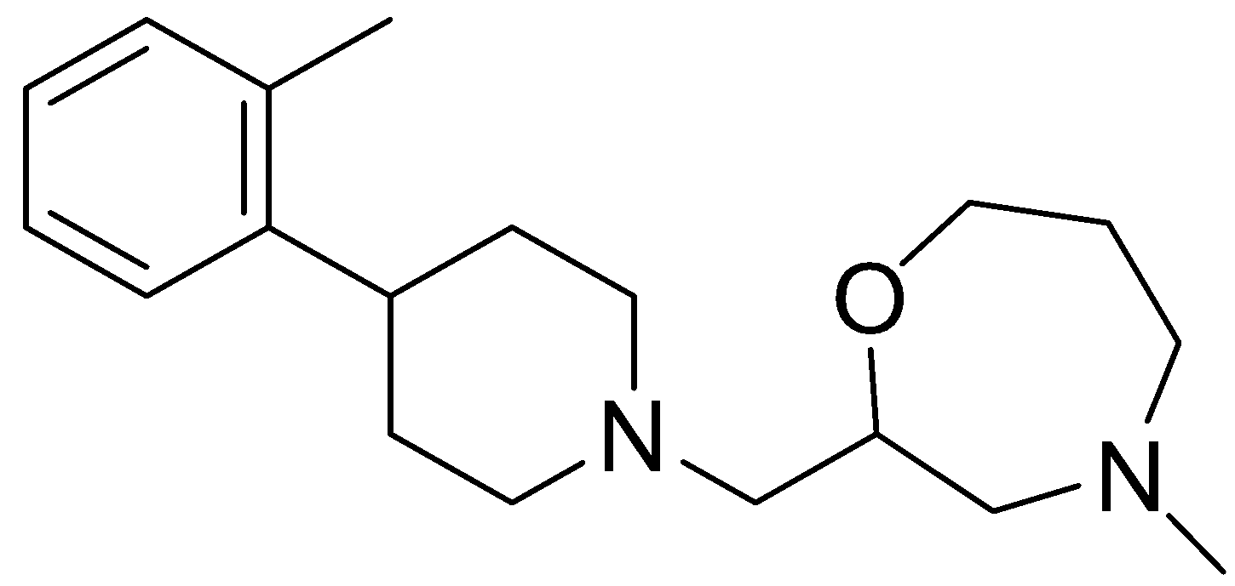
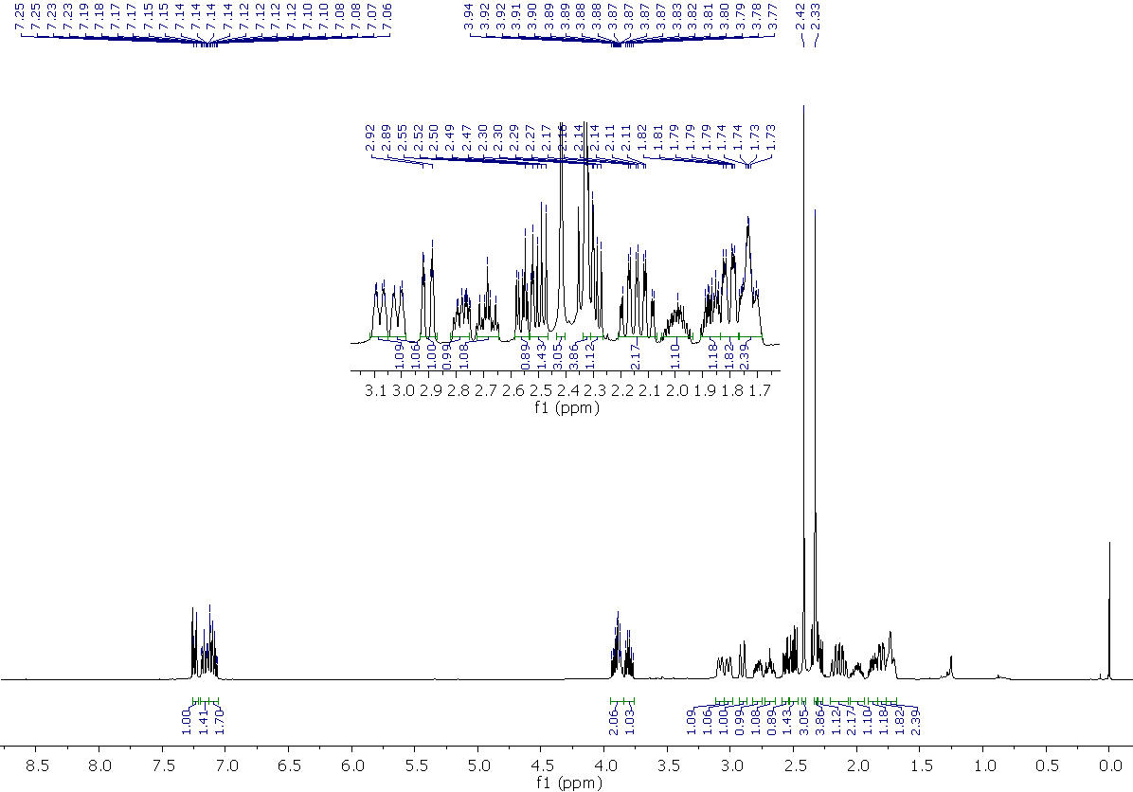
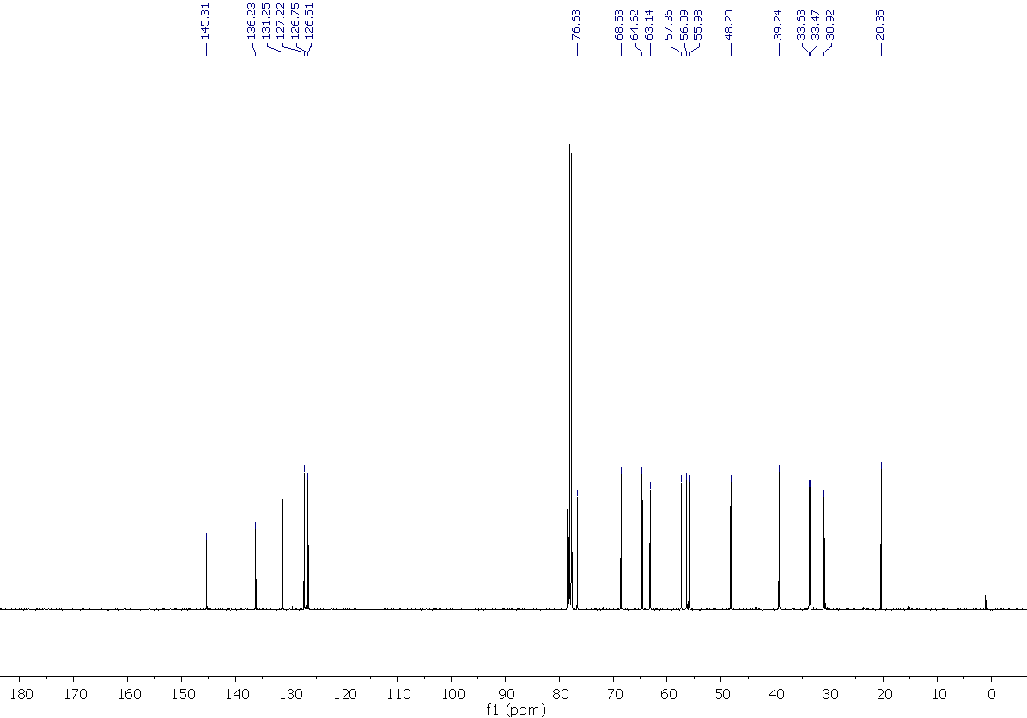
3-{1-[(4-(4-methylbenzyl)-1,4-oxazepan-2-yl)methyl]piperidin-4-yl}phenol, 46
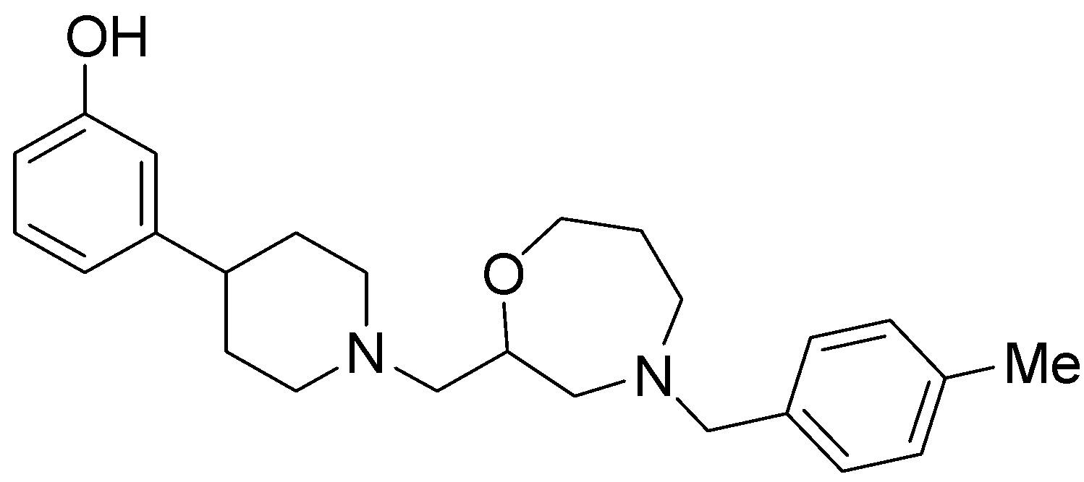
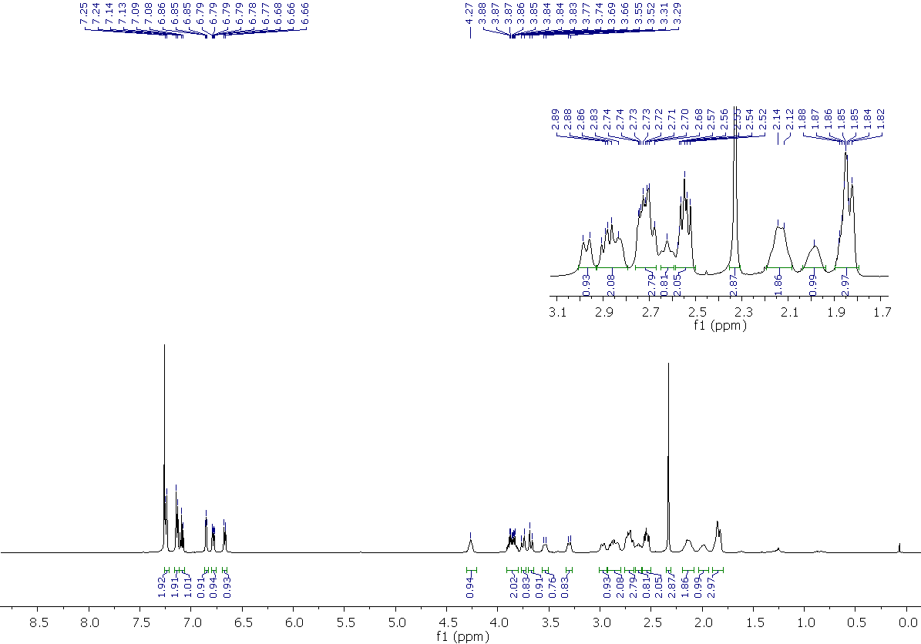
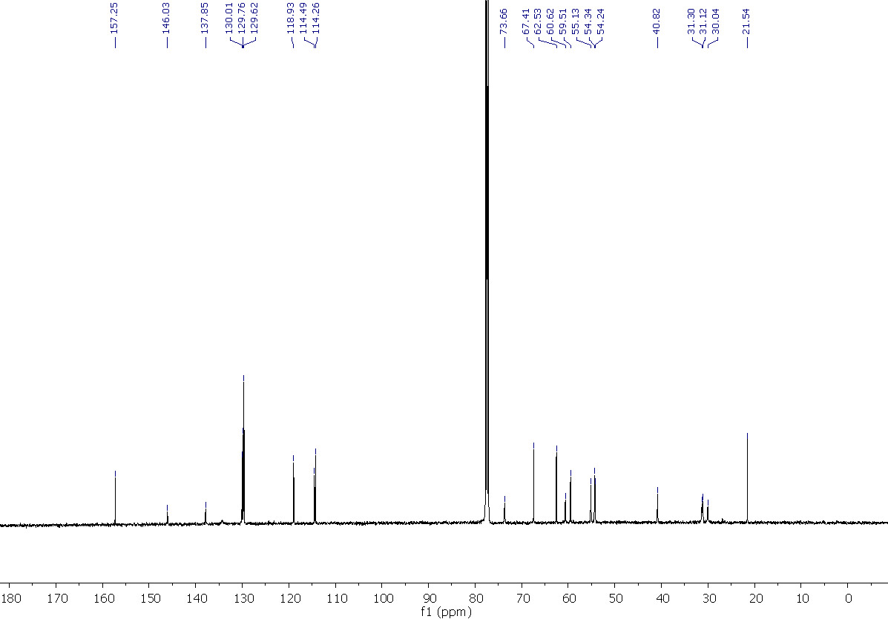

3-{1-[(4-(4-chlorobenzyl)-1,4-oxazepan-2-yl)methyl]piperidin-4-yl}phenol, 47

3-{1-[(4-(4-Methoxybenzyl)-1,4-oxazepan-2-yl)methyl]piperidin-4-yl}phenol, 48
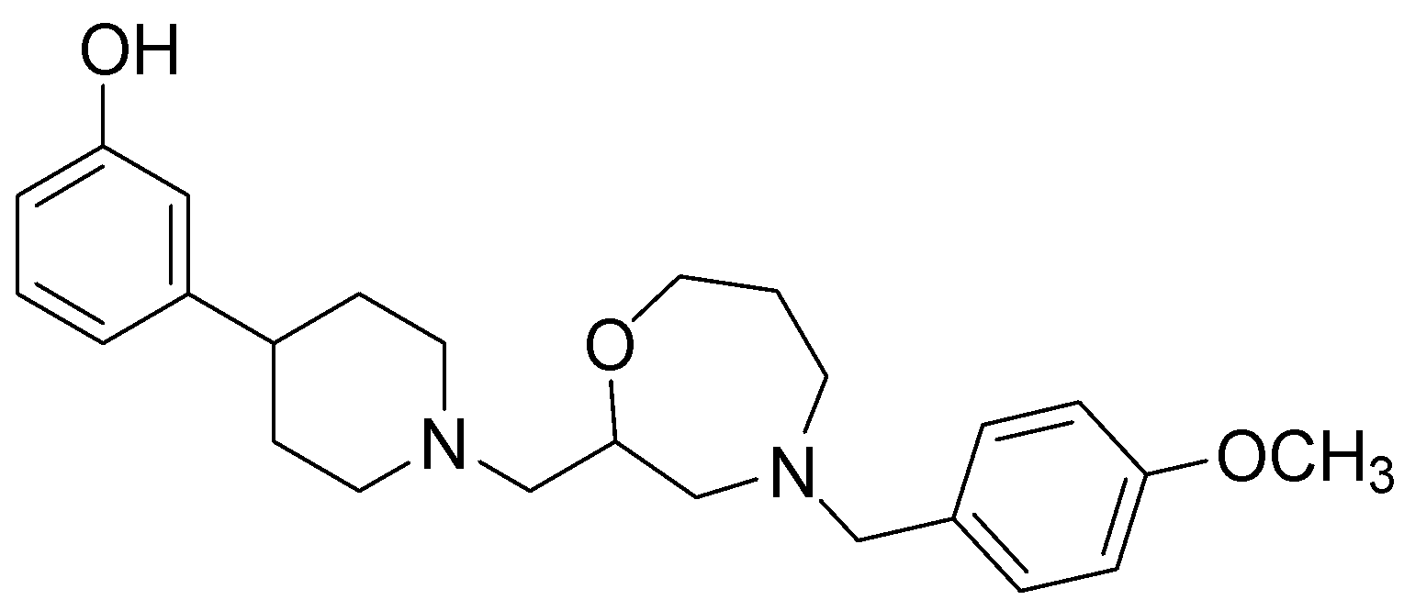
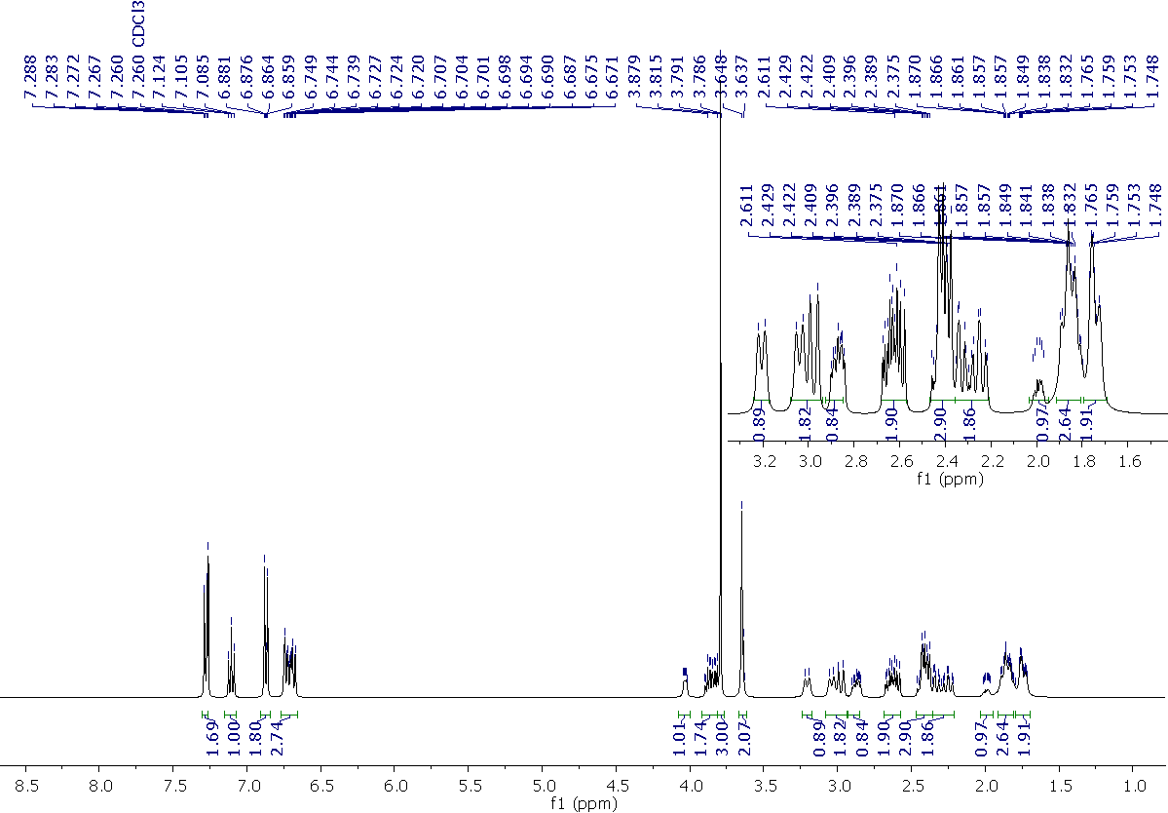
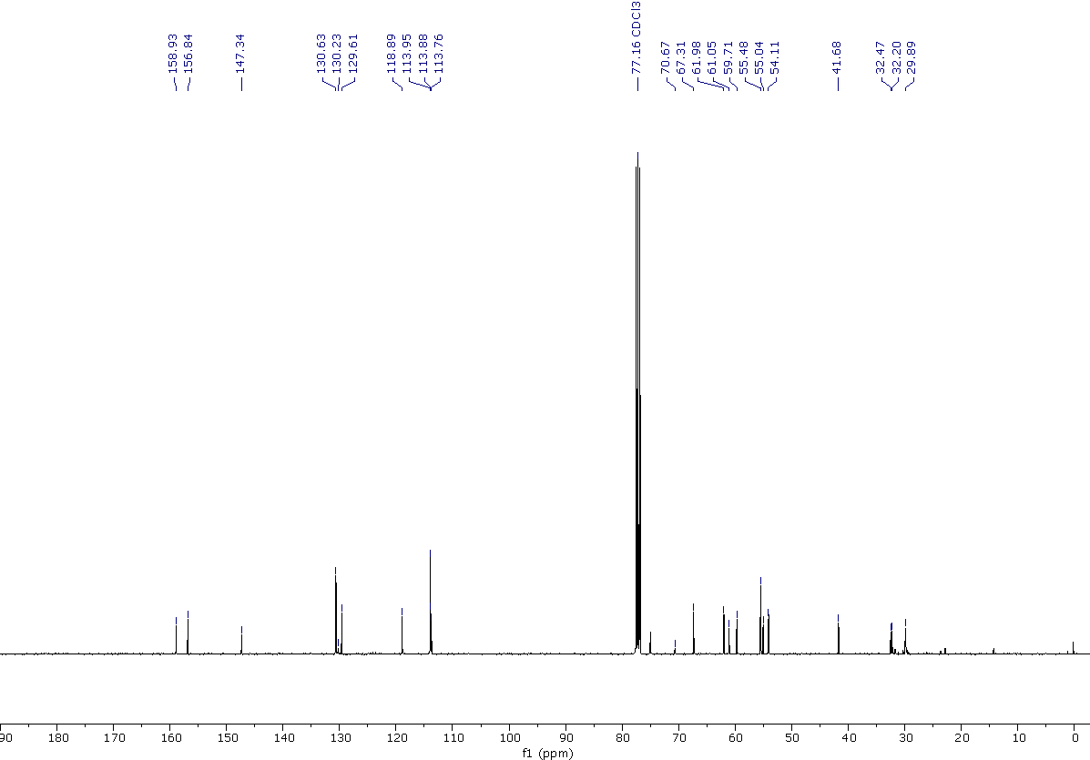

3-{1-[(4-(3,4-Dichlorobenzyl)-1,4-oxazepan-2-yl)methyl]piperidin-4-yl}phenol, 49
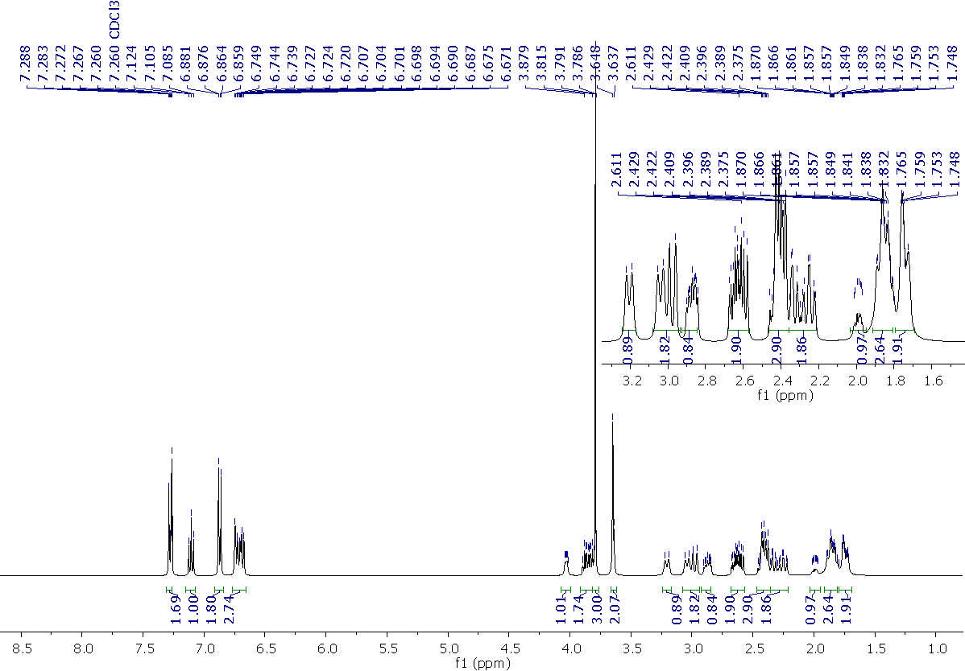
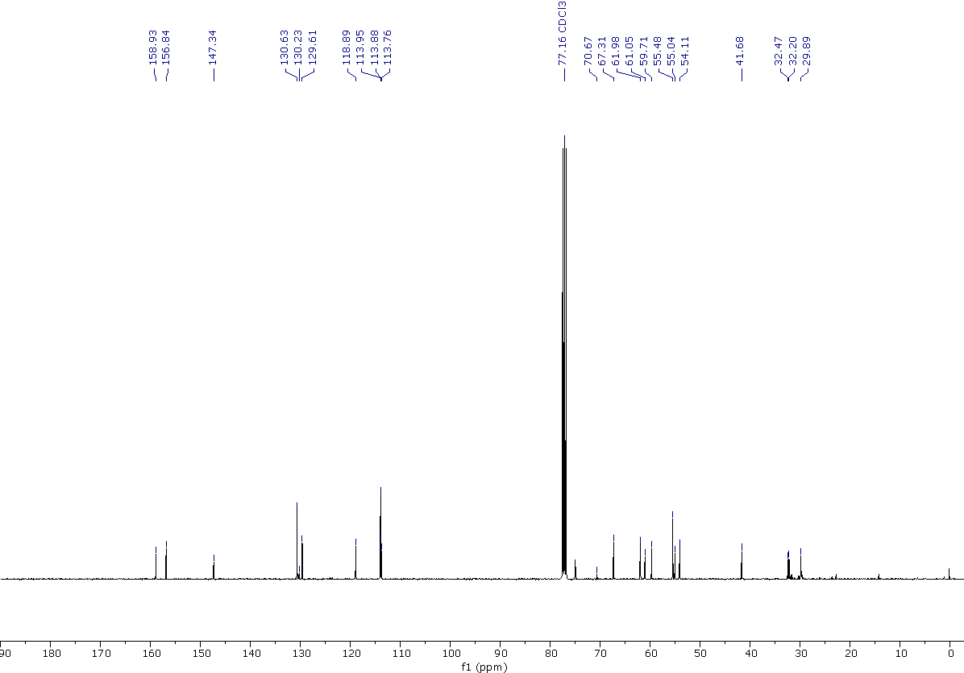

4-benzyl-2-[(3-morpholinopyrrolidin-1-yl)methy]-1,4-oxazepane, 50

3-(1-((4-benzyl-1,4-oxazepan-2-yl)methyl)pyrrolidin-3-yl)phenol ,51

Solubility
The stock solutions (10-2M) of the assayed compounds were diluted to decrease molarity, from 300 μM to 0.1μM, in a 384-well transparent plate (Greiner 781801) with 1% DMSO: 99% PBS buffer.
Incubate at 37ºC and read after 2 hours in a NEPHELOstar Plus (BMG LABTECH).
Analysis:
The results were adjusted to a segmented regression to obtain the maximum concentration in which compounds are soluble.
Table 2. Solubility of the tested compounds.
Compound | Solubility (µM)
1 | 30.8
4 | >100
27 | 73.3

Microsomal stability at human microsomes
Human microsomes from Thermo-Fischer containing 20 mg/ml of protein were used in the assay. Brief protocol: The following quantities were added to each well of a 96-well microplate.
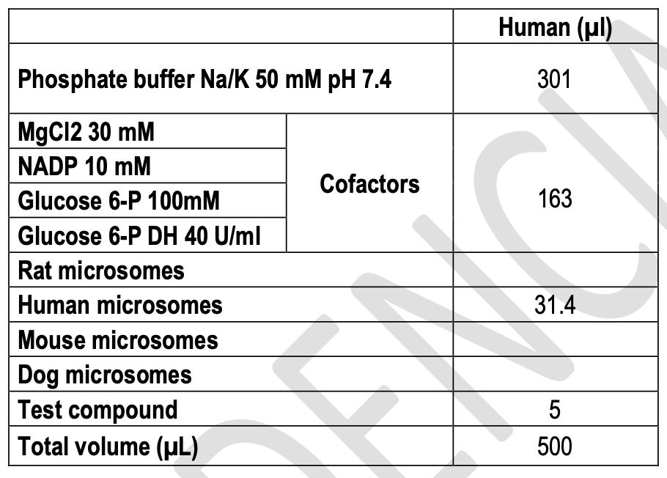

Plates were incubated at 37ºC and 75 µL samples were taken at 0, 10, 20, 40 and 60 minutes.
Samples were transferred to a microplate and 75 µl Acetonitrile + IS(Rolipram) were added for inactivating the
microsomes, and 30 µl of H₂O with 0.5% formic acid for improving the chromatographic conditions and kept at 4ºC.

When all the samples were taken the plate was centrifuged at 46000 g for 30 min at 15ºC.
Stationary phase: ACQUITY BEH C18 1.7µm 2.1x50mm (Waters)/ ACQUITY HSST3 1.8µm 2.1x100mm (Waters)
Mobile phase: A: 0.1% formic; B: acetonitrile+0.1% formic acid

Gradient:
Time (min) | A | B
0 | 100% | 0%
0.1 | 100% | 0%
1 | 0% | 100%
2.5 | 0% | 100%
2.6 | 100% | 0%
3 | 100% | 0%
Flow: 0.6 ml/min
The chromatographic equipment employed was an UPLC QSM Waters Acquity.
Metabolic stability was calculated from the logarithm of the remaining compound at each of the times evaluated.

Table 3. Stability parameters obtained for each of the studied compounds.

 | Microsomal stability
Compound | %Remanent (60min) | t1/2 (min) | Clint (μL/min*mg prot)
1 | 40.6 | 45.62 | 24.16
3 | 12.8 | 20.1 | 40.0
4 | 0.4 | 1.6 | 516.6
10 | 55.5 | 69.84 | 13.76
11 | 93.2 | 478.06 | 2.01
12 | 20.8 | 29.98 | 32.06
13 | 4.8 | 14.28 | 67.30
27 | 55.9 | 47.0 | 17.1
29 | 77.4 | 605.4 | 1.3
35 | 57.6 | 79.2 | 10.1
47 | 10.3 | 18.2 | 44.1

Plasma stability
Plasma pooled from healthy donors was employed in the assay.
Brief protocol: Plates containing 5µM compounds in plasma (total volume: 100µL) were incubated at 37ºC at the diferent times (0, 60, 120 and 360 min). Then 300µl Acetonitrile were added for precipitating plasma protein, and the plate was centrifuged at 4000 g for 60 min at 4ºC. Supernatant was taken and analyzed by UPLC/MS/MS for sample quantification. Stationary phase: ACQUITY BEH C18 1.7µm 2.1x100mm (Waters)
Mobile phase: 0.1% Formic acid water/0.1% formic acid in acetonitrile

Time | Water | Acetonitrile
0 | 100% | 0%
0.1 | 100% | 0%
1 | 0% | 100%
2 | 0% | 100%
2.1 | 100% | 0%
2.5 | 100% | 0%

Gradient:
Flow: 0.6 ml/min
The chromatographic equipment employed was an UPLC QSM Waters Acquity. Compound concentrations
were calculated from the MS peak areas.
Table S4. Remaining percentage of the compounds in plasma at the different times.
 | Plasma stability in human plasma
 | T(min)
Compound | 0 | 60 | 120 | 360
1 | 100 | 99.1 | 96.9 | 81.2
Entiomer 1A | 100.0 | 90.4 | 107.5 | 110.5
Enantiomer 1B | 100.0 | 99.4 | 80.3 | 89.4
3 | 100.0 | 86.9 | 88.9 | 78.9
4 | 100.0 | 88.2 | 78.5 | 37.4
10 | 100.0 | 107.5 | 106.5 | 64.0
11 | 100.0 | 86.0 | 82.2 | 86.6
12 | 100.0 | 97.6 | 90.3 | 76.0
13 | 100.0 | 102.9 | 99.4 | 81.1
33 | 100.0 | 113.2 | 110.3 | 98.6
35 | 100.0 | 102.9 | 95.0 | 89.2
27 | 100.0 | 92.4 | 90.0 | 81.5
29 | 100.0 | 99.9 | 100.1 | 86.2
47 | 100.0 | 86.4 | 88.1 | 75.9

Human plasma protein binding
Plasma from Seralab was used in the assay.
Brief protocol:
The assay was carried out by using Rapid Equilibrium Dialysis (RED) from Thermo Scientific. The compounds were dissolved at 5 μM in plasma and added to the corresponding insert of the RED device. Dialysis buffer was added to the corresponding insert of the RED Device. Plate was incubated for 4h at 37ºC. After the incubation period 50 μL aliquots of each chamber were transferred to empty vials. 50 μL of dialysis buffer were added to the plasma samples and 50 μL of plasma were added to the buffer samples. 300 μL of acetonitrile were added to all the samples and centrifuged at 4000 rpm. 100 μL aliquots of the supernatants were transferred to a LC analysis plate. Samples were analyzed in a UPLC/MS/MS.
Stationary phase: ACQUITY BEH C18 1.7μm 2.1x50mm (Waters)
Gradient: A (H2O + 0.1% Formic acid); B (ACN + 0.1% Formic acid); Flow: 0.6mL/min

t(min) | A (%) | B (%)
0 | 95 | 5
0.1 | 95 | 5
1 | 0 | 100
2 | 0 | 100
2.1 | 95 | 5
2.5 | 95 | 5

Flow: 0.6 ml/min
The chromatographic equipment employed was an ACQUITY UPLC / Xevo TQD System. Compound concentrations were calculated from the MS peak areas.

 | Bioavailability test
Compound | Plasma protein binding (%) | Unbound fraction (%)
1 | 91.2 | 8.8
enantiomer 1A | 85.2 | 14.8
enantiomer 1B | 80.5 | 19.5
3 | 98.9 | 1.1
4 | 67.3 | 32.7
10 | 78 | 22.1
11 | 76.9 | 23.1
12 | 99.5 | 0.5
13 | 88.1 | 11.9
27 | 73.7 | 26.3
29 | 58.1 | 41.9
33 | 72.5 | 27.5
35 | 98.6 | 1.4
47 | 99 | 1
Table 5. Human plasma protein binding determination of tested compounds.

CYP450 inhibition assay
All the incubations were performed in 250 μL reaction medium containing sodium/potassium phosphate buffer 50mM, pH 7.4, 3mM MgCl2, an NADPH regeneration system 1mM NADP, 10mM glucose 6-phosphate, and 1 U/mL glucose 6-phosphate dehydrogenase, 0.3 mg protein/mL of liver microsomes (HLM ThermoFischer), and a substrate cocktail composed of phenacetin for CYP1A2, diclofenac for CYP2C9, S-mephenytoin for CYP2C19, Bufuralol for CYP2D6 and midazolam and testosterone for CYP3A4. Final concentrations of substrate in the reaction medium were: 5μM phenacetin, 5μM diclofenac, 100μM S-mephenytoin, 5μM bufuralol, 3 μM midazolam, and 50 μM testosterone. Following 25 min of incubation at 37ºC, the reactions were terminated by the addition of ice-cold acetonitrile, and the plate was centrifuged at 4000 g for 30 min at 4ºC. Supernatant was taken and analyzed by UPLC/MS/MS for quantification of the metabolites acetaminophen (CYP1A2), 4'-hydroxy-mephenytoin (CYP2C19), 4′-hydroxy diclofenac (CYP2C9),1’-hydroxy-bufuralol (CYP2D6) and 6β-hydroxy-testosterone and 1-hydroxy-midazolam (CYP3A4).

The chromatographic equipment employed was an UPLC QSM Waters Acquity.
Stationary phase: Reverse phase Acquity UPLC® BEHC18 1,7 μm (2.1 mm x 100 mm) (Waters)
Mobile phase: 0.1% Formic acid water/0.1% formic acid in acetonitrile
Flow: 0.8 ml/min

Gradient:
Time | Water | Acetonitrile
0 | 100% | 0%
0.1 | 100% | 0%
0.5 | 0% | 100%
0.75 | 0% | 100%
1 | 100% | 0%
1.25 | 100% | 0%

Standard compound results:
Table 6. Inhibition percent values obtained and inhibitor potency values (IC50) described in the literature for the
compounds used to validate the assay.
Cytochrome | Compound | % inhibition obtained | IC50 (µM) described | Reference
CYP1A2 | Furafylline | 76.5 ± 1.6 (15μM) | 7.5 | ^{[3]}
CYP2C9 | Sulfaphenazole | 52.8 ± 11.8 (1.5μM) | 0.72 | ^{[4]}
CYP2C19 | Tranylcypromine | 39.6 ± 6.3 (5μM) | 10.9 | ^{[3]}
CYP2D6 | Quinidine | 59.7 ± 2.4 (0.5μM) | 0.2 | ^{[4]}
CYP3A4 (Testosterone) | Ketoconazole | 75.0 ± 4.5 (0.1μM) | 0.05 | ^{[5]}
CYP3A4 (Midazolam) | Ketoconazole | 58.7 ± 5.9 (0.1μM) | 0.12 | ^{[5]}

Table 7. Results of CYP1A2, CYP2C9, and CYP2C19 inhibition of tested compounds.
 | CYP1A2 |  | CYP2C9 |  | CYP2C19
Compound | % inhibition (1µM) | % inhibition (10 μM) | % inhibition (1µM) | % inhibition (10 μM) | % inhibition (1µM) | % inhibition (10 μM) | IC₅₀ (nM)
1 |  | 9 ± 1 |  | 27 ± 1 |  |  | 1556
enantiomer 1A | 3.1 ± 1.7 |  | -0.1 ± 5.7 |  | -12.5 ± 5.4
enantiomer 1B | -7.7 ± 1.5 |  | 2.4 ± 0 |  | -2.6 ± 4.1
3 |  | 39.9 ± 1.4 |  | 1.7 ± 2.4 |  | -7.3 ± 8.6
4 |  | 37.9 ± 1.1 |  | 11.2 ± 6.9 |  | 25.3 ± 6.6
27 |  | 22.4 ± 6.2 |  | 0.7 ± 0.4 |  | 63.6 ± 1.8
29 |  | 35.9 ± 4 |  | 5.3 ± 15.9 |  | 2.3 ± 1.3
33 | 2.9 ± 8.9 |  | 5.9 ± 3.1 |  | -4 ± 1.6
35 |  | 22.2 ± 5.9 |  | -2.3 ± 1.3 |  | 5.5 ± 2.6
47 |  | 21.4 ± 7.7 |  | 3.1 ± 0.3 |  | 20.7 ± 15.2

Table 8. Results of CYP2D6, and CYP3A4 inhibition of tested compounds.
 | CYP2D6 |  |  | CYP3A4 (DBF) |  | CYP3A4 (7-BFC)
Compound | % inhibition (1µM) | % inhibition (10 μM) | IC₅₀ (nM) | % inhibition (1µM) | % inhibition (10 μM) | % inhibition (1µM) | % inhibition (10 μM) | IC₅₀ (nM)
1 |  |  | 3434 |  | 57 ± 4 |  |  | 1789
enantiomer 1A | -11.8 ± 6.1 |  |  | -10.3 ± 6.3 |  | -1.3 ± 1.3
enantiomer 1B | 3.6 ± 2 |  |  | 2.6 ± 4.1 |  | 0.7 ± 0.6
3 |  | 54 ± 4.5 |  |  | 5.8 ± 1.2 |  | -4.7 ± 5.3
4 |  | 34.1 ± 5.7 |  |  | 18.5 ± 17.6 |  | 13.8 ± 7.6
27 |  | 56.8 ± 7.3 |  |  | 24.9 ± 5.1 |  | 8.1 ± 1.5
29 |  | 17.3 ± 17 |  |  | 9.6 ± 11.9 |  | 5.7 ± 16.8
33 | 5.5 ± 5.7 |  |  | 5.9 ± 2.4 |  | 8.2 ± 4.9
35 |  | 3.1 ± 5.1 |  |  | 9.1 ± 5.8 |  | 8 ± 0.5
47 |  | 46.3 ± 2.3 |  |  | 2.3 ± 1.6 |  | 5.4 ± 0.2

hERG ion channel inhibition

The assay was carried out at a CHO cell line transfected with the hERG potassium channel. 72h before the assay, 2500 cells were seeded on a 384 well black plate (Greiner 781091). Cell line were maintained at 37ºC in a 5% CO₂ atmosphere for 24h and at 30ºC in a 5% CO₂ atmosphere for 48h plus. hERG activity was measured by using the FluxorTM Potassium Ion Channel Assay Kit (Fisher F10016). Medium was replaced for 20μl Loading Buffer and the cells were incubated for 60 minutes at RT, protected from direct light. After incubation, loading buffer was replaced by assay buffer and the compounds were incubated for 30 minutes at RT. 5μl of Stimulus Buffer was added to each well and the fluorescence was read (λex=490 nm, λem=525nm) using imaging plate reader system (FDSS7000EX, Hamamatsu®) every second after the establishment of a baseline line.

Assay validation:

Control used to validate the assay.
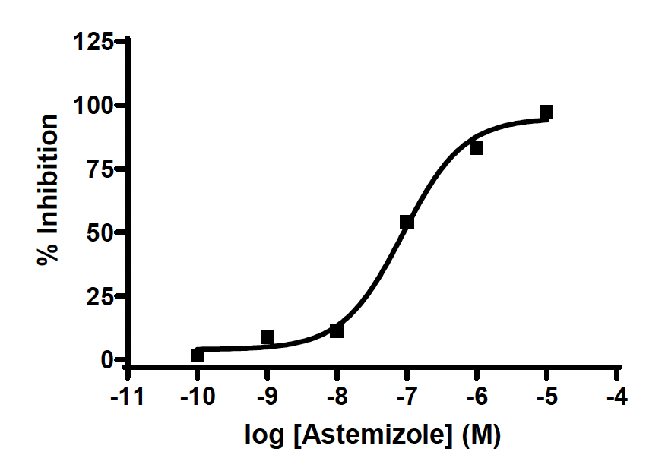
Figure 4. Representation of the concentration-response curve of the compound used as standard control. The mean ± SEM (vertical bars) of each measure determined in duplicate of the percentage of maximum effect is shown.

Table 9. Values (IC₅₀) obtained and described in the literature for the compound used to validate the assay.

Channel | Compound | IC50 (nM) obtained | IC50 (nM) described | Bibliographic reference
hERG | Astemizole | 87.6 | 48 | Molecular devices

Table 10. Inhibition hERG ion channel of tested compounds.
Compounds | hERG IC₅₀(nM) | %Inhibition (10µM)
1 | 2860
enantiomer 1A |  | 20 ± 6
enantiomer 1B |  | 13 ± 2
2 | 4341
3 | 8700
4 |  | 27 ± 3
10 | 2266
11 | 3606 | 9±1
12 | 1288-3100
13 |  | 42 ± 1
23 | 594
27 | 33 ± 3
32 | 4132
35 |  | 26 ± 1
47 | 5800

