Method S1 WRF Model evaluation
We utilize observational meteorology data from three networks:
(1) Automated Surface Observing Systems (ASOS):
https://mesonet.agron.iastate.edu/request/download.phtml?network=AZ_ASOS
(2) Flood Control District of Maricopa County ALERT System (ALERT)
https://alert.fcd.maricopa.gov/showrpts_mc.html
(3) Arizona Meteorological Network (AZMET)
http://ag.arizona.edu/azmet.
The full names and locations of all stations are shown in Figure S1. All stations provide hourly air temperature, wind speed, and relative humidity across June-August in 2023.

The diurnal cycles (June-August average) of air temperature, wind speed, and relative humidity are well-captured by the control WRF simulation (Figure S2), with average root mean squared error (RMSE) values of 1.44℃, 0.69 m/s, and 7.02%, respectively (Table S2). Air temperature shows daytime agreement among urban stations, while a mean daytime overestimation of 2℃ among cropland stations. At night, air temperatures are underestimated by ~1℃ among both urban and cropland stations. Wind speed is reproduced well at urban stations, while a midday overestimation of ~1 m/s occurs at cropland stations. For relative humidity, a dry bias persists across the diurnal cycle, with a 6% underestimation among urban stations and an 8% underestimation among cropland stations. Among all stations, DES (urban station) and J70 (urban station) demonstrate the best overall performance across all three variables. Detailed evaluation statistics at each station are summarized in Table S2.

Method S2 Formulas for calculating components of human-environment heat exchange
With assumptions of null internal body heat storage, negligible mechanical work, and negligible conductive heat exchange, the heat balance equation is expressed as ^{1,2}:
$E_{req}=M-R_{skin}-C_{skin}-C_{res}-E_{res}$ (W) (1)
where $E_{req}$ is the rate of evaporative heat loss from the skin surface required for heat balance; $M$ is internal metabolic heat production, equaling metabolic rate since mechanical work is negligible; $R_{skin}$ and $C_{skin}$are and the rate of dry heat exchange through the skin by radiation and convection combined; $C_{res}$ and $E_{res}$ are the convective and evaporative heat exchange in the respiratory tract.

The dry heat exchange through the skin by radiation and convection ($R_{skin}+C_{skin}$) is given by ³:
$R_{skin}+C_{skin}=\frac{(T_{sk}-t_{o})}{R_{cl}+\frac{1}{{(h_{c}+h}_{r})+f_{cl}}}A_{d}$ (W) (2)
where $T_{sk}$ is skin temperature (°C), which is set to 35°C assuming maximally vasodilated skin ²; $t_{o}$ is the operative temperature (°C), which is estimated as equation 3 ⁴; $R_{cl}$ is the dry heat transfer resistance of clothing (m²℃/W), assumed to be 0.0558 for light shorts and cotton T-shirt; $h_{c}$ is the convective heat transfer coefficients (m²W/℃), which is calculated based on equation 4 ^{5,6}; $h_{r}$ is the radiative heat transfer coefficients (m²W/℃), which is estimated as equation 5 ^{5,6}; $f_{cl}$ is the clothing area factor, which is calculated as 1+$I_{cl}$ (clothing insulation, assumed to be 0.36 for light shorts and cotton T-shirt).
$t_{o}=\frac{(h_{r}T_{r}+h_{c}T_{a})}{{h_{c}+h}_{r}}$ (℃) (3)
where $T_{r}$ is the mean radiant temperature (℃), $T_{a}$ is the dry-bulb temperature (℃).
$h_{c}=\left\{\begin{aligned}3.1, { v}_{air}<0.2 \\ 8.3{{×v}_{air}}^{0.6}, {0.2<v}_{air}\end{aligned}\right.$ (Wm²/℃) (4)
where $v_{air}$ is wind velocity (m/s).
$h_{r}=4εσ×A_{eff}{\left[\frac{T_{sk}+T_{r}}{2}+273.2\right]}^{3}$ (5)
where 𝜀 is area-weighted emissivity of the clothed body surface, 𝜎 is Boltzmann’s Constant (5.67 ×10⁻⁸ Wm²K⁻⁴), and $A_{eff}$ is the effective exposed area of the body referring to the fraction of body area exposed that can be used for heat transfer with the surrounding environment (0.73 for standing).

The heat transfer via convection ($C_{res}$) and evaporation ($E_{res}$) occurs from the respiratory tract are estimated by ASHRAE ⁷:
$C_{res}=0.0014×M\left(34-T_{a}\right)×A_{d}$(W) (6)
$E_{res}=0.0173×M\left(5.87-P_{a}\right)×A_{d }$(W) (7)
where $P_{a}$ is the water vapor pressure of the inspired air in kPa, $A_{d}$ is the body surface area (m²), estimated based on total body mass, $m$ (kg), and height, $H$ (m) ⁸:
$A_{d}= 0.202×m^{0.425}×H^{0.725}$ (m²W) (8)

However, $E_{req}$ cannot always be achieved due to limitations on the maximum evaporative heat loss capacity caused by the environment, clothing, and sweating capacity of human body ($E_{\max_{constrain}}$). Therefore, $E_{\max_{constrain}}$ represents two distinct but related constraints on evaporative loss. In high-humidity environments, $E_{\max_{constrain}}$ is mainly limited by the thermal environment, clothing, and maximum skin wettedness, referred to as $E_{\max_{wet}}$; in dry environments, where the potential to evaporate is high, $E_{\max_{constrain}}$ is constrained mainly by maximum sweat rate, denoted as $E_{\max_{sweat}}$, This constraint occurs when people are not able to produce the sweat required to achieve the needed evaporative heat loss. Therefore, $E_{\max_{constrain}}$ is defined as the minimum of these two values ⁹:
${E_{\max_{constrain}}=min⁡(E}_{\max_{wet}}{, E}_{\max_{sweat}})$ (W) (9)
$E_{\max_{wet}}=ω_{max}×\frac{(P_{sk,sat}-P_{a})}{R_{e,cl}+\frac{1}{h_{e}f_{cl}}}A_{d}$ (W) (10)
where $ω_{max}$ is maximum skin wittedness (assumed to be 0.85), $P_{sk,sat}$ is the water vapor pressure at the skin surface when saturated with sweat (kPa; constant at 5.62 kPa because of $T_{sk}$=35°C), $R_{e,cl}$ is the evaporative resistance of clothing (m²kPa/W), $h_{e}$ is the evaporative heat transfer coefficient (W/m²kPa), estimated by ¹⁰:
$h_{e}=h_{c}×LR$ (W/m²kPa) (11)
where $LR$ is the Lewis Relation (16.5 ℃/kPa).
$E_{\max_{constrain}}$ in dry environments ($E_{\max_{sweat}}$) is constrained by the maximum sweat rate ^{11,12}s:
$E_{\max_{sweat}}=\frac{S_{max}×λ×ρ}{3.6}r$(W) (12)
where $S_{max}$ is maximum hourly sweat rate (0.75L/hr), λ is the latent heat of vaporization of sweat (2426 J/g), 𝜌 is the density of sweat (assumed as equivalent to water density of 1 kg/L), and $r$ is the sweating efficiency ¹³, which is the proportion of sweat produced that evaporates from the skin surface:
$r=\left\{\begin{aligned}1-\frac{{ω_{req}}^{2}}{2} , ω_{req}<1 \\ 0.5 , ω_{req}≥1\end{aligned}\right.$ (13)
$$r=\min\left(r,1\right)$$
where $ω_{req}$ is calculated by:
$ω_{req}=\frac{E_{req}}{\frac{E_{\max_{wet}}}{ω_{max}}}$ (14)

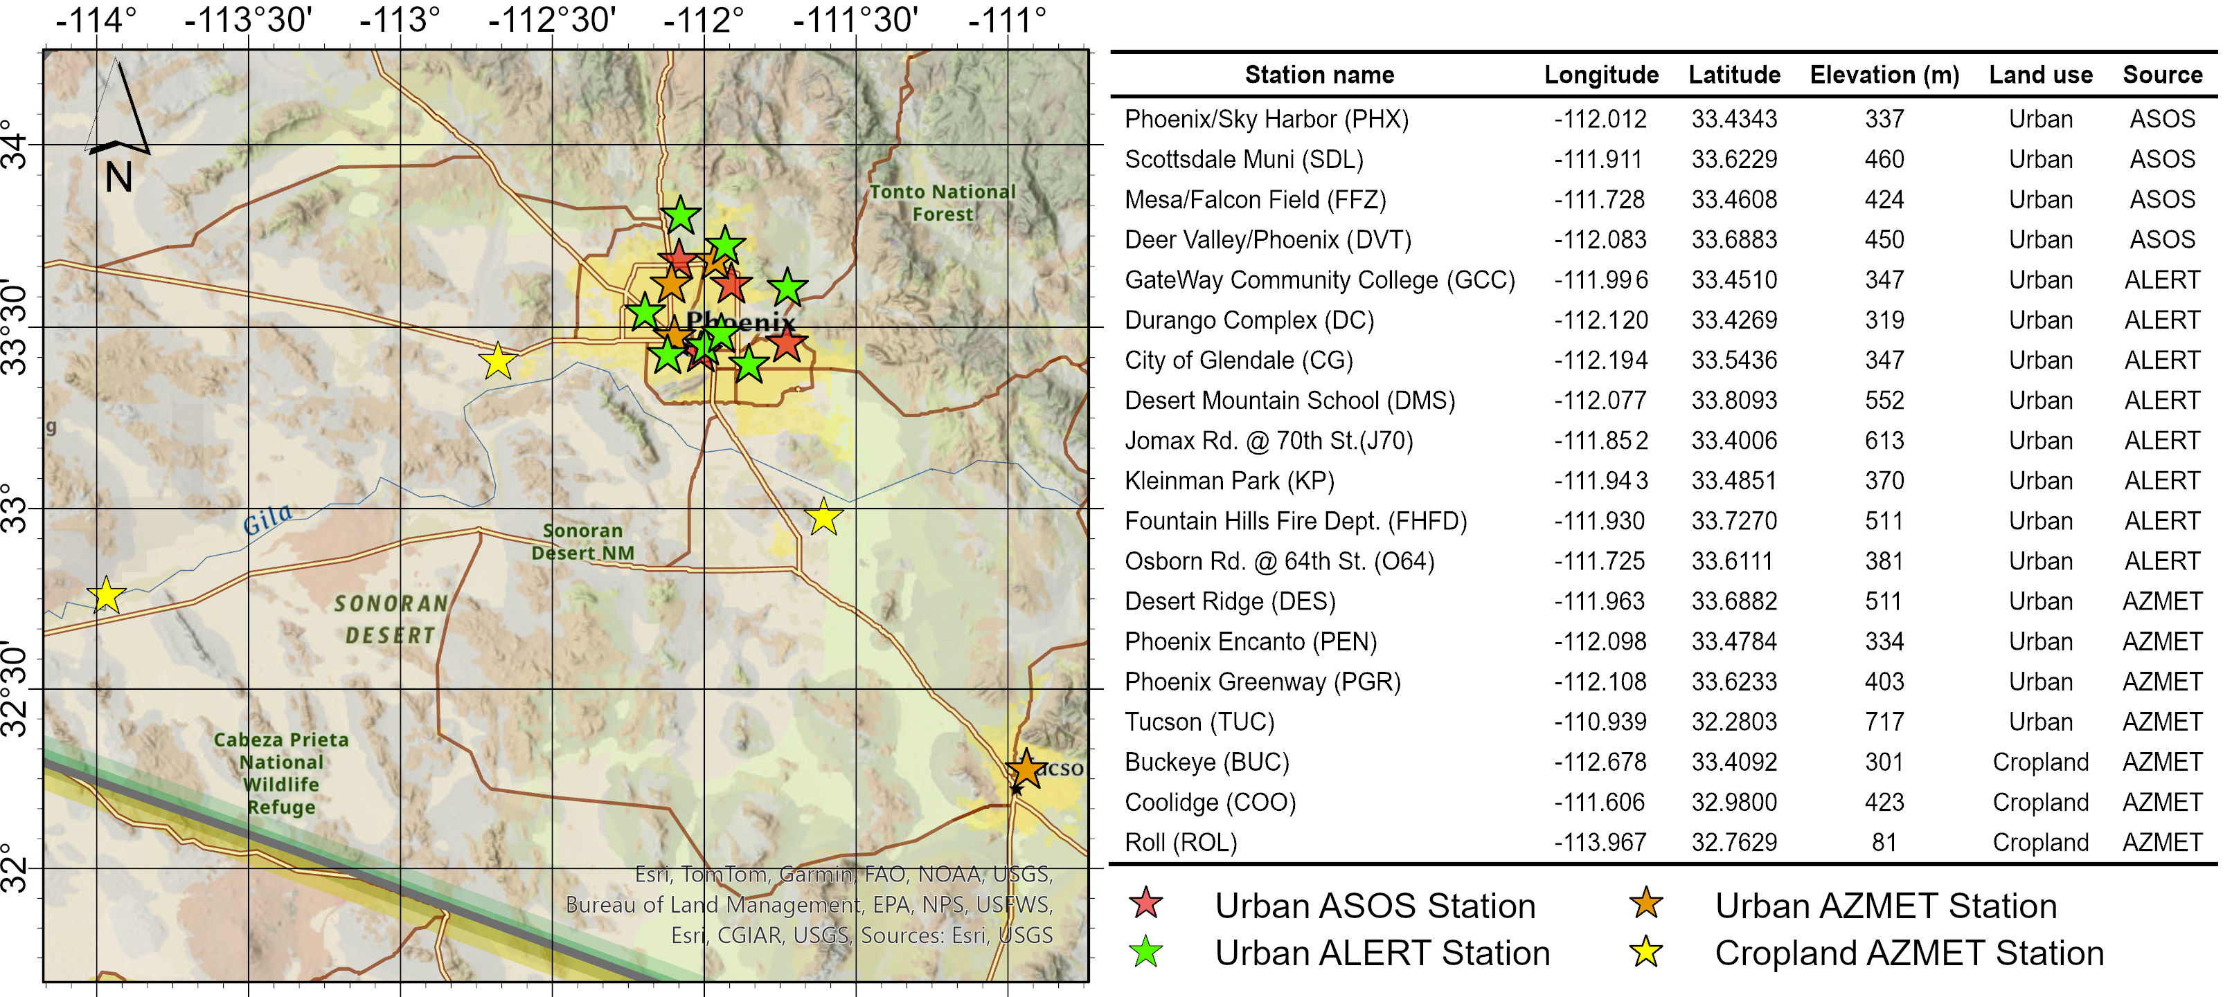

Fig.S1 Illustration of meteorological stations used for WRF evaluation. Spatial distribution (Left) and detailed information (Right) of the meteorological stations used for model evaluation. Station types: National Weather Service automated (ASOS), Flood Control District of Maricopa County ALERT System (ALERT), and Arizona Meteorological Network (AZMET). Urban stations are denoted by red/orange/green stars, cropland stations by yellow stars.
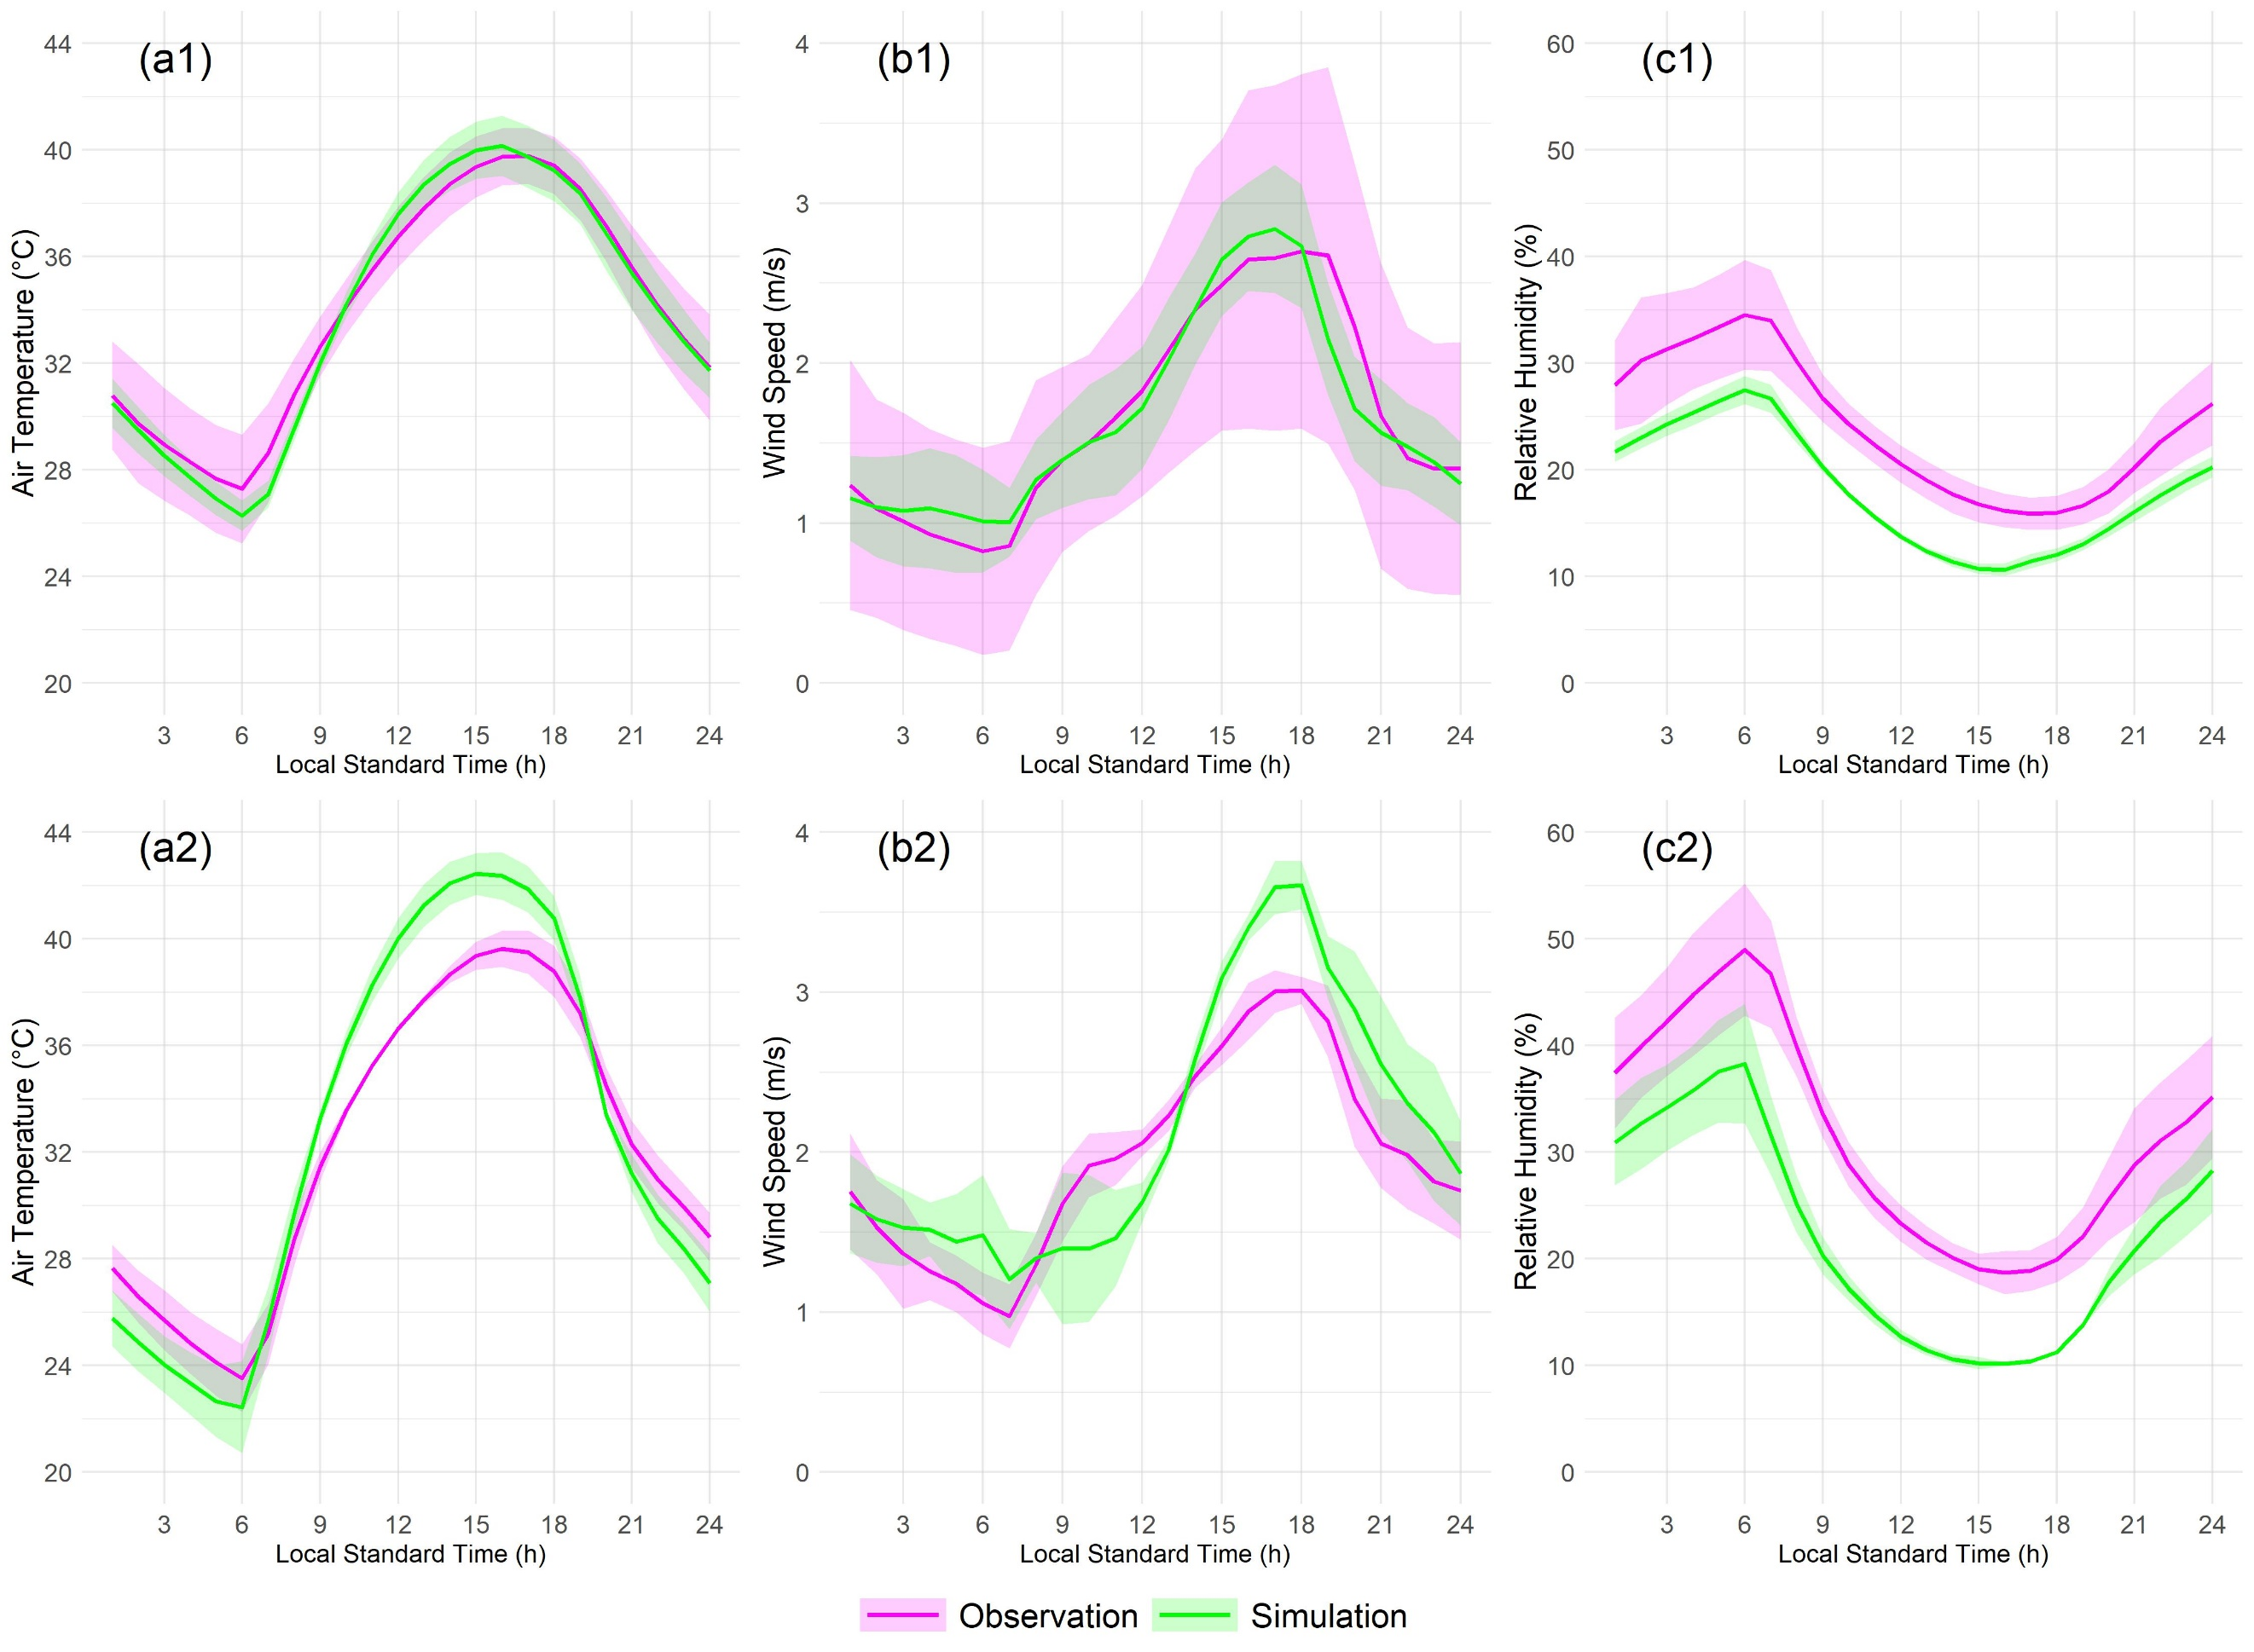
Fig.S2 WRF model performance evaluation. Diurnal cycles (June-August average) of air temperature (a1, a2), wind speed (b1, b2), and relative humidity (c1, c2) between control WRF simulation and corresponding observation from meteorological stations at urban (top) and cropland (bottom) stations. The shaded areas indicate ±1 standard deviation of the mean across all stations within each category.
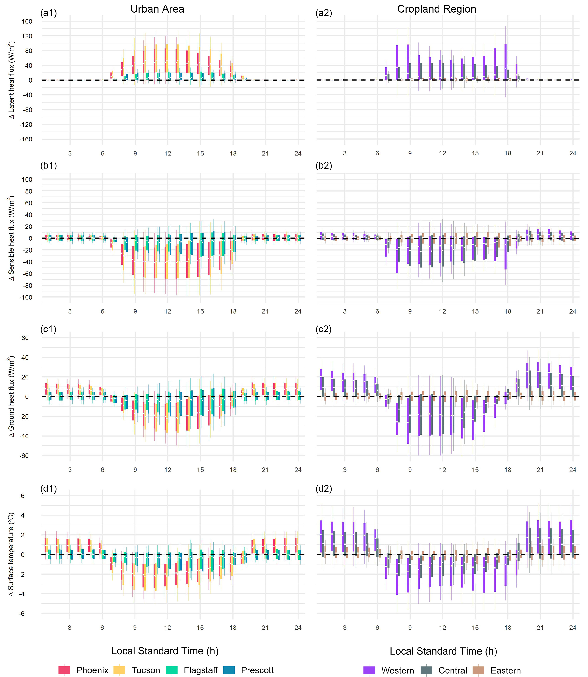
Fig.S3 Simulated diurnal cycles of irrigation effects on surface energy budget and surface temperature. Box-and-whisker plots illustrate the distribution of diurnal changes in sensible heat flux (a1, a2), latent heat flux (b1, b2), ground heat flux (c1, c2), and surface temperature (d1, d2), contrasting urban areas (left panels) with croplands (right panels).
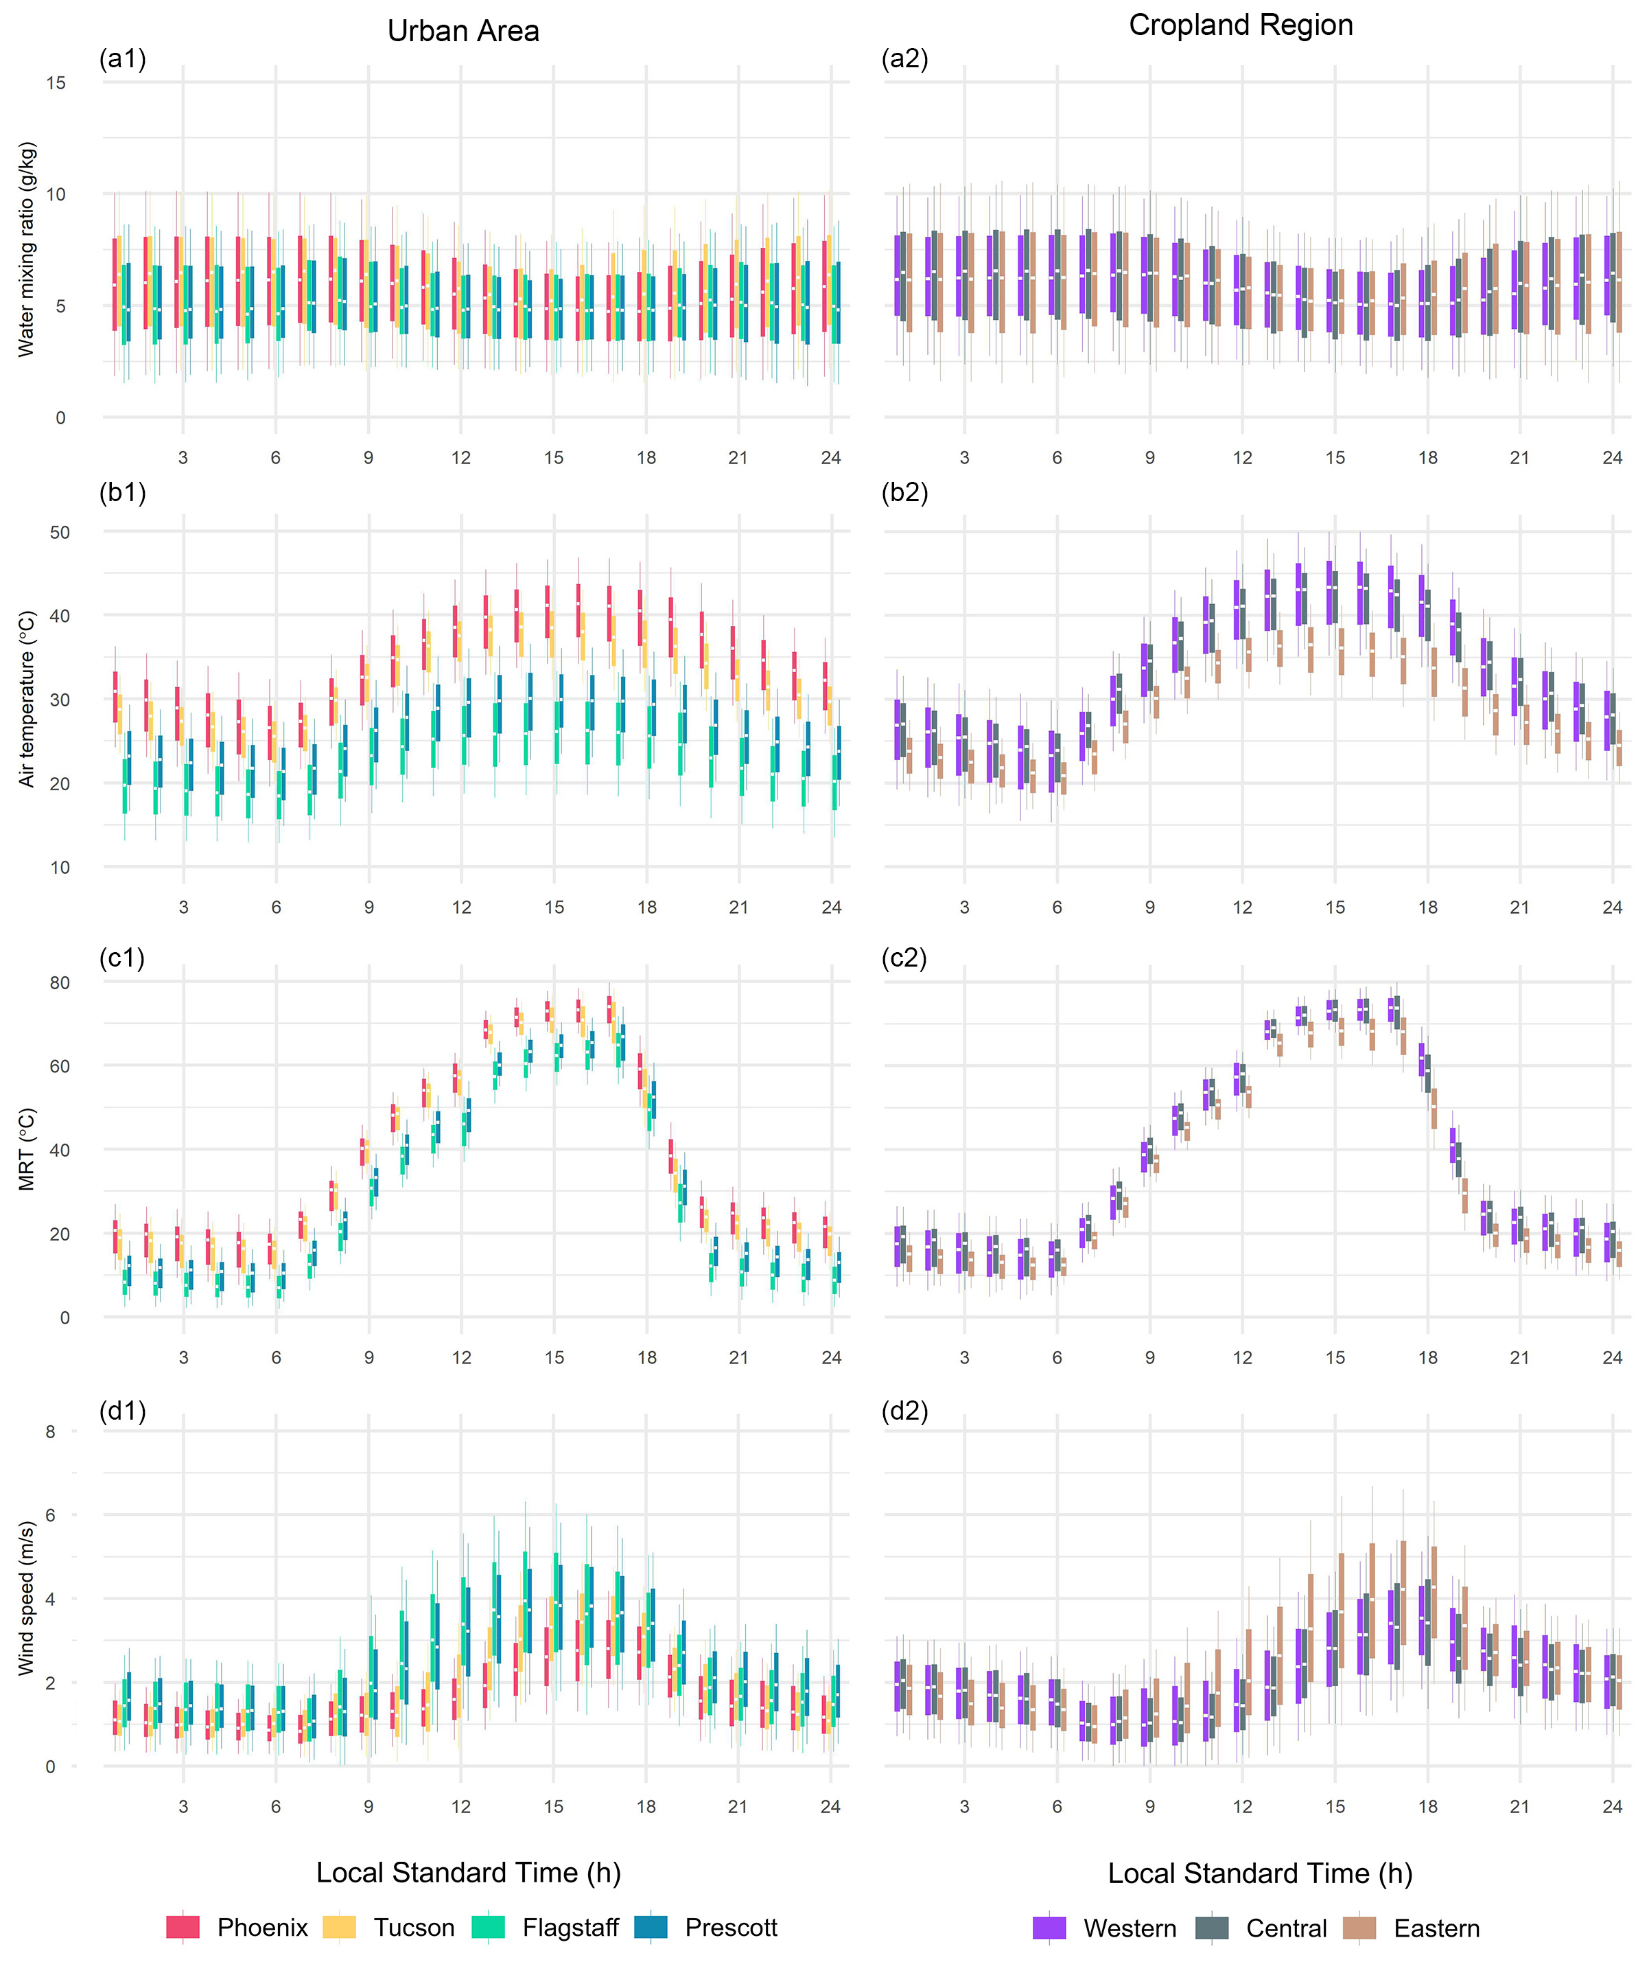
Fig.S4 Simulated diurnal cycles of environmental factors under control scenario. Box-and-whisker plots depict the baseline diurnal cycles of air temperature (a1, a2), water vapor mixing ratio (b1, b2), wind speed (c1, c2), and mean radiant temperature (d1, d2), contrasting urban areas (left panels) with croplands (right panels).
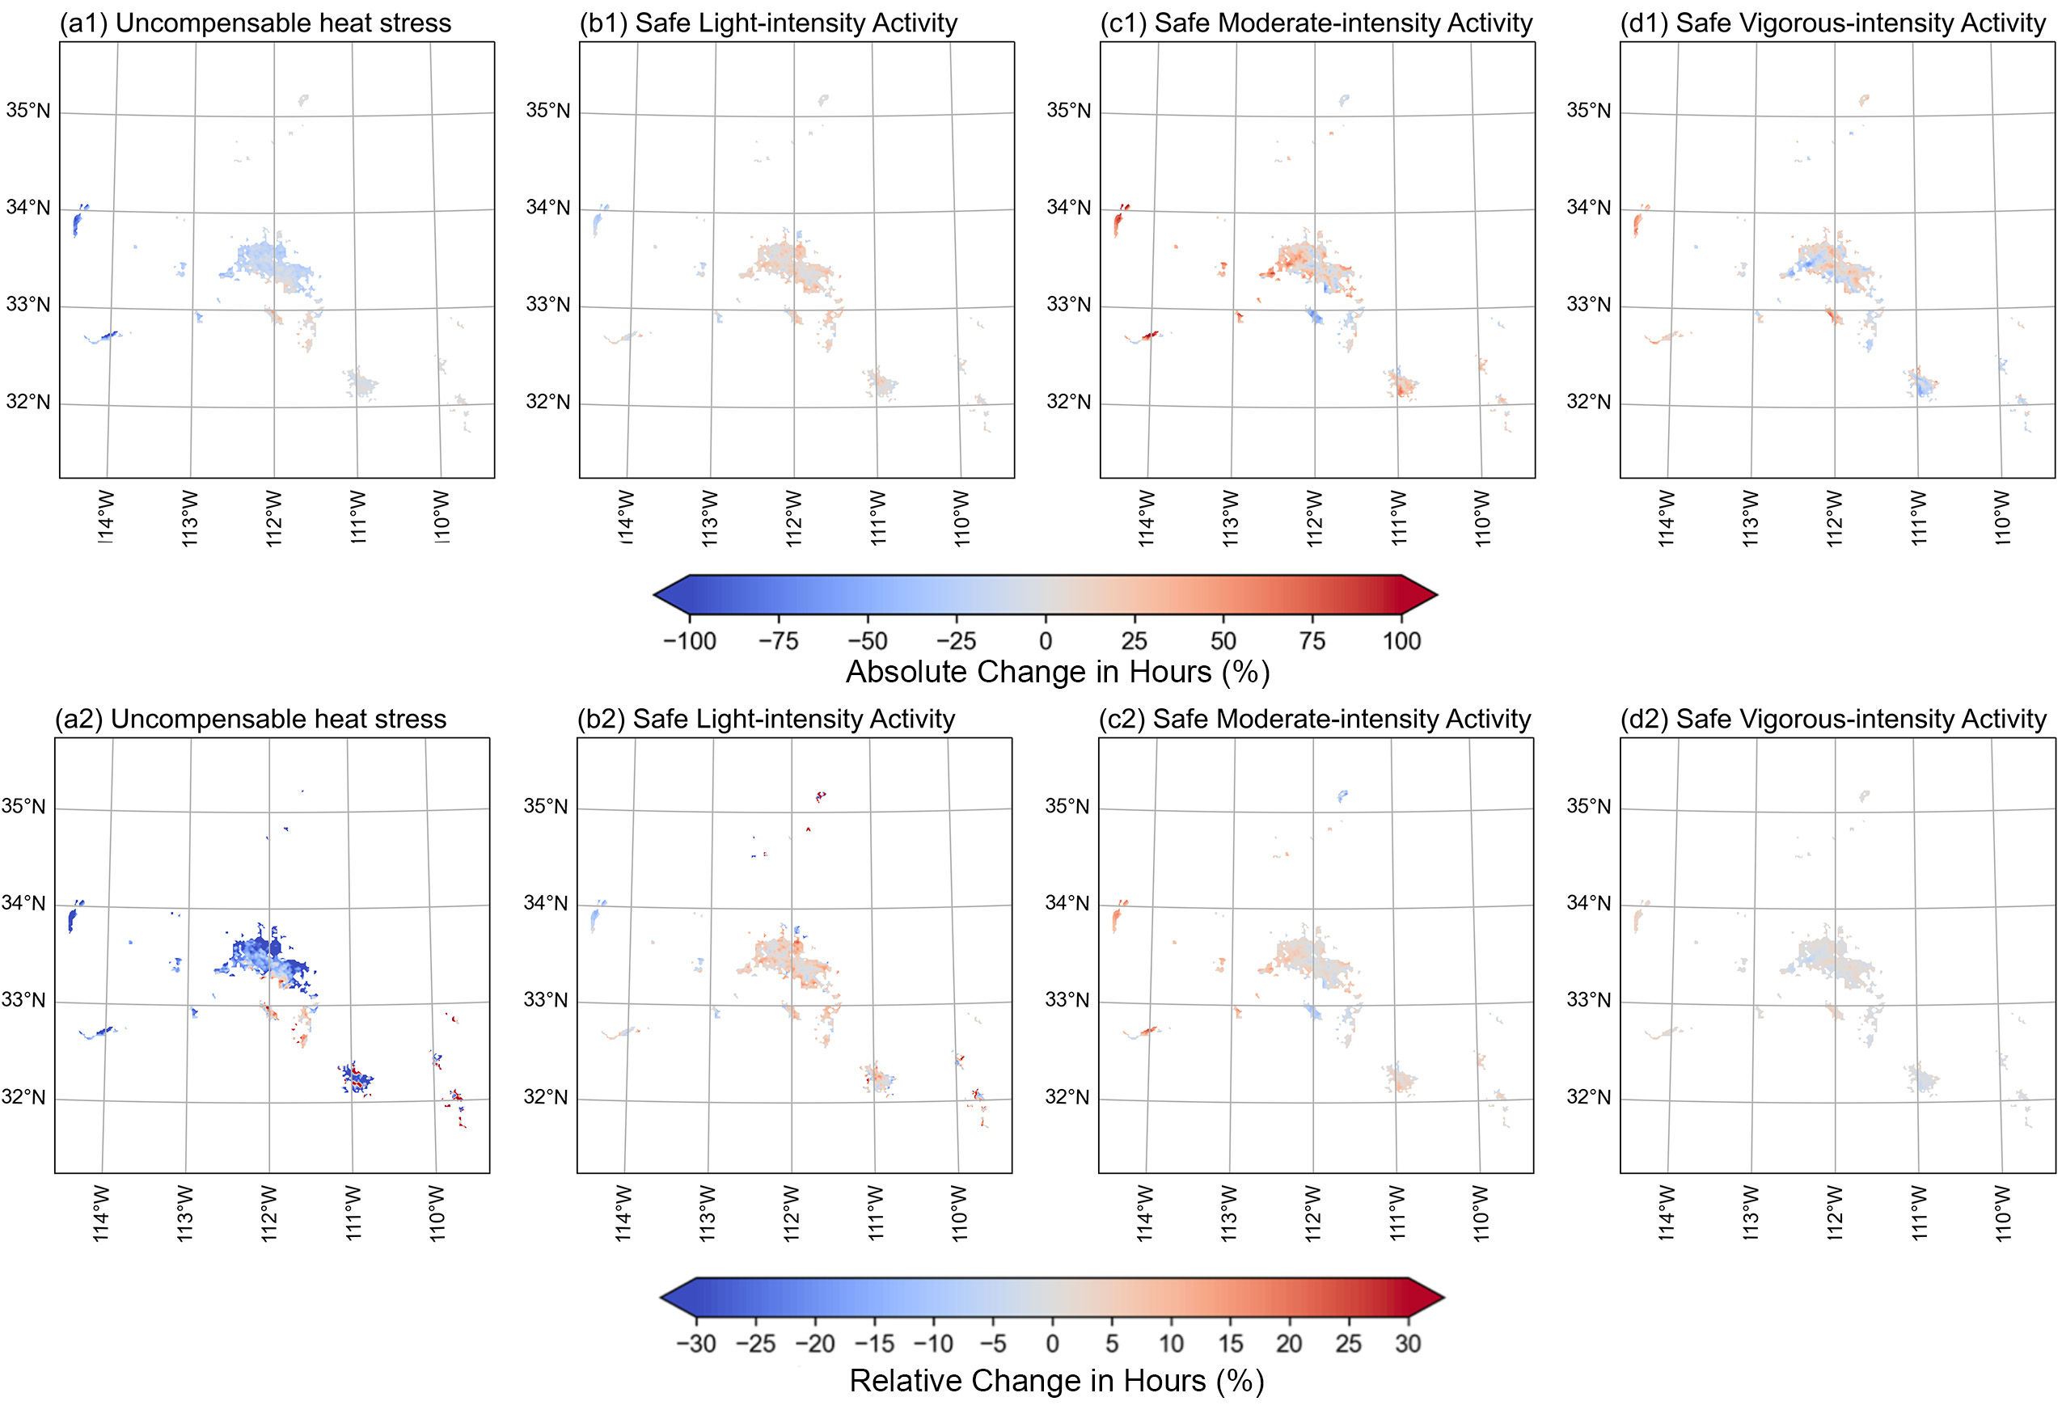
Fig.S5 Simulated spatial distribution of irrigation-induced absolute (top row) and relative (bottom row) changes in cumulative hours under different labor capacity levels. (a) uncompensable heat stress, maximum safe activity level limited to (b) light, (c) moderate, and (d) vigorous intensity.
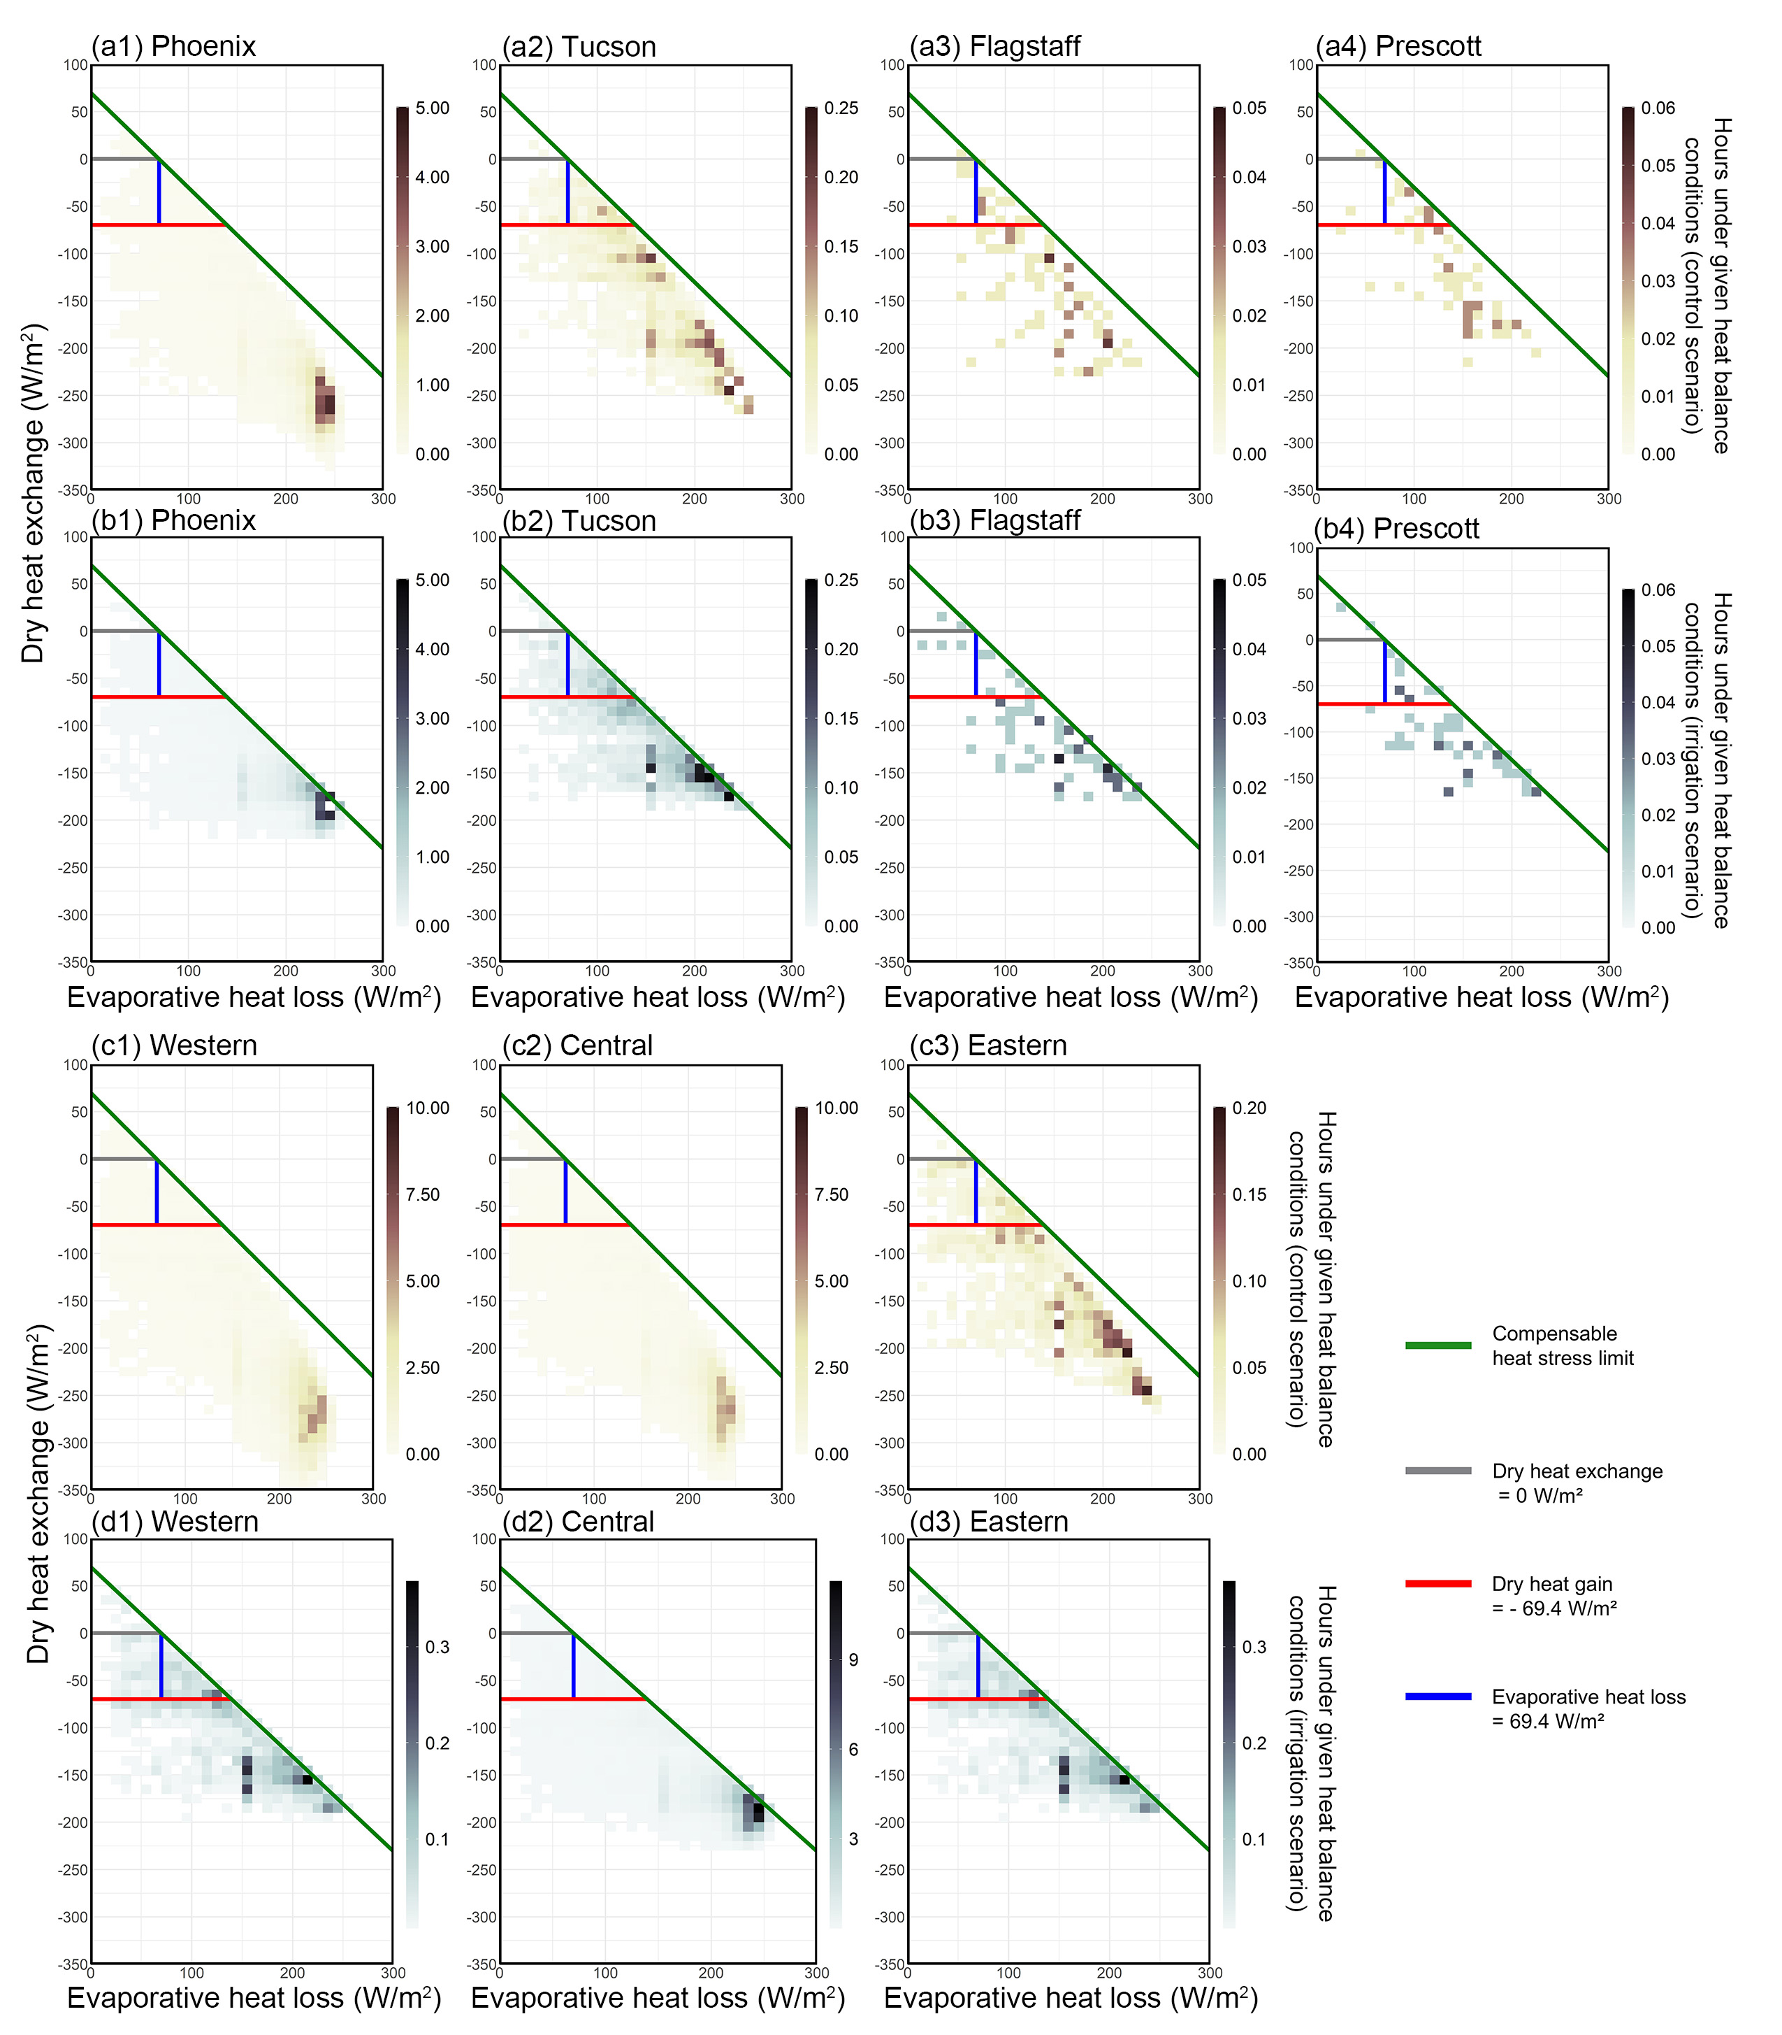
Fig. S6 2D histograms of relative frequency of given human heat balance conditions under uncompensable heat stress. The distributions show the hours of occurrences within each 10 W/m² bin of evaporative heat loss (x-axis) and dry heat exchange (y-axis) at different regions. A fixed value of internal metabolic heat production (M = 69.98 W/m²) is outlined the uncompensable heat stress condition.

Table S1 Main physical parameterizations used for all simulations.
Model version: | Version 4.3.3
Horizontal grid (innermost): | ΔX and ΔY = 2 km
Number of points (innermost): | 231 (x direction), 246 (y direction)
Vertical levels: | 40 levels
Radiation scheme: | RRTMGª (longwave and shortwave)
Land surface model: | Noah LSM
Urban representation: | BEP+BEM^{b}
Cumulus scheme (only for the outermost grids): | Modified Tiedtke scheme
Microphysics scheme: | WSM-6^{c}
PBL scheme: | Mellor-Yamada-Janjic TKE scheme
Surface layer: | Monin-Obukhov (Janjic) scheme
Initial and lateral boundary conditions: | ERA5 reanalysis data
ª The new version of the Rapid Radiative Transfer Model (RRTM)
^{b} The Multi-layer, Building Environment Model scheme with Multi-layer, Building Environment Parameterization
^{c} The WRF Single-Moment 6 class graupel microphysics scheme
Table S2 Evaluation statistics for control simulation. The root mean square error (RMSE) and mean absolute error (MAE) are computed for each meteorology stations and the corresponding model grids.
 | Air Temperature (℃) |  | Wind Speed (m/s) |  | Relative Humidity (%)
Station | RMSE | MAE | RMSE | MAE | RMSE | MAE
PHX | 1.73 | 1.43 | 0.56 | 0.49 | 11.86 | 10.56
SDL | 0.92 | 0.74 | 0.27 | 0.24 | 8.75 | 8.12
FFZ | 1.42 | 1.26 | 0.25 | 0.20 | 6.84 | 6.54
DVT | 1.37 | 1.14 | 0.43 | 0.39 | 11.00 | 9.67
GCC | 1.67 | 1.56 | 0.26 | 0.22 | 8.98 | 8.72
DC | 2.14 | 1.89 | 0.39 | 0.30 | 9.05 | 8.43
CG | 2.66 | 2.38 | 0.62 | 0.56 | 11.38 | 11.24
DMS | 2.05 | 1.72 | 1.90 | 1.82 | 1.74 | 1.36
J70 | 0.55 | 0.48 | 0.86 | 0.74 | 5.76 | 5.57
KP | 0.68 | 0.54 | 0.86 | 0.74 | 5.90 | 5.79
FHFD | 1.66 | 1.57 | 0.93 | 0.76 | 5.45 | 5.19
O64 | 1.90 | 1.38 | 0.86 | 0.80 | 4.06 | 3.62
DES | 1.61 | 1.15 | 0.32 | 0.27 | 3.11 | 2.85
PEN | 1.96 | 1.47 | 0.99 | 0.88 | 6.72 | 6.53
PGR | 0.93 | 0.72 | 1.07 | 1.05 | 6.97 | 6.87
TUC | 0.83 | 0.73 | 0.59 | 0.55 | 7.73 | 7.67
BUC | 1.49 | 1.26 | 0.55 | 0.44 | 4.79 | 4.54
COO | 0.99 | 0.82 | 0.69 | 0.53 | 5.65 | 5.45
ROL | 0.88 | 0.70 | 0.75 | 0.71 | 7.59 | 7.53
Average | 1.44 | 1.21 | 0.69 | 0.61 | 7.02 | 6.64

Table S3 Personal characteristics used for the human heat balance model.
Weight (kg) | 65
Height (m) | 1.70
Age (years) | 18 - 59
Dubois-Dubois surface corporal area ($A_{d}$; m²) | 1.72
Effective body radiative area ($A_{eff}$) | 0.73
Area-weighted emissivity of the clothed body surface (𝜀) | 0.98
Insulation value ($I_{cl}$) | 0.158
Dry heat transfer resistance of clothing ($R_{cl}$; m²℃/W) | 0.0558
Evaporative resistance of clothing ($R_{e,cl}$; m²Pka/W) | 0.02
Maximum skin wettedness ($ω_{max}$) | 0.85
Water vapor pressure at the skin surface when saturated with sweat ($P_{sk,sat}$; kPa) | 5.62
Maximum hourly sweat rate ($S_{max}$; L/hour) | 0.75

Reference
1. Cramer, M. N. & Jay, O. Partitional calorimetry. Journal of Applied Physiology 126, 267–277 (2019).
2. Havenith, G. & Fiala, D. Thermal Indices and Thermophysiological Modeling for Heat Stress. in Comprehensive Physiology 255–302 (John Wiley & Sons, Ltd, 2015). doi:10.1002/cphy.c140051.
3. Guzman-Echavarria, G., Middel, A., Vecellio, D. J. & Vanos, J. The development of an adaptive heat stress compensability classification applied to the United States. Int J Biometeorol (2024) doi:10.1007/s00484-024-02766-7.
4. Winslow, C.-E. A., Herrington, L. P. & Gagge, A. P. Physiological reactions of the human body to varying environmental temperatures. American Journal of Physiology-Legacy Content 120, 1–22 (1937).
5. Parsons, K. Human Thermal Environments: The Effects of Hot, Moderate, and Cold Environments on Human Health, Comfort, and Performance, Third Edition. (CRC Press, 2014). doi:10.1201/b16750.
6. ISO 8996:2004. ISO https://www.iso.org/standard/34251.html.
7. ASHRAE. ASHRAE HANDBOOK 1997. (1997).
8. Du Bois, D. & Du Bois, E. F. A formula to estimate the approximate surface area if height and weight be known. 1916. Nutrition 5, 303–311; discussion 312-313 (1989).
9. Vanos, J. et al. A physiological approach for assessing human survivability and liveability to heat in a changing climate. Nat Commun 14, 7653 (2023).
10. Lewis, W. K. The Evaporation of a Liquid Into a Gas. Transactions of the American Society of Mechanical Engineers 44, 325–332 (1922).
11. Morris, N. B. et al. Electric fan use for cooling during hot weather: a biophysical modelling study. The Lancet Planetary Health 5, e368–e377 (2021).
12. Foster, J. et al. Quantifying the impact of heat on human physical work capacity; part II: the observed interaction of air velocity with temperature, humidity, sweat rate, and clothing is not captured by most heat stress indices. Int J Biometeorol 66, 507–520 (2022).
13. Candas, V., Libert, J. P. & Vogt, J. J. Influence of air velocity and heat acclimation on human skin wettedness and sweating efficiency. Journal of Applied Physiology 47, 1194–1200 (1979).

