Table (1): The mean, standard deviation (SD) values of the percentage of dead bacterial cells among the different final irrigation protocol group
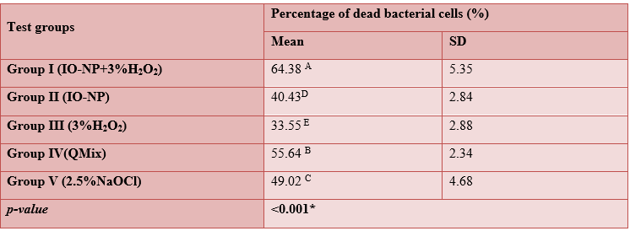
Superscripts with different capital letters indicate statistically significance difference within the same column. Superscripts with different small letters indicate statistically significance difference within the same raw. - *; significant (p≤0.05) ns; non-significant (p>0.05)

Table (2): The mean, standard deviation (SD) values of the percentage of dead bacterial cells of Group I (IO-NP + 3% H₂O₂) in the middle and the apical thirds at different depths
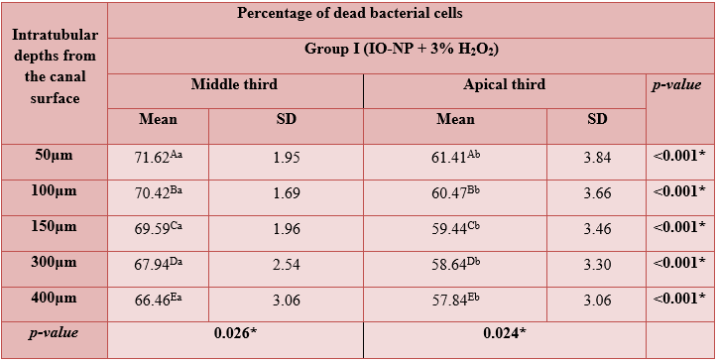
Superscripts with different capital letters indicate statistically significance difference within the same column. Superscripts with different small letters indicate statistically significance difference within the same raw. - *; significant (p≤0.05) ns; non-significant (p>0.05)

Table (3): The mean, standard deviation (SD) values of the dead bacterial cells of group II (IO-NP) in the middle and the apical thirds
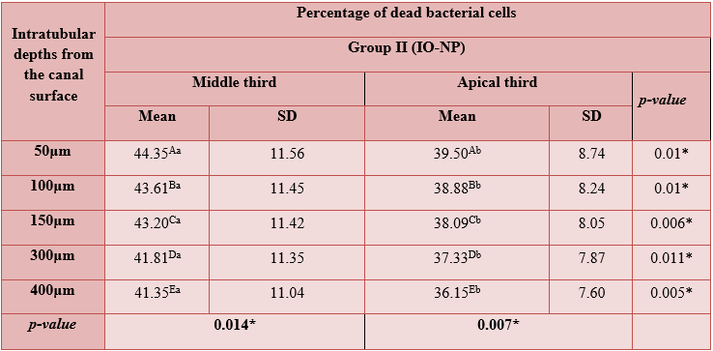
Superscripts with different capital letters indicate statistically significance difference within the same column. Superscripts with different small letters indicate statistically significance difference within the same raw. - *; significant (p≤0.05) ns; non-significant (p>0.05)

Table (4): The mean, standard deviation (SD) values of the percentage of dead bacterial cells of group III (3% H₂O₂) in the middle and the apical thirds
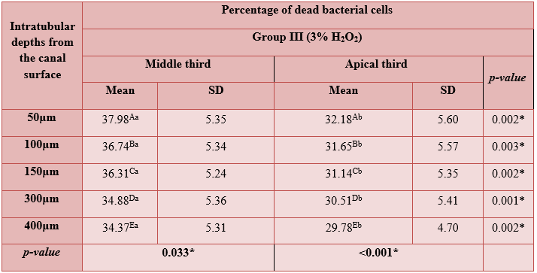
Superscripts with different capital letters indicate statistically significance difference within the same column. Superscripts with different small letters indicate statistically significance difference within the same raw. - *; significant (p≤0.05) ns; non-significant (p>0.05)

Table (5): The mean, standard deviation (SD) values of the percentage of dead bacterial cells of group IV (QMix) in the middle and the apical thirds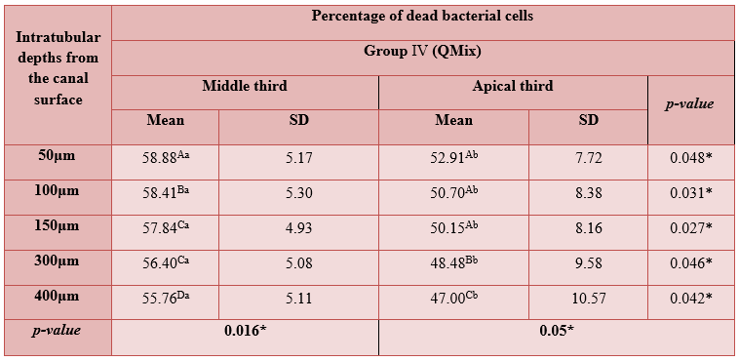
Superscripts with different capital letters indicate statistically significance difference within the same column. Superscripts with different small letters indicate statistically significance difference within the same raw. - *; significant (p≤0.05) ns; non-significant (p>0.05)

Table (6): The mean, standard deviation (SD) values of the percentage of dead bacterial cells of group V (2.5% NaOCl) in the middle and the apical thirds
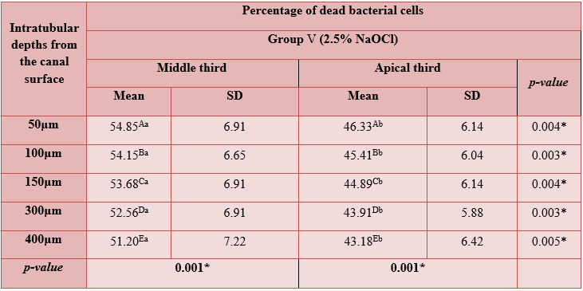
Superscripts with different capital letters indicate statistically significance difference within the same column. Superscripts with different small letters indicate statistically significance difference within the same raw. - *; significant (p≤0.05) ns; non-significant (p>0.05)

Table (7): The mean, standard deviation (SD) values of the percentage of dead bacterial cells of different irrigation groups in middle and apical third at different depths
 | Fe3O4+H2O2 |  |  |  | Q Mix |  |  |  | NaOCl |  |  |  | Fe3O4 NP |  |  |  | H2O2 |  |  |  | p-value
 | Middle third |  | Apical third |  | Middle third |  | Apical third |  | Middle third |  | Apical third |  | Middle third |  | Apical third |  | Middle third |  | Apical third |  | p-value
Depth | M | SD | M | SD | M | SD | M | SD | M | SD | M | SD | M | SD | M | SD | M | SD | M | SD | p-value
50µm | 71.62 | 1.95 | 61.41 | 3.84 | 58.88 | 5.17 | 52.91 | 7.72 | 54.85 | 6.91 | 46.33 | 6.14 | 44.35 | 11.56 | 39.50 | 8.74 | 37.98 | 5.35 | 32.18 | 5.60 | ≤0.001*
100µm | 70.42 | 1.69 | 60.47 | 3.66 | 58.41 | 5.30 | 50.70 | 8.38 | 54.15 | 6.65 | 45.41 | 6.04 | 43.61 | 11.45 | 38.88 | 8.24 | 36.74 | 5.34 | 31.65 | 5.57 | ≤0.001*
150µm | 69.59 | 1.96 | 59.44 | 3.46 | 57.84 | 4.93 | 50.15 | 8.16 | 53.68 | 6.91 | 44.89 | 6.14 | 43.20 | 11.42 | 38.09 | 8.05 | 36.31 | 5.24 | 31.14 | 5.35 | ≤0.001*
300µm | 67.94 | 2.54 | 58.64 | 3.30 | 56.40 | 5.08 | 48.48 | 9.58 | 52.56 | 6.91 | 43.91 | 5.88 | 41.81 | 11.35 | 37.33 | 7.87 | 34.88 | 5.36 | 30.51 | 5.41 | ≤0.001*
400µm | 66.46 | 3.06 | 57.84 | 3.06 | 55.76 | 5.11 | 47.00 | 10.57 | 51.20 | 7.22 | 43.18 | 6.42 | 41.35 | 11.04 | 36.15 | 7.60 | 34.37 | 5.31 | 29.78 | 4.70 | ≤0.001*
 | 0.026* |  | 0.024* |  | 0.016* |  | 0.05* |  | 0.001* |  | 0.001* |  | 0.014* |  | 0.007* |  | 0.033* |  | ≤0.001*

Superscripts with different capital letters indicate statistically significance difference within the same column. Superscripts with different small letters indicate statistically significance difference within the same raw. - *; significant (p≤0.05) ns; non-significant (p>0.05)

