Supplementary Fig 1 - Smear grades of direct sputum samples extracted using Genolyse (a) and Trueprep (b) with their success in tNGS runs

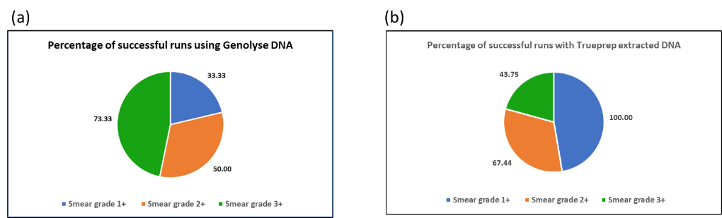

Supplementary Fig 2 - Bacillary load of direct sputum samples as estimated by CFUs/ml in Trueprep and their success in tNGS runs

Supplementary Fig 3 – Diversity of single nucleotide polymorphisms (SNPs) observed among the first line and second line drugs among samples identified by tNGS in this study. The figure shows the distribution of SNPs among (A) rpoB of Rifampicin; (B) katG, kasA and inhA of isoniazid; (C) embB of ethambutol; (D) pncA of pyrazinamide; (E) gyrA and gyrB of fluoroquinolones; (F) rrs, rrl, rplC, gid and eis promoter of aminoglycosides

