Supplemental Information

Stimuli Validation
Study 1

To validate that our vignettes were indeed deemed to reflect hypocritical behavior for the treatment group (Hypocrisy Condition) and non-hypocritical behavior for the control group (Mere Harm condition) we ran a post-hoc validation survey with a new sample of 16 US participants (Age: M= 41.5, SD= 12.7; Gender: 50% Female, 43.8% Male, 6.2% Non-binary; Political Orientation: 18.8% Very Left, 50% Left, 25% Center, 6.2% Right), as is customary for statement validations, where they were presented with the different vignettes and were asked to answer:

“Do you find the character’s behavior hypocritical?” Yes / No

The table below represents the percentage of participants (16 total) that answered ‘yes’ per topic, by condition:

Topic | Condition
Topic | Hypocrisy | Mere harm
Flight | 81% | 0%
Recycle | 100% | 0%
Beef | 100% | 0%
Car | 100% | 0%

Study 2

To validate that our fictitious social media posts were indeed deemed to reflect hypocritical behavior for the treatment group (Hypocrisy Condition) and non-hypocritical behavior for the control group (Mere Harm condition) we ran a post-hoc validation survey with a new sample of 19 US participants (Age: M= 35.7, SD= 12.2; Gender: 57.9% Female, 42.1% Male; Political Orientation: 10.5% Very Left, 36.8% Left, 31.6% Center, 10.5% Right, 10.5% Very Right), where they were presented with the different posts and were asked to answer:

“Do you find the politician’s behavior hypocritical?’ Yes / No

The table below represents the percentage of participants (19 total) that answered ‘yes’ per topic, by condition:

Topic | Condition
Topic | Hypocrisy | Mere Harm
Fossil | 84% | 47%
Jet | 68% | 26%
Meat | 58% | 21%

Plausibility of stimuli (Study 2)

To check how plausible participants found the social media posts, we included a question about this in our Study 2. After reading each post, participants were asked to answer:

On a scale from 1 to 7, where 1 is 'Very unlikely' and 7 is 'Very Likely,' how likely do you find the social media post you just read to be true?

The table below represents the mean response per topic and by condition:

Topic | Condition
Topic | Hypocrisy | Control
Fossil | 4.85±1.63 | 4.63±1.81
Jet | 5.74±1.43 | 5.48±1.49
Meat | 5.15±1.50 | 4.75±1.69

The figure below represents a histogram of the responses by condition.

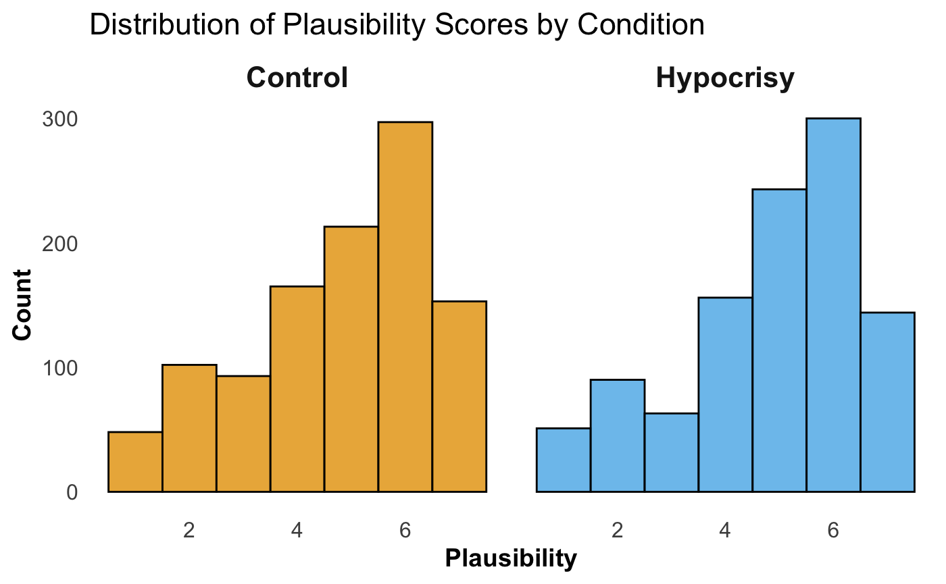

Plausibility explained by CC Policy Support

 | Plausibility
Coefficient | Est. | Std. Beta | CI (95%) | Std. CI | p
(Intercept) | 4.36 | -0.00 | 4.09 – 4.63 | -0.07 – 0.07 | <0.001
cc policy | 0.13 | 0.14 | 0.06 – 0.21 | 0.06 – 0.21 | <0.001
Observations | 706
R² / R² adjusted | 0.018 / 0.017

Methods

Study 1

Sample

Following our pre-registered sample goal, we surveyed 260 US participants (n=256 after discarding those who did not pass attention checks). Data collection was conducted using MTurk via CloudResearch. Demographics are summarized below:

Variable | Options | Average | SD | Percentage
Age |  | 41.04 | 11.04
Gender | Man |  |  | 53.52%
Gender | Woman |  |  | 45.70 %
Gender | Non-binary |  |  | 0.39%
Gender | Prefer not to say |  |  | 0.39%
Political Orientation | Liberal/ Left wing |  |  | 21.48%
 | Conservative/ Right wing |  |  | 17.19%
 | Very liberal/ Left wing |  |  | 30.47%
 | Very conservative/ Right wing |  |  | 12.11%
 | Moderate |  |  | 17.58%
 | Other |  |  | 1.17%
Education | Bachelor’s (4 – year) |  |  | 46.09%
 | Highschool |  |  | 13.28%
 | Master’s degree |  |  | 6.64%
 | Doctorate’s degree |  |  | 1.17%
 | Associate’s (2 – year) |  |  | 8.98%
 | Professional degree |  |  | 1.56%
 | Less than High School |  |  | 0.78%
 | Some college |  |  | 19.92%
 | Some Graduate School |  |  | 1.56%

Survey

For all conditions, participants were presented with four vignettes. Each focused on a different Climate change action topic (Reducing use of flights, Recycling, Reducing beef consumption, Reducing commute by car). The Table below includes the text for each vignette in each condition.

Topic | Hypocrisy | Transgression
Flying | John is an environmental activist and last year tracked big attention in social media by asking people to stop flying to help the environment. That same year, John took 10 flights. | John lives in a house in a town. John took 10 flights last  year.
Recycling | This year, Laura started a petition for her apartment building administration to build special  recycling-bins structure and insisted that all inhabitants use it. That same year, Laura did not engage in any kind of recycling at home. | Laura lives in an apartment in a city. In the past year, Laura  did not engage in any kind of recycling at home.
Beef | This month, Alex talked to his group of friends about how important it is that they stop eating meat  to help the environment. Alex ate beef 5 times a week that same month. | Alex lives in a house in a town. Alex ate beef 5 times a week  in the past month.
Car | Last month, Sofia talked to her co-  workers about how important it is that they stop using their  cars and switch to biking in order to help the environment.  Sofia drove her car everyday that same month. | Sofia lives in an apartment in a city. Sofia drove her car  everyday in the past month.

Study 2

Sample

Following our pre-registered sample goal, we surveyed 800 US participants (n=706 after discarding those who did not pass attention checks or did not match the applied cloud research pre-screeners). Data collection was conducted using MTurk via CloudResearch, where, to ensure a balanced number of Conservative/Republican and Liberal/Democratic participants, pre-screeners for both political party and political orientation were applied. Participants that in our demographic questions responded with political orientations dissonant with political party affiliations were also excluded since it did not align with the cloud research pre-screener and it could create confusion on the interpretation of results. Demographics are summarized below:

Variable | Options | Average | SD | Count | Percentage
Age |  | 44.64 | 13.00
Gender | Man |  |  | 356 | 50.42%
Gender | Woman |  |  | 342 | 48.44%
Gender | Non-binary |  |  | 6 | 0.86%
Gender | Prefer not to say |  |  | 2 | 0.28%
Race | White or European |  |  | 549
 | Black or African American |  |  | 57
 | Asian or Asian American |  |  | 33
 | Hispanic or Latino/a/x |  |  | 20
 | American Indian or Alaska Native |  |  | 1
 | Middle Eastern or North African |  |  | 1
 | Mixed Race |  |  | 43
 | Prefer not to say |  |  | 2
Religion | Protestant |  |  | 231
 | Roman Catholic |  |  | 129
 | Agnostic |  |  | 105
 | Atheist |  |  | 99
 | Nothing in particular |  |  | 65
 | Something else |  |  | 33
 | Jewish |  |  | 11
 | Mormon |  |  | 9
 | Buddhist |  |  | 8
 | Orthodox |  |  | 7
 | Muslim |  |  | 4
 | Prefer not to say |  |  | 4
 | Hindu |  |  | 1
Education | Bachelor’s |  |  | 299
 | Highschool |  |  | 188
 | Master’s or Doctorate |  |  | 115
 | Associate’s |  |  | 102
 | Elementary |  |  | 1
 | Prefer not to say |  |  | 1
Parent’s education | Bachelor’s |  |  | 269
 | Highschool |  |  | 204
 | Master’s or Doctorate |  |  | 117
 | Associate’s |  |  | 90
 | Elementary |  |  | 19
 | Prefer not to say |  |  | 7
Political Party | Democratic Party |  |  | 370
 | Republican Party |  |  | 336
Political Orientation | Liberal/ Left wing |  |  | 233
 | Conservative/ Right wing |  |  | 232
 | Very liberal/ Left wing |  |  | 137
 | Very conservative/ Right wing |  |  | 104

Survey

For all conditions, participants were presented with three stimuli (snapshots of a social media post) each focused on a different Climate change action topic (Fossil fuel industry, Private Jet use, Meat industry), and were told to imagine they entered their preferred social media platform and saw the following post from a news source. The Table below includes the sexts for each stimulus in each condition. The Figure below shows an example of how the stimulus looked like.

Version | Wing | Green principles but harmful behavior (hypocrisy) | No special principles mentioned but harmful behavior (mere harm)
Fossil Fuel Industry | Right | “Right-wing president XXXX committs to important Carbon reduction goals at COP28, the last UN Climate Change Conference. A few weeks after, he passes national bills to make huge investments in the fossil fuel industry” | “Right-wing president XXXX, commits to important goals for the country at the Global Meeting, a recent international event. A few weeks after, he passes national bills to make huge investments in the fossil fuel industry”
Fossil Fuel Industry | Left | “Left-wing president XXXX committs to important Carbon reduction goals at COP28, the last UN Climate Change Conference. A few weeks after, he passes national bills to make huge investments in the Fossil Fuel industry” | “Left-wing president XXXX, committs to important goals for the country at the Global Meeting, a recent international event. A few weeks after, he passes national bills to make huge investments in the Fossil Fuel industry”
Private jet | Right | “Conservative party candidate XXXXXX promises huge environmental efforts during the last presidential debate, and then, travels in a private jet to continue his campaign” | “Conservative party candidate XXXXXX promises huge efforts to restore trust at the last presidential debate, and then, travels in a private jet to continue his campaign”
Private jet | Left | “Liberal party candidate XXXXXX promises huge environmental efforts during the last presidential debate, and then, travels in a private jet to continue his campaign” | “Liberal party candidate XXXXXX promises huge efforts to restore trust at the last presidential debate, and then, travels in a private jet to continue his campaign”
Meat Industry | Right | “Republican party senator XXXX says he cares about taking action for the environment in a recent interview. Later, he votes in favor of a bill that will help the meat industry expand” | “Republican party senator XXXX, talks about his priorities for decisions in congress in a recent interview. Later, he votes in favor of a national bill that would help the meat industry expand”
Meat Industry | Left | “Democratic party senator XXXX says he cares about taking action for the environment in a recent interview. Later, he votes in favor of a bill that will help the meat industry expand” | “Democratic party senator XXXX, talks about his priorities for decisions in congress in a recent interview. Later, he votes in favor of a national bill that would help the meat industry expand”

Statistical Analyses
Study 1

Model with interaction term + Mean Judgment

 | Judgment
Coefficient | Est. | Std. Beta | CI (95%) | Std. CI | p | std. p
Intercept | 4.93 | 0.63 | 4.49 – 5.37 | 0.50 – 0.76 | <0.001 | <0.001
Condition (Hypocrisy) | -2.87 | -1.29 | -3.50 – -2.23 | -1.48 – -1.11 | <0.001 | <0.001
Policy Support | -0.14 | -0.16 | -0.26 – -0.03 | -0.30 – -0.03 | 0.014 | 0.014
Hypocrisy*PolicySupp | 0.27 | 0.31 | 0.11 – 0.43 | 0.13 – 0.50 | 0.001 | 0.001
Observations | 257
R² / R² adjusted | 0.443 / 0.437

QQplot for residuals of the model
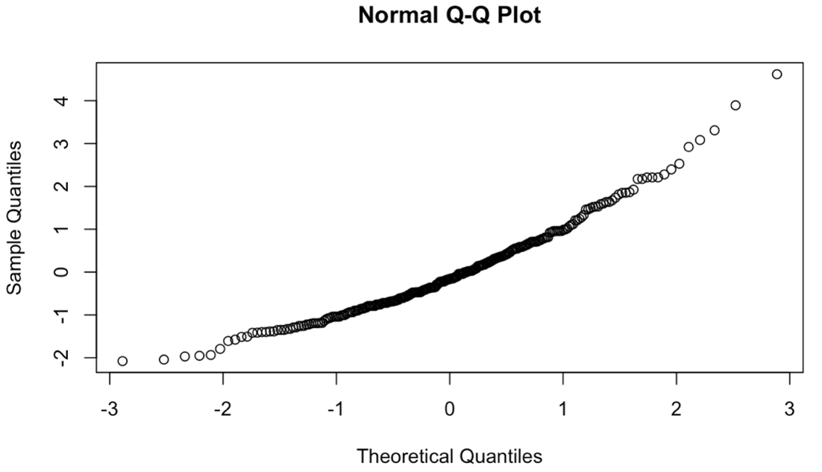

Given that the qq plot of residuals looks is highly deviated from a normal distribution, we try a mixed effects model as a next step below.

Model with vignettes as random effects

 | Judgment
Coefficient | Est. | Std. Beta | CI (95%) | Std. CI | p | std. p
Intercept | 4.93 | 0.53 | 4.50 – 5.36 | 0.33 – 0.73 | <0.001 | <0.001
Condition (Hypocrisy) | -2.87 | -1.09 | -3.27 – -2.46 | -1.19 – -0.99 | <0.001 | <0.001
Policy Support | -0.14 | -0.14 | -0.21 – -0.07 | -0.21 – -0.07 | <0.001 | <0.001
Hypocrisy*PolicySupp | 0.27 | 0.26 | 0.17 – 0.37 | 0.16 – 0.36 | <0.001 | <0.001
Random Effects
σ² | 2.00
τ₀₀ _{topic} | 0.11
ICC | 0.05
N _{topic} | 4
Observations | 1028
Marginal R² / Conditional R² | 0.312 / 0.349

QQplot for residuals of the model

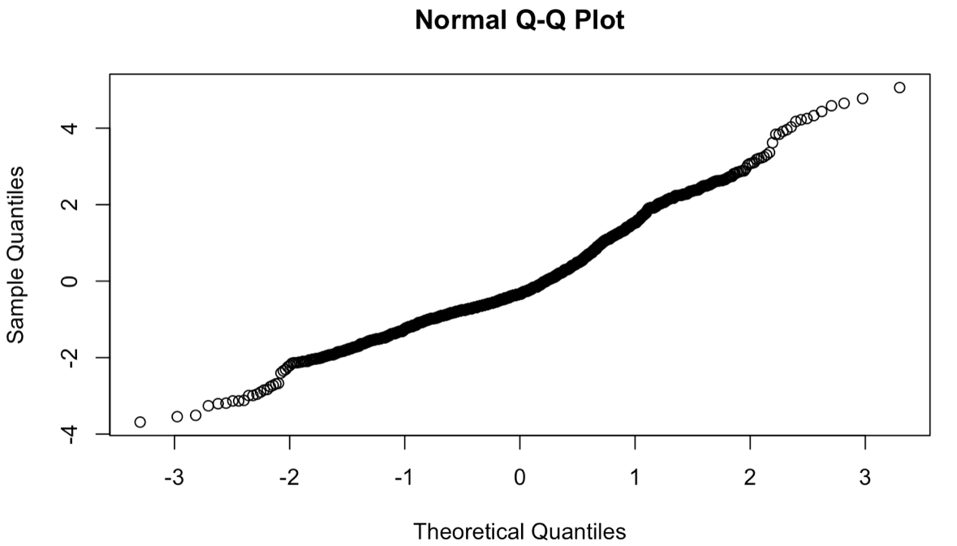

Study 2

Model with Hypocrisy Condition & CC policy support interaction term and with Mean Judgment as DV:

 | Judgment
Coefficient | Est. | Std. Beta | CI (95%) | Std. CI | p | std. p
Intercept | 4.88 | 0.22 | 4.60 – 5.15 | 0.13 – 0.31 | <0.001 | <0.001
Condition (Hypocrisy) | -1.04 | -0.45 | -1.43 – -0.64 | -0.57 – -0.32 | <0.001 | <0.001
Policy Support | -0.42 | -0.51 | -0.50 – -0.35 | -0.60 – -0.42 | <0.001 | <0.001
Hypocrisy*PolicySupp | 0.12 | 0.15 | 0.02 – 0.23 | 0.02 – 0.28 | 0.024 | 0.024
Observations | 706
R² / R² adjusted | 0.254 / 0.251

QQplot of residuals for the model
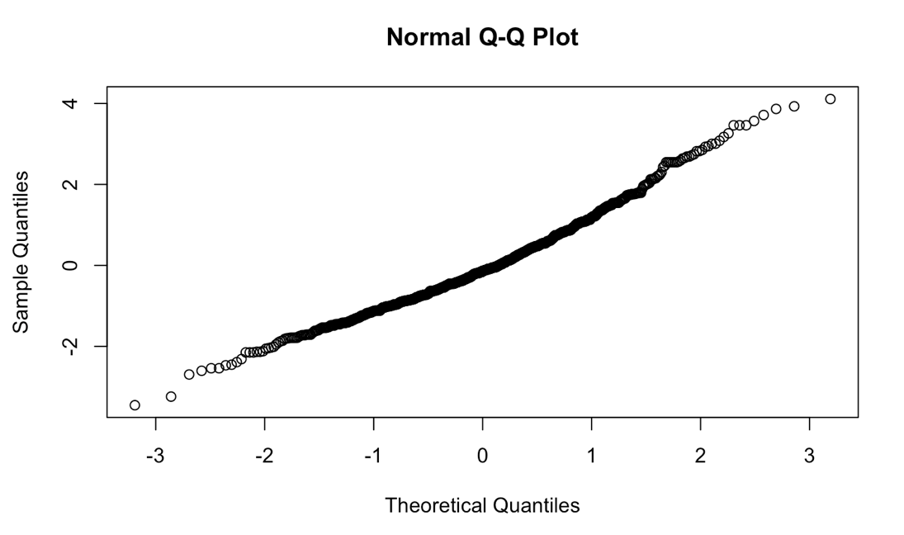

Same model but including the politically ‘moderate/center’ participants:

 | Judgment
Coefficient | Est. | Std. Beta | CI (95%) | Std. CI | p | std. p
Intercept | 4.78 | 0.22 | 4.52 – 5.05 | 0.13 – 0.30 | <0.001 | <0.001
Condition (Hypocrisy) | -0.97 | -0.44 | -1.35 – -0.58 | -0.57 – -0.32 | <0.001 | <0.001
Policy Support | -0.39 | -0.47 | -0.46 – -0.32 | -0.56 – -0.38 | <0.001 | <0.001
Hypocrisy*PolicySupp | 0.11 | 0.13 | 0.00 – 0.21 | 0.00 – 0.25 | 0.046 | 0.046
Observations | 778
R² / R² adjusted | 0.227 / 0.224

Model with Hypocrisy Condition & CC policy support interaction term and Judgment as DV with ‘Topic’ as random effect

 | Judgment
Coefficient | Est. | Std. Beta | CI (95%) | Std. CI | p | std. p
Intercept | 4.88 | 0.17 | 4.43 – 5.32 | -0.05 – 0.39 | <0.001 | 0.132
Condition (Hypocrisy) | -1.04 | -0.35 | -1.35 – -0.73 | -0.42 – -0.27 | <0.001 | <0.001
Policy Support | -0.42 | -0.40 | -0.48 – -0.37 | -0.45 – -0.34 | <0.001 | <0.001
Hypocrisy*PolicySupp | 0.12 | 0.11 | 0.04 – 0.21 | 0.04 – 0.19 | 0.004 | 0.004
Random Effects
σ² | 2.72
τ₀₀ _{topic} | 0.12
ICC | 0.04
N _{topic} | 3
Observations | 2118
Marginal R² / Conditional R² | 0.150 / 0.185

QQ plot of residuals for the model

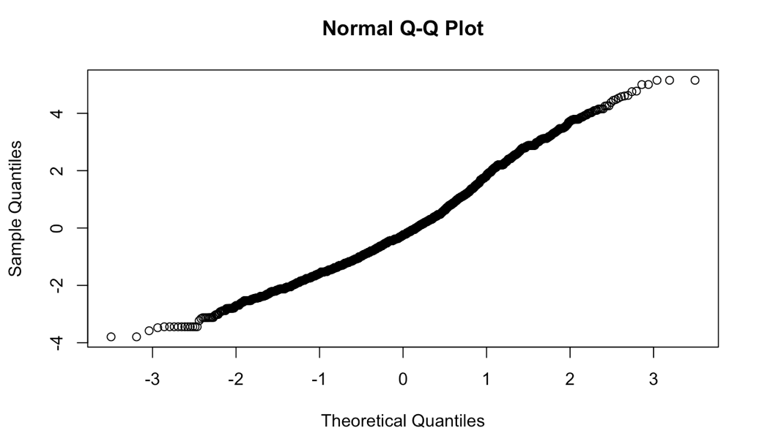

Same model but including the politically ‘moderate/center’ participants:

 | Judgment
Coefficient | Est. | Std. Beta | CI (95%) | Std. CI | p | std. p
Intercept | 4.80 | 0.17 | 4.37 – 5.23 | -0.05 – 0.38 | <0.001 | 0.125
Condition (Hypocrisy) | -0.98 | -0.34 | -1.27 – -0.68 | -0.42 – -0.27 | <0.001 | <0.001
Policy Support | -0.39 | -0.37 | -0.45 – -0.34 | -0.42 – -0.31 | <0.001 | <0.001
Hypocrisy*PolicySupp | 0.11 | 0.10 | 0.03 – 0.19 | 0.03 – 0.17 | 0.008 | 0.008
Random Effects
σ² | 2.74
τ₀₀ _{topic} | 0.11
ICC | 0.04
N _{topic} | 3
Observations | 2346
Marginal R² / Conditional R² | 0.135 / 0.169

Same model but controlling for Plausibility:

 | Judgment
Coefficient | Est. | Std. Beta | CI (95%) | Std. CI | p | std. p
Intercept | 4.92 | 0.17 | 4.44 – 5.40 | -0.05 – 0.39 | <0.001 | 0.133
Condition (Hypocrisy) | -1.04 | -0.35 | -1.35 – -0.73 | -0.42 – -0.27 | <0.001 | <0.001
Policy Support | -0.42 | -0.39 | -0.48 – -0.37 | -0.45 – -0.34 | <0.001 | <0.001
Plausibility | -0.01 | -0.01 | -0.05 – 0.03 | -0.05 – 0.03 | 0.637 | 0.637
Hypocrisy*PolicySupp | 0.12 | 0.11 | 0.04 – 0.21 | 0.04 – 0.19 | 0.004 | 0.004
Random Effects
σ² | 2.73
τ₀₀ _{topic} | 0.12
ICC | 0.04
N _{topic} | 3
Observations | 2118
Marginal R² / Conditional R² | 0.150 / 0.185

Model with ingroup/outgroup, judgment as DV and topic as random effects

 | Judgment
Coefficient | Est. | Std. Beta | CI (95%) | Std. CI | p
(Intercept) | 3.78 | 0.34 | 3.37 – 4.18 | 0.12 – 0.56 | <0.001
condition hc [Hypocrisy] | -0.67 | -0.37 | -0.81 – -0.52 | -0.45 – -0.28 | <0.001
ingroup f [outgroup] | -0.57 | -0.31 | -0.72 – -0.42 | -0.40 – -0.23 | <0.001
Random Effects
σ² | 3.03
τ₀₀ _{topic} | 0.12
ICC | 0.04
N _{topic} | 3
Observations | 2118
Marginal R² / Conditional R² | 0.058 / 0.093

QQ plot of residuals of the model
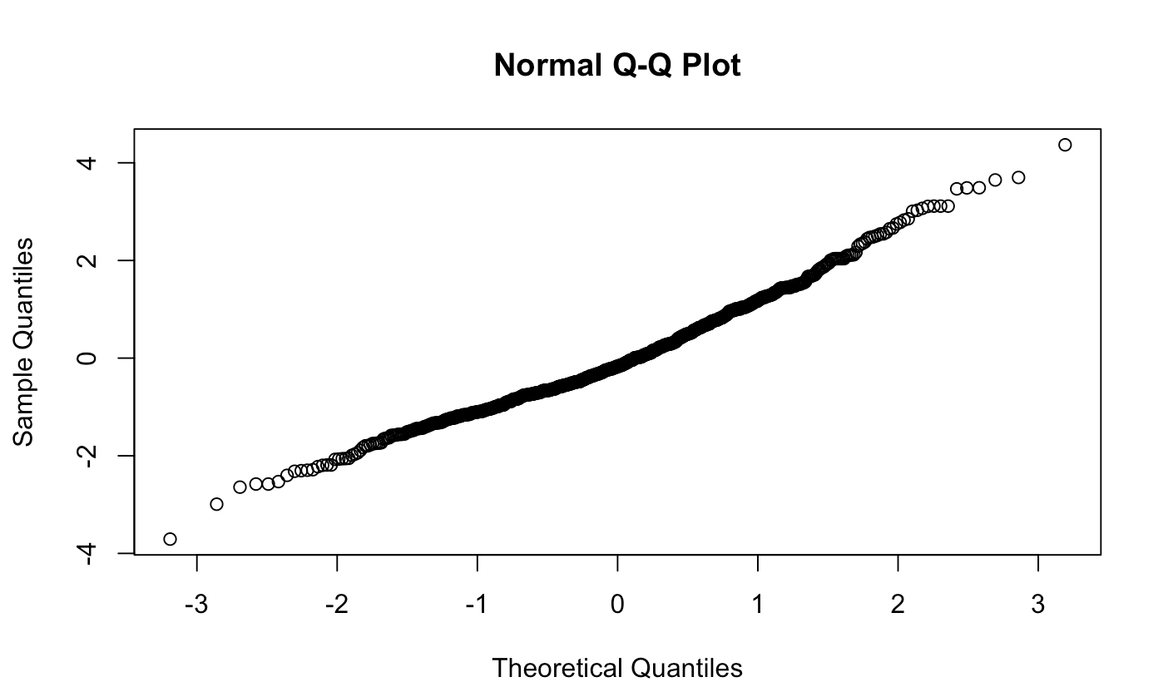

Same model but controlling for Plausibility:

 | Judgment
Coefficient | Est. | Std. Beta | CI (95%) | Std. CI | p
(Intercept) | 3.99 | 0.34 | 3.53 – 4.45 | 0.11 – 0.56 | <0.001
condition hc [Hypocrisy] | -0.66 | -0.36 | -0.81 – -0.51 | -0.45 – -0.28 | <0.001
ingroup f [outgroup] | -0.56 | -0.31 | -0.71 – -0.41 | -0.39 – -0.23 | <0.001
Plausibility | -0.05 | -0.04 | -0.09 – -0.00 | -0.08 – -0.00 | 0.041
Random Effects
σ² | 3.03
τ₀₀ _{topic} | 0.12
ICC | 0.04
N _{topic} | 3
Observations | 2118
Marginal R² / Conditional R² | 0.059 / 0.094

Model including interaction with CC policy support

 | Judgment
Coefficient | Est. | Std. Beta | CI (95%) | Std. CI | p | std. p
(Intercept) | 5.17 | 0.34 | 4.72 – 5.62 | 0.11 – 0.56 | <0.001 | 0.003
condition hc [Hypocrisy] | -0.63 | -0.35 | -0.77 – -0.49 | -0.42 – -0.27 | <0.001 | <0.001
ingroup f [outgroup] | -0.94 | -0.32 | -1.25 – -0.64 | -0.40 – -0.25 | <0.001 | <0.001
cc policy | -0.42 | -0.39 | -0.48 – -0.36 | -0.45 – -0.34 | <0.001 | <0.001
ingroup f [outgroup] × cc  policy | 0.11 | 0.10 | 0.02 – 0.19 | 0.02 – 0.18 | 0.011 | 0.011
Random Effects
σ² | 2.64
τ₀₀ _{topic} | 0.12
ICC | 0.04
N _{topic} | 3
Observations | 2118
Marginal R² / Conditional R² | 0.175 / 0.210

QQ plot of residuals of the model

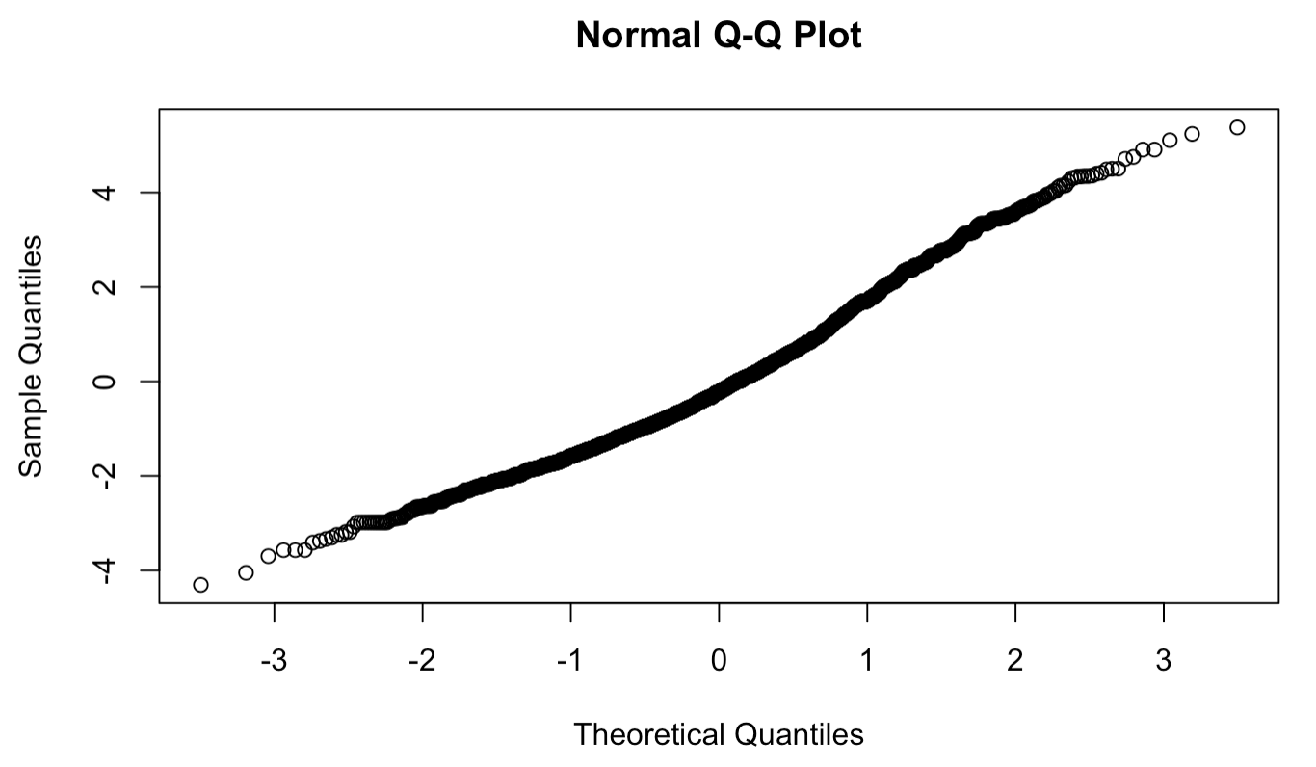

Same model but controlling for Plausibility:

Judgment

Coefficient | Est. | Std. Beta | CI (95%) | Std. CI | p | std. p
(Intercept) | 5.17 | 0.34 | 4.68 – 5.66 | 0.11 – 0.56 | <0.001 | 0.003
condition hc [Hypocrisy] | -0.63 | -0.35 | -0.77 – -0.49 | -0.42 – -0.27 | <0.001 | <0.001
ingroup f [outgroup] | -0.94 | -0.32 | -1.25 – -0.64 | -0.40 – -0.25 | <0.001 | <0.001
cc policy | -0.42 | -0.39 | -0.48 – -0.36 | -0.45 – -0.34 | <0.001 | <0.001
likely | -0.00 | -0.00 | -0.04 – 0.04 | -0.04 – 0.04 | 0.966 | 0.966
ingroup f [outgroup] × cc  policy | 0.11 | 0.10 | 0.02 – 0.19 | 0.02 – 0.18 | 0.011 | 0.011
Random Effects
σ² | 2.64
τ₀₀ _{topic} | 0.12
ICC | 0.04
N _{topic} | 3
Observations | 2118
Marginal R² / Conditional R² | 0.175 / 0.210

Environmental donation behavior

Donation= [1*(Environmental donation) -1*(CC denial donation) + 0*(Neutral donation)]/100

Wilcoxon test

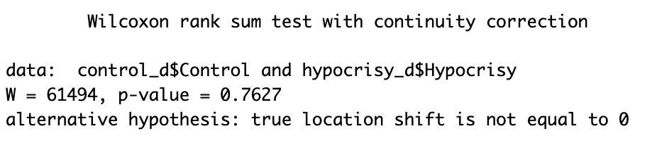

Model with interaction term between CC policy support and Hypocrisy and Ingroup/Outgroup Conditions

 | Donation
Coefficient | Est. | Std. Beta | CI (95%) | Std. CI | p | std. p
(Intercept) | -0.03 | 0.08 | -0.17 – 0.10 | -0.06 – 0.22 | 0.603 | 0.282
condition hc [Hypocrisy] | -0.12 | -0.08 | -0.28 – 0.05 | -0.28 – 0.12 | 0.165 | 0.414
cc policy | 0.09 | 0.31 | 0.05 – 0.12 | 0.19 – 0.43 | <0.001 | <0.001
ingroup f [outgroup] | 0.00 | -0.15 | -0.16 – 0.16 | -0.35 – 0.04 | 0.993 | 0.129
condition hc [Hypocrisy]  × cc policy | 0.02 | 0.08 | -0.02 – 0.06 | -0.06 – 0.22 | 0.257 | 0.257
cc policy × ingroup f  [outgroup] | -0.02 | -0.08 | -0.06 – 0.02 | -0.22 – 0.06 | 0.273 | 0.273
condition hc [Hypocrisy]  × ingroup f [outgroup] | 0.08 | 0.16 | -0.06 – 0.21 | -0.12 – 0.44 | 0.270 | 0.270
Observations | 706
R² / R² adjusted | 0.103 / 0.095

QQplot of the residuals of the model

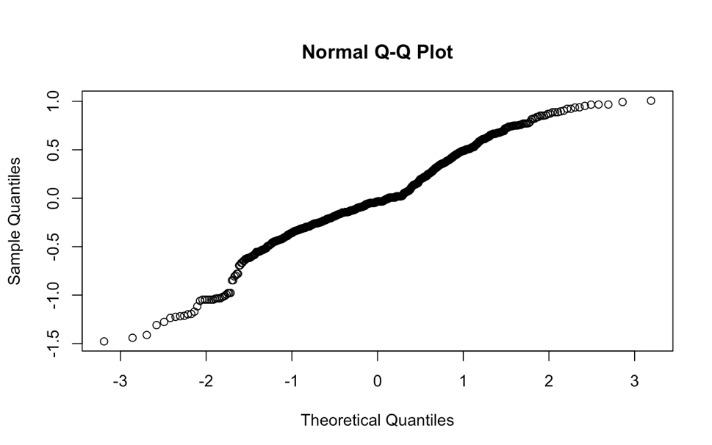

Bootstrapped model

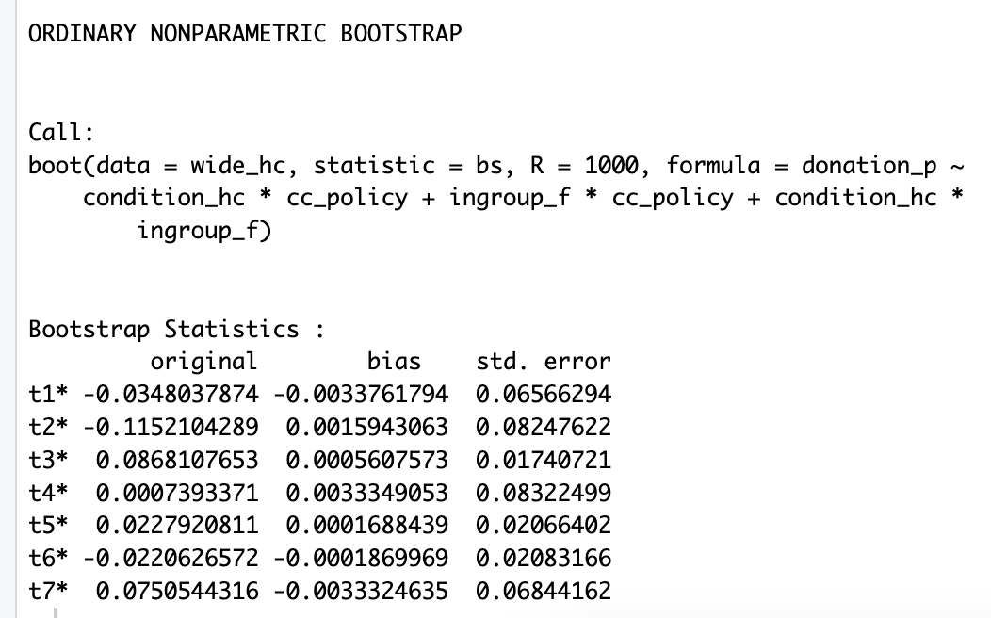

- Boot CI for CC Policy coefficient

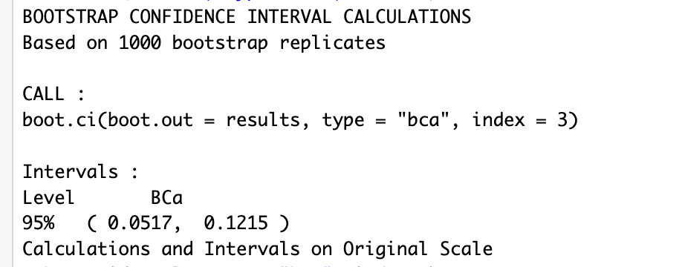

Does Donation behavior vary by Plausibility ratings?

 | Donation
Coefficient | Est. | Std. Beta | CI (95%) | Std. CI | p
(Intercept) | 0.12 | -0.00 | 0.01 – 0.23 | -0.07 – 0.07 | 0.027
likely | 0.02 | 0.07 | -0.00 – 0.04 | -0.00 – 0.15 | 0.057
Observations | 706
R² / R² adjusted | 0.005 / 0.004

Exploratory Analysis:

Emotions analysis

Model for Negative emotions:

 | Negative Emotions
Coefficient | Est. | Std. Beta | CI (95%) | Std. CI | p
(Intercept) | 24.39 | -0.28 | 17.43 – 31.36 | -0.47 – -0.08 | <0.001
condition hc [Hypocrisy] | 10.29 | 0.29 | 7.34 – 13.24 | 0.21 – 0.37 | <0.001
ingroup f [outgroup] | 9.55 | 0.27 | 6.60 – 12.51 | 0.19 – 0.35 | <0.001
Random Effects
σ² | 1201.01
τ₀₀ _{topic} | 32.78
ICC | 0.03
N _{topic} | 3
Observations | 2118
Marginal R² / Conditional R² | 0.039 / 0.064

Model for Positive Emotions

 | Positive Emotions
Coefficient | Est. | Std. Beta | CI (95%) | Std. CI | p
(Intercept) | 21.13 | 0.20 | 17.07 – 25.18 | 0.05 – 0.35 | <0.001
condition hc [Hypocrisy] | -4.67 | -0.18 | -6.92 – -2.43 | -0.26 – -0.09 | <0.001
ingroup f [outgroup] | -5.92 | -0.22 | -8.16 – -3.68 | -0.31 – -0.14 | <0.001
Random Effects
σ² | 691.76
τ₀₀ _{topic} | 9.87
ICC | 0.01
N _{topic} | 3
Observations | 2118
Marginal R² / Conditional R² | 0.020 / 0.034

