Table. 1: Characteristics of biopolymers used in geotechnical engineering [20–23].
Specifications | Chemical composition | Biopolymer
High viscosity | 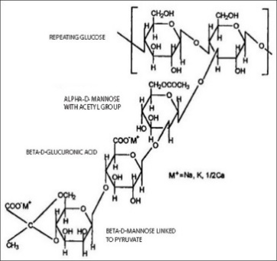 | Xanthan Gum
Gel formation by dissolving in boiling water and cooling to room temperature | 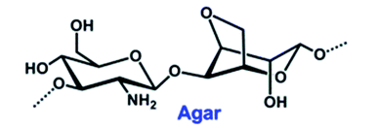 | Agar Gum
Gel formation by heating in aqueous solutions | 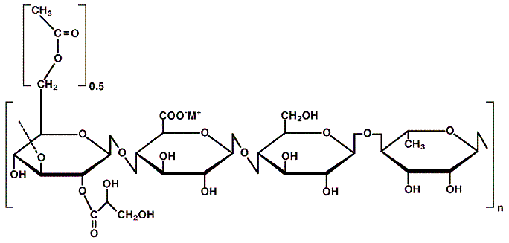 | Gellan Gum
Gel formation  Thickener | 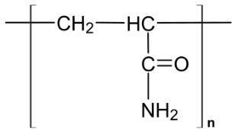 | Polyacrylamide
Gel formation by heating in aqueous solutions | (C6H10O5) | Curdlan
Its properties depend on the chain length. | 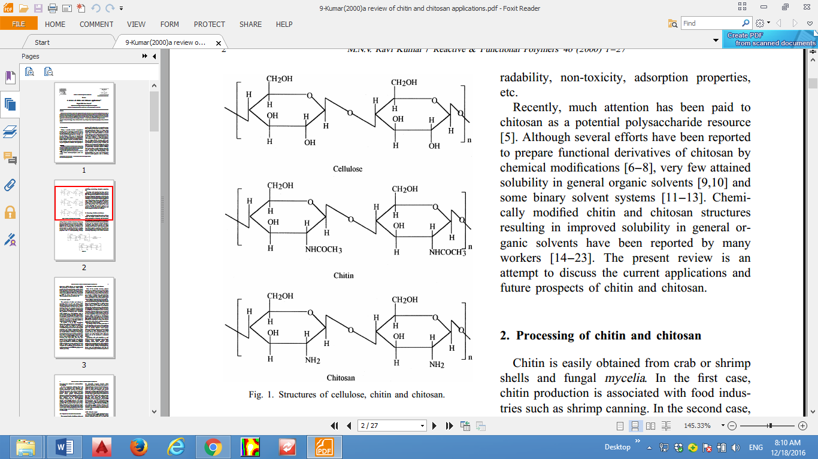 | Cellulose
High viscosity (gelatinization ability) | 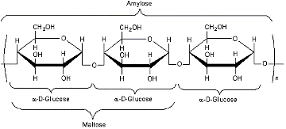 | Starch
Capable of performing immune functions in the human body  Ability to absorb cholesterol | 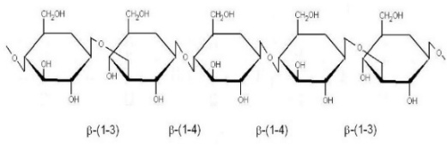 | Beta-Glucan
Biodegradable gel formation |  | Chitosan

table. 3 soil’s characteristics
Soil condition Examination results
Plastic Limit (PL) 30.79%
Liquid Limit (LL) 21.49%
Plasticity Index (PI) 9.30%

