Supplementary
Table 1. Inclusion and exclusion criteria by site
Site A
Inclusion Criteria |  | Exclusion Criteria
a) | Histologically or cytologically confirmed malignant advanced solid tumours due to commence ICI therapy | g) | Prior surgery, radiation, chemotherapy, or other anti-cancer therapy within 4 weeks prior to enrolment in the study. Endocrine/hormonal treatments may be continued.
b) | Documented tumour progression as defined by clinical, biochemical, or radiological (RECIST) criteria. | h) | All patients who have received prior immunotherapy / ICI must be discussed with the sponsor regarding eligibility to enrol on this translational study
c) | Measurable disease (clinical or radiological) | i) | Diagnosis of immunodeficiency or receiving systemic steroid therapy or any other form of immunosuppressive therapy within 7 days before enrolling in the research study. The use of physiologic doses of corticosteroids may be approved after consultation with the chief investigator.
d) | Life expectancy greater than 3 months | j) | No known history of human immunodeficiency virus (HIV) (known HIV1 / 2 antibodies positive), no known active hepatitis B (defined as known positive HBsAg) or hepatitis C (defined as known positive Hep C Ab and known quantitative HCV RNA results > lower limits of detection of assay)
e) | Age ≥18 years | k) | Active autoimmune disease that has required systemic immunosuppressive treatment in the past 2 years (i.e. with the use of disease modifying agents, corticosteroids or other immunosuppressive drugs). Replacement therapy (e.g. thyroxine, insulin, or physiologic corticosteroid replacement therapy for adrenal or pituitary insufficiency, etc.) is not considered a form of systemic treatment.
f) | Signed informed consent | l) | Active infection requiring systemic therapy
 |  | m) | No previous allogeneic tissue / solid organ transplant
Site B
Inclusion Criteria |  | Exclusion Criteria
a) | Patients due to commence neoadjuvant chemotherapy or chemoradiation for documented histologically confirmed early-stage locally advanced breast cancer or early-stage locally advanced GI cancers diagnoses. Including: | h) | Previous diagnosis of cancer that was treated with chemotherapy, radiation therapy, chemoradiation combination therapy or immunotherapy before or any other anticancer treatment.
b) | Breast Cancer – all HER-2 positive, ER and PR positive subtypes and TNBC treated with neoadjuvant treatment, including monoclonal antibodies | i) | Active infection requiring systemic antibiotic therapy
c) | Rectal Cancer treated with neoadjuvant therapy | j) | Previous allogenic tissue/solid organ transplant
d) | Oesophageal Cancer treated with a neoadjuvant approach including gastro-oesophageal junctional carcinoma
e) | ECOG Performance Status 0-2
f) | Age≥ 18 years old
g) | Willingness and consent to comply with study protocol with signed informed consent obtained

Site C
Inclusion Criteria |  | Exclusion Criteria
a) | Able to give written informed consent | f) | Less than 18 years of age
b) | Be over 18 years of age. | g) | Patients who, in the opinion of the clinician, would not be able to comply with the study requirements or who would be distressed by being invited to participate
c) | Life expectancy greater than 3 months | h) | Previous ICI treatment
d) | Scheduled to receive any line of palliative ICI alone or in combination with Tyrosine Kinase Inhibitors (TKI) and/or cytotoxic chemotherapy | i) | Patients on clinical ICI trials (academic or commercial) are excluded unless the trial sponsor gives written permission
e) | Able to provide stool samples at home and post to the CR@UCC laboratory

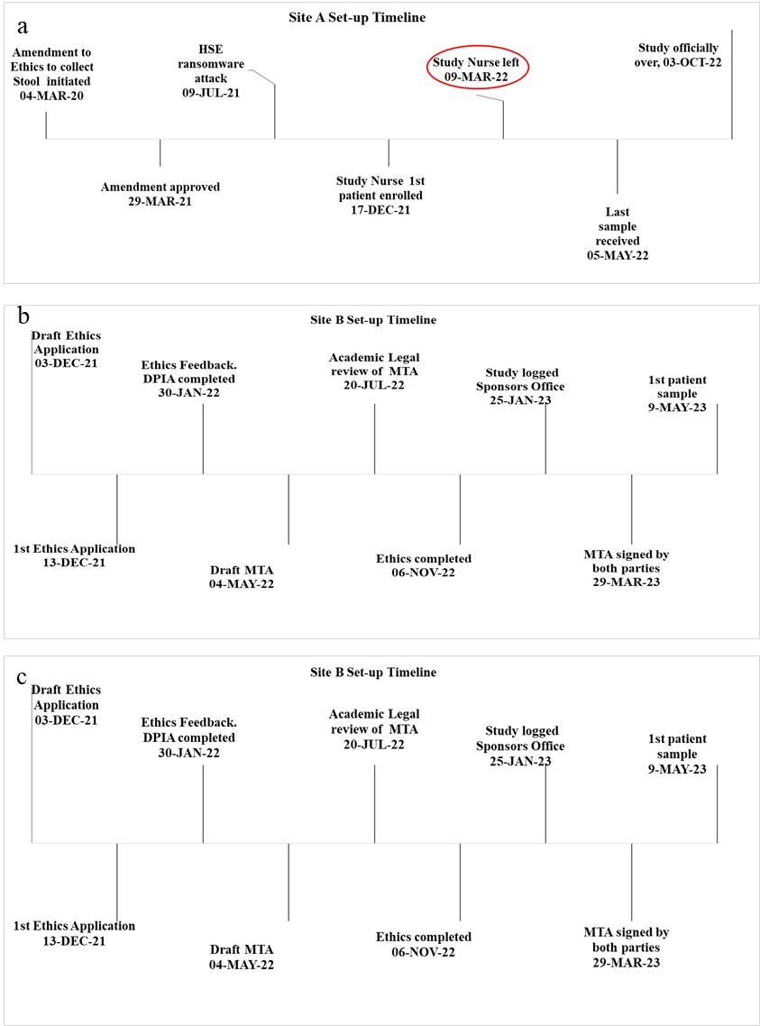

Supplementary Figure 1. Timeline for each translational microbiome-wide association study (MWAS), from the decision to initiate the study through to first participant consent or sample collection, highlighting key events. Events are shown in chronological order but are not to scale. a) Site A; b) Site B; c) Site C.

