Supplementary figures

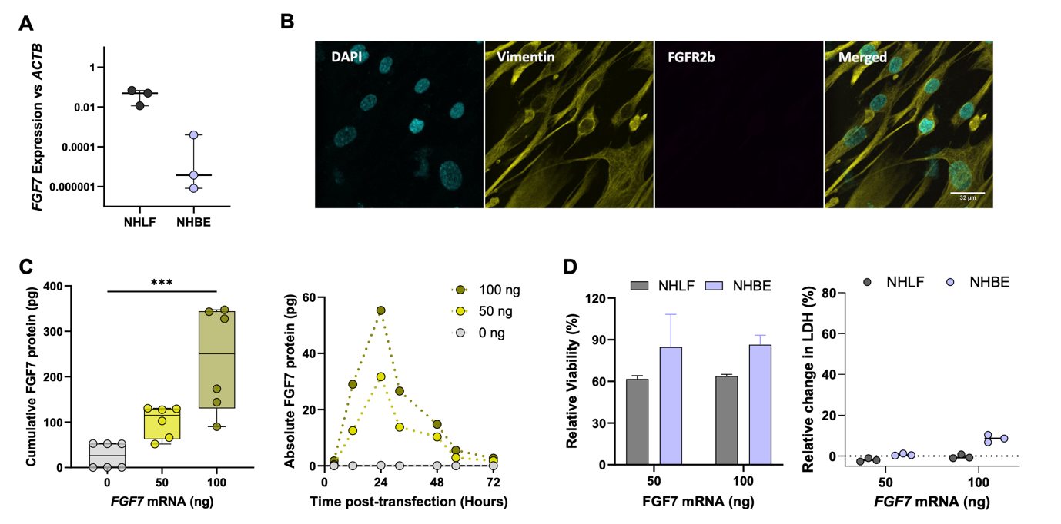

Figure S1. Characterisation of baseline FGF7-FGFR2 in primary lung cells and FGF7 secretion post-transfection of primary human lung fibroblasts. (A) Baseline gene expression of FGF7 in primary normal human bronchial epithelial cells (NHBE) and normal human lung fibroblasts (NHLF) (n =3 primary donors). (B) Immunofluorescent staining of primary NHLF depicting DAPI (blue), vimentin (yellow) and absence of FGFR2b receptor. Scale bar = 32 µm. (C) Primary NHLF were transfected with 50 and 100 ng of modified FGF7 mRNA complexed with Lipofectamine and cumulative FGF7 protein in supernant was measured over 72 hours and at multiple time points to capture expression kinetics (n = 2 primary donors). (D) Viability was mesured by resazurin based assay and cytotoxicity measured by LDH release 24 hours after transfection with FGF7 mRNA complexed with lipofectamine and compared to non-transfected control (1 primary donor).

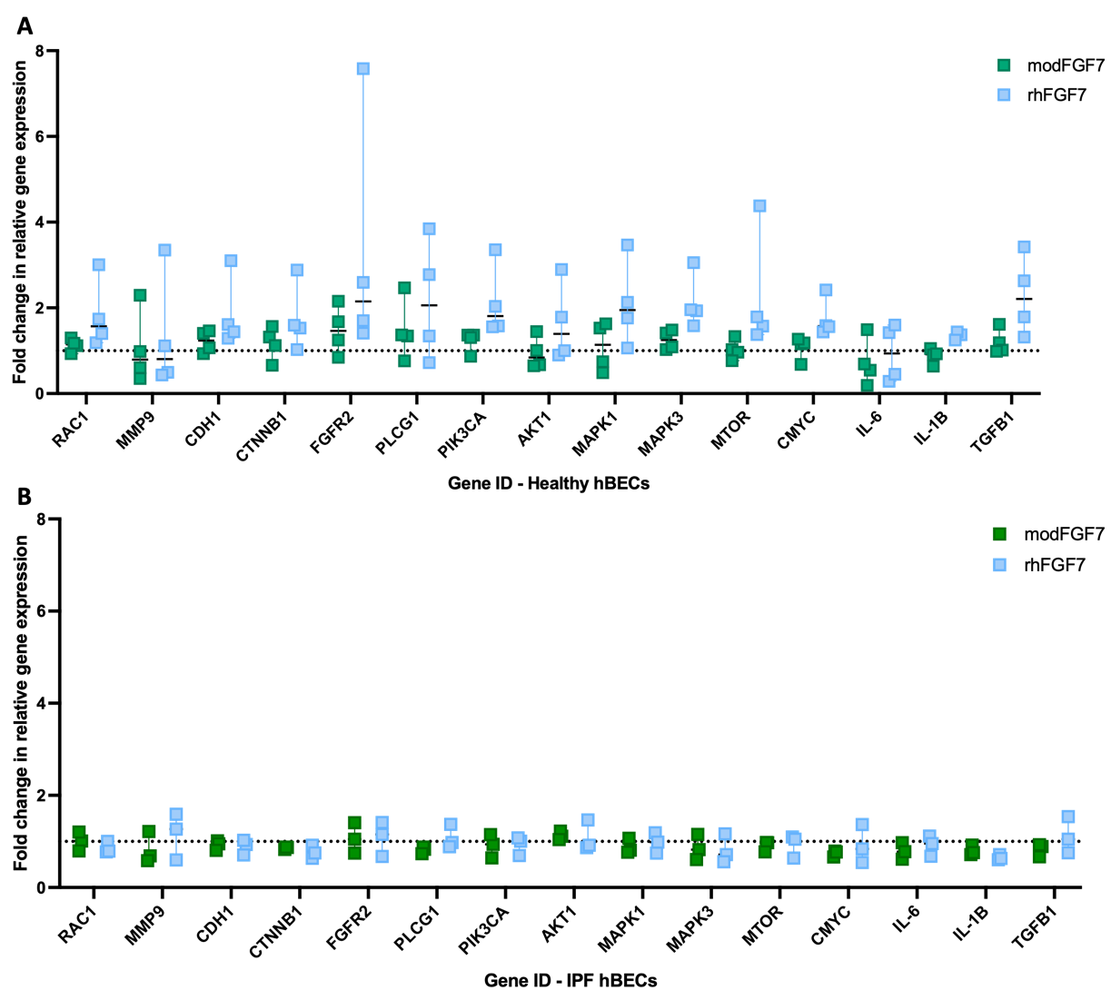

Figure S2. Gene expression in healthy and IPF primary hBEC wounds 72 hours post-injury relative to housekeeping gene ACTB and fold-change normalised to control. Primary human bronchial epithelial cell (hBEC) monolayers from either healthy (A) or IPF donors (B) were treated with rhFGF7 (20 pg/µl), supernatant from primary hBECs transfected with 50 ng FGF7 mRNA (modFGF7), or untreated hBEC conditioned media (control), for 72 hours before mechanical injury of the epithelial monolayer. Cultures were harvested 72 hours after injury and gene expression determined relative to housekeeping gene (ACTB). Fold change in relative gene expression was normalised to control (dashed line at Y = 1). N = 4 primary cell donors for healthy hBECs and 3 primary donors for IPF hBECs, each donor represents a pooled technical triplicate.

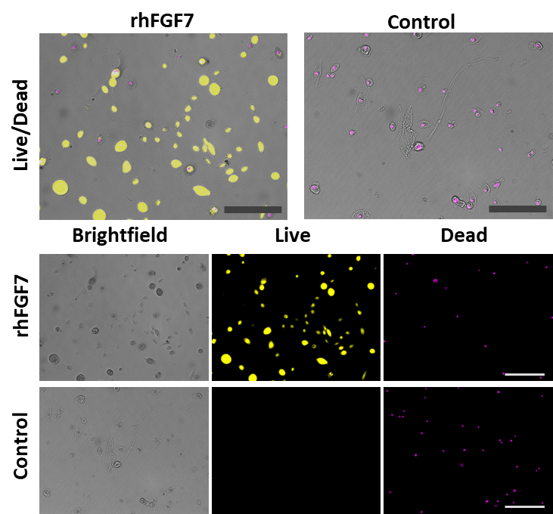

Figure S3. Live/dead staining of primary hBEC seeded at low density. Representative immunofluorescent imaging depicting live (yellow) and dead (magenta) primary human bronchial epithelial cells (hBECs) at 40-hours post-treatment with 20 pg/µl rhFGF7 or PBS control in an additional primary cell donor. Scale bars = 200 µm.

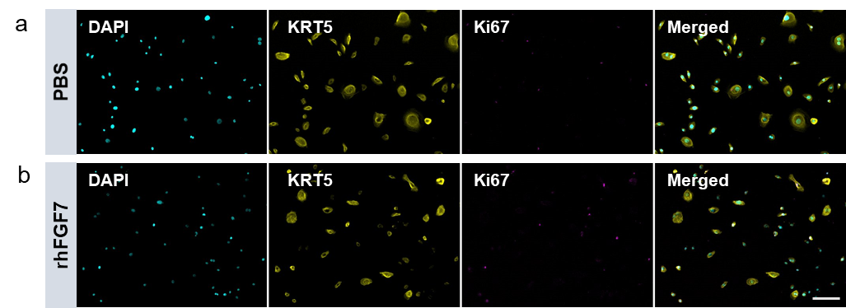

Figure S4. Immunostaining of cell proliferation and basal cell markers in primary hBEC seeded at low density. Representative images of DAPI (blue), KRT5 (yellow), Ki67 (magenta) in an additional primary hBEC donor a) treated with PBS control or b) rhFGF7 (20 pg/μL). Scale bar = 100 μm

