Supplementary information for:
Charge transfer across the metal/oxide interface determines the rate of CO₂ hydrogenation to methanol over Cu/ZnO catalysts
Jonas A. Boysen¹, Rasmus Svensson², Niels. D. Nielsen¹, Mads Lützen³, Lin Bigom-Eriksen¹, Andrey Shavorskiy⁴, Thomas E. Andersen¹, Jacob L. Fischer¹, Jean-Claude Grivel⁵, Christian D. Damsgaard^{3,6}, Anker D. Jensen¹, Henrik Grönbeck² and Jakob M. Christensen¹
¹Department of Chemical and Biochemical Engineering, Technical University of Denmark,
2800 Kgs. Lyngby, Denmark
²Department of Physics and Competence Centre for Catalysis, Chalmers University of
Technology, SE-412 96 Göteborg, Sweden
³National Centre for Nanofabrication and Characterisation, Technical University of Denmark, 2800 Kgs. Lyngby, Denmark
⁴MAX IV Laboratory, Lund University, 22484 Lund, Sweden
⁵Department of Energy Conversion and Storage, Technical University of Denmark,
2800 Kgs. Lyngby, Denmark
⁶Department of Physics, Technical University of Denmark,
2800 Kgs. Lyngby, Denmark
*jmc@kt.dtu.dk

1 Further experimental details and results
1.1 Employed samples
Table S1 shows a summary of the samples used in the investigations. For the studies varying the Cu surface area, we prepared Cu/ZnO samples with different metallic areas by varying the composition, varying the addition rate (dripping speed) of the nitrate and carbonate solutions during the precipitation and by varying the calcination temperature. The slow, medium and fast dripping speeds correspond to 6 mL/min, 12 mL/min and 17 mL/min. However, as the control is manual, the dripping speeds are not more accurate than ± 10-15%. The mechanistic and spectroscopic investigations used the CZA1 sample with 37.1 m² Cu/g surface area. We prepared pure ZnO by precipitation. For the mechanistic analyses, we also used a 10 wt% Pt on precipitated ZnO sample prepared by impregnation and commercial pure Pt black from Sigma Aldrich. For TEM and IR spectroscopy on Pt/ZnO, we used a sample with 2 wt% Pt impregnated onto commercial low-surface area ZnO from Sigma Aldrich. The low surface area ZnO was chosen to get better TEM images showing the profile of the Pt particles as facilitated by the large ZnO crystals. To ensure that the IR and XPS shifts for Pt/ZnO were not due to particle size effects we also made a Pt/SiO₂ sample by impregnating Pt onto commercial SiO₂ from Saint Gobain.
Table S1 The samples used in the experimental work.
Name | Sample | Cu surface area (m²/g_{cat}) | Avg. particle diameter (nm) | Composition (mol%) | Calcination temperature (°C) | Dripping speed during precipitation
CZA1 | Cu/ZnO/Al₂O₃ | 37.1 | 10.8 | 60/30/10 | 330 | Slow
CZA2 | Cu/ZnO/Al₂O₃ | 33.0 | 12.2 | 60/30/10 | 330 | Medium
CZA3 | Cu/ZnO/Al₂O₃ | 25.5 | 15.8 | 60/30/10 | 330 | Fast
CZA4 | Cu/ZnO/Al₂O₃ | 16.5 | 22.3 | 55/27/18 | 330 | Medium
CZA5 | Cu/ZnO/Al₂O₃ | 14.3 | 25.8 | 55/27/18 | 500 | Medium
CZA6 | Cu/ZnO/Al₂O₃ | 12.0 | 30.7 | 55/27/18 | 600 | Medium
CZ | Cu/ZnO | 5.7 | 11.7 | 10/90 | 330 | Medium
ZnO-HSA | ZnO | 31ª | 34.5 | 100 | 330 | Medium
ZnO-LSA | Commercial ZnO from Sigma Aldrich | 7.7ª
SiO₂ | Commercial SiO₂ from, Saint Gobain | 252
 | Pt black | 32^{b} | 8.8 | 100 | N/A
 | 2 wt% Pt/ZnO | 7.7ª | Ca. 10^{c} |  | 330
 | 2 wt% Pt/SiO₂ |  |  |  | 330
 | 10 wt% Pt/ZnO | 31ª |  |  | 330
a ZnO area b Pt area c From TEM

1.2 Analyses of the reaction mechanism
1.2.1 Comparison of formate distribution and methanol isotope composition
When switching from H₂ to D₂ during CO₂ hydrogenation, IR spectroscopy shows that some surface formates are exchanged from HCOO to DCOO indicating that formate is involved in the catalytic reaction (Fig. E1f). However, to prove the involvement of formate we had to quantify the isotope distribution of formate and the formed methanol in a given situation. We achieved steady state methanol synthesis with a 4:1 H₂:CO₂ mixture and then made a small perturbation by replacing H₂ with a 9:1 H₂:D₂ mixture. Kinetic analyses reveal that formate formation is quasi equilibrated during methanol synthesis (Fig. E1c). As long as perturbations are so small that the changes in total coverage are also small, we can express the coverage of formate from the equilibrium expressions in Eqs. 1 and 2. Here we write up the global equilibria in terms of the detailed mechanism most indications are that the formate formation is by an Eley-Rideal mechanism¹.
${½H}_{2}+{CO}_{2}⇌{HCOO}_{ads}⟹θ_{HCOO}=K_{HCOO}{\left(\frac{p_{H_{2}}^{}}{p°}\right)}^{½}\left(\frac{p_{{CO}_{2}}^{}}{p°}\right)θ_{*}$ Eq. 1
${½D}_{2}+{CO}_{2}⇌{DCOO}_{ads}⟹θ_{DCOO}=K_{HCOO}{\left(\frac{p_{D_{2}}^{}}{p°}\right)}^{½}\left(\frac{p_{{CO}_{2}}^{}}{p°}\right)θ_{*}$ Eq. 2
Where p° is the standard pressure. For the equilibrium constant we have:
$K=exp\left(\frac{-ΔH}{RT}\right)exp\left(\frac{ΔS}{R}\right)$ Eq. 3
Here ΔH and ΔS represent the reaction enthalpy and entropy for the reactions in Eqs. 1&2.
The relative coverage becomes:
$\frac{θ_{DCOO}}{θ_{DCOO}+θ_{HCOO}}=\frac{K_{HCOO}p_{H_{2}}^{0.5}}{K_{DCOO}p_{D_{2}}^{0.5}+K_{HCOO}p_{H_{2}}^{0.5}}$ Eq. 4

Adsorbate-adsorbate interactions will typically result in contributions to Eq. 3², which means that absolute coverages determined from the Langmuir model can be incorrect. However, when we focus on a small perturbation that does not significantly change the total coverage the adsorbate-adsorbate interactions term cancels out in Eq. 4. In order to evaluate Eq. 4, we need the difference in ΔH and ΔS between HCOO and DCOO (the absolute values cancel out in Eq. 4). The difference in ΔS was obtained from the DFT calculations by Behrens and co-workers³. The difference in ΔH was obtained from the difference in desorption energy between pre-adsorbed HCOO and DCOO during TPD experiments using the Redhead equation. Here we assumed a pre-factor of 10¹³ s⁻¹, but since we focus on differences this assumption largely cancels out. Fig. S1 shows the CO₂ evolution in TPDs of pre-adsorbed HCOO and DCOO, we made two runs with HCOO and used the difference to estimate the uncertainty in the determinations which are shown as error bars in Fig. 1a in the main text.
Fig. S1 CO₂ evolution during TPD in Ar for pre-adsorbed HCOO and DCOO on Cu/ZnO/Al2O3. 50 NmL/min Ar flow, 2 °C/min ramp.

Fig. S2 Methanol MS signals (31-36) when switching from an 80/0/20 H₂/D₂/CO₂ feed to a 72/8/20 H₂/D₂/CO₂ feed at 135 °C 1 bar, 4.8·10⁴ NmL/g_{cat}/h.

In the MS, a CX₃OY molecule gives an 80% signal on the mass of CX₃OY and a 100% signal on the mass of CX₂OY. Because literature ^{4–6} suggests that all methanol isotopes behave similarly we use a statistical distribution when there are multiple possibilities. For CX₂YOX we split the 100% signal into a 67% contribution for CXYOX and a 33% contribution for CX₂OX as there are two ways of making the former and one way of making the latter. We use this to deconvolute the isotope distribution of the methanol molecules. Table S2 shows the steady state MS signals in H₂/D₂.

Table S2. MS signals (Í10¹⁰) at steady state in 72/8/20 H₂/D₂/CO_{2.}
m/z | Signal
31 | 2.37814
32 | 2.32146
33 | 0.735776
34 | 0.103639

As we measure no mass 35 and 36, we have no 3-deuterium species and we thus have 5 possible isotopes: CH₃OH, CDH₂OH, CH₃OD, CDH₂OD and CHD₂OH. We then use a least squares solver to find the isotope distribution that best describes the masses. Below we give the sample calculations for masses 31 and 32, with C denoting the concentration of each species.
$m_{31}=1∙C_{CH_{3}OH}+0.33∙C_{C{DH}_{2}OH}$ Eq. 5
$m_{32}=0.8∙C_{CH_{3}OH}+0.67∙C_{C{DH}_{2}OH}+1∙C_{CH_{3}OD}+0.33∙C_{C{DH}_{2}OD}+0.67∙C_{C{HD}_{2}OD}$ Eq. 6
A small uncertainty comes from the fact that there is not enough mathematical information to disentangle CDH₂OD and CHD₂OH (4 equations, 5 unknowns). The numerical solver routine typically assigns all the 2-deuterium contribution to one of these species and sets the other to 0. However, these are minority species and they both arise from DCOO (as they both have a D-C bond), so this uncertainty does not change any conclusions. The numerical solutions are carried out in Microsoft Excel or in Python. Note that the people writing the Python scripts have routinely used AI to check for errors in their code (this represents the only use of AI in this work). Note also that the minor noise in the data in e.g. Fig. S2 is exacerbated by the numerical solver disentangling the isotopes and this is the reason why a figure such as Fig. 1d is relatively noisy.

1.2.2 Quantification of the turnovers on Cu and ZnO
Fig. S3 shows the methanol (CDH₂OH) formation during temperature programmed hydrogenation of pre-adsorbed DCOO on Cu, Pt/ZnO and Pt. The results are normalized to the same metal/ZnO area ratio as in the Cu/ZnO catalyst employed for mechanistic evaluations. We used the isotopically labelled species to eliminate the effects of re-adsorption that are characterized by isotope scrambling.

Fig. S3 The relative CDH₂OH production in TPH of pre-adsorbed DCOO, all samples are compared at the same metal or ZnO surface area. 50 NmL/min H₂ flow, 2 °C/min ramp.

The onset temperature of methanol formation in Fig. S3 is 90 °C for pure Cu and 142 °C for Pt/ZnO. For Pt/ZnO the onset temperature is defined as the point where the methanol formation exceeds that of pure Pt which is an indication that formate on ZnO is being converted. We can use this to determine the difference in activation energy between the conversion of formates on Cu and ZnO by Eq. 7

$exp\left(\frac{-E_{a}}{8.314\frac{J}{mol∙K}∙363K}\right)=exp\left(\frac{-\left(E_{a}+{ΔE}_{a}\right)}{8.314\frac{J}{mol∙K}∙415K}\right)⟺{ΔE}_{a}=9.4\frac{kJ}{mol}$ Eq. 7

At a representative temperature range for methanol synthesis of 220-280 °C this difference corresponds to an 8-10 fold higher rate from formate on Cu. As a further verification that formates on the metal are far more reactive than formates on ZnO Fig. S4 show the formation of methanol (CDH₂OH) from pre-adsorbed DCOO on Pt/ZnO and Cu/ZnO/Al₂O₃ compared at an identical ZnO surface area. The results show that the formates on ZnO corresponds to the least reactive formates on the Cu/ZnO/Al₂O₃ sample.

Fig. S4 The relative CDH₂OH production in TPH of pre-adsorbed DCOO. The samples are compared at the same ZnO surface area. 50 NmL/min H₂ flow, 2 °C/min ramp.

1.2.3 Further arguments for the role of HCOOH dissociation as the rate limiting step

The major argument for the unimolecular dissociation of formic acid as the rate limiting step in methanol synthesis is that conversion of a pulse of formic acid is possible at the same temperature where adsorbed formate can be converted (Fig. 1c) and that the conversion of formic acid is independent of whether the surrounding gas is H₂ or D₂ (Fig. 1e). However, an additional argument comes from the reaction kinetics. The methanol synthesis is first order in the hydrogen pressure (Fig. S5) on both Cu and Cu/ZnO/Al₂O₃.

Fig. S5 Methanol synthesis rate vs hydrogen pressure (220 ℃ 40 bar, feed flow = 270 NmL/min, p_{CO2} = 1.2 bar, balance Ar, 3.83·10⁶ NmL/g_{cat}/h for Cu/ZnO/Al₂O₃ and 6.48·10⁴ NmL/g_{cat}/h for unsupported Cu).

Our identified reaction mechanism is a quasi-equilibrated formation of HCOOH and then a rate limiting dissociation of HCOOH. In a Langmuir-Hinshelwood kinetic scheme, this is consistent with the 1. Order nature of the reaction, with r→ denoting the forward reaction rate.

$H_{2}+{CO}_{2}⇌{HCOOH}_{ads}⟹θ_{HCOOH}=K_{HCOOH}\left(\frac{p_{H_{2}}^{}}{p°}\right)\left(\frac{p_{{CO}_{2}}^{}}{p°}\right)θ_{*}$ Eq. 8
${HCOOH}_{ads}⟶{HCO}_{ads}+{OH}_{ads}⟹r_{→}={kK}_{HCOOH}\left(\frac{p_{H_{2}}^{}}{p°}\right)\left(\frac{p_{{CO}_{2}}^{}}{p°}\right)θ_{*}$ Eq. 9

We know experimentally⁷ that on pure Cu, coverages are low. This means that $θ_{*}≅1$ and that the Langmuir model consequently is reasonably accurate². The reaction rate on pure Cu should therefore according to Eq. 10 be exactly proportional to the H₂ pressure and this is also observed in Fig. S5. For Cu/ZnO/Al₂O₃, coverages are higher⁸ and as a result the reaction order deviates slightly from 1 due to coverage effects.
The other argument for HCOOH dissociation as the rate limiting step is that conversion of pulses of formic acid is independent of whether the surrounding gas is H₂ or D₂ indicating that only formic acid is involved in the rate limiting step. Fig. 1d in the main text uses experiments on unsupported Cu to establish this. Here we show that unsupported Cu and Cu/ZnO/Al₂O₃ behave identically in their HCOOH conversion and that the use of unsupported Cu is due to a greater isotopic scrambling for Cu/ZnO/Al₂O₃ that could risk distorting the results.

Fig. S6 shows experiments where a HCOOH pulse is injected during TPH of pre-adsorbed formate for both unsupported Cu and Cu/ZnO/Al₂O₃, similar to the experiment shown in Fig. 1c in the main text. Fig. S6 demonstrates that unsupported Cu and Cu/ZnO/Al₂O₃ behave identically in terms of their conversion of HCOO and HCOOH, except for the fact that the methanol yield is raised by an order of magnitude for Cu/ZnO/Al₂O₃ due to the Cu-ZnO synergy.
Fig. S6 TPH of pre-adsorbed HCOO on unsupported Cu or Cu/ZnO/Al₂O₃ compared to an experiment with a HCOOH pulse injection at 200 ℃ during the TPH experiment. Left: Unsupported Cu with and without pulse injection. Right: comparison of the pulse injection experiments during TPH for unsupported Cu or Cu/ZnO/Al₂O₃.

Fig. S7 shows the type of pulse experiments used to achieve Fig. 1e in the main text. Fig. S7 shows that for Cu/ZnO/Al₂O₃, the isotope composition can change between pulses, whereas this does not occur for pure Cu. We attribute this isotope scrambling to readsorption of the formed methanol in a form where H and can be exchanged. Since it is known⁹ that formed methanol readsorbs as CH₃O on the ZnO this is the most likely explanation. For Cu/ZnO/Al₂O₃, formed CDH₂OH readsorbs as CDH₂O, undergoes H/D exchange to CH₃O and in the subsequent pulse release of adsorbed CH₃O changes the isotope composition. Because isotope labeling conclusions are potentially distorted by such isotope scrambling effects, we have based the conclusions in Fig. 1e on experiments with pure Cu. The quantification of the pulses in Fig. S7 is achieved by making a GC measurement during the pulse and then calibrating the continuous MS signal to this measurement. The error bars in Fig. 1e arise from the variations visible in the data for unsupported Cu in Fig. S7, and the variation mainly arises from the manual injection of a small DCOOD pulse (2 μL of liquid) with a GC syringe.

Fig. S7 Relative concentrations of the two major isotopes CDH₂OH and CH₃OH during injection of successive pulses of DCOOD into an H₂ flow passing over Cu/ZnO/Al₂O₃ (left) and unsupported Cu (right).

Another strong argument that we have indeed identified the correct rate limiting step is that the kinetic isotope effect in formic acid conversion is the same as in the overall methanol synthesis reaction as observed here (see section 1.9) and elsewhere^{3,10,11}.

Fig. S8 Comparison of the H₂/D₂ kinetic isotope effect for the X₂/CO₂ reaction to CX₃OX (Cu/ZnO/Al₂O₃, 135 °C, 1 bar, X/CO₂ = 4/1 4.8∙10⁴ NmL/g_{cat}/h) and for the conversion of formic acid into methanol (unsupported Cu, 200 °C, 1 bar, 53 μmol pulses of XCOOX injected into 100 NmL/min H₂ flow).

1.2.4 Overall mechanistic conclusions
Fig. S9 summarizes the identified reaction mechanism and notes where the conclusions for each reaction step can be found. The illustration in Fig. S9 (and Fig. 1f) is made using the molecular arrangements identified in the DFT calculations.
Fig. S9 The reaction mechanism most consistent with the experimental observations with markings at each reaction step indicating the figures/data leading to the conclusion about this mechanistic step. Colours: O: red, Zn: light blue, C: black, Cu: tan, H: white.

1.3 Ambient pressure XPS analysis
1.3.1 Energy calibration
Appropriate energy calibration is essential for accurate XPS measurements. Fig. S10 shows a diagram of the sample which is lying on a grounded Au foil. Fig. S10 also shows the C 1s regions in survey spectra of two samples. The fact that the position and intensity of the C 1s signal depends on the sample indicates that adventitious carbon is mainly present on the sample rather than on the Au foil.
Fig. S10 Left Diagram of the powder sample lying on the grounded Au foil. Right XPS measurements (from survey spectra) in the C 1s region for both pure Cu and Cu/ZnO/Al₂O₃.
For Cu/ZnO/Al₂O₃, there are three possible energy references for the Cu XPS energies, namely Zn 2p_{3/2} from the ZnO matrix, C 1s from adventitious carbon and Au 4f_{7/2} from the Au foil. For pure Cu there are the C 1s and Au 4f_{7/2} values. Fig. S11 shows that using C and Zn gives similar results for Cu/ZnO/Al₂O₃ whereas using Au gives a different energy correction. This indicates that elements on the Cu/ZnO/Al₂O₃ sample (Cu, Zn, C etc) experience a different charging. For pure Cu, the corrections from Au and C give similar values indicating that the pure Cu sample and the Au foil are charged to the same degree. On this basis, we have used Zn as the energy reference for Cu/ZnO/Al₂O₃ and Au as the energy reference for pure Cu. The fact that using C would give the same energy corrections is an indication that we have triangulated the correct energies for the samples

Fig. S11 Energy corrections when using Zn 2p_{3/2} (from high level XPS measurements on Cu/ZnO systems^{12–14}) using C 1s at 284.8 eV and using Au 4f_{7/2} af 84.0 eV for both pure Cu and Cu/ZnO/Al₂O₃.

1.3.2. Correction for relaxation differences in samples
It is also important to ensure that the observed binding energy shifts in XPS are true chemical shifts in the initial state of the samples and not simply relaxation differences between the samples i.e. differences in the response to creation of positively charged ions by photoemission during the measurements. Fig. S12 shows the Auger and XPS spectra for Cu/ZnO/Al₂O₃ and pure Cu in 14 mbar H₂ at 250 ℃.
Fig. S12 Cu LMM Auger spectrum (Left) and Cu 2p_{3/2} XPS spectrum (Right) for Cu/ZnO/Al₂O₃ and pure Cu (the Raney-type sample) in 14 mbar H₂ at 250 ℃.

Shifts in the XPS spectrum can arise from intrinsic differences in the initial state of the material (the true chemical shift ΔE), which describes a real difference between materials in their natural state. Shifts can also arise from differences in relaxation towards the photoemission process (the relaxation difference ΔR), which is an extrinsic effect created by the XPS measurement. These effects can be disentangled by a relaxation model¹⁵ which utilizes that the Auger measurement is more affected by relaxation differences, as its final state contains two holes compared to one hole in the final state of the XPS measurement. If we apply such a model to the results in Fig. S12 we obtain Eq. 10:

$\left.\begin{matrix}{ΔE}_{B}=ΔE-ΔR=-0.2eV \\ {ΔE}_{KIN,Aug}=-ΔE+3ΔR=-0.3eV\end{matrix}\right\}⟹ΔE=-0.45eV \& ΔR= -0.25 eV$ Eq. 10

Eq. 10 shows that there are true intrinsic differences between the states of Cu in the Cu/ZnO/Al₂O₃ catalyst and in pure Cu.

1.3.3 Ruling out CuZn alloying as an explanation for XPS energy shifts
It is also necessary to ensure that the observed XPS binding energy shifts are not simply the result of CuZn alloying. Fig. S13 shows the average and standard deviation of the Cu reference spectra in the NIST database¹⁶ and our measurements for Cu/ZnO/Al₂O₃ catalyst and unsupported Cu (both in 14 mbar H₂ at 250 ℃ from Fig. S12) and literature values for CuZn brass alloys^{17–19}. The results show that CuZn alloying represents an increase in XPS binding energy relative to pure Cu whereas the Cu/ZnO/Al₂O₃ exhibits a decrease in binding energy.
Fig. S13 Wagner plot showing the Auger kinetic energy as a function of XPS binding energy for our measurements on Cu/ZnO/Al₂O₃ and unsupported as well as the Cu references in the NIST database¹⁶ and literature values for CuZn brass alloys^{17–19}. Note how brass formation shifts the binding energies towards higher values.

1.3.4 The Cu samples used
In our experimental work we have utilized a Raney-type Cu material, which contains 1 wt% Al₂O₃ as a structural stabilizer, as our reference for pure Cu. This material has a far greater thermal stability than completely pure Cu which makes e.g. reaction rate measurements far more reliable. To ensure that there are no effects of the Al₂O₃ component on the electronic structure of the Cu, we have compared the Raney type material to pure Cu (from reduction of commercial CuO powder) using ambient pressure XPS and Fig. S14 shows that the state of Cu is identical in the two materials.
Fig. S14 Cu 2p_{3/2} XPS spectra for Raney-type Cu and for pure Cu from reduction of commercial CuO both measured in 14 mbar H₂ at 250 ℃.

1.3.5 The oxygen passivated samples
The raw samples used for the synchrotron XPS study have been pre-reduced and then re-oxidized with N₂O in our catalytic reactor. This is a treatment known to yield approximately 0.5 monolayer of O on the Cu surface but not substantial amounts of bulk oxidation²⁰. For the spectra in the main text, these samples were treated with hydrogen in situ to remove the surface oxygen, but we also conducted measurements on the “raw” O-covered samples. The XPS and Auger measurement on such O-covered samples are shown in Fig. S15 Cu LMM Auger spectrum (Left) and Cu 2p3_{/2} XPS spectrum (Right) for Cu/ZnO/Al2O3 and pure Cu (the Raney-type sample) in samples that have been pre-reduced and then passivated by oxidizing the surface with N2O. With a typical inelastic mean free path of electrons in a solid of ca. 10 Å and a nearest neighbour distance of ca. 2.5 Å in Cu these measurements will probe ca. 1-4 atomic layers depending on the crystal orientation relative to the X-ray beam and detector. Fig. S15 shows that the spectra are still dominated by metallic contributions from the subsurface layers - also when the topmost surface layer is oxidized. Fig. S14 shows that the downshift in binding energy characteristic of a negatively charged surface is also evident in these oxygen covered samples. However, due to the more ill-defined nature of these samples, especially the differences in Cu⁺/Cu²⁺ distribution we have not included these measurements in the main text.

Fig. S15 Cu LMM Auger spectrum (Left) and Cu 2p_{3/2} XPS spectrum (Right) for Cu/ZnO/Al₂O₃ and pure Cu (the Raney-type sample) in samples that have been pre-reduced and then passivated by oxidizing the surface with N₂O.

1.4 TEM measurements
We conducted TEM measurements on the 2 wt% Pt on low surface area ZnO model system both before pre-reduction and after pre-reduction in 95 mbar CO or 50 mbar H₂. Fig. S16 shows a size distribution and representative TEM images. The size distribution is broad and centred at ca. 10 nm, but there are both considerably larger and smaller particles in the sample. However, considering that the Pt particle size is approximately the same as the size range for the employed Pt black sample (see Table S1) we conclude that the spectroscopic shifts between Pt/ZnO and Pt black are not due to particle size effects.

Fig. S16 Size distribution analysis of the 2 wt% Pt/ZnO sample without pre-reduction and after reduction at 175 ℃ in 95 mbar CO or 50 mbar H₂. Also shown are TEM images showing both the larger and smaller Pt particles in the H₂-reduced sample.

We did not conduct extensive TEM analyses of Cu/ZnO samples because images of these complex realistic catalysts are difficult to interpret. Fig. S17 shows an image of the (N₂O passivated) CZA2 sample after reaction tests. The surface area analyses in Table S1 indicates that the sample should be a matrix of ca. 10-15 nm Cu particles and similarly sized ZnO particles and this is confirmed by the TEM measurements. Further TEM analysis of these samples would necessitate the use of model systems and is beyond the scope of this work.

Fig. S17 TEM image of the CZA2 sample after reaction tests.

1.5 Analyses of a Pt/SiO₂ system
To further verify that the differences between supported Pt/ZnO and bulk Pt black are not due to e.g. particle size effects we also made a comparison to a 2 wt% Pt on SiO₂ support. Fig. S18 shows XPS measurements that compare the state of Pt in Pt/ZnO, Pt/SiO₂ and Pt black. The results illustrate that the state of supported Pt in Pt/SiO₂ is identical to pure Pt black. Hence the differences seen for Pt/ZnO must be a support effect and not a size effect. Fig. S19 compares IR measurements of CO adsorbed on Pt/ZnO, Pt/SiO₂ and Pt black. Pt/SiO₂ exhibits a small shift by ca. 10 cm⁻¹ relative to Pt black, whereas Pt/ZnO represents a larger shift of ca. 40 cm⁻¹. Fig. S19 shows theoretical calculations of the C-O stretching frequency for CO on an infinite Pt(111) surface, on 54 atom Pt clusters and on a full Pt/ZnO system. The results illustrate that frequencies for CO on a small 54 atom cluster are redshifted by ca. 10 cm⁻¹ relative to infinite Pt(111) so the small shifts seen for Pt/SiO₂ could most likely be a size effect. Again we can thereby conclude that the majority of the 40 cm⁻¹ shift observed for CO on Pt/ZnO is mainly a support effect and not a size effect.

Fig. S18 Pt 4f XPS measurements comparing Pt/ZnO, Pt/SiO₂ and platinum black

Fig. S19 Left: IR spectra of adsorbed CO comparing Pt/ZnO, Pt/SiO₂ and platinum black. Right: Calculated C-O stretching frequency as a function of the charge on the Pt particle. Orange: Full Pt/ZnO($\text{10}\overline{\text{1}}\text{0}$) system, dark blue: e⁻ added to free Pt cluster, black: Pt(111).

1.6 IR measurements of CO on Cu
We also conducted IR spectroscopy on CO adsorbed on unsupported Cu and on Cu/ZnO/Al₂O₃. Generally, these results indicate a redshift for Cu/ZnO/Al₂O₃ similar to the situation observed for Pt/ZnO as illustrated in Fig. S20. However, we have previously reported²¹ that the spectra of weakly adsorbed CO on Cu samples are difficult to interpret.
Fig. S20 IR spectra of pre-reduced (0.05 atm H₂, 175 ℃) unsupported Cu exposed to 0.4 mbar CO at -120 ℃ and then measured immediately after flushing away the gas phase with He (from Nielsen et al.²¹) and of pre-reduced (0.05 atm H₂, 175 ℃) and then H₂-treated (13 bar H₂, 175 ℃) Cu/ZnO/Al₂O₃ exposed to14 mbar CO at 16 ℃ and then measured immediately after flushing away the gas phase with He.

We also conducted comparative analyses of CO adsorption on Cu with DFT. As evident from a comparison of experimental (Fig. S20) and theoretical (Fig. S21) frequencies there is a discrepancy unless the experimental measurement only probes oxidized sites (i.e. sites with a negative excess charge in Fig. S21) or highly undercoordinated Cu atoms. These interpretational challenges were also discussed in our earlier paper²¹. However, one important observation to note in Fig. S21 is that binding energy differences between edges and facets are strongly increased by an increased negative charge on the crystal.

Fig. S21 Top: The different considered CO adsorption configurations. Atomic color codes: gray (C), red (O), and brown (Cu). Bottom: (Left) The wavenumber of the C-O stretch vibration as a function of excess charge and (right) the CO adsorption energy for CO adsorbed on: the (111) facet of the unsupported (54 atom) Cu NP (red stars), the edge of the unsupported (54 atom) Cu NP (red circles), the (111) facet of the 201 atom truncated octahedron NP (black stars), and the edge of the 201 atom truncated octahedron NP (black circles).

1.7 IR measurements to quantify the rate of H₂ activation
We used IR spectroscopy on unsupported ZnO and Cu/ZnO/Al₂O₃ during an H₂/D₂ switch to estimate how the kinetics of H activation depend on the presence of Cu metal. As illustrated by Eq. 12, OH/OD exchange on the ZnO can take place by replacing rather than dissociating a H-H bond, and for that reason we did not use the OH/OD absorbance to measure the rate of hydrogen activation. In Eq. 12 O_{a} and O_{b} denote two different neighbouring O atoms on the ZnO surface. Instead, we used the integrated change in the absorbance from lattice vibrations as these are affected by atomic hydrogen within the ZnO. We first normalized the spectra according to the maximal OH/OD absorbance in order to account for the major differences in reflected IR intensity with Cu/ZnO/Al₂O₃ and ZnO. The data points in Fig. E3f then represents the integrated absorbance of the lattice vibration range as illustrated in Fig. S22.
$O_{a}-H+O_{b}+D_{2}⇌O_{a}-H-D-D-O_{b}⇌HD+O_{a}+O_{b}-D$ Eq. 12
Fig. S22 IR spectra of pre-reduced Cu/ZnO/Al₂O₃ at 135 ℃ during a shift from 1 bar H₂ to 1 bar D₂.

1.8 The role of the sites directly at the interface vs the wider metal surface
Our DFT calculations in Fig. 3b suggest that the stabilisation of adsorbed formate is 3-4 times stronger on the sites right at the Cu-ZnO interface compared to the wider metal surface which was modelled as a site 3 atomic distances away from the interface. Our DFT-assisted deconvolution of the IR measurements of CO on Pt/ZnO similarly suggest that the electrical fields right at the interface are 3-4 times stronger than those on the wider metal surface. The continuum modelling in Fig. 2g shows the same conclusion. It is thus clear that sites right at the interface experience a stronger modification whereas sites on the wider metal surface experience a smaller but still significant modification due to the electronic interactions between the phases. For a given catalytic reaction, the sites that end up performing the majority of the turnovers will depend on which sites have the most appropriate level of modification. For the CO₂ hydrogenation, our calculations could indicate that the strong modification right at the interface can lead to prohibitively high coverages here (Fig. 4c), which means that most of the turnovers should occur on the wider metal surface. Fig. S23 shows literature^{22,23} values for the TOF of Cu/ZnO catalysts as a function of Cu particle size. Fig. S23 illustrates that the TOF is independent of particle size (and even lower for very small particles) even though the relative concentration of interfacial sites grows for smaller particles. These literature results indicate that the sites right at the interface may not be responsible for a large fraction of turnovers in the methanol synthesis. The R&D labs from the industrial suppliers of these catalysts report^{24,25} that no significant SMSI effects occur. However, SMSI type decoration of the metal particles by ZnO would lower the accuracy of these quantifications which means that the conclusion is not absolutely certain.

Fig. S23 Literature data for the TOF in methanol synthesis as a function of particle size and cross section diagrams (to scale) of how the periphery (red) becomes relatively more prominent relative to the wider surface (yellow) as the particles become smaller. Left: Data from van den Berg et al. ²³ 260 °C, 40 bar 23/7/60/10 CO/CO₂/H₂/Ar. Right: Data from Doesburg et al. ²² 70 bar, 240 °C, 4/3.5/82/10.5 CO/CO₂/H₂/inert.

1.9 H₂ to D₂ switch during methanol synthesis
Previous studies have shown that formates are exchanged during isotope switching²⁶ or modulation²⁷ experiments. However, such studies have used high temperatures where thermal decomposition/desorption could also exchange adsorbates not involved in the reaction. For that reason, we made an H₂/D₂ isotope switching at a low temperature of 135 ℃ where thermal decomposition of adsorbed formate is not very significant (see Fig. S1). Fig. S24 shows the reaction rate when swiching from H₂ to D₂ during CO₂ hydrogenation and Fig. S25 shows IR spectra during the transition. As Fig. E1d shows that surface formates are exchanged in conjunction with a verifiable change in reaction rate this suggests that formate is involved in the reaction mechanism. Fig. S26 shows the IR spectrum after pre-adsorption of formate (from a pulse of HCOOH) on ZnO. Note that formate on ZnO is characterized by a strong feature at 1600-1700 cm⁻¹. Since Fig. S25 shows that this feature is not affected during the isotope switch in methanol synthesis with Cu/ZnO/Al₂O₃, these species are clearly not playing a significant role in methanol synthesis.

Fig. S24 Methanol synthesis rate as a function of time on stream with Cu/ZnO/Al₂O₃ when switching from a CO₂/H₂ feed to a CO₂/D₂ feed. Reaction conditions: 135 °C, 1 bar, X/CO₂ = 4/1 (X = H₂ or D₂) 4.8∙10⁴ NmL/g_{cat}/h.

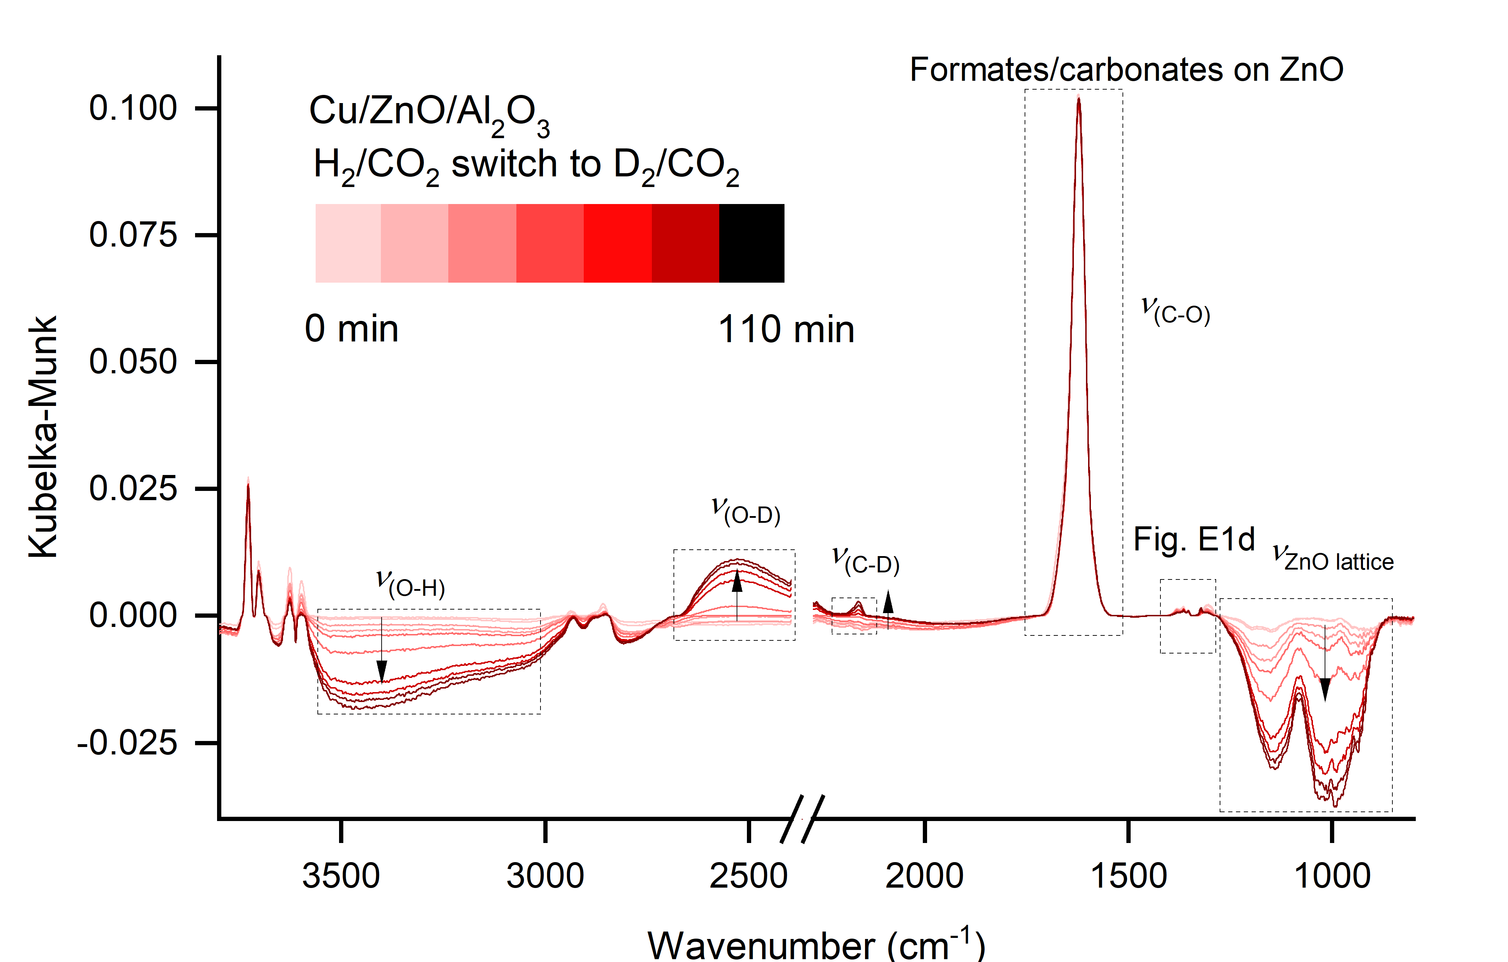
Fig. S25 Infrared spectra during the isotope switch in Fig. S24 Methanol synthesis rate as a function of time on stream with Cu/ZnO/Al2O3 when switching from a CO2/H2 feed to a CO2/D2 feed. Reaction conditions: 135 °C, 1 bar, X/CO2 = 4/1 (X = H2 or D2) 4.8∙104 NmL/gcat/h. which illustrate that the main changes are that adsorbed H is exchanged for adsorbed D.

Fig. S26 Infrared spectrum of formates/carbonates on ZnO after adsorption from HCOOH. As the main feature at 1600 cm⁻¹ is not exchanged in Fig. S24 we can conclude that formates on ZnO are spectators during methanol synthesis.

2. Further details and results from the DFT calculations

The details of the DFT calculations are described in the main text. All presented results are zero-point corrected. The zero-point corrections for H adsorbed on the surface were included by evaluating the vibrations for heterolytic and homolytic H₂ adsorption on pristine ZnO($10\overline{1}0$) as described in 2.1. Only the hydrogen atoms and the atoms bonded to the hydrogen atoms were displaced in the vibrational analysis.
2.1 Hydrogen adsorption on bare ZnO$(10\overline{1}0)$
The adsorption of H₂ is investigated on the bare p(6x5) ZnO($10\overline{1}0$) surface. This corresponds to a 1/15 ML coverage, with respect to the three-fold coordinated oxygen atoms in the surface. The optimized structures are shown in Fig. S27 with heterolytic adsorption (left) and homolytic adsorption (right). The heterolytic adsorption is favored (E_{ads}(2H) = -0.05 eV) compared to the homolytic adsorption (E_{ads}(2H) = 0.34 eV). However, the adsorption is in both cases weak, and endothermic in the case of homolytic adsorption.
Fig. S27: Heterolytic (left) and homolytic (right) H₂ adsorption on ZnO($10\overline{1}0$).

2.2 Hydrogen adsorption on Cu/ZnO$(10\overline{1}0)$ and Pt/ZnO$(10\overline{1}0)$
The homolytic and heterolytic adsorption of H₂ is explored for different configurations in the Cu/ZnO and Pt/ZnO systems where the metal is modeled by a 54-atom NP. On the Cu/ZnO structure (top row of Fig. S28), the heterolytic adsorption energy is only slightly different (∼0.05-0.1 eV) than adsorption on the bare ZnO surface. The Bader charge of the Cu NP is unaffected in the case of heterolytic adsorption of H₂. A larger effect is observed for homolytic adsorption. If H₂ adsorbs far away from the Cu particle, the adsorption energy is 0.1 eV. Although the adsorption is endothermic, it is still a stronger adsorption than on the bare ZnO surface. The stronger adsorption on Cu/ZnO is in this case combined with an electron transfer of 0.40 e from the oxide to the Cu NP. If H₂ is instead adsorbed homolytically close to the Cu NP, the adsorption energy is strongly increased to -1.8 eV.
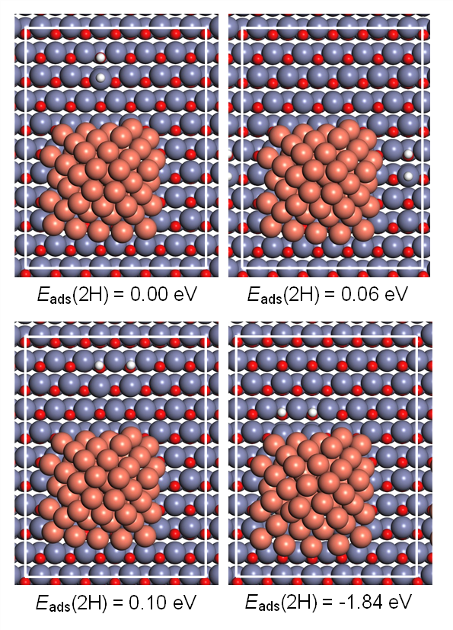
Fig. S28 Heterolytic adsorption (top) and homolytic adsorption (bottom) of H₂ onto Cu₅₄/ZnO($10\overline{1}0$).

On the Pt/ZnO system, the heterolytic adsorption of H₂ close (parallel) to the Pt NP (top right Fig. S29), is similar to the adsorption on Cu/ZnO. The heterolytic and homolytic adsorption configurations further away from the Pt NP are associated with a stronger adsorption than on both ZnO and Cu/ZnO. In these cases, the Pt NP facilitates slight distortions of the ZnO surface, enabling the stronger adsorption. Similar to the homolytic adsorption close to the Cu NP, the homolytic adsorption close to the Pt NP is strong. The charge transfer owing to H adsorption close to the Pt NP is calculated to be 0.76 e. Thus, the charge transfer is larger on Pt/ZnO than on Cu/ZnO.

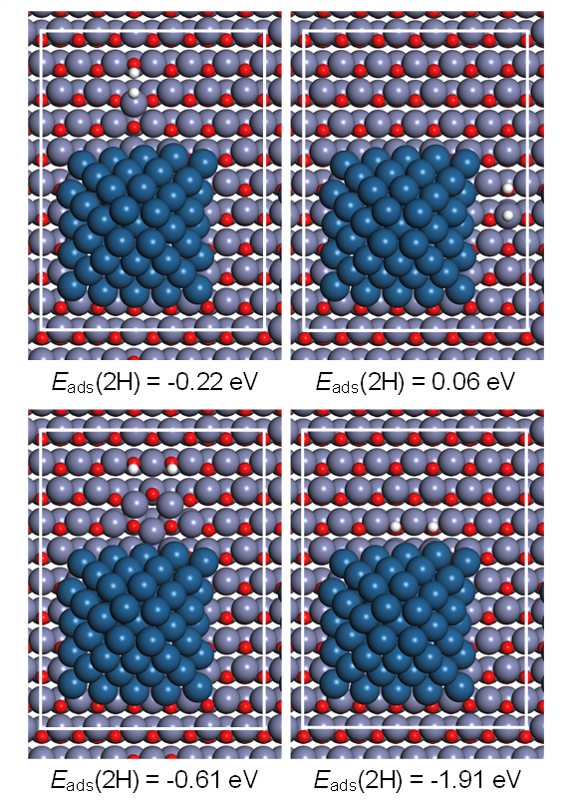
Fig. S29 Heterolytic adsorption (top) and homolytic adsorption (bottom) in the Pt₅₄/ZnO($10\overline{1}0$) system.
The calculations show that the heterolytic adsorption is relatively unaffected by the inclusion of a Cu NP supported on the ZnO surface. The heterolytic adsorption further away from a Pt NP is strengthened, owing to slight Pt NP-facilitated oxide distortions. However, due to the possibility of electron transfer to the metal NPs, the homolytic adsorption energy of H₂ is significantly increased, and favored compared to the heterolytic adsorption (except far away from the Cu NP). The homolytic adsorption energy is the strongest close to the NP, as the charge transfer also gives rise to favorable Coulomb interactions between the positively charged H and the metal NP. Adsorbed hydrogen should, therefore, be concentrated on the oxide surface close to the metal NP.

2.3 Higher hydrogen coverages on Cu/ZnO$(10\overline{1}0)$ and Pt/ZnO$(10\overline{1}0)$
To investigate the behavior at higher H coverages, the surface is occupied with increasingly more H atoms. The hydrogen atoms are initially placed close to the metal NP. Adsorption sites further away from the NP are occupied upon increasing coverage. The average H₂ adsorption energy and charge transfer to the 54-atom NPs are shown in Fig. S30 for Cu (top) and Pt (bottom). The charge transfer to the NPs is increasing upon increasing coverages for both Cu/ZnO and Pt/ZnO. However, the charge is saturated for a coverage of about 0.75 monolayers. The average adsorption energies are in both cases increasing at higher coverages, due to the saturation of charge, and the unfavorable adsorption sites far away from the NP. It should be noted that at higher coverages (when H adsorbs far from the NP), the adsorption of H on the Cu and Pt NPs become favored over adsorption on the oxide. The adsorption energy of ½H_{2 (g)}, has previously²⁸ been calculated with the PBE+D3 functional to be -0.29 eV and -0.55 eV on Cu(111) and Pt(111), respectively.
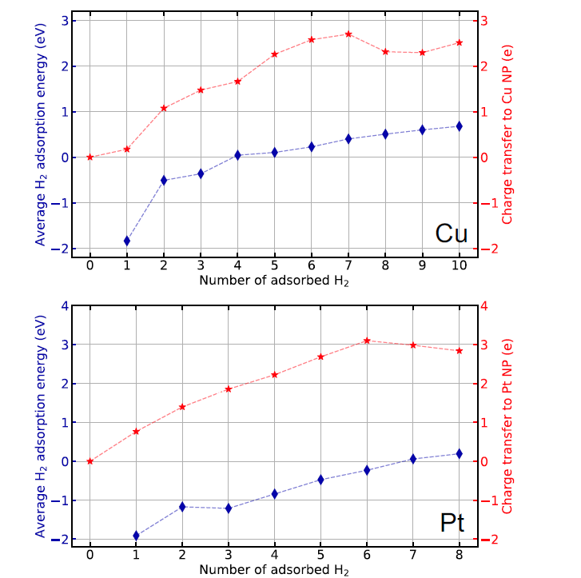
Fig. S30 The average H₂ adsorption energy (blue) and total transferred charge to the supported 54-atom metal NP (red) at different number of adsorbed H in the cell. Cu (top) and Pt (bottom).
Because of the large number of configurations, it is difficult to find the optimal adsorption structure for high coverages. To investigate the influence of the distribution of H on the surface, eight different configurations with 6 H randomly (coverage 0.37 ML with respect to available three-fold oxygen sites) distributed in Cu/ZnO and Pt/ZnO systems are investigated, where the first configuration is chosen so that all H are close to the NP. In Fig. S31, the average adsorption energy of H₂ and the charge transfer to the supported metal NP are presented for Cu (top) and Pt (bottom). The different H configurations are presented on the x-axis, with the numbering shown in the figure to the right. The average adsorption energy depends on the adsorption sites, which are consistent with the results for 2H. An H coverage of 0.37 monolayers is expected to be exothermic for some configurations in Cu/ZnO, and for all configurations in the Pt/ZnO system.
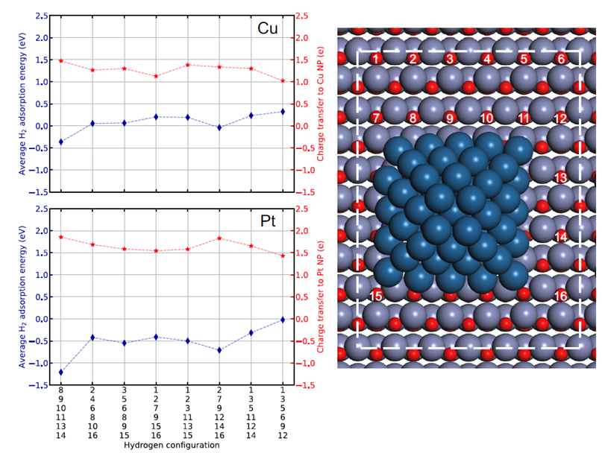
Fig. S31 The average H₂ adsorption energy (blue) and the charge transfer to the NPs (red), for the eight different H configurations. Top) Cu/ZnO. Bottom) Pt/ZnO. The configurations are presented on the x-axis and visualized in the right figure.
We find a clear correlation between the adsorption energy, and the charge transferred to the metal NPs, see Fig. S32. Here, the average H₂ adsorption energy is reported as a function of the charge transfer to the NP for Cu (red) and Pt (blue). The general trend is that the H₂ adsorption energy is strengthened with increasing charge transfer to the NPs.
Fig. S32 The average H₂ adsorption energy as a function of charge transfer to the Cu (red) and Pt (blue) NPs.

2.4 Generality of charge transfer and stabilization of homolytic H₂ adsorption

Three properties that may play a role in the behavior of the adsorption of hydrogen are:
- The degree of Cu/Zn alloying of the supported particles
- The metal particle size
- The surface orientation of the ZnO support
The three different properties are explored in the following sections.
2.4.1 Effects of CuZn alloying

To investigate whether the possible alloying of Cu and Zn has any influence on the charge transfer upon the homolytic adsorption of H₂, 12 randomly chosen atoms in the 54-atom Cu NP are exchanged to Zn atoms. The relaxed CuZn/ZnO($\text{10}\overline{\text{1}}\text{0}$) system is presented in Fig. S33. The average H₂ adsorption energy and the total transferred charge as a function of the number of adsorbed H₂ are presented in Fig. S34. As a reference, the average adsorption energy and transferred charge upon the homolytic adsorption of H₂ in the Cu/ZnO($\text{10}\overline{\text{1}}\text{0}$) is included. As for the Cu NP, the CuZn alloy NP facilitates the homolytic adsorption of hydrogen on the support as compared to the homolytic adsorption on the bare ZnO($\text{10}\overline{\text{1}}\text{0}$) surface (E_{ads} = +0.34 eV). The alloying slightly weakens the H₂ adsorption energy and the amount of transferred charge. The tabulated data for the homolytic adsorption of H₂ in the two systems are presented in Table S3.
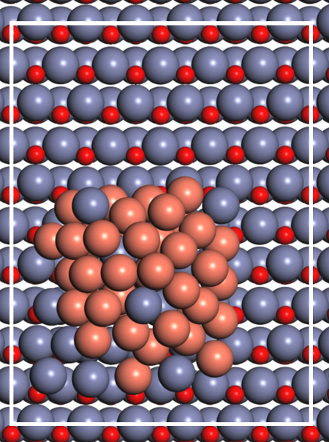
Fig. S33 Atomic model of the 54-atom CuZn/ZnO($\text{10}\overline{\text{1}}\text{0}$) system. Atomic color codes: red (O), brown (Cu), and blue (Zn).

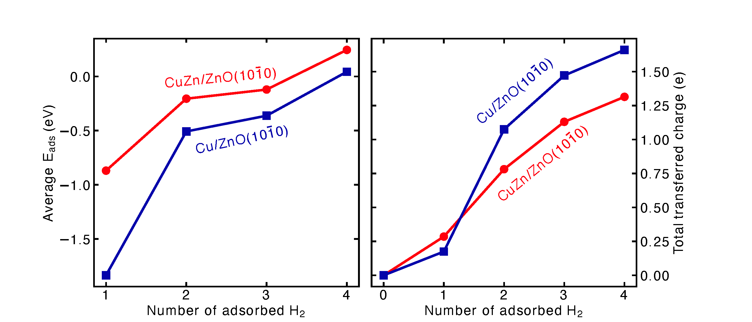
Fig. S34 Left: The average adsorption energy of H₂ as a function of the number of homolytically adsorbed H₂ for CuZn/ZnO($\text{10}\overline{\text{1}}\text{0}$) [red] and Cu/ZnO($\text{10}\overline{\text{1}}\text{0}$) [blue]. Right: The total transferred charge as a function of the number of homolytically adsorbed H₂ for CuZn/ZnO($\text{10}\overline{\text{1}}\text{0}$) [red] and Cu/ZnO($\text{10}\overline{\text{1}}\text{0}$) [blue]. The metal particle contains 54 atoms.

Table S3 The average homolytic adsorption energy of H₂ and the total transferred charge upon the homolytic adsorption of H₂.
System | Average H₂ adsorption energy (eV) | Total transferred charge (e)
Cu/ZnO($\text{10}\overline{\text{1}}\text{0}$)-2H | -1.835 | 0.17
Cu/ZnO($\text{10}\overline{\text{1}}\text{0}$)-4H | -0.508 | 1.08
Cu/ZnO($\text{10}\overline{\text{1}}\text{0}$)-6H | -0.362 | 1.47
Cu/ZnO($\text{10}\overline{\text{1}}\text{0}$)-8H | 0.043 | 1.66
CuZn/ZnO($\text{10}\overline{\text{1}}\text{0}$)-2H | -0.869 | 0.29
CuZn/ZnO($\text{10}\overline{\text{1}}\text{0}$)-4H | -0.205 | 0.78
CuZn/ZnO($\text{10}\overline{\text{1}}\text{0}$)-6H | -0.121 | 1.13
CuZn/ZnO($\text{10}\overline{\text{1}}\text{0}$)-8H | 0.245 | 1.31

2.4.2 Effects of particle size

To investigate whether the size of the metal NP influences the adsorption energy and the charge transfer upon the homolytic adsorption of H₂, a smaller Cu NP (29 atoms) and a larger Cu NP (87 atoms) are placed on the ZnO($\text{10}\overline{\text{1}}\text{0}$) surface, and hydrogen is adsorbed. Atomic models of the relaxed systems are presented in Fig. S35. The average adsorption energy of H₂ and the total transferred charge upon the homolytic adsorption of H₂ is presented in Fig. S36. The results for the homolytic adsorption of hydrogen on bare ZnO($\text{10}\overline{\text{1}}\text{0}$) and the 54-atom Cu NP supported on ZnO($\text{10}\overline{\text{1}}\text{0}$) are included as reference. On bare ZnO($\text{10}\overline{\text{1}}\text{0}$), the homolytic adsorption is, in the low coverage region (2H), associated with an adsorption energy of 0.34 eV. The average adsorption energy increases monotonically with the number of adsorbed H₂, which shows that coverage has large effects on the adsorption energy, also in the absence of a supported metal NP. When a Cu NP is supported on the ZnO($\text{10}\overline{\text{1}}\text{0}$) surface, the average adsorption strength of H₂ is substantially increased. The increased adsorption strength is the weakest for the 29-atom Cu NP and for the 54-atom Cu NP. This indicates that while the particle size may play a role, different NP configurations might induce different oxygen adsorption sites, for which the facility for H₂ adsorption energy differs. The three-fold coordinated oxygen atoms, on which H bonds, should preferably be located close to the NP, to increase the stabilization contribution stemming from the Coulomb interactions. However, all Cu NPs substantially increase the adsorption strength, and similar charge transfer effects can be observed for all particles. Note that the stabilization decreases further away from the NP. The tabulated values for the H₂ adsorption properties are presented in Table S4.
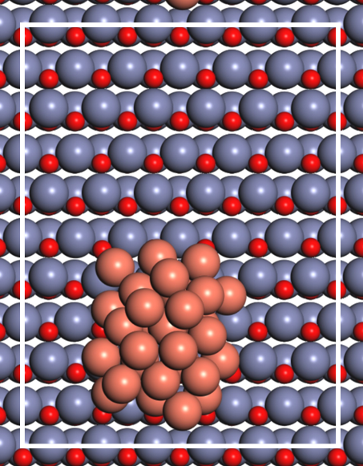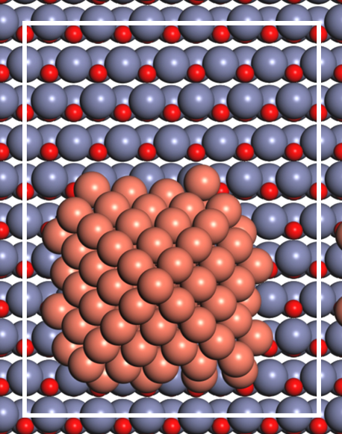
Fig. S35: Left: The relaxed 29-atom Cu NP supported on ZnO($\text{10}\overline{\text{1}}\text{0}$). Right: The relaxed 87-atom Cu NP supported on ZnO($\text{10}\overline{\text{1}}\text{0}$). Atomic color codes: red (O), brown (Cu), and blue (Zn).
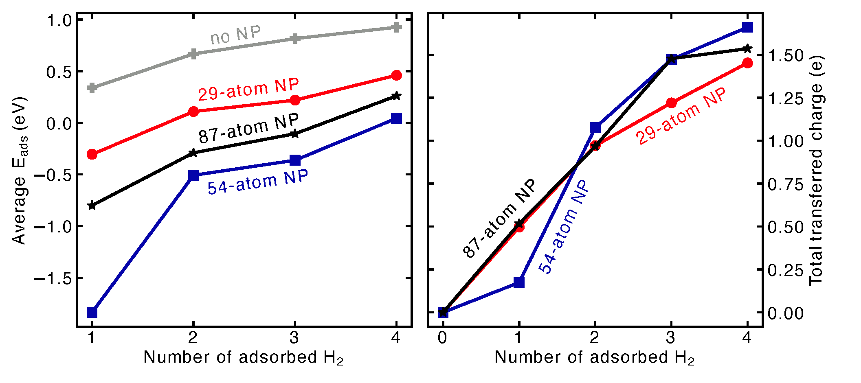
Fig. S36: Left: The average homolytic H₂ adsorption energy for bare ZnO($\text{10}\overline{\text{1}}\text{0}$) [gray], 29-atom Cu NP supported on ZnO($\text{10}\overline{\text{1}}\text{0}$) [red], 54-atom Cu NP supported on ZnO($\text{10}\overline{\text{1}}\text{0}$) [blue], and 87-atom Cu NP supported on ZnO($\text{10}\overline{\text{1}}\text{0}$) [black]. Right: The total transferred charge to the Cu NP upon the homolytic adsorption of H₂.

Table S4 The average adsorption energy of H₂ and the total transferred charge upon the homolytic adsorption of H₂.
System | Average H₂ adsorption energy (eV) | Total transferred charge (e)
ZnO(10¯10)-2H | 0.338 | -
ZnO(10¯10)-4H | 0.667 | -
ZnO(10¯10)-6H | 0.814 | -
ZnO(10¯10)-8H | 0.925 | -
29-atom Cu/ZnO(10¯10)-2H | -0.305 | 0.50
29-atom Cu/ZnO(10¯10)-4H | 0.109 | 0.97
29-atom Cu/ZnO(10¯10)-6H | 0.219 | 1.22
29-atom Cu/ZnO(10¯10)-8H | 0.460 | 1.45
54-atom Cu/ZnO(10¯10)-2H | -1.835 | 0.17
54-atom Cu/ZnO(10¯10)-4H | -0.508 | 1.08
54-atom Cu/ZnO(10¯10)-6H | -0.362 | 1.47
54-atom Cu/ZnO(10¯10)-8H | 0.043 | 1.66
87-atom Cu/ZnO(10¯10)-2H | -0.800 | 0.52
87-atom Cu/ZnO(10¯10)-4H | -0.290 | 0.97
87-atom Cu/ZnO(10¯10)-6H | -0.106 | 1.48
87-atom Cu/ZnO(10¯10)-8H | 0.260 | 1.54
2.4.3 Effects of oxide surface orientation
Experimentally, ZnO occurs as nanoparticles, on which Cu NPs are supported. To explore whether the oxide surface orientation affects the charge transfer upon the homolytic adsorption of H₂, two additional oxide surfaces are investigated. The additional oxide surfaces are p(4x5) ZnO($\text{11}\overline{\text{2}}\text{0}$) and p(4x3) ZnO($\text{21}\overline{\text{3}}\text{0}$). The calculated surface energies and band gaps are presented in Table S5.
Table S5 The calculated surface energies and band gaps of the investigated oxide surfaces. Notice that in order to keep the oxide stoichiometric, the surface is slightly different on the top and bottom sides.
System | Average surface energy (eV/Å) | Band gap (eV)
p(6x5) ZnO(10¯10) | 0.067 | 1.30
p(4x5) ZnO(1¯120) | 0.069 | 1.84
p(4x3) ZnO(2¯130) | 0.070 | 1.79

Firstly, the heterolytic and homolytic adsorptions of H₂ are investigated on the bare oxide surfaces. The optimized adsorption configurations are visualized in Fig. S37. The heterolytic adsorption of H₂ is on both oxide surfaces endothermic, in contrast to the heterolytic adsorption on ZnO($\text{10}\overline{\text{1}}\text{0}$) (E_{ads} = -0.05 eV). The homolytic adsorption of H₂ is unfavorable, being 0.71 eV and 0.63 on ZnO($\text{11}\overline{\text{2}}\text{0}$) and ZnO($\text{21}\overline{\text{3}}\text{0}$), respectively.
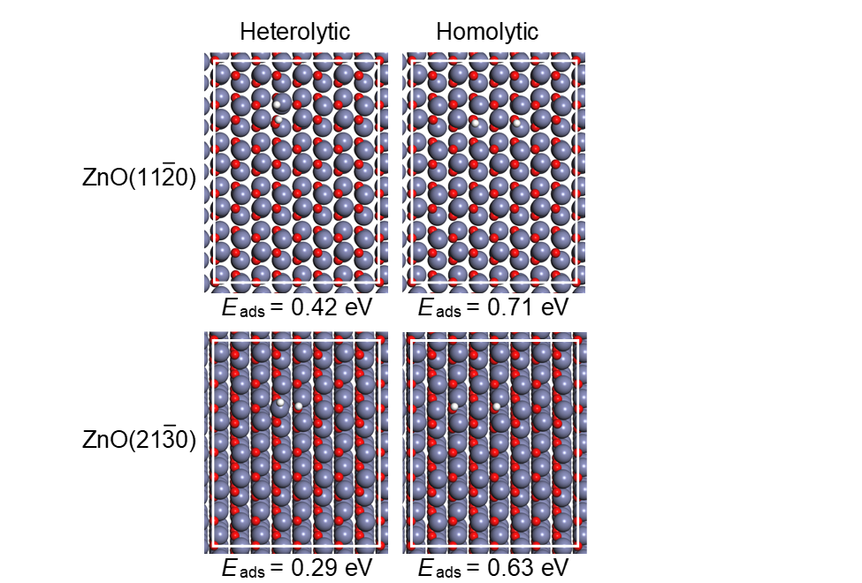
Fig. S37: The heterolytic adsorption (left) and homolytic adsorption (right) on ZnO($\text{11}\overline{\text{2}}\text{0}$) (top) and ZnO($\text{21}\overline{\text{3}}\text{0}$) (bottom). Atomic color codes: white (H), red (O), blue (Zn).

To investigate the effects of a supported Cu NP on the homolytic adsorption of H₂ on the two oxide surfaces, a 54-atom Cu NP is added to the system. The relaxed structures Cu NP supported on the two oxides are shown in Fig. S38.
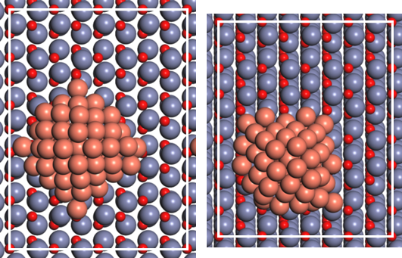
Fig. S38: Relaxed structures of a Cu NP supported on left) ZnO($\text{11}\overline{\text{2}}\text{0}$) and right) ZnO($\text{21}\overline{\text{3}}\text{0}$). Atomic color codes: red (O), brown (Cu), and blue (Zn).

The average adsorption energy and the total transferred charge upon the homolytic adsorption of H₂ is presented in Fig. S39. In the low coverage region (2H), the homolytic adsorption is on ZnO($\text{11}\overline{\text{2}}\text{0}$) stabilized by ∼ 0.4 eV, in the presence of a Cu NP, with respect to the adsorption on the bare ZnO($\text{11}\overline{\text{2}}\text{0}$) surface. On ZnO($\text{21}\overline{\text{3}}\text{0}$), the homolytic adsorption of H₂ is stabilized by ∼ 0.6 eV in the presence of a Cu NP, with respect to the bare surface. For ZnO($\text{21}\overline{\text{3}}\text{0}$) the stabilization of homolytically adsorbed H₂ is notable also at higher coverages. On ZnO($\text{11}\overline{\text{2}}\text{0}$), the average adsorption energy is significantly weaker at higher coverages. In this case, the perimeter of the Cu NP align with the low-coordinated O atoms in the surface, hence forces H to be adsorbed further away from the NP. The homolytic adsorption of H₂ is for all oxides associated with a significant transfer of charge to the Cu NP. Tabulated data for the homolytic adsorption properties are presented in Table S6.

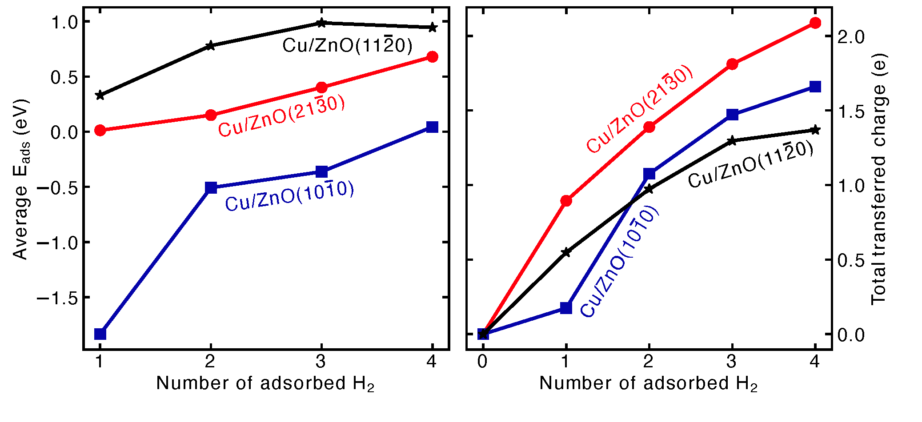
Fig. S39: Left: Average adsorption energy (left) and the transferred charge upon homolytic adsorption of H₂ (right) for Cu/ZnO($\text{10}\overline{\text{1}}\text{0}$) [blue], Cu/ZnO($\text{11}\overline{\text{2}}\text{0}$) [black], and Cu/ZnO($\text{21}\overline{\text{3}}\text{0}$) [red].

Table S6 Tabulated data for the average adsorption energy and total transferred charge upon the homolytic adsorption of H₂.

System | Average H₂ adsorption energy (eV) | Total transferred charge (e)
Cu/ZnO(11¯20)-2H | 0.331 | 0.55
Cu/ZnO(11¯20)-4H | 0.780 | 0.97
Cu/ZnO(11¯20)-6H | 0.987 | 1.30
Cu/ZnO(11¯20)-8H | 0.945 | 1.37
Cu/ZnO(21¯30)-2H | 0.012 | 0.89
Cu/ZnO(21¯30)-4H | 0.150 | 1.39
Cu/ZnO(21¯30)-6H | 0.401 | 1.81
Cu/ZnO(21¯30)-8H | 0.680 | 2.09

2.4.4 Conclusions regarding charge transfer and stabilization of homolytic H₂ adsorption
The homolytic adsorption of H₂ on the ZnO oxide is stabilized, regardless of particle size, and oxide surface orientation. The potential alloying of Cu with Zn only slightly affects the adsorption energy of H₂ and the charge transfer to the metal NP. A significant difficulty is the non-equivalence of all O-atoms in the oxide surface upon the addition of a Cu NP; hence the average adsorption energy is presented. The adsorption strength is strongly dependent on the Cu-H distance, hence, both the shape and size of the Cu NP may have consequences on the adsorption properties, as certain particles may block the O-atoms that are facile for the H₂ adsorption.

2.5 Hydrogen subsurface adsorption (absorption)
To investigate whether H can be adsorbed in subsurface sites in ZnO, the three different surface orientations of ZnO are investigated. The subsurface adsorption induces some distortion in the ZnO surface; hence, the zero-point correction includes the OH group and the distorted Zn atom. The zero-point correction for ZnO($\text{10}\overline{\text{1}}\text{0}$) is used for all configurations. Relaxed structures of the most stable subsurface hydrogen adsorptions are presented in Fig. S40 for ZnO($\text{10}\overline{\text{1}}\text{0}$) [left], ZnO($\text{11}\overline{\text{2}}\text{0}$) [middle], and ZnO($\text{21}\overline{\text{3}}\text{0}$) [right]. The corresponding zero-point corrected absorption energies are indicated below. The subsurface adsorption (with respect to $\frac{1}{2}$ H₂(g)) are endothermic for all three surface orientations.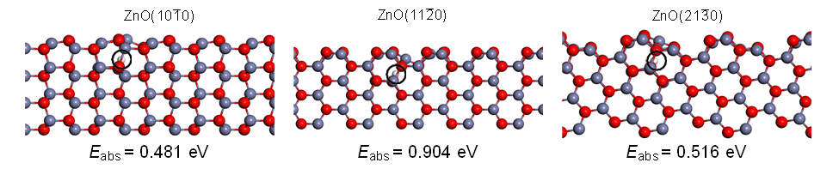
Fig. S40 Atomic models of the relaxed structures of H absorbed in ZnO($\text{10}\overline{\text{1}}\text{0}$) [left], ZnO($\text{11}\overline{\text{2}}\text{0}$) [middle], and ZnO($\text{21}\overline{\text{3}}\text{0}$) [right]. Atomic color codes: white (H), red (O), and blue (Zn).
The situation is changed when a 54-atom metal NP is supported on the oxide. The optimized structures of the most stable subsurface adsorptions are presented in Fig. S41 for Cu/ZnO($\text{10}\overline{\text{1}}\text{0}$) [top left], Pt/ZnO($\text{10}\overline{\text{1}}\text{0}$) [top right], Cu/ZnO($\text{11}\overline{\text{2}}\text{0}$) [bottom left], and Cu/ZnO($\text{21}\overline{\text{3}}\text{0}$) [bottom right]. The presence of a Cu NP stabilizes subsurface adsorption by 0.8–1.0 eV. For both Cu/ZnO($\text{10}\overline{\text{1}}\text{0}$) and Cu/ ZnO($\text{21}\overline{\text{3}}\text{0}$), the adsorption is exothermic and associated with negative Gibbs free energies even at 260 ℃. For Cu/ZnO($\text{11}\overline{\text{2}}\text{0}$), the adsorption is stabilized significantly, however, it is still endothermic. For Cu/ZnO($\text{10}\overline{\text{1}}\text{0}$), H may populate the subsurface position of ZnO when these configurations become more favorable than the surface adsorption. For the Cu/ZnO($\text{21}\overline{\text{3}}\text{0}$), the subsurface adsorption is favored over the surface adsorption. The high stability of H absorption is associated with a charge transfer to the Cu NP, similar to the case of surface adsorption of H. The charge transfers are 0.15 e [Cu/ZnO($\text{10}\overline{\text{1}}\text{0}$)], 0.30 e [Cu/ZnO($\text{11}\overline{\text{2}}\text{0}$)], and 0.56 e [Cu/ ZnO($\text{21}\overline{\text{3}}\text{0}$)]. (Note that the charge transfer in this case is per H, and not H₂). Upon subsurface adsorption, Zn in the surface is pushed towards the Cu particle (which could, perhaps, be a potential pathway for the alloy formation and SMSI type morphology changes). To investigate the generality of the charge transfer upon H subsurface adsorption, an additional calculation of subsurface adsorption was performed for Pt/ZnO($\text{10}\overline{\text{1}}\text{0}$). Also in this case, the subsurface adsorption is stabilized by the metal NP. The adsorption is stabilized by ∼ 0.8 eV, with a corresponding charge transfer of 0.36 e to the Pt NP. To conclude, for Cu/ZnO($\text{10}\overline{\text{1}}\text{0}$) H is likely to populate sites on the surface and subsurface. For Cu/ZnO($\text{11}\overline{\text{2}}\text{0}$) both adsorption and absorption of H are endothermic. For the Cu/ZnO($\text{21}\overline{\text{3}}\text{0}$) system, absorption in the sublayer of ZnO is favored over the surface adsorption of H. Furthermore, the absorption is strongly exothermic (and exergonic even at high temperatures).

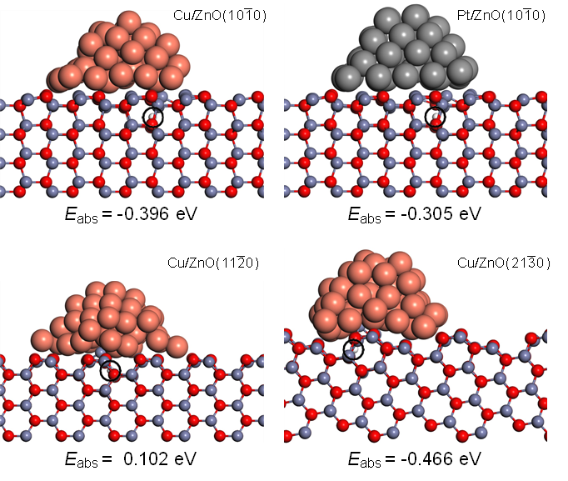
Fig. S41 Atomic models of the relaxed structures of H absorbed in the oxide of: Cu/ZnO($\text{10}\overline{\text{1}}\text{0}$) [top left], Pt/ZnO($\text{10}\overline{\text{1}}\text{0}$) [top right], Cu/ZnO($\text{11}\overline{\text{2}}\text{0}$) [bottom left], and Cu/ZnO($\text{21}\overline{\text{3}}\text{0}$) [bottom right]. Atomic color codes: white (H), red (O), brown (Cu), blue (Zn), and gray (Pt).

2.6 Energy contributions of the stabilizing effect
The stabilization of the homolytic H₂ adsorption and the charge transfer from the oxide to the metal can be separated into different energy contributions:
- The energy gain transferring an electron from the conduction band of ZnO to the Fermi energy of Cu.
- The image charge between the H⁺ and the induced negative charge in the metal
- Structural relaxations in the metal/oxide interface
- Structural relaxation of the OH group in the ZnO surface

The contributions are highly coupled as discussed for charge transfer across thin metal supported oxide films²⁹.

2.7 Charge transfer effects on the HCOO adsorption
The stability of formate (HCOO) was investigated on different adsorption sites and different H coverages on the ZnO support. The system was modeled using a Cu rod, supported on a p(4x4) ZnO($10\overline{1}0$) surface. The Cu rod is periodic, and due to the slight lattice miss-match, the Cu atoms have a compressive strain of ∼1%.
As in the case of the supported Cu NP, a clear charge transfer is observed upon the homolytic adsorption of H₂ on the ZnO surface. The investigated hydrogen configurations and the total transferred charge are shown in Fig. S42. Upon the homolytic adsorption of 2H, 0.56 e is transferred to the Cu rod. Upon the homolytic adsorption of 8H, 1.60 e is transferred to the Cu rod.
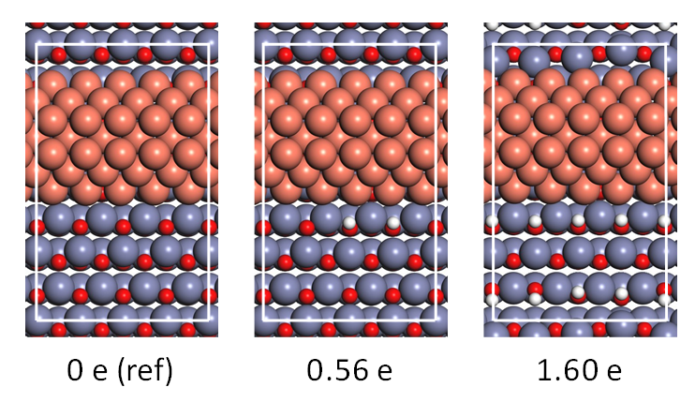
Fig. S42 The different hydrogen configurations on the CuRod/ZnO surface, with corresponding charge transfer to Cu. The charge of the Cu rod on the bare ZnO($10\overline{1}0$) is used for reference.
In Fig. S43, three different adsorption configurations of HCOO at three different hydrogen coverages are presented: no H coverage (top), 2 adsorbed H (middle), and 1 ML H coverage [with respect to the 3-fold coordinated O atoms in the oxide surface] (bottom). Below each structure, the corresponding zero-point corrected adsorption energy (black), Gibbs free energy of adsorption at 135 ℃ (red), and Gibbs free energy of adsorption at 260 ℃ (blue) are presented. [The Gibbs free energy of adsorption is calculated with respect to CO₂(g) at 4 bar and H₂(g) at 16 bar.]
For the bare Cu/ZnO($10\overline{1}0$) [no H coverage], the adsorption of HCOO is weak. The most favorable adsorption site of HCOO is low-coordinated Cu atoms at the top edge of the Cu-rod. The adsorption on the (111) facet of the Cu rod is close to thermo-neutral. When 2H is adsorbed on ZnO($10\overline{1}0$), the adsorption strength of HCOO on the interface Cu atoms is increased, owing to the hydrogen bonds between HCOO and the H-atoms adsorbed on the oxide. The adsorption strength on the under-coordinated Cu atoms and on the (111) facet is close to unaffected. However, the adsorption strength of HCOO is significantly increased for all adsorption sites with an increased H-coverage on the ZnO($10\overline{1}0$) surface. The stronger adsorption energy on all considered sites indicates that the charge transfer from H to the Cu surface influences the adsorption strength of HCOO. The most favorable adsorption site is the interface Cu atoms, on which the adsorption is exergonic at both temperatures, owing to the charge transfer and the enabled HCOO-H bonds.
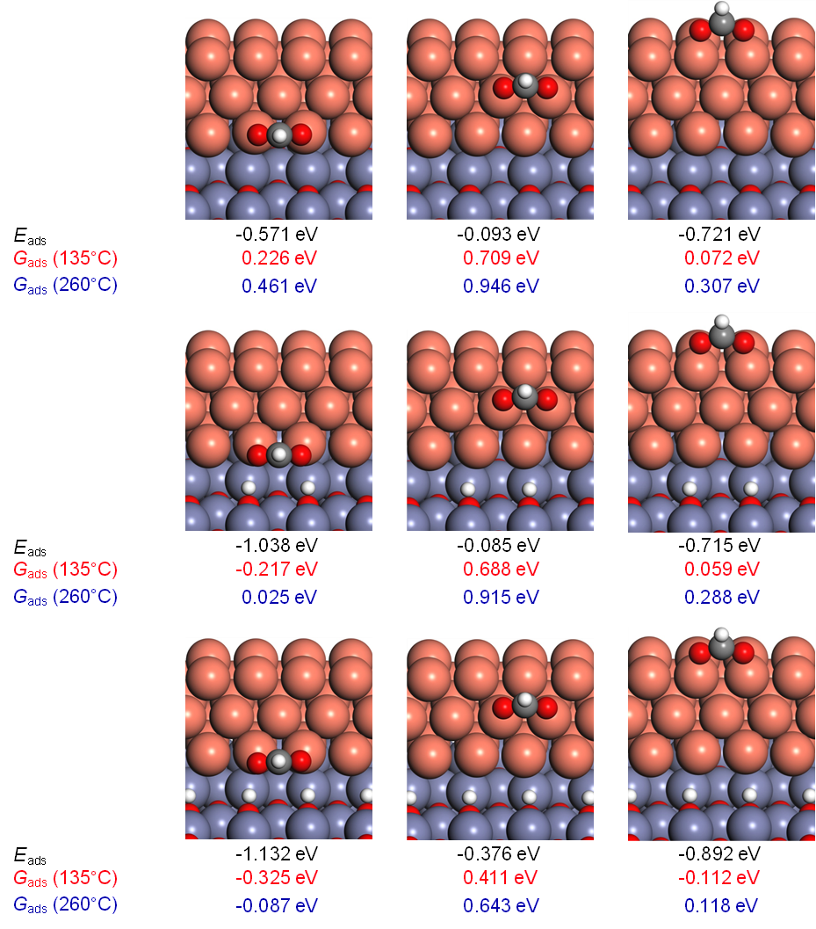
Fig. S43 Atomic models of the different adsorption configurations of HCOO. Below each structure, the zero-point corrected adsorption energy (black), the Gibbs free energy of adsorption at 135 ℃ (red) and the Gibbs free energy of adsorption at 260 ℃ (blue) are presented. Atomic color codes: white (H), gray (C), red (O), brown (Cu), and blue (Zn).

2.8 HCOO-HCOO interactions
To investigate HCOO-HCOO interactions, different pair-wise interactions are investigated on the supported Cu rod. The different adsorption configurations (for both a bare ZnO surface, and a fully H-covered ZnO surface) are presented in Fig. S44. The adsorption energy with respect to the sum of the adsorption energies of the isolated HCOO molecules are presented at the bottom. Note that ”identical adsorption configurations with respect to the Cu atoms” is not the same as ”identical adsorption configurations in the Cu/ZnO system”, as the Cu-Zn distances differ. Therefore, ∆E, captures the adsorption-adsorption interactions, and adsorption energy differences due to a slightly different adsorption site (most notable for HCOO adsorbed on interface Cu at high H coverage, where the second HCOO cannot form as favorable H-bonds). Note that for all adsorption configurations, the energy difference is small, as compared to the isolated adsorptions. However, for all considered configurations, the energy difference is more positive (weaker adsorption) when ZnO is H-covered.
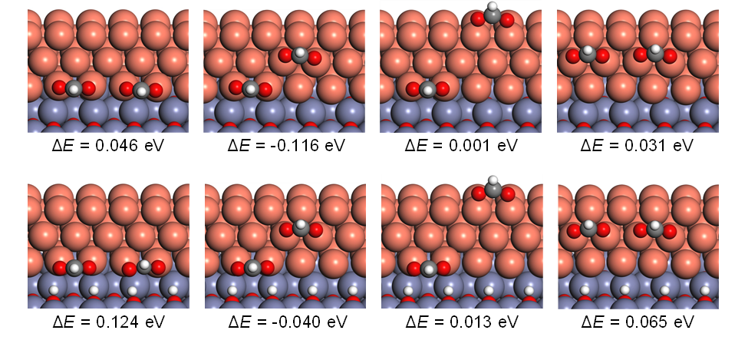
Fig. S44 Atomic models of the adsorption of two HCOO on Cu for top) an empty ZnO surface and bottom) a fully H-covered ZnO surface. Under each structure, the difference in adsorption energy with respect to the isolated adsorptions of the two HCOO are presented. Atomic color codes: white (H), gray (C), red (O), brown (Cu), blue (Zn).

2.9 Effects of dispersion interactions
To investigate whether the calculated trends are affected by dispersion interactions, some comparative calculations are performed with PBE+D3. The D3 part model dispersion interactions²⁸. The Cu rod/ZnO system is used, with the ZnO lattice parameter calculated with PBE. Also in this case, the adsorption of H₂ on ZnO($10\overline{1}0$) is strongly exothermic (0.26 eV more exothermic than with PBE). The difference in adsorption energy for the different HCOO configurations are presented in Fig. S45. When the dispersion interactions are described using the D3-approach, the adsorption strength of HCOO is increased by 0.23–0.36 eV for the different adsorption configurations. The increased adsorption strength may switch the adsorption from endergonic to exergonic at higher temperatures. However, it does not alter the trends presented for the adsorption energies evaluated with PBE. The adsorption energy is significantly increased due to the charge transfer, and HCOO adsorbed on interface Cu is further stabilized by the enabled HCOO-H bonds.
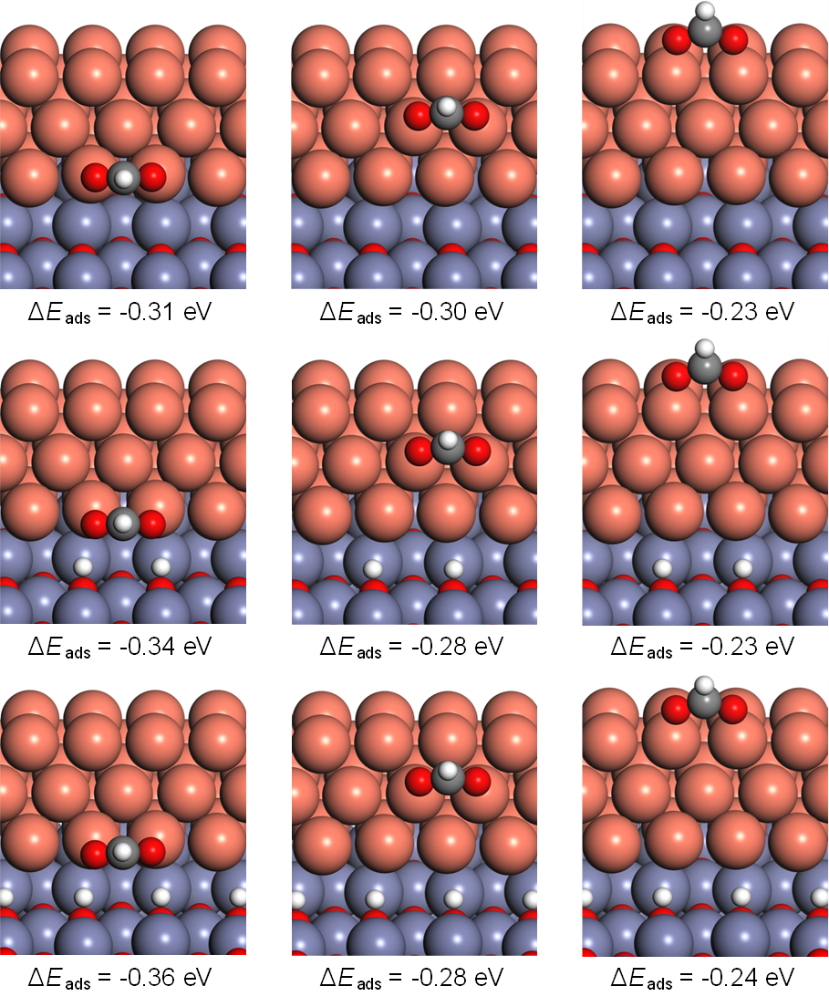
Fig. S45 Atomic models of the different adsorption configurations of HCOO. Note that the PBE calculated structures are shown. The geometries when PBE+D3 is used are close to unaffected (only slightly shortened bond lengths). Below each structure, the difference in adsorption energy when disperse interactions are described with D3 approach, as compared to only PBE, are presented. Atomic color codes: white (H), gray (C), red (O), brown (Cu), and blue (Zn).

2.10 Vibrational characterization of CO adsorbed on Pt
To account for the discrepancy between the DFT calculated and experimentally measured C-O stretch vibrational frequencies in gas phase, all frequencies are scaled with a constant factor of $\frac{f{\left(CO\left(g\right)\right)}_{exp.}}{f{\left(CO\left(g\right)\right)}_{calc.}}≈1.007$. The experimentally measures IR spectra are deconvoluted by first considering CO adsorbed in top and bridge configurations on a p(3x3) Pt(111) separated by [calculated with a Brillouin zone sampling of (5,5,1) k-points], shown in Fig. S46. The slab is modeled using 6 layers, of which the bottom two layers are kept fixed to their corresponding bulk positions. It can clearly be seen that the C-O stretch in the experimentally measures spectra originates from CO adsorbed in top configurations, as the bridge bounded CO is associated with significantly lower vibrational energies. Hence, only vibrational modes for CO bounded in top configurations are considered.
Fig. S46 The optimized structures for CO adsorbed in a top configuration (left) and a bridge configuration (right), as well as the associated C-O stretch vibrational energies.
To investigate how the C-O stretch wavenumber is affected by the charge of the nanoparticle, two nanoparticles are artificially charged by either removing or introducing additional electrons. The investigated 201 atom Pt NP and the unsupported Pt NP are visualized in Fig. S47.

Fig. S47 CO adsorbed on the investigated Pt NPs.

In Fig. S48, the C-O stretch vibrational frequency is presented as a function of the excess charge of the particles. At negative excess charge, the Pt NPs have a deficit of electrons and are, hence, positively charged. It should be noted that the two adsorption sites are slightly different in the two systems, as the next-nearest neighbor configurations are different. Hence, the C-O stretch energy for CO adsorbed on the particles with no excess charge, is slightly lower for the smaller NP (right in Fig. S48). Interestingly, a monotonic trend can be seen between the excess charge of the NPs, and the C-O stretch wavenumber. The more negatively charged the NP is, the lower the C-O stretch wavenumber. For the nanoparticle to the right in Fig. S48, the calculated C-O stretch wavenumber (for the same adsorption site) and Bader charge of the supported 54-atom NP is added. The data follows the prediction based on the virtually charged particle. It is clear that a charge transfer from the oxide to the supported NP results in a red-shift of the C-O stretch wavenumber.
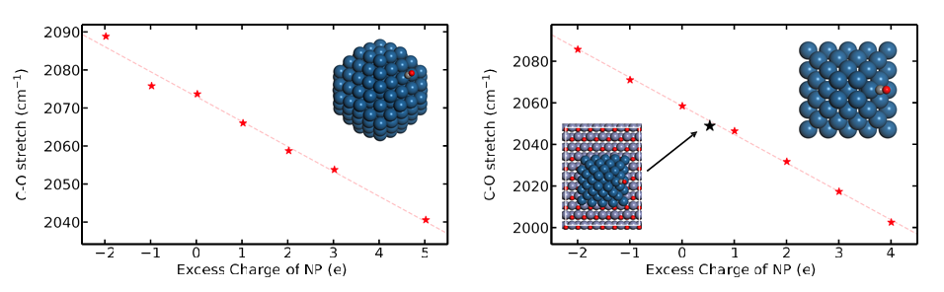
Fig. S48 The C-O stretch vibrational frequency as a function of nanoparticle charge for left) the 201-atom truncated octahedron NP and right) the unsupported 54-atom Pt NP. Note the agreement with the result for the supported Pt NP in the right figure.

3. Construction of the energy diagram in Fig. 2f
The energy diagram in Fig. 2f is made on the basis of the literature^{30–33}. Fig. S49 shows further details. The diagram is constructed from measurements of the ZnO electron affinity, χ , the Cu work function, ϕ, the measured ZnO band gap, E_{gap, ZnO}, and the measured or calculated defect levels for ad-/absorbed H and O vacancies.
Fig. S49 Electron energy diagram^{33–35} for Cu/ZnO.

4. References for supplementary information
1. Quan, J. et al. Vibration-driven reaction of CO₂ on Cu surfaces via Eley–Rideal-type mechanism. Nat. Chem. 11, 722–729 (2019).
2. Hansen, S. I. et al. An Adsorption Isotherm That Includes the Interactions between Adsorbates. J. Phys. Chem. C 129, 5287–5300 (2025).
3. Kunkes, E. L., Studt, F., Abild-Pedersen, F., Schlögl, R. & Behrens, M. Hydrogenation of CO₂ to methanol and CO on Cu/ZnO/Al₂O₃: Is there a common intermediate or not? J. Catal. 328, 43–48 (2015).
4. Nishimura, T., Niwa, Y., Tsuchiya, T. & Nozoye, H. Ionic dissociation of methanol studied by photoelectron–photoion coincidence spectroscopy. J. Chem. Phys. 72, 2222–2225 (1980).
5. Omura, I., Kaneko, T., Yamada, Y. & Tanaka, K. Mass Spectrometric Studies of Photoionization. V. Methanol and Methanol-d1. J. Phys. Soc. Jpn 27, 981–984 (1969).
6. Beynon, J. H., Fontaine, A. E. & Lester, G. R. Mass spectrometry: the mass spectrum of methanol. Part I. Thermochemical information. Intl. J. Mass Spec. 1, 1–24 (1968).
7. Nielsen, N. D., Jensen, A. D. & Christensen, J. M. Quantification of Formate and Oxygen Coverages on Cu Under Industrial Methanol Synthesis Conditions. Catal. Lett. 150, 2447–2456 (2020).
8. Nakamura, I., Fujitani, T., Uchijima, T. & Nakamura, J. A model catalyst for methanol synthesis: Zn‐deposited and Zn‐free Cu surfaces. J. Vac. Sci. Technol. A 14, 1464 (1998).
9. Fujita, S. I., Usui, M., Ito, H. & Takezawa, N. Mechanisms of Methanol Synthesis from Carbon Dioxide and from Carbon Monoxide at Atmospheric Pressure over Cu/ZnO. J. Catal. 157, 403–413 (1995).
10. Lin, T. C., Nolen, M. A., Farberow, C. A., Kwon, S. & Bhan, A. Mechanistic and kinetic relevance of hydrogen and water in CO₂ hydrogenation on Cu-based catalysts. J. Catal. 443, (2025).
11. Belysheva, T. V., Shub, F. S. & Temkin, M. I. Isotope Effect in the Synthesis of Methanol when Hydrogen is Replaced by Deuterium II. Kinetic Isotope Effect. Kin. Katal. 19, (1978).
12. Amann, P. et al. The state of zinc in methanol synthesis over a Zn/ZnO/Cu(211) model catalyst. Science 376, 603–608 (2022).
13. Kuld, S., Conradsen, C., Moses, P. G., Chorkendorff, I. & Sehested, J. Quantification of Zinc Atoms in a Surface Alloy on Copper in an Industrial-Type Methanol Synthesis Catalyst. Angew. Chem. Intl. Ed. 53, 5941–5945 (2014).
14. Kattel, S., Ramírez, P. J., Chen, J. G., Rodriguez, J. A. & Liu, P. Active sites for CO2 hydrogenation to methanol on Cu/ZnO catalysts. Science 355, 1296–1299 (2017).
15. Bahl, M. K., Tsai, S. C. & Chung, Y. W. Auger and photoemission investigations of the platinum-SrTiO₃(100) interface: Relaxation and chemical-shift effects. Phys. Rev. B 21, 1344 (1980).
16. P.J. Linstrom & W.G. Mallard. NIST Chemistry WebBook, NIST Standard Reference Database Number 69. (National Institute of Standards and Technology, Gaithersburg MD, 2025).
17. Schütte, K. et al. Synthesis of Cu, Zn and Cu/Zn brass alloy nanoparticles from metal amidinate precursors in ionic liquids or propylene carbonate with relevance to methanol synthesis. Nanoscale 6, 3116–3126 (2014).
18. Wiame, F. et al. Oxidation of α-brass: A photoelectron spectroscopy study. Surf. Sci. 641, 51–59 (2015).
19. Okamoto, Y., Fukino, K., Imanaka, T. & Teranishi, S. Surface characterization of CuO-ZnO methanol-synthesis catalysts by X-ray photoelectron spectroscopy. 2. Reduced catalysts. J. Phys. Chem. 87, 3747–3754 (1983).
20. Chatterjee, R. et al. Mapping Support Interactions in Copper Catalysts. Top. Catal. 62, (2019).
21. Nielsen, N. D., Smitshuysen, T. E. L., Damsgaard, C. D., Jensen, A. D. & Christensen, J. M. Characterization of oxide-supported Cu by infrared measurements on adsorbed CO. Surf. Sci. 703, 121725 (2021).
22. Doesburg, E. B. M., Höppener, R. H., De Koning, B., Xiaoding, X. & Scholten, J. J. F. Preparation and Characterization of Copper/Zinc Oxide/Alumina Catalysts for Methanol Synthesis. Stud. Surf. Sci. Catal. 31, 767–783 (1987).
23. Van Den Berg, R. et al. Structure sensitivity of Cu and CuZn catalysts relevant to industrial methanol synthesis. Nat. Comm. 13057 (2016).
24. Barrow, N. et al. Doubling the life of Cu/ZnO methanol synthesis catalysts via use of Si as a structural promoter to inhibit sintering. Sci. Adv. 10, eadk2081 (2024).
25. Kuld, S. et al. Quantifying the promotion of Cu catalysts by ZnO for methanol synthesis. Science 352, 969–974 (2016).
26. Zabilskiy, M. et al. The unique interplay between copper and zinc during catalytic carbon dioxide hydrogenation to methanol. Nat. Commun. 11, 2409 (2020).
27. Al Abdulghani, A. J. et al. Uncovering the Pressure-Dependent Mechanism of CO₂ Hydrogenation to Methanol on Ga-Promoted Cu/ZrO₂ Using Operando Modulation-Excitation DRIFTS. J. Am. Chem. Soc. 147, 27438–27448 (2025).
28. Svensson, R. & Grönbeck, H. Spontaneous Charge Separation at the Metal-Water Interface. ChemPhysChem 25, e202400099 (2024).
29. Frondelius, P., Hellman, A., Honkala, K., Häkkinen, H. & Grönbeck, H. Charging of atoms, clusters, and molecules on metal-supported oxides: A general and long-ranged phenomenon. Phys. Rev. B 78, 085426 (2008).
30. Jacobi, K., Zwicker, G. & Gutmann, A. Work function, electron affinity and band bending of zinc oxide surfaces. Surf. Sci. 141, 109–125 (1984).
31. Gartland, P. O., Berge, S. & Slagsvold, B. J. Photoelectric Work Function of a Copper Single Crystal for the (100), (110), (111), and (112) Faces. Phys. Rev. Lett. 28, 738 (1972).
32. Hofmann, D. M. et al. Hydrogen: A Relevant Shallow Donor in Zinc Oxide. Phys. Rev. Lett. 88, 045504 (2002).
33. Allen, M. W. & Durbin, S. M. Influence of oxygen vacancies on Schottky contacts to ZnO. Appl. Phys. Lett. 92, 122110 (2008).
34. Frost, J. C. Junction effect interactions in methanol synthesis catalysts. Nature 334, 577–580 (1988).
35. Van de Walle, C. G. & Neugebauer, J. Universal alignment of hydrogen levels in semiconductors, insulators and solutions. Nature 423, 626–628 (2003).

