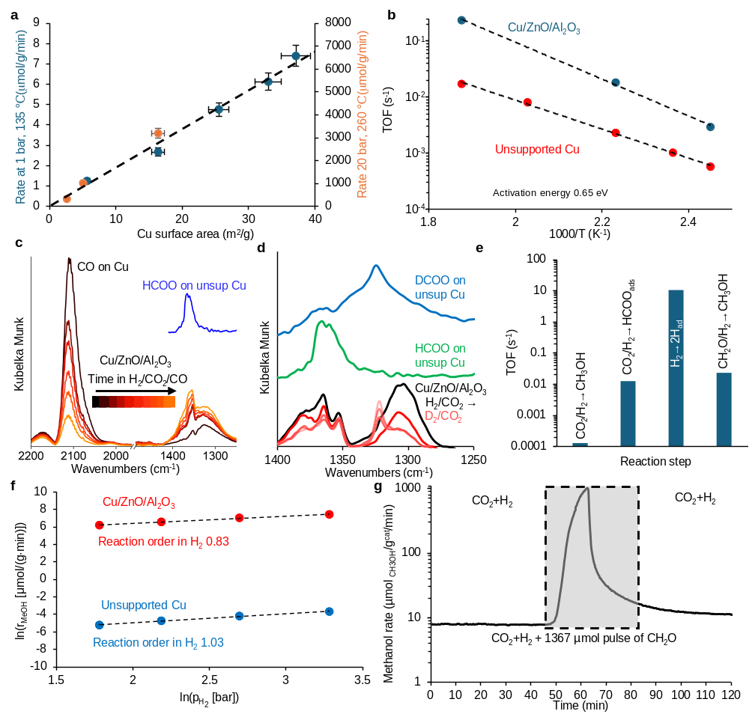 Fig. E1 Further details on the methanol synthesis mechanism. a Methanol formation rates at 1 bar, 135 ℃ and at 20 bar, 260 ℃ (H₂/CO₂ = 4/1) as a function of the Cu surface area of the samples. b TOF for methanol synthesis with unsupported Cu and Cu/ZnO/Al₂O₃. H₂/CO₂ = 4/1, 20 bar. c Infrared spectra of Cu/ZnO/Al₂O₃ as a function of time on stream in CO/CO₂/H₂:0.33/10/40 at 135 °C and 2 bar. The coincident displacement of CO from Cu and emergence of adsorbed formate shows that formate is present on Cu during reaction. d Infrared spectra of Cu/ZnO/Al₂O₃ when switching from a CO₂/H₂ feed to a CO₂/D₂ feed. 135 °C, 1 bar, X/CO₂ = 4/1 (X = H₂ or D₂). The results show that formates are converted in the methanol synthesis. e Comparison of TOFs at 135 ℃ for methanol synthesis and formaldehyde hydrogenation measured here to H₂ and CO₂ activation rates from the literature⁴⁷. f Methanol synthesis rate vs hydrogen pressure (220 ℃ 40 bar, feed flow = 270 NmL/min, p_{CO2} = 1.2 bar, balance Ar, 3.83·10⁶ NmL/g_{cat}/h for Cu/ZnO/Al₂O₃ and 6.48·10⁴ NmL/g_{cat}/h for unsupported Cu). g Steady state methanol reaction rate (135 ℃, 1 bar, H₂/CO₂ = 3/1) on Cu/ZnO/Al₂O₃ catalyst as a function of time including the introduction of a pulse of formaldehyde (CH₂O) into the feed.

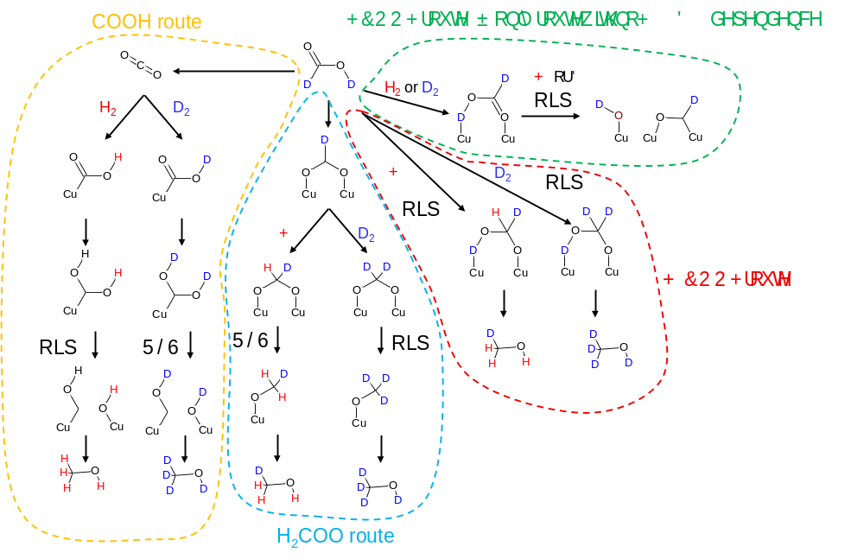
Fig. E2 Mechanistic implications of the absence of H₂/D₂ effect in formic acid conversion. Illustration of how rate-limiting steps^{10,22,23} (RLS) via H₂COO, H₂COOH or COOH would depend on the presence of H₂ or D₂, whereas the direct formic acid dissociation does not. The absence of H₂/D₂ effect in formic acid conversion (Fig. 1d) is therefore most consistent with HCOOH dissociation as the rate-limiting step. The routes via H₂COO and H₂COOH add 3 protons before/during the rate-limiting step and are also ruled out by the 1. order hydrogen dependence in Fig. E1f.

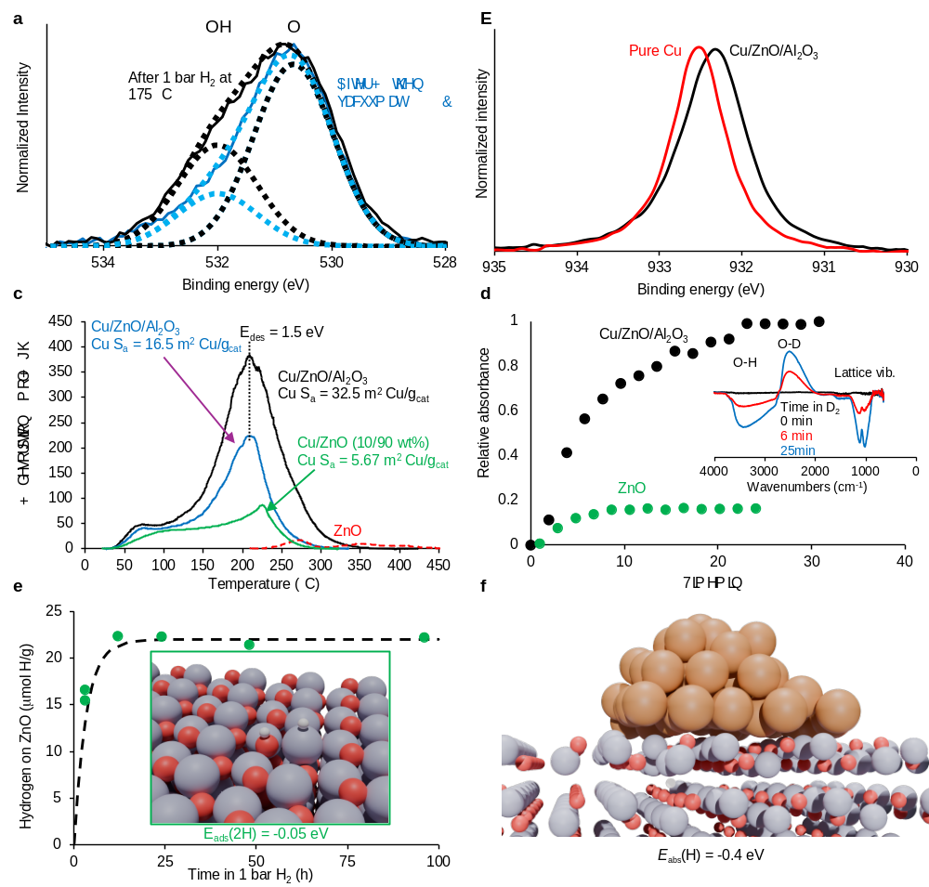Fig. E3 Further characterization of charge transfer effects. a O 1s XPS spectra for Cu/ZnO/Al₂O₃ after exposure to 1 bar, 175 ℃ and after subsequent heating in vacuum to 250 ℃. Dotted lines show deconvolutions into O and OH and their sum. b Cu 2p XPS spectra of Cu/ZnO/Al₂O₃ and unsupported Cu in 14 mbar H₂ at 250 ℃. c H₂ TPD spectra for different samples after pre-reduction and exposure to 1 bar H₂ at 175 ℃. d Normalized IR absorbance from H/D-modifications of lattice vibrations (see inserted Cu/ZnO/Al₂O₃ spectra for location) during a switch from H₂ to D₂ at 1 bar and 135 ℃. e Hydrogen adsorption on pure ZnO as a function of time and the calculated stable adsorption configuration of two H on ZnO($\text{10}\overline{\text{1}}\text{0}$). Zn: light blue, O: red, H: white. f Calculated structure of Cu₅₄ on ZnO($\text{10}\overline{\text{1}}\text{0}$) with H absorbed in the oxide below the Cu particle. The absorption is exothermic in the presence of Cu. Note how the Zn atoms above the H atom are shifted towards the Cu particle due to the attractive H⁺_{(ZnO)}-e⁻_{(Cu)} interaction created between the phases. Cu: tan, Zn: light blue, O: red, H: white.

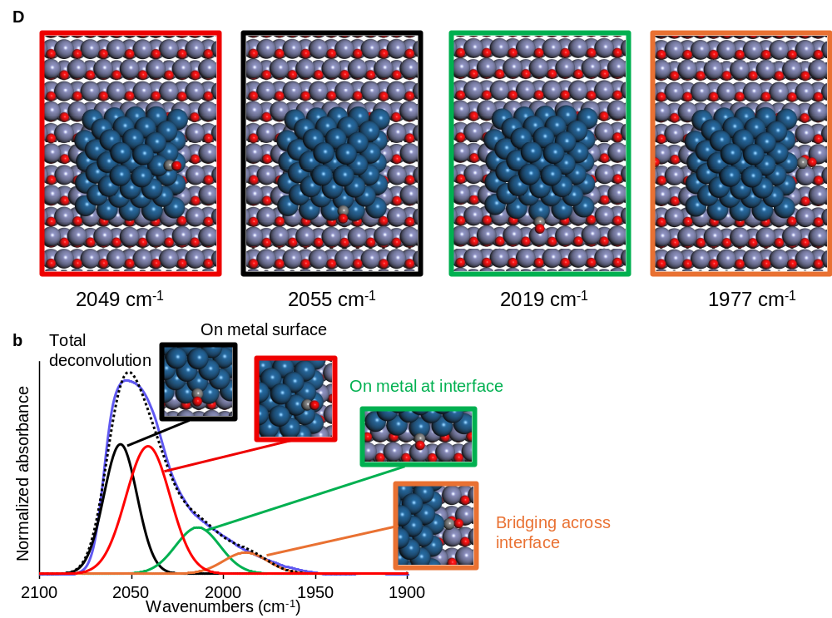
Fig. E4 Deconvolution of the infrared spectrum of CO on Pt/ZnO into the different sites. a DFT Calculated C-O stretch vibration frequencies CO adsorption on (red) a (111) microfacet, (black) a (111) microfacet close to the support, (green) and (orange) at the interface b Deconvolution of the measured IR spectrum into two groups of sites at the interface and two groups of sites on the wider Pt surface. Colours: Pt: dark blue, Zn: light blue, O: red, C: grey.

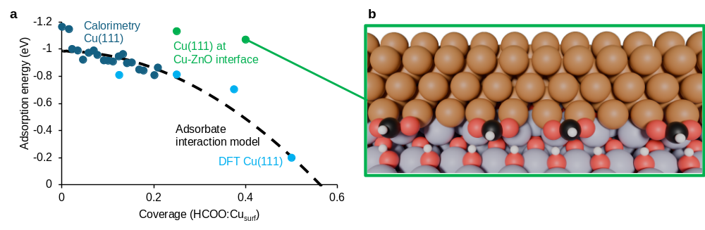Fig. E5 The stability of high coverages at the Cu-ZnO interface. a The adsorption energy of formate on Cu(111) from calorimetry⁴⁸ and DFT⁴⁹ as well as interpolation by an isotherm model⁵⁰ taking into account adsorbate interactions, compared to our calculated HCOO adsorption energies at the Cu-ZnO interface. Notice how high coverages are very stable at the Cu-ZnO interface. b Structure of adsorbed formate at a high coverage (HCOO:Cu_{surf} = 0.4) right at the interface. Cu: tan, Zn: light blue, O: red, H: white. Notice from the transition and final states in the rate-limiting step in Fig. 4 how the dissociation products need to be shifted into bridge sites with no adjacent neighbours and notice how this is impossible at the highly covered interface.

