Supplemental Material

GM1 ganglioside modulates the inflammasome-autophagy axis to protect microglia against Aβ oligomer-induced neuroinflammation

Wenxuan Wang¹, Lin Zhao PhD¹, and Shawn N. Whitehead PhD¹

¹Vulnerable Brain Lab, Department of Anatomy and Cell Biology, Schulich School of Medicine and Dentistry, Western University, London, Ontario, Canada, N6A 5C1

Corresponding Author:
Shawn Whitehead, PhD
Department of Anatomy and Cell Biology
458 Medical Sciences Building
The University of Western Ontario
London, Ontario, Canada
N6A 3K7
519 661-2111 x80440
shawn.whitehead@schulich.uwo.ca

Gene | Forward Primer (5”3”) | Reverse Primer (5”3”)
Rpl-13α | GTTCGGCTGAAGCCTACCAG | TTCCGTAACCTCAAGATCTGCT
Il-6 | GCCAGAGTCCTTCAGAGAGAT | GGAAATTGGGGTAGGAAGGAC
Il-1β | GCCACCTTTTGACAGTGATGAG | GACAGCCCAGGTCAAAGGTT
Nlrp3 | CCTTGGAGACACAGGACTCAG | CGCACAGATCGCCAAGATCA
iNOS | AGGGACTGAGCTGTTAGAGACA | AGAGAAACTTCCAGGGGCAAG
Tnf-α | GCCTCTTCTCATTCCTGCTTG | CTGATGAGAGGGAGGCCATT
Tgf-β | AATCAACGGGATCAGCCCC | AGAAGTTGGCATGGTAGCCC
Glb1 | CGGTCGACCTCCAATTCTTCGG | TACTTGACCCTTGGACCACCCA
Hexa | CTACATCCAGACGCTGCTGGAC | TACTGGCATTTCTTCCCGCCAC
B4galnt1 | GAGATATACCAGGTGAACCTGAG | CTGCCGGTTGAGTTTATCCA
B3galt4 | GGTTAAAGCCGTCCTCCCACCT | ACCAGTAGTAGGACCGCCAGGA
Neu3 | TTCATTGAGCCCCAGGTGAC | AAAGGCCGGAAGCTCACTAC
Map1lc3a | GTCCTGGACAAGACCAAGTTCC | CCATTCACCAGGAGGAAGAAGG
Atg5 | GGACAGCTGCACACACTTGG | TGGCTCTATCCCGTGAATCAT
Ulk1 | GCAGCAAAGACTCCTGTGACAC | CCACTACACAGCAGGCTATCAG
Ctsd | AGGTGAAGGAGCTGCAGAAG | ATTCCCATGAAGCCACTCAG
Lamp1 | ACCTGTCGAGTGGCAACTTCA | GGGCACAAGTGGTGGTGAG

Table S1: Forward and reverse primer sequences used for qPCR experiments (mus musculus).

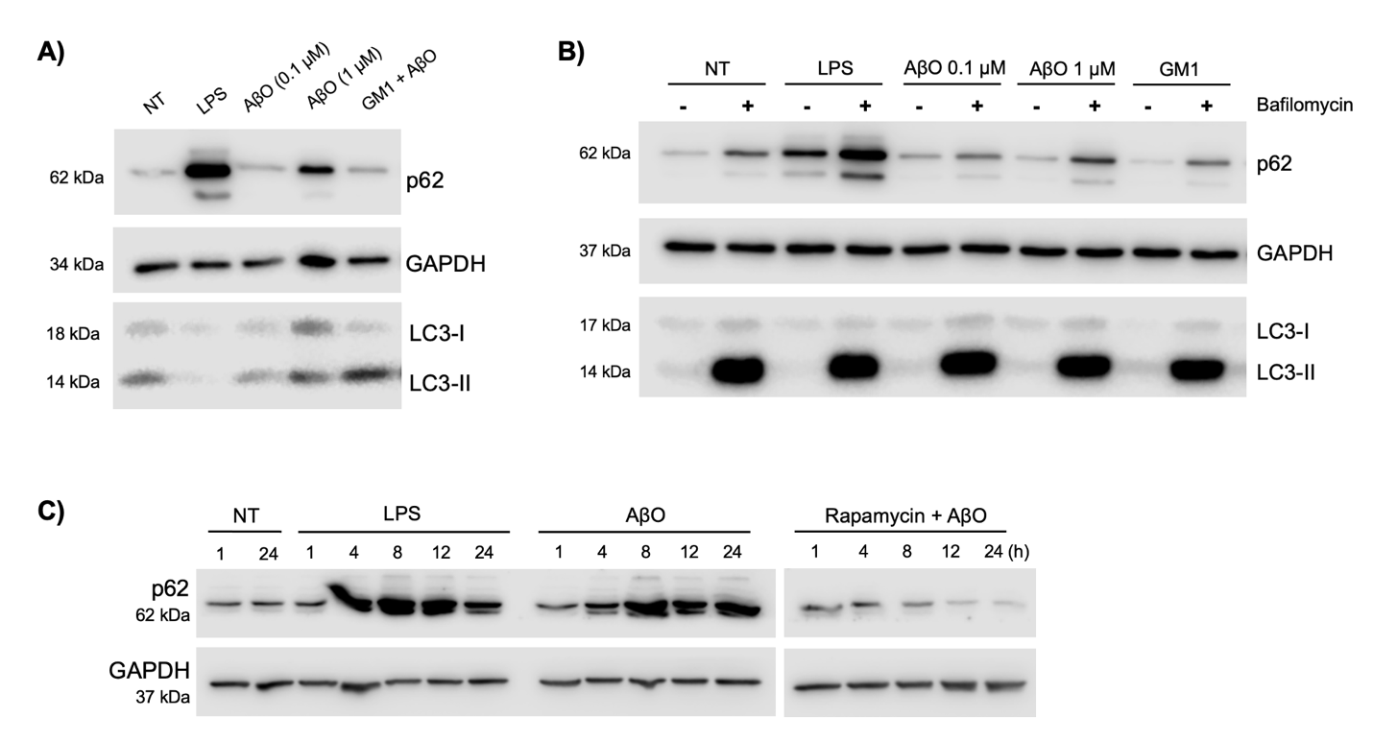

Supplemental Figure S1: Western blots analysis of autophagy flux. A) LC3 II/I ratio and p62 protein expression following microglia activation with LPS or AβO. B) Autophagy changes with Bafilomycin A1 (100 nM) post-treatment. C) p62 protein expression across 24 h time course with rapamycin (100 nM) pre-treatment and AβO activation.

Figure 4C:
Figure 4B:
p-p65

NLRP3
p65

Pro-IL-1β

LC3B

Caspase-1

Aβ 1-42

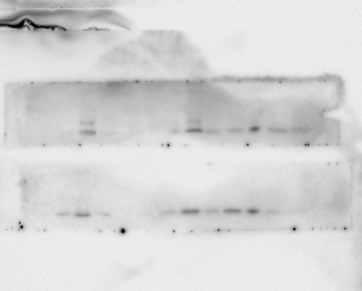
Figure 4G:

Alpha-tubulin
Cleaved caspase-1

Tsg101

Cleaved IL-1β

Supplemental Figure S2: Full western blot images for Figure 4. Representative western blot images in the main text were taken from the first 4 samples from the left.

Figure 5C
GAPDH
p-AKT
LC3a/b
GAPDH
p62
AKT
GAPDH
p62
LC3a/b

Figure 5F

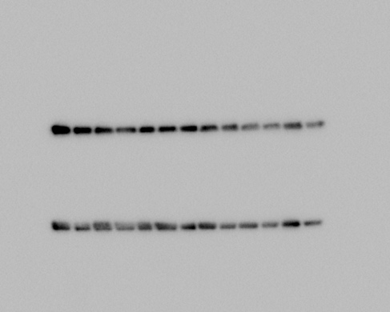
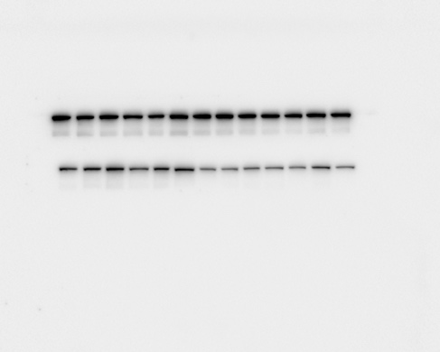
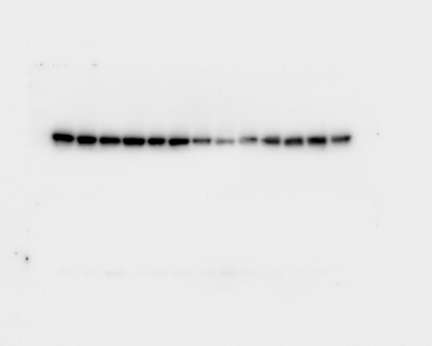
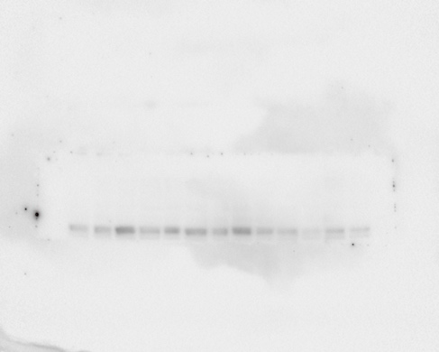
mTOR
Figure 5G

p-mTOR

Supplemental Figure S3: Full western blot images for Figure 5. Representative western blot images in the main text were taken from the first 4 samples (Fig. 5C, 5F) or the first 6 samples (Fig. 5G) from the left.

Figure 6C
Lamp2

Aβ 1-42

Figure 6D

Cathepsin D
Lamp2a

Supplemental Figure S4: Full western blot images for Figure 6. Representative western blot images in the main text were taken from the first 5 samples (Fig. 6C) or the first 4 samples (Fig. 6D) from the left.

